**Accretion HW 4**

**Zhiwei Pan 1901110222**

**Q1**

I forgot to draw the figure last week so I make up this time.

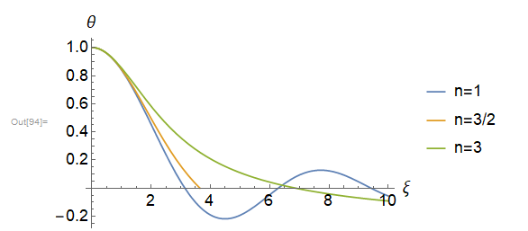

**Q1**

Bernoulli equation: 

At the sonic point $r_{c}$, we have: 







Non-isothermal EoS: 



