**Homework 2**

Pan Zhiwei 1901110222

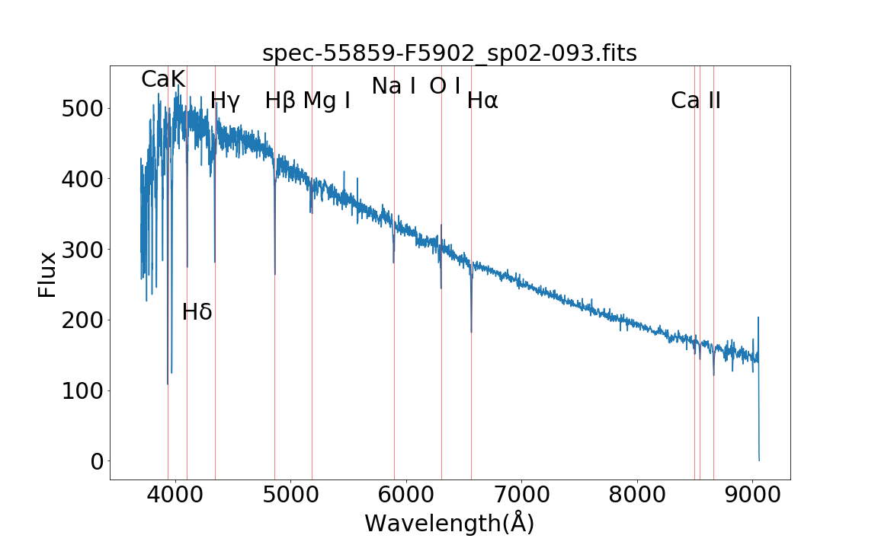**1**

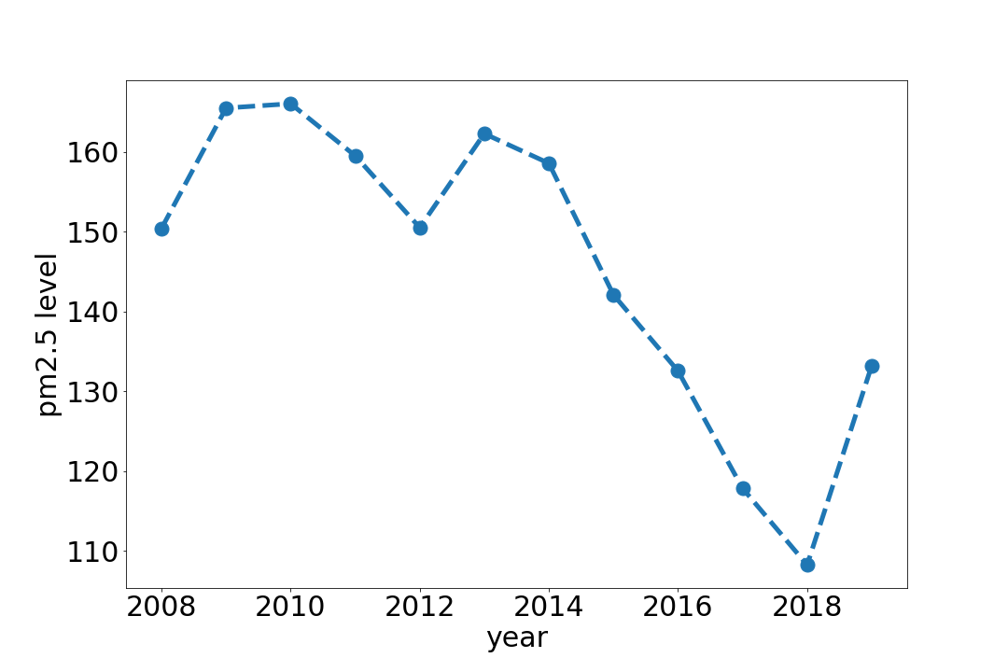Figure 1

Figure 2

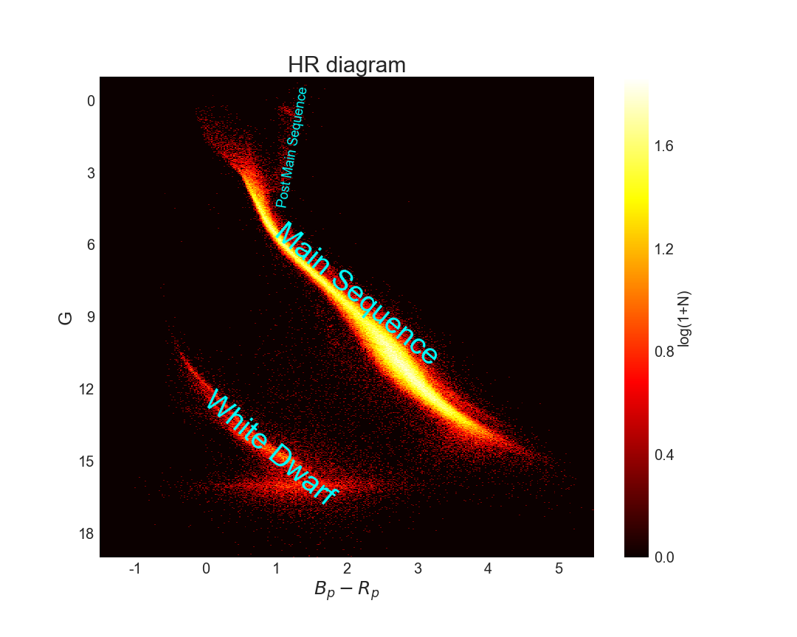**2**

**2.a & 2.b**

Figure 3

**2.c**

Because each original measurement such as flux has error, so the final physical properties such as ,, have uncertainties and the point is that we should correctly calculate error propagation:

I consider a Gaussian noise with such uncertainties on raw data and replot HR diagram. As figure 4 show, uncertainties have little effect on most regions compared with figure 3, which indicates that the quality of Gaia data is pretty high and Gaia photometry is good.

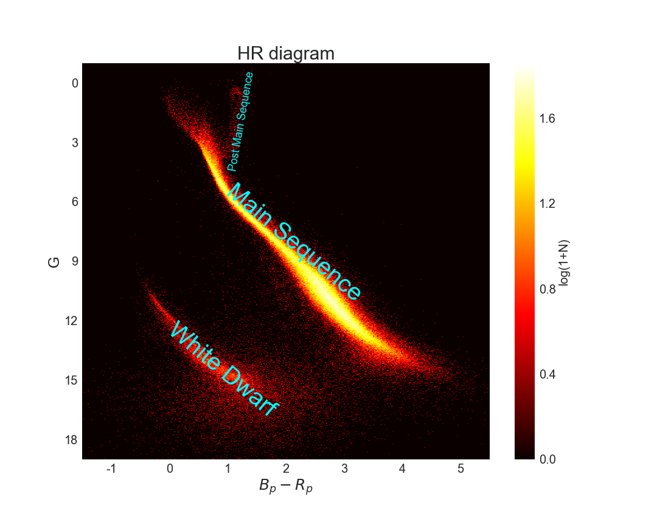 Besides, we can find that the faint region of white dwarf in HR diagram changed more diffused while in figure 3 there exits an apparent cutoff at G~16 mag. Then we can infer that the faint limit absolute magnitude of Gaia is 16 mag. Fortunately, this diffusion doesn’t prevent us characterizing white dwarfs because the color uncertainties are relative small.

Figure 4

**3**

**3.a**

**Pleiades membership**

raw data from Vizier: Infrared observations of the Pleiades (Stauffer+, 2007)

**Hyades membership**

Vizier: Pan-STARRS1 (PS1) observations of the Hyades (Goldman+, 2013)

**NGC752 membership**

Vizier: Photometry and radial velocities in NGC752 (Daniel+, 1994)

**3.b**

**Take Pleiades for example:**

Step 1:

I use CDS X-match service to crossmatch Pleiades(Stauffer+, 2007, hereafter called Table P) with Gaia DR2 in 5 arcsec radius. Then I find that the number of matched table(hereafter called Table M) is larger than number of raw catalogue. The reason may be that CDX X-match service will return all the object within the match radius.

Step 2:

In order to secure that all the objects are from Table P, I use Topcat to crossmatch the Table M with Table P and get Table Final. Because Topcat returns the best match(the nearest match), I can make sure that each of object in Table Final is in Table P. The number of Table P is 1367.

Step 3:

I choose 1280 data whose relative plx error <10% and then draw 3 distributions in figure 5, figure 6, figure 7. Figure5 shows the distance distribution of Table Final and I use FWHM as the radius criteria of a cluster, which may underestimate the number of a cluster. In this case it’s about 132 and 140 pc. Figure 6 and Figure 7 show the proper motion distribution and I set a very loose criteria as 15, 25 and -50, -40. Using these three criteria, I get 682 cluster members.

I use the same method and choose 329 Hyades members from 742 raw data(Goldman+, 2013) and 83 NGC752 members from 247 raw data(Daniel+, 1994)

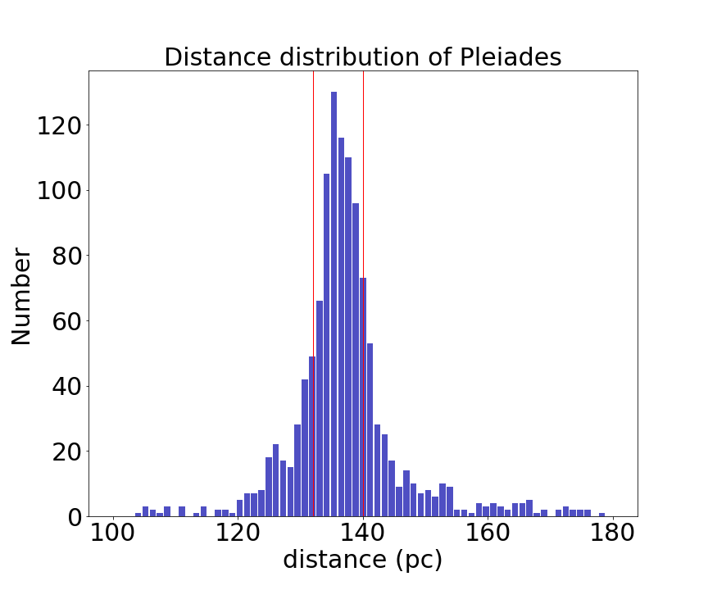

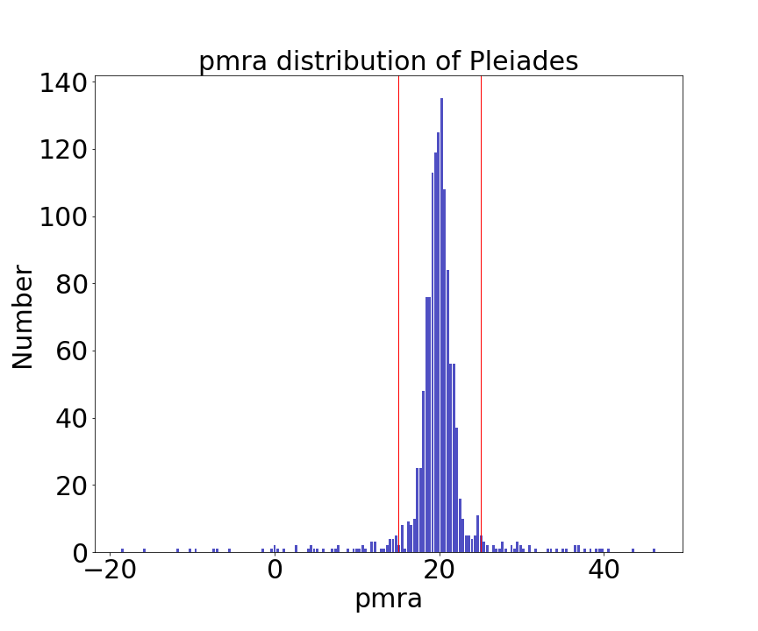Figure 5

Figure 6

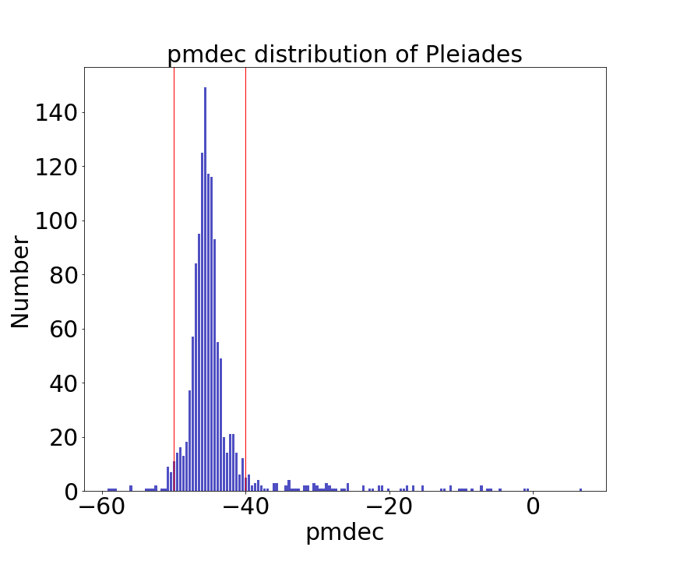

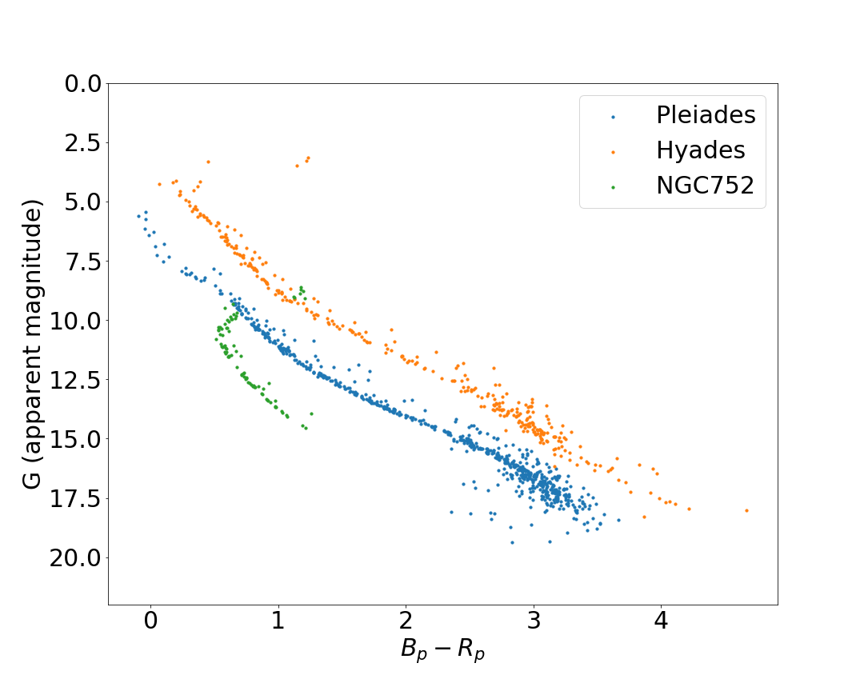Figure 7

**3.c**

Figure 8

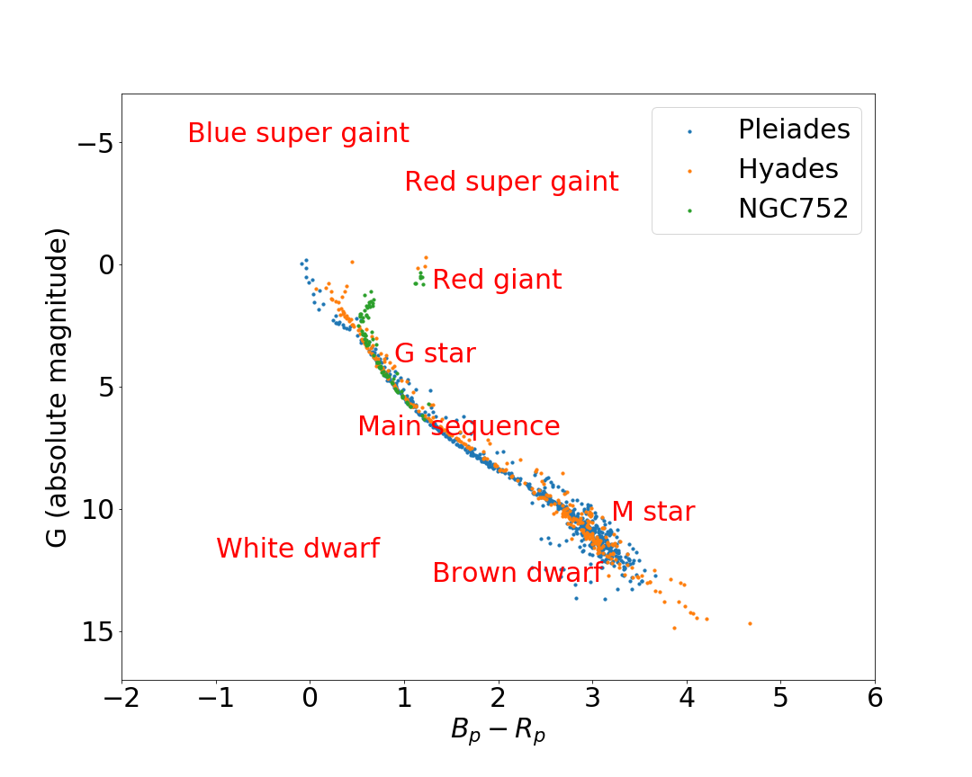

Figure 9

The y-axis of figure 8 is apparent magnitude and that of figure 9 is absolute magnitude.

Brown dwarf is radiating gravitational energy.

White dwarf is purely radiating thermal energy without nuclear reaction.

Main sequence star is burning hydrogen in the core.

Red giant is burning hydrogen in the hydrogen shell around the helium core.

Super giant is burning metal elements such as carbon.

**3.d**

In figure 8, clusters have difference in apparent magnitude, which indicates that Hyades is the closest cluster and NGC752 is the furthest cluster. In figure 9, we can see that Pleiades doesn’t have red giants, which indicates that it is the youngest cluster.

The turn-off point of NGC752 is fainter than that of Hyades, which indicates that relative long lifetime stars are dying. Therefore, NGC752 is the oldest cluster among these three clusters.

I also see that there are no white dwarfs or super giants in three clusters.

**3.e**

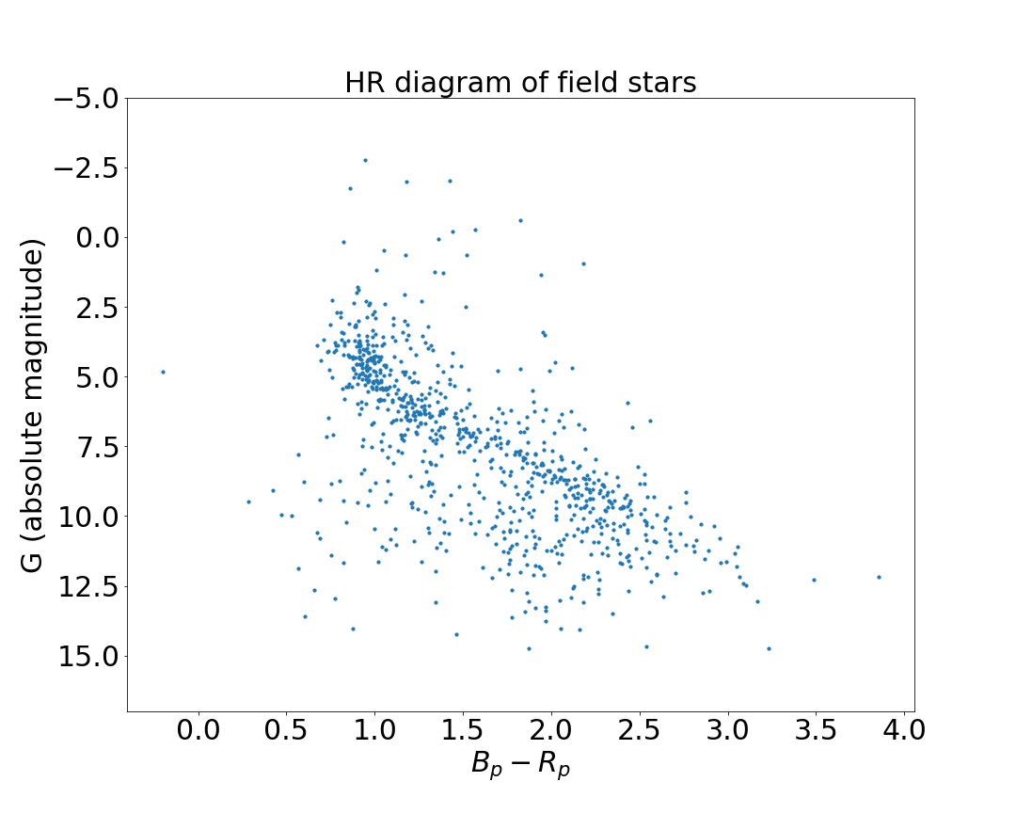

Figure 10

I use online Vizier query to get field stars in regions where 50<ra<50.5, 18<dec<18.5. As figure 10 shows, the distribution of HR diagram is very diffused and there exit white dwarfs compared with clusters above. So we can infer that each different field star may have very different burn time and physical properties while stars in a cluster can be a stellar population.

**4**

**4.a**

**Planck function:**

**4.b**

make , we have

solve this equation and we can get:

**4.c**

, the wavelength of the black-body radiation peak flux, is inversely proportional to temperature.

**4.d**

We define L: luminosity of Sun,

D: distance between Earth and Sun

R:radius of Earth

Earth’s absorption term:

Earth’s emission term:

Because we regard Earth as a blackbody, then we have:

we use and get

**5**

**5.a**

**5.b**

=0

if we take *:*

**5.c**

For ideal gas:

for pure ionized H:

for pure ionized He:

**5.d**

so the virial theorem is satisfied.

**6**

1. ideal gas：lots of mass points without interactions and their collisions are perfectly elastic. The ideal gas follows the equation:
2. virial theorem: in a gravitational bound stable system, the relationship of average kinetic energy <T> and average potential energy <V> follows the equation:
3. blackbody: an ideal object that can absorb radiation completely at every wavelength.
4. energy transport by convection: energy transport from high temperature region to low temperature region because of the temperature gradient.
5. Kelvin-Helmholz timescale: It’s a theoretical estimate of how long a [star](https://everything2.com/title/star) would shine with current [luminosity](https://everything2.com/title/luminosity) if the only power source were the conversion of [gravitational potential](https://everything2.com/title/gravity) energy.
6. HR diagram: It’s a 2-d figure with luminosity/magnitude versus effective temperature/color index, which can show different properties of different objects.
7. Jeans mass:  If the mass of a gaseous cloud exceeds the critical mass called Jeans mass, the cloud will collapse.
8. stellar effective temperature: the all-wavelength radiation emitted by a star equals the total energy emitted by a blackbody at a certain temperature called stellar effective temperature.
9. hydrostatic equilibrium: In this state, downward force exerted by [gravity](https://www.wisegeek.com/what-is-gravity.htm) of the fluid is balanced by an upward force exerted by the pressure.

**Acknowledgement:**

I thank my roommate Pang Yuxuan, for we did so many discussions.

**Reference:**

Wiki

Vizier: <http://vizier.u-strasbg.fr/>

Gherczeg: <http://kiaa.pku.edu.cn/~gherczeg/stellar/>