**Homework 3**

Zhiwei Pan 1901110222

**Q1**

**Saha Equation:**



I set , which is typical density of coronae.

Then I use the approximation: , and and ionization potential are shown intable 1 and 2:

**table 1: for H and C**

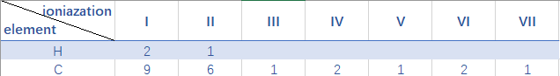

**table 2: for H and C**

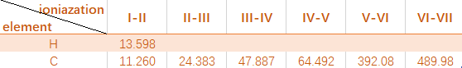

(unit: eV)

**(a)(b)**

Figure 1 and 2 show the ionization fraction versus temperature of H and C.

**(c)**

My x-axis is in log and y-axis is in linear.

The reason is that particles at different ionization level dominates at different temperature and the different of temperature is very large (exponential) while the difference of ionization fraction 0 to 1 is small.

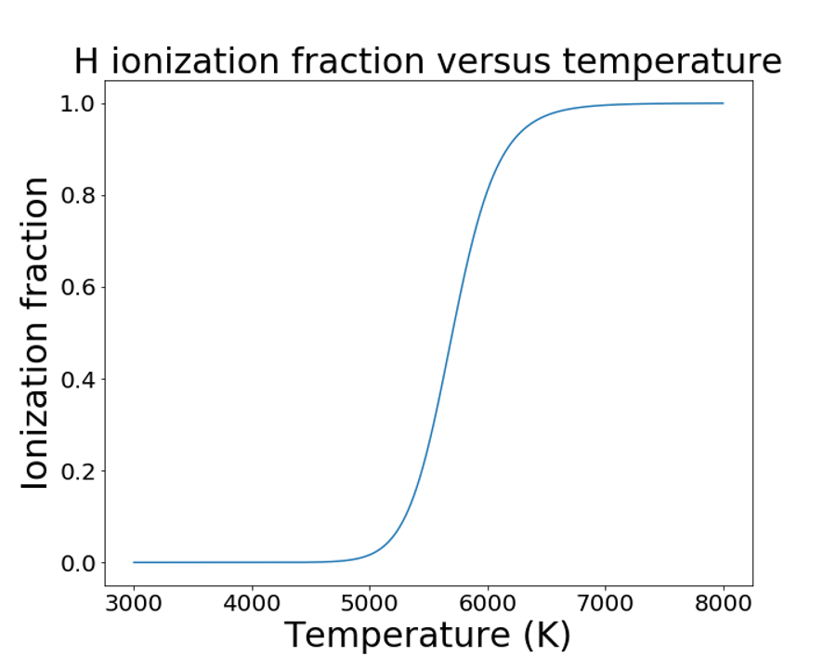

**Figure 1**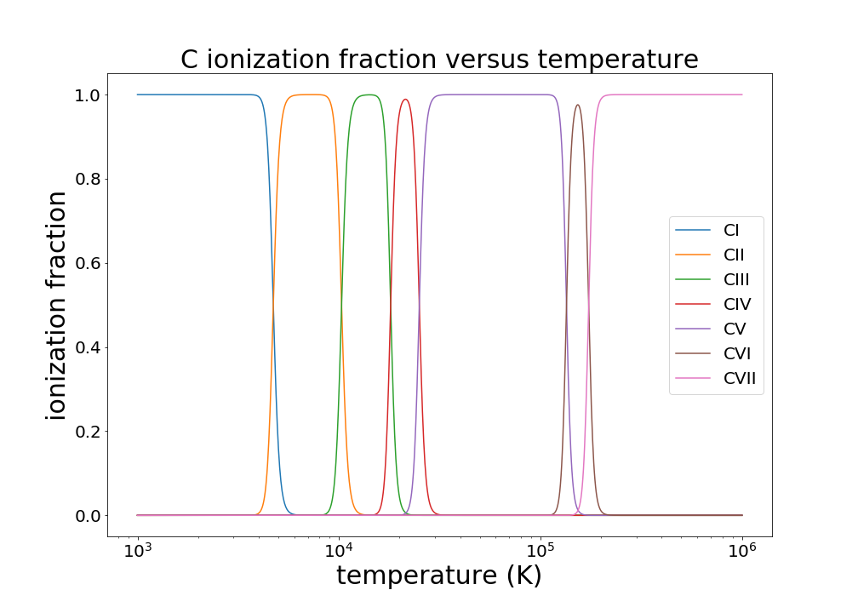

**Figure 2**

**(d)**

If I can see C Ⅰ in absorption in a stellar spectrum, the stellar temperature must be lower than around 5500 K otherwise neutral carbon will be completely ionized.

Based on the similar reason, that the solar coronae can be see in C Ⅵ implies that the temperature of solar coronae is more than about 300,000 K.

**Q2**

**(a) (b)**

1. **Ideal gas:** The momentum distribution *n(p)* for classical, non- relativistic particles of mass m in LTE is given by the MB distribution:



1. The pressure is calculated by using v=p/m :



So we have:

1. **Complete electron degeneracy:** In the limit that , the maximum momentum is called the Fermi momentum *,* then we have:



Then we use:





For non-relativistic:,



For non-relativistic:,





1. **Radiation:**



1. **Equation of state regimes**

For ionized hydrogen:

1. **Between electron and degeneracy and ideal gas pressure:**

For NR:

For ER:

1. **Between radiation and ideal gas pressure:**
2. **Between relativistic vs. non-relativistic degenerate electron pressure**
3. **To crystallization of the ions:**



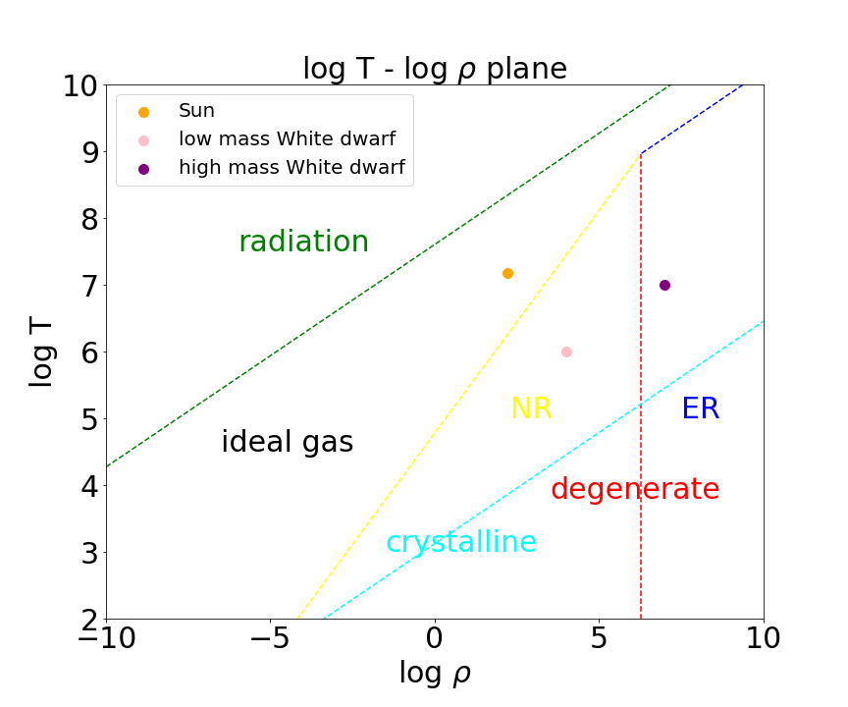

**Figure 3**

**Q3**

**(a)**

Polytropic relation is: , for ER:

By solving Lane-Emden equation:



Then we can get the relation between M, R, K:



(from Onno Pols, Chapter 4, Table 4.1)





**(b)for only He:**





**(c)for C and O:**





**Q4**

**(a)**



The energy emitted by one pp chain is :



(from Onno Pols, Chapter 6.4.1)

So, the number of reactions per second take place in the sun is:



**(b)**

The mass of He produced in the sun every second is:



**(c)**



**(d)**



**Q5**

**(a)**

Figure 4 and 5 show the various processes contributing to the opacity.

Region 1 is the region where molecules and dust dominate. Region 2 is negative H ion. Region 3 is bound-free and free-free absorption. Region 4 is electron scattering. Region 5 is conductivity opacity.

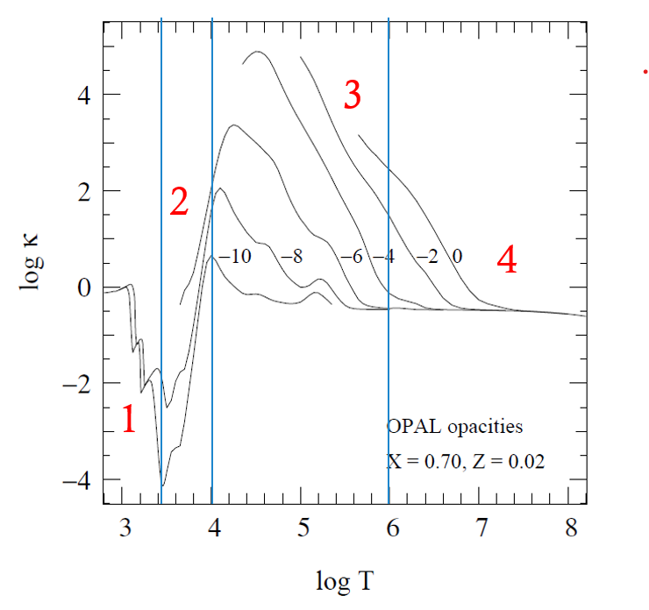

**Figure 4**

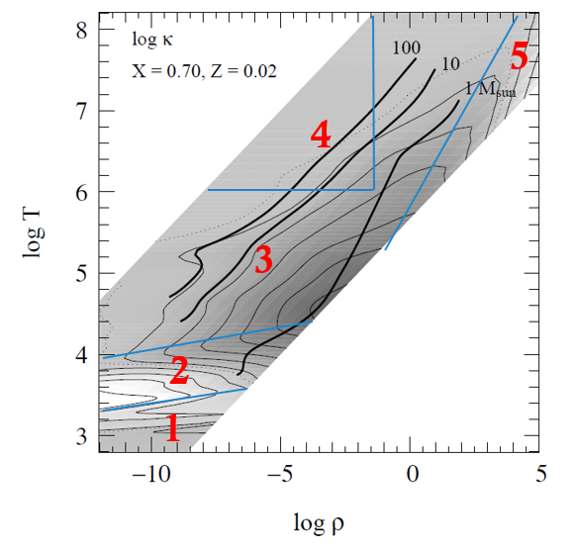

**Figure 5**

**(b)**

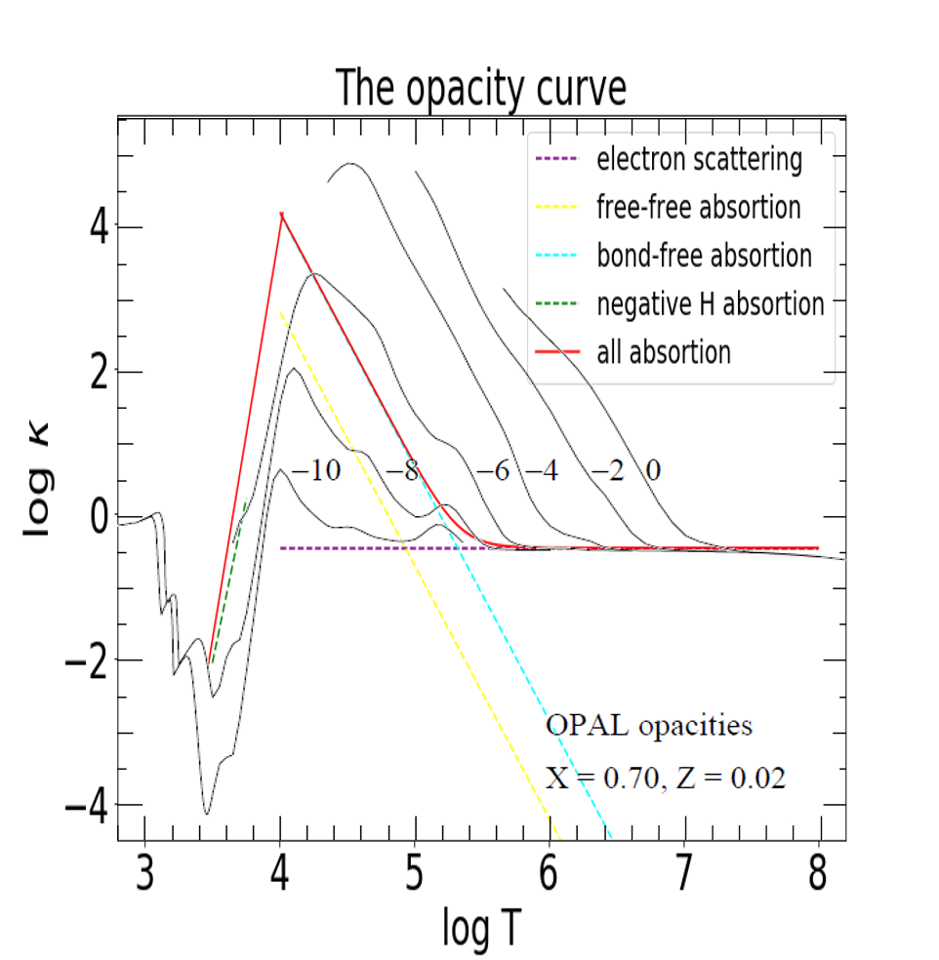

**Figure 6**

Figure 6 shows the comparison between the approximations with OPAL opacities. I have to mention that the low T end of red all absorption line is plotted by linear interpolation in order to keep the continuity.

We can see that the green negative H absorption line fits the realistic opacity curve well. The red all absorption line at 4.3<logT<6 is lower than OPAL because we only consider these four processes and they are only approximations. The red all absorption line at logT>6 fits well because that this region is only dominated by electron scattering. Besides, rough interpolation results in the overestimate of opacity at 3.8<logT<4.3

**(c)**

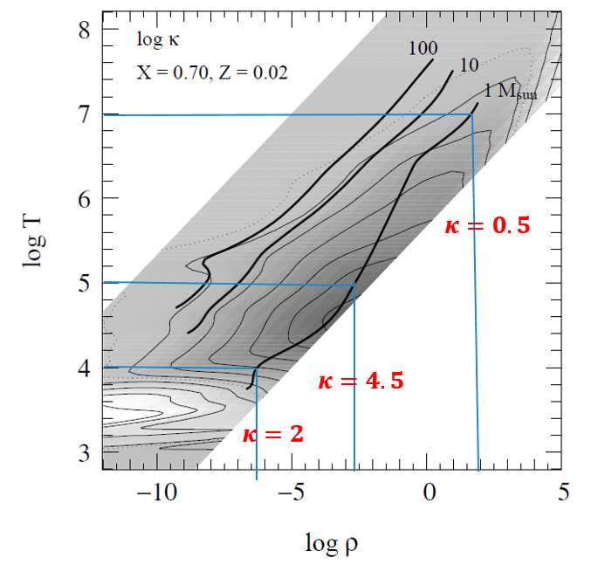

**Figure 7**

Figure 7 shows the parameter I choose where:

So when :

When :

When :

**(d)** 







Make



**Q6**

A key point of this question is how to convert the G mag and color into mass. My idea is that I draw a CMD figure by model and then use it to match the Gaia data point.

**The first step** is to plot CMD based on the data from the website. As figure 8 shows, I plot 3 isochrones with different metallicities. The metallicity of upper brunch is Z=0.025, the middle brunch is Z=0.015 and the last is Z=0.005. Different color represents different mass bin from . The black dots are 200 Gaia data points just for demonstration.

The problem we meet here is that CMD model points are not dense enough to form a function, which means that given a G magnitude and a color index, it is impossible to use these CMD model points to precisely get every mass value.

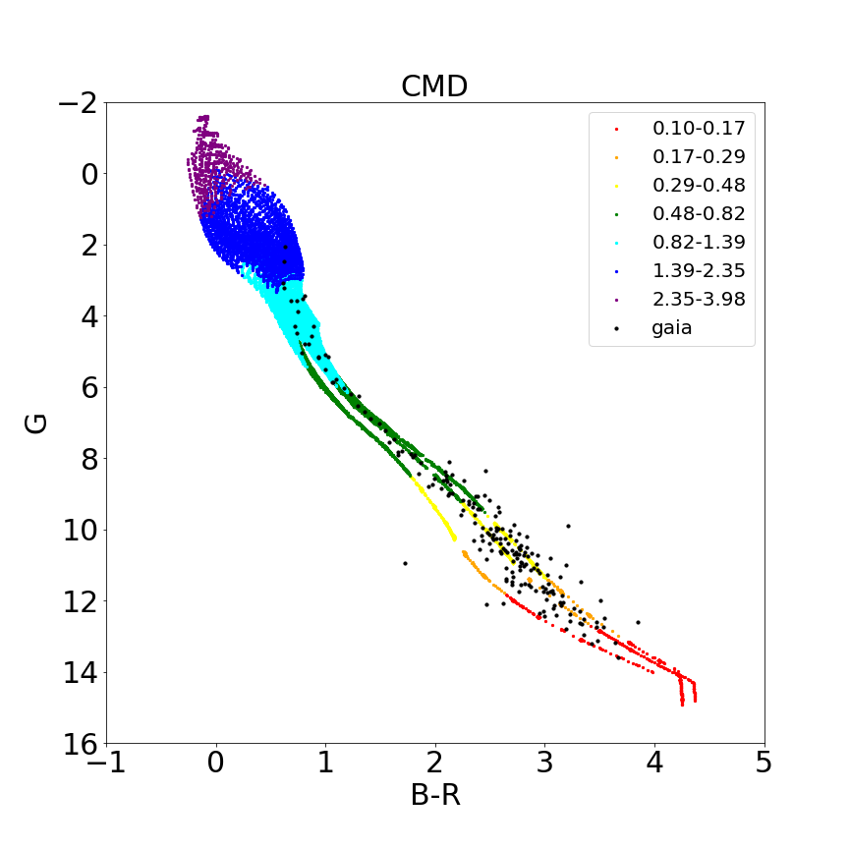

**Figure 8**

Thera are many approximation methods such as interpolation, regression and machine learning. In this case, I use multiple linear regression. Because the dispersion of bright region (G<4) is much larger than faint region, I divide the CMD model data into two subsample and individually do the regression.

Figure 9 and Figure 10 show the comparison between model and fit result. Bottom panel of figure 9 is the low mass data fit:

We can see that the linear fit is pretty precise. One thing I have to mention that I consider the quadratic and cubic terms in regression just for precise rather than physical reasons.

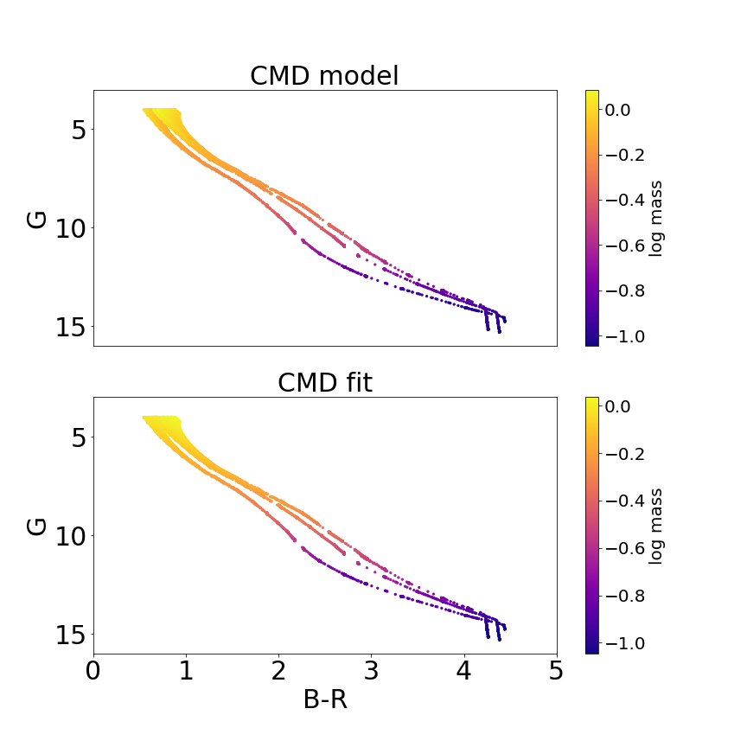

**Figure 9**

The high mass data fit in figure10 is :

*

**The second step** is to select proper Gaia data, estimate the mass using the regression function above and finally calculate IMF.

To begin with, I select data with these criteria:

* relative error of G, B, Rmag < 0.1
* astrometric_excess_noise< 1
* 0< G <15: for sample completeness
* G<3*bprp+6: rule out white dwarfs
* G>4 or bprp<1: rule out red giants

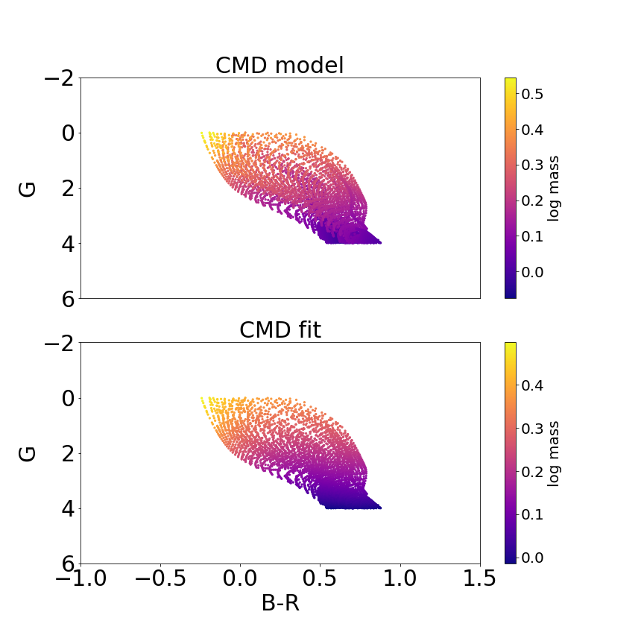

**Figure 10**

Then I convert the Gmag and color of selected Gaia data into mass and then calculate IMF, the uncorrected IMF.

Because the raw data we use are all sources within 100pc from us, we don’t need to consider about the effect of effective Volume. The only thing I should consider is to multiply the large mass correction resulted from the short lifetime of large stars.

I assume that:

Correction=

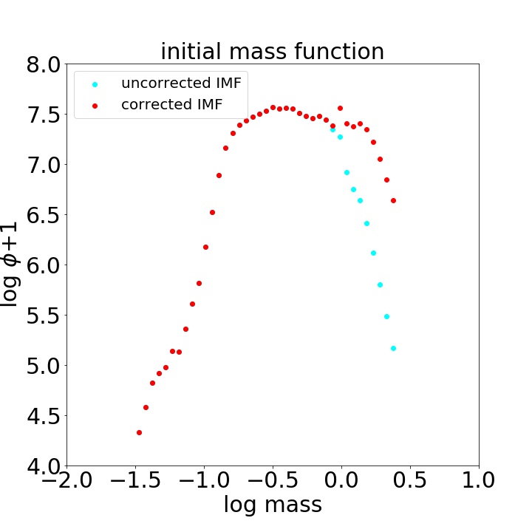

**Figure 11**

Figure 11 show the result of initial mass function. Red dots represents the corrected IMF. The main difference between IMF we calculated using Hipparcos and this IMF is the mass range. We only calculate IMF at 1<M< for Hipparcos while this IMF focuses on the low mass end. Another difference is that we can linearly fit Hippacros IMF while this IMF may require a double-powerlaw. Besides, The slope of Gaia IMF at M>1 is steeper than Hippacros IMF.

**Acknowledgement:**

I thank my roommate Yuxuan Pang, for we did so many discussions. I thanks GAIA for their amazing data.

**Reference:**

Onno pols 《STELLAR STRUCTURE AND EVOLUTION》

Gherczeg data: <http://kiaa.pku.edu.cn/~gherczeg/stellar/>

Wiki

**Appendix: python code for Q1**



