**Homework 4**

Zhiwei Pan 1901110222

**Q1**

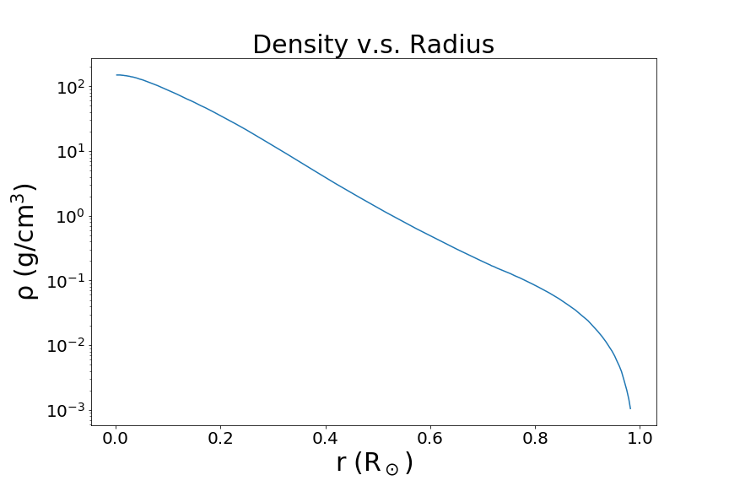(a)

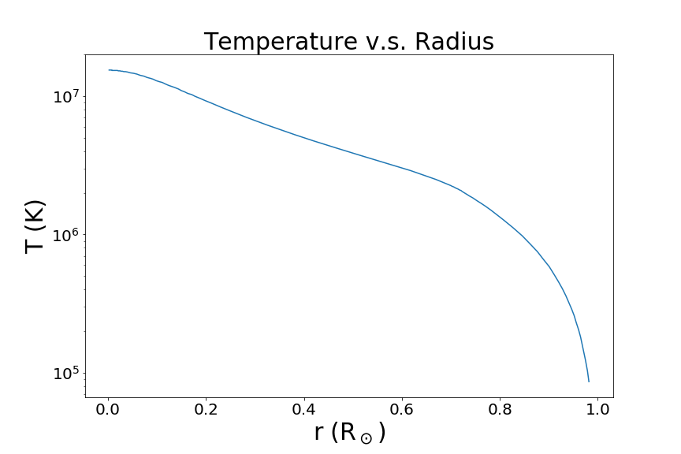 **Figure 1**

**Figure 2**

(b)

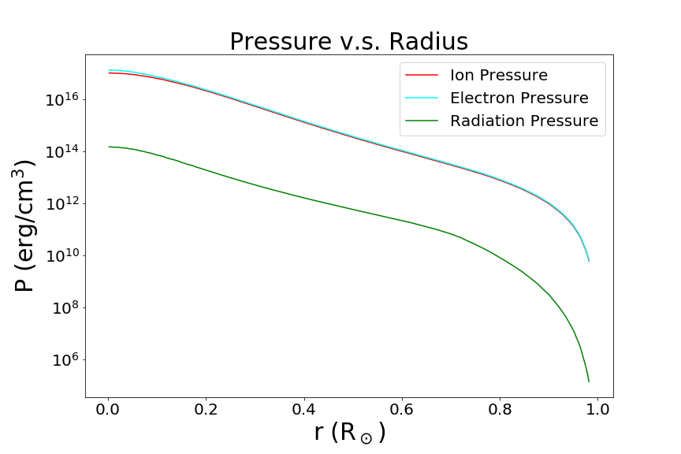

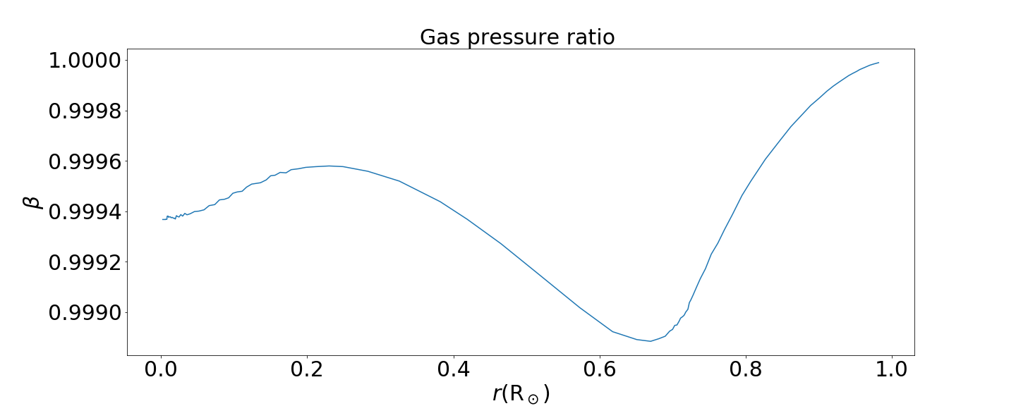**Figure 3**

**Figure 4**

Assume ideal gas then we can calculate the pressure:











Then we define: 

Figure 3 and 4 show the pressure and $β$ as a function of radius.

(c)

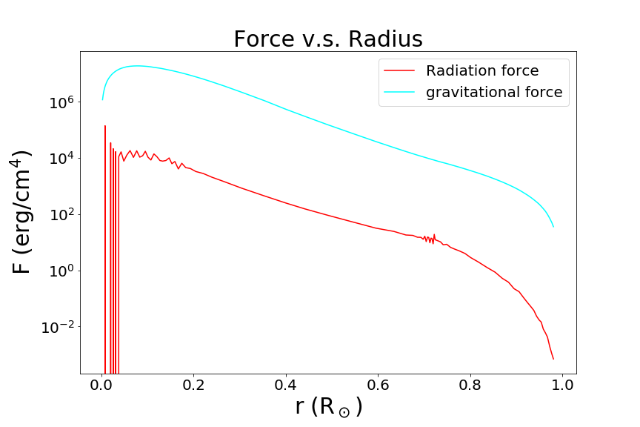

**Figure 5**

As figure 5 shows, radiation force is much smaller than the gravitational force so it’s not important.

(d)

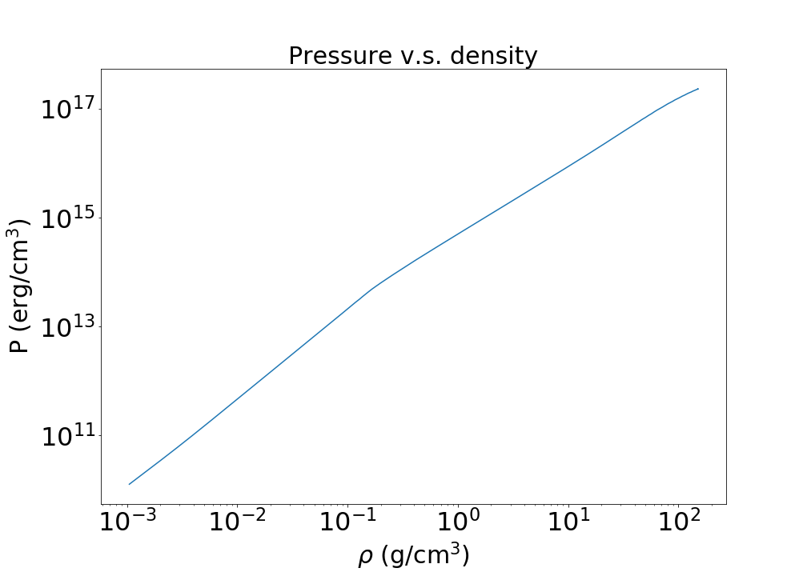

**Figure 6**

Figure 6 shows the relation between Pressure and density in log scale. We can find that it’s very similar to linear relation, which means that:

$P\sim ρ^{γ}$*.* Because of the similarity of such a kind of equation of state we can say that a polytrope model is very close to Standard Solar Model.

(e)(f)

For a polytrope of $n=3, β=0.9995853:$









**Figure 7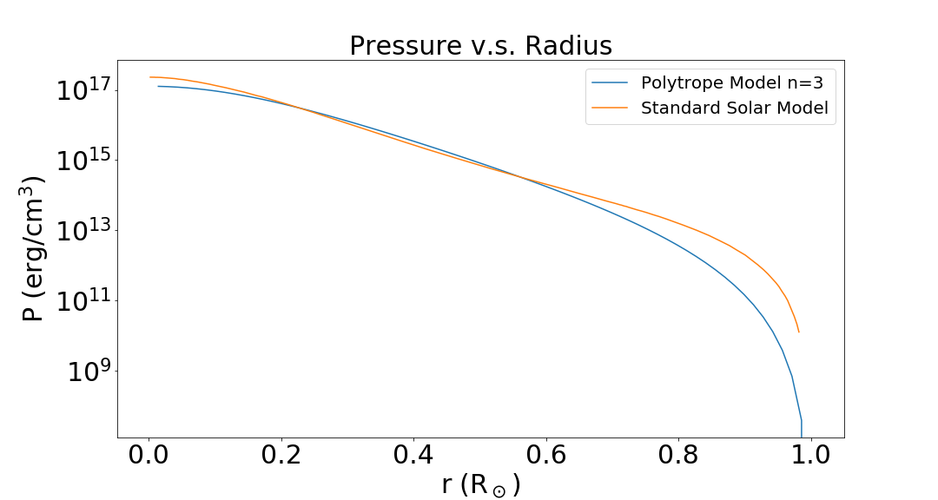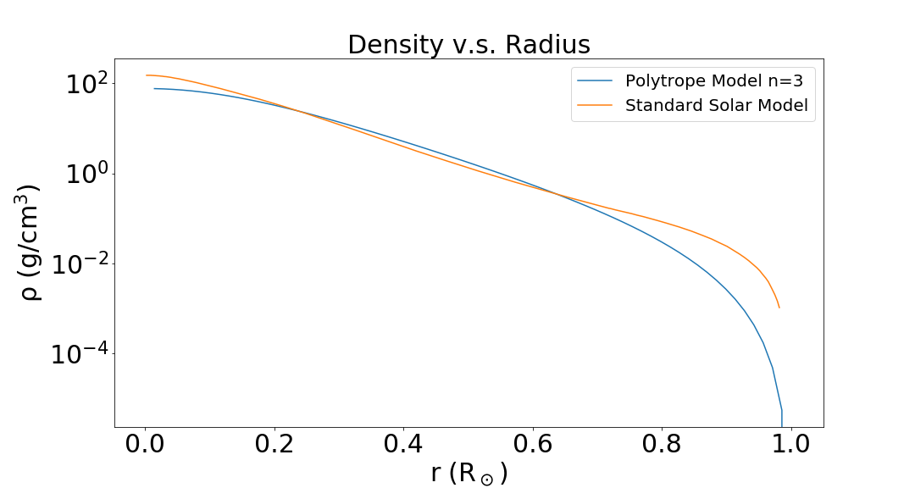  
Figure 8**

Figure 7 and 8 show the density and pressure distributions of these two models. Figure 9 demonstrates the pressure versus density. We can see that they are very similar so we can conclude that this polytrope model with n=3 is very accurate compared with Standard Solar Model.

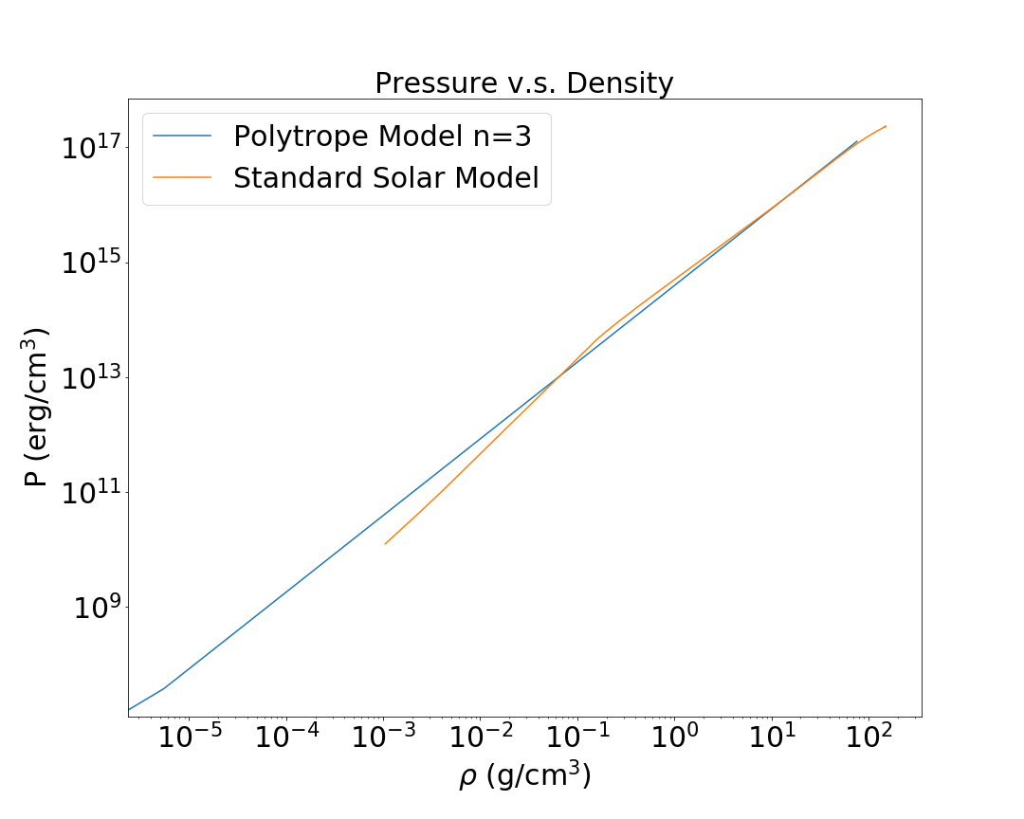

**Figure 9**

**Q2**

(a) 

And we have: 









(b)







So the velocity of the convective element is much smaller than sound speed.

(c) 

So the convection doesn’t alter significantly the hydrostatic structure of the region.

(d)

The crossing time is:



The thermal timescale is:



The nuclear timescale is:



So the times are:



So that over a thermal timescale, and certainly over a nuclear timescale, convective elements will cross the region many times and makes convective region inside a star mixed homogeneously.

**Q3**

(a)

The value I use is: $m_{e}=0.511 MeV$

$$m_{{}_{}^{1}H}=938.272 MeV, m_{{}_{}^{2}H}=1875.613 MeV$$

$$m_{{}_{}^{3}{He}}=2808.392 MeV, m_{{}_{}^{4}{He}}=3727.378 MeV$$

Then I calculate the energy released in each reaction:

**Table 1**:PP1 energy released

|  |  |
| --- | --- |
| Reaction of PPI | Energy released (MeV) |
| $${}_{}^{1}H+{}_{}^{1}H→{}_{}^{2}H+e^{+}+ν$$ | E1=1.442 |
| $${}_{}^{2}H+{}_{}^{1}H→{}_{}^{3}{He}+γ$$ | E2=5.493 |
| $${}_{}^{3}{He}+{}_{}^{3}{He}→{}_{}^{4}{He}+2{}_{}^{1}H$$ | E3=12.861 |

(b)

The total energy released in the PPⅠ reaction is:



(c)

The average energy of neutrino is:



Then the energy of the three pp-chain release is:



So PP1 release the most energy.

The energy released by unit mass is:



(d)

The triple-α reaction is:



The energy released is:



The energy release per unit mass is:



(e)

The mass of the core is:



The total energy release is:

,

So the time is:\





**Q4**

(a)

the condition is :





(b)

**Table 2**: rotation parameters

|  |  |  |  |  |
| --- | --- | --- | --- | --- |
| Spectral type | M/ $M_{⊙}$ | R/ $R_{⊙}$ | $$V_{rot}$$ | $$δ$$ |
| O5 | 60 | 12 | 190 | 0.038 |
| B2.5 | 7 | 3.23 | 200 | 0.097 |
| B5 | 4 | 2.35 | 210 | 0.136 |
| A0 | 2.5 | 1.81 | 190 | 0.137 |
| A7 | 1.8 | 1.55 | 160 | 0.116 |
| F0 | 1.6 | 1.48 | 95 | 0.044 |
| F5 | 1.4 | 1.36 | 25 | $$3.2×{10}^{-3}$$ |
| G0 | 1.2 | 1.13 | 12 | $$7.1×{10}^{-4}$$ |
| G2 | 1 | 1 | 2.3 | $$2.8×{10}^{-5}$$ |

As **table 2** shows, $δ$ of A0 is the largest so the largest departure for spherical symmetry occurs in early A stars.

**Acknowledgement:**

I thank my roommate Yuxuan Pang, for we did so many discussions. I also thank Jiayi Tang and Tai Zhou.

**Reference:**

Onno pols 《STELLAR STRUCTURE AND EVOLUTION》

Wiki