**Random PARTICLE SIMUlation system**

**(ParticleSimu)**

# Version

0.5.3

You can always find the latest version in the following website:

www.panzichao.wix.com/person

# Date

2015-09-21

# Function

1. Generate random particles with typical shape and gradation in a container.
2. The following shapes of the particle are supported now: circle, ellipse, polygon, sphere, ellipsoid, cylinder, and capsule.
3. The following shapes of the container are supported now: circle, rectangle, cylinder and box.
4. Periodic boundary condition is supported (for circle and cylinder container, periodic boundary condition is not available, because it cannot be well defined).

# Update

1. Change the source files into a compatible form with gfortran

# Interface

## Input

The input file should be exactly named as: “Input.dat”, and be placed in the same folder as the executable file.

Currently, the input file should contain the following parameters:

|  |  |  |  |
| --- | --- | --- | --- |
| spatial_dimension |  | | |
| container_type |  | | |
| container_size1 | container_size2 | | container_size3 |
| particle_occupy_percentage |  | | |
| total_sieve_num |  | | |
| particle_size1 | particle_size1 | … | particle_sizeN |
| cdf1 | cdf2 | … | cdf3 |
| particle_type |  | | |
| aspect_ratio1 | aspect_ratio2 | | |
| min_side_num | max_side_num | | |
| periodic_bc_on |  | | |

All the above parameters are compulsory, although some of them may not be used. Otherwise, an I/O error will occur.

The meanings and permitted values of the above parameters are explained as follows.

CAUTION: The current version does not include a “data-check” and “exception-handle”. So it is up to the users to make sure the input parameters are correct.

spatial_dimension : 2 for 2-D, 3 for 3-D.

This parameter is included for future use. It is not used in the current version.

container_type

|  |  |
| --- | --- |
| 1 | rectangular container |
| 2 | box container |
| 3 | circular container |
| 4 | cylindrical container |

container_size1, container_size2, container_size3

|  |  |  |
| --- | --- | --- |
| container_type = 1 | container_size1 | length in x direction |
| container_size2 | length in y direction |
| container_size3 | not used |
| container_type = 2 | container_size1 | length in x direction |
| container_size2 | length in y direction |
| container_size3 | length in z direction |
| container_type = 3 | container_size1 | radius |
| container_size2 | not used |
| container_size3 | not used |
| container_type = 4 | container_size1 | radius of cross section |
| container_size2 | height |
| container_size3 | not used |

particle_occupy_percentage

This parameter refers to the area fraction or volume fraction of the particles in a 2-D or 3-D case. The possible range of this parameter is 0~1.0, dependent on the gradation of the particles.

total_sieve_num

particle_size1~ particle_sizeN

cdf1~ cdfN

These parameters define the gradation of the particles. total_sieve_num = N. particle_size is the representative size of the particle in each level, and cdf is the corresponding Cumulative Distribution Function of particle_size.

Representative size:

|  |  |
| --- | --- |
| circle | diameter |
| ellipse | 2 * a (major diameter) |
| polygon | diameter of the circle which has the same area |
| sphere | diameter |
| ellipsoid | 2 * b (the middle diameter) |
| cylinder | 2 * a (the major diameter of cross section) |
| capsule | diameter of cross section |

The representative size roughly refers to the smallest size of the sieve which allows the particles to pass through.

particle_type

|  |  |
| --- | --- |
| 1 | circle |
| 2 | ellipse |
| 3 | polygon |
| 4 | sphere |
| 5 | ellipsoid |
| 6 | cylinder |
| 7 | capsule |

aspect_ratio1, aspect_ratio2

Two parameters related to the major characteristics of the shape of the particle. They may or may not be used dependent on particle_type.

|  |  |  |
| --- | --- | --- |
| particle_type = 1 | aspect_ratio1 | not used |
| aspect_ratio2 | not used |
| particle_type = 2 | aspect_ratio1 | a / b |
| aspect_ratio2 | not used |
| particle_type = 3 | aspect_ratio1 | max (h / l)* |
| aspect_ratio2 | not used |
| particle_type = 4 | aspect_ratio1 | not used |
| aspect_ratio2 | not used |
| particle_type = 5 | aspect_ratio1 | a / b |
| aspect_ratio2 | b / c |
| particle_type = 6 | aspect_ratio1 | h / (2 * a) |
| aspect_ratio2 | a / b |
| particle_type = 7 | aspect_ratio1 | h (2 * r) |
| aspect_ratio2 | not used |

* For polygon, there exists a rectangle for each side. aspect_ratio1 refers to the maximum value of h / l among every side.

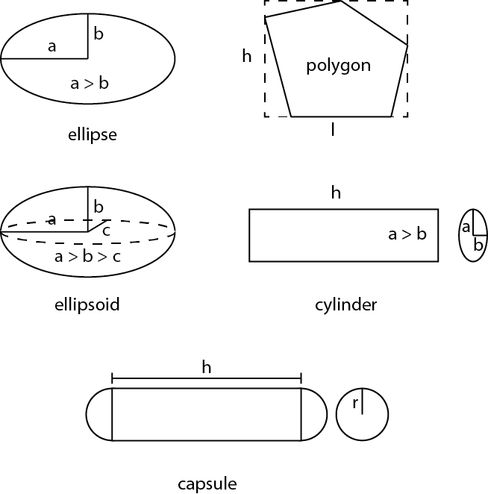

Figure Major characteristics of shapes of particles

min_side_num, max_side_num

These parameters are only used for polygon (particle_type = 3). They refers to the possible minimum and maximum of the total side number (vertex number) of the polygon. The actually side number of the polygon is randomly generated between these two parameters.

periodic_bc_on : 1 for periodic boundary condition, 0 for no periodic boundary condition

CAUTION: for circle and cylinder containers (container_type = 3 or 4), this parameter is not used.

## Output

In all of the following output, the positions of the particle, e.g., center_x_pos, are in the coordinate where (0,0,0) is placed at the center of the container.

### Circular particle

Output file: ‘circle.dat’

|  |  |  |
| --- | --- | --- |
| radius | center_x_pos | center_y_pos |

### Elliptical particle

Output file: ‘ellipse.dat’

|  |  |  |  |  |
| --- | --- | --- | --- | --- |
| major radius | minor radius | rotation angle | center_x_pos | center_y_pos |

### Polygonal particle

Output file: ‘side_num.dat’, ‘vertex_x_pos.dat’, ‘vertex_y_pos.dat’

side_num.dat:

|  |
| --- |
| side number of 1st polygon |
| side number of 2nd polygon |
| …… |
|  |

vertex_x_pos.dat (vertex_y_pos.dat)

|  |  |  |  |
| --- | --- | --- | --- |
| 1st polygon, 1st vertex | 1st polygon, 2st vertex | … | 1st polygon, nth vertex |
|  |  |  |  |
|  |  |  |  |
|  |  |  |  |

***n*** equals ***max_side_num***

If side_num < n, all the values after side_num are set as 0.0. For example:



### Ellipsoid particle

|  |  |  |  |
| --- | --- | --- | --- |
| 1st radius | 2nd radius | 3rd radius | rotation angle around x axis |
| rotation angle around y axis | rotation angle around z axis | center_x_pos | center_y_pos |
| center_z_pos |  |  |  |

### Cylinder particle

|  |  |  |  |
| --- | --- | --- | --- |
| 1st radius | 2nd radius | height | rotation angle around x axis |
| rotation angle around x axis | rotation angle around x axis | center_x_pos | center_y_pos |
| center_z_pos |  |  |  |

### Capsule particle

|  |  |  |  |
| --- | --- | --- | --- |
| radius | height | rotation angle around x axis | rotation angle around y axis |
| rotation angle around z axis | center_x_pos | center_y_pos | center_z_pos |

# Examples

|  |  |
| --- | --- |
| Input file | Result |
| 2  1  20 20 20  0.3  2  1.9999 2.0001  0.0 1.0  1  2.0 1.0  4 8  0 |  |
| 2  1  20 20 20  0.3  2  1.9999 2.0001  0.0 1.0  3  2.0 1.0  4 8  0 |  |
| 2  1  20 20 20  0.3  2  1.9999 2.0001  0.0 1.0  3  2.0 1.0  4 8  0 |  |
| 2  3  20 20 20  0.3  2  1.9999 2.0001  0.0 1.0  3  2.0 1.0  4 8  0 |  |
| 3  2  20 20 20  0.2  2  1.9999 2.0001  0.0 1.0  5  2.0 2.0  4 8  0 |  |
| 3  2  20 20 20  0.2  2  1.9999 2.0001  0.0 1.0  7  2.0 2.0  4 8  0 |  |
| 3  4  10 30 20  0.2  2  1.9999 2.0001  0.0 1.0  5  2.0 2.0  4 8  0 |  |

# Contributors

Zichao Pan

Ph.D.

Postdoctoral researcher

Department of Civil Engineering and Geosciences

Delft University of Technology

[panzichao@gmail.com](mailto:panzichao@gmail.com)

[Z.Pan-1@tudelft.nl](mailto:Z.Pan-1@tudelft.nl) (temporary)