Using rapid temperature falls to estimate future strong cold front frequency in CMIP6 climate projections
Paola B Corrales
Martin Singh
Michael J. Reeder
2026-04-28
Abstract
We use day-to-day falls in daily-maximum surface air temperature to assess future changes in cold front frequency in a set of CMIP6 climate models under the SSP5-8.5 scenario. We find a general decrease in cold front frequency across the Northern Hemisphere, particularly over the oceans, and a poleward shift in the Southern Hemisphere, with increased frequency over midlatitude land regions. The frequency of strong temperature falls correlates positively with the meridional temperature gradient and transient eddy kinetic energy, implicating large-scale baroclinicity and storm track changes in future frontal behavior. Over Southern Hemisphere land areas, this relationship weakens, suggesting the influence of regional thermodynamic processes.

Introduction
Cold fronts are an important feature of weather in extratropical regions and their associated circulation contribute a substantial fraction of the preciptiation in these regions (Konstali et al. 2024; Catto and Pfahl 2013). Cold fronts are also linked to extreme events, such as heavy precipitation (Catto and Pfahl 2013) and severe wildfires in southern Australia (Reeder, Spengler, and Musgrave 2015) and other regions. Understanding how cold fronts change with warming is therefore of importance for understanding the changing likelihood of extremes and fire weather.
Several computational methods have been developed to identify cold fronts using different characteristics. Some of these methods look for spatial gradients in temperature and humidity at different atmospheric levels (Berry, Reeder, and Jakob 2011), others identify gradients in the wind field alone (Simmonds, Keay, and Bye 2012) or a combination of dynamic and thermodynamic variables (Thomas and Schultz 2019). These methods have been developed for the data on a regular grid (e.g. outputs from numerical models or reanalysis) and their results depend on setting different thresholds, which may need to be calibrated for different grid resolutions.
Here, we take a simpler approach, first introduced by Reeder, Spengler, and Musgrave (2015). We measure the occurrence of cold fronts using temporal changes in temperature at a fixed location. Specifically, we identify the passage of cold fronts with large day-to-day falls in near-surface daily-maximum temperature. This method has been shown to be suitable for the detection of strong cold fronts in southeastern Australia (Cai et al. 2022; Reeder, Spengler, and Musgrave 2015), and can successfully identify cold fronts in data with different resolutions, including both station data and reanalyses (King, Reeder, and Jakob (2024)). Indeed, King, Reeder, and Jakob (2024) developed a climatology of cold-front frequency in global climate models from phase 6 of the Coupled Model Intercomparison Project (CMIP6) which produced results comparable to other, more complex, cold-front detection algorithms. While the models tend to overestimate front frequency in polar regions and underestimate the occurrence of large temperature falls over midlatitude land regions compared with ERA5, they accurately represent the patterns of front frequency equatorward of about 60°.
As global temperatures continue to rise, understanding how this warming will affect the occurrence of cold fronts is crucial for projecting changes in extreme weather and fire risk. One of the few studies to address this question is Catto et al. (2014), who identified fronts using an objective detection method based on temperature and humidity fields (Berry, Reeder, and Jakob 2011). In this framework, fronts are represented as line features, marking sharp gradients in thermodynamic variables. Using this approach in 18 CMIP5 models, they compared historical simulations (1980–2005) with projections under the Representative Concentration Pathway 8.5 scenario (2080–2100). They found an overall decrease in front frequency in the Northern Hemisphere, with a poleward shift in the latitude of maximum frequency and a significant decrease at high latitudes. The Southern Hemisphere also showed a poleward shift in the frequency maximum.
In contrast, Konstali et al. (2024) identified fronts in CESM2-LE simulations using the gradient of equivalent potential temperature at 850 hPa. In this approach, frontal systems are represented as areas of strong gradients rather than discrete lines. Using this methodology, they found an increase in the frequency of fronts, which they suggest may be associated with fronts becoming stronger or more elongated in both hemispheres.
Motivated by the contrasting results of previous studies, here we consider again projections of the CMIP6 ensemble, but we consider a simpler method of estimating changes in front frequency and intensity with cooling based on day-to-day falls in maximum surface air temperature. This approach offers several advantages. First, the method’s simplicity and resolution-independence allows us to compare it with earlier studies using other methodologies. Second, focusing on local temperature falls provides a complementary perspective to Lagrangian approaches, as day-to-day temperature falls are the most direct impact of cold fronts on local weather.
Consistent with Catto et al. (2014), we find a decrease in cold front frequency in the northern hemisphere and a poleward shift in the Southern Hemisphere. Seeking to develop a physical explanation for these changes, we first studied the response of the meridional temperature gradient and it relationship with the change in front frequency. We also explored the relationship between changes in front frequency and transient eddy kinetic energy, as it is directly related to the storm tracks. Several studies have shown a poleward shift on the storm tracks in future climate change scenarios, particularly in the Southern Hemisphere (O’Gorman 2010; Tamarin and Kaspi 2017; Chemke 2022), and these changes could also influence the location and intensity of future cold fronts.

Data and Methods
We analyse 10 models from phase 6 of the Coupled Model Intercomparison Project (CMIP6, Eyring et al. (2016)), including the Historical experiment up to 2014 and the Shared Socioeconomic Pathways 5 (SSP5-8.5) from the Scenario Model Intercomparison Project (ScenarioMIP, O’Neill et al. (2016)) from 2015 to 2100, as described in Table 1. We selected these models based on the data available for the historical and scenario experiments stored on the Australian National Computational Infrastructure (NCI) replica data store.
Table 1: List of the coupled model intercomparison project phase 6 (CMIP6) climate model used in this analysis.
List of models used for the analysis.
Model | Institution | Ensamble member used
CMCC-ESM2
(Lovato, Peano, and Butenschön 2021a, 2021b) | CMCC | r1i1p1f1
EC-Earth3
(Consortium (EC-Earth) 2019a, 2019c) | EC-Earth-Consortium | r1i1p1f1
EC-Earth3-CC
(Consortium (EC-Earth) 2020b, 2021) | EC-Earth-Consortium | r1i1p1f1
EC-Earth3-Veg
(Consortium (EC-Earth) 2019b, 2019d) | EC-Earth-Consortium | r1i1p1f1
EC-Earth3-Veg-LR
(Consortium (EC-Earth) 2020a, 2023) | EC-Earth-Consortium | r1i1p1f1
GFDL-CM4
(Guo, John, Blanton, McHugh, Nikonov, Radhakrishnan, Rand, Zadeh, Balaji, Durachta, Dupuis, Menzel, Robinson, Underwood, Vahlenkamp, Bushuk, et al. 2018; 2018) | NOAA-GFDL | r1i1p1f1
INM-CM4-8
Volodin et al. (2019b) | INM | r1i1p1f1
INM-CM5-0
(Volodin et al. 2019d, 2019c) | INM | r1i1p1f1
MPI-ESM1-2-HR
(Jungclaus et al. 2019; Schupfner et al. 2019) | DKRZ | r1i1p1f1
NorESM2-MM
(Bentsen et al. 2019a, 2019b) | NCC | r1i1p1f1

Front Identification
We identify falls in surface air temperature as a proxy for frontal passages by calculating the change in daily maximum temperature from one day to the next ($ΔT$). $ΔT$ is calculated for all grid points and days in the study period. King, Reeder, and Jakob (2024) defined a passage of a strong cold front as a $ΔT≤−{10}^{∘}C$. That is, a cold front passage is identified on day $i$ if the maximum temperature on day $i+1$ is at least 10 deg C lower than that of day $i$. While this value is reasonable for detecting strong falls in temperature over land, it may underestimate the frequency of fronts over the ocean due to the smaller temperature variability. For this reason, in this study, we use the value of the 2.5th percentile of $ΔT$ (as we want to capture the most negative temperature falls) as a threshold for each grid point to identify falls in temperature, hereafter $ΔT_{2.5}=ΔT≤{2.5}^{th}$ percentile. This percentile is chosen because the mean of the 2.5th percentile over all midlatitude land areas (between 25$​^{∘}$ to 55$​^{∘}$) is close to $−{10}^{∘}C$, the threshold used by King, Reeder, and Jakob (2024). The percentiles are calculated over the historical period between 1979 and 2014 for each model at each grid point. It is important to note that by using this threshold we detect frontal passages in exactly 2.5% of days. In regions of regular frontal passage the 2.5th percentile of $ΔT$ generally corresponds to strong fronts, and our identification method produces reasonable results. However, outside these regions (e.g., in the tropics) we identify temperature drops that can be associated to midlatitude frontlike features but also other processes.

Time-mean Meridional Temperature Gradient
We calculated the time-mean meridional temperature gradient ($∂\overset{‾}{T}/∂y$) at each grid point using central finite differences for the temperature at 850 hPa. We then area-averaged $∂\overset{‾}{T}/∂y$ over different regions, e.g., between 25$​^{∘}$ and 65$​^{∘}$ latitude for each hemisphere. This process produces the same results as if calculating the temperature difference between two latitudes but has the advantage of allowing the calculation of $∂\overset{‾}{T}/∂y$ for regions over land and sea independently.

Storm Tracks Estimation
To estimate the storm track location we follow previous work (O’Gorman 2010; Chemke 2022) and use the band-pass filtered transient eddy kinetic energy (EKE) in the upper troposphere. For each model, we calculated the EKE as $EKE=0.5\left(u′^{2}+v′^{2}\right)$, where $u′$ and $v′$ are obtained using a Fast Fourier Transform high-pass filter applied to daily horizontal wind at 250 hPa with a 6-day cutoff.

Results
Figure 1 a) shows the change in the frequency of $ΔT_{2.5}$ between the yearly averaged $ΔT_{2.5}$ frequency for last 20 years of the 21$​^{st}$ century (SSP5-8.5 experiment) and the last 20 years of the 20$​^{th}$ century (historical experiment). Figure 1 b and c) show the zonal mean of $ΔT_{2.5}$ frequency for each latitude over sea and over land respectively. In the Northern Hemisphere over land, there is a robust decrease in $ΔT_{2.5}$, particularly north of 40$​^{∘}$ latitude, except in western and central Europe where the multi-model mean shows an increase but the signal is not robust across the ensemble. A similar pattern of changes in front frequency was also found by Catto et al. (2014) using CMIP5 and a different methodology to identify fronts, reinforcing the reliability of the methodology used in this analysis. Over the oceans, front frequency also tends to decrease over the North Atlantic, which shows a multi-model mean increase in front frequency west of continental Europe. This local increase may be interpreted as a shift of front frequency toward the pole in this sector, although it does not appear consistently across the ensemble.
In the Southern Hemisphere over land, the change is generally positive with an increase of 5 strong temperature falls per year in some areas. Other authors have also found an increase in the frequency of fronts in the south and east regions of Africa and Australia (Catto et al. 2014; Konstali et al. 2024).
Changes in $ΔT_{2.5}$ frequency over the Southern Hemisphere ocean regions are less robust across the ensemble, but the ensemble mean shows a tripolar pattern, with increases in a band centered around 40$​^{∘}$-50$​^{∘}$ S (depending on the longitude) and decreases poleward and equatorward. This pattern indicates that the areas of higher front frequency shift poleward in the future scenario. In the Indian ocean, the pattern in more complicated, with a second band of increased frequency in the subtropics most pronounced in the Agulas region. The oceanic regions in the Southern Hemisphere are also associated with an increase in $∂\overset{‾}{T}/∂y$ and in storm track activity (not shown).
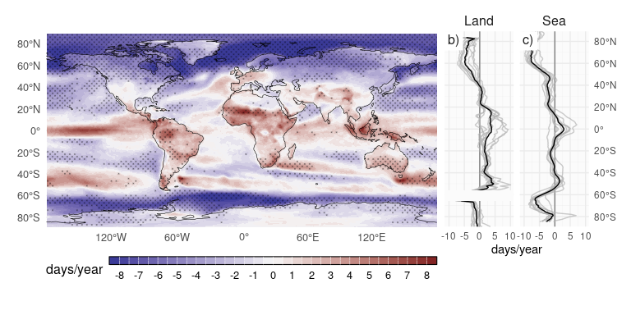
Figure 1: a) Multimodel mean change in the frequency of $ΔT_{2.5}$ (days/year, SSP5-8.5 2018-2100 minus Historical 1980-2000) and zonal mean change over sea b) and land c), each grey line represents a model listed in Table 1 and a black line represents the multimodel mean. In a) dotted areas show where at least 90% of the models agree in the sign of change.
Figure 2 shows ensemble-mean time series of the zonal-mean frequency of strong temperature falls for different latitude bands in each hemisphere. Consistent with the map in Figure 1, the trends in frequency are negative over ocean in the Northern hemisphere, but positive over land equatorward of 50$​^{∘}$ N. Over the Southern hemisphere, trends are generally positive over land, with changes over ocean generally consistent with a poleward shift of fronts.
While there is considerable variation between models in these trends (see boxplots on right of Figure 2), particularly at more poleward locations, for most of the zonal mean trends, there is consistency in the sign of the trend across models.
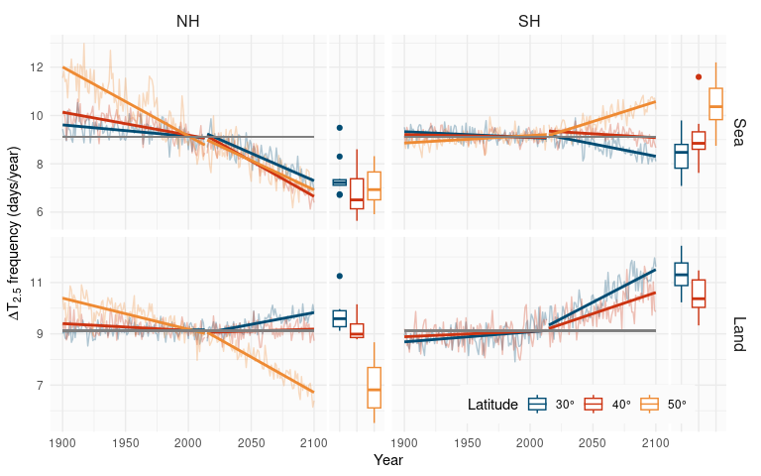
Figure 2: Multimodel mean frequency of $ΔT_{2.5}$ for the historical period (1900-2014) and SSP5-8.5 (2015-2100) over land and sea for different 2° wide latitude bands centered at 30, 40 and 50°. The grey line represents the climatological frecuency for 1979-2014, equal to 9.125 $ΔT_{2.5}$/year. On the right of each panel box plots of the intermodel distribution is shown for the period 2080-2100. In the boxplots the lower and upper hinges correspond to the first and third quartiles and the upper (lower) whisker extends to the largest (smallest) value no further than 1.5 * inter-quartile range. Outside the whiskers dots represents outliners.
To explore the distribution of the change in temperature falls of different intensity, Figure 3 shows the change in frequency of $ΔT$ using different percentiles, from 10$​^{th}$ to 0.1$​^{th}$, as thresholds to identify the falls in temperature. The percentile values are again calculated from the historical period between 1979 and 2014 for each grid point and model as in Figure 1. This figure shows that the change in the frequency of $ΔT$ is greater at lower percentile thresholds, which identify more extreme temperature falls. For example in the Northern Hemisphere over the sea, the 0.1 percentile threshold shows that there will be less than half as many falls in temperature in the future over 50$​^{∘}$ N, with the opposite expected over land in the Southern Hemisphere. However, it is important to note that lower percentiles thresholds are associated with rarer events, meaning fewer occurrences per year. These results suggest that regions projected to experience more temperature falls in the future, such as land areas in midlatitudes in the Southern Hemisphere, will also experience more intense $ΔT$, whereas regions with a decreasing frequency of events will see less intense falls in temperature.
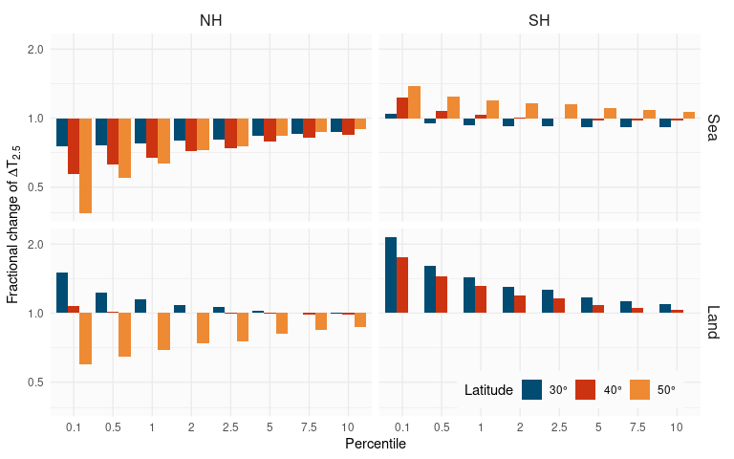
Figure 3: Fractional change in the frequency of strong $ΔT$ averaged between the years 2081-2100 under the SSP5-8.5 scenario compared to that averaged between 1980-2000 in the historical scenario, for different thresholds defined by their percentile value for each grid point and model calculated over the historical period (1979-2014).

Mecanisms
We now investigate the mechanisms driving the changes in $ΔT_{2.5}$ frequency described above. We consider a simple perspective on midlatitude temperature variability based on advection as a key driver (Schneider, Bischoff, and Płotka 2015). According to this view, changes in midlatitude temperature variability are closely linked to changes in large-scale temperature gradients and to the strength of mixing by geostrophic turbulence. Motivated by this perspective, we explore relationships between changes in front frequency and changes in the large-scale meridional temperature gradient ($∂\overset{‾}{T}/∂y$) and the eddy kinetic energy (EKE) within the midlatitude storm tracks.
Figure 4 a) shows that, in both hemispheres, there is a strong correlation between increases in front frequency and changes in the large-scale meridional surface temperature gradient $∂\overset{‾}{T}/∂y$ across models. Here, $∂\overset{‾}{T}/∂y$ is taken as the time and zonal-mean meridional temperature gradient averaged between 25$​^{∘}$ and 65$​^{∘}$ in each hemisphere over either land or ocean. As previously noted by Catto et al. (2014), reductions in front frequency in the Northern Hemisphere are associated with a decrease in the the temperature gradient near the surface, while opposite changes in surface temperature gradients in the Southern Hemisphere drive increases is front frequency there. Here, we find that this relationship holds within the model ensemble; larger increases or decreases in $∂\overset{‾}{T}/∂y$ in a given model are associated with larger projected increases or decreases in $ΔT$. A similar relationship across the ensemble is present when comparing changes in the frequency of $ΔT_{2.5}$ and changes in the energy of the storm track. Here we estimate the storm track energy by taking the band-pass filtered eddy kinetic energy at 250 hPa (see Section 2.3) and integrating over the 25$​^{∘}$ and 65$​^{∘}$ latitudes in each hemisphere. Models with projected decreases in EKE tend to project larger decreases in the frequency of $ΔT_{2.5}$. The exception is the Southern Hemisphere over land where all models project weak changes in EKE and large increases in the frequency of $ΔT_{2.5}$. The reason for this difference is unclear, but could suggest the importance of local land processes in amplifying fronts over land in some regions of the Southern Hemisphere (Muir and Reeder 2010). Another hypothesis is that the most of the land affected by fronts in the Southern hemisphere is north of the mean storm tracks, and thus the storm tracks has only a weak effect on temperature variability there. Supporting this, Harvey, Shaffrey, and Woollings (2014) found that the storm track response in the Southern Hemisphere during summer is associated with the change in the low level $∂\overset{‾}{T}/∂y$ mainly poleward of 65$​^{∘}$ S, i.e. over the southern oceans.
Notwithstanding the above caveat, our results suggest that changes in the mean meridional temperature gradient and storm track intensity play an important role in modulating changes in front frequency in a warming climate. Indeed, differences in how these quantities change in projections appear to account for the differences in front frequency changes between hemispheres. However, our results do not provide strong evidence for the relative importance of the two factors: aside from over Southern Hemisphere land, both factors correlate with the $ΔT_{2.5}$ frequency across the model ensemble and both are theoretically associated with changes in temperature variability.
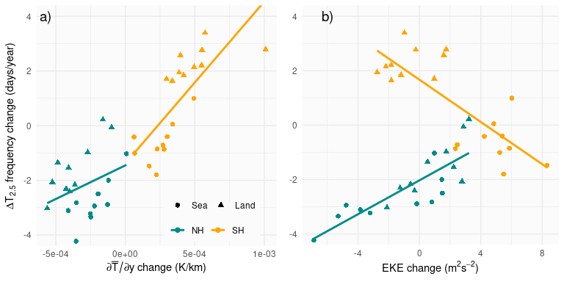
Figure 4: Mean change in the mean $ΔT_{2.5}$ frequency and a) mean merdional temperature gradient $∂\overset{‾}{T}/∂y$ and b) the eddy kinetic energy of the storm track EKE for SSP5-8.5 (2080-2100) compared with the historical period (1980-2000) for each model. Values are calculated for the northern (25$​^{∘}$ to 65$​^{∘}$) and southern (-25$​^{∘}$ to -65$​^{∘}$) hemispheres and over sea (circles) and land (triangles). Each solid line corresponds to a linear regression for each hemisphere.

Summary and Discussion
In this study, we use day-to-day falls in near-surface maximum temperature as a method to detect cold fronts and to evaluate changes in their frequency under future warming, in a set of 10 models from CMIP6. By using a specific percentile threshold, we ensure a consistent detection of strong temperature falls across different regions, improving the detection particularly over oceans where the temperature variability is lower. While the temperature drop method may misidentify other forms of temperature variability as fronts, previous studies have shown that this methodology provides a simple and robust method for characterising the frequency of fronts over midlatitude regions.
Our results show a general decrease in the frequency of fronts across the Northern Hemisphere, especially over oceans, and a poleward shift in frontal activity in the Southern Hemisphere. Over land in the Southern Hemisphere, notably in southern Australia and Africa, we find an increase in frontal frequency and intensity. These findings align with previous studies using more complex methods to identify fronts, strengthening confidence in our approach.
We find a positive correlation between changes in $ΔT_{2.5}$ frequency and the meridional temperature gradient and transient eddy kinetic energy (EKE). This is consistent with a model for midlatitude temperature variability driven primarily by advection, and suggests that the large-scale baroclinic background state is an important control on front frequency in a warming climate. Further work could tease apart the individual effects of temperature gradients versus the intensity of the storm track, noting that these are linked, since changes in the mean thermodynamic structure affect how the storm track behaves (O’Gorman 2010). An important exception to the above correlations is that, in Southern Hemisphere land regions, front frequency increases despite a decrease in the EKE of the storm track. This may reflect the fact that storm track dynamics have less direct control over frontal systems, which could be more influenced by mesoscale processes, land–sea contrast, and regional thermodynamic effects.
There are other factors not analyzed here that could contribute to the projected changes in frontal activity. For example, sea surface temperature (SST) gradients can influence the development and intensity of atmospheric fronts through air–sea interactions. Parfitt, Czaja, and Kwon (2017) showed that surface sensible heat fluxes associated with strong SST gradients, such as those found in the Gulf Stream or Kuroshio Current regions, can amplify fronts through diabatic frontogenesis. However, Reeder, Spengler, and Spensberger (2021) showed that atmospheric fronts along SST fronts are amplified primarily by adiabatic frontogenesis, i.e. the deformation of the wind field that helps increase the equivalent potential temperature gradient.
More generally, frontal cyclogenesis is directly affected by the wind and temperature fields. Consequently, projected changes in frontal frequency may also reflect modifications in the large-scale circulation, such as shifts in the background flow, changes in horizontal wind shear, or variations in baroclinicity. Further analysis is needed to quantify the contribution of these mechanisms to projected changes.

Acknowledgments
This research was supported by the Australian Research Council Centre of Excellence for Climate Extremes (CE170100023), the Australian Research Council Centre of Excellence for the Weather of the 21st Century (CE230100012), with the assistance of resources from the National Computational Infrastructure (NCI Australia), an NCRIS enabled capability supported by the Australian Government. P.C. also acknowledges the use of the following open-source software projects that supported data analysis, visualization, and reproducible reporting: R (v4.3.1, R Core Team (2023)), metR (Campitelli 2025a), rcdo (Campitelli 2025b), data.table (Barrett et al. 2025), ggplot2 (Wickham 2016), patchwork (Pedersen 2024), cowplot (Wilke 2024), ggside (Landis 2024), Quarto (Allaire et al. 2025).

Open research
The CMIP6 data used in the manuscript is publicly available at the Earth System Grid Federation https://esgf-node.llnl.gov/projects/cmip6/. A version-controlled repository of the code used to create this analysis, including the necessary code to download the derived data can be found at https://github.com/paocorrales/t-drop-trends. The derived data that support the findings of this study are also openly available in Zenodo at http://doi.org/, version 0.xx.

References
Allaire, J. J., Charles Teague, Carlos Scheidegger, Yihui Xie, Christophe Dervieux, and Gordon Woodhull. 2025. “Quarto.” https://doi.org/10.5281/zenodo.5960048.
Barrett, Tyson, Matt Dowle, Arun Srinivasan, Jan Gorecki, Michael Chirico, Toby Hocking, Benjamin Schwendinger, and Ivan Krylov. 2025. “Data.table: Extension of ‘Data.frame‘.”
Bentsen, Mats, Dirk Jan Leo Oliviè, Øyvind Seland, Thomas Toniazzo, Ada Gjermundsen, Lise Seland Graff, Jens Boldingh Debernard, et al. 2019a. “IPCC DDC: NCC NorESM2-MM Model Output Prepared for CMIP6 CMIP.” World Data Center for Climate (WDCC) at DKRZ. https://doi.org/10.26050/WDCC/AR6.C6CMNCCN2.
———, et al. 2019b. “IPCC DDC: NCC NorESM2-MM Model Output Prepared for CMIP6 ScenarioMIP.” World Data Center for Climate (WDCC) at DKRZ. https://doi.org/10.26050/WDCC/AR6.C6SPNCCN2.
Berry, Gareth, Michael J. Reeder, and Christian Jakob. 2011. “A Global Climatology of Atmospheric Fronts.” Geophysical Research Letters 38 (4). https://doi.org/10.1029/2010GL046451.
Cai, Dejun, Nerilie J Abram, Jason J Sharples, and Sarah E Perkins-Kirkpatrick. 2022. “Increasing Intensity and Frequency of Cold Fronts Contributed to Australia’s 2019–2020 Black Summer Fire Disaster.” Environmental Research Letters 17 (9): 094044. https://doi.org/10.1088/1748-9326/ac8e88.
Campitelli, Elio. 2025a. “metR: Tools for Easier Analysis of Meteorological Fields.” https://doi.org/10.5281/zenodo.2593516.
———. 2025b. “Rcdo: Create CDO Commands from r Functions.” https://eliocamp.github.io/rcdo/.
Catto, J. L., N. Nicholls, C. Jakob, and K. L. Shelton. 2014. “Atmospheric Fronts in Current and Future Climates.” Geophysical Research Letters 41 (21): 7642–50. https://doi.org/10.1002/2014GL061943.
Catto, J. L., and S. Pfahl. 2013. “The Importance of Fronts for Extreme Precipitation.” Journal of Geophysical Research: Atmospheres 118 (19): 10, 791–10, 801. https://doi.org/10.1002/jgrd.50852.
Chemke, Rei. 2022. “The Future Poleward Shift of Southern Hemisphere Summer Mid-Latitude Storm Tracks Stems from Ocean Coupling.” Nature Communications 13 (1): 1730. https://doi.org/10.1038/s41467-022-29392-4.
Consortium (EC-Earth), EC-Earth. 2019a. “IPCC DDC: EC-Earth-Consortium EC-Earth3 Model Output Prepared for CMIP6 CMIP.” World Data Center for Climate (WDCC) at DKRZ. https://doi.org/10.26050/WDCC/AR6.C6CMEEE3.
———. 2019b. “IPCC DDC: EC-Earth-Consortium EC-Earth3-Veg Model Output Prepared for CMIP6 CMIP.” World Data Center for Climate (WDCC) at DKRZ. https://doi.org/10.26050/WDCC/AR6.C6CMEEEVE.
———. 2019c. “IPCC DDC: EC-Earth-Consortium EC-Earth3 Model Output Prepared for CMIP6 ScenarioMIP.” World Data Center for Climate (WDCC) at DKRZ. https://doi.org/10.26050/WDCC/AR6.C6SPEEE3.
———. 2019d. “IPCC DDC: EC-Earth-Consortium EC-Earth3-Veg Model Output Prepared for CMIP6 ScenarioMIP.” World Data Center for Climate (WDCC) at DKRZ. https://doi.org/10.26050/WDCC/AR6.C6SPEEEVE.
———. 2020a. “IPCC DDC: EC-Earth-Consortium EC-Earth3-Veg-LR Model Output Prepared for CMIP6 CMIP.” World Data Center for Climate (WDCC) at DKRZ. https://doi.org/10.26050/WDCC/AR6.C6CMEEEVL.
———. 2020b. “IPCC DDC: EC-Earth-Consortium EC-Earth-3-CC Model Output Prepared for CMIP6 CMIP.” World Data Center for Climate (WDCC) at DKRZ. https://doi.org/10.26050/WDCC/AR6.C6CMEEEEC.
———. 2021. “IPCC DDC: EC-Earth-Consortium EC-Earth3-CC Model Output Prepared for CMIP6 ScenarioMIP.” World Data Center for Climate (WDCC) at DKRZ. https://doi.org/10.26050/WDCC/AR6.C6SPEEEEC.
———. 2023. “IPCC DDC: EC-Earth-Consortium EC-Earth3-Veg-LR Model Output Prepared for CMIP6 ScenarioMIP.” World Data Center for Climate (WDCC) at DKRZ. https://doi.org/10.26050/WDCC/AR6.C6SPEEEVL.
Eyring, Veronika, Sandrine Bony, Gerald A. Meehl, Catherine A. Senior, Bjorn Stevens, Ronald J. Stouffer, and Karl E. Taylor. 2016. “Overview of the Coupled Model Intercomparison Project Phase 6 (CMIP6) Experimental Design and Organization.” Geoscientific Model Development 9 (5): 1937–58. https://doi.org/10.5194/gmd-9-1937-2016.
Guo, Huan, Jasmin G. John, Chris Blanton, Colleen McHugh, Serguei Nikonov, Aparna Radhakrishnan, Kristopher Rand, Niki T. Zadeh, V. Balaji, Jeff Durachta, Christopher Dupuis, Raymond Menzel, Thomas Robinson, Seth Underwood, Hans Vahlenkamp, Krista A. Dunne, et al. 2018. “IPCC DDC: NOAA-GFDL GFDL-CM4 Model Output Prepared for CMIP6 ScenarioMIP.” World Data Center for Climate (WDCC) at DKRZ. https://doi.org/10.26050/WDCC/AR6.C6SPNGGFD.
Guo, Huan, Jasmin G. John, Chris Blanton, Colleen McHugh, Serguei Nikonov, Aparna Radhakrishnan, Kristopher Rand, Niki T. Zadeh, V. Balaji, Jeff Durachta, Christopher Dupuis, Raymond Menzel, Thomas Robinson, Seth Underwood, Hans Vahlenkamp, Mitchell Bushuk, et al. 2018. “IPCC DDC: NOAA-GFDL GFDL-CM4 Model Output.” World Data Center for Climate (WDCC) at DKRZ. https://doi.org/10.26050/WDCC/AR6.C6CMNGGFC.
Harvey, B. J., L. C. Shaffrey, and T. J. Woollings. 2014. “Equator-to-Pole Temperature Differences and the Extra-Tropical Storm Track Responses of the CMIP5 Climate Models.” Climate Dynamics 43 (5): 1171–82. https://doi.org/10.1007/s00382-013-1883-9.
Jungclaus, Johann, Matthias Bittner, Karl-Hermann Wieners, Fabian Wachsmann, Martin Schupfner, Stephanie Legutke, Marco Giorgetta, et al. 2019. “IPCC DDC: MPI-M MPIESM1.2-HR Model Output Prepared for CMIP6 CMIP.” World Data Center for Climate (WDCC) at DKRZ. https://doi.org/10.26050/WDCC/AR6.C6CMMXME2.
King, Malcolm J., Michael J. Reeder, and Christian Jakob. 2024. “Strong Temperature Falls as a Cold Frontal Metric in Australian Station Observations, Reanalyses and Climate Models.” Quarterly Journal of the Royal Meteorological Society 150 (765): 4788–4805. https://doi.org/10.1002/qj.4841.
Konstali, Kjersti, Thomas Spengler, Clemens Spensberger, and Asgeir Sorteberg. 2024. “Linking Future Precipitation Changes to Weather Features in CESM2-LE.” Journal of Geophysical Research: Atmospheres 129 (16): e2024JD041190. https://doi.org/10.1029/2024JD041190.
Landis, Justin. 2024. “Ggside: Side Grammar Graphics.” https://github.com/jtlandis/ggside.
Lovato, Tomas, Daniele Peano, and Momme Butenschön. 2021a. “IPCC DDC: CMCC CMCC-ESM2 Model Output Prepared for CMIP6 CMIP.” World Data Center for Climate (WDCC) at DKRZ. https://doi.org/10.26050/WDCC/AR6.C6CMCMCMC.
———. 2021b. “IPCC DDC: CMCC CMCC-ESM2 Model Output Prepared for CMIP6 ScenarioMIP.” World Data Center for Climate (WDCC) at DKRZ. https://doi.org/10.26050/WDCC/AR6.C6SPCMCMC.
Muir, Les C., and Michael J. Reeder. 2010. “Idealized Modelling of Landfalling Cold Fronts.” Quarterly Journal of the Royal Meteorological Society 136 (653): 2147–61. https://doi.org/10.1002/qj.692.
O’Gorman, Paul A. 2010. “Understanding the Varied Response of the Extratropical Storm Tracks to Climate Change.” Proceedings of the National Academy of Sciences 107 (45): 19176–80. https://doi.org/10.1073/pnas.1011547107.
O’Neill, Brian C., Claudia Tebaldi, Detlef P. van Vuuren, Veronika Eyring, Pierre Friedlingstein, George Hurtt, Reto Knutti, et al. 2016. “The Scenario Model Intercomparison Project (ScenarioMIP) for CMIP6.” Geoscientific Model Development 9 (9): 3461–82. https://doi.org/10.5194/gmd-9-3461-2016.
Parfitt, Rhys, Arnaud Czaja, and Young-Oh Kwon. 2017. “The Impact of SST Resolution Change in the ERA-Interim Reanalysis on Wintertime Gulf Stream Frontal Air-Sea Interaction.” Geophysical Research Letters 44 (7): 3246–54. https://doi.org/10.1002/2017GL073028.
Pedersen, Thomas Lin. 2024. “Patchwork: The Composer of Plots.”
R Core Team. 2023. “R: A Language and Environment for Statistical Computing.” Vienna, Austria: R Foundation for Statistical Computing. https://www.R-project.org/.
Reeder, Michael J., Thomas Spengler, and Ruth Musgrave. 2015. “Rossby Waves, Extreme Fronts, and Wildfires in Southeastern Australia.” Geophysical Research Letters 42 (6): 2015–23. https://doi.org/10.1002/2015GL063125.
Reeder, Michael J., Thomas Spengler, and Clemens Spensberger. 2021. “The Effect of Sea Surface Temperature Fronts on Atmospheric Frontogenesis.” Journal of the Atmospheric Sciences 78 (6): 1753–71. https://doi.org/10.1175/JAS-D-20-0118.1.
Schneider, Tapio, Tobias Bischoff, and Hanna Płotka. 2015. “Physics of Changes in Synoptic Midlatitude Temperature Variability.” Journal of Climate 28 (6): 2312–31. https://doi.org/10.1175/JCLI-D-14-00632.1.
Schupfner, Martin, Karl-Hermann Wieners, Fabian Wachsmann, Christian Steger, Matthias Bittner, Johann Jungclaus, Barbara Früh, et al. 2019. “IPCC DDC: DKRZ MPI-ESM1.2-HR Model Output Prepared for CMIP6 ScenarioMIP.” World Data Center for Climate (WDCC) at DKRZ. https://doi.org/10.26050/WDCC/AR6.C6SPDKME2.
Simmonds, Ian, Kevin Keay, and John Arthur Tristram Bye. 2012. “Identification and Climatology of Southern Hemisphere Mobile Fronts in a Modern Reanalysis.” Journal of Climate 25 (6): 1945–62. https://doi.org/10.1175/JCLI-D-11-00100.1.
Tamarin, T., and Y. Kaspi. 2017. “The Poleward Shift of Storm Tracks Under Global Warming: A Lagrangian Perspective.” Geophysical Research Letters 44 (20): 10, 666–10, 674. https://doi.org/10.1002/2017GL073633.
Thomas, Carl M., and David M. Schultz. 2019. “Global Climatologies of Fronts, Airmass Boundaries, and Airstream Boundaries: Why the Definition of ‘Front’ Matters.” Monthly Weather Review 147 (2): 691–717. https://doi.org/10.1175/MWR-D-18-0289.1.
Volodin, Evgeny, Evgeny Mortikov, Andrey Gritsun, Vasily Lykossov, Vener Galin, Nikolay Diansky, Anatoly Gusev, et al. 2019a. “INM INM-CM4-8 Model Output Prepared for CMIP6 CMIP Historical.” Earth System Grid Federation. https://doi.org/10.22033/ESGF/CMIP6.5069.
———, et al. 2019b. “IPCC DDC: INM INM-CM4-8 Model Output Prepared for CMIP6 ScenarioMIP.” World Data Center for Climate (WDCC) at DKRZ. https://doi.org/10.26050/WDCC/AR6.C6SPINIC8.
———, et al. 2019c. “IPCC DDC: INM INM-CM5-0 Model Output Prepared for CMIP6 ScenarioMIP.” World Data Center for Climate (WDCC) at DKRZ. https://doi.org/10.26050/WDCC/AR6.C6SPINIC0.
———, et al. 2019d. “IPCC DDC: INM INM-CM5-0 Model Output Prepared for CMIP6 CMIP.” World Data Center for Climate (WDCC) at DKRZ. https://doi.org/10.26050/WDCC/AR6.C6CMINIC0.
Wickham, Hadley. 2016. “Ggplot2: Elegant Graphics for Data Analysis.” Springer-Verlag New York. https://ggplot2.tidyverse.org.
Wilke, Claus O. 2024. “Cowplot: Streamlined Plot Theme and Plot Annotations for ’Ggplot2’.” https://wilkelab.org/cowplot/.

