IoT 2023 CHALLENGE 2
(1) Name: Paolo Longo Person Code: 10677668
(2) Name: Nicola Calligaro Person Code: 10624660

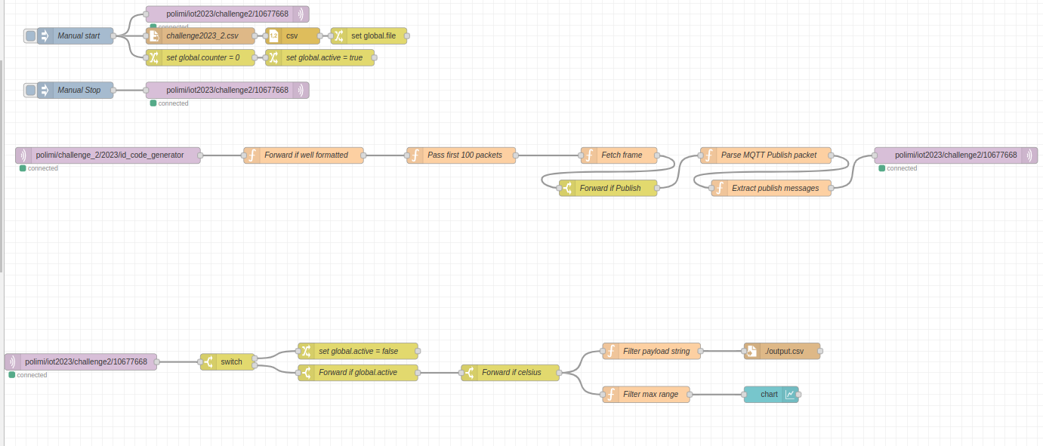
Picture of the entire Node-Red flow
We are going to explain this by splitting the toal flow into sub parts for a better visualization and easier explanation.
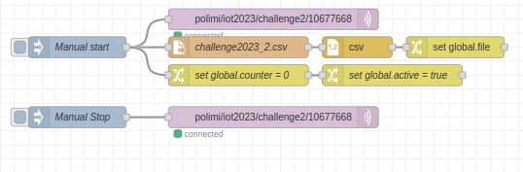

START & END part (4): this flow aims at publishing one PUB message with payload = “START” on the topic “/polimi/iot2023/challenge2/10677668” at the public HiveMQ Broker when the top button is clicked and publishing another PUB message with payload = “END” on the same topic when clicking the bottom one. In order to accomplish the task reported into the challenge instructions, we assume that the user clicks once the start button at any time after the beginning of the deployment and then waits until 100 messages have been received in the following part for clicking the end button in order to complete the task. Furthermore, while the “START” message is published, the csv file provided to us is read and stored into one global variable.
Manual start: inject node which activates the flow when the button is clicked, forwarding one message with payload = “START”
Manual Stop: inject node which activates the flow when the button is clicked, forwarding one message with payload = “END”
Challenge2023_2.csv: read file node which aims at reading the csv file provided to us by instructions
csv: csv’s parser node which converts the just read csv file into an array of rows (array of MQTT packets as a matter of fact)
set global.file: change node which saves the content of the just read csv file as an array of rows into the global variable file.
Set global.counter = 0: change node which sets the global variable counter to 0. This varaible is used for keeping track of how many messages, coming from the subscription to “/polimi/iot2023/challenge2/id_code_generator” topic, has been processed.
set global.active = true: change node which sets the global variable active to true. This is used then in the following part in order to be aware whether the flow is allowed to process or not PUB messages.
/polimi/iot2023/challenge2/10677668: this node(s) represents one MQTT client which publishes messages to the topic “/polimi/iot2023/challenge2/10677668” at the public HiveMQ Broker. In this setting, it will publish only START and END messages.
ID receiver & Republishing PUB messages (1+2): this flow aims at implementing (1) and (2) of the challenge instructions. In addition to these, the flow actually starts computing only after a “START” PUB message has been published to the topic “/polimi/iot2023/challenge2/10677668”.
/polimi/iot2023/challenge2/id_code_generator: this node represents one MQTT client which is subscribed to the topic “/polimi/iot2023/challenge2/id_code_generator” and forwards all the PUB messages published at this topic.
Forward if well formatted: function node which filters only expected messages in input (with the structure defined in the challenge instructions).
Pass first 100 packets: function node which keeps track of how many messages have been processed after the first “START” PUB message has been published. This is done by using the global counter variable in order to count the number of messages processed.
Fetch frame: function node which executes the set of istructions reported in (1) to the id value of flow variable packet and filters the rows contained into the global variable file in order to extract the row corresponding to the number just computed. Consequently, it forwards the extracted row reporting only the “No.”, “Info”, “Message” fields.
Forward if Publish: switch node which forwards only if the “Info” field of the input received contains “Publish Message” (aka the extracted row from the file is a PUB message).
Parse MQTT Publish packet: function node which goal is to reconstruct the structure of MQTT PUB messages from the single row, filtered in the csv file, received as input. It returns a list of (id, topic, message) like values.
Extract publish messages: function node which create PUB messages from the ones received as input, adding to these the current timestamp, removing the topic and setting payload equal to the message content. All this is done following the format suggested in the challenge instructions at (2).
/polimi/iot2023/challenge2/10677668: this node represents one MQTT client which is publisher for the topic “/polimi/iot2023/challenge2/10677668” and forwards all the PUB messages received as input to the node.
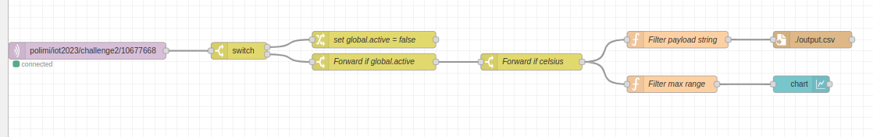
Subscription part (3): this flow aims at subscribe to “/polimi/iot2023/challenge2/PERSON_CODE” topic at the same broker as before and react to messages published by us at the same topic (performed in the previous part) following the challenge’s instructions at (3).
/polimi/iot2023/challenge2/10677668: this node represents one MQTT client which is subscribed to the topic “/polimi/iot2023/challenge2/10677668” and forwards all the PUB messages published at this topic.
Switch: switch node which defines one path of the flow that is taken when the payload of the input message is equal to “END” and another path in the case of payload not equal to “START”.
Set global.active = false: change node which sets the global variable active to false.
Forward if global.active: switch node which let the flow continue only in the case the global.active is set to true (the first “START” PUB message has been sent).
Forward if celsius: switch node which controls in the message payload received that attribute “unit” = “C”. In the positive case, it forwards the received message.
Filter payload string: function node which extracts the payload from the received message and forwards it.
./output.csv: write file node which appends the string received as input.
Filter max range: function node which extracts the max range value (msg.payload(“range”)[1]) from the payload of the received message and forwards it.
Chart: chart node which is used for plotting all the received values, corresponding of the max range values of the filtered PUB messages received by the subscriber after the START and referring to celsius unit.

