VERTEX 4D - Demo Rehearsal Evidence Pack
Ensayo completo con seed demo: dashboard, cohort, intervention queue, comments/rubric, Decision Memo print y Outcome Report print.
Campo | Valor
Fecha de ensayo | 2026-08-24
Branch | agent/vertex-v4-redesign
Commit base del ensayo | 6709b1e
Demo cohort | cohort_83a643a003
Facilitator login | facilitator@northstar-demo.example / vertex-demo-2026
Servidor local usado | http://127.0.0.1:8010

Resultado ejecutivo
- El flujo buyer-facing completo se pudo recorrer de punta a punta con datos demo realistas.
- Se generaron PDFs de navegador para el Decision Memo y el Cohort Outcome Report.
- Las vistas print son las mas presentables para entregar al buyer: limpias, trazables y con disclaimer de no-overclaim.
- La UI web normal funciona, pero el tema claro tiene bajo contraste en tablas, labels secundarios y algunos bloques largos.
- El producto esta listo para un rehearsal interno y casi listo para demo buyer; antes de buyer en vivo conviene corregir contraste y probar responsive mobile.

Artifacts generados
Artifact | Ruta
Decision Memo PDF | docs/demo_rehearsal_assets/decision-memo-run_demo_economics_changed.pdf
Cohort Outcome Report PDF | docs/demo_rehearsal_assets/cohort-outcome-report-demo.pdf
Capturas PNG | docs/demo_rehearsal_assets/01-login.png a 09-outcome-report-print.png
Manifest del ensayo | docs/demo_rehearsal_assets/capture_manifest.json

Secuencia en grafica
La ruta ejecutada replica lo que veria un buyer al observar una demo institucional guiada.
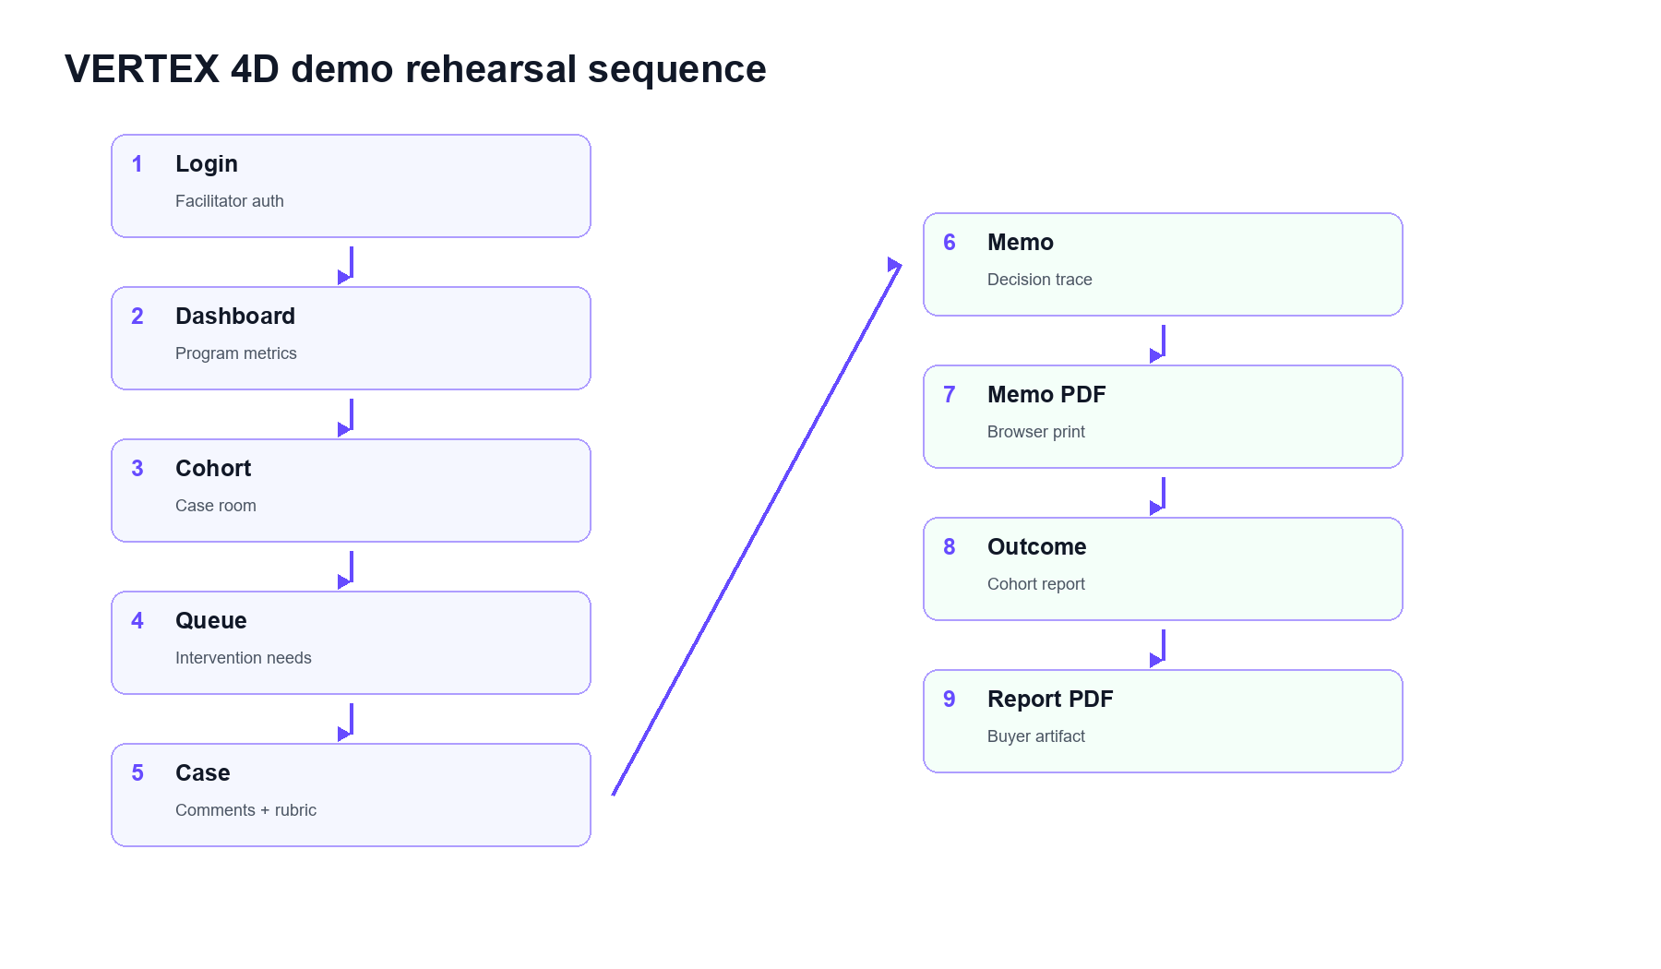
Grafica de la secuencia recorrida durante el ensayo.

Flujo dual actual
VERTEX ya opera con dos carriles conectados: el founder produce evidencia y decision traceability; el facilitator convierte esa evidencia en seguimiento de cohort, intervenciones y artifacts institucionales.
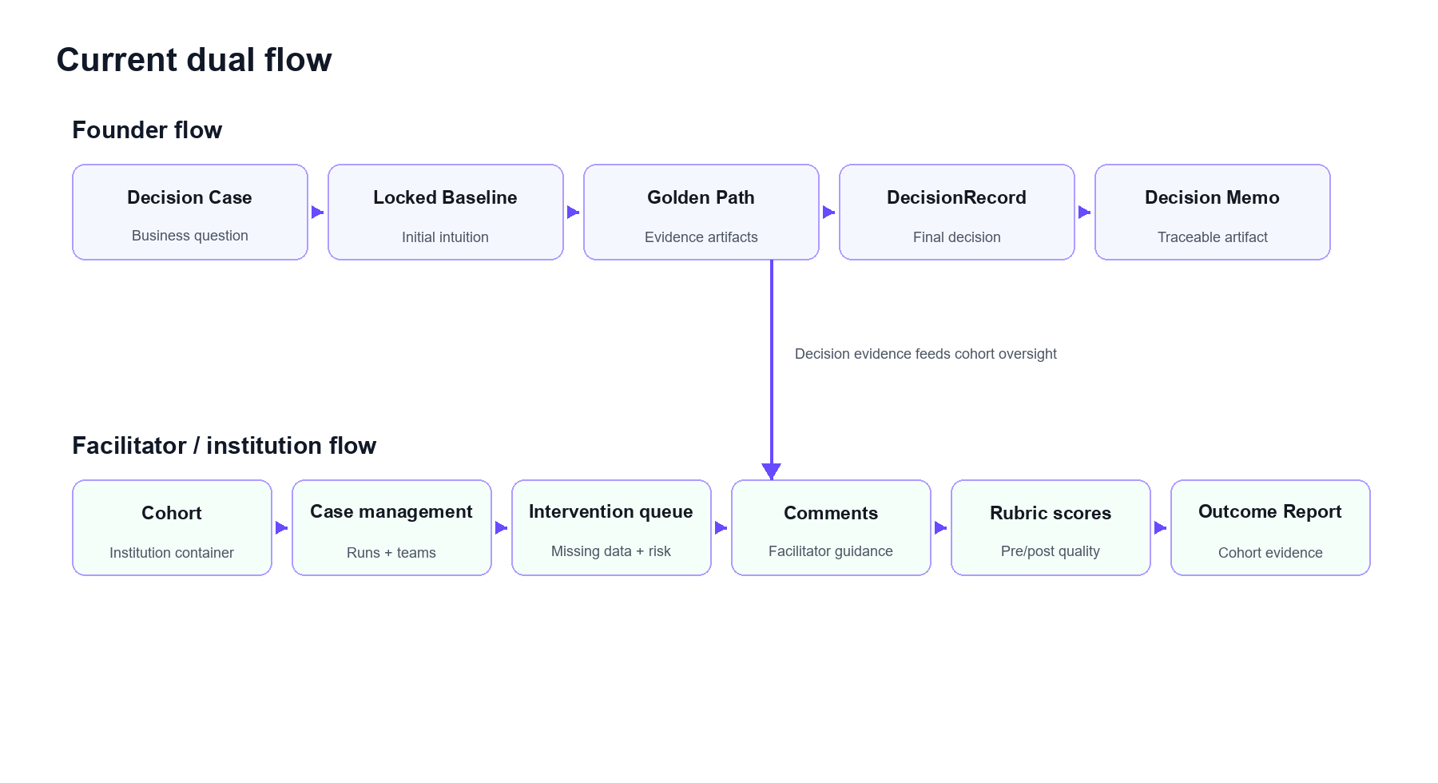
Flujo dual actual: founder flow y facilitator/institution flow.

Capturas y resultado de cada paso
Paso | Pantalla | Que hice | Que paso | URL
1 | Login | Open the live local app and prepare facilitator authentication. | Login page loaded correctly. | http://127.0.0.1:8010/login
2 | Facilitator dashboard | Open the program-level dashboard after facilitator login. | Dashboard renders cohort metrics, Decision Case counts, locked snapshots and open comments. | http://127.0.0.1:8010/dashboard/facilitator
3 | Cohort case room | Open the seeded demo cohort case room. | Cohort totals, add-case controls and intervention queue are visible. | http://127.0.0.1:8010/dashboard/facilitator/cohorts/cohort_83a643a003
4 | Intervention queue | Focus the cohort page on the intervention queue. | SkillBridge and ClinicFlow appear as honest intervention needs with reasons. | http://127.0.0.1:8010/dashboard/facilitator/cohorts/cohort_83a643a003
5 | Case comments and rubric gap | Open the case that needs facilitator intervention. | Open comment and missing post score are visible on the case. | http://127.0.0.1:8010/dashboard/facilitator/cohorts/cohort_83a643a003
6 | Decision Memo | Open the economics-changed Decision Memo. | Memo shows initial decision context, final decision, pricing insight and artifact traceability. | http://127.0.0.1:8010/dashboard/lab/decision-memo?run_id=run_demo_economics_changed
7 | Decision Memo print view | Open print-friendly Decision Memo artifact. | White print view includes generated timestamp, run/team/cohort identifiers, traceability IDs and no-overclaim disclaimer. | http://127.0.0.1:8010/dashboard/lab/decision-memo/print?run_id=run_demo_economics_changed
8 | Cohort Outcome Report | Open the cohort-level institutional report. | Report summarizes completion, baselines, DecisionRecords, stakeholder/price/decision changes and intervention needs. | http://127.0.0.1:8010/dashboard/facilitator/cohorts/cohort_83a643a003/outcome-report
9 | Outcome Report print view | Open print-friendly Cohort Outcome Report artifact. | White print view includes cohort identifiers, case table, missing data labels, methodology and no-overclaim disclaimer. | http://127.0.0.1:8010/dashboard/facilitator/cohorts/cohort_83a643a003/outcome-report/print

Paso 1: Login
Que hice: Open the live local app and prepare facilitator authentication.
Que paso: Login page loaded correctly.
URL: http://127.0.0.1:8010/login
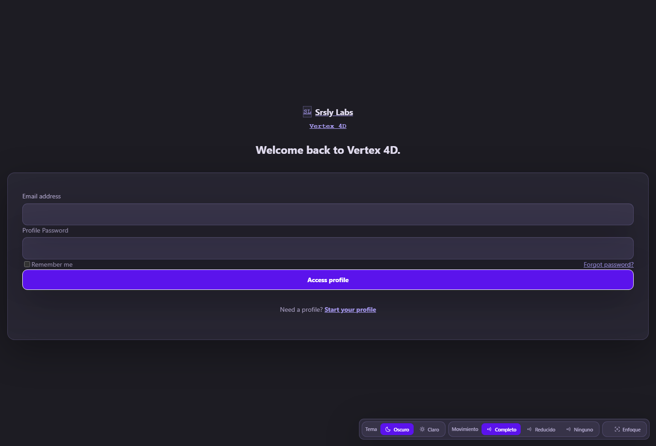
Captura 1: Login

Paso 2: Facilitator dashboard
Que hice: Open the program-level dashboard after facilitator login.
Que paso: Dashboard renders cohort metrics, Decision Case counts, locked snapshots and open comments.
URL: http://127.0.0.1:8010/dashboard/facilitator
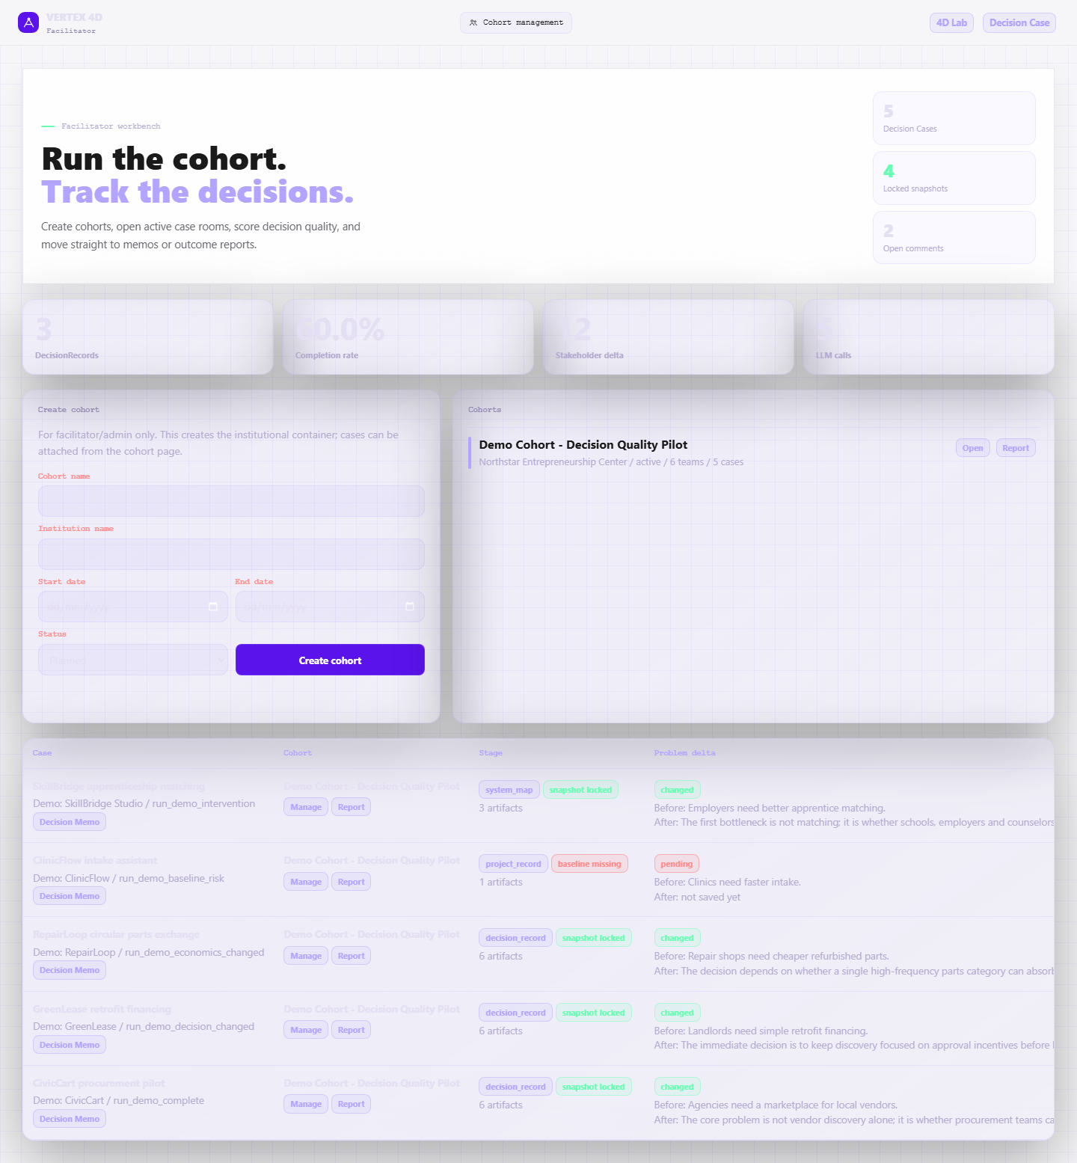
Captura 2: Facilitator dashboard

Paso 3: Cohort case room
Que hice: Open the seeded demo cohort case room.
Que paso: Cohort totals, add-case controls and intervention queue are visible.
URL: http://127.0.0.1:8010/dashboard/facilitator/cohorts/cohort_83a643a003
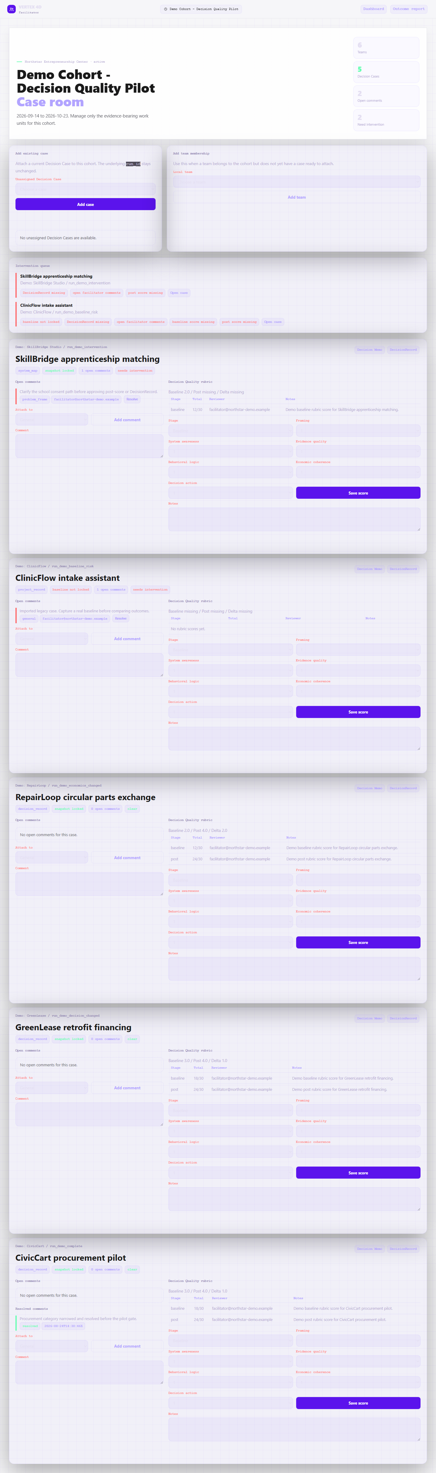
Captura 3: Cohort case room

Paso 4: Intervention queue
Que hice: Focus the cohort page on the intervention queue.
Que paso: SkillBridge and ClinicFlow appear as honest intervention needs with reasons.
URL: http://127.0.0.1:8010/dashboard/facilitator/cohorts/cohort_83a643a003
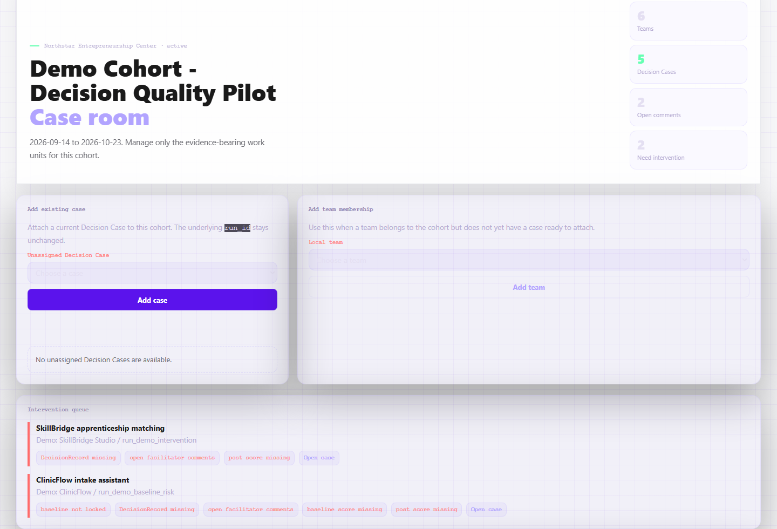
Captura 4: Intervention queue

Paso 5: Case comments and rubric gap
Que hice: Open the case that needs facilitator intervention.
Que paso: Open comment and missing post score are visible on the case.
URL: http://127.0.0.1:8010/dashboard/facilitator/cohorts/cohort_83a643a003
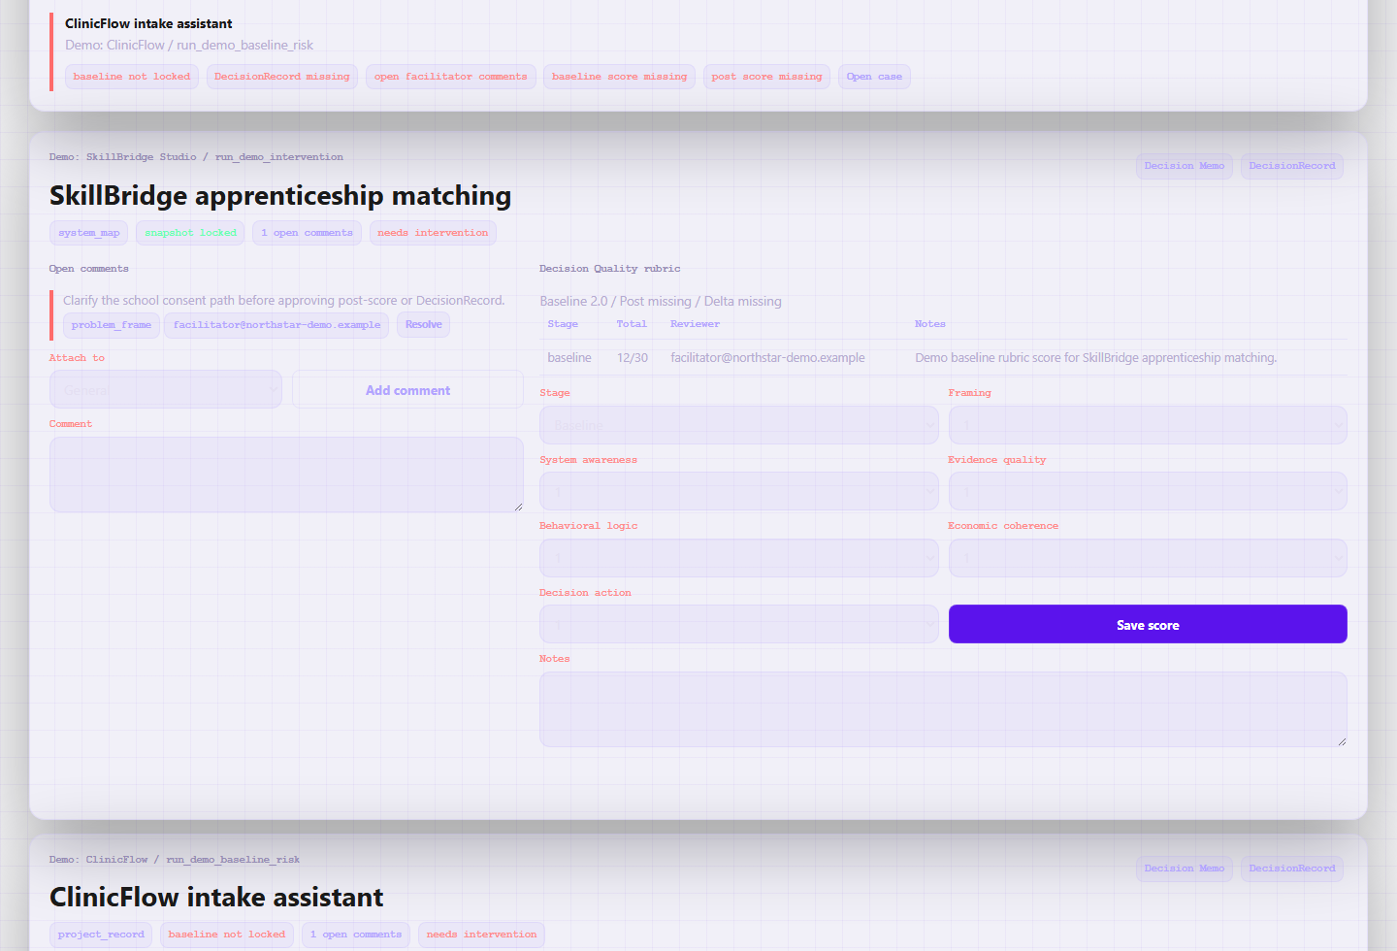
Captura 5: Case comments and rubric gap

Paso 6: Decision Memo
Que hice: Open the economics-changed Decision Memo.
Que paso: Memo shows initial decision context, final decision, pricing insight and artifact traceability.
URL: http://127.0.0.1:8010/dashboard/lab/decision-memo?run_id=run_demo_economics_changed
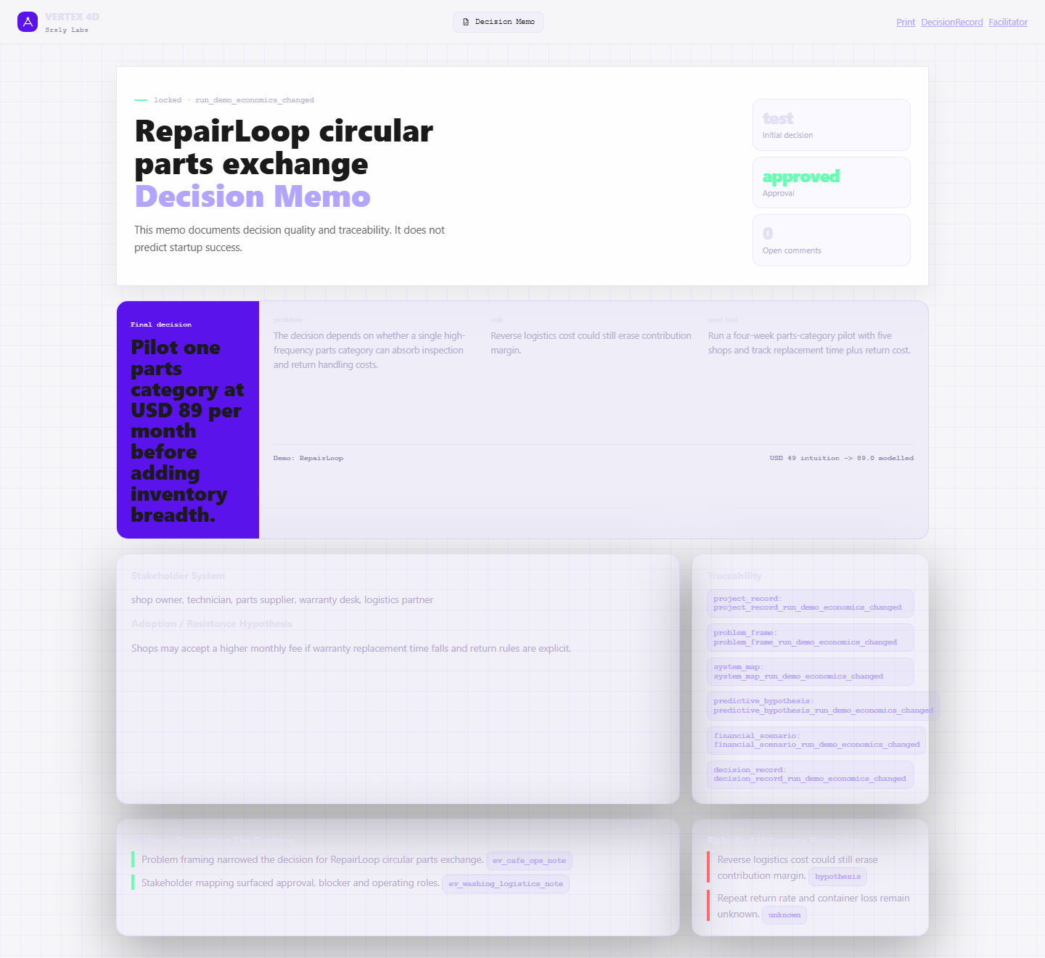
Captura 6: Decision Memo

Paso 7: Decision Memo print view
Que hice: Open print-friendly Decision Memo artifact.
Que paso: White print view includes generated timestamp, run/team/cohort identifiers, traceability IDs and no-overclaim disclaimer.
URL: http://127.0.0.1:8010/dashboard/lab/decision-memo/print?run_id=run_demo_economics_changed
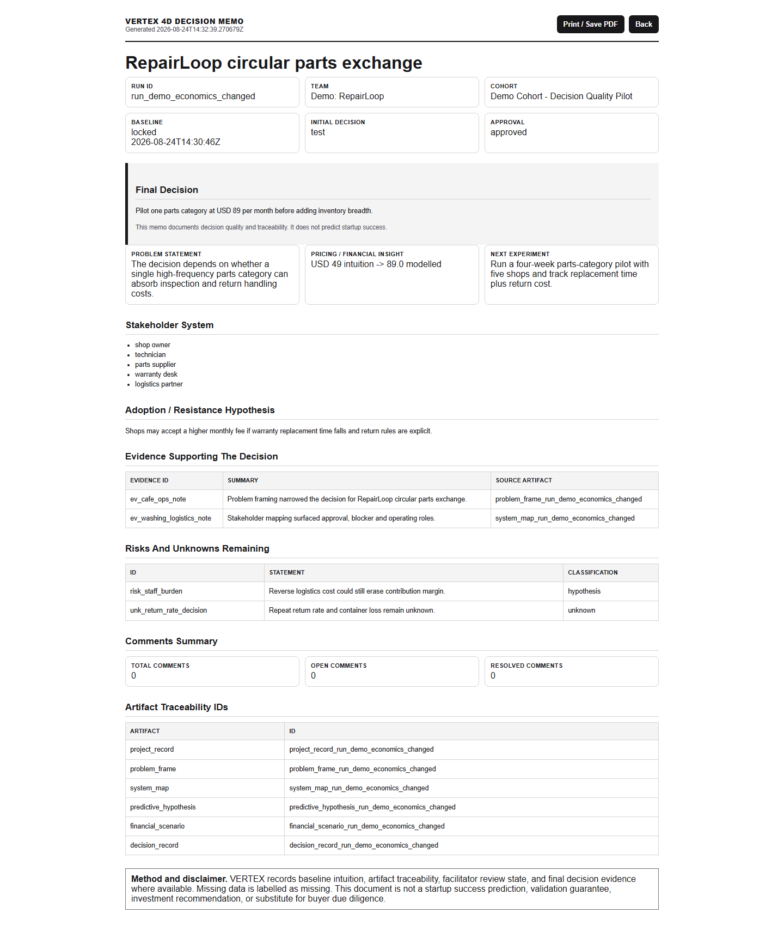
Captura 7: Decision Memo print view

Paso 8: Cohort Outcome Report
Que hice: Open the cohort-level institutional report.
Que paso: Report summarizes completion, baselines, DecisionRecords, stakeholder/price/decision changes and intervention needs.
URL: http://127.0.0.1:8010/dashboard/facilitator/cohorts/cohort_83a643a003/outcome-report
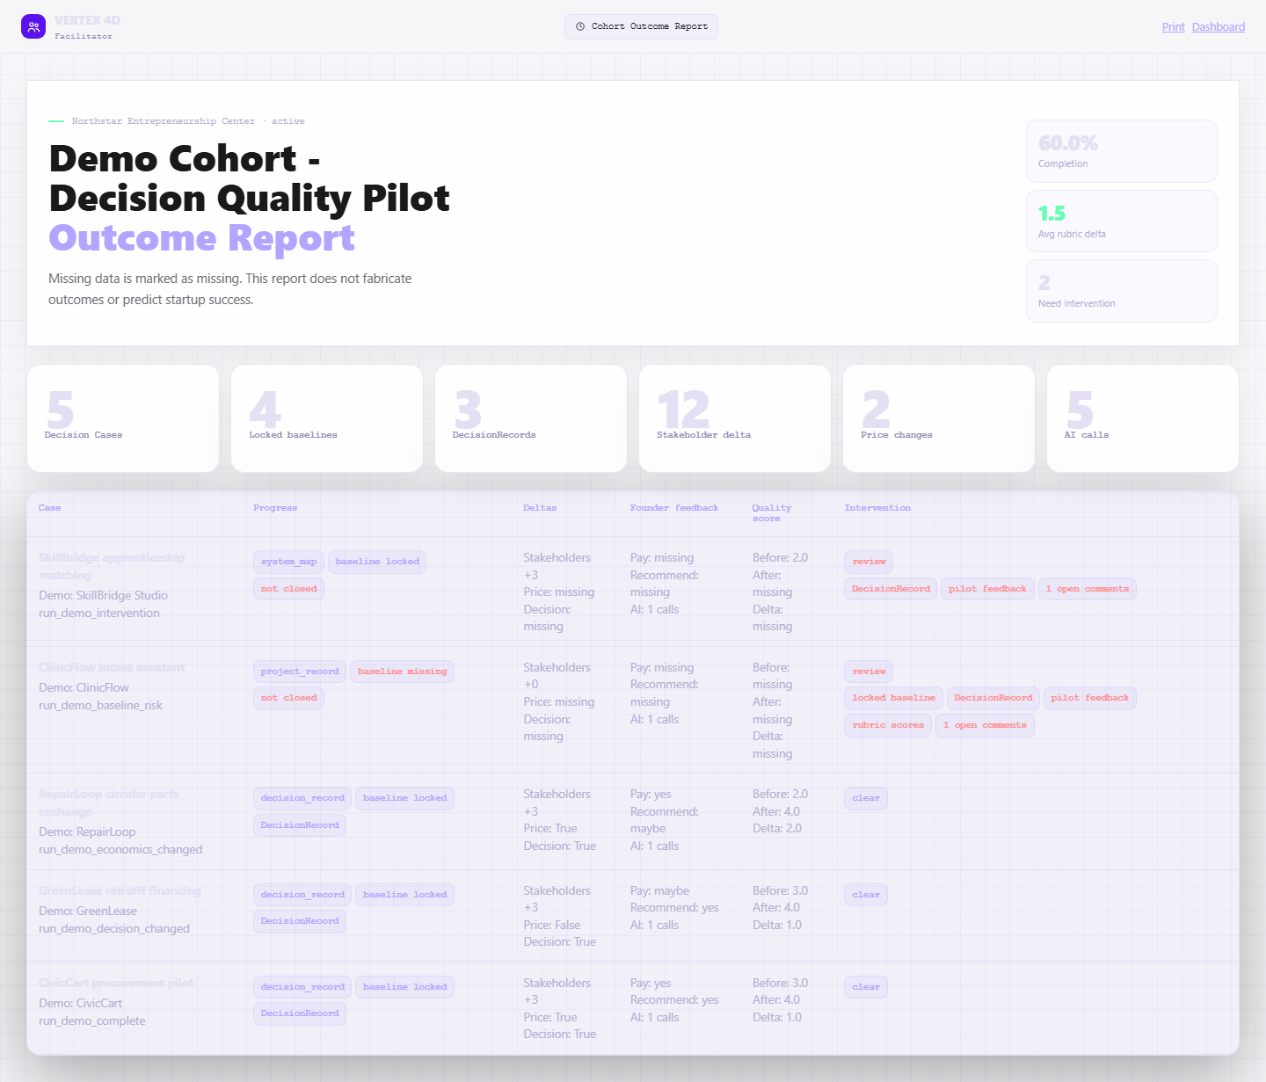
Captura 8: Cohort Outcome Report

Paso 9: Outcome Report print view
Que hice: Open print-friendly Cohort Outcome Report artifact.
Que paso: White print view includes cohort identifiers, case table, missing data labels, methodology and no-overclaim disclaimer.
URL: http://127.0.0.1:8010/dashboard/facilitator/cohorts/cohort_83a643a003/outcome-report/print
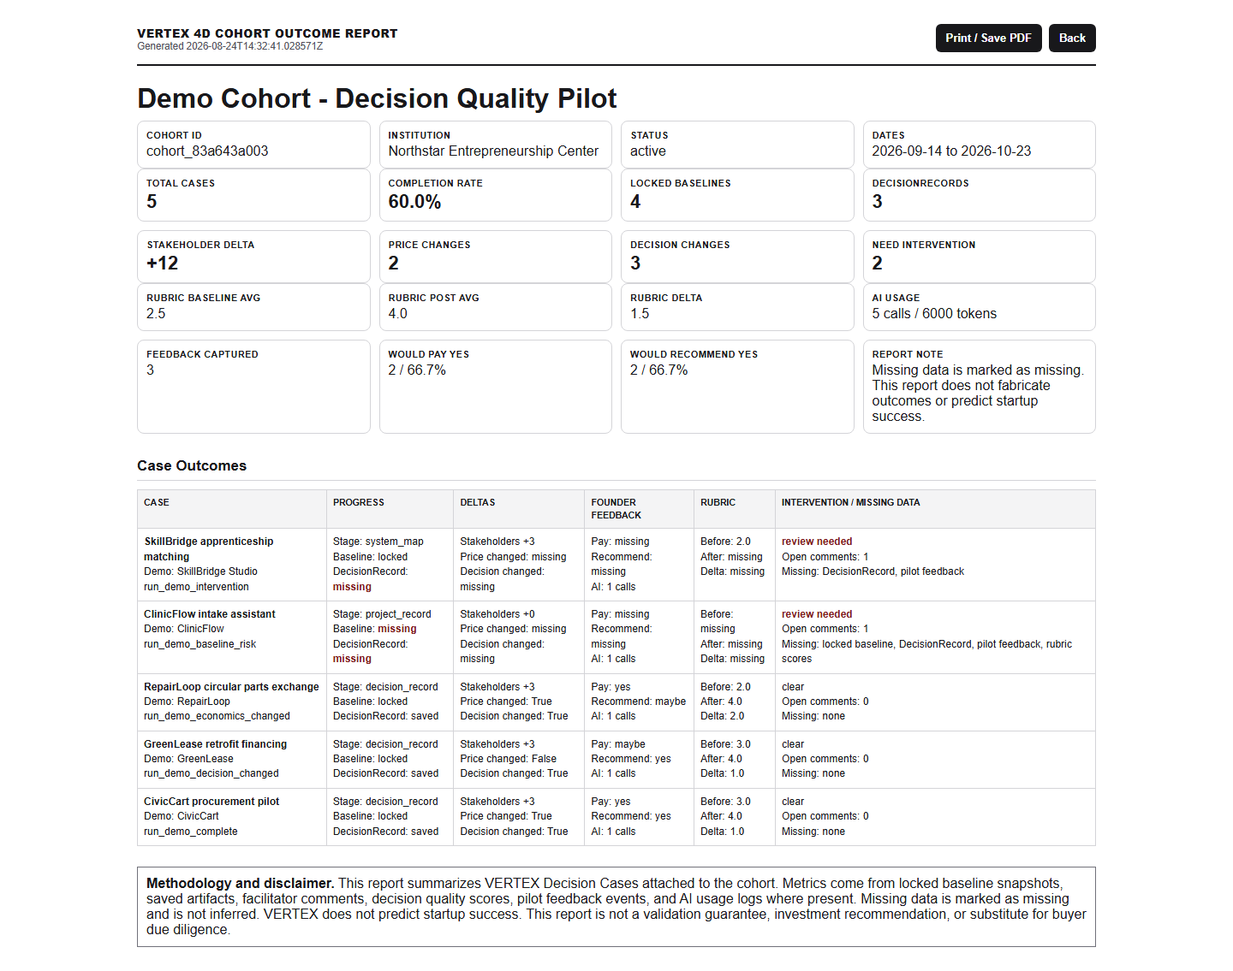
Captura 9: Outcome Report print view

Estado frente al roadmap
Determinacion: VERTEX esta en cierre de Meses 0-2 y entrando a Meses 2-4. Tiene algunos artifacts de Meses 4-6 adelantados, especialmente Outcome Report y print/export por navegador, pero aun falta validacion comercial real con cohorts pagados.
Roadmap | Estado | Evidencia actual | Falta
Meses 0-2: Pilot hardening | Mayormente logrado | Journey demo estable, baseline/post assessment, Decision Memo, dashboard facilitador, analytics/eventos y reportes print. | Ajuste de contraste/responsive QA completo; Evidence Gate mas explicito como gate de producto.
Meses 2-4: Alpha y Beta pilots | Listo para iniciar | Seed demo cubre 5 casos, intervention queue, comentarios, rubric pre/post y pricing experiments como narrativa. | Ejecutar 8-12 founders reales, luego 20-40 equipos; medir friccion y completar feedback real.
Meses 4-6: Commercial V1 | Parcial adelantado | Outcome reports, print artifacts, checklist, proposal, follow-up docs y roles basicos. | Cohort setup mas robusto, better export, permisos formales, onboarding institucional y 3-5 pilotos pagados.
Meses 6-9: Institutional readiness | No iniciado | Hay privacidad practica y docs iniciales, pero no enterprise readiness. | Multi-program dashboard, SSO/SAML, security documentation, white-label ligero, export/API basico.
Meses 9-12: Scale test | No iniciado | La base conceptual esta, pero aun no hay escala comercial. | Annual licenses, self-service paid, vertical templates, cohort benchmarking, LMS integrations si ventas lo justifica.

Faltantes recomendados antes de buyer demo
- Ajustar contraste del tema claro en dashboard, cohort table, report web y texto secundario.
- Hacer QA responsive mobile real, porque aun no se valido en este ensayo.
- Pulir el layout web normal del Decision Memo para que el bloque de decision final no domine excesivamente.
- Convertir Evidence Gate en un checkpoint explicito dentro del journey, no solo evidencia trazable en artifacts.
- Ejecutar un rehearsal con narracion de 8-12 minutos usando docs/VERTEX_DEMO_SCRIPT.md y medir tiempos.
- Despues del demo interno, correr 8-12 founders reales como Alpha pilot y reemplazar demo assumptions por evidencia real.

Handoff operativo
Tema | Estado actual
Seed command | python -m scripts.seed_demo_cohort --json
Reset command | python -m scripts.seed_demo_cohort --reset-demo
Start app | python -m uvicorn main:app --host 127.0.0.1 --port 8010
Facilitator | facilitator@northstar-demo.example / vertex-demo-2026
Dashboard | http://127.0.0.1:8010/dashboard/facilitator
Cohort | http://127.0.0.1:8010/dashboard/facilitator/cohorts/cohort_83a643a003
Decision Memo print | http://127.0.0.1:8010/dashboard/lab/decision-memo/print?run_id=run_demo_economics_changed
Outcome Report print | http://127.0.0.1:8010/dashboard/facilitator/cohorts/cohort_83a643a003/outcome-report/print
No push | Confirmado: no se hizo push durante este ensayo.

Notas de verdad comercial
- El demo prueba decision quality, traceability, before/after evidence e intervention need.
- No prueba market success, investment readiness, startup validation garantizada ni due diligence del buyer.
- Los datos son demo y estan marcados como Northstar / Demo; no deben mezclarse con claims de pilotos reales.
- El siguiente paso recomendado es un rehearsal buyer-facing cronometrado y despues un Alpha pilot con 8-12 founders reales.

