Executive Master in Project Management for Business Performance & Innovation (2021 - 2022)

Capstone project teamwork presentation

# Learning objectives

Participants will gather competence in dealing in teams with a real-life portfolio, program and project context by completing a set of tasks that comprises Portfolio and Project Management.

# Capstone project context

## The situation

### The business organization

Magnus SpA is an Italy headquartered multinational business that designs, engineers and manufactures precision milled parts for internal combustion automotive power train.

Typical sales involve the design and production of engine blocks components for clients belonging to tier 1 of the automotive supply chain, that in turn sell integrated power trains to automotive OEM, the brands the final consumer sees on the market.

Magnus SpA has been severely affected by the 2020 and 2021 automotive market disruptions induced by the global COVID19 pandemic.

The pandemic has changed final automotive consumer trends and the availability of components and materials.

As a result less car have been produced and Magnus turnover has decreased.

Moreover Magnus SpA business model has a medium-long term threat related to the growth of the electric vehicles, as its sales depend mostly on the market demand of internal combustion engines.

### Key financial indicators

All figures in euro(€) millions

**Economics**

|  |  |  |  |
| --- | --- | --- | --- |
|  | 2021 | 2020 | Change |
| **Sales** | **326** | **394** | **-17%** |
| **Cost of goods sold** | **282** | **340** | **-17%** |
| Material | 197 | 246 | -20% |
| Direct labour | 25 | 28 | -11% |
| Overhead | 60 | 66 | -9% |
| **S.G.A.** | **15** | **16** | **-6%** |
| Selling | 8 | 9 | -11% |
| General | 5 | 5 | 0% |
| Administrative | 2 | 2 | 0% |
| **EBITDA** | **29** | **38** | **-24%** |
| % of Sales | 8,90% | 9,64% |  |
|  |  |  |  |

**Cash-flow**

|  | 2021 | 2020 | Change |
| --- | --- | --- | --- |
| **Operating cash-flow** |  |  |  |
| Net income | 68 | 163 | -58% |
| Items not involving current cash flows | 206 | 198 | 4% |
| Changes in operating assets and liabilities | 54 | 35 | 54% |
| **Cash provided from operations** | **328** | **396** | **-17%** |
| Fixed asset additions | -115 | -144 | -20% |
| Increase in investments, other assets and intangible assets | -33 | -38 | -13% |
| **Cash used for investing** | **-148** | **-182** | **-19%** |
| **Net Cash-flow** | **180** | **214** | **-16%** |

**Key financial indicators**

|  | 2021 | 2020 | Change |
| --- | --- | --- | --- |
| Return on Invested Capital |  |  |  |
| ROI | 4,70% | 10,10% | -53% |
| Return on Equity |  |  |  |
| ROE | 7,00% | 15,50% | -55% |

Current organization

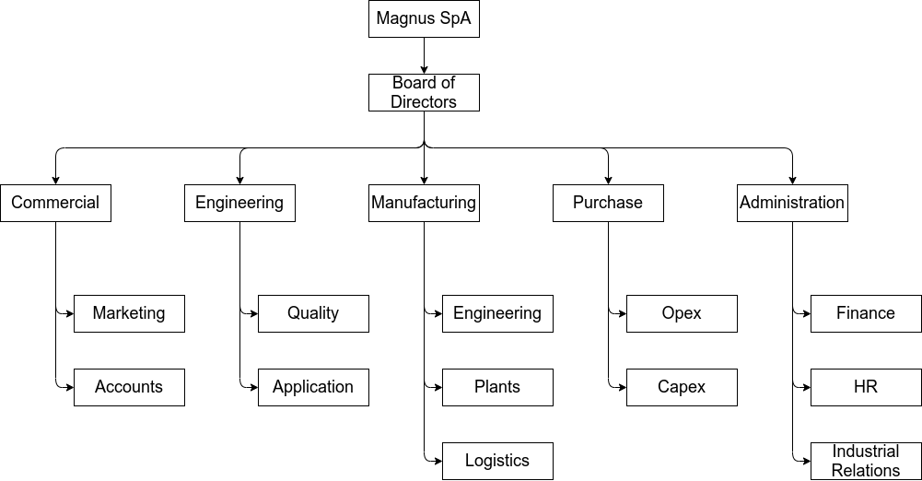

### Current macro operating processes

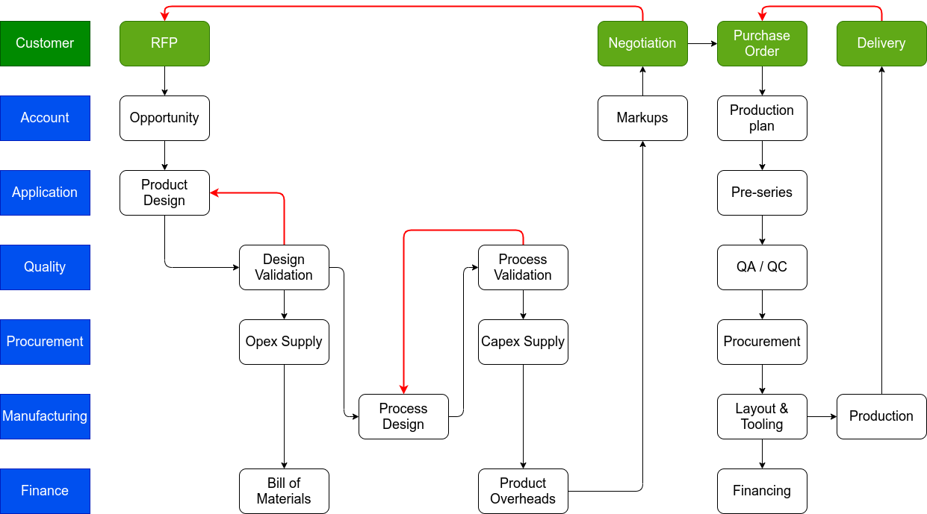

### Market environment

**Volatility**

Global sales of cars and SUVs had been in gradual retreat from the 94.3 million high of 2017, but then dived about 16% to 76.5 million in 2020, as the corona virus came out of nowhere to shut down many economies. Europe performed even worse in percentage terms. After roughly stagnating from 2017 to 2019’s 18.1 million, sales in Western and Central Europe slumped 24.2% in 2020 to 13.73 million.

So any attempt at forecasting how the industry will fare in 2021 will likely find a doubting audience, and anyone saying what will happen further out into the future will be seen as either brave or foolish.

However, we’re in recovery from the worst of the pandemic and the economic havoc it wrought in 2020, but the recovery is not quite turning out to be as smooth as many predicted. The scale of the disruption to economies and industries, as well as the complexities for governments in dealing with an unprecedented public health crisis, have ensured that.

In the automotive sector, the rebound to overall sales and output as economies opened up again continued into 2021, until a number of bumps in the recovery path became evident and depressed vehicle markets – particularly in the second half of the year. A semiconductor shortage and subsequent supply-side impacts was compounded by the uneven progress – looked at globally – of vaccination strategies and the emergence of new Covid-19 variants that hit some regions (notably southeast Asia) more severely than others.

The chart below – showing the seasonally adjusted annualised rate of sales for the global light vehicle market – illustrates how the global market recovery petered out in 2021 after a sharp rebound in the second half of 2020.

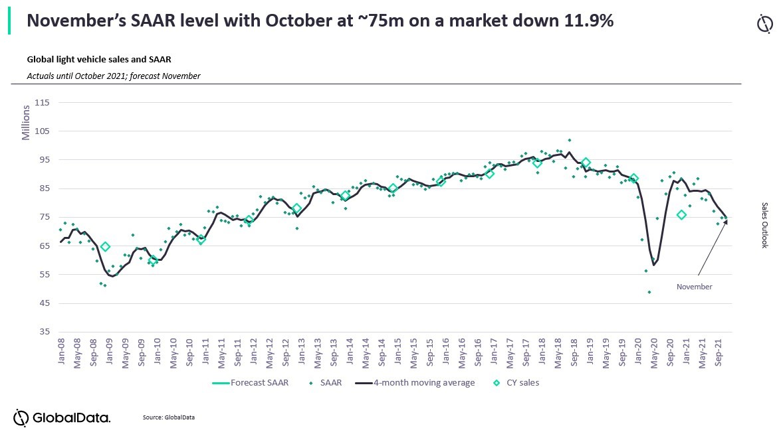

**Sluggish long-term outlook**

Global Light Vehicle Sales: Volatility Impacts the Near-Term Outlook; Mobility Dynamics Drive 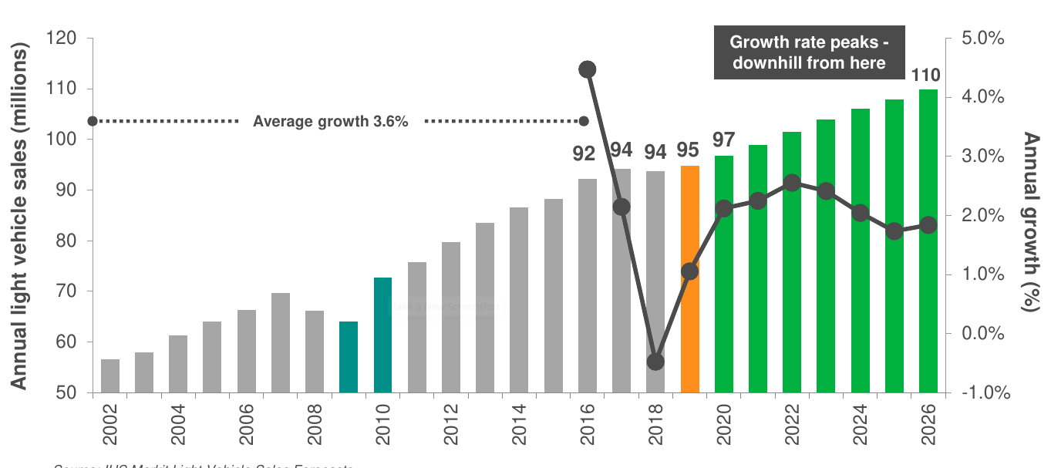Slower Growth Long Term

**The Changing Automotive World**

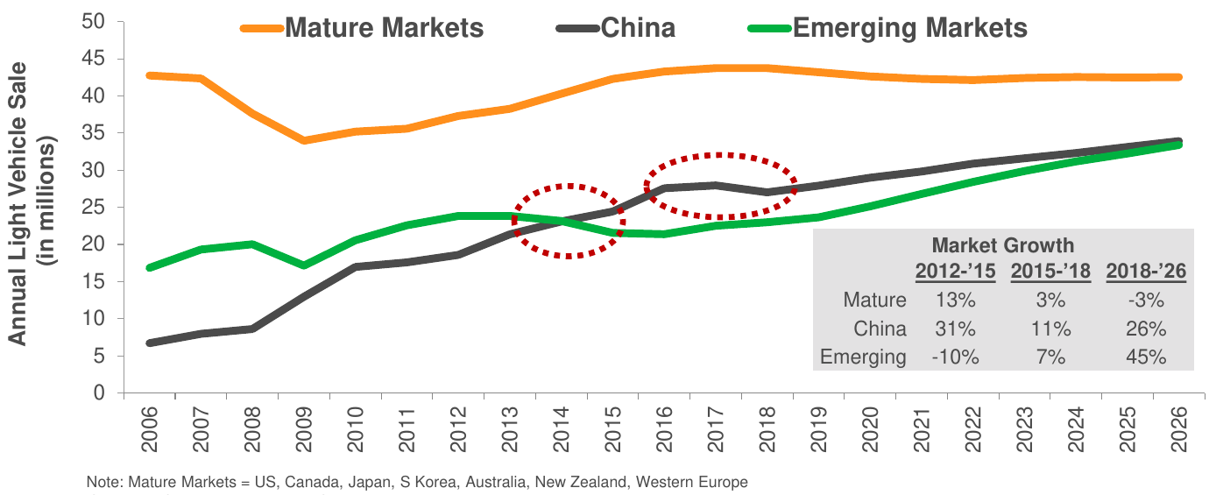

Emerging Markets Outlook is Key to Growth; Limited Potential in Mature Markets

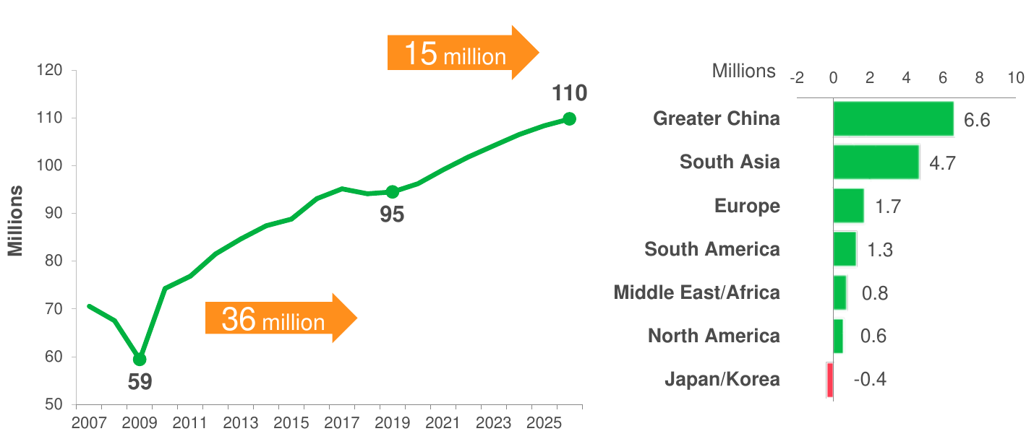Transition from Mature Markets to Emerging Markets Intensifies in the Longer Term

### Magnus’ strategy

**Strategic vision**

As we have seen the financials of Magnus require a strategic vision to adapt their business model to the current and forecast market environment.

Overall the strategic vision relies on three key elements:

* Future profits must be sustained by cost reduction and optimization: reducing overheads and selling, general and administrative costs
* Increase ROI: improve profitability on fixed and intangible assets
* Develop emerging markets to recover and increase sales

**Strategic scorecard**

The Balanced Scorecard Links Performance Measures

* How do customers see us? (**customer** perspective)
* What must we excel at? (**internal** perspective)
* Can we continue to improve and create value? (innovation and **learning** perspective)
* How do we look to shareholders? (**financial** perspective)

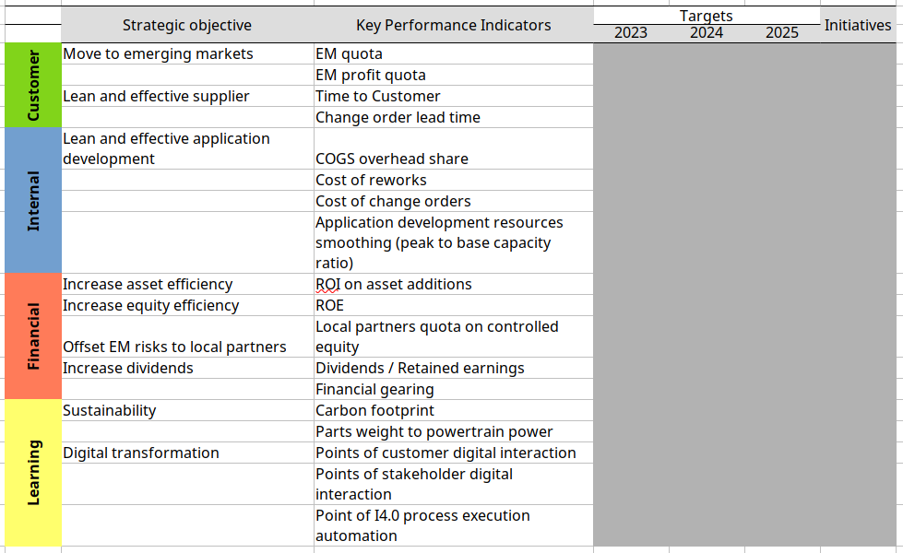**see https://hbr.org/1992/01/the-balanced-scorecard-measures-that-drive-performance-2**

**The India option** - Automotive market outlook for India

India’s future car market outlook forecasts a 4.8% CAGR over the next 5 years, with a projected 3.08 million units sold in 2025. Maruti will surpass 1.5 Million sales per year, remaining the undiscussed leader, followed in a distance by the growing brands Hyundai and Tata.

*The present situation in India*

Since Q3 of the fiscal year 2018, the Indian auto industry has been slowing down, liquidity tightening, rising acquisition costs, and weak customer sentiment have largely contributed to the economic downturn. In this already difficult environment, India’s automotive and transportation sectors have been hit hardest.

Following the pattern of countries where COVID-19 has spread earlier, lockdown measures and other restrictions have limited travel, making it impossible for many consumers to purchase vehicles. What’s more painful is that the coronavirus prevailed when car manufacturers were still trying to recover from the decline in annual sales in 2019 when 3.1 M units were sold, down 7.4% compared to 2018.

Given the current situation, Economists now predict that the country’s GDP will shrink by 1.5% to 5% in fiscal 2021.

The spread of COVID-19 worsened the situation to an unpredictable level. In March 2020, when the Indian government implemented the lockdown policy, car sales fell to 142.134 units, a little less than half the sales compared to March 2019. The worst was yet to come since in May sales fell by 85% with only 36.576 units sold. At the moment India’s vehicle sales in 2020 are down 18.3% with 2.12M units sold Year to Date in October.

A similar story happened in India’s shared-mobility field. In the ride-hailing segment, double-digit rapid growth was achieved in 2018, and the number of rides per day only increased marginally in the first six months of 2019. The initial difficulty was due to changes in state-level regulations and a shortage of driver-partners. Recently, COVID-19 has led to a sharp decline in the use of ride-sharing and other services.

*An Outlook to the Future*

Although India’s manufacturing market is fiercely competitive, this slowdown may be short-lived. As COVID-19 prompts consumers to consider new modes of travel and the government takes action to stimulate the local economy, several favorable trends, including the growth of electric vehicles (EV), may accelerate.

In small-format segments, some driving factors are already encouraging growth. For example, small-format electric vehicles have faster parity compared to traditional internal combustion engine (ICE) vehicles because of their lower total cost of ownership (TCO) because of their lower fuel and maintenance costs.

There are also several developments that can help the small-format e-mobility market, firstly incentives from the central government such as the Faster Adoption and Manufacturing Program for hybrid and EV (FAME), implemented in 2015 and updated in 2019 to provide consumers and domestic companies with various incentives. Secondly, the reduced battery pack prices, which should fall noticeably by 2030, making electric vehicles more affordable. And finally, an increase in consumer preparedness towards the adoption of EVs compared to ICE vehicles given by an increase of familiarity with this kind of vehicle caused by an increase in the numbers of EVs on the road.

Another key factor to consider is the higher possibility of penetration of connectivity features across segments. Connectivity was important even before COVID-19 impacted the country, but will continue to be a differentiator. The ongoing pandemic may accelerate the adoption of connectivity features in commercial vehicles, especially in agriculture and infrastructure, since both scenarios will become the focus as the Indian government tries to restart the economy. Government subsidies will help tractor demand return to pre-COVID-19 levels by June, and can also promote recovery in sales of construction equipment and medium and heavy commercial vehicles.

Based on the projection to 2025 of all historical auto market data (by segment, brand, and model) with all internal factors and economic outlook, our research team is projecting the industry at 3.08 million units by 2025, with a 2020-2025 CAGR of 4.8%.

According to our forecast up to 2025, Maruti will remain the undiscussed leader, reaching over 1.5 million sales a year, and widening the gap to its closest competitor, Hyundai, which on the other hand will surpass the half-million sales per year mark in 2023, followed by Tata, which will achieve over 250k sales per year in 2025.

The electrification effect will be negligible in absolute terms while exponential in percentage.

Indeed, just these days the first electric or hybrid versions are presented in the market, with little hope for high sales, considering the huge price gap towards the similar ICE models. India is probably the most price-sensitive market in the World and no-one is ready to spend an over 100% gap for an EV.

In addition, the people’s concern towards the environment looks still very low and the government’s incentives for consumers and manufacturers (FAME program) seems absolutely inadequate to stimulate the desired shift towards electrification.

## The task

Overall the Capstone teams should act as PMOs (project management officers) to ensure that the India action deliver the expected benefits to Magnus SpA.

Inputs

Magnus’ executives, on the basis of the opportunities and threats illustrated, have selected three projects that are the components of the Magnus India portfolio.

### 1. Production facility.

In the past Magnus had subnitted a proposal to Global Prime Cars (GPC), an Indian automotive power train business, concerning the supply of new production line for aluminum cylinder heads, including line design, production equipment procurement and installation.

Following the adoption of the India strategy, Magnus and GPC have agreed for the joint creation of Magnus India, a corporation owned jointly by them.

As such the proposed manufacturing facility will be constructed by the new entity.

GPC will take care of the construction of the building and general services, while the new entity will provide for the production line, in accordance with the delivery system stipulated in the previous RFP prepared by GPC and accepted by Magnus.

Project governance

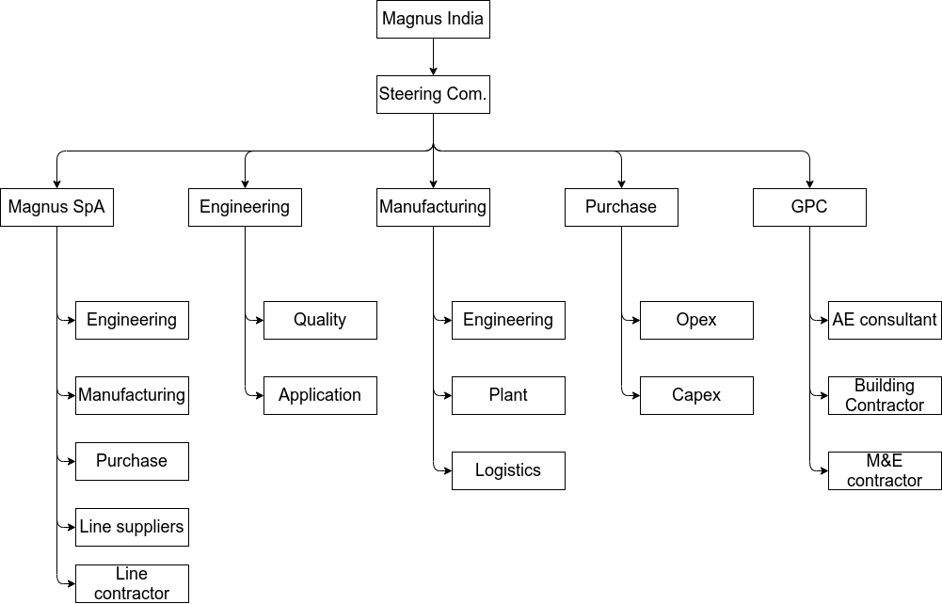

Requirements and constraints

Scope

* Production line
  + engineering: process, equipment, layout design and specifications
  + procurement: scout, RFP, contract and procure equipment and installation contract
  + equipment fabrication, transport and delivery
  + installation
  + test and commision
* Building and systems:
  + Consultant selection
  + Design
  + Permit and fulfillment of statutory requirements
  + Tender and contracting
  + Construction design and on site activities
* Facility integration
  + Requirements
  + Project management
  + Supervision and approvals
  + Handover testing
  + Pre-series

Time: H1 2022 → H2 2023

Cost:

Building 7M€

Line 30M€

Integration: to be defined

Risks: to be defined

### 2. Business process re-engineering and ERP implementation

Magnus has recognized that their business processes have to be upgraded to cope with the “new” automotive market landscape.

Magnus India has acknowledged that they will serve as a best practice in implementing a business process re-engineering and ERP software deployment that will serve the new entity operations.

Magnus India has contacted an IT business company that has presented a case for such a project.

This project deals with the organizational and IT tasks required to configure and deploy an ERP software system.

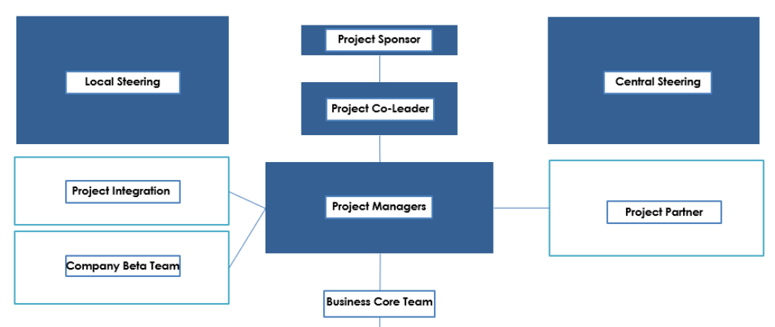Project governance

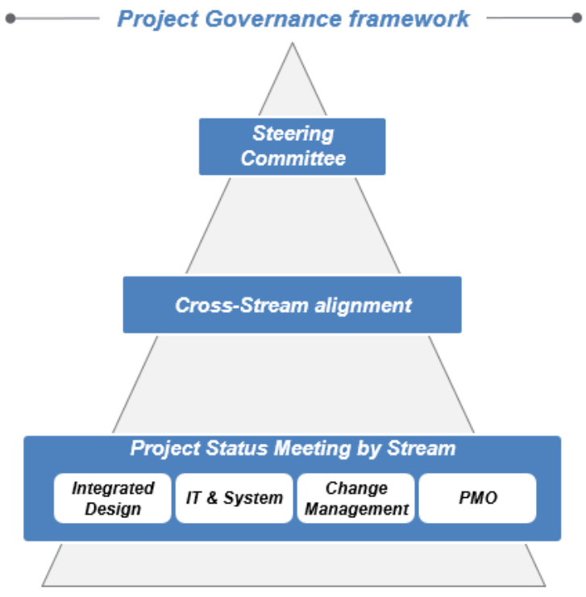

Scope:

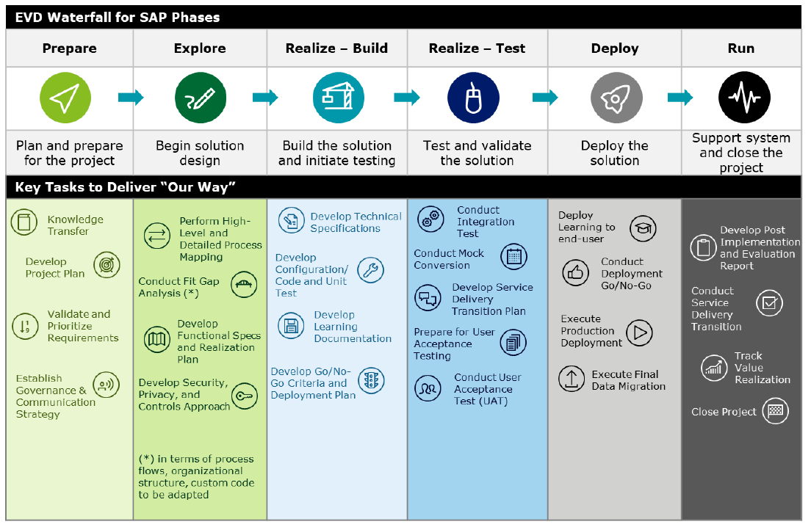Time: see below

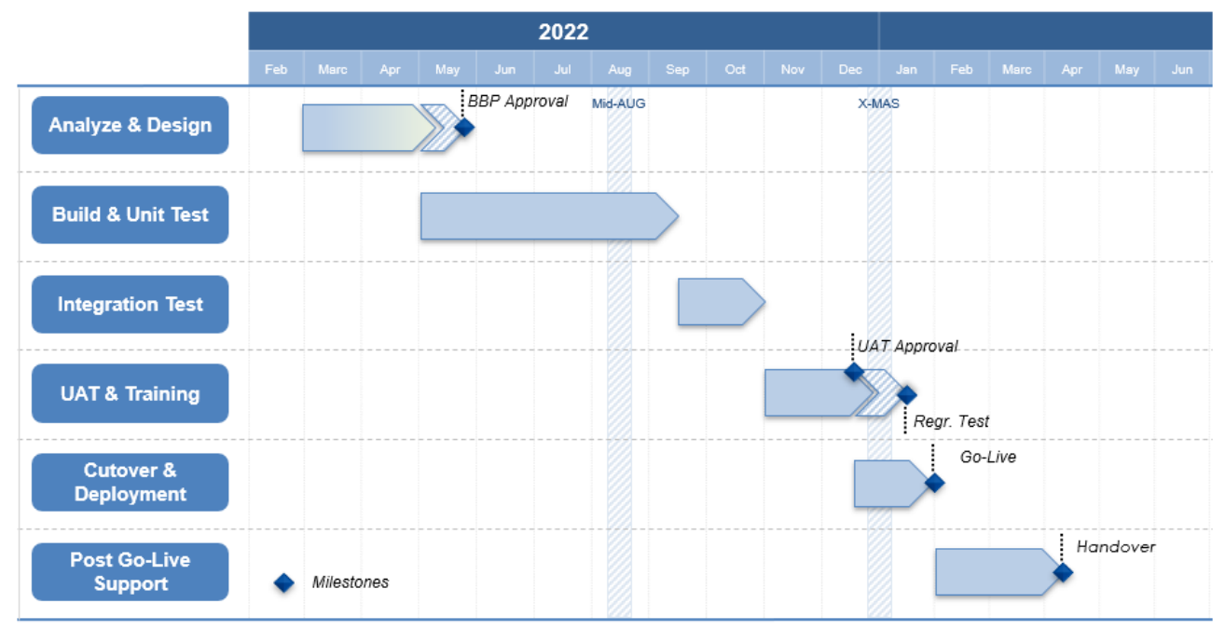Cost: to be defined

Risks: to be defined

### 3. Application engineering platforms

Magnus has seen that the application engineering function is critical for customer quality and overall operational effectiveness.

The application engineering function deals with the development of specific products to be sold to tier 1 or OEM customers. Their responsibility is to design the components and the process required to manufacture them, in line with the requirements of the customer. This function implements the Advanced Product Quality Planning (APQP) method that is required in the automotive industry.

Coherently, this project aims at developing the platform / program approach to product management whereby a specific application required by a customer is developed within a program of similar products. This allows for efficiencies and economies of scale and optimizes the capabilities of the application engineering function.

The adoption of the platform delivery system rests on the theoretical framework of the “projectization of the firm”, a methodological concept developed by Midler and pioneered by Renault.

This rest on the concept that product or application development must be delivered using a project approach rather than a permanent process of the firm, as this allows for better stakeholders engagement, reaction to requirements change and better monitoring and control of the delivery.

This project deals with the organizational tasks required to implement the application engineering function re-organization.

Project justification

As we have shown earlier Magnus implements a classical functional organization that is deployed over a rather traditional macro operation process.

If we map application development over the organization chart we obtain a rather complicated web of relationships that happen below the radar of functional management:

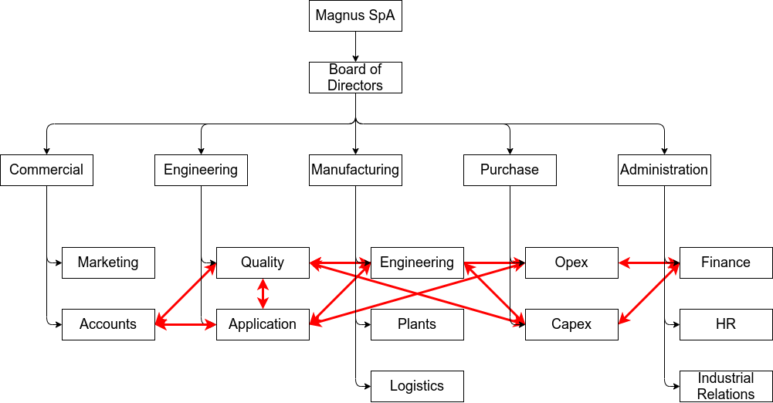

This approach is effective in terms of outputs as far as functions serve with a specific highly specialized competence, but is inefficient in terms of outcomes and impacts.

The major issue is a lack of monitoring and control in the development phases. Application engineers and other operatives don’t have a clear accountability on development economics and quality metrics

Thus the project is about the transition toward a matrix organization:

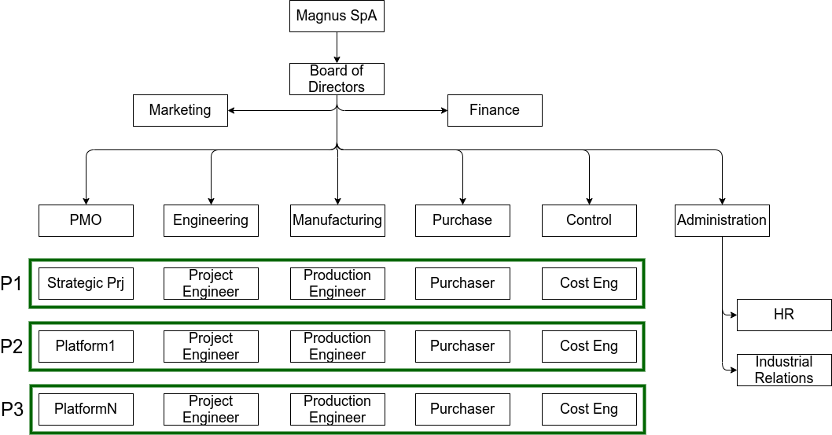

Project governance: to be defined

Scope:

* Change Management
  + Goal creation: document and communicate the change, establish awareness and adoption goals, define KPI
  + Establishment of a change team: define and empower change sponsor, engage stakeholders, implement task force, determine resources
  + Plan development: task list creation, time line, risk assessment
  + Plan execution: create decision making processes, address resistance, communicate performance, hire resources
  + Reinforcement: provide incentives, engage internal subject matter experts, review and adapt
* Training
  + Foundational concepts and methods
  + Competence building
  + Instruction for new tools
* Deliver change enablers
  + New Organizational design: governance system, RACI structures, corporate, delivery and support processes
  + Digital tooling redesign and implementation: communication, ERP, information, document and knowledge sharing, EPPM
  + Logistics: re-design and re-layout working spaces

Time: H1 2022 → H2 2024

Cost: to be defined

Risks:

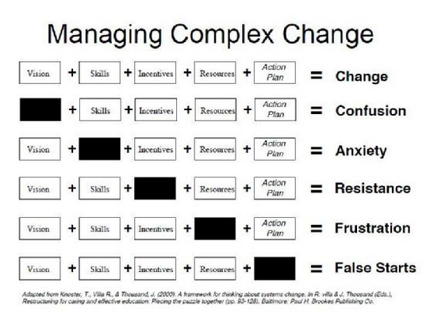

## Activities

As project management teams you will initiate and plan the projects

As portfolio managers you will integrate the project into a portfolio system

Upon collection and consolidation of the projects into the portfolio you will assess:

* the overall feasibility and viability of the India strategic initiative.
* The risk associated with the India strategic initiative

### Tools

We will provide access to Oracle Primavera P6 EPPM, a web environment for enterprise project portfolio management.

These videos illustrate the features of the platform:

<https://youtu.be/A3kyXWk7_vo>

<https://youtu.be/9JWMcBgSRXE>

<https://youtu.be/FElNyZl-PIY>

## Results

### Expected outcomes

By completing the capstone task you should be able to demonstrate the:

* Integration of the portfolio and project data to ensure that the India strategy is planned to achieve the deliverables within the environmental and organizational constraints to enable the strategic plan
* Stakeholders engagement to understand and map the expected benefits and requirements
* Work and cost to deliver the strategic plan
* Optimization of human, financial and material resources required to deliver the portfolio of projects
* Management of risks associated to the strategic plan

### Expected Impact

Ability to fill the Magnus strategic balanced scorecard

