

Design of a Double-Reduction Gearbox

**A Report Prepared For:**

ME 321: Kinematics and Dynamics of Machines

Professor Seyed Amir Mousavi Lajimi

**Prepared By:**

Sherman Qiu | 20651425

Paolo Torres | 20656027

July 25, 2019

Table of Contents

List of Figures 2

List of Tables 2

1 Introduction 3

1.1 Background 3

References 4

List of Figures

**Figure 1**: Proposed layout of the gearbox [1] 4

List of Tables

**Table 1**: Gearbox input parameters [1] 5

**Table 2**: Parameters needed to calculate bending stress number [2] 8

**Table 3**: Additional parameters needed to calculate contact stress number [2] 9

**Table 4**: Parameters needed to calculate allowable stress [2] 9

**Table 5**: Required Brinell Hardness [2] 10

**Table 6**: Allowable stresses for SAE 4140 OQT 400 [2] 10

# Introduction

## Problem Description

The purpose of this report is to detail the design of a speed-reduction gearbox. This gearbox will contain a single input shaft driven at a constant rotational speed by a set power source and shall transmit this power to a single output shaft at a lower rotational speed. Speed reduction will be achieved using a 2 sets of gear pairs connected by an intermediate shaft. Figure 1 shows a diagram of this proposed arrangement with the input and output shafts, intermediate shaft, and gears labelled.

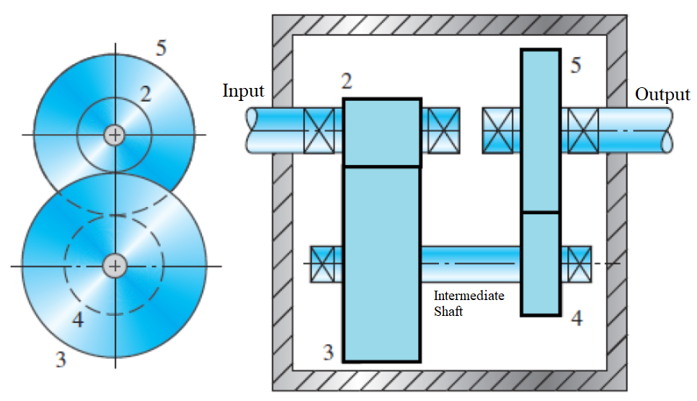

**Figure 1**: Proposed layout of the gearbox [1]

The parameters of the gearbox that will be determined in this report are the material choice and dimensions for the gears and the intermediate shaft. In addition, this gearbox will adhere to a set of input constraints listed in section 1.2. Many of the necessary calculations in this report will be carried out in MATLAB, and the source code is given in Appendix A.

## Design Specifications

Table 1 below shows the input parameters the gearbox must conform to:

**Table 1**: Gearbox input parameters [1]

|  |  |
| --- | --- |
| Specification | Value |
| Input Power | 20.00 HP |
| Input Shaft Speed | 1750 RPM |
| Output Shaft Speed | 82.00 – 88.00 RPM |
| Power Source Intensity | Moderate Shock |
| Driven Machine Intensity | Moderate Shock |
| Maximum Gearbox Size | B: 14.00” 14.00”  H: 22.00” |
| Gear Bearing Life | 12000 h |
| Intermediate Shaft Life | Forever |
| Reliability | 99.00% |

In addition, the following geometric constraints are imposed on the input and output shafts:

* Input and output shafts must be in-line
* Input and output shafts must extend 4” outside of gearbox

## Assumptions

The following assumptions will be made in this report according to convention and/or engineering judgement:

* All gears used will be 20° solid full depth involute spur gears
* Only grade 1 steels can be considered as material choices
* All gears and bearings are frictionless
* The gearbox is a commercial enclosed gear unit
* The gearbox will be operating in a temperature range of 32°F to 250°F
* A safety factor of 1 is acceptable for the gears
* A safety factor of 2.5 is acceptable for the shaft
* Pinion 2 rotating clockwise
* Design of the key seats may be omitted (more information in section 2.2)

# Methods and Results

## Gear Design

### Gear Ratios and Number of Teeth

There are 4 gears in total, as shown in Figure 1: , , , and . In order simplify the design process and reduce the amount of engineering time needed, the pinions ( and ) and driven gears ( and ) will be made identical to each other. This cuts the number of gears that need to be designed in half. The maximum and minimum velocity ratios are as follows:

Given that there are two gear pairs, the theoretical minimum velocity ratio for each pair is the square root of the total velocity ratio:

The number of teeth in all gears will be minimized to reduce size and material cost. According to Table 8-7, the minimum number of pinion teeth that can support a gear ratio of above 4.459 without interference is 16 [2]. The max gear ratio in this case is 6.31 and the maximum number of driven gear teeth is 101 [2]. From this, a theoretical range for the number of driven gear teeth can be calculated:

The lowest integer number within the interval is 72. Note this is below 101. In conclusion:

A check confirms these values are acceptable:

### Speed and Torque

The speed in each gear can be calculated as follows:

The torque in each gear, given a transmitted power of 20 HP, can be calculated as follows:

### Diameter and Diametral Pitch

Since gears 2 and 4 along with gears 3 and 5 are identical, and the input and output shaft are in line, the total vertical height occupied by the gears can be expressed as follows:

Using the standard addendum specified in Table 8-1 and noting pitch diameter can be written as , this expression becomes:

This total distance plus the thickness of the gearbox walls and any clearances must be less than the maximum gearbox height (22”). Let the sum of the clearances and wall thickness be 1.000”:

Rounding 5.619 up to the nearest standard diametral pitch from Table 8-2 yields a diametral pitch of 6.000 teeth/in. This can be used to calculate the pitch diameters of each gear:

### Bending Stress Number

Gears 4 and 5 will experience higher torques than gears 2 and 3. Thus, pinion gear 4 will experience the highest stresses. The calculations for bending stress will be done on gear 4 and all parameters in this section will refer to gear 4. Firstly, tangential force will be computed:

According to Table 8-1, standard face width is equal to . However, it was found that this face width resulted stresses that exceeded the value of any available material. Thus, a face width of 4” will be selected instead. Note that this value is acceptable since the total face width of 2 gears stacked side by side (8”) does not exceed the maximum gearbox length of 14”.

Finally, pitch line speed is calculated as follows:

The remaining parameters needed to calculate bending stress number are summarized in Table 2.

**Table 2**: Parameters needed to calculate bending stress number [2]

|  |  |  |
| --- | --- | --- |
| Parameter | Value | Source |
| Geometry Factor | 0.27 | Figure 9-10 |
| Overload Factor | 2.00 | Table 9-1 |
| Size Factor | 1.00 | Table 9-2 |
| Pinion Proportion Factor | 0.1625 | Figure 9-12 |
| Mesh Alignment Factor | 0.1885 | Figure 9-13 |
| Load Distribution Factor | 1.351 | 1.0 +  **+** |
| Rim Thickness Factor | 1.0 | Figure 9-14 |
| AGMA Quality Number | 10 | Table 9-5 |
| Dynamic Factor | 1.180 | Table 9-6 |

Finally, bending stress number can be computed:

### Contact Stress Number

In order to calculate contact stress number, the parameters from Table 2, along with face width and pitch diameter. Two new parameters must also be computed, shown below in Table 3.

**Table 3**: Additional parameters needed to calculate contact stress number [2]

|  |  |  |
| --- | --- | --- |
| Parameter | Value | Source |
| Elastic Coefficient | 2300 | Figure 9-7 |
| Geometry Factor | 0.103 | Table 9-17 |

Contact stress number is calculated as:

### Allowable Stress

To calculate the required allowable bending and contact stress, the expected number of load cycles is needed. For a service life of 12000 hours and 1 load application per revolution (q = 1), number of load cycles can be found as:

Using this value, plus a known reliability of 99%, the remaining parameters needed to calculate allowable stress can be found. The results are summarized in Table 4.

**Table 4**: Parameters needed to calculate allowable stress [2]

|  |  |  |
| --- | --- | --- |
| Parameter | Value | Source |
| Reliability Factor | 1.00 | Table 9-11 |
| Bending Strength Stress Cycle Factor for Steels | 0.9590 | Figure 9-21 |
| Pitting Resistance Stress Cycle Factor for Steels | 0.9262 | Figure 9-22 |

A safety factor of 1 will be assumed. Thus, the required allowable bending and contact stress are:

### Material Selection

A material must be selected with an allowable stress equal to or greater than the allowable stresses calculated in section 2.1.6. To do this, the Brinell hardness required for each allowable stress will be computed and the maximum will be taken. The results are shown in Table 5.

**Table 5**: Required Brinell Hardness [2]

|  |  |  |
| --- | --- | --- |
| Allowable Stress | Required HB | Source |
|  | 415.0 | Figure 9-18 |
|  | 557.2 | Figure 9-19 |

Thus, a Brinell hardness of 557.2 is required. A suitable material is SAE 4140 OQT 400 steel, with an HB of 578 [2]. The allowable stresses found from this hardness value are shown in Table 6.

**Table 6**: Allowable stresses for SAE 4140 OQT 400 [2]

|  |  |  |
| --- | --- | --- |
| Allowable Stress | Value | Source |
|  | 57480 psi | Figure 9-18 |
|  | 215200 psi | Figure 9-19 |

Both these values exceed the required allowable stress found in section 2.1.6. The safety factor using this material cab also be calculated:

Therefore, safety factor for SAE 4140 OQT 400 is 1.032.

### Power Transmission Capability

The power transmission capability must be computed to ensure the gearbox is able to safely transmit the required 20.0 hp. As a result, this capacity needs to be calculated for both the pinion and the gear, and as well account for both bending and pitting resistance. In order to calculate these values, parameters from Table 2, Table 3, Table 4 and Table 6, along with face width and pitch diameter, are used. The power transmission capability for gear 4, and considering both bending stress and contact stress, are as follows:

For gear 5, a number of parameters need to be recalculated due to differences in diameter, rotational speed, and torque. These values are summarized in Table 7.

Table 7: Parameters needed to calculate power capacity for gear 5 [2]

|  |  |  |
| --- | --- | --- |
| Parameter | Value | Source |
| Geometry Factor | 57480 psi | Figure 9-10 |
| Pinion Proportion Factor | 0.04580 | Figure 9-12 |
| Mesh Alignment Factor | 0.1885 | Figure 9-13 |
| Load Distribution Factor | 1.234 | 1.0 +  **+** |
|  | 27640 psi | Figure 9-18 |
|  | 90920 psi | Figure 9-19 |
| Bending Strength Stress Cycle Factor for Steels | 0.9851 | Figure 9-21 |
| Pitting Resistance Stress Cycle Factor for Steels | 0.9588 | Figure 9-22 |

The power transmission capacities for this gear are:

The calculations show that power transmitting capacity for both gears are above the required 20.0 hp, meaning the gearbox can safely operate under this condition.

### Summary

In the final design, all gear specifications are determined using the source code in Appendix A. The results show they all have a safety factor greater than 1.0 and a power transmitting capacity above 20.0 hp. This means the gears can safely operate under all input values and satisfy the required conditions. The pertinent gear parameters for gearbox design are summarized in Table 8. Note that if a parameter is not given, it is assumed to be calculated according to the standard formulas listed in Table 8-1 [2].

**Table 8**: Gear parameters for gearbox design [2]

|  |  |  |  |  |
| --- | --- | --- | --- | --- |
| Parameter | Gear 2 | Gear 3 | Gear 4 | Gear 5 |
| Number of Teeth | 16 | 72 | 16 | 72 |
| Rotational Speed () | 1750 | 388.9 | 388.9 | 86.42 |
| Torque ( | 60.02 | 270.1 | 270.1 | 1215 |
| Pitch Diameter () | 2.667 | 12 | 2.667 | 12 |
| Face Width (in) | 4.000 | | | |
| Material | SAE 4140 OQT 400 () | | | |
| Safety Factor | 1.032 | | | |
| Power Transmission Capability (Bending) (hp) | - | - | 25.62 | 21.03 |
| Power Transmission Capability (Contact) (hp) | - | - | 21.31 | 20.07 |

## Shaft Design

### Proposed Shaft Layout

### Torque Analysis

The torque of the intermediate shaft is equal to the torque experienced by gears 3 and 4 from section 2.1.2, with a conversion factor applied to convert from to as follows:

The torque diagram can be seen in Figure 2.

**Figure 2**: Torque diagram of the intermediate shaft

### Load Analysis (Top)

For analysis of the loads in the tangential direction, a top view of the shaft is considered. Using the torques from section 2.1.2 and diameters from section 2.1.3, the tangential forces on gears 3 and 4 are:

The corresponding reaction forces on the bearings are determined with static equilibrium moment and force equations:

The shear and bending moment diagrams in the tangential direction can be seen in Figure 3 and Figure 4.

**Figure 3**: Shear diagram in the tangential direction

**Figure 4**: Moment diagram in the tangential direction

### Load Analysis (Front)

For analysis of the loads in the radial direction, a front view of the shaft is considered .Using the tangential forces from section 2.2.3, the radial forces on gears 3 and 4 are:

The corresponding reaction forces on the bearings are determined with static equilibrium moment and force equations:

The shear and bending moment diagrams in the radial direction can be seen in Figure 5 and Figure 6

**Figure 5**: Shear diagram in the radial direction

**Figure 6**: Moment diagram in the radial direction

### Diameter Calculation

To compute the diameter of the shaft, a number of design parameters are required. The safety factor is chosen to be 2.5 to account for uncertainties in actual material strength and loading conditions [2]. The stress concentration factor will be 3.0 to account for the retaining ring groove having a sharp fillet radii [2]. The torque of the shaft from section 2.2.2 and maximum moment from section 2.2.4 are used in the calculation. Through iteration, the correct size factor of the shaft is approximately . The remaining parameters are acquired from Appendix 3, Table 5-2, Table 5-3 and Table 5-4 and summarized in Table 9.

**Table 9**: Diameter parameters for shaft design [2]

|  |  |  |
| --- | --- | --- |
| Parameter | Value | Source |
| Yield Strength | 251000 psi | Appendix 3 |
| Fatigue Limit | 96000 psi | Table 5-2 |
| Reliability Factor | 0.81 | Table 5-3 |

The adjusted endurance limit is:

Using the parameters in Table 9 as well as calculated values, the diameter of the shaft is:

This computed minimum diameter is at the base of the ring groove, so the value must be increased by 6% to account for typical groove depth for the nominal size of the shaft [2]:

Using Table A2-1, the final diameter of the shaft is rounded to the nearest preferred basic size:

### Summary

# Discussion and Recommendations

References

|  |  |
| --- | --- |
| [1] | A. M. Lajimi, *Kinematics and Dynamics of Machines: Optional Project,* Waterloo: University of Waterloo, 2019. |
| [2] | R. L. Mott, E. M. Vavrek and J. Wang, Machine Elements in Mechanical Design, 6th ed., New York: Pearson Education Inc., 2018. |

# Appendix A: MATLAB Source Code

# Appendix B: Drawings