**Question 3**

**Information**

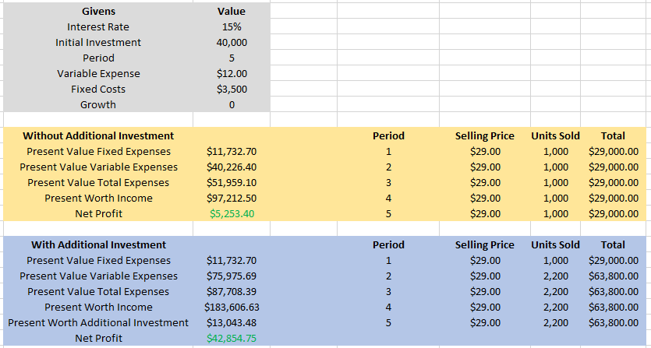

**Interest Rate vs. Present Worth Without Additional Investment**

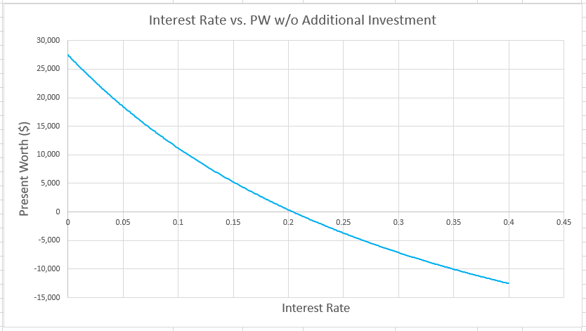

**Interest Rate vs. Present Worth With Additional Investment**

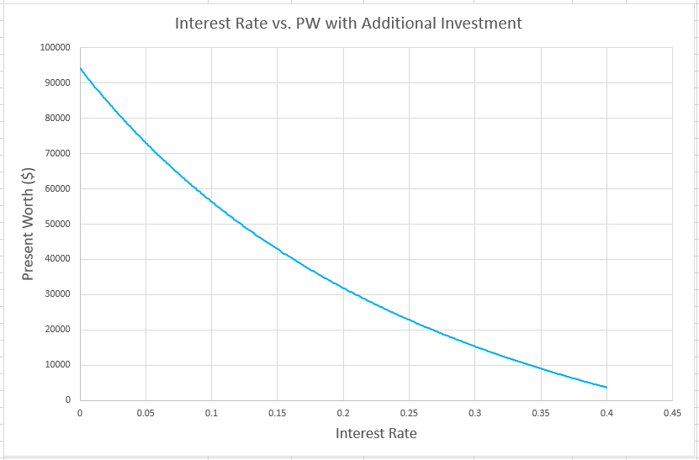

**Questions**

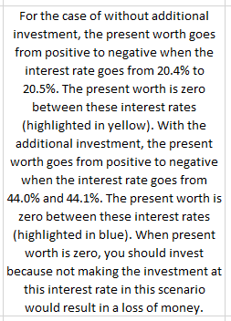

**Point at Which Present Worth Without Additional Investment Crosses Zero**

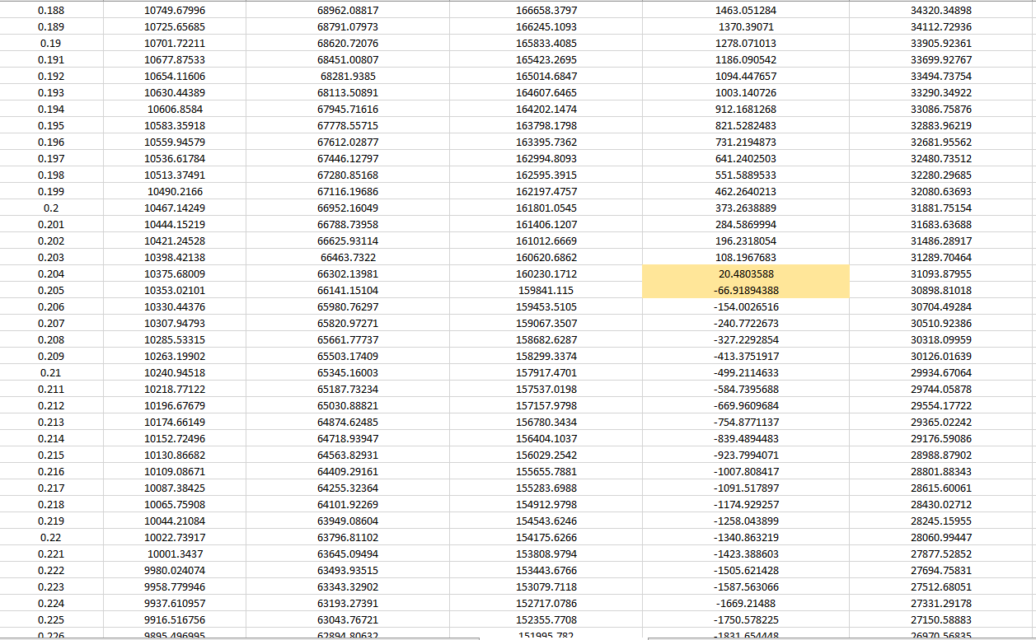

**Point at Which Present Worth With Additional Investment Crosses Zero**

