# Question 1

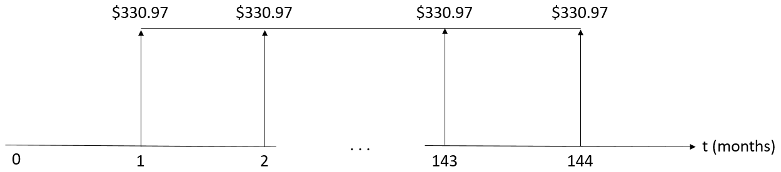

He should save at the end of each month to cover the tuition and housing.

# Question 2

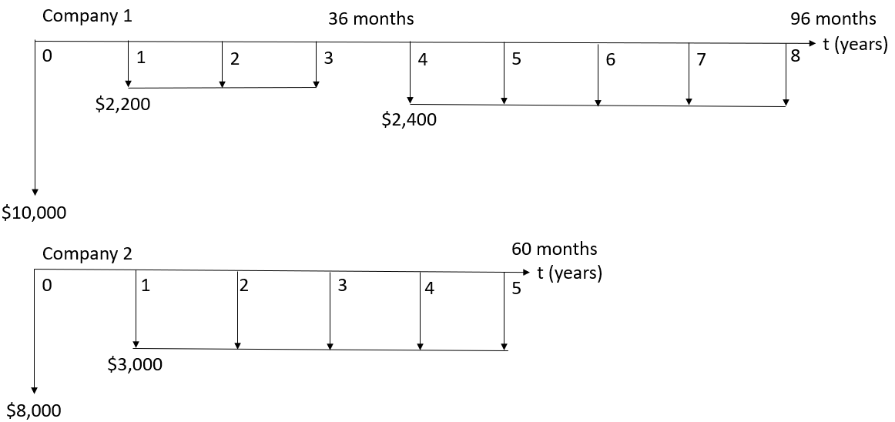

, so Company 1 has the better offer.

# Question 3

The present worth of this maintenance plan is $242,444.10.

# Question 4

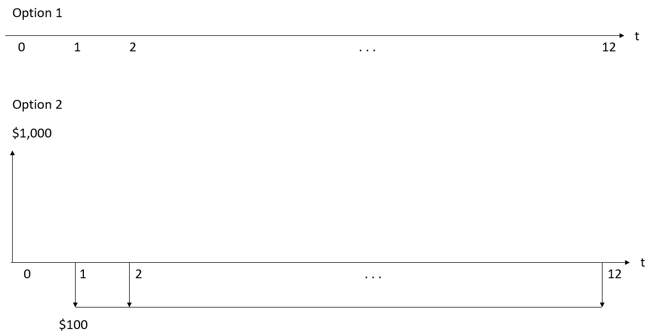

Option 1 is more beneficial for him at the end of the year because he does not need to spend any money, unlike in Option 2, where he needs to spend $137.47.

# Question 5

The present worth of purchase and maintenance cost with an interest rate of is .