# Question 1

There are drawbacks of having consistent demand. Consistent demand is when a product sells at a uniform rate throughout the year, meaning it is independent of the season. As a result, the production of the product needs to be consistent throughout the year. This could cause problems for the firm if the product is more easily made during a specific time, or similarly, harder to produce during a certain season. For example, assume the COVID-19 vaccines such as ones developed by Pfizer and Moderna will be in consistent demand throughout the year. In this case, issues arise in the transportation of these vaccines throughout the world, as factors such as environmental extremes, i.e., harsh winters, and clashes between countries, affect its ability to be distributed evenly and appropriately to different places.

# Question 2

Single period model is a model where goods typically cannot be held over to the next period, and when they can they incur significant price reductions. Therefore, the objective is to choose an order quantity that will minimize shortage and excess costs. The service level () is the probability that demand will not be greater than the quantity of goods on hand:

Where is shortage costs and is excess costs. A higher service level affects the optimal stocking policy in single period inventory model because since goods cannot be held over to the next period, then there will be more shortage costs to account for. In the case of a lower service level, there is less shortage costs, and thus, more revenue for the company.

# Question 3

The bullwhip effect is when demand/order variability gets progressively larger the further back in a supply chain is the company. This effect is caused by the isolation of manufacturing from the retail sector, errors in forecasting, promotional pricing, and the trade show effect. The implications include a strain on manufacturing capacity, rescheduling, increased inventory holdings, and shelf-life issues. Therefore, two remedies to the bullwhip effect are:

1. Make product to order.
2. Increase inventories.

# Question 4

Using Table 12-3, given that , then this means that .

Now, calculate , using the equation where both demand and lead time are variable:

The reorder point for these canisters is .

# Question 5

1. Critical path and slack times.

Note: All paths go from left to right.

|  |  |  |
| --- | --- | --- |
| **Path** | **Length (weeks)** | **Path Slack (weeks)** |
|  |  |  |
|  |  |  |
|  |  |  |

Critical path: .

1. If activity 2 and 4 took 5 extra weeks.

|  |  |  |
| --- | --- | --- |
| **Path** | **Length (weeks)** | **Path Slack (weeks)** |
|  |  |  |
|  |  |  |
|  |  |  |

Critical path: .

The critical path changes to .

# Question 6

or units. , EOQ is not feasible.

or units. , EOQ is not feasible.

or units. , EOQ is feasible.

Next, need to compare total cost of units with those of and .

Therefore, the order quantity that will minimize total cost is indeed units.

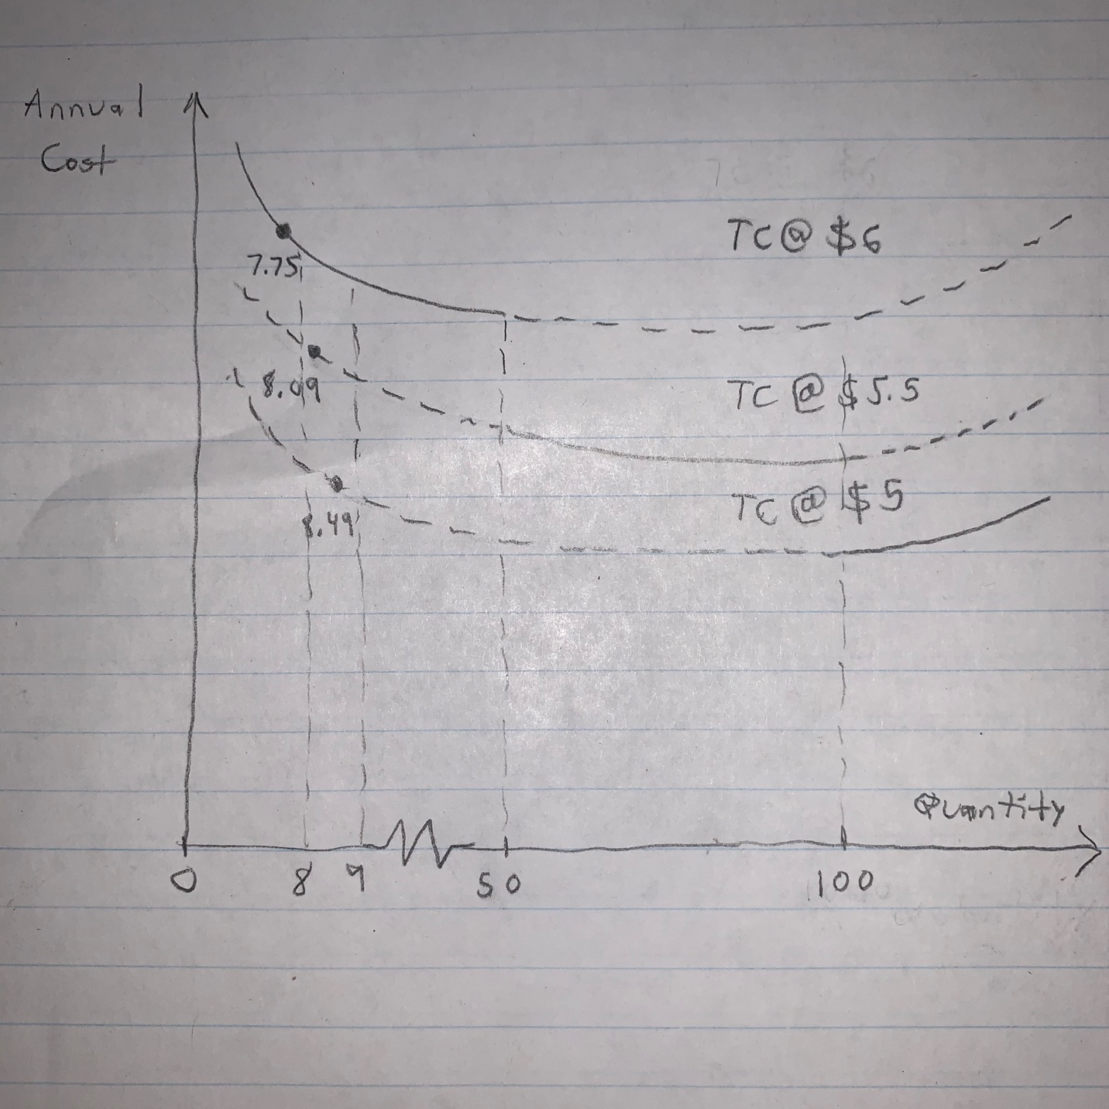

As shown in the conceptual graph, the optimal order quantities on the and lines are infeasible, thus, the quantity on the line is used.

# Question 7

4 hours to produce a unit 40 hours per week per worker 100 workers 1,000 regular.

|  |  |  |  |  |  |  |  |  |  |  |  |  |  |  |
| --- | --- | --- | --- | --- | --- | --- | --- | --- | --- | --- | --- | --- | --- | --- |
| **Month** |  | **1** | **2** | **3** | **4** | **5** | **6** | **7** | **8** | **9** | **10** | **11** | **12** | **Total** |
| **Forecast** |  | 9,000 | 7,000 | 5,000 | 4,000 | 2,000 | 1,500 | 1,000 | 1,200 | 1,600 | 3,000 | 5,700 | 7,000 | 48,000 |
| **Output** | | | | | | | | | | | | | | |
| **Regular** |  | 0 | 1,000 | 1,000 | 1,000 | 1,000 | 1,000 | 1,000 | 1,000 | 1,000 | 1,000 | 1,000 | 1,000 | 12,000 |
| **Part Time** |  |  |  |  |  |  |  |  |  |  |  |  |  | 0 |
| **Overtime** |  | 0 | 1,000 | 1,000 | 1,000 | 1,000 | 500 | 0 | 200 | 600 | 1,000 | 1,000 | 1,000 | 9,300 |
| **Subcontract** |  | 0 | 5,000 | 3,000 | 2,000 | 0 | 0 | 0 | 0 | 0 | 1,000 | 3,700 | 5,000 | 26,700 |
| **Output Forecast** |  | -9,000 | 0 | 0 | 0 | 0 | 0 | 0 | 0 | 0 | 0 | 0 | 0 | 0 |
| **Inventory** | | | | | | | | | | | | | | |
| **Beginning** |  | 9,000 | 0 | 0 | 0 | 0 | 0 | 0 | 0 | 0 | 0 | 0 | 0 |  |
| **Ending** |  | 0 | 0 | 0 | 0 | 0 | 0 | 0 | 0 | 0 | 0 | 0 | 0 |  |
| **Average** |  | 4,500 | 0 | 0 | 0 | 0 | 0 | 0 | 0 | 0 | 0 | 0 | 0 | 4,500 |
| **Backorder** |  | 0 | 0 | 0 | 0 | 0 | 0 | 0 | 0 | 0 | 0 | 0 | 0 | 0 |
| **Costs** | | | | | | | | | | | | | | |
| **Regular** | $300 | $0 | $30,000 | $30,000 | $30,000 | $30,000 | $30,000 | $30,000 | $30,000 | $30,000 | $30,000 | $30,000 | $30,000 | $360,000 |
| **Part Time** |  |  |  |  |  |  |  |  |  |  |  |  |  |  |
| **Overtime** | $360 | $0 | $36,000 | $36,000 | $36,000 | $36,000 | $18,000 | $0 | $7,200 | $21,600 | $36,000 | $36,000 | $36,000 | $298,800 |
| **Subcontract** | $420 |  | $210,000 | $126,000 | $84,000 |  |  |  |  |  | $42,000 | $155,400 | $210,000 | $827,400 |
| **Hire/Layoff** | $500 |  |  |  |  |  |  |  |  |  |  |  |  | $0 |
| **Inventory** | $10 | $45,000 |  |  |  |  |  |  |  |  |  |  |  | $45,000 |
| **Backorders** |  |  |  |  |  |  |  |  |  |  |  |  |  |  |
|  |  |  |  |  |  |  |  |  |  |  |  |  |  | $1,531,200 |

Total cost .

# Question 8

P:

|  |  |  |  |  |  |  |  |  |  |
| --- | --- | --- | --- | --- | --- | --- | --- | --- | --- |
| **Week** | **Beginning Inventory** | **1** | **2** | **3** | **4** | **5** | **6** | **7** | **8** |
| **Quantity** |  |  |  |  |  |  |  | 400 |  |

P:

|  |  |  |  |  |  |  |  |  |  |
| --- | --- | --- | --- | --- | --- | --- | --- | --- | --- |
| **Item P**  **LT 1 week** | **Beginning Inventory** | **1** | **2** | **3** | **4** | **5** | **6** | **7** | **8** |
| Gross Requirements |  |  |  |  |  |  |  | 400 |  |
| Schedule Receipts |  |  |  |  |  |  |  |  |  |
| Projected On-Hand |  |  |  |  |  |  |  |  |  |
| Net Requirements |  |  |  |  |  |  |  | 400 |  |
| Planned-Order Receipts |  |  |  |  |  |  |  | 400 |  |
| Planned-Order Releases |  |  |  |  |  |  | 400 |  |  |

B:

|  |  |  |  |  |  |  |  |  |  |
| --- | --- | --- | --- | --- | --- | --- | --- | --- | --- |
| **Item B**  **LT 1 week** | **Beginning Inventory** | **1** | **2** | **3** | **4** | **5** | **6** | **7** | **8** |
| Gross Requirements |  |  |  |  |  |  | 400 |  |  |
| Schedule Receipts |  |  |  |  |  |  |  |  |  |
| Projected On-Hand |  |  |  |  |  |  | 0 |  |  |
| Net Requirements |  |  |  |  |  |  | 400 |  |  |
| Planned-Order Receipts |  |  |  |  |  |  | 450 |  |  |
| Planned-Order Releases |  |  |  |  |  | 450 |  |  |  |

D:

|  |  |  |  |  |  |  |  |  |  |
| --- | --- | --- | --- | --- | --- | --- | --- | --- | --- |
| **Item D**  **LT 2 weeks** | **Beginning Inventory** | **1** | **2** | **3** | **4** | **5** | **6** | **7** | **8** |
| Gross Requirements |  |  |  |  |  | 900 |  |  |  |
| Schedule Receipts |  |  | 80 |  |  |  |  |  |  |
| Projected On-Hand | 50 |  |  |  | 130 | 130 |  |  |  |
| Net Requirements |  |  |  |  |  | 770 |  |  |  |
| Planned-Order Receipts |  |  |  |  |  | 770 |  |  |  |
| Planned-Order Releases |  |  |  | 770 |  |  |  |  |  |

The amount for the planned-order releases of D in Week 3 is .