

**MTE 322 Project 1**

Prepared for:

MTE 322 – Electromechanical Machine Design

By:

Paolo Torres – 20656027

# Coloring Page

The gear train in Figure 1 is colored in with four different colors: blue, green, red, and orange. Each color represents a different speed that the part is rotating at, with blue being the housing of the gear train, thus being stationary.

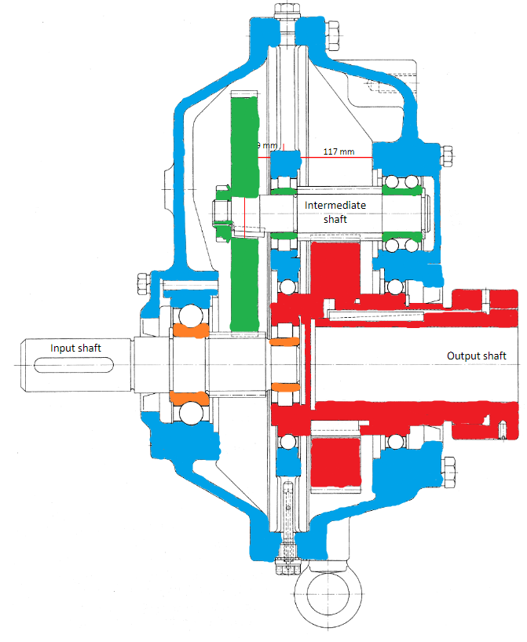

Figure 1: Gear train with colors representing different speeds (blue is stationary)

# Assembly Model and Procedure

## Cross Section and Model

## Procedure

# Free Body Diagram and Calculations

## Free Body Diagram

## Calculations

The reduction ratio is:

The input and output torques are:

The pinion and gear forces applied on the intermediate shaft are:

On the x-y plane, the forces applied in the y-direction are:

On the x-z plane, the forces applied in the z-direction are: