━━━━━━━━━━━━━━━━━━━━━━━━━━━━━━━━━━━━━━━━
Architecture Diagrams
━━━━━━━━━━━━━━━━━━━━━━━━━━━━━━━━━━━━━━━━

Project: Cebuana Lhuillier Parking Reservation System
Version: 1.0
Date: February 22, 2026
Classification: Internal — Confidential

Table of Contents
━━━━━━━━━━━━━━━━━━━━━━━━━━━━━━
Right-click and select 'Update Field' to populate the Table of Contents.

All diagrams use Mermaid syntax, compatible with GitHub Markdown rendering.
━━━━━━━━━━━━━━━━━━━━━━━━━━━━━━━━━━━━━━━━━━━━━━━━━━

1. Component Architecture (UML Component Diagram)
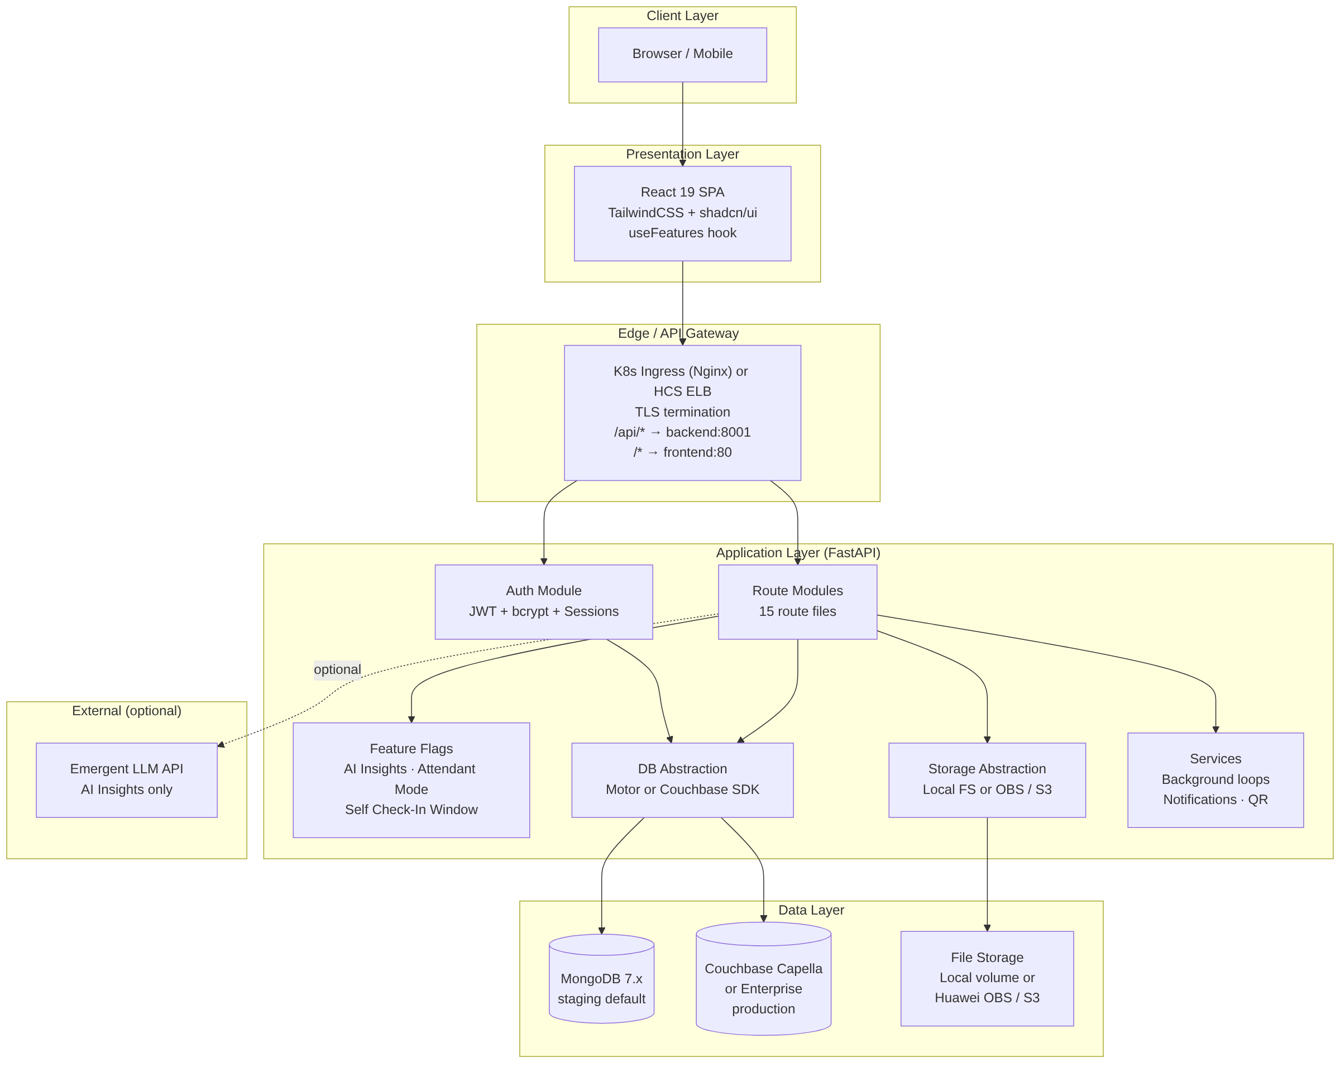
1. Component Architecture (UML Component Diagram)
━━━━━━━━━━━━━━━━━━━━━━━━━━━━━━━━━━━━━━━━━━━━━━━━━━

2. Deployment Architecture — Huawei CCE (Kubernetes) Production Target
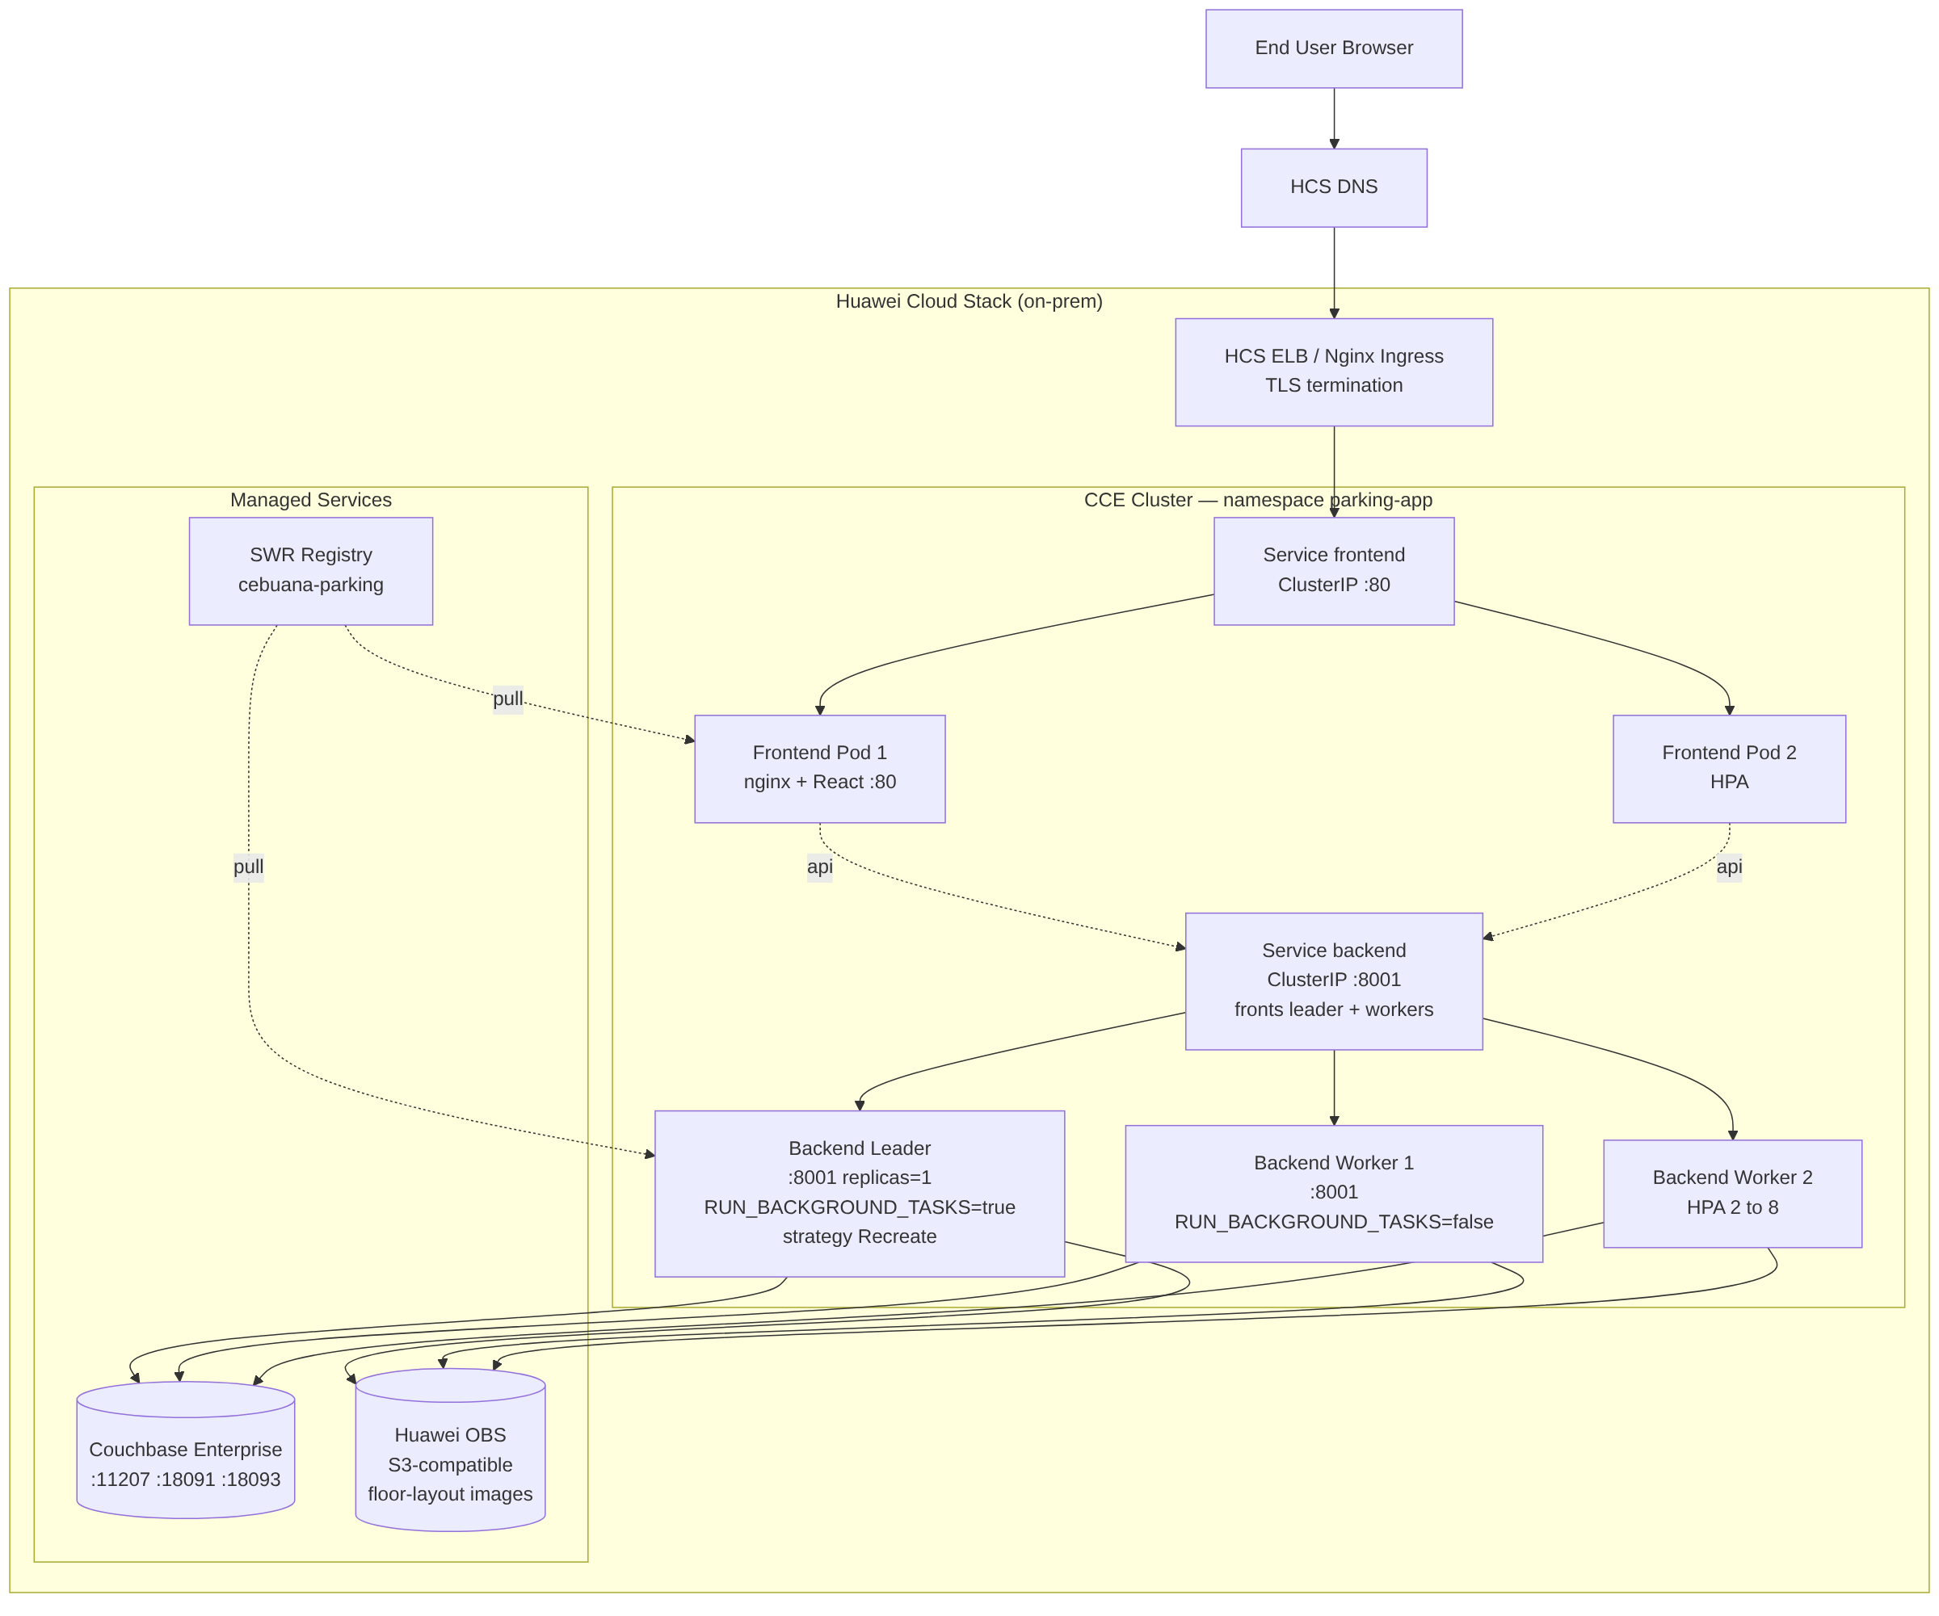
2. Deployment Architecture — Huawei CCE (Kubernetes) Production Target
━━━━━━━━━━━━━━━━━━━━━━━━━━━━━━━━━━━━━━━━━━━━━━━━━━

3. Application Layer Detail
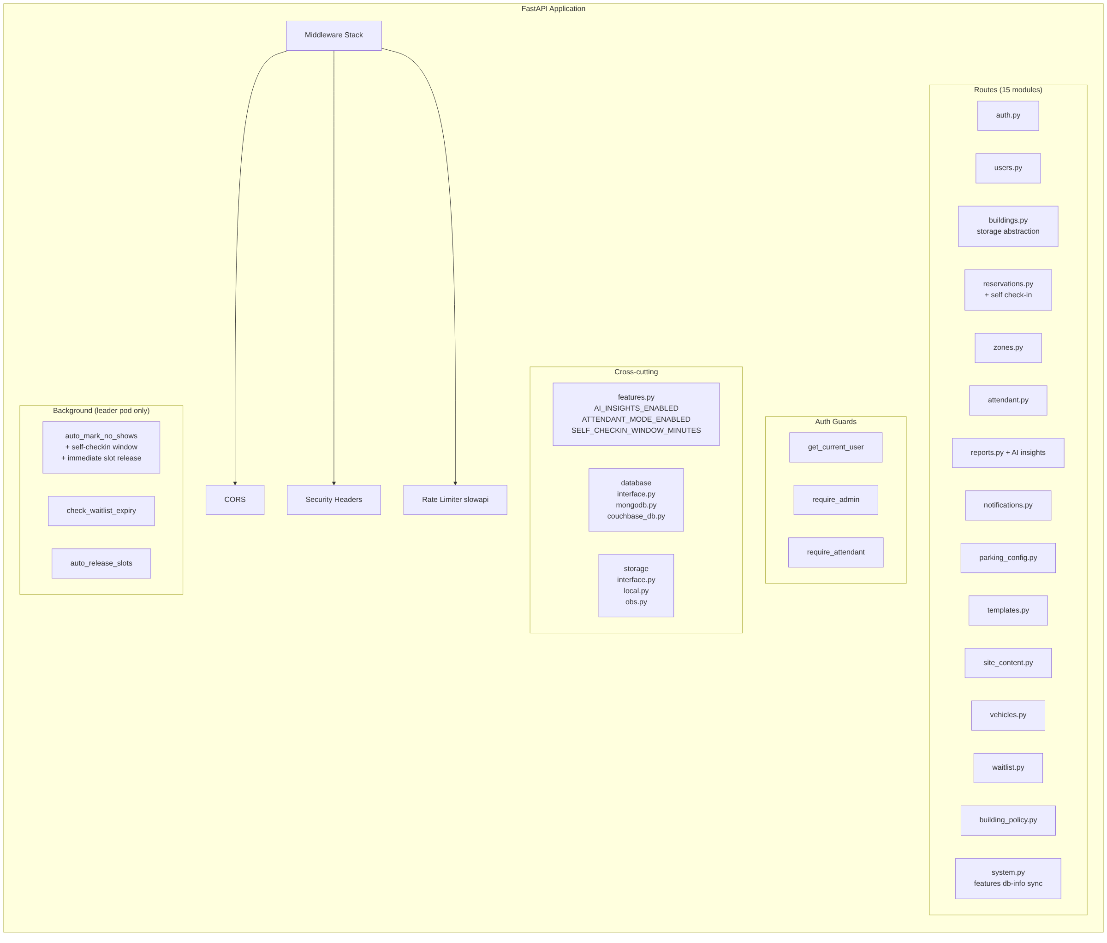
3. Application Layer Detail
━━━━━━━━━━━━━━━━━━━━━━━━━━━━━━━━━━━━━━━━━━━━━━━━━━

4. Frontend Component Tree
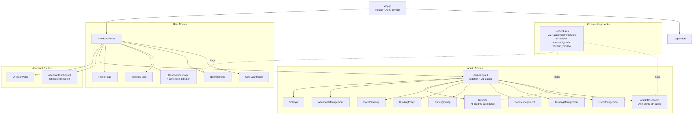
4. Frontend Component Tree
━━━━━━━━━━━━━━━━━━━━━━━━━━━━━━━━━━━━━━━━━━━━━━━━━━

