━━━━━━━━━━━━━━━━━━━━━━━━━━━━━━━━━━━━━━━━
Entity Relationship Diagram
━━━━━━━━━━━━━━━━━━━━━━━━━━━━━━━━━━━━━━━━

Project: Cebuana Lhuillier Parking Reservation System
Version: 1.0
Date: February 22, 2026
Classification: Internal — Confidential

Table of Contents
━━━━━━━━━━━━━━━━━━━━━━━━━━━━━━
Right-click and select 'Update Field' to populate the Table of Contents.

The ERD below is **database-agnostic**: the same entities exist in both MongoDB (collections) and Couchbase (collections inside the `_default` scope of bucket `db_parking`). The DB Abstraction Layer keeps the application code identical against either backend.
━━━━━━━━━━━━━━━━━━━━━━━━━━━━━━━━━━━━━━━━━━━━━━━━━━

ERD (Mermaid)
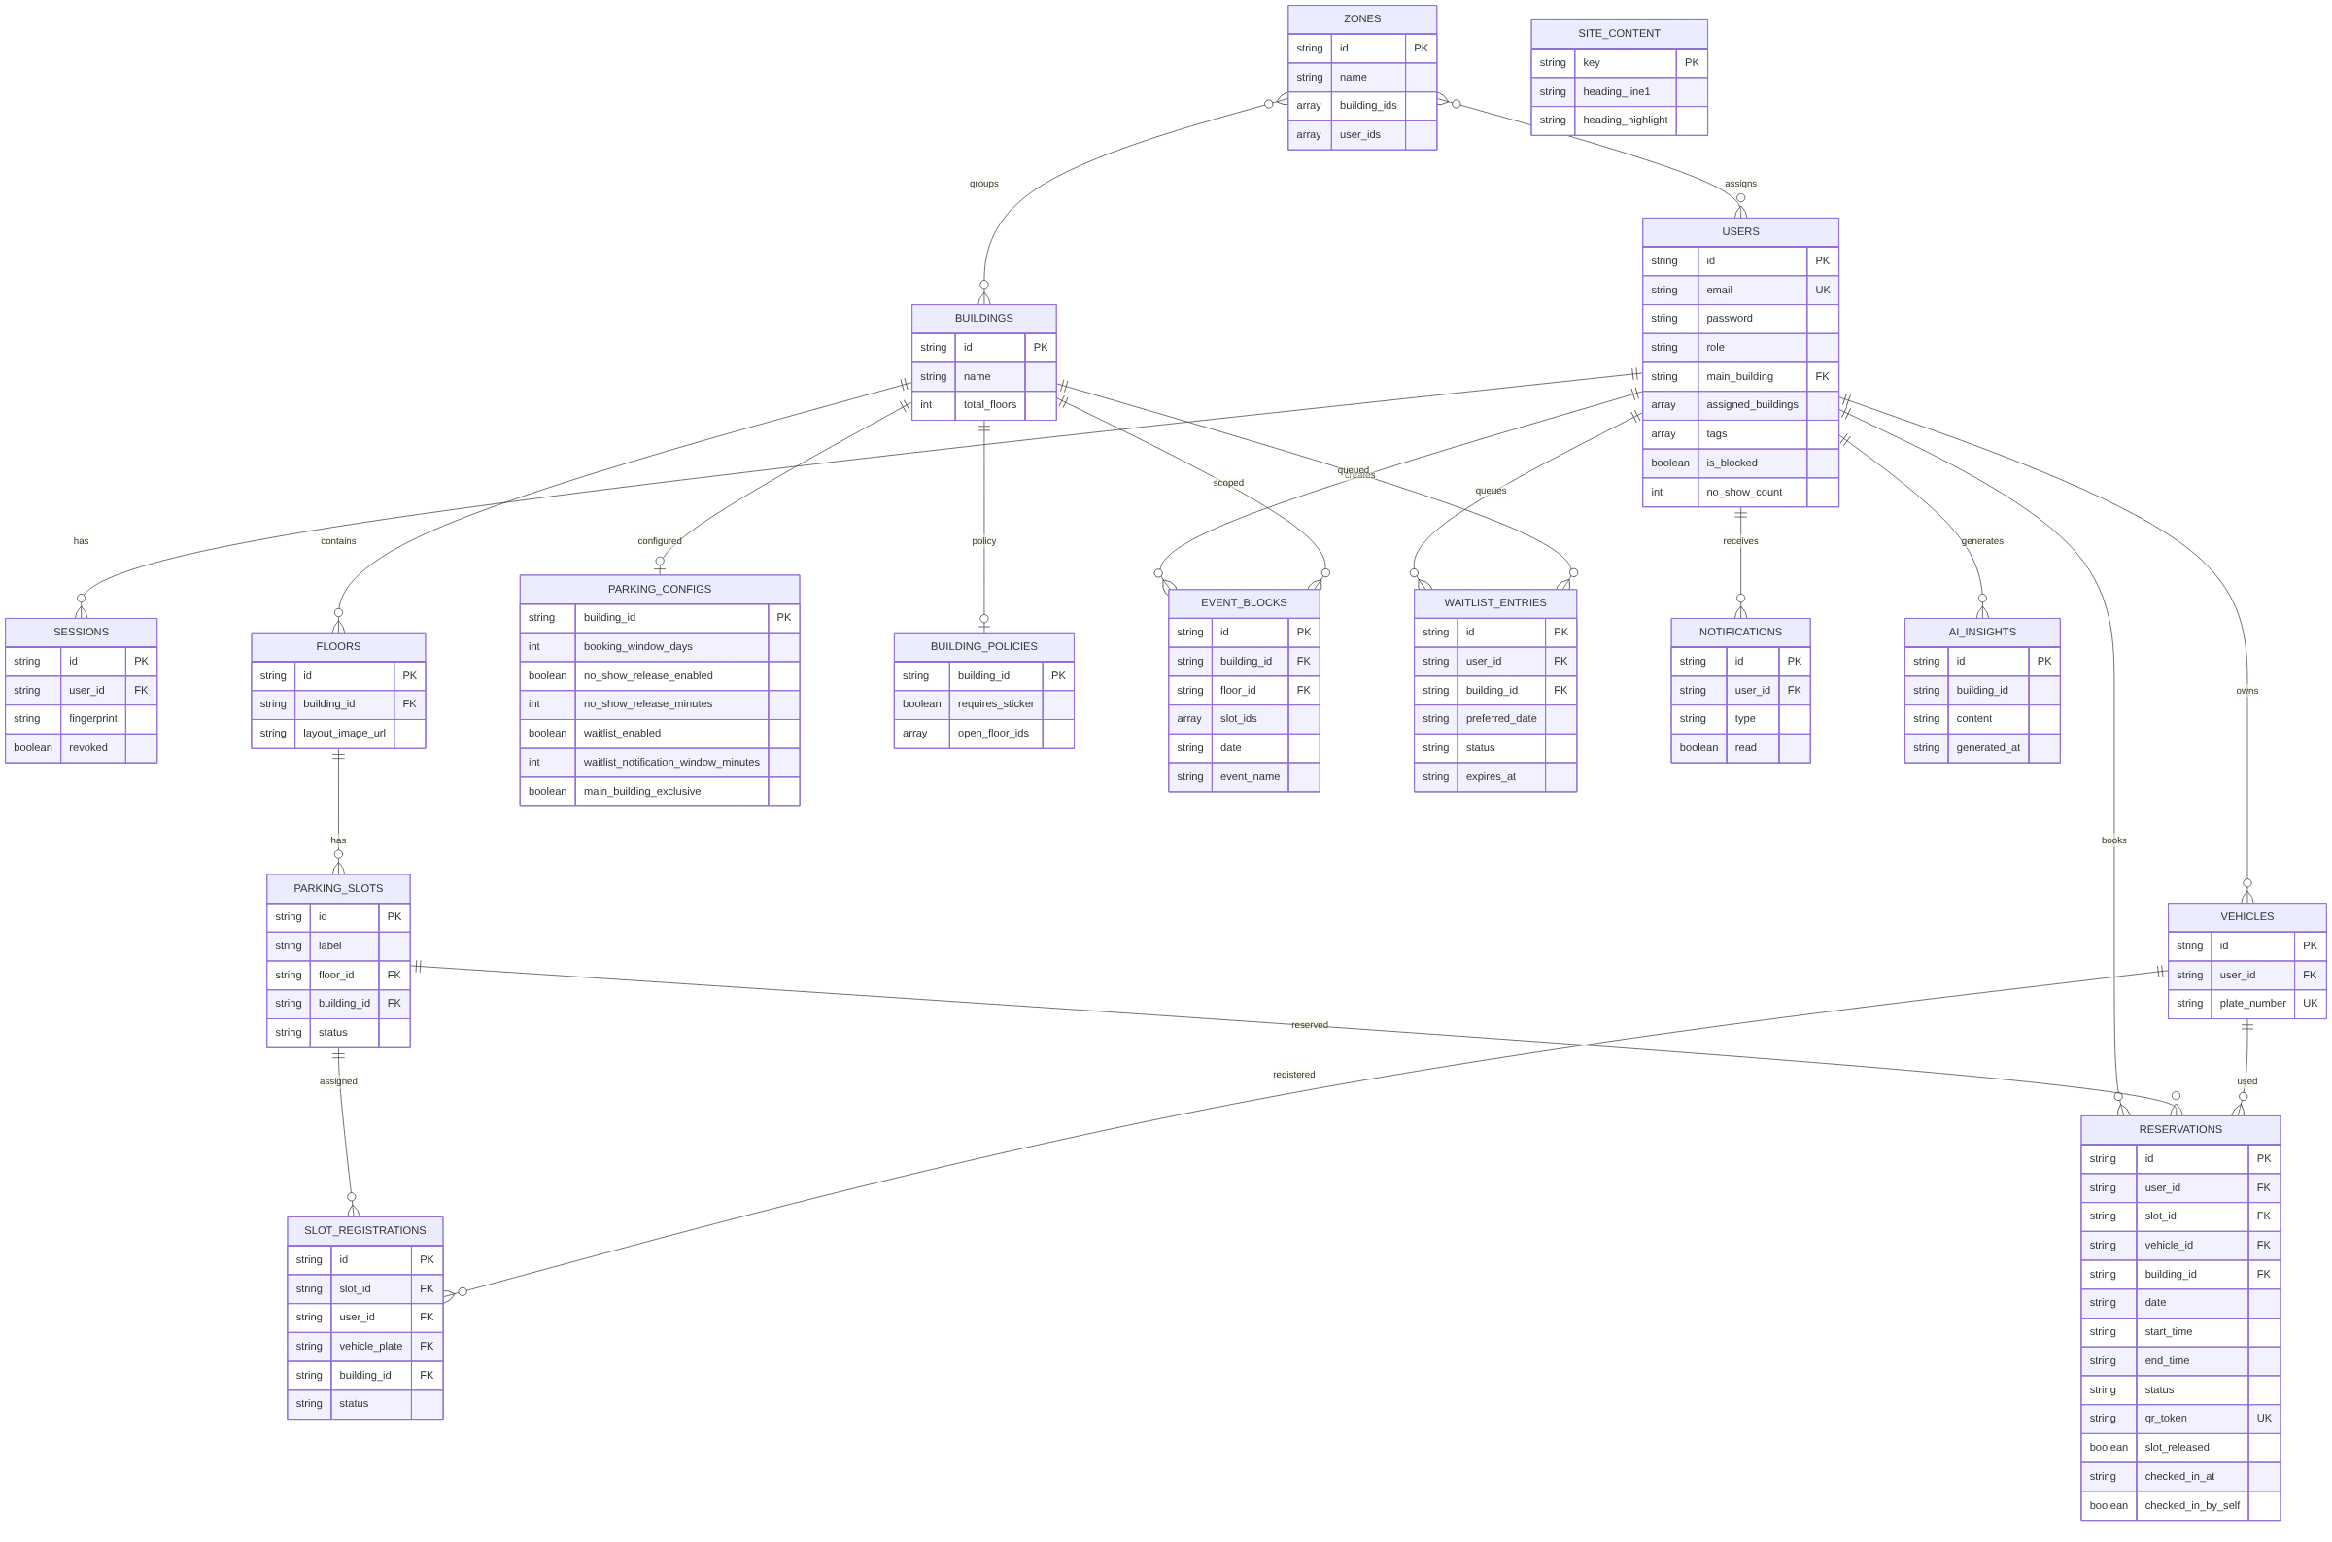
ERD (Mermaid)
━━━━━━━━━━━━━━━━━━━━━━━━━━━━━━━━━━━━━━━━━━━━━━━━━━

Index Summary
The same logical indexes are present on both DB backends; the abstraction layer maps them to the appropriate primitive (MongoDB index spec / Couchbase GSI).
Collection | Indexes
users | id (unique), email (unique)
sessions | id (unique), user_id
reservations | id (unique), user_id, building_id, slot_id, date, qr_token, compound(slot_id+date+status), compound(status+date+slot_released)
buildings | id (unique)
floors | id (unique), building_id
parking_slots | id (unique), floor_id
vehicles | id (unique), user_id, plate_number (unique)
zones | id (unique)
notifications | id (unique), compound(user_id+created_at)
parking_configs | building_id (unique)
building_policies | id (unique), building_id (unique)
slot_registrations | id (unique), compound(slot_id+user_id+status), vehicle_plate
event_blocks | id (unique), compound(building_id+date), compound(floor_id+date)
waitlist_entries | id (unique), compound(building_id+preferred_date+status)
ai_insights | id, generated_at
site_content | key (unique)

━━━━━━━━━━━━━━━━━━━━━━━━━━━━━━━━━━━━━━━━━━━━━━━━━━

