━━━━━━━━━━━━━━━━━━━━━━━━━━━━━━━━━━━━━━━━
Sequence Diagrams
━━━━━━━━━━━━━━━━━━━━━━━━━━━━━━━━━━━━━━━━

Project: Cebuana Lhuillier Parking Reservation System
Version: 1.0
Date: February 22, 2026
Classification: Internal — Confidential

Table of Contents
━━━━━━━━━━━━━━━━━━━━━━━━━━━━━━
Right-click and select 'Update Field' to populate the Table of Contents.

All diagrams use Mermaid syntax, compatible with GitHub Markdown rendering. The participant `DB` represents the **DB Abstraction Layer** which speaks to MongoDB or Couchbase depending on `DB_TYPE`.
━━━━━━━━━━━━━━━━━━━━━━━━━━━━━━━━━━━━━━━━━━━━━━━━━━

1. User Login Sequence
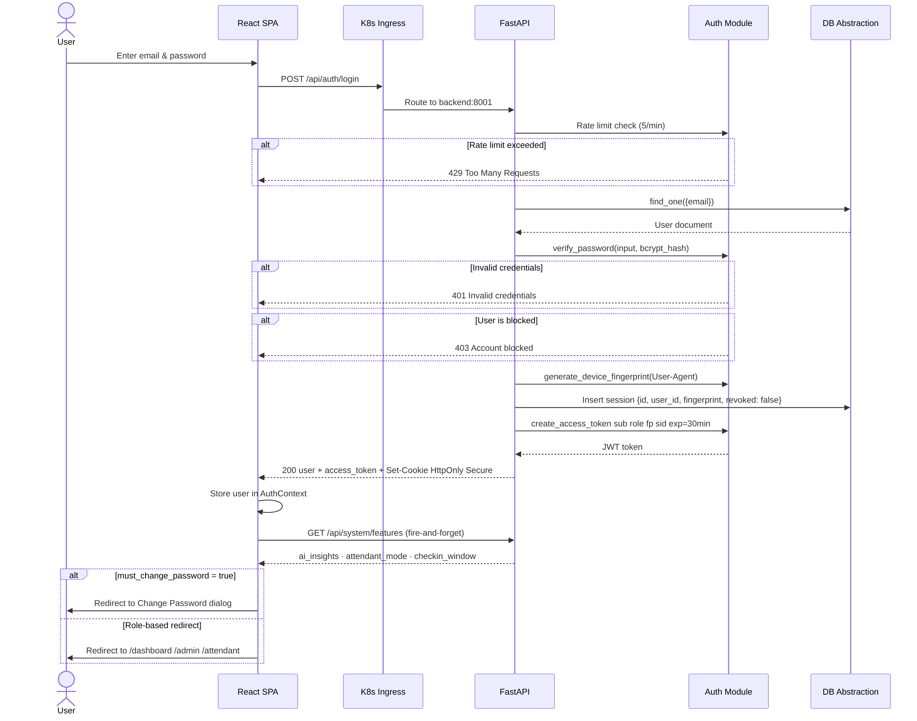
1. User Login Sequence
━━━━━━━━━━━━━━━━━━━━━━━━━━━━━━━━━━━━━━━━━━━━━━━━━━

2. Parking Reservation Booking Sequence
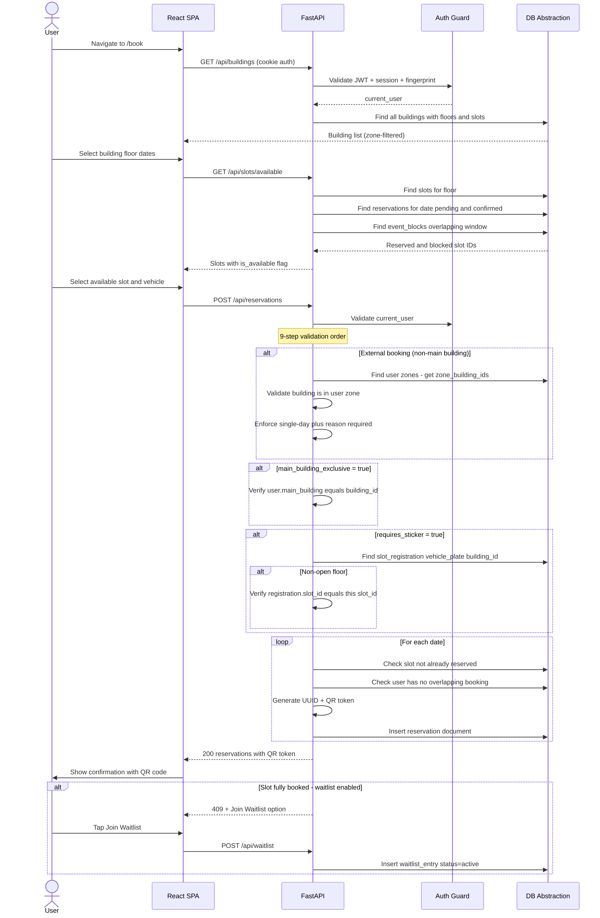
2. Parking Reservation Booking Sequence
━━━━━━━━━━━━━━━━━━━━━━━━━━━━━━━━━━━━━━━━━━━━━━━━━━

3. Attendant No-Show Reporting Sequence
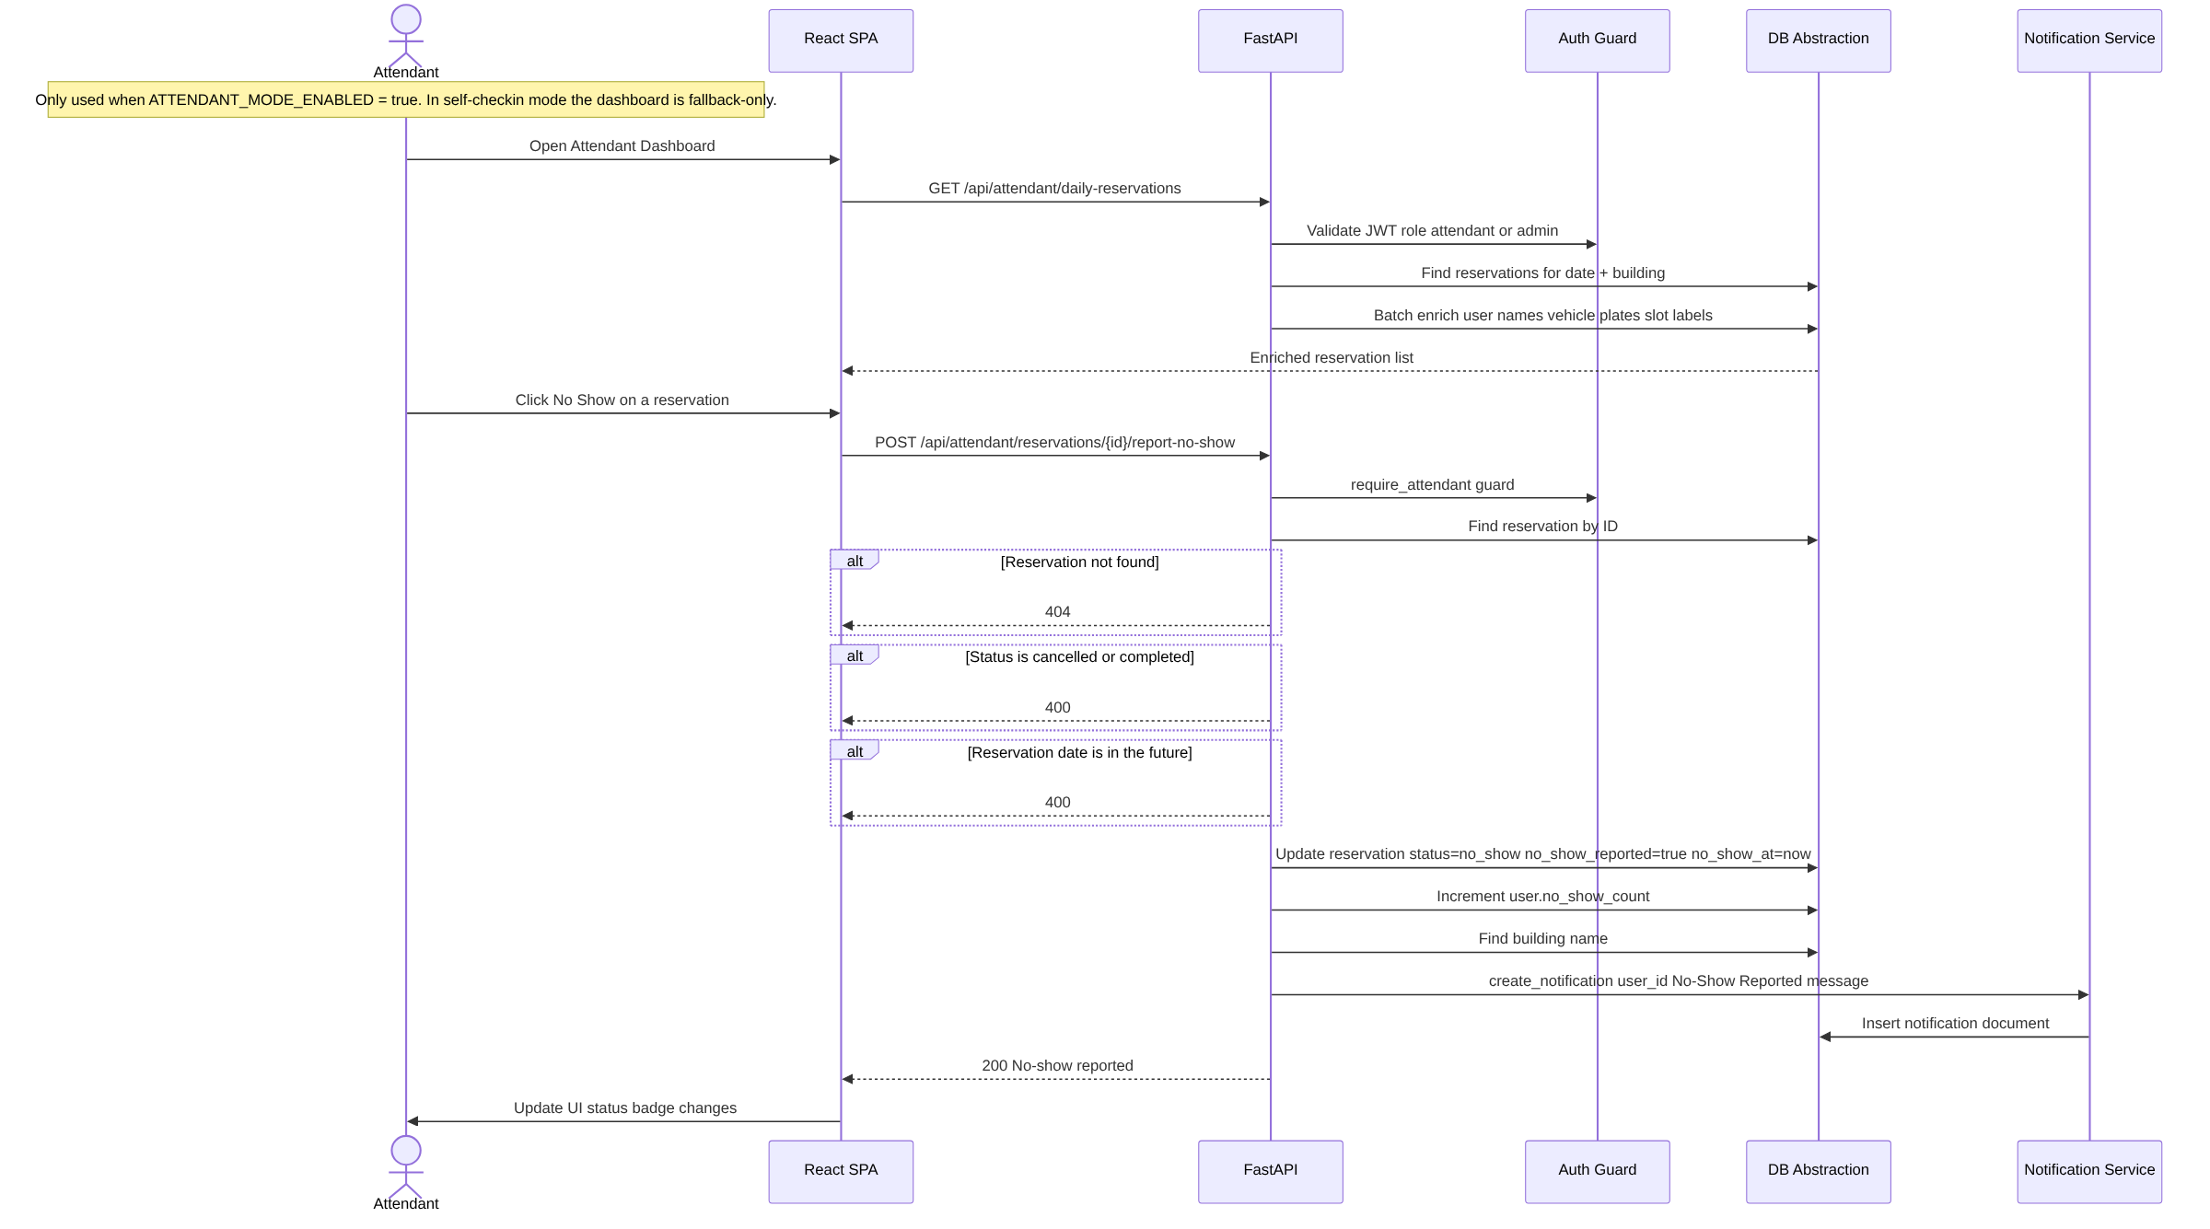
3. Attendant No-Show Reporting Sequence
━━━━━━━━━━━━━━━━━━━━━━━━━━━━━━━━━━━━━━━━━━━━━━━━━━

4. Admin Bulk User Upload Sequence
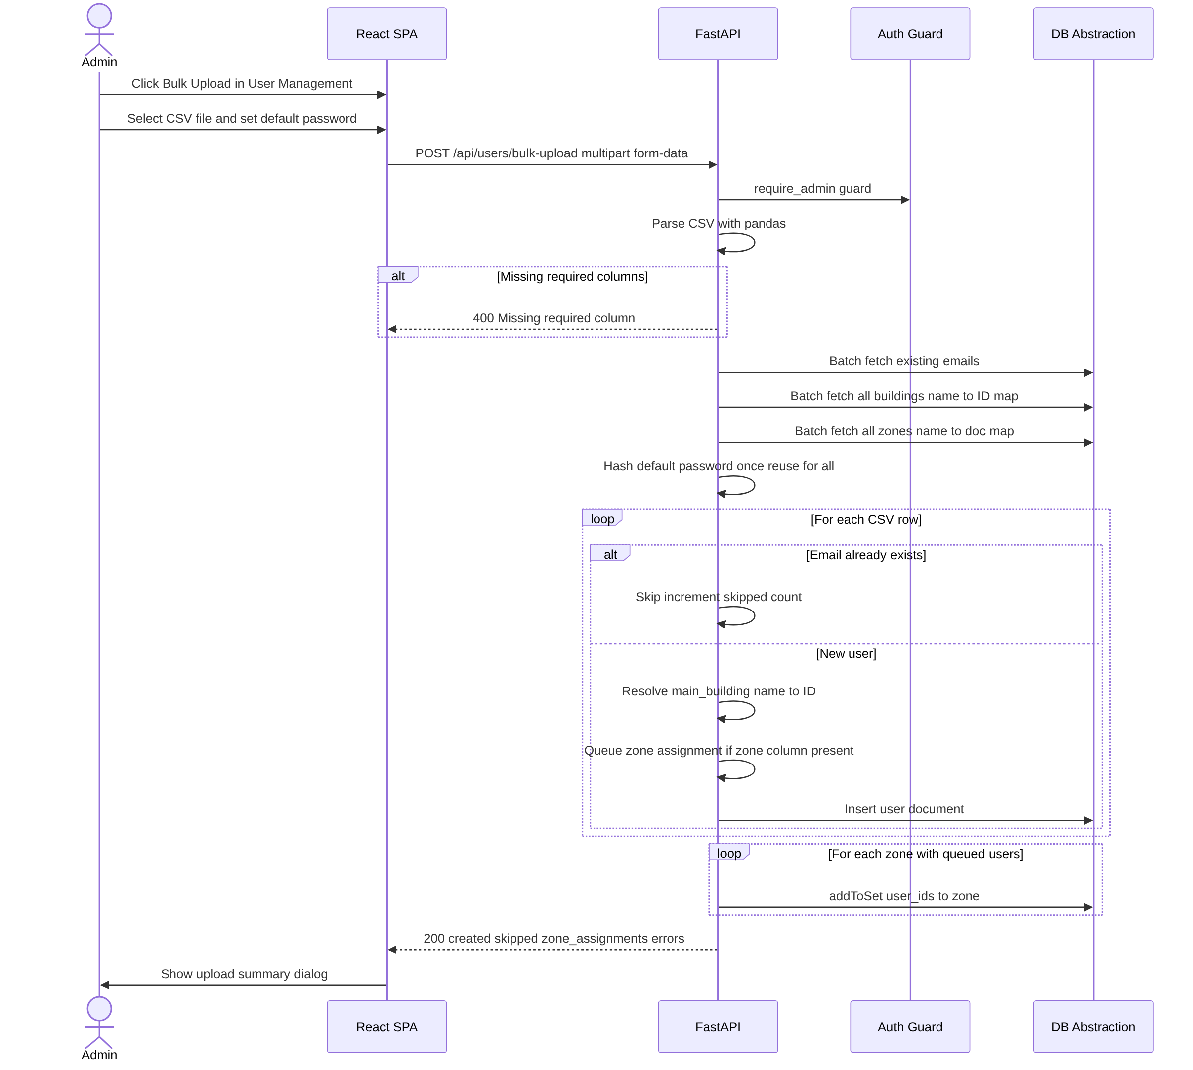
4. Admin Bulk User Upload Sequence
━━━━━━━━━━━━━━━━━━━━━━━━━━━━━━━━━━━━━━━━━━━━━━━━━━

5. QR Code Scan Verification Sequence
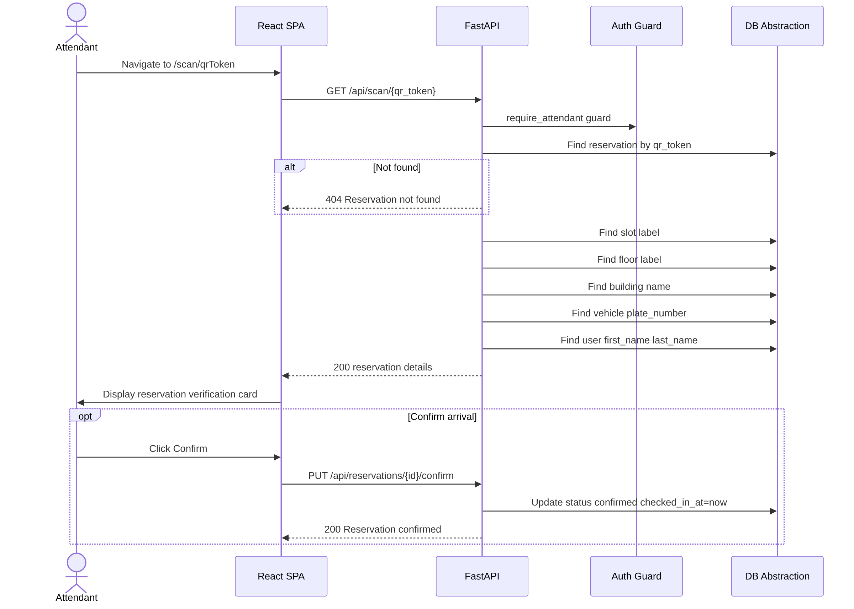
5. QR Code Scan Verification Sequence
━━━━━━━━━━━━━━━━━━━━━━━━━━━━━━━━━━━━━━━━━━━━━━━━━━

6. Self Check-In Sequence (Attendant Mode OFF)
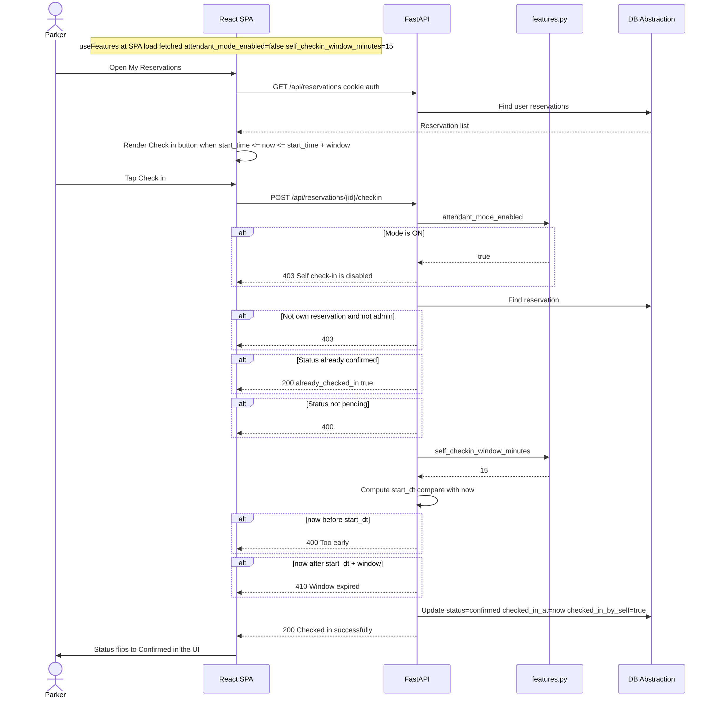
6. Self Check-In Sequence (Attendant Mode OFF)
━━━━━━━━━━━━━━━━━━━━━━━━━━━━━━━━━━━━━━━━━━━━━━━━━━

7. Background No-Show + Waitlist Notification Sequence
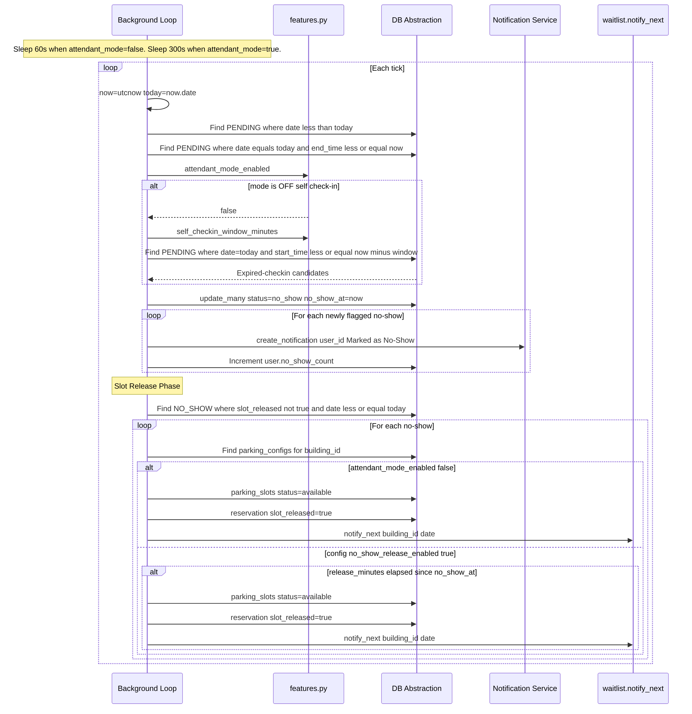
7. Background No-Show + Waitlist Notification Sequence
━━━━━━━━━━━━━━━━━━━━━━━━━━━━━━━━━━━━━━━━━━━━━━━━━━

8. Waitlist Notification & Claim Sequence
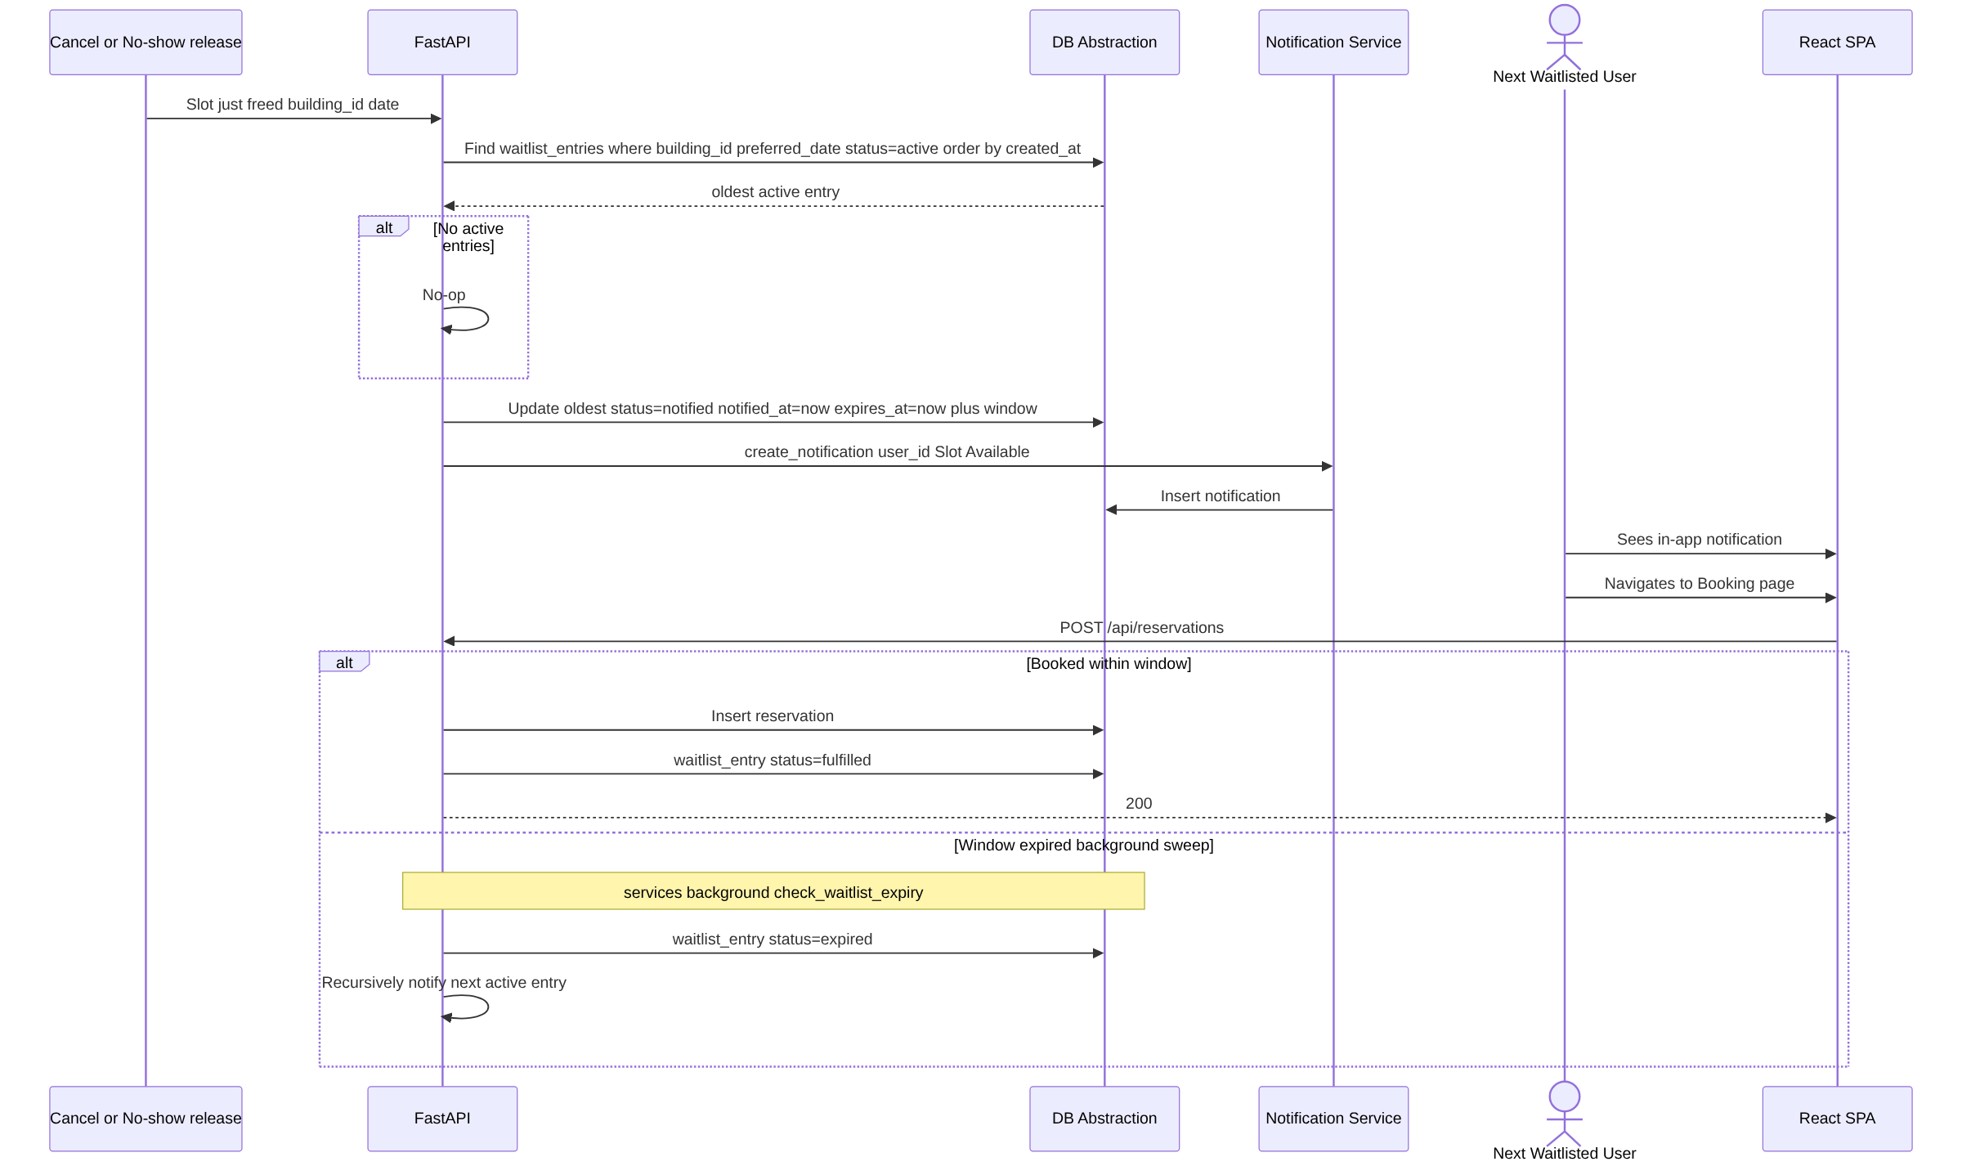
8. Waitlist Notification & Claim Sequence
━━━━━━━━━━━━━━━━━━━━━━━━━━━━━━━━━━━━━━━━━━━━━━━━━━

9. Session Validation Sequence (Every Authenticated Request)
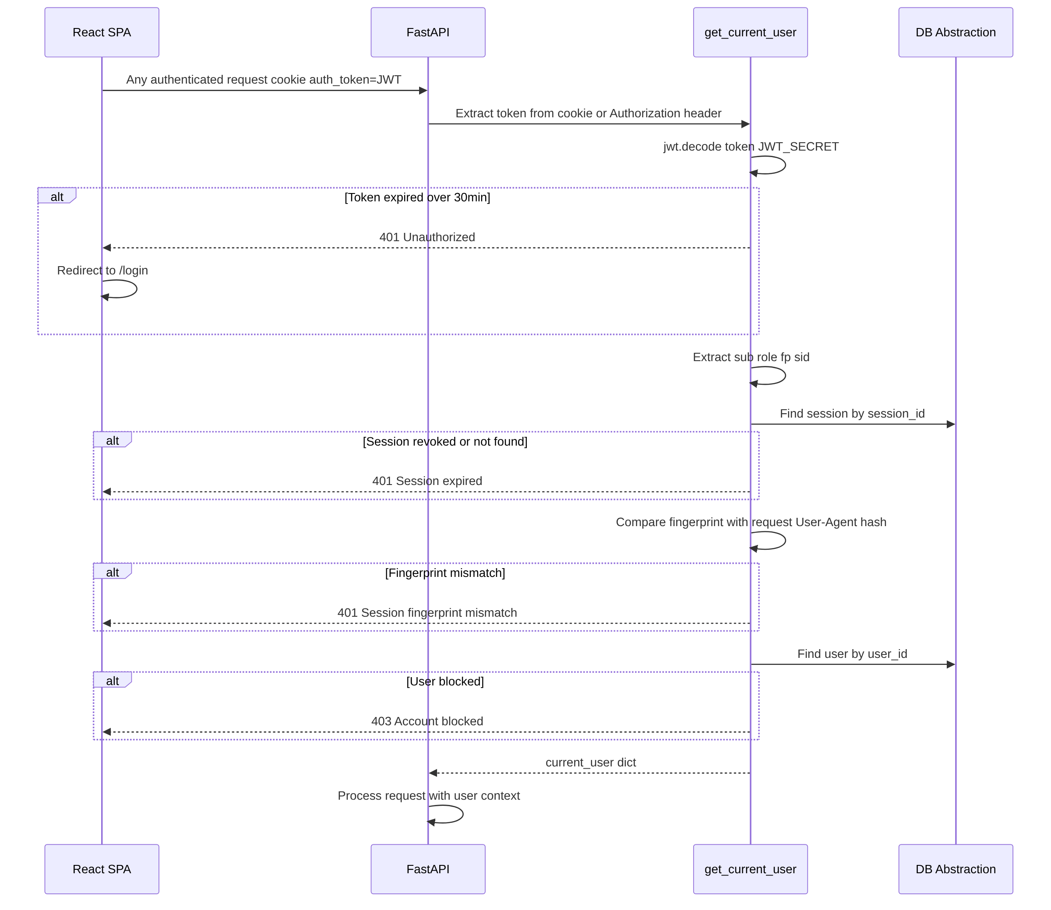
9. Session Validation Sequence (Every Authenticated Request)
━━━━━━━━━━━━━━━━━━━━━━━━━━━━━━━━━━━━━━━━━━━━━━━━━━

