Software Requirements Specification
FX Trading Tracker Platform | Version 2.0
Generated: 2026-08-24 08:11 UTC
Classification: CONFIDENTIAL

1. Introduction
This SRS defines the technical requirements for the FX Trading Tracker, a web-based platform for FX deal ticket management with multi-role workflow, settlement proofs, reports, and audit logging.

2. System Architecture
Three-tier architecture: React SPA frontend, FastAPI REST backend, switchable MongoDB/Couchbase database with Emergent/S3 storage.
Component | Technology | Responsibility
Frontend SPA | React 19, TailwindCSS, Shadcn/UI | User interface, API calls
API Server | FastAPI, Uvicorn | REST endpoints, JWT auth, business logic
Database | MongoDB (Motor) / Couchbase (SDK 4.6) | Switchable document storage
Storage | Emergent / S3 (boto3) | Settlement proof file storage
Reports | ReportLab, CSV | PDF/CSV export with branded templates

3. Technology Stack

3.1 Backend
Package | Version | Purpose
FastAPI | 0.110.1 | REST API
Pydantic | 2.12.5 | Validation
Motor | 3.7.1 | MongoDB async
Couchbase | 4.6.0 | Enterprise DB
boto3 | 1.42.58 | S3 storage
ReportLab | 4.4.10 | PDF gen
python-jose | 3.4.0 | JWT
bcrypt | 4.3.0 | Password hashing

3.2 Frontend
Package | Version | Purpose
React | 19.0.0 | UI framework
React Router | 7.5.1 | Routing
TailwindCSS | 3.4.17 | CSS
Shadcn/UI | latest | Components
Axios | 1.8.4 | HTTP
Recharts | 2.15.3 | Charts

4. Functional Requirements

FR-001: Authentication
- JWT auth with 24h expiry
- RBAC (Trader/Treasury/Admin/Sysadmin)
- bcrypt password hashing

FR-002: Deal Management
- Create deals with Buy/Sell, 6 transfer types
- Auto reference FX-YYYYMMDD-NNNN
- Crypto network selection (SOLANA/ETHEREUM/TRON)
- FX-Intercompany dual Ours

FR-003: Treasury
- Pending queue with customizable columns
- Confirm/Return with mandatory remarks
- Proof requirement enforcement

FR-004: Reference Data
- Admin CRUD for all reference entities
- Bank account searchable autocomplete
- CSV/Excel import with fld_* format support

FR-005: Reports
- 8 report types with server-side pagination
- CSV and branded PDF export
- Admin-configurable permissions

5. API Specification
Method | Endpoint | Description
POST | /api/auth/login | Authenticate, returns JWT
POST | /api/deals | Create deal ticket
GET | /api/deals | List deals
GET | /api/deals/treasury | Treasury queue
POST | /api/deals/{id}/confirm | Confirm deal
POST | /api/deals/{id}/return | Return deal
POST | /api/deals/{id}/proof | Upload proof
GET | /api/reports/{type} | Report data (json/csv/pdf)
POST | /api/reference/bank-accounts/import | Global bank account import
POST | /api/reference/companies/import | FX Client import

6. Data Models

6.1 Deal Document
Field | Type | Description
reference_number | String | FX-YYYYMMDD-NNNN
client_name | String | Client name
transaction_type | String | Buy/Sell
transfer_type | String | FX type
currency_amount | Float | Principal
rate | Float | FX rate
amount | Float | Converted
from_network | String | Crypto network (if applicable)
status | String | pending/confirmed/returned/cancelled

7. Security Requirements
ID | Requirement
SEC-01 | JWT auth on all endpoints except login
SEC-02 | bcrypt password hashing
SEC-03 | Role-based access enforcement
SEC-04 | File upload validation (10MB)
SEC-05 | CORS configured
SEC-06 | All actions audit-logged

8. User Interface Specifications
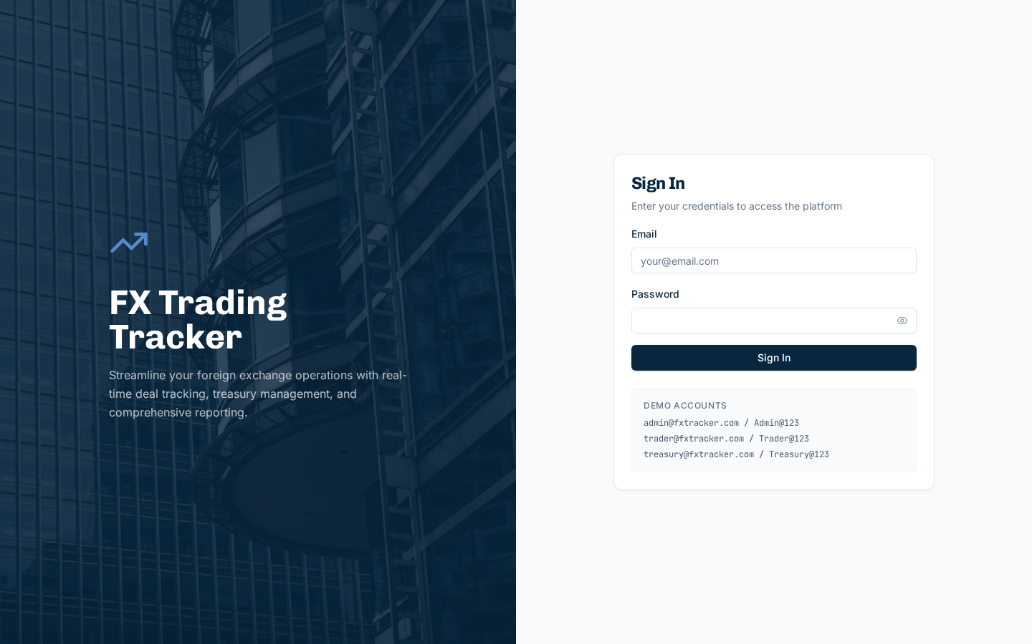
Figure 8.1 - Login Page
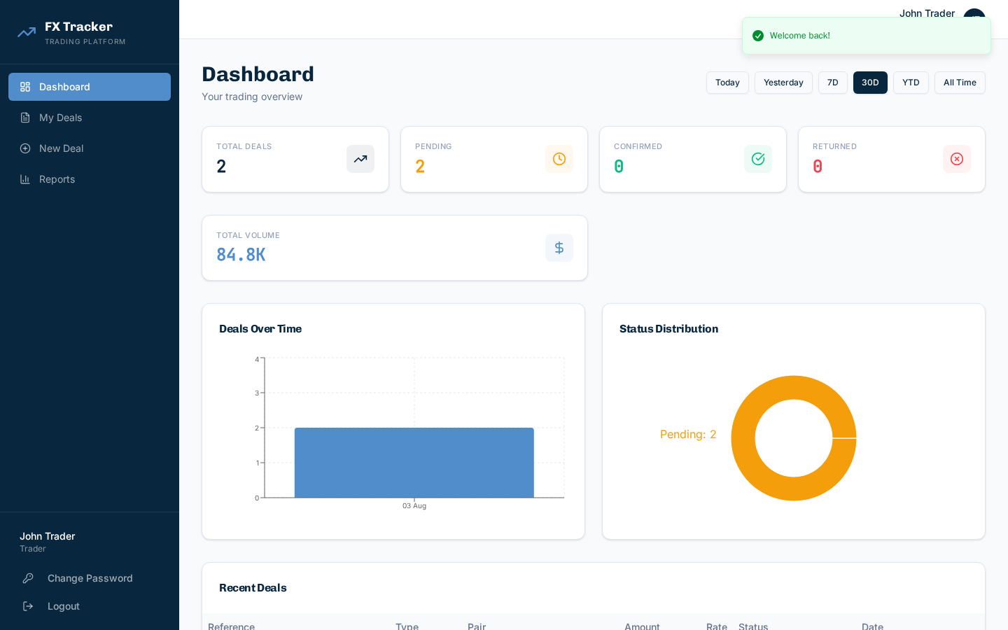
Figure 8.2 - Dashboard
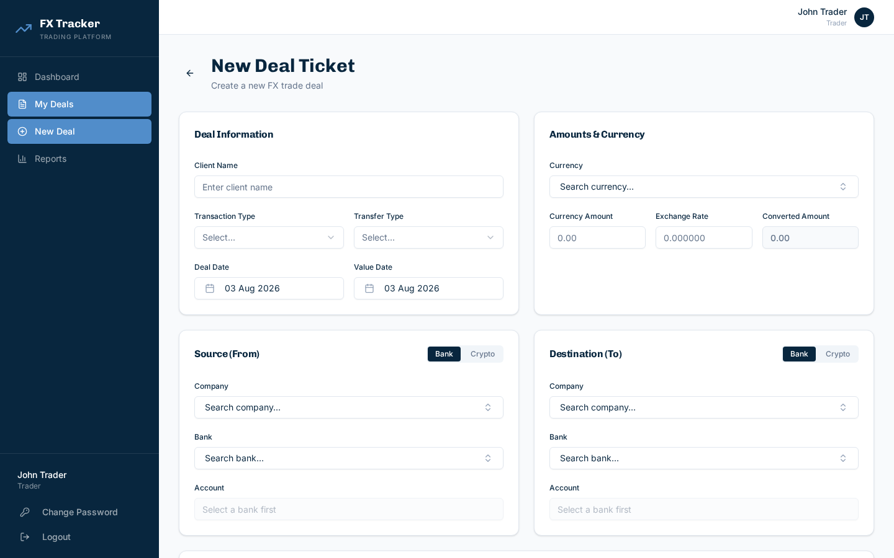
Figure 8.3 - New Deal Form
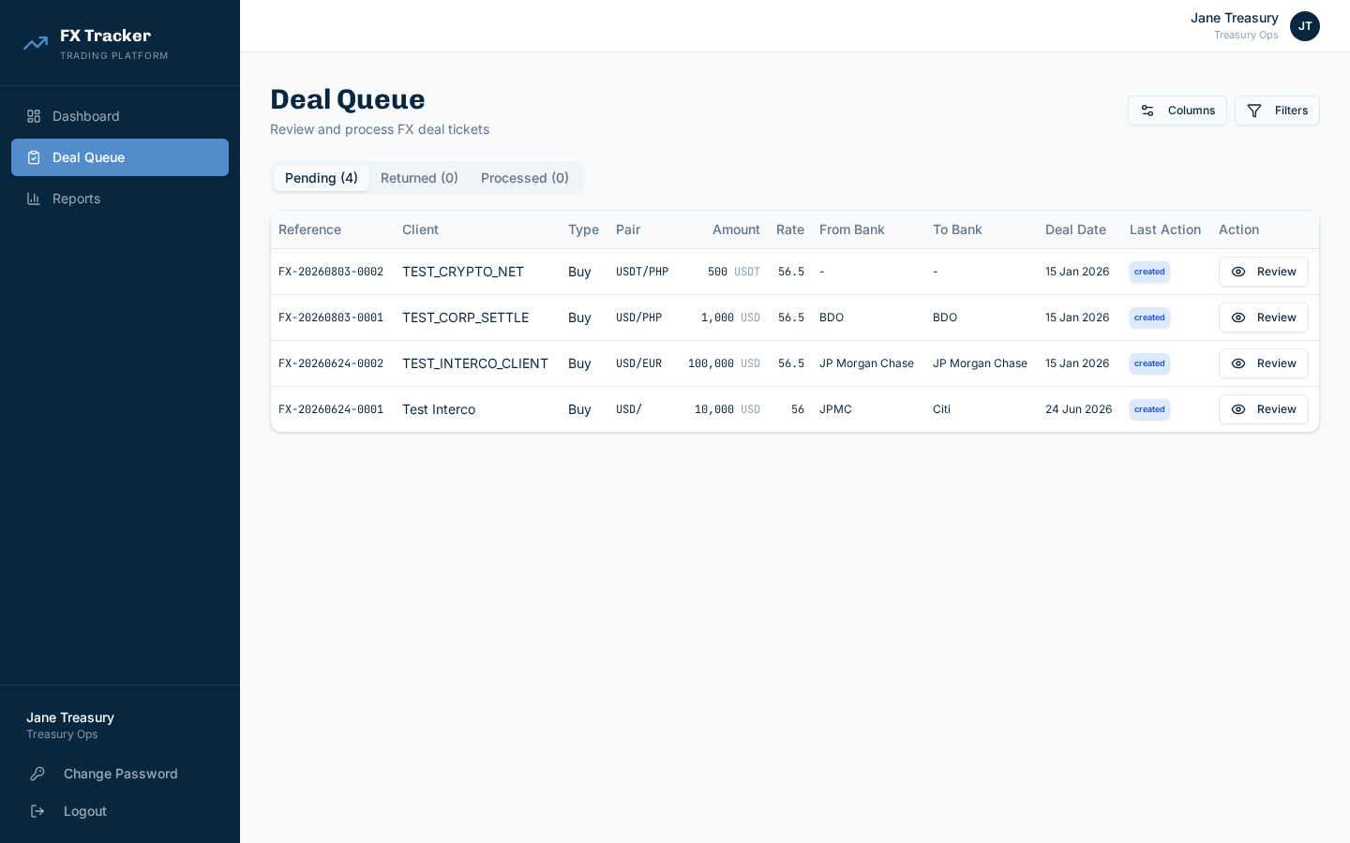
Figure 8.4 - Treasury Queue
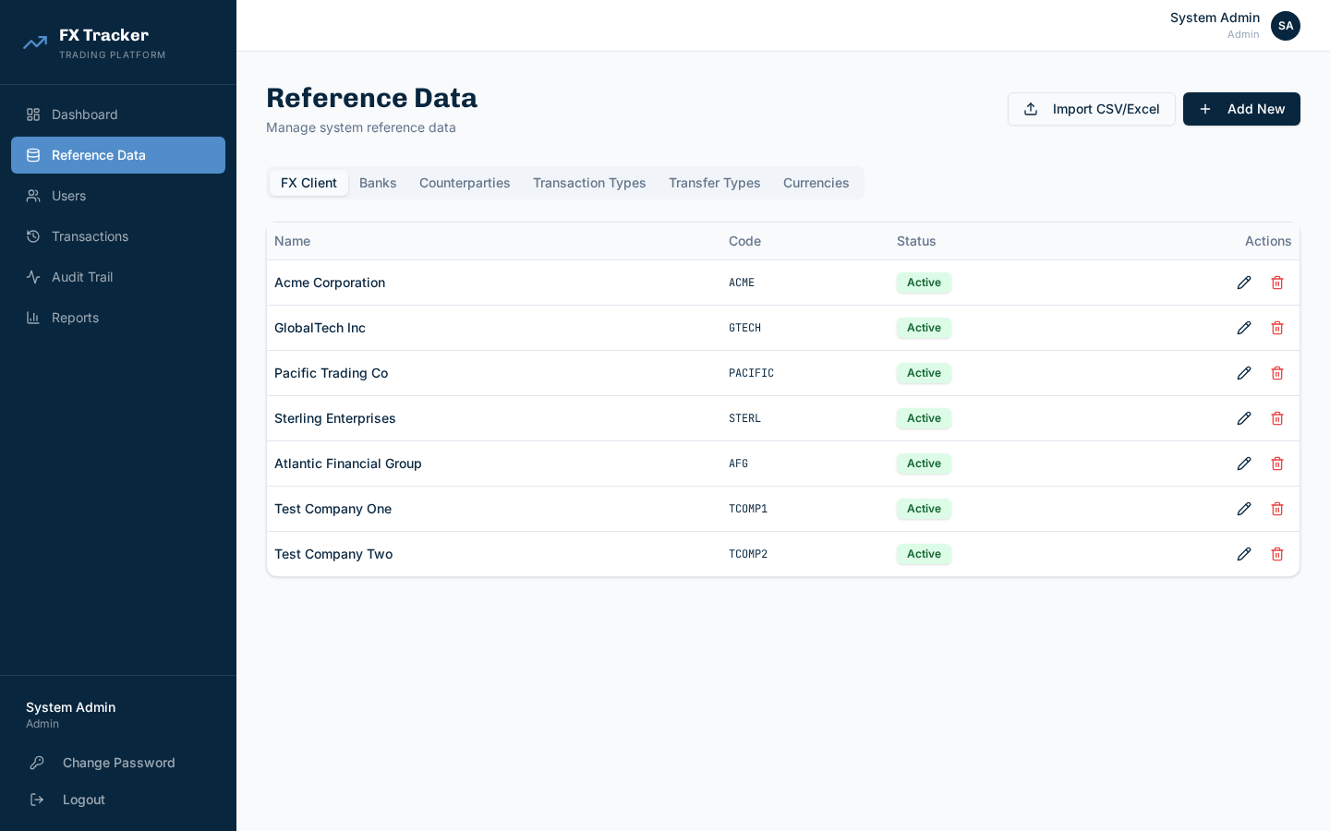
Figure 8.5 - Reference Data
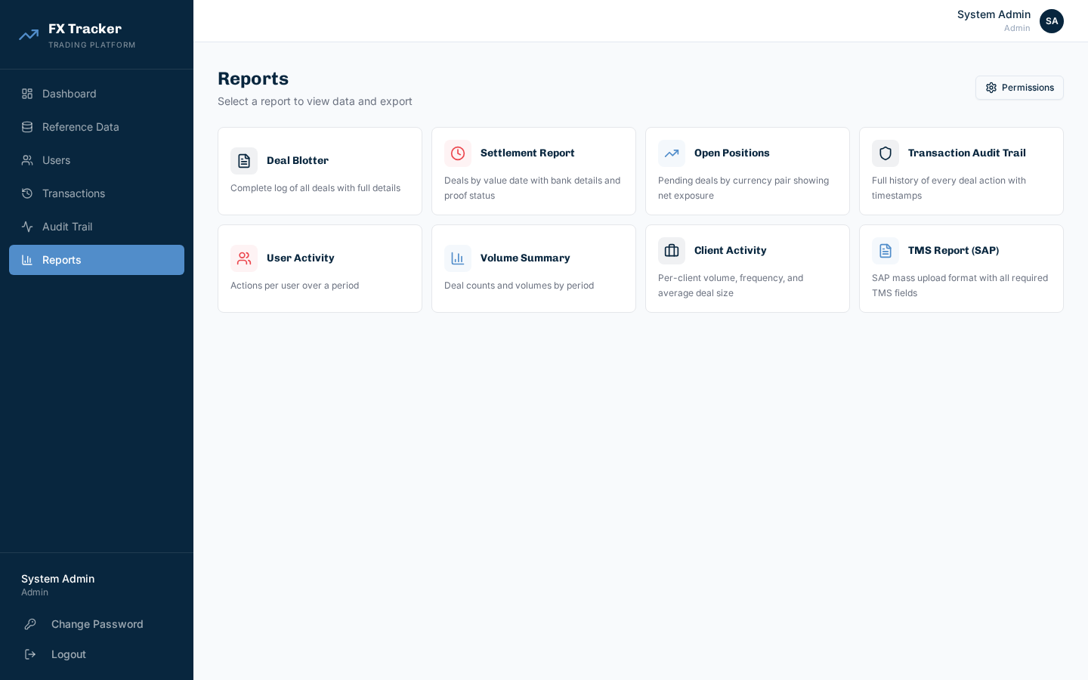
Figure 8.6 - Reports
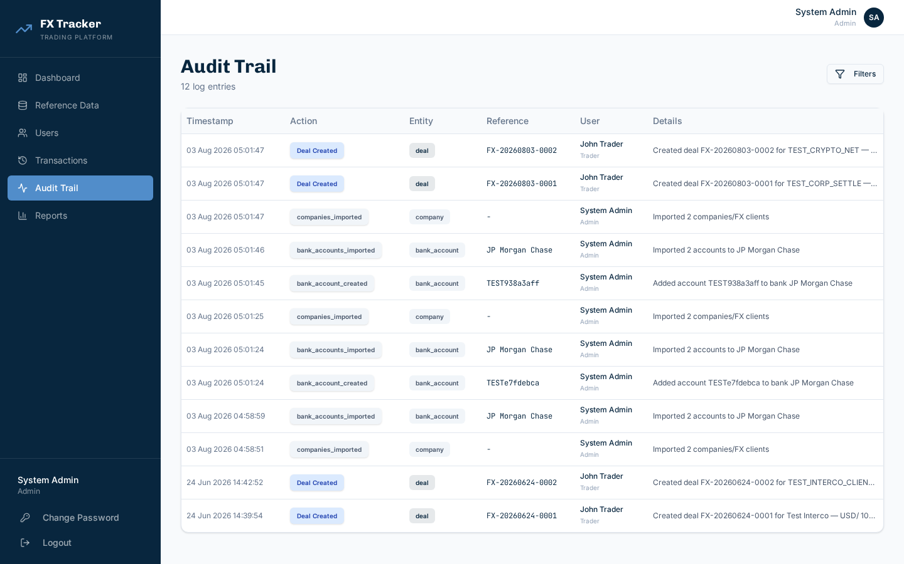
Figure 8.7 - Audit Trail
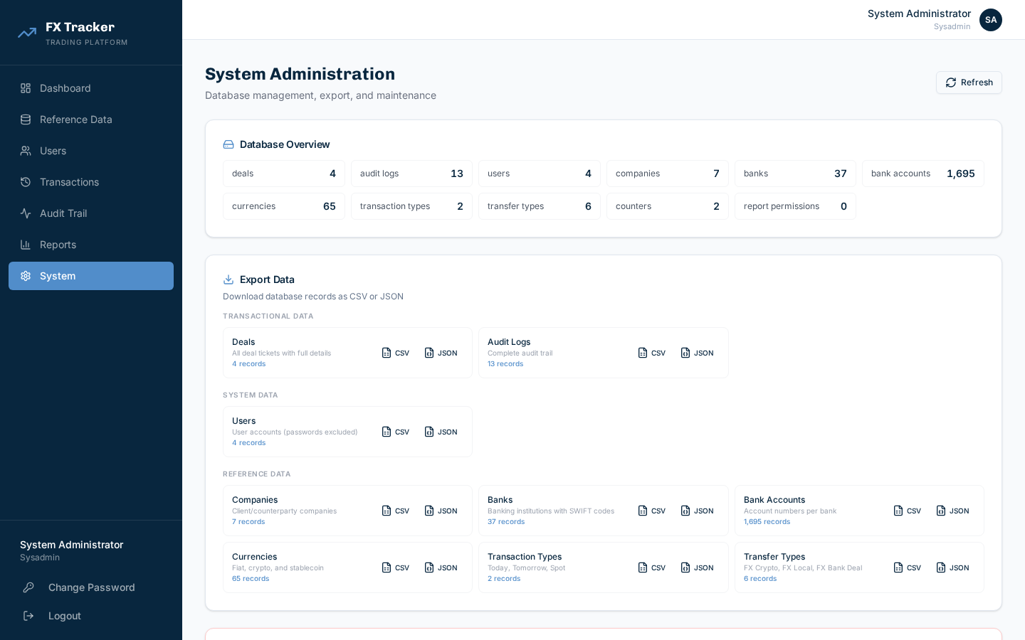
Figure 8.8 - System Admin

9. Deployment Architecture
Variable | Purpose
DB_TYPE | mongodb or couchbase
STORAGE_TYPE | emergent or s3
MONGO_URL | MongoDB connection
REACT_APP_BACKEND_URL | Frontend API URL

10. Integration Points
Integration | Protocol | Status
MongoDB | Motor async | Active
Couchbase | SDK 4.6 | Validated
Emergent Storage | HTTP | Active
S3/Huawei OBS | boto3 | Validated
ReportLab | Python | Active

