Business Requirements Document
FX Trading Tracker Platform | Version 2.0
Generated: 2026-09-11 14:52 UTC
Classification: CONFIDENTIAL

1. Executive Summary
The FX Trading Tracker is a web-based platform designed to streamline the management of foreign exchange deal tickets within a multi-role operational environment. The system replaces manual spreadsheet-based tracking with a structured, auditable workflow that connects traders, treasury processors, and administrators.
The platform supports the complete deal lifecycle from ticket creation through treasury confirmation, with built-in settlement proof management, comprehensive reporting, and full audit trail capabilities. It is designed for on-premise deployment with switchable database (MongoDB/Couchbase Enterprise) and storage (Emergent/S3-compatible/Huawei OBS) backends.
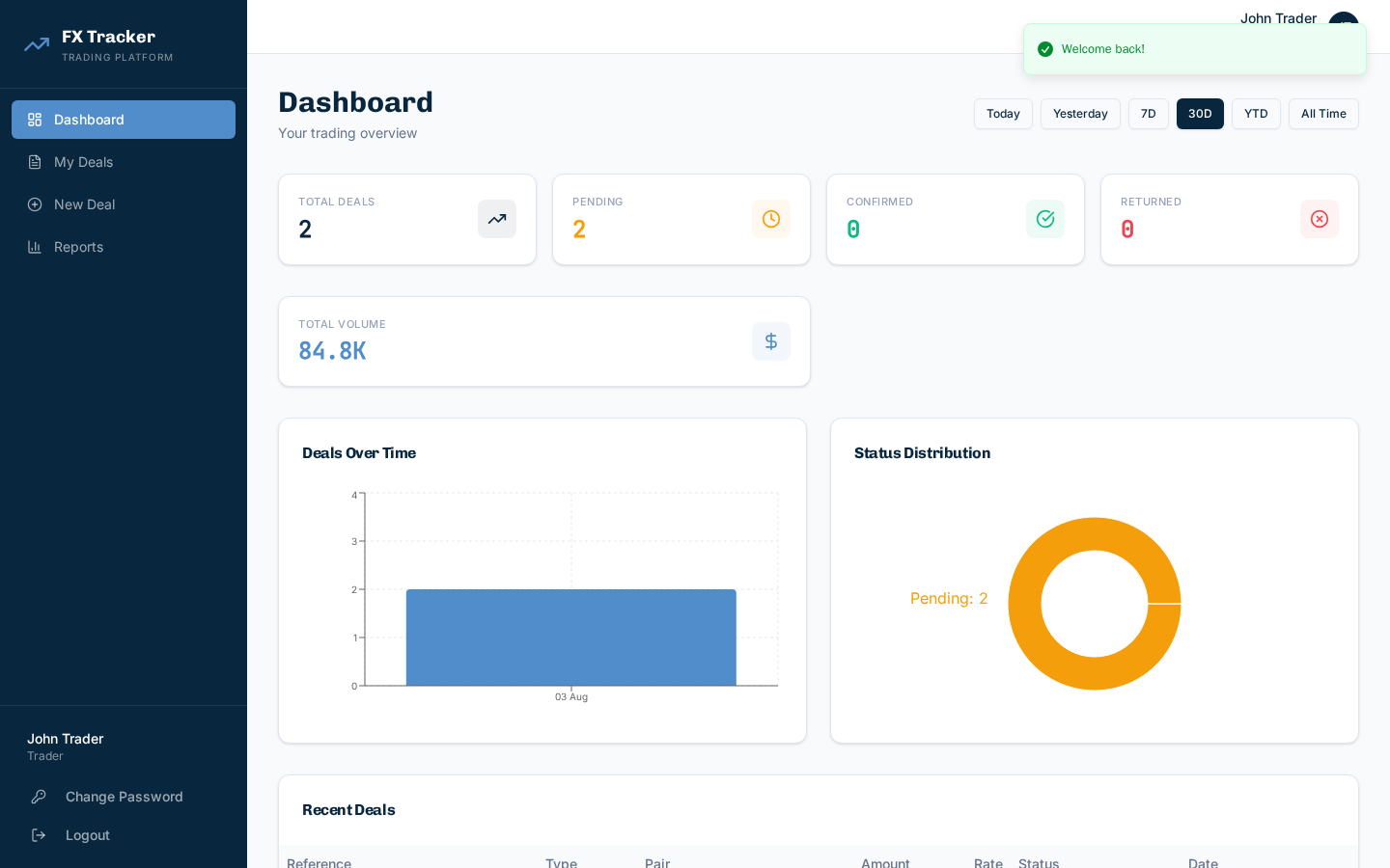
Figure 1.1 - FX Trading Tracker Dashboard

2. Business Objectives
- Operational Efficiency - Replace manual spreadsheet tracking with structured deal ticket workflow.
- Compliance & Auditability - Full audit trail, settlement proof management, role-based access.
- Accuracy - Structured forms, validation, automated calculations.
- Visibility - Dashboards, 8 report types, CSV/PDF exports.
- Scalability - Switchable database (MongoDB/Couchbase) and storage (Emergent/S3) backends.
- Crypto Support - Native crypto wallet with blockchain network selection (SOLANA/ETHEREUM/TRON).

3. Stakeholders
Stakeholder | Role | Interest
FX Traders | Primary user | Create deal tickets, manage client proofs, track deal status
Treasury Team | Processor | Review, confirm/return deals, upload processor proofs
Operations Admin | Administrator | Manage users, reference data, reports, audit trail
System Admin | IT/DevOps | Database management, system exports, controlled reset
Management | Consumer | Reports, dashboards, volume analysis
Compliance/Audit | Auditor | Audit trail, transaction history, settlement proof review

4. Scope

4.1 In-Scope
- Multi-role authentication (Trader, Treasury, Admin, System Admin)
- Deal ticket CRUD with Buy/Sell types and 6 transfer types
- Counterparty management, bank/crypto account management with CSV/Excel bulk import
- Settlement proof upload/management, treasury confirmation workflow
- 8 report types with CSV/PDF export, admin-configurable permissions
- Full audit trail, system administration (DB stats/exports/reset)
- On-premise deployment readiness (switchable MongoDB/Couchbase, Emergent/S3)

4.2 Out-of-Scope (Future)
- Email/SMS notifications
- Scheduled reports
- Approval workflow
- Real-time price feeds
- Mobile native app

5. Business Requirements

BR-001: Deal Ticket Management
The system shall enable authorized traders to create, view, and manage FX deal tickets with structured fields.
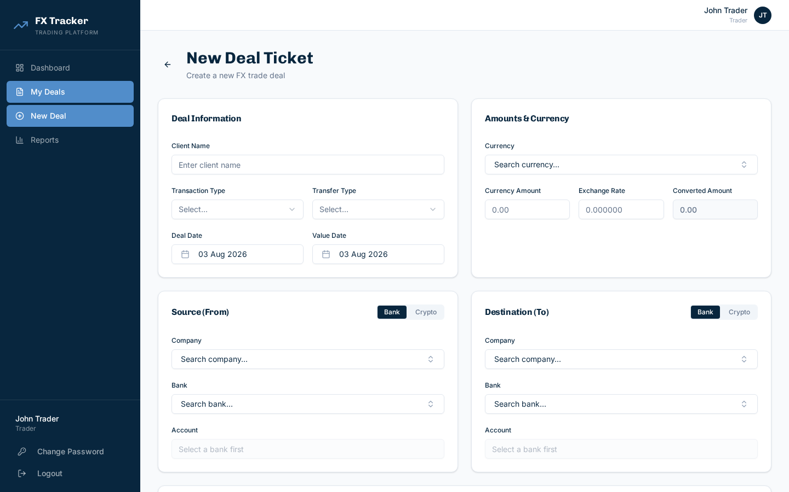
Figure 5.1 - New Deal Ticket Form

BR-002: Treasury Processing Workflow
Treasury processors shall review pending deals, upload proofs, and confirm or return deals with mandatory remarks.
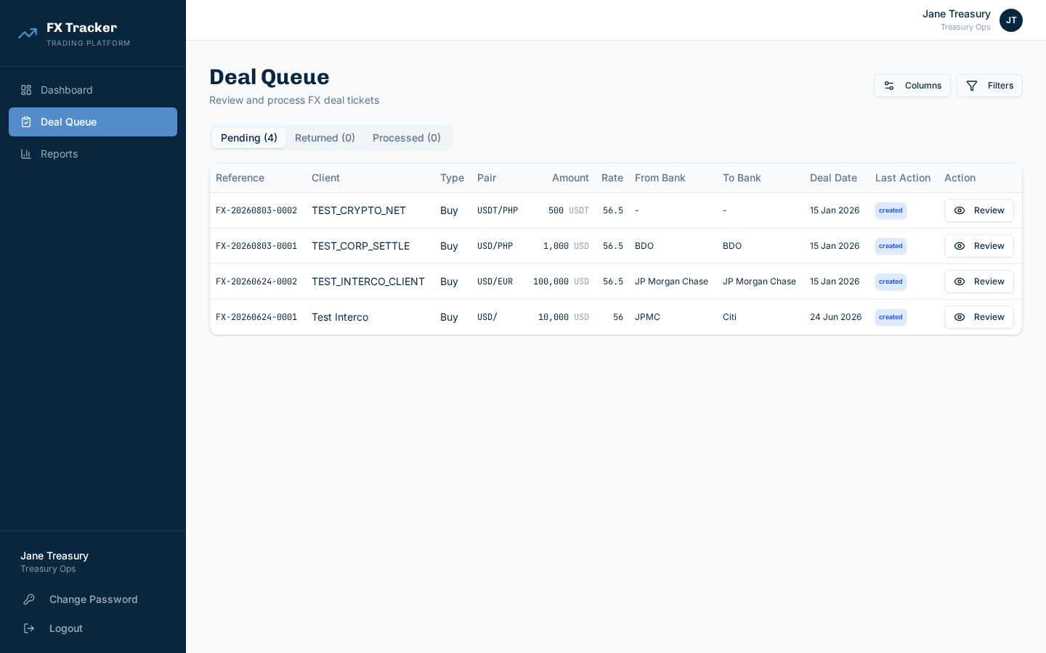
Figure 5.2 - Treasury Deal Queue

BR-003: Reference Data Management
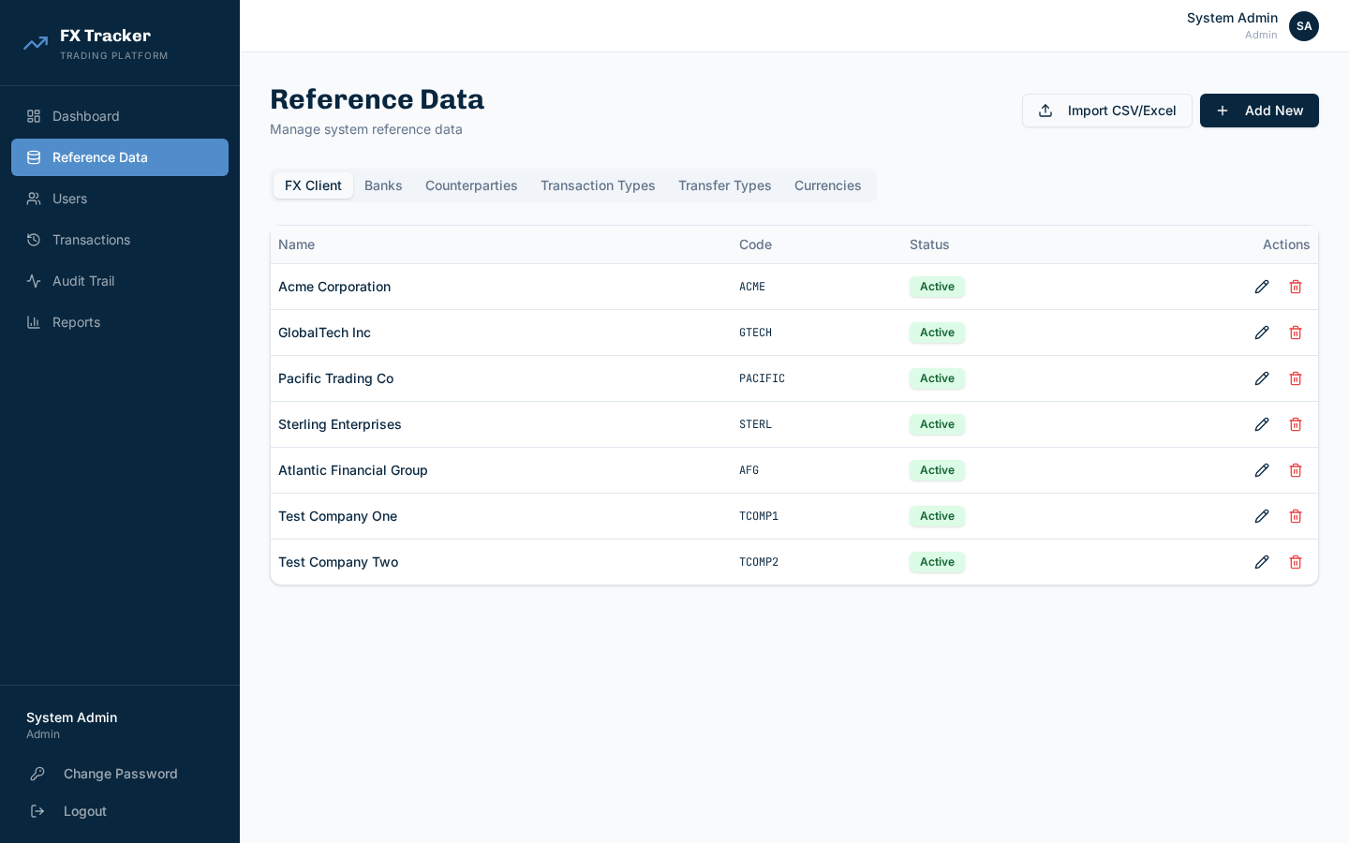
Figure 5.3 - Reference Data Management

BR-004: Reporting & Analytics
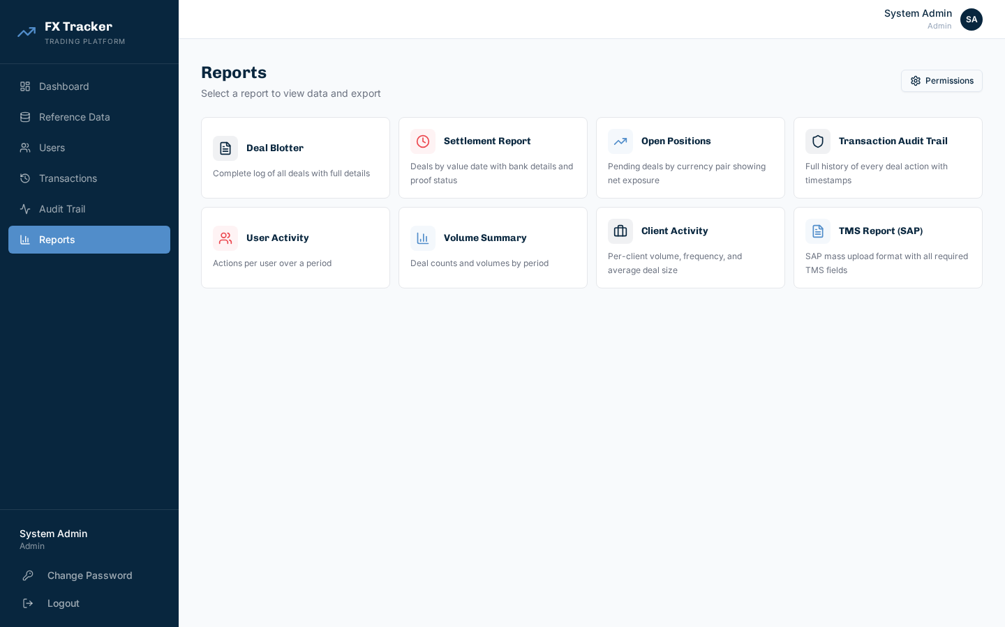
Figure 5.4 - Reports Page

BR-005: Multi-Bank Account Import
Support CSV/Excel import in both simple and legacy fld_* formats with auto bank matching/creation.

6. Workflow & Process Flows

6.1 Deal Lifecycle
State | Triggered By | Next States | Actions
Pending | Trader creates deal | Confirmed, Returned, Cancelled | Treasury: Review/Confirm/Return; Trader: Cancel
Confirmed | Treasury confirms | Terminal | View only
Returned | Treasury returns | Pending (resubmit) | Trader: Edit, Resubmit
Cancelled | Trader cancels | Terminal | View only

7. Data Requirements
Entity | Key Fields | Source
Deal Ticket | Reference, Client, Type, Pair, Amount, Rate, Accounts, Network | Trader
FX Client | Name, Code, Type | Admin/CSV
Bank Account | Number, Name, Currency, Type, Address | Admin/CSV
Counterparty | Name, Code | Admin
Settlement Proof | File URL, Type, Timestamp | Upload
Audit Log | Action, Entity, User, Timestamp, Details | System

8. Non-Functional Requirements
Category | Requirement
Performance | Dashboard < 2s. Pagination supports 10,000+ records.
Security | RBAC, JWT, bcrypt, audit logging.
Scalability | Switchable MongoDB/Couchbase and Emergent/S3.
Browser Support | Chrome, Firefox, Safari, Edge. Responsive.

9. Assumptions & Constraints
- Users have modern browsers with JS enabled.
- On-premise infra provided.
- Legacy CSV uses fld_* columns.

Constraints
- No real-time FX rate feeds.
- Proofs limited to images/PDF, 10MB max.
- No approval workflow yet.

10. Acceptance Criteria
ID | Criteria | Validation
AC-01 | Trader creates deal with all required fields | Deal in pending queue
AC-02 | Treasury confirms/returns with remarks | Status changes, audit logged
AC-03 | Admin imports 1000+ bank accounts via CSV | Created, duplicates skipped
AC-04 | Reports generate correctly with CSV/PDF export | Data matches, files download
AC-05 | Audit trail captures all actions | Correct metadata logged

11. Glossary
Term | Definition
Deal Ticket | FX trade record with client, currency, amount, rate, accounts
Settlement Proof | Documentary evidence of fund transfer
Counterparty | PJL Group entity for FX Local/Intercompany deals
TMS | Treasury Management System (SAP-compatible export)
Crypto Network | Blockchain (SOLANA/ETHEREUM/TRON) for crypto transactions

