User Manual
FX Trading Tracker Platform | Version 2.0
Generated: 2026-09-11 14:52 UTC
Classification: CONFIDENTIAL

1. Introduction & Roles
The FX Trading Tracker manages FX deal tickets with multi-role workflow, settlement proofs, reports, and audit logging.
Role | Access
Trader | Create deals, upload client proofs, reports
Treasury | Review/process deals, processor proofs, reports
Admin | Users, reference data, audit trail, imports, reports
System Admin | Full admin + DB reset/exports/stats

2. Getting Started
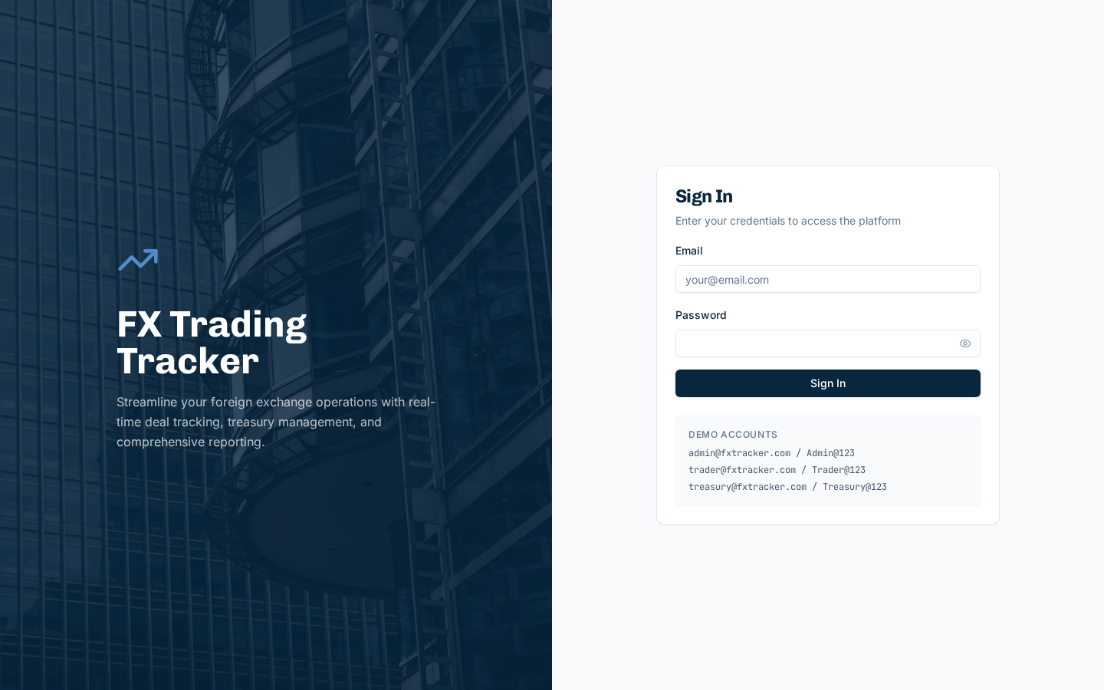
Figure 2.1 - Login Page
Enter Email and Password, click Sign In. Sidebar shows role-based navigation.

3. Dashboard
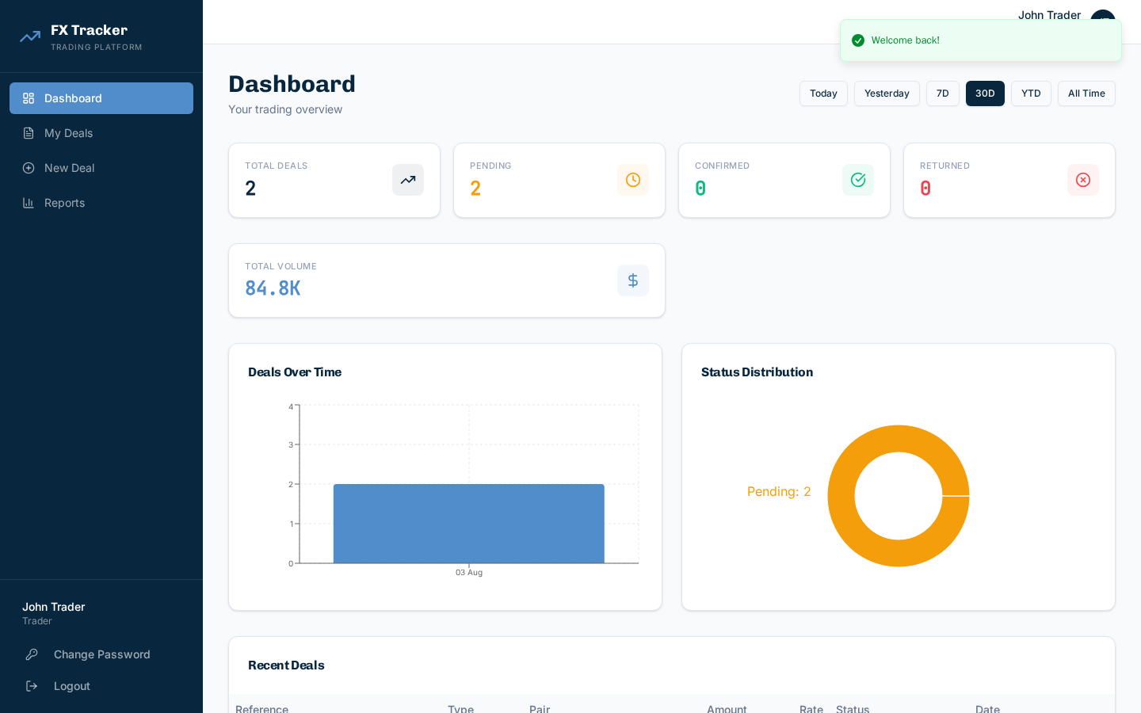
Figure 3.1 - Dashboard
Summary cards, date filters (Today/7D/30D/YTD/All), and charts (Deals Over Time, Status Distribution).

4. My Deals (Trader)
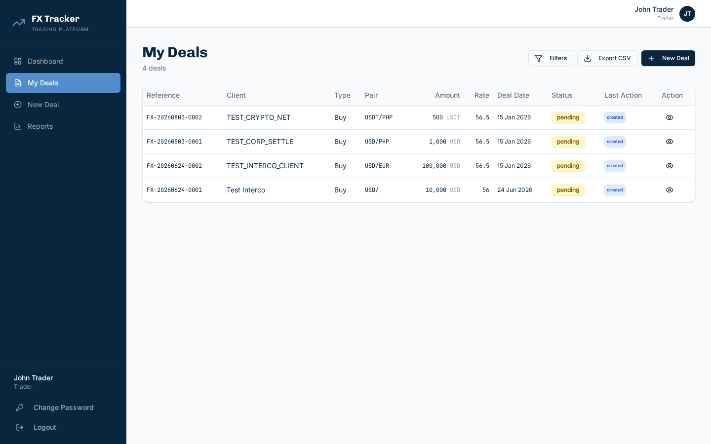
Figure 4.1 - My Deals
Amount shows original currency amount with label. Last Action shows most recent history badge. Click eye icon for full deal detail.
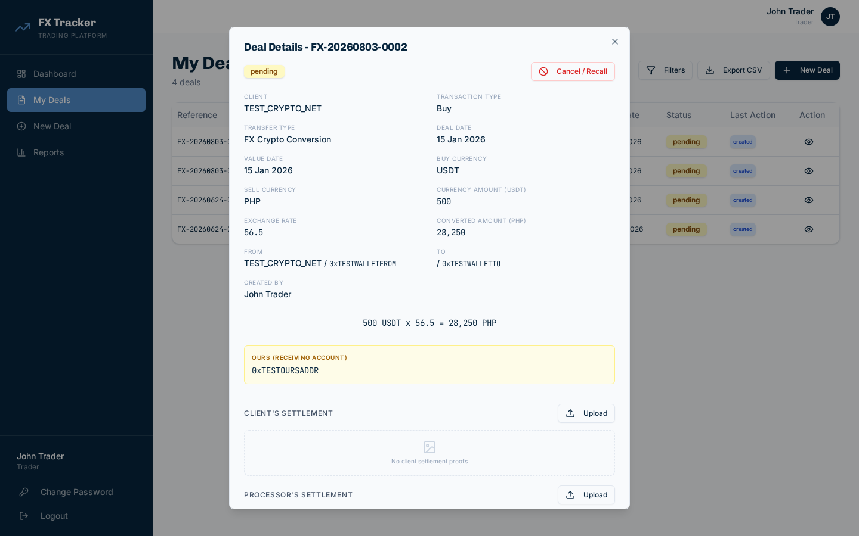
Figure 4.2 - Deal Detail

5. New Deal Ticket
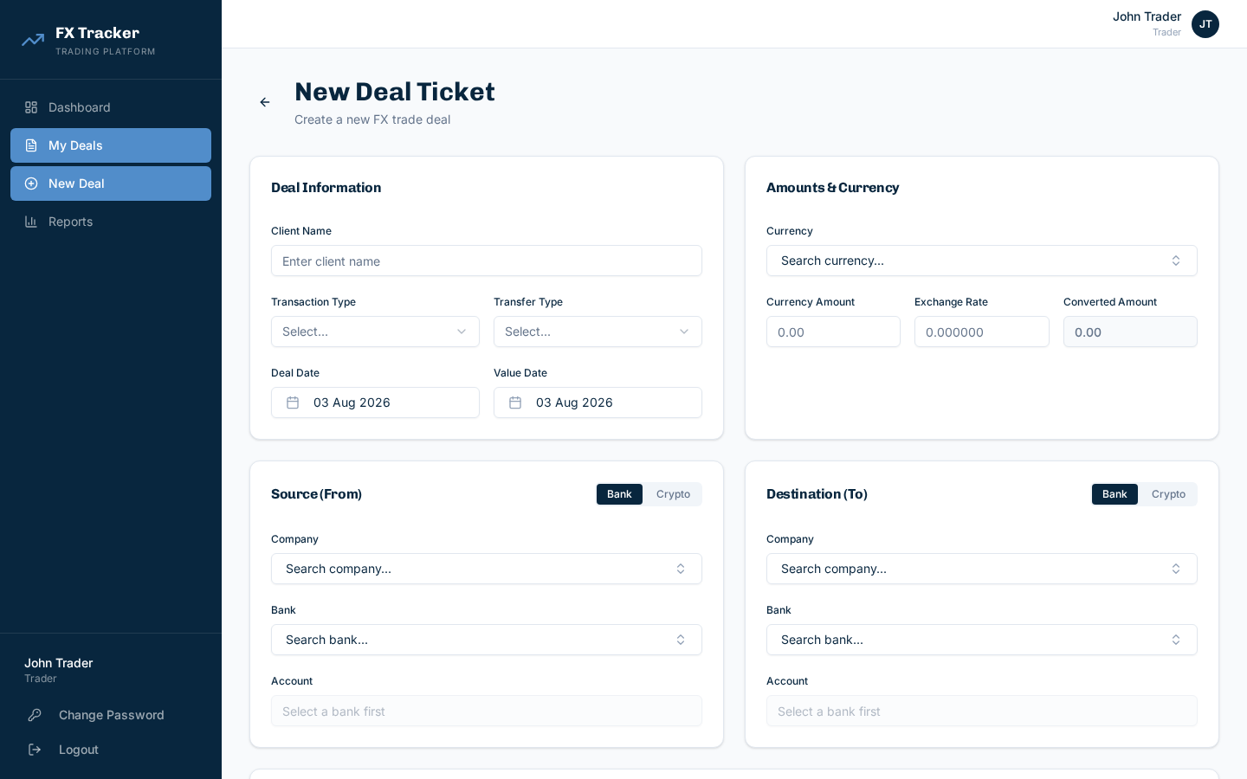
Figure 5.1 - New Deal Form
Field | Required | Notes
Client Name | Yes | Free text
Transaction Type | Yes | Buy/Sell
Transfer Type | Yes | See Appendix
Currency | Yes | Searchable
Amount | Yes | Principal
Rate | Yes | FX rate

5.1 Source/Destination/Ours
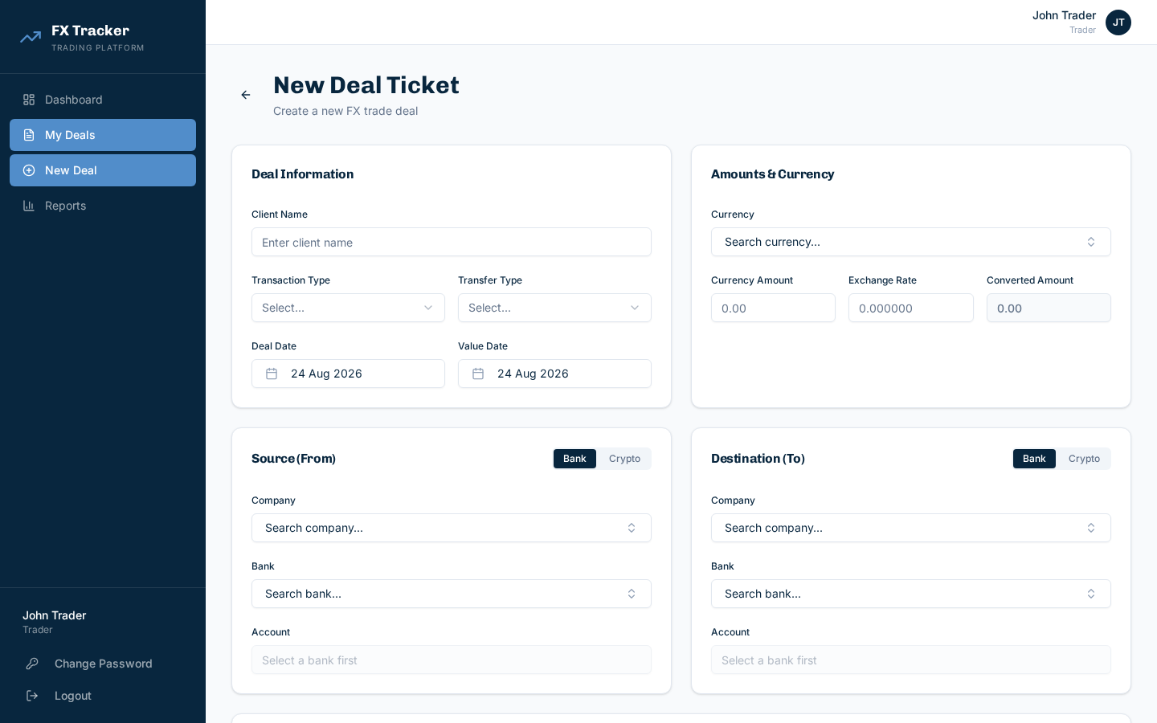
Figure 5.2 - Source/Destination sections
Bank mode: Company/Counterparty + Bank + Account (searchable). Crypto mode: Wallet + Network (SOLANA/ETHEREUM/TRON).

6. Deal Queue (Treasury)
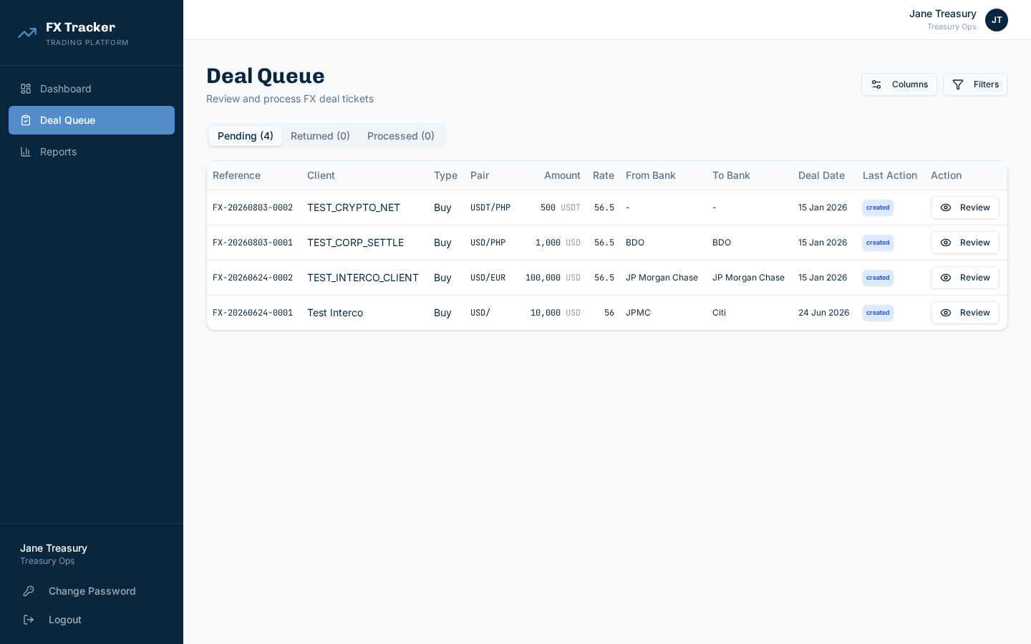
Figure 6.1 - Treasury Queue
Tabs: Pending, Returned, Processed. Click Review, enter remarks, Confirm or Return. Min 1 proof required for confirmation.

7. Reference Data (Admin)
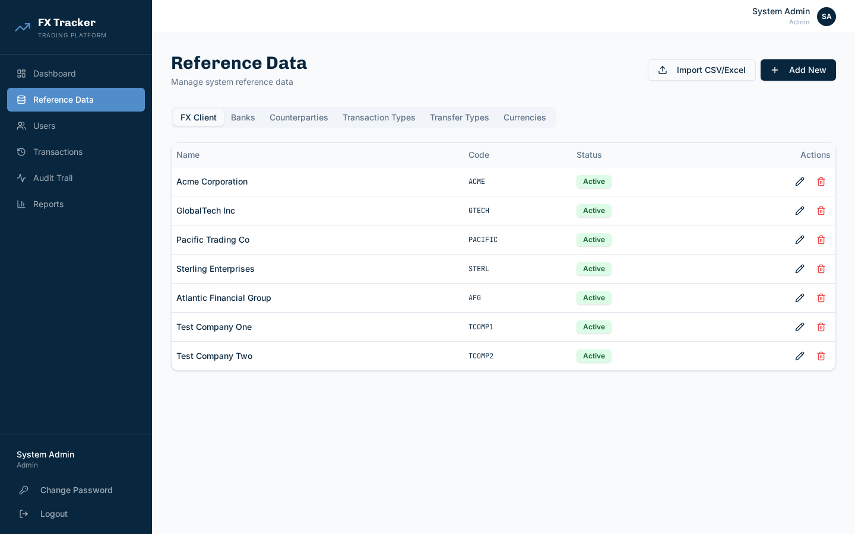
Figure 7.1 - FX Client tab
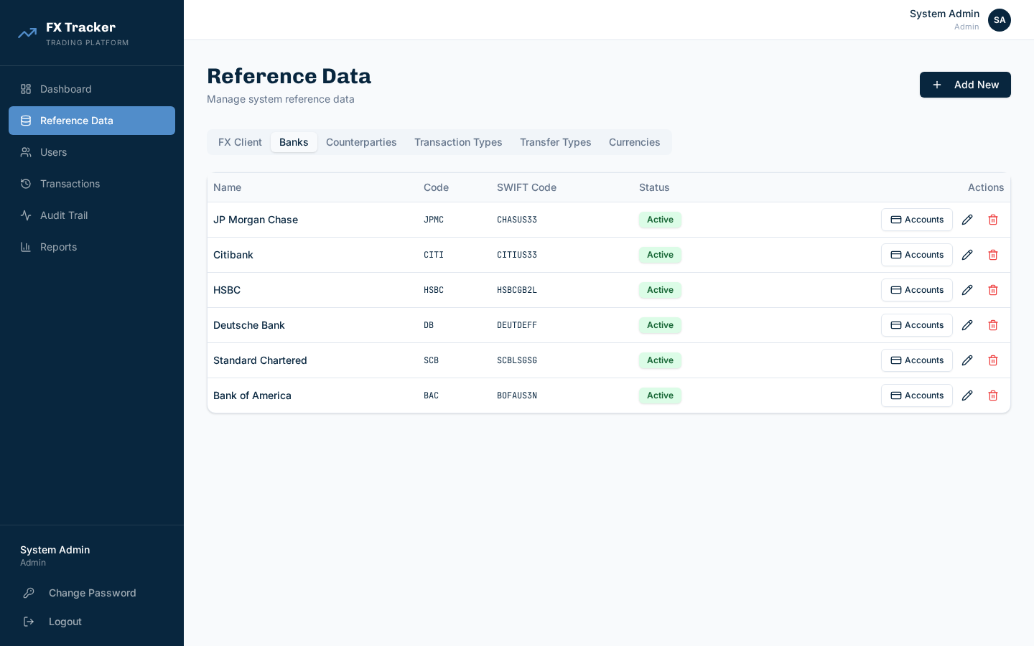
Figure 7.2 - Banks with Import Accounts CSV
6 tabs: FX Client, Banks, Counterparties, Transaction/Transfer Types, Currencies. CSV/Excel import for FX Clients and Bank Accounts (including legacy fld_* format with auto bank creation).

8. User Management
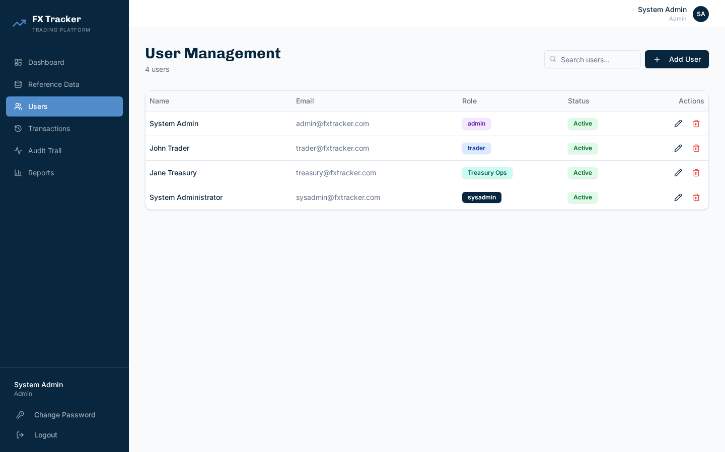
Figure 8.1 - Users

9. Transactions & Audit Trail
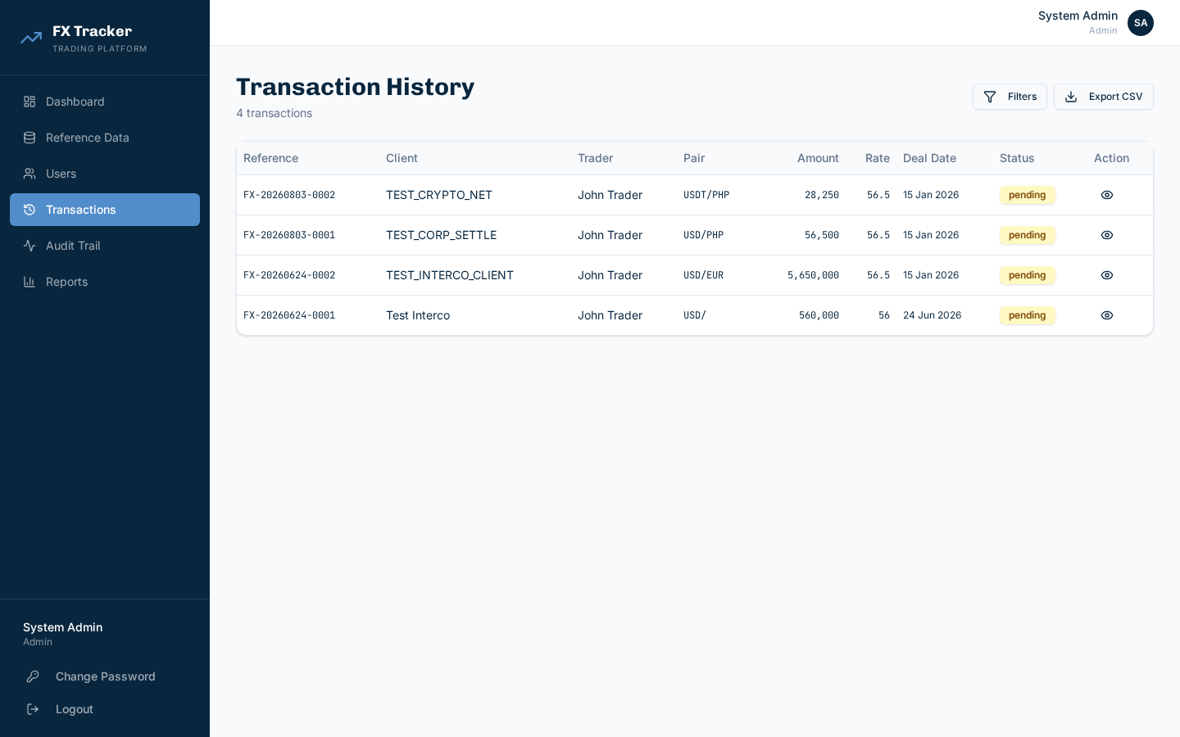
Figure 9.1 - Transactions
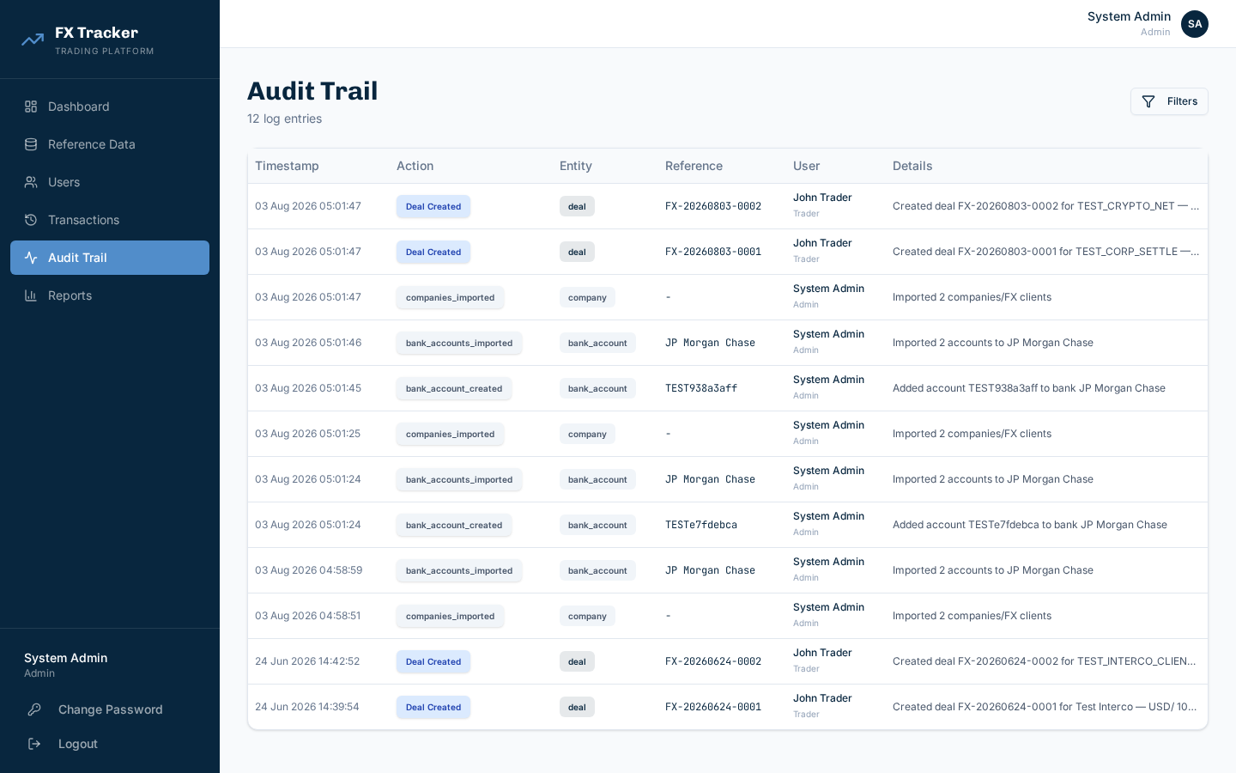
Figure 9.2 - Audit Trail

10. Reports
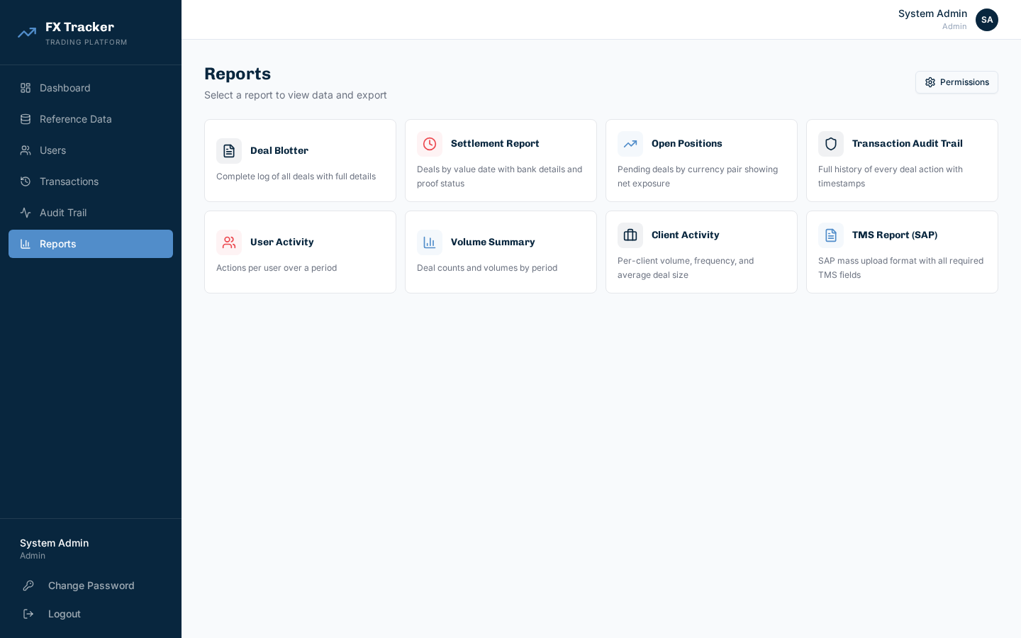
Figure 10.1 - Reports
Report | Description
Deal Blotter | Complete log
Settlement | By value date
Open Positions | Pending by pair
Audit Trail | Actions
User Activity | Per user
Volume Summary | By period
Client Activity | Per client
TMS (SAP) | 21-column SAP

11. System Administration
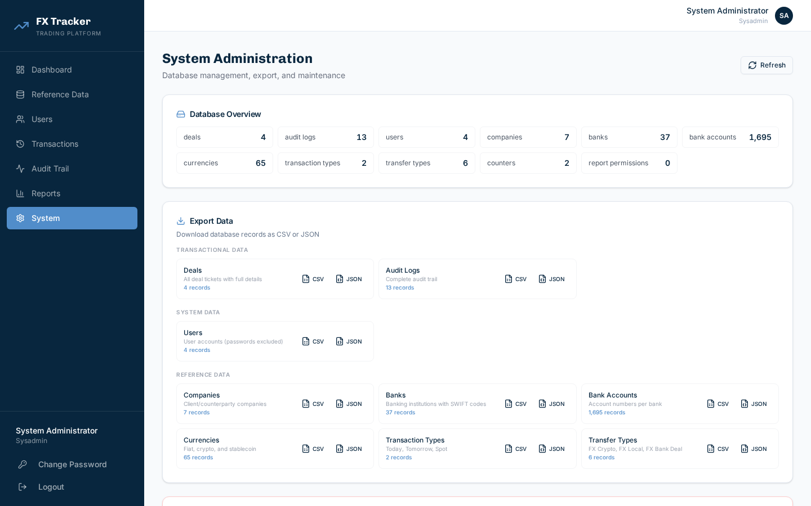
Figure 11.1 - System Admin
Only accessible to sysadmin role.
DB Statistics, Data Export (CSV/JSON), Database Reset (clears deals/audit, retains users/ref data).

12. Appendix: Transfer Types & Networks
Transfer Type | Code | Counterparty | Destination
FX Crypto Conversion | FX_CRYPTO | No | Yes
FX Local | FX_LOCAL | Yes | Yes
FX Bank Deal | FX_BANK | No | Hidden
FX-Intercompany | FX_INTERCO | Yes | Yes (dual Ours)
FX - Corporate Settlement | FX_CORP_SETTLE | Yes | Yes
PDAX Withdrawal | PDAX_WD | No | Yes
Crypto Networks: SOLANA, ETHEREUM, TRON
Status Workflow: Created → Pending → Confirmed | Returned | Cancelled. Returned → Edit → Resubmit → Pending.

