Case Study

C2: Marry, buzzy HTML5 games

# Description

Marry is a video game company. It promotes simple HTML5 games related to buzzy and hot topics discussed in social media, typically autorunners, puzzles or simple role-playing games. Social discussion trends are analyzed every week to quickly produce (in maximum 2 working days) a themed videogame and promote it in the remaining days of the week. For example, in 2020 they produced “Albano e i dinosauri”[1] an autorunner in which the well-known Italian singer has to exterminate all the dinosaurs he meets on his path.

Selecting the topics and themes that better meet the buzzy trends that will become relevant hot trends on social media is crucial for Marry. Topics must be capable of attracting users and develop viral diffusion online. For this reason, the identification of trending topics relates to multiple dimensions: impressions, reach, endurance, positive sentiment, and stimuli to ironic discussions[2].

# Assignment

Describe the knowledge acquisition process illustrated in this case study using the Knowledge Uplift Trail method presented in class.

The following questions can guide the exercise:

* Which goal does Marry want to achieve?
* Which knowledge is used to reach this goal?
* Which steps allow to uplift this knowledge?
* Which information allows to acquire this knowledge?
* 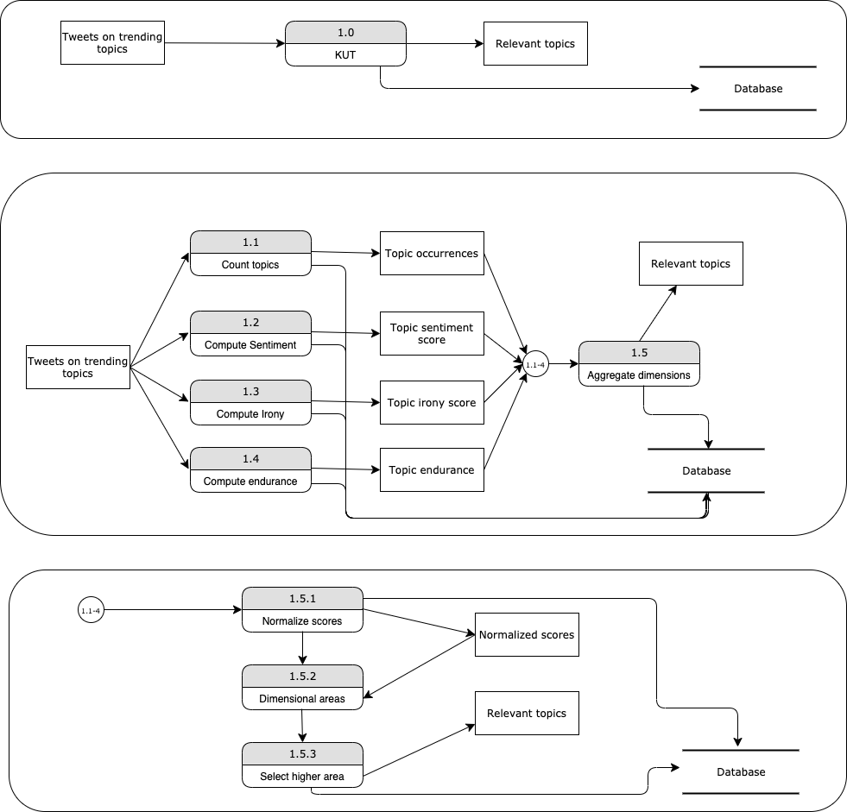

|  |  |  |  |  |
| --- | --- | --- | --- | --- |
|  | ***Input*** | ***Acquired Knowledge*** | | ***Output*** |
|  |  | ***Analytics/Models*** | ***Type*** |  |
| ***Step 1*** | Tweets on trending topics | Count topics | Descriptive | Topic occurrences |
| ***Step 2*** | Tweets on trending topics | Compute Sentiment | Descriptive | Topic sentiment score |
| ***Step 3*** | Tweets on trending topics | Compute Irony | Descriptive | Topic irony score |
| ***Step 4*** | Tweets on trending topics | Compute endurance | Descriptive | Topic endurance |
| ***Step 5*** | Step1  Step2  Step3  Step4 | Multidimensional relevance | Predictive | Relevant topics |

1. <https://www.repubblica.it/spettacoli/musica/2020/05/24/news/al_bano_a_domenica_in_l_uomo_ha_distrutto_i_dinosauri_fermera_anche_il_coronavirus_-257531509/>
2. https://sproutsocial.com/insights/social-media-metrics/