#### Aggioranto il 03/10/2023

# Intro

Go ahead, play around with the editor! Be sure to check out **bold** and *italic* styling, or even [links](https://google.com). You can type the Markdown syntax, use the toolbar, or use shortcuts like cmd-b or ctrl-b.

## Lists

Unordered lists can be started using the toolbar or by typing *, -, or +. Ordered lists can be started by typing 1..

#### Unordered

* Lists are a piece of cake
* They even auto continue as you type
* A double enter will end them
* Tabs and shift-tabs work too

Insert citation [@barbon2020evaluating]

## What about images?

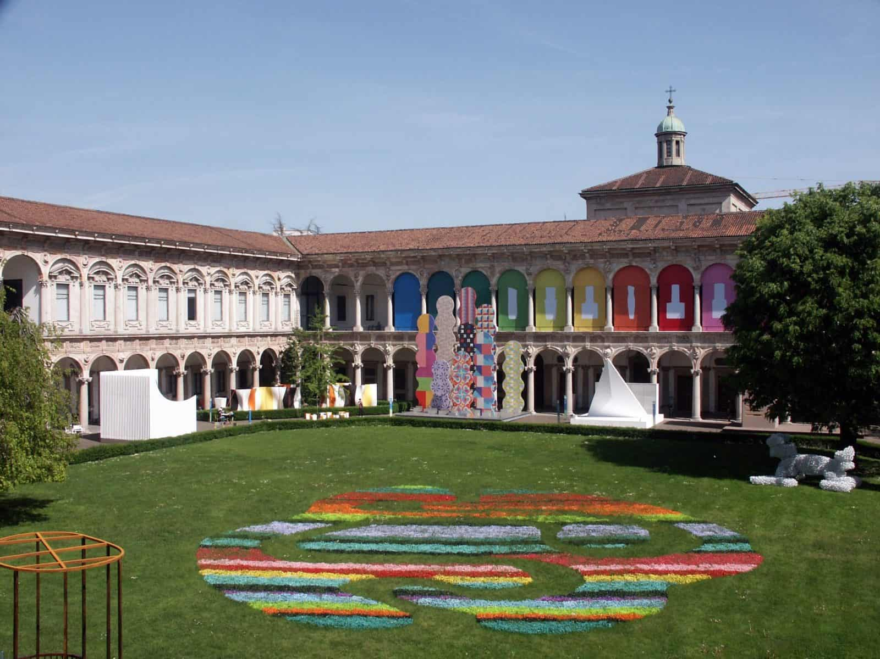

UNIMI

## What about tables?

| Colonna 1 | Colonna 2 | Colonna 3 |
| --- | --- | --- |
| Testo | Testo | Testo |
| Testo | Testo | Testo |

## Biblio