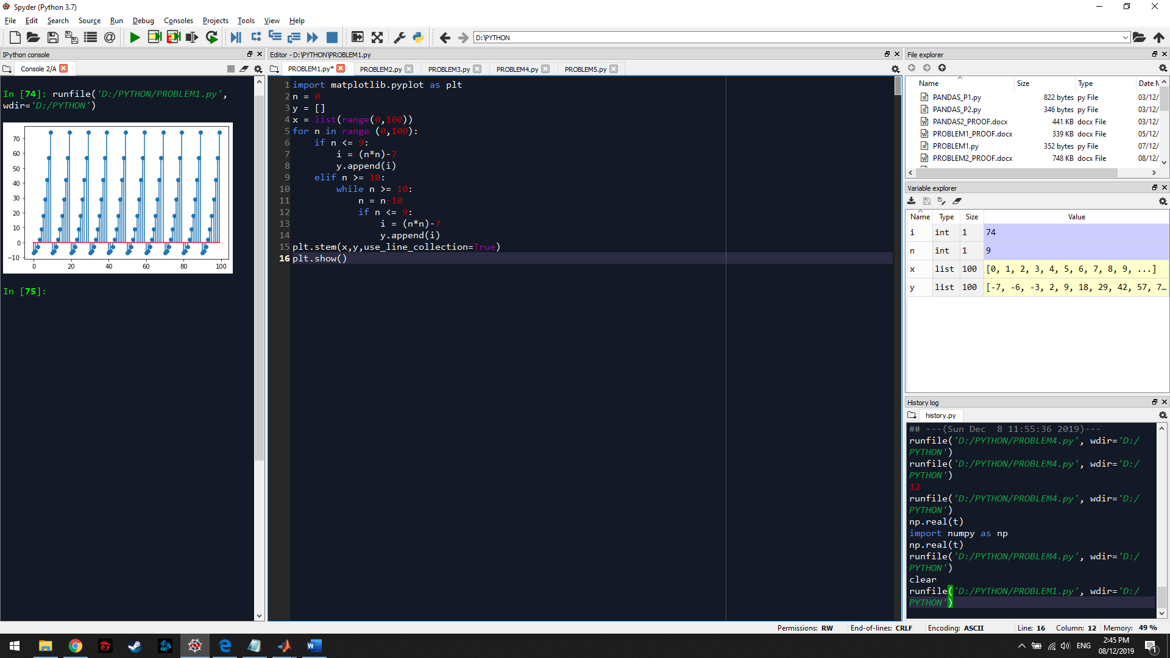

GRAPH:

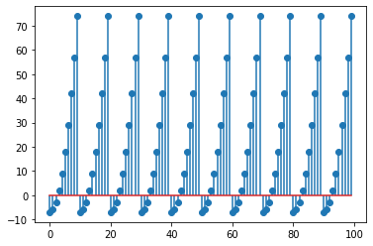

The graph shows a repetitive pattern because of the second condition in the problem: “If n is greater than or equal to ten, subtract ten from n to make n eligible for the first condition.” This condition restricts n from having a value greater than or equal to 10, so the values in the y-axis are the same across every point along the x-axis.