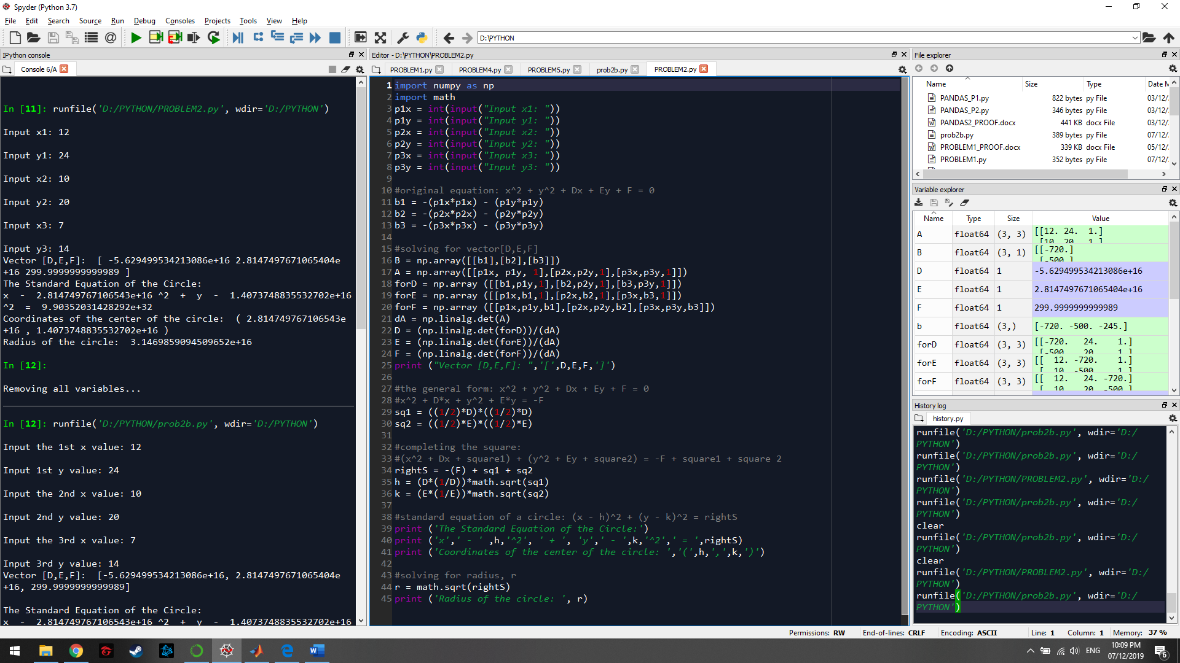

Above is my first program where everything works (surprisingly) given the formulas needed to get the answers to the question, but the syntaxes were redundant and unnecessary variables were all over the place, so I decided to clean my code up and reduce the times that the program has to set/declare another variable to as much as I could. Attached below this paragraph is my second and final code. Both codes give the same results with only the second one has an overall cleaner code (it looks better compared to my first, variable-infested version of the code.

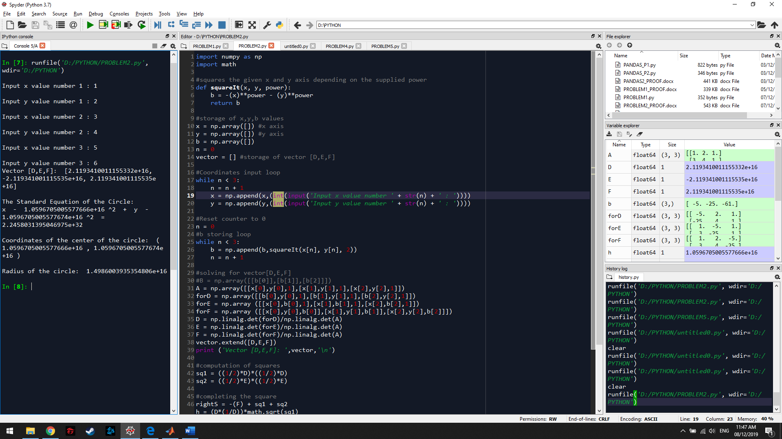

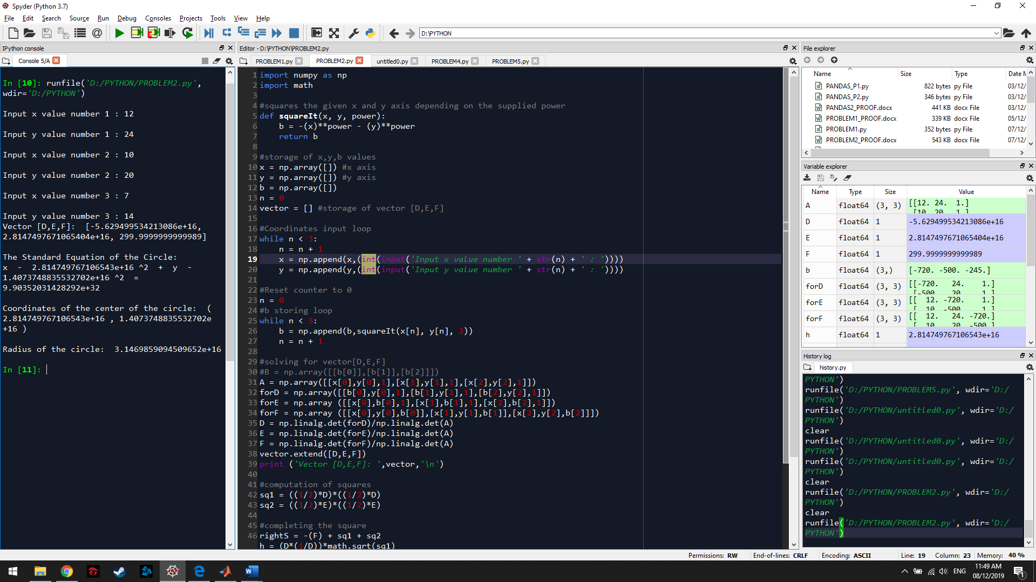

For repetitive inputs that are stored in similar arrays, I looped the input process. I also created a function to be used later in the program when getting the elements for array b. At least a few lines and a lot of variables were removed to optimize the code a bit.