ERROR:

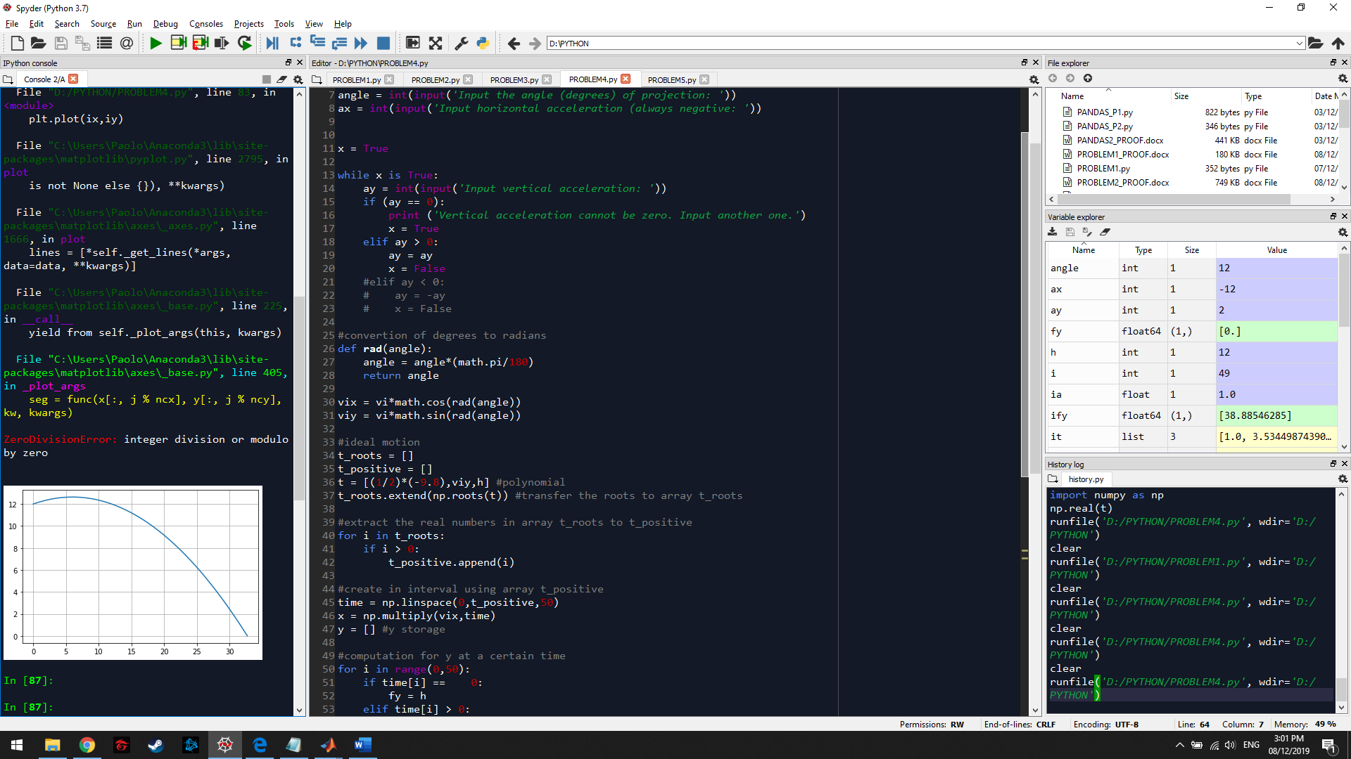

Without the force negative code for variable “ay”, the non-ideal graph cannot be plotted as an error occurs. However, once the force negative command is enabled, the proper graph for the trajectory will be plotted.

WORKING:

