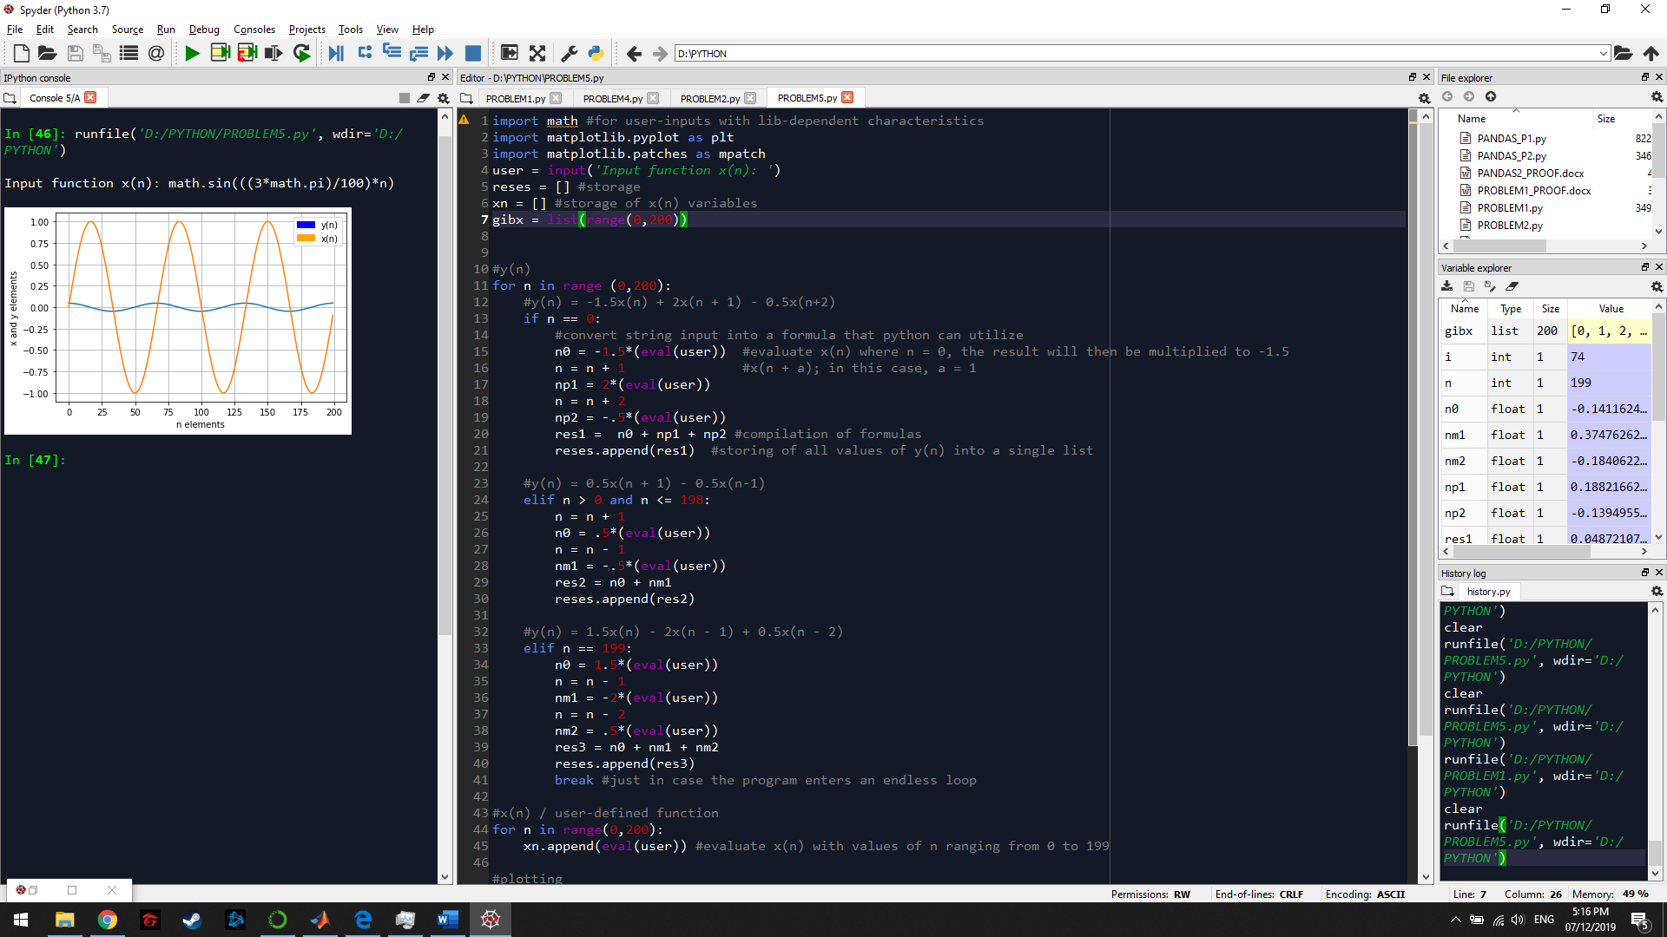

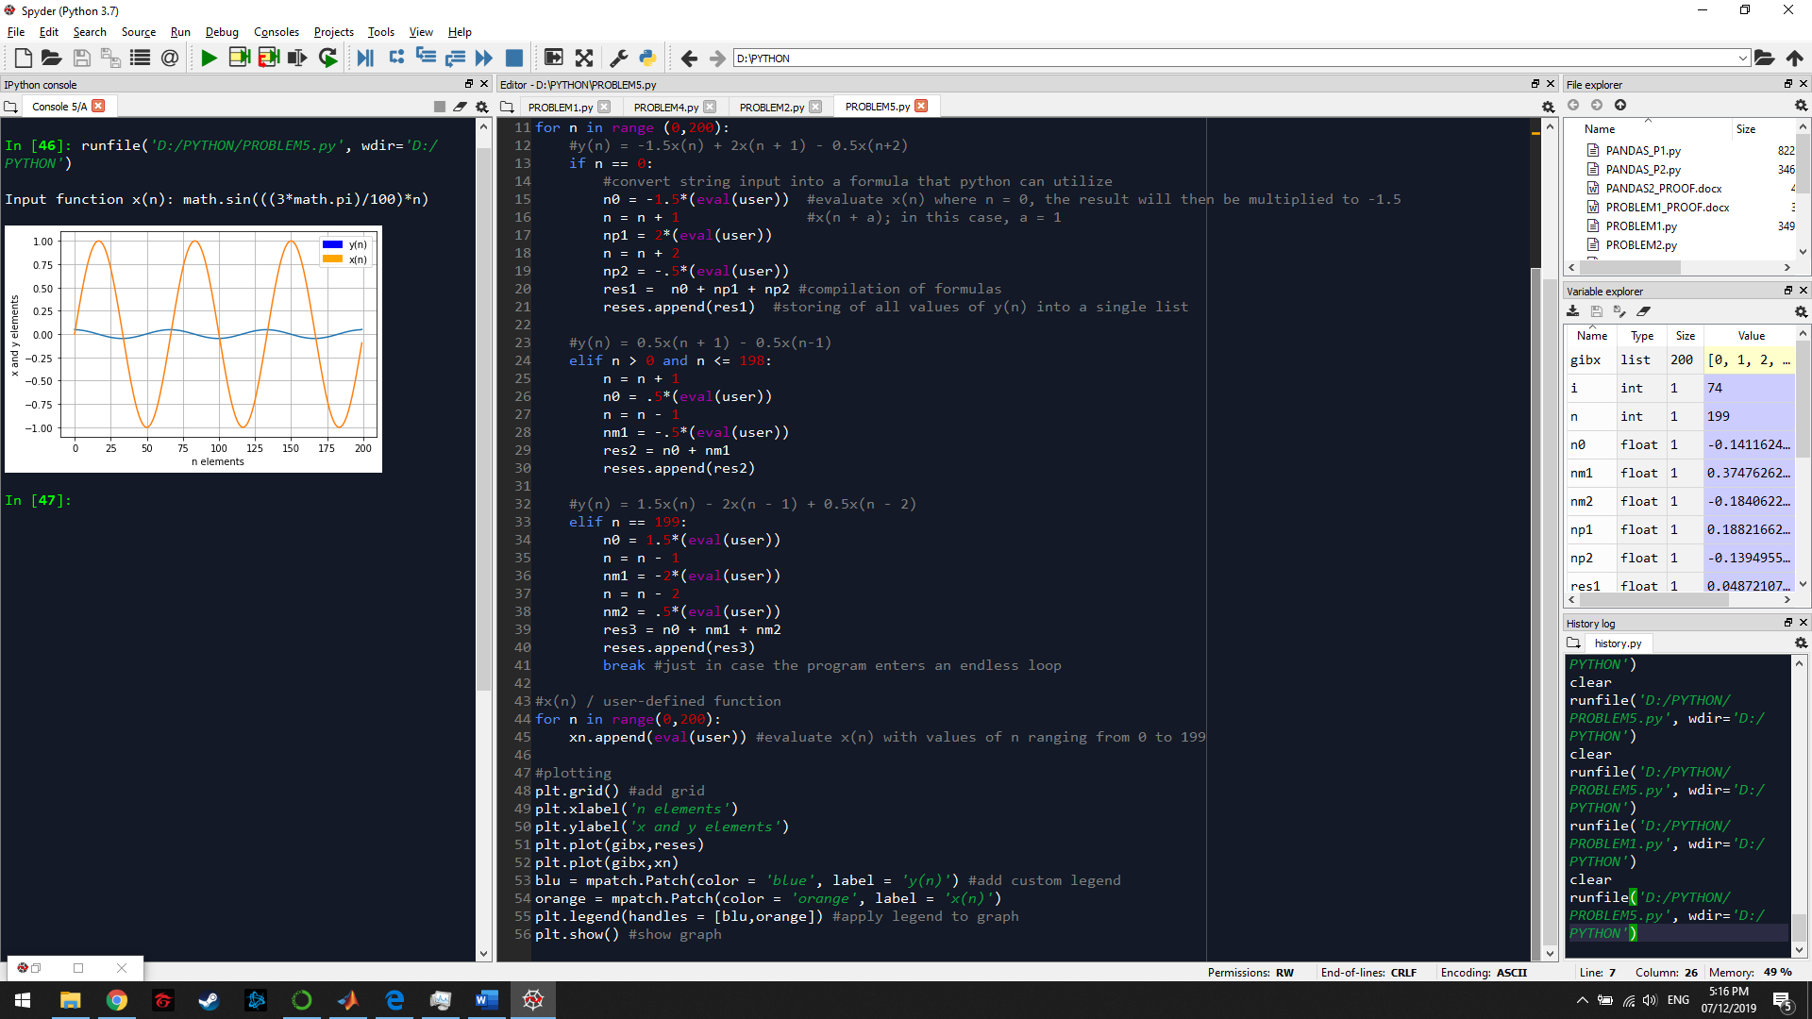

Since my knowledge about python syntaxes and functions are limited, instead of forcing my program to solve for functions that also contain functions that require varying values of n within those functions, I thought of dividing the formulas into separate parts and just adding them together at the end, so that the referred value of n is followed. Then, each element of y(n) and x(n) will then be stored into their respective lists (initially empty).