PANDAS PROBLEM 1: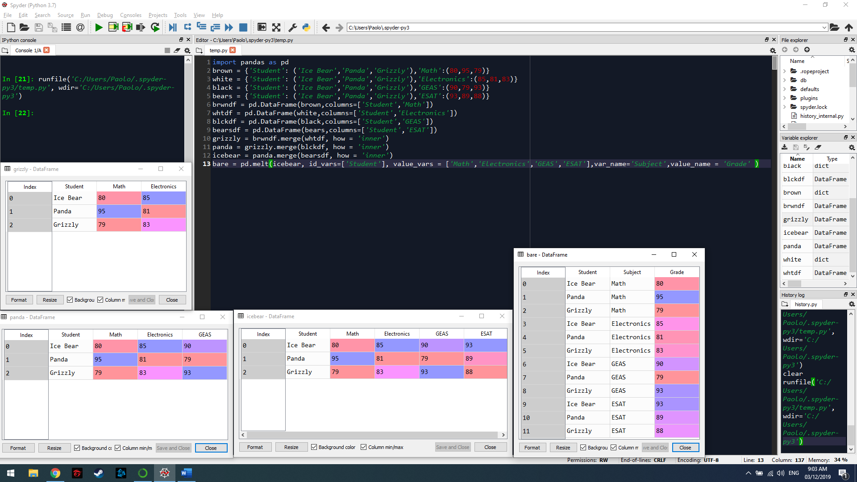

PANDAS PROBLEM 2:

