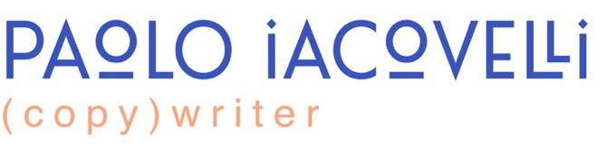

contact
paoloiacovelli.com
paoloiacovelli1@gmail.com
917-818-8555

education

book180 | Spring 2026

Copywriting

Columbia University | Fall 2021

MFA in Creative Writing, Fiction

The New School | Spring 2018

BA in Literary Studies, Writing

publications
The King of Video Poker
Clash Books, 2024

Strung some words together on a page. Then strung some more words together on some more pages. And somehow got the thing published

skills
- AI-literate
- Writing (stories, emails, occasional haiku)
- Big effing insights
- Playing well with others
- Haberdasher (aspiring)
- Sommelier (de facto)
- Cinephile (AMC Stub’s A-List)
- Knowing every Bob Dylan lyric
- Soccer ball juggler
- Ambidextrous

languages
- English: Native
- French: Native
- Italian: Native
- Spanish: Conversational

work experience

Food and Wine Manager

McNally Jackson Independent Books

Oct 2023 – Dec 2025
- Directed day-to-day operations for a high-volume team, increasing efficiency and employee engagement
- Developed SOPs, onboarding checklists, and training manuals, reducing onboarding time by 30%
- Collaborated cross-functionally with accounting, ownership, and vendors to streamline financial operations, cutting invoicing delays by 40%
- Took advantage of my employee discount to amass enough books resulting in the dire need of yet another Billy bookshelf

Editorial Research Assistant

Columbia University

Sept 2020 – Dec 2022
- Coordinated the development of a research-based manuscript, and supporting data-driven insights using AI and quantitative methods
- Herded cats to get an overcommitted professor to meet benchmarks

Creative Writing Instructor

High School for Fashion Industries

Sept 2019 – Dec 2019
- Designed and delivered a semester-long course curriculum, including lesson planning, content creation, and assessment
- Instilled the pipe dream to pursue writing in one student

