# Pre-Requisite

1. Install the following:
   1. Java 11
   2. Selenium
   3. Cucumber
   4. Chrome Driver
   5. IntelliJ
   6. TestNG

# How To Execute:

We have 2 ways to execute :

1st Way : We can execute by going to the feature file, opening it, and click the run button while inside the feature file.

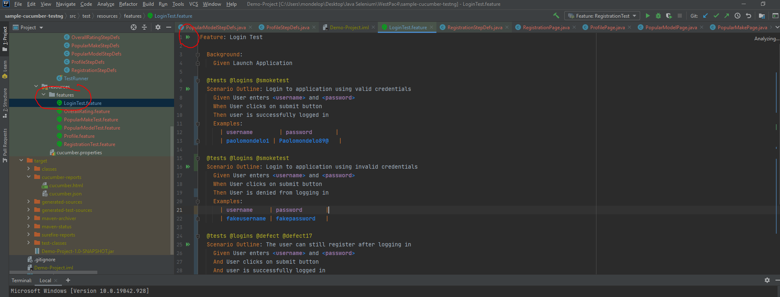

2nd way:

1. Go to Test Runner.

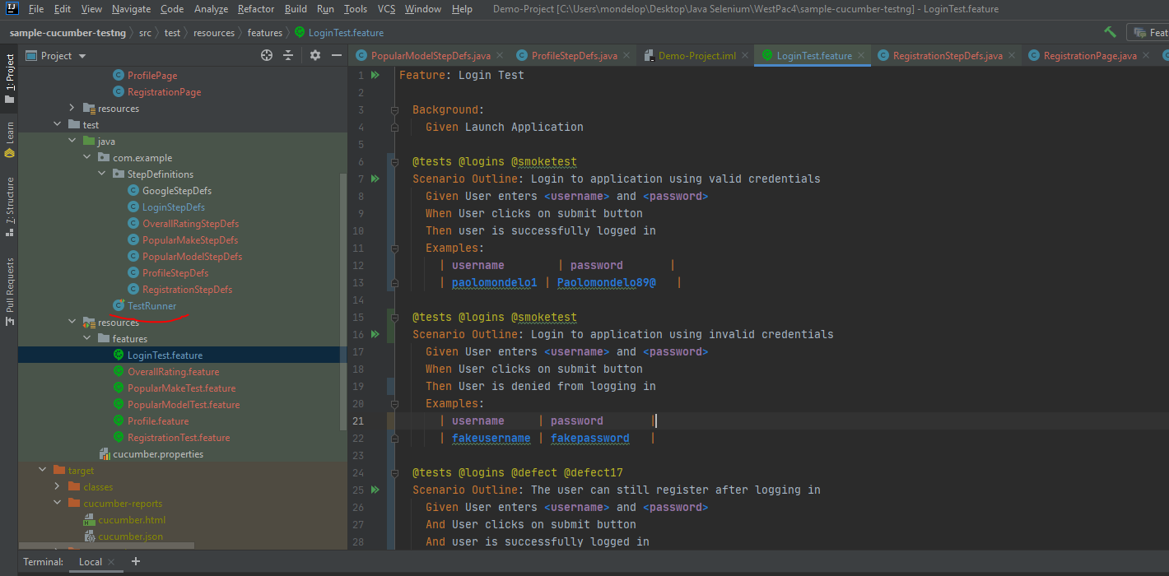

1. Update the test runner with your chosen tag:

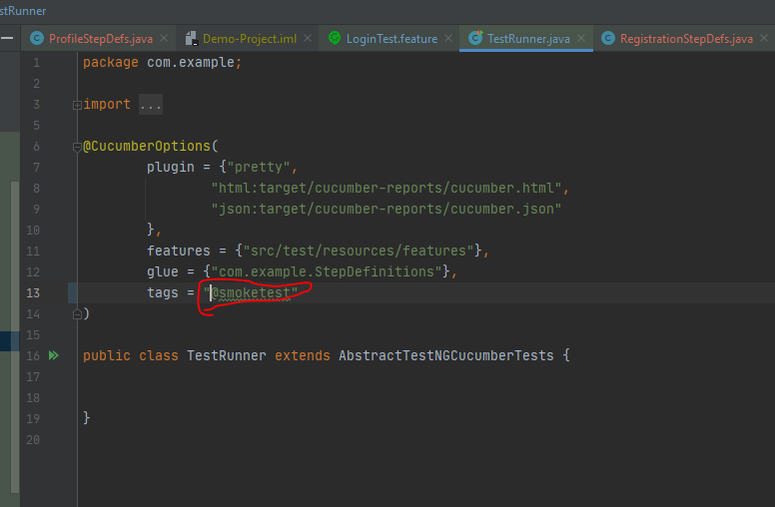

1. On the command line, type “mvn clean verify” and press enter.

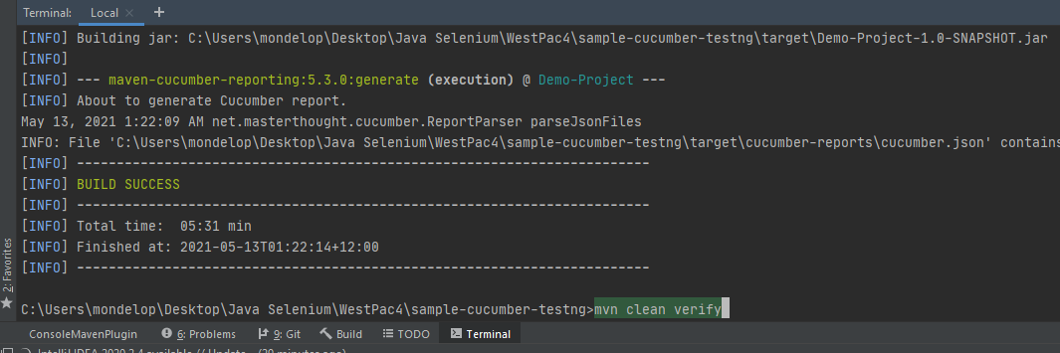

1. After execution, there are two ways to retrieve the report:
   1. Via Cucumber Folder,click the cucumber.html file.

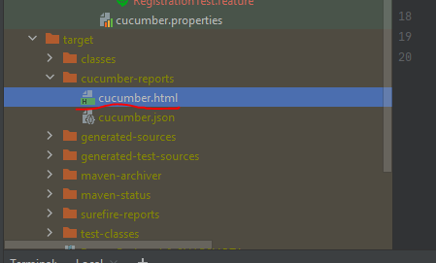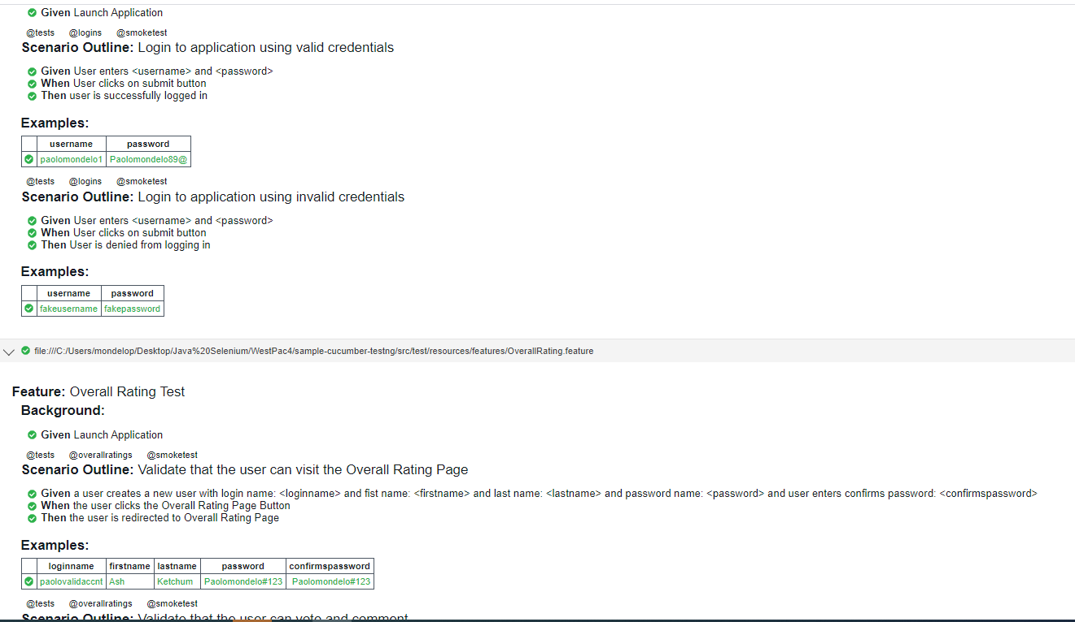

* 1. 2nd way, on the terminal box, click the hyperlink of the report.

