CALMARA®
(calmazetine)

Website Briefing

Selective V1b receptor antagonist for treatment-inadequate GAD

Document type: Draft marketing brief for HCP website build
Prepared by: Medical Affairs Lead & Senior Brand Manager, CNS Portfolio
Approval status: Draft v1.0 — indicative copy, pending MLR review
Date: March 2026
Approval code: [GB-XXXXX — assign before MLR submission]

Contents
1. Drug Profile
2. Mechanism of Action
3. Clinical Programme: SERENITY
4. Safety Profile
5. Prescribing Information
6. Adverse Event Reporting
7. References
8. Site Navigation
9. Page Content
Page 1: Home
Page 2: Efficacy
Page 3: Safety
Page 4: Dosing & Administration
Page 5: Patient Support
Page 6: Resources
10. Footer Content
11. Image Assets
12. Imagery Direction

1. Drug Profile
Field | Detail
Brand name | CALMARA
Generic name | calmazetine
Drug class | First-in-class oral selective antagonist of the arginine vasopressin V1b receptor (AVPR1B)
Indication | Treatment of generalised anxiety disorder (GAD) in adults who have had an inadequate response to at least one adequate course of an SSRI or SNRI
Formulation | 120 mg film-coated tablets
Dosing | 120 mg orally once daily from Day 1. No titration. No loading dose. With or without food.
Schedule | Non-scheduled (not a controlled substance). Continuous use; no defined duration limit.
Approval | MHRA — [PLACEHOLDER]
Brand colour | #3D5A80 (steel blue)
Accent colour | #C4A35A (muted gold)
Approval code | [GB-XXXXX — assign before MLR submission]

CALMARA brand rule: CALMARA always appears in capitals, with ® on first mention per page. Generic name (calmazetine) in lowercase parentheses on first mention. No tagline — no promotional strapline in the header.
────────────────────────────────────────────────────────────

2. Mechanism of Action
CALMARA (calmazetine) is a first-in-class oral selective antagonist of the arginine vasopressin V1b receptor (AVPR1B). Its mechanism is entirely distinct from monoaminergic, GABAergic, and serotonergic pathways.¹
Arginine vasopressin (AVP) acts synergistically with corticotropin-releasing hormone (CRH) at the pituitary V1b receptor to amplify ACTH and cortisol secretion in response to stress. Dysregulation of AVP/V1b signalling has been identified in chronic stress models and in post-mortem studies of individuals with anxiety and affective disorders.¹²
In patients with GAD, sustained HPA axis hyperactivation contributes to the persistent, excessive worry and somatic symptoms that define the condition. Current pharmacotherapies — SSRIs, SNRIs, buspirone — act on monoaminergic transmission but do not directly address this neuroendocrine component.²
By selectively antagonising V1b receptors, calmazetine:
- Reduces stress-axis hyperactivity at the pituitary level¹
- Reduces ACTH and cortisol secretion driven by AVP/CRH synergy¹
- Does not act on V1a or V2 receptors — basis for favourable CV and renal safety¹
- Does not produce sedation, receptor-level dependence, or cognitive dulling¹
- No serotonergic side effects; no sexual dysfunction class effect¹

Key differentiator: Calmazetine is not a sedative. It is not associated with dependence, withdrawal, or rebound anxiety. This distinction is clinically relevant for prescribers managing patients who drive, operate machinery, or require cognitive clarity at work.¹
────────────────────────────────────────────────────────────

3. Clinical Programme: SERENITY
The CALMARA approval is supported by the SERENITY programme — two Phase III, randomised, double-blind, placebo-controlled trials conducted across 74 sites in North America and Western Europe.³⁴

SERENITY-1 and SERENITY-2 (pooled analysis)
Design: Randomised, double-blind, placebo-controlled
Population: 614 adults with confirmed DSM-5 GAD, HAM-A ≥18, inadequate response to ≥1 SSRI or SNRI
Inadequate response: Failure to achieve remission (HAM-A ≤7) after ≥8 weeks at adequate dose
Exclusions: Current/recent benzodiazepine use (within 4 weeks), active substance use disorder, primary MDD
Randomisation: 1:1 to CALMARA 120 mg once daily or matching placebo
Duration: 24 weeks
Primary endpoint: Proportion achieving ≥50% reduction in HAM-A total score at Week 24
Publication: [PLACEHOLDER]

Primary endpoint:
Endpoint | CALMARA | Placebo | P-value
HAM-A total score ≥50% reduction at Week 24 | 62.4% | 24.7% | p < 0.0001

Key secondary endpoints (Week 24):
Endpoint | CALMARA | Placebo | P-value
HAM-A remission (score ≤7) | 41.8% | 13.2% | p < 0.0001
GAD-7 score ≤4 (minimal anxiety) | 54.3% | 19.1% | p < 0.0001
CGI-I score 1 or 2 (much/very much improved) | 66.7% | 28.4% | p < 0.0001
PROMIS Anxiety T-score improvement ≥10 pts | 48.9% | 14.6% | p < 0.0001
SDS total score improvement ≥40% | 55.1% | 20.3% | p < 0.0001

Pooled ITT population (N=614). All p-values after pre-specified multiplicity correction.

Onset of effect
Statistically significant separation from placebo on HAM-A total score from Week 2 (SERENITY-1) and Week 3 (SERENITY-2). HAM-A ≥4-point reduction at Week 4: 38.1% vs 14.9%. Onset notably faster than registrational SSRI data, though cross-trial comparisons require methodological caveats.³⁴

Long-term data (open-label extension)
OLE of SERENITY-1 followed 241 patients for an additional 52 weeks. HAM-A response maintained in 78.4%. No new safety signals over 76 weeks. No clinically significant cortisol axis suppression — 24-hour urinary free cortisol within normal reference ranges throughout.⁵
────────────────────────────────────────────────────────────

4. Safety Profile
Safety consistent with V1b-selective pharmacology. No signal for dependence, withdrawal, or rebound anxiety. No clinically meaningful effects on BP, serum sodium, or renal function.³⁴

Adverse events (pooled SERENITY-1 and SERENITY-2)
Adverse event | CALMARA | Placebo
Somnolence (transient) | 8.4% | 3.1%
Nausea | 7.2% | 3.6%
Headache | 6.5% | 5.8%
Dizziness | 4.9% | 2.0%
Fatigue | 4.1% | 3.9%
Dry mouth | 3.6% | 1.6%
Discontinuation due to AE | 4.2% | 2.6%

Notable findings
Somnolence: Predominantly within first 2 weeks, largely self-resolving. Discontinuation due to somnolence: 1.6%. CALMARA is not a sedative.³⁴
No dependence or withdrawal: No signal in 24-week controlled period or 76-week OLE. Not a controlled substance.³⁴⁵
Cortisol axis: No clinically significant suppression. 24-hour urinary free cortisol within normal ranges throughout 76 weeks.⁵
CV and renal: No meaningful effects on BP, serum sodium, or renal function — consistent with V1b selectivity over V1a/V2.¹

Special populations
[PLACEHOLDER — requires SmPC data for renal, hepatic, elderly, pregnancy/lactation]
────────────────────────────────────────────────────────────

5. Prescribing Information (abbreviated — for every page footer)
CALMARA (calmazetine) 120 mg film-coated tablets. Please refer to the SmPC before prescribing. Indication: GAD in adults with inadequate response to ≥1 SSRI or SNRI. Dosage: 120 mg once daily. No titration. With or without food. Contraindications: [PLACEHOLDER]. Warnings: [PLACEHOLDER]. Interactions: [PLACEHOLDER]. Side effects: Common (≥1/100 to <1/10): Somnolence, nausea, headache, dizziness, fatigue, dry mouth. Legal category: POM (not scheduled). Pack/price: [PLACEHOLDER]. MAH: AstraZeneca UK Ltd. MA number: [PLACEHOLDER]. Full PI from: AstraZeneca UK Ltd, 2 Pancras Square, London N1C 4AG. [GB-XXXXX] | DOP: [Month Year]
────────────────────────────────────────────────────────────

6. Adverse Event Reporting (for every page footer)
Adverse events should be reported. Reporting forms and information can be found at www.mhra.gov.uk/yellowcard or search for MHRA Yellow Card in the Google Play or Apple App Store. Adverse events should also be reported to AstraZeneca by visiting contactazmedical.astrazeneca.com or by calling 0800 783 0033.
────────────────────────────────────────────────────────────

7. References (for every page footer)
1. [PLACEHOLDER — CALMARA SmPC. AstraZeneca UK Ltd.]
2. [PLACEHOLDER — AVP/V1b pathway and anxiety disorders.]
3. [PLACEHOLDER — SERENITY-1 publication.]
4. [PLACEHOLDER — SERENITY-2 publication.]
5. [PLACEHOLDER — SERENITY-1 OLE publication.]
6. [PLACEHOLDER — GAD epidemiology, UK-specific.]
7. [PLACEHOLDER — SSRI/SNRI limitations in GAD.]
────────────────────────────────────────────────────────────

8. Site Navigation
Top bar links: Contact Us (https://www.astrazeneca.co.uk/contact-us.html) | AZ Employee Login (https://login.astrazeneca.com)
Main navigation pages: Efficacy | Safety | Dosing & Administration | Patient Support | Resources
Utility: Search | Login

9. Page Content
Copy below is indicative and may be adapted for web presentation while preserving all clinical claims and data points verbatim.
Each page must end with expandable sections for Prescribing Information, Adverse Event Reporting, and References (see sections 5, 6, and 7 above).
CALMARA brand rule: CALMARA always appears in capitals, with ® on first mention per page. Generic name (calmazetine) in lowercase parentheses on first mention. No tagline.
────────────────────────────────────────────────────────────

PAGE 1: Home
URL path: /calmara/
────────────────────────────────────────────────────────────

Section 1 — Hero (indication statement above the fold)
Block: hero-teaser


https://lumivex-images.pages.dev/hero-home.jpeg
Usage: Home — hero
Heading: CALMARA® (calmazetine) — a non-monoaminergic option for treatment-inadequate GAD
Body text: CALMARA is indicated for the treatment of generalised anxiety disorder in adults who have had an inadequate response to at least one adequate course of an SSRI or SNRI. Selective V1b receptor antagonist — a mechanism distinct from monoaminergic, GABAergic, and serotonergic pathways.¹
Call to action: View clinical data → /calmara/efficacy
Call to action: Prescribing Information → /calmara/resources
────────────────────────────────────────────────────────────

Section 2 — Primary efficacy headline (centred text) | light background
Block: introduction
Section metadata: Style: light
Heading: 62.4% achieved ≥50% reduction in HAM-A total score at Week 24
Body text: Versus 24.7% with placebo (p < 0.0001) in the SERENITY Phase III programme. Statistically significant separation observed from Week 2.³⁴
────────────────────────────────────────────────────────────

Section 3 — MoA teaser (two-column) | highlight background
Block: columns-teaser
Section metadata: Style: highlight

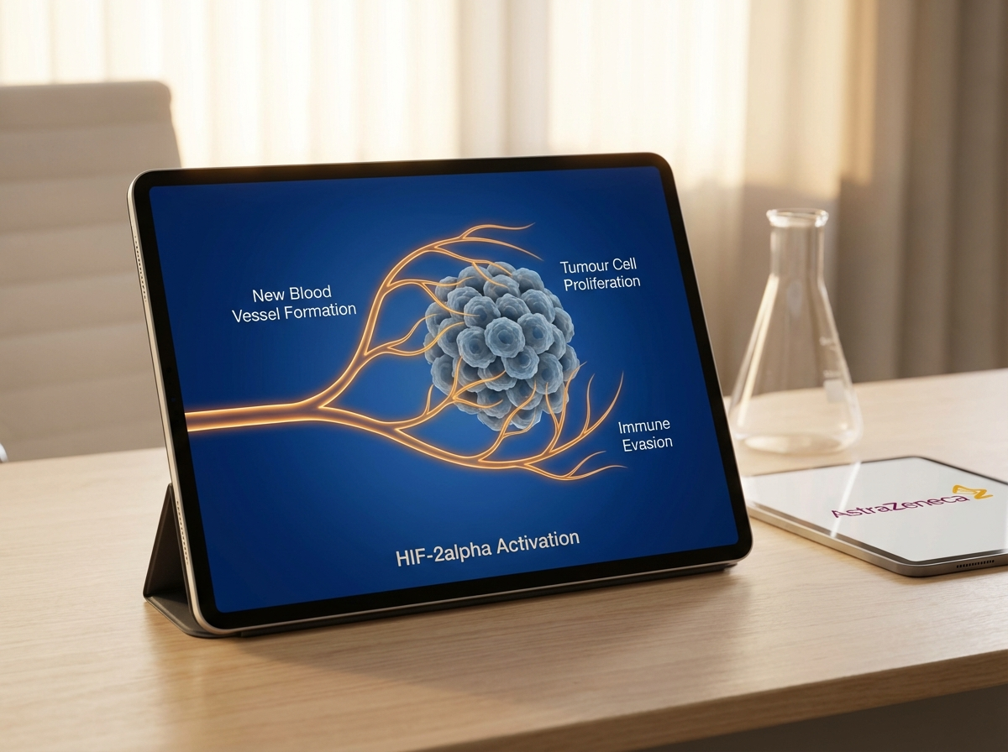
https://eluvion-images.pages.dev/pathway-cascade.jpeg
Usage: Home — MoA teaser
Heading: Targeting the stress axis, not monoaminergic transmission
Body text: Calmazetine selectively antagonises the V1b receptor at the pituitary, reducing HPA axis hyperactivation in response to stress. It does not act on monoaminergic, GABAergic, or serotonergic pathways. CALMARA is not a sedative and is not associated with dependence, withdrawal, or rebound anxiety.¹
Call to action: Explore mechanism of action → /calmara/efficacy
────────────────────────────────────────────────────────────

Section 4 — Key outcome cards (three columns)
Block: cards-teaser

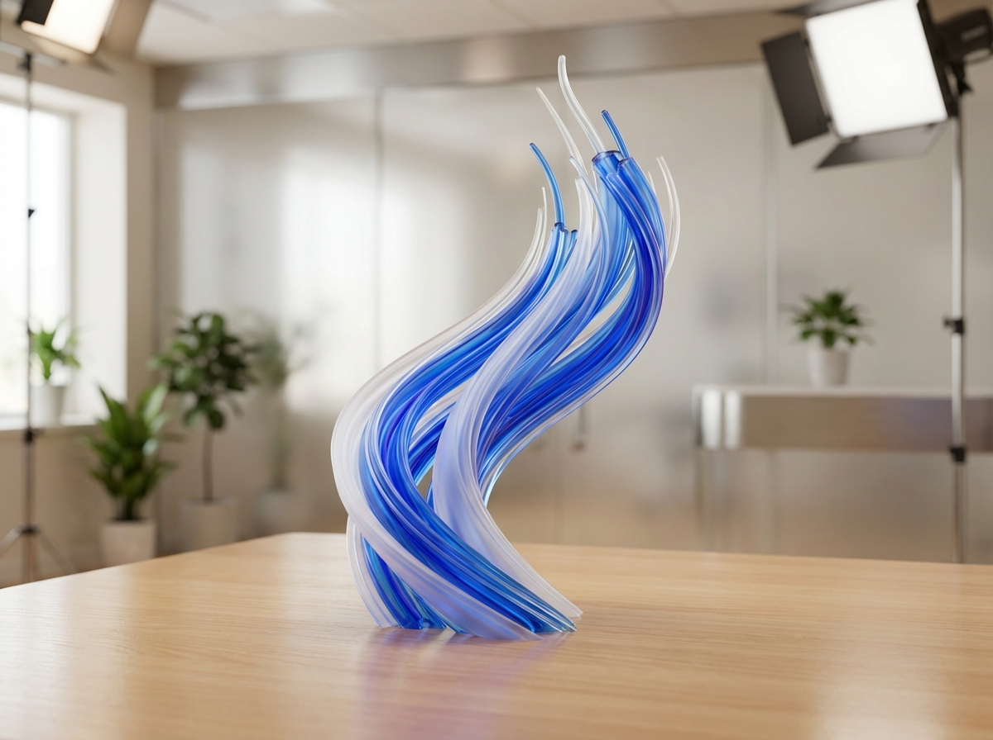
https://revantha-images.pages.dev/card-efficacy.jpeg
Usage: Home — remission card
Card heading: 41.8% achieved remission
Card body: HAM-A remission (score ≤7) at Week 24 versus 13.2% with placebo (p < 0.0001). Response observed from as early as Week 2.³⁴
Card link: View SERENITY data → /calmara/efficacy
────────────────────────────────────────────────────────────

https://eluvion-images.pages.dev/card-safety.jpeg
Usage: Home — safety card
Card heading: No dependence or withdrawal signal
Card body: Safety profile consistent with V1b selectivity. No signal for dependence, withdrawal, or rebound anxiety. Not a controlled substance.³⁴⁵
Card link: View safety profile → /calmara/safety
────────────────────────────────────────────────────────────
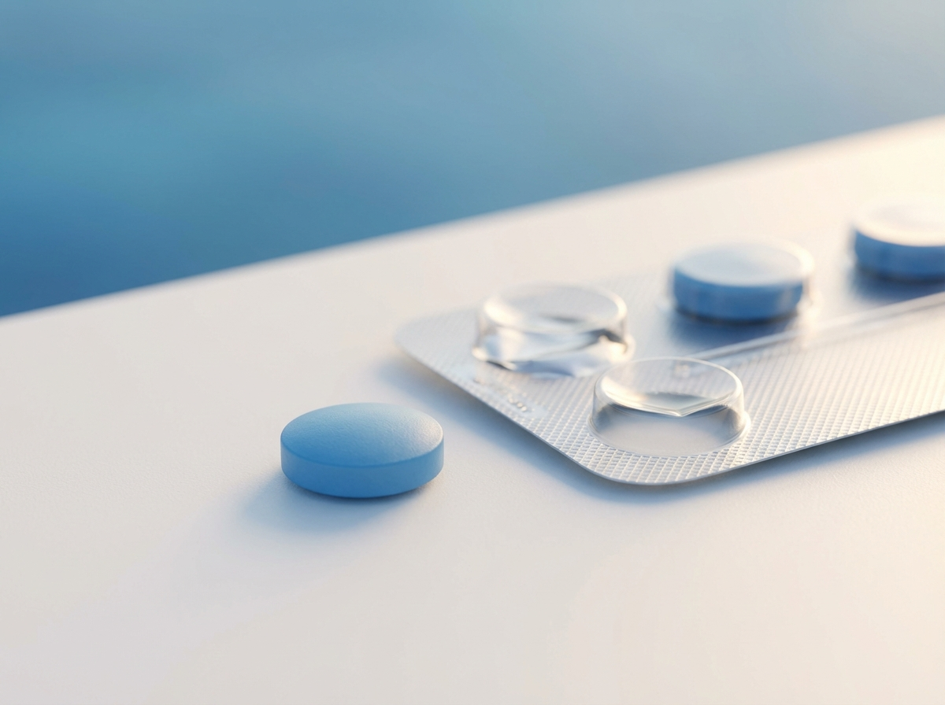
https://zenturis-images.pages.dev/card-dosing.jpeg
Usage: Home — dosing card
Card heading: 120 mg once daily from Day 1
Card body: No titration. No loading dose. Can be taken with or without food. Approved for continuous use with no defined treatment duration limit.¹
Card link: See dosing information → /calmara/dosing
────────────────────────────────────────────────────────────

Section 5 — Prescribing information footer
Block: accordion | Expandable: PI | AE Reporting | References

Page metadata
Title: CALMARA (calmazetine) | GAD Treatment | AstraZeneca UK
Description: CALMARA (calmazetine) is a selective V1b receptor antagonist for generalised anxiety disorder in adults with inadequate SSRI/SNRI response. View efficacy, safety, and prescribing information.

PAGE 2: Efficacy
URL path: /calmara/efficacy
────────────────────────────────────────────────────────────

Section 1 — Page header (text only)
Block: title
Heading: SERENITY Phase III programme — clinical efficacy data
Body text: Two randomised, double-blind, placebo-controlled 24-week trials in 614 adults with GAD and documented inadequate response to ≥1 SSRI or SNRI (HAM-A ≥18)³⁴
────────────────────────────────────────────────────────────

Section 2 — Headline statistics carousel (4 slides) | light background
Block: carousel-teaser
Section metadata: Style: light


https://lumivex-images.pages.dev/tab-luminance1.jpeg
Usage: Efficacy — slide 1
Slide heading: 62.4% HAM-A response at Week 24
Slide body: ≥50% reduction in HAM-A total score versus 24.7% placebo (p < 0.0001).³⁴
────────────────────────────────────────────────────────────
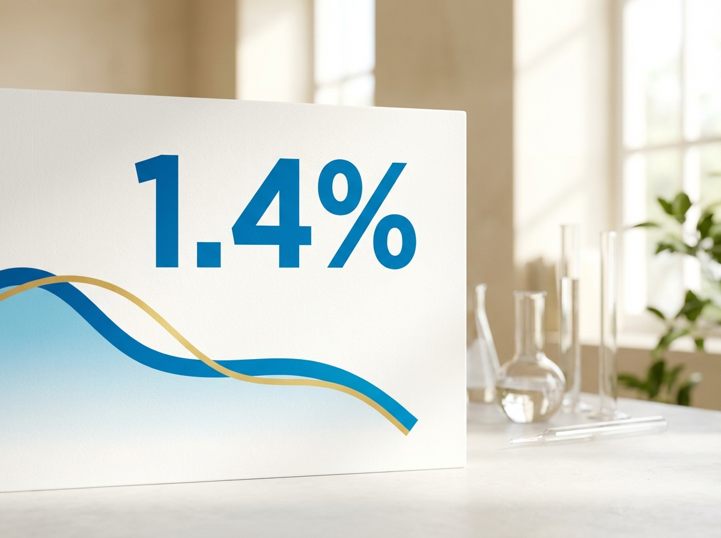
https://zenturis-images.pages.dev/tab-zenith1.jpeg
Usage: Efficacy — slide 2
Slide heading: 41.8% achieved remission
Slide body: HAM-A remission (score ≤7) versus 13.2% placebo (p < 0.0001).³⁴
────────────────────────────────────────────────────────────

https://treluxia-images.pages.dev/tab-luminos1.jpeg
Usage: Efficacy — slide 3
Slide heading: 66.7% much or very much improved
Slide body: CGI-I score 1 or 2 versus 28.4% placebo (p < 0.0001).³⁴
────────────────────────────────────────────────────────────
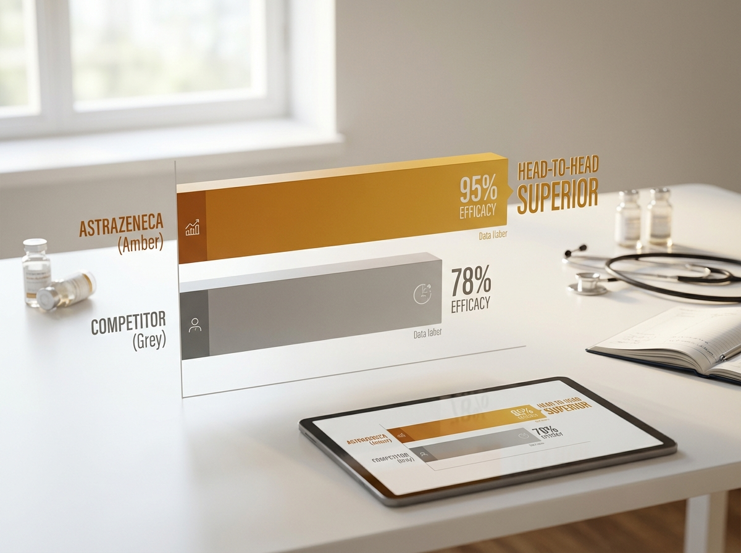
https://lumivex-images.pages.dev/tab-luminance2.jpeg
Usage: Efficacy — slide 4
Slide heading: Separation from placebo by Week 2
Slide body: HAM-A ≥4-point reduction at Week 4: 38.1% vs 14.9%.³⁴
────────────────────────────────────────────────────────────

Section 3 — Full results table | highlight background
Block: table-data
Section metadata: Style: highlight
Endpoint (Week 24) | CALMARA | Placebo | P-value
HAM-A ≥50% reduction (primary) | 62.4% | 24.7% | p < 0.0001
HAM-A remission (score ≤7) | 41.8% | 13.2% | p < 0.0001
GAD-7 ≤4 (minimal anxiety) | 54.3% | 19.1% | p < 0.0001
CGI-I 1 or 2 (much/very much improved) | 66.7% | 28.4% | p < 0.0001
PROMIS Anxiety T-score ≥10 pts | 48.9% | 14.6% | p < 0.0001
SDS total score ≥40% | 55.1% | 20.3% | p < 0.0001

────────────────────────────────────────────────────────────

Section 4 — Onset of effect (two-column) | light background
Block: columns-teaser
Section metadata: Style: light


https://eluvion-images.pages.dev/trial1-results.jpeg
Usage: Efficacy — onset
Heading: Onset of effect — separation from Week 2
Body text: Statistically significant separation from placebo from Week 2 (SERENITY-1) and Week 3 (SERENITY-2). HAM-A ≥4-point reduction at Week 4: 38.1% vs 14.9%. Onset notably faster than registrational SSRI data, though cross-trial comparisons require methodological caveats.³⁴
────────────────────────────────────────────────────────────

Section 5 — Long-term data (two-column) | highlight background
Block: columns-teaser
Section metadata: Style: highlight

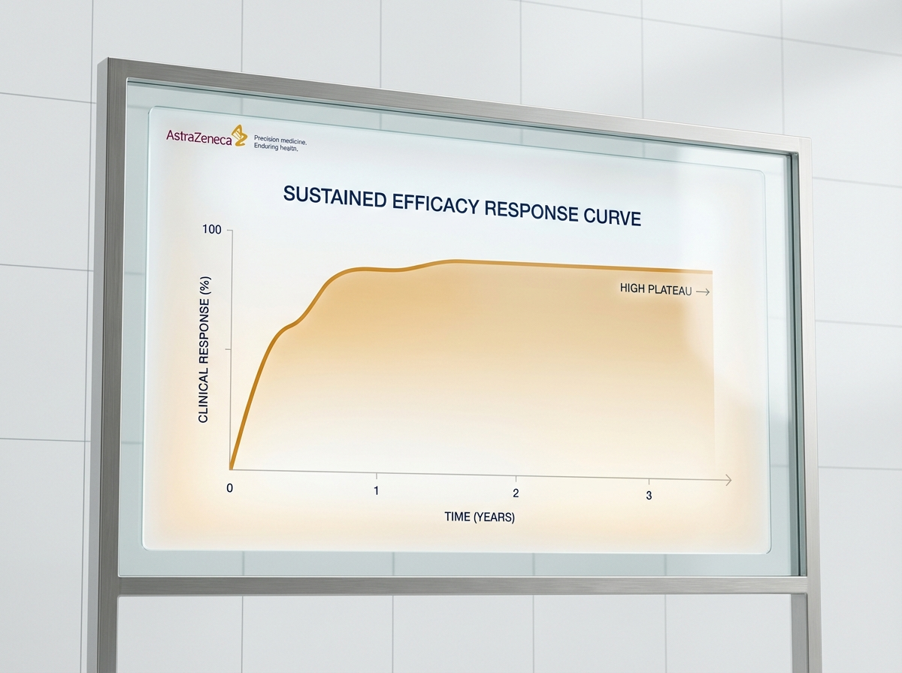
https://lumivex-images.pages.dev/columns-longterm.jpeg
Usage: Efficacy — OLE data
Heading: Long-term efficacy maintained over 76 weeks
Body text: OLE of SERENITY-1 followed 241 patients for 52 additional weeks. HAM-A response maintained in 78.4%. No new safety signals. No clinically significant cortisol axis suppression.⁵
Call to action: View safety profile → /calmara/safety
────────────────────────────────────────────────────────────

Section 6 — Prescribing information footer
Block: accordion | Expandable: PI | AE Reporting | References

Page metadata
Title: Efficacy Data | CALMARA (calmazetine) | SERENITY Phase III | AstraZeneca UK
Description: SERENITY Phase III data for CALMARA in treatment-inadequate GAD. 62.4% HAM-A response. Onset from Week 2. 76-week OLE data.

PAGE 3: Safety
URL path: /calmara/safety
────────────────────────────────────────────────────────────

Section 1 — Page header
Block: title
Heading: Safety profile of CALMARA® (calmazetine)
Body text: Evaluated across the SERENITY programme and 76-week open-label extension³⁴⁵
────────────────────────────────────────────────────────────

Section 2 — Safety summary | light background
Block: introduction
Section metadata: Style: light
Heading: Consistent with V1b-selective pharmacology
Body text: No signal for dependence, withdrawal, or rebound anxiety. No clinically meaningful effects on blood pressure, serum sodium, or renal function.³⁴
────────────────────────────────────────────────────────────

Section 3 — AE table | highlight background
Block: table-data
Section metadata: Style: highlight
Adverse event | CALMARA | Placebo
Somnolence (transient) | 8.4% | 3.1%
Nausea | 7.2% | 3.6%
Headache | 6.5% | 5.8%
Dizziness | 4.9% | 2.0%
Fatigue | 4.1% | 3.9%
Dry mouth | 3.6% | 1.6%
Discontinuation due to AE | 4.2% | 2.6%

────────────────────────────────────────────────────────────

Section 4 — Notable findings cards | light background
Block: cards-teaser
Section metadata: Style: light

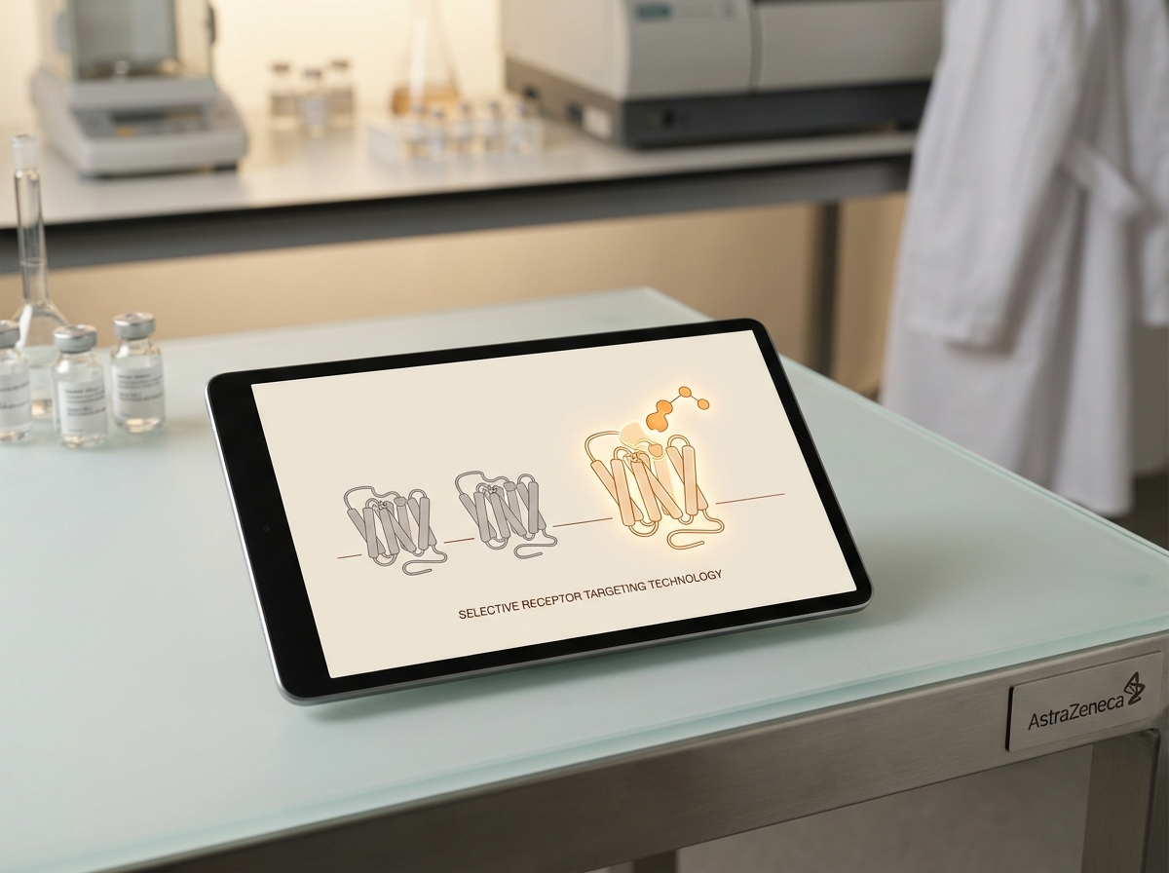
https://lumivex-images.pages.dev/card-selectivity.jpeg
Usage: Safety — somnolence
Card heading: Somnolence — transient and self-resolving
Card body: Predominantly within first 2 weeks. Discontinuation due to somnolence: 1.6%. CALMARA is not a sedative.³⁴
────────────────────────────────────────────────────────────

https://novapril-images.pages.dev/card-safety.jpeg
Usage: Safety — dependence
Card heading: No dependence, withdrawal, or rebound
Card body: No signal in 24-week controlled period or 76-week OLE. Not a controlled substance.³⁴⁵
────────────────────────────────────────────────────────────

https://novapril-images.pages.dev/safety-monitoring.jpeg
Usage: Safety — cortisol
Card heading: Cortisol axis — no significant suppression
Card body: 24-hour urinary free cortisol within normal ranges throughout 76 weeks of treatment.⁵
────────────────────────────────────────────────────────────

Section 5 — CV and renal safety | highlight background
Block: columns-teaser
Section metadata: Style: highlight


https://lumivex-images.pages.dev/columns-monitoring.jpeg
Usage: Safety — CV/renal
Heading: Cardiovascular and renal safety
Body text: No clinically meaningful effects on blood pressure, serum sodium, or renal function — consistent with V1b selectivity over V1a and V2 receptors.¹
────────────────────────────────────────────────────────────

Section 6 — Prescribing information footer
Block: accordion | Expandable: PI | AE Reporting | References

Page metadata
Title: Safety Profile | CALMARA (calmazetine) | AstraZeneca UK
Description: Safety data for CALMARA from SERENITY Phase III and 76-week OLE. No dependence or withdrawal. Transient somnolence. Cortisol axis safety confirmed.

PAGE 4: Dosing & Administration
URL path: /calmara/dosing
────────────────────────────────────────────────────────────

Section 1 — Page header
Block: title
Heading: Dosing and administration of CALMARA® (calmazetine)
Body text: 120 mg once daily from Day 1. No titration. No loading dose.¹
────────────────────────────────────────────────────────────

Section 2 — Dosing regimen | highlight background
Block: columns-teaser
Section metadata: Style: highlight

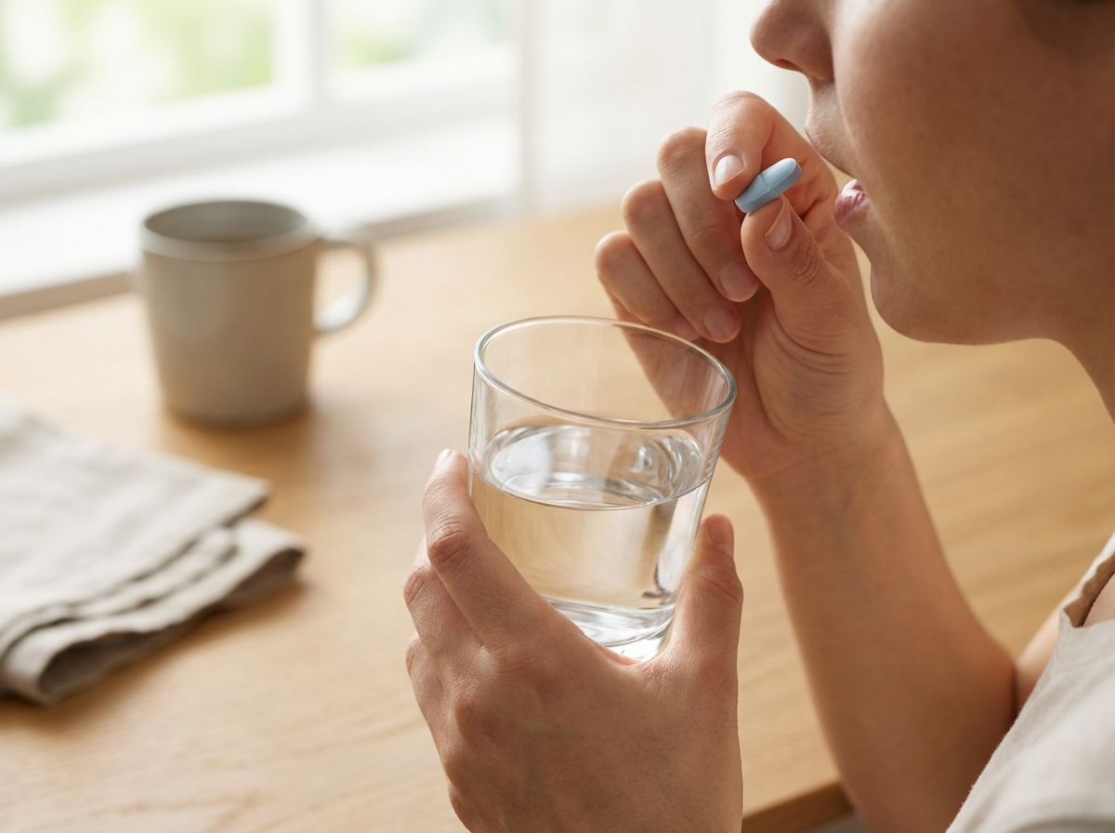
https://zenturis-images.pages.dev/columns-admin.jpeg
Usage: Dosing — regimen
Heading: Simple once-daily oral dosing
Body text: Dose: 120 mg once daily from Day 1. No titration required. No loading dose. Administration: Can be taken with or without food. Duration: Approved for continuous use; no defined treatment duration limit. Scheduling: Not a controlled substance.¹
────────────────────────────────────────────────────────────

Section 3 — Practical information (expandable) | light background
Block: accordion
Section metadata: Style: light
Panel 1: "Food interaction" — Can be taken with or without food. [PLACEHOLDER — confirm from SmPC]
Panel 2: "Missed dose" — Take as soon as remembered same day. Do not double dose. [PLACEHOLDER]
Panel 3: "Hepatic impairment" — [PLACEHOLDER — requires SmPC]
Panel 4: "Renal impairment" — [PLACEHOLDER — requires SmPC]
Panel 5: "Drug interactions" — [PLACEHOLDER — requires SmPC]
────────────────────────────────────────────────────────────

Section 4 — Patient resources link
Block: columns-teaser

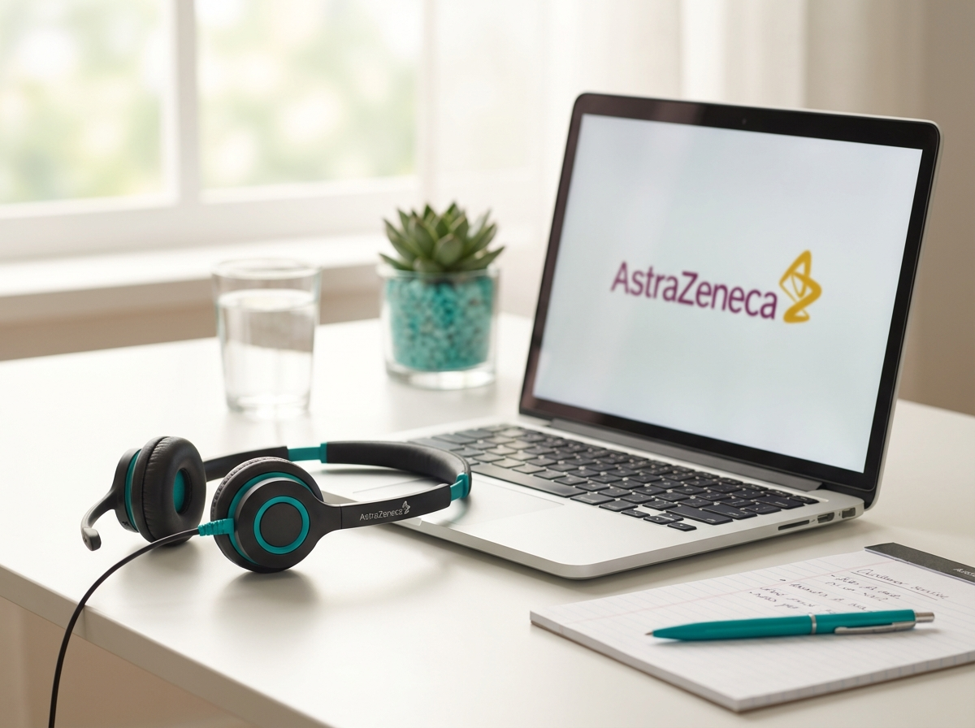
https://novapril-images.pages.dev/contact-support.jpeg
Usage: Dosing — patient link
Heading: Patient support and starter resources
Body text: Access the CALMARA patient eligibility checklist, starter kit request, and patient support hub enrolment.
Call to action: Access patient support → /calmara/patient-support
────────────────────────────────────────────────────────────

Section 5 — Prescribing information footer
Block: accordion | Expandable: PI | AE Reporting | References

Page metadata
Title: Dosing & Administration | CALMARA (calmazetine) | AstraZeneca UK
Description: CALMARA dosing: 120 mg once daily from Day 1 with no titration. Practical prescribing information.

PAGE 5: Patient Support
URL path: /calmara/patient-support
────────────────────────────────────────────────────────────

Section 1 — Page header
Block: title
Heading: Patient support for CALMARA® (calmazetine)
Body text: Practical resources to reduce administrative friction at first prescription
────────────────────────────────────────────────────────────

Section 2 — Support cards | light background
Block: cards-teaser
Section metadata: Style: light

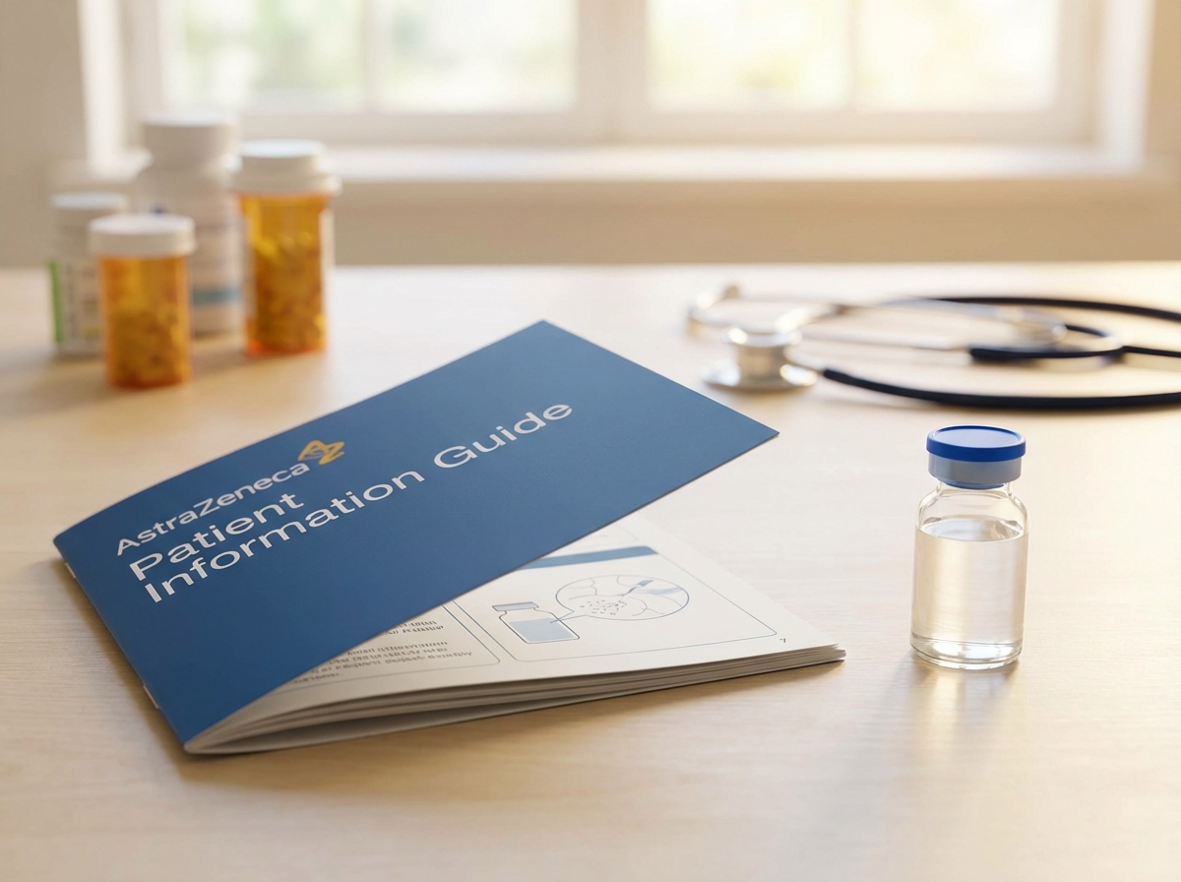
https://eluvion-images.pages.dev/resource-patient.jpeg
Usage: Patient Support — checklist
Card heading: Patient eligibility checklist
Card body: One-page checklist to confirm indication criteria during consultation. Downloadable PDF.
Card link: Download checklist → [PLACEHOLDER]
────────────────────────────────────────────────────────────

https://vitessa-images.pages.dev/contact-support.jpeg
Usage: Patient Support — hub
Card heading: Patient support hub enrolment
Card body: [PLACEHOLDER — hub details]
Card link: [PLACEHOLDER]
────────────────────────────────────────────────────────────
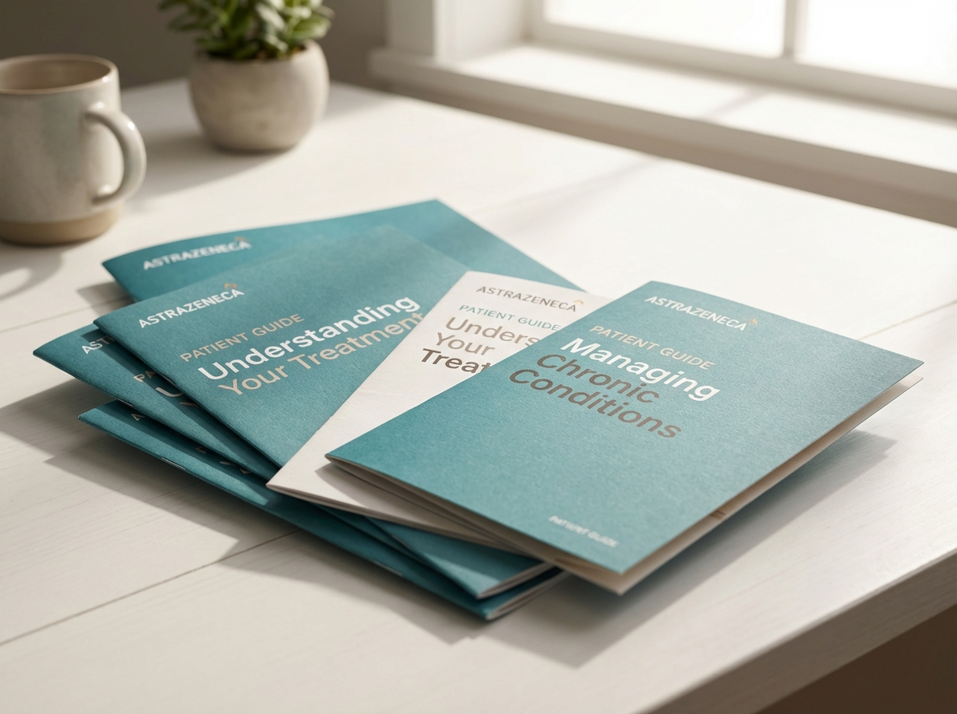
https://novapril-images.pages.dev/resource-patient.jpeg
Usage: Patient Support — co-pay
Card heading: Co-pay assistance and starter kit
Card body: [PLACEHOLDER — co-pay and starter kit details]
Card link: [PLACEHOLDER]
────────────────────────────────────────────────────────────

Section 3 — Eligibility criteria | highlight background
Block: columns-teaser
Section metadata: Style: highlight


https://novapril-images.pages.dev/hcp-consultation.jpeg
Usage: Patient Support — eligibility
Heading: Identifying appropriate patients for CALMARA
Body text: CALMARA is indicated for adults with GAD who have had an inadequate response to ≥1 SSRI or SNRI (failure to achieve remission HAM-A ≤7 after ≥8 weeks at adequate dose). Consider for patients who have cycled through multiple therapies or require a non-monoaminergic option.¹
Call to action: View dosing information → /calmara/dosing
────────────────────────────────────────────────────────────

Section 4 — Prescribing information footer
Block: accordion | Expandable: PI | AE Reporting | References

Page metadata
Title: Patient Support | CALMARA (calmazetine) | AstraZeneca UK
Description: Patient support for CALMARA including eligibility checklist, hub enrolment, and co-pay assistance for GAD patients.

PAGE 6: Resources
URL path: /calmara/resources
────────────────────────────────────────────────────────────

Section 1 — Page header
Block: title
Heading: Resources for healthcare professionals
Body text: Prescribing information, publications, and clinical education for CALMARA® (calmazetine)
────────────────────────────────────────────────────────────

Section 2 — Resource cards | light background
Block: cards-teaser
Section metadata: Style: light

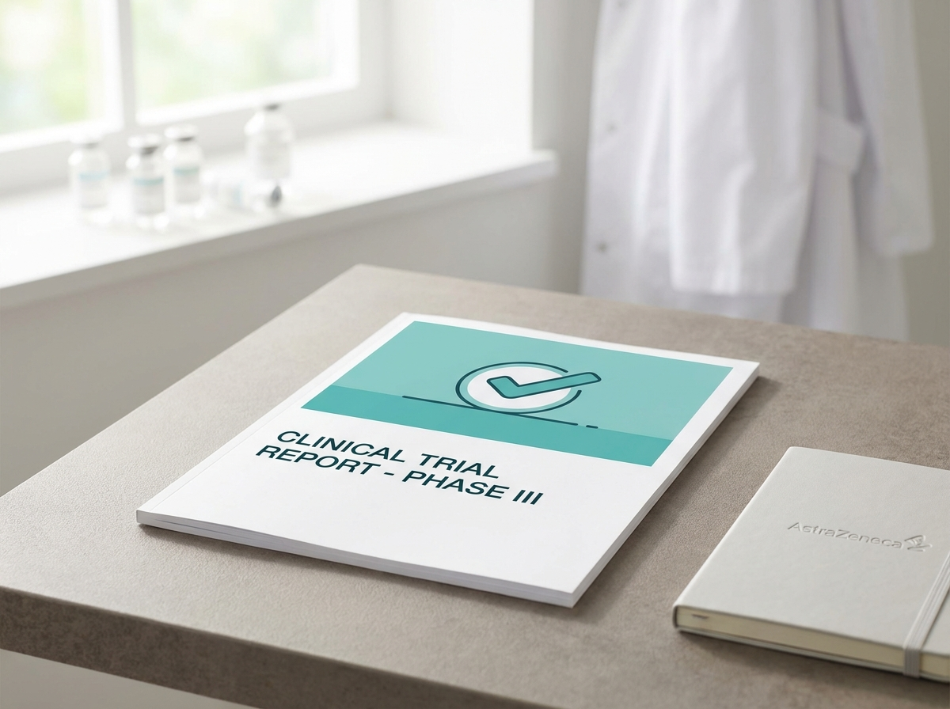
https://vitessa-images.pages.dev/resource-prescribing.jpeg
Usage: Resources — PI
Card heading: Prescribing Information
Card body: Full SmPC and PIL for CALMARA (calmazetine).
Card link: Download PI (PDF) → [PLACEHOLDER]
────────────────────────────────────────────────────────────

https://eluvion-images.pages.dev/resource-clinical.jpeg
Usage: Resources — publications
Card heading: SERENITY publications
Card body: Primary manuscripts for SERENITY-1, SERENITY-2, and OLE data.
Card link: View publications → [PLACEHOLDER]
────────────────────────────────────────────────────────────
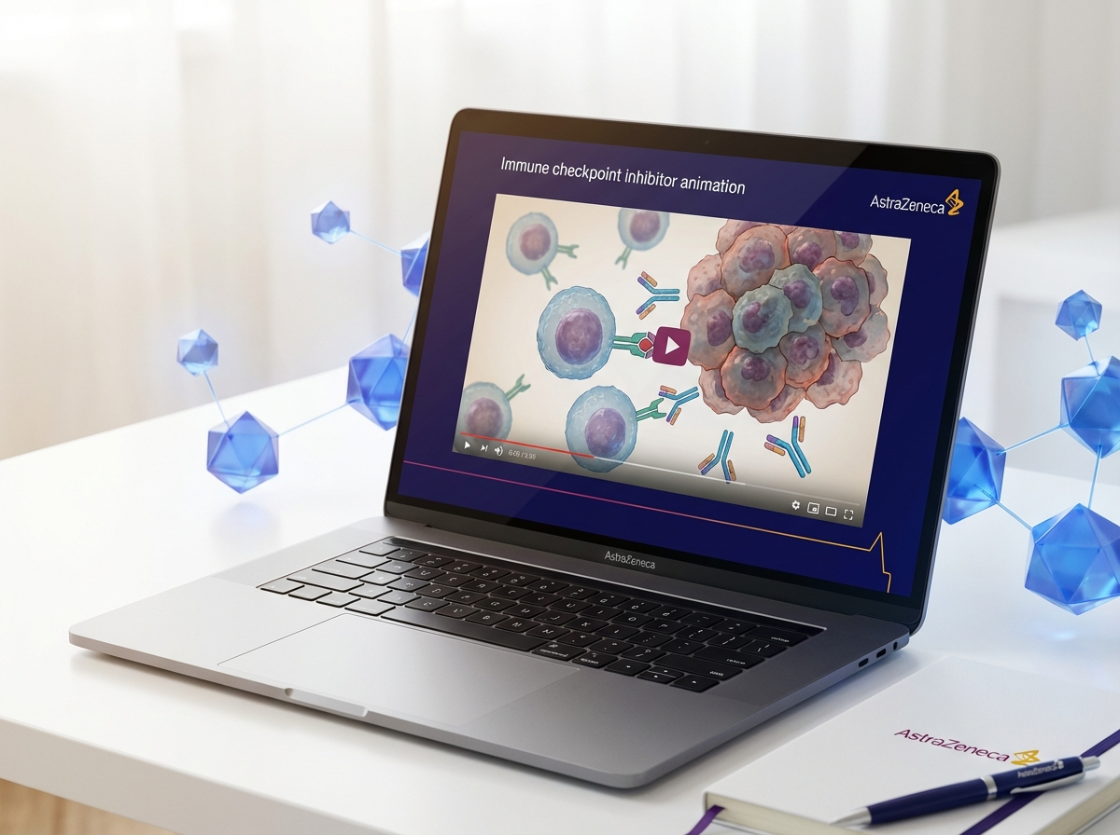
https://revantha-images.pages.dev/resource-education.jpeg
Usage: Resources — CME
Card heading: CME and patient education
Card body: Education modules, webinars, and patient materials for GAD management.
Card link: Explore CME resources → [PLACEHOLDER]
────────────────────────────────────────────────────────────

Section 3 — Contact | highlight background
Block: introduction
Section metadata: Style: highlight
Heading: Medical information enquiries
Body text: For medical information about CALMARA or any AstraZeneca product, visit contactazmedical.astrazeneca.com or call 0800 783 0033.
────────────────────────────────────────────────────────────

Section 4 — Prescribing information footer
Block: accordion | Expandable: PI | AE Reporting | References

Page metadata
Title: HCP Resources | CALMARA (calmazetine) | AstraZeneca UK
Description: Prescribing information, SERENITY publications, and CME for CALMARA in generalised anxiety disorder.

10. Footer Content
- Logo: AstraZeneca logo (linked to /calmara/)
- Approval code: [GB-XXXXX] | DOP: [Month Year]
- Copyright: © [Year] AstraZeneca. All rights reserved. CALMARA is a registered trademark of the AstraZeneca group of companies.
- Page links: Efficacy | Safety | Dosing & Administration | Patient Support | Resources
- Regulatory links: Report Adverse Event | Medical Information | Privacy Policy | Terms of Use | Accessibility
- Date of preparation: Date of Preparation: [Month Year]
────────────────────────────────────────────────────────────

11. Image Assets
All images reused from existing site CDNs. Contingency images noted for therapy-area-specific generation.
Filename | Usage | Source CDN URL
hero-home.jpeg | Home — hero | https://lumivex-images.pages.dev/hero-home.jpeg
pathway-cascade.jpeg | Home — MoA | https://eluvion-images.pages.dev/pathway-cascade.jpeg
card-efficacy.jpeg | Home — remission | https://revantha-images.pages.dev/card-efficacy.jpeg
card-safety.jpeg | Home — safety | https://eluvion-images.pages.dev/card-safety.jpeg
card-dosing.jpeg | Home — dosing | https://zenturis-images.pages.dev/card-dosing.jpeg
tab-luminance1.jpeg | Efficacy — slide 1 | https://lumivex-images.pages.dev/tab-luminance1.jpeg
tab-zenith1.jpeg | Efficacy — slide 2 | https://zenturis-images.pages.dev/tab-zenith1.jpeg
tab-luminos1.jpeg | Efficacy — slide 3 | https://treluxia-images.pages.dev/tab-luminos1.jpeg
tab-luminance2.jpeg | Efficacy — slide 4 | https://lumivex-images.pages.dev/tab-luminance2.jpeg
trial1-results.jpeg | Efficacy — onset | https://eluvion-images.pages.dev/trial1-results.jpeg
columns-longterm.jpeg | Efficacy — OLE | https://lumivex-images.pages.dev/columns-longterm.jpeg
card-selectivity.jpeg | Safety — somnolence | https://lumivex-images.pages.dev/card-selectivity.jpeg
card-safety.jpeg | Safety — dependence | https://novapril-images.pages.dev/card-safety.jpeg
safety-monitoring.jpeg | Safety — cortisol | https://novapril-images.pages.dev/safety-monitoring.jpeg
columns-monitoring.jpeg | Safety — CV/renal | https://lumivex-images.pages.dev/columns-monitoring.jpeg
columns-admin.jpeg | Dosing — regimen | https://zenturis-images.pages.dev/columns-admin.jpeg
contact-support.jpeg | Dosing — patient | https://novapril-images.pages.dev/contact-support.jpeg
resource-patient.jpeg | Support — checklist | https://eluvion-images.pages.dev/resource-patient.jpeg
contact-support.jpeg | Support — hub | https://vitessa-images.pages.dev/contact-support.jpeg
hcp-consultation.jpeg | Support — eligibility | https://novapril-images.pages.dev/hcp-consultation.jpeg
resource-prescribing.jpeg | Resources — PI | https://vitessa-images.pages.dev/resource-prescribing.jpeg
resource-clinical.jpeg | Resources — pubs | https://eluvion-images.pages.dev/resource-clinical.jpeg
resource-education.jpeg | Resources — CME | https://revantha-images.pages.dev/resource-education.jpeg

────────────────────────────────────────────────────────────

12. Imagery Direction
Per the original briefing:
- Anxiety is invisible. Avoid visual metaphors: head-holding, dark silhouettes, isolation, hands clasped in worry.
- Communicate competence, scientific rigour, and understanding of the patient population.
- Patients in contexts suggesting restored function: working, conversation, ordinary daily life.
- Diverse demographics reflecting GAD prevalence across age, gender, and ethnicity.
- HCP imagery: professional and attentive in consultation settings. No "empathic smile" stock trope.
- MoA illustrations: clean, proportionate, scientifically plausible. No "neural network" abstractions.
- Restrained colour palette: off-white base, dark slate text, one restrained accent.
- No high-saturation wellness palettes, gradient backgrounds, or consumer advertising aesthetics.
- Generous whitespace. Dense layouts signal consumer advertising, not clinical reference.

Contingency images for generation if reused images are too generic:
Filename | Usage | Description
moa-hpa-axis.jpeg | MoA diagram | [GENERATE] Tier 3: Illustrated HPA axis — hypothalamus, pituitary with V1b highlighted, adrenal cortex. AVP/CRH pathways. Steel blue + muted gold. White background.
hero-calmara.jpeg | Home hero | [GENERATE] Tier 2: Person in 40s at desk, focused work, natural window light, calm expression, diverse. Conveys restored function, not wellness.

