NYVEX®
(nyvexabart)

Website Briefing

Selective IL-31Rα blockade for moderate-to-severe prurigo nodularis

Document type: Draft marketing brief for HCP website build
Prepared by: Marketing — UK Dermatology Franchise
Approval status: Draft v1.0 — indicative copy, pending MLR review
Date: March 2026
Approval code: [GB-XXXXX — assign before MLR submission]

Contents
1. Drug Profile
2. Mechanism of Action
3. Clinical Programme: RESOLVE
4. Safety Profile
5. Prescribing Information
6. Adverse Event Reporting
7. References
8. Site Navigation
9. Page Content
Page 1: Home
Page 2: Efficacy
Page 3: Safety
Page 4: Dosing & Administration
Page 5: Patient Support
Page 6: Resources
10. Footer Content
11. Image Assets
12. Imagery Direction

1. Drug Profile
Field | Detail
Brand name | NYVEX
Generic name | nyvexabart
Drug class | Fully human IgG1 monoclonal antibody, anti-IL-31 receptor alpha (IL-31Rα)
Indication | Treatment of moderate-to-severe prurigo nodularis (PN) in adults whose disease is inadequately controlled with topical therapies
Formulation | 180 mg solution for injection in a prefilled autoinjector
Dosing | 360 mg (2 × 180 mg) loading dose at Week 0, then 180 mg SC once every 4 weeks
Approval | MHRA — [PLACEHOLDER — date to be confirmed]
Brand colour | #2B6E8A (slate teal)
Accent colour | #D47B3E (warm amber)
Approval code | [GB-XXXXX — assign before MLR submission]

NYVEX brand rule: NYVEX always appears in capitals, with ® on first mention per page. Generic name (nyvexabart) appears in lowercase parentheses on first mention.
────────────────────────────────────────────────────────────

2. Mechanism of Action
NYVEX (nyvexabart) is a fully human IgG1 monoclonal antibody that selectively binds to the interleukin-31 receptor alpha subunit (IL-31Rα), blocking IL-31 signalling.¹
Prurigo nodularis is driven by a self-reinforcing neuroimmune feedback loop. IL-31, produced predominantly by activated Th2 cells, acts on IL-31Rα expressed on sensory neurons and keratinocytes. This signalling drives the intense, chronic pruritus that defines PN. Persistent scratching in response to pruritus leads to nodule formation, which further amplifies the itch-scratch cycle.¹ ²
By selectively blocking IL-31Rα, NYVEX:
- Blocks IL-31Rα on sensory neurons, interrupting the neural itch signal¹
- Reduces keratinocyte-mediated inflammatory signalling downstream of IL-31¹
- Breaks the itch-scratch-nodule feedback loop that perpetuates disease¹ ²
- Does not result in broad immunosuppression — selectivity for IL-31Rα avoids the off-target effects associated with dual IL-4Rα blockade¹

Unlike agents that target the IL-4/IL-13 pathway, NYVEX selectively neutralises IL-31 signalling. Conjunctivitis, a recognised class effect of IL-4/IL-13 pathway inhibitors, was not observed at increased rates with NYVEX in clinical trials — consistent with its selective mechanism of action.¹
────────────────────────────────────────────────────────────

3. Clinical Programme: RESOLVE
The NYVEX approval is supported by the RESOLVE programme — two Phase III, randomised, double-blind, placebo-controlled trials conducted in adults with moderate-to-severe prurigo nodularis.³ ⁴

RESOLVE-1 and RESOLVE-2 (pooled analysis)
Design: Randomised, double-blind, placebo-controlled
Population: 612 adults with confirmed moderate-to-severe PN (IGA-PN ≥ 3, minimum 20 nodules)
Duration: 24 weeks
Primary endpoint: Proportion of patients achieving IGA-PN 0/1 (clear or almost clear) at Week 24
Key secondary endpoints: WI-NRS itch reduction, DLQI, nodule count reduction, sleep disturbance improvement
Publication: [PLACEHOLDER — requires reference details]

Primary endpoint:
Endpoint | NYVEX | Placebo | P-value
IGA-PN 0/1 (clear or almost clear) at Week 24 | 58.3% | 16.1% | p < 0.0001

Key secondary endpoints (Week 24):
Endpoint | NYVEX | Placebo
≥4-point reduction in WI-NRS (worst itch) | 67.4% | 20.8%
DLQI 0/1 (no impact on quality of life) | 44.1% | 11.3%
Reduction in active nodule count ≥75% | 61.8% | 18.4%
Sleep disturbance NRS improvement ≥3 pts | 55.2% | 17.9%

Onset of action
A meaningful reduction in WI-NRS (≥4 points) was observed as early as Week 2 in a proportion of patients, with separation from placebo reaching statistical significance from Week 4 onward.³ ⁴
────────────────────────────────────────────────────────────

4. Safety Profile
The overall safety profile of NYVEX was consistent with its mechanism of action.³ ⁴

Most common adverse events (≥5% in NYVEX arm)
Adverse event | NYVEX | Placebo
Injection site reactions | 8.4% | [PLACEHOLDER]
Nasopharyngitis | 7.1% | [PLACEHOLDER]
Headache | 5.6% | [PLACEHOLDER]

Key safety findings
No meaningful increase in serious infections compared to placebo³ ⁴
No increase in malignancies compared to placebo³ ⁴
No increase in major cardiovascular events compared to placebo³ ⁴
Conjunctivitis (IL-4/IL-13 class effect) was not observed at increased rates with NYVEX — consistent with selective IL-31Rα targeting¹

Special populations
[PLACEHOLDER — requires SmPC data for renal impairment, hepatic impairment, elderly, pregnancy/lactation]
────────────────────────────────────────────────────────────

5. Prescribing Information (abbreviated — for every page footer)
NYVEX (nyvexabart) 180 mg solution for injection in a prefilled autoinjector. Please refer to the Summary of Product Characteristics (SmPC) before prescribing. Indication: Treatment of moderate-to-severe prurigo nodularis in adults whose disease is inadequately controlled with topical therapies. Dosage and administration: 360 mg (two 180 mg injections) loading dose at Week 0, then 180 mg subcutaneously once every 4 weeks. Intended for self-administration after appropriate training. Contraindications: [PLACEHOLDER]. Warnings and precautions: [PLACEHOLDER]. Interactions: [PLACEHOLDER]. Side effects: Common (≥1/100 to <1/10): Injection site reactions, nasopharyngitis, headache. Legal category: POM. Pack and price: [PLACEHOLDER]. Marketing authorisation holder: AstraZeneca UK Ltd. MA number: [PLACEHOLDER — PLGB XXXXX/XXXX]. Full prescribing information available from: AstraZeneca UK Ltd, 2 Pancras Square, London N1C 4AG. [GB-XXXXX] | DOP: [Month Year]
────────────────────────────────────────────────────────────

6. Adverse Event Reporting (for every page footer)
Adverse events should be reported. Reporting forms and information can be found at www.mhra.gov.uk/yellowcard or search for MHRA Yellow Card in the Google Play or Apple App Store. Adverse events should also be reported to AstraZeneca by visiting contactazmedical.astrazeneca.com or by calling 0800 783 0033.
────────────────────────────────────────────────────────────

7. References (for every page footer)
1. [PLACEHOLDER — NYVEX SmPC. AstraZeneca UK Ltd. Date.]
2. [PLACEHOLDER — PN pathophysiology reference. Authors. Journal Year; Volume: Pages.]
3. [PLACEHOLDER — RESOLVE-1 publication. Authors. Journal Year; Volume: Pages.]
4. [PLACEHOLDER — RESOLVE-2 publication. Authors. Journal Year; Volume: Pages.]
5. [PLACEHOLDER — PN epidemiology reference, UK-specific data.]
6. [PLACEHOLDER — PN burden/QoL reference.]
────────────────────────────────────────────────────────────

8. Site Navigation
Top bar links: Contact Us (https://www.astrazeneca.co.uk/contact-us.html) | AZ Employee Login (https://login.astrazeneca.com)
Main navigation pages: Efficacy | Safety | Dosing & Administration | Patient Support | Resources
Utility: Search | Login

9. Page Content
Copy below is indicative and may be adapted for web presentation while preserving all clinical claims and data points verbatim.
Each page must end with expandable sections for Prescribing Information, Adverse Event Reporting, and References (see sections 5, 6, and 7 above).
NYVEX brand rule: NYVEX always appears in capitals, with ® on first mention per page. Generic name (nyvexabart) in lowercase parentheses on first mention.
────────────────────────────────────────────────────────────

PAGE 1: Home
URL path: /nyvex/
────────────────────────────────────────────────────────────

Section 1 — Hero (full-width image with text overlay)
Block: hero-teaser


https://treluxia-images.pages.dev/hero-home.jpeg
Usage: Home — hero
Heading: NYVEX® (nyvexabart) — selective IL-31Rα blockade for moderate-to-severe prurigo nodularis
Body text: NYVEX is indicated for the treatment of moderate-to-severe prurigo nodularis in adults whose disease is inadequately controlled with topical therapies.¹
Call to action: See clinical data → /nyvex/efficacy
Call to action: View Prescribing Information → /nyvex/resources
────────────────────────────────────────────────────────────

Section 2 — MoA teaser (two-column: image left, text right) | light background
Block: columns-teaser
Section metadata: Style: light

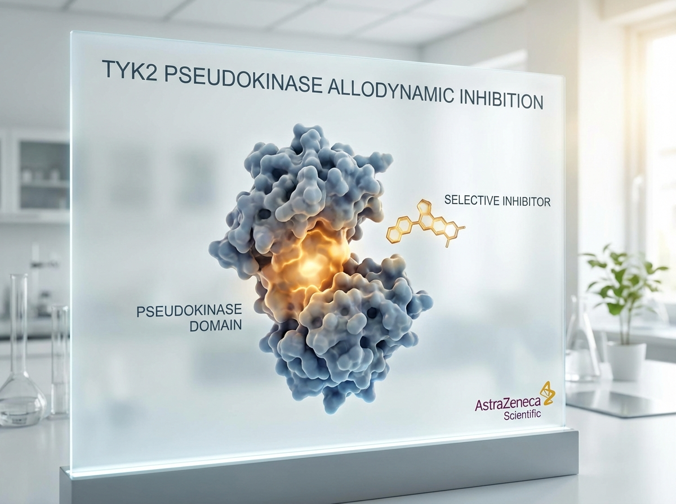
https://lumivex-images.pages.dev/columns-moa.jpeg
Usage: Home — MoA teaser
Heading: Selectively interrupting the neuroimmune itch cycle
Body text: NYVEX blocks IL-31Rα signalling — the key driver of chronic pruritus and nodule formation in PN. Unlike IL-4/IL-13 pathway inhibitors, NYVEX does not result in broad immunosuppression.¹
Call to action: Explore mechanism of action → /nyvex/efficacy
────────────────────────────────────────────────────────────

Section 3 — Primary efficacy headline (centred text) | highlight background
Block: introduction
Section metadata: Style: highlight
Heading: 58.3% of patients achieved clear or almost clear skin at Week 24
Body text: IGA-PN 0/1 response rate with NYVEX versus 16.1% with placebo (p < 0.0001) in the RESOLVE Phase III programme.³ ⁴
────────────────────────────────────────────────────────────

Section 4 — Key outcome cards (three equal columns)
Block: cards-teaser


https://vitessa-images.pages.dev/card-efficacy.jpeg
Usage: Home — itch reduction card
Card heading: Itch reduction from Week 2
Card body: 67.4% of patients achieved a clinically meaningful reduction in worst itch (WI-NRS ≥4-point improvement) at Week 24.³ ⁴
Card link: View efficacy data → /nyvex/efficacy
────────────────────────────────────────────────────────────

https://novapril-images.pages.dev/card-safety.jpeg
Usage: Home — safety card
Card heading: Safety consistent with mechanism
Card body: No increase in serious infections, malignancies, or major cardiovascular events versus placebo. Conjunctivitis not observed.³ ⁴
Card link: View safety profile → /nyvex/safety
────────────────────────────────────────────────────────────

https://treluxia-images.pages.dev/card-clinical-data.jpeg
Usage: Home — dosing card
Card heading: Simple once-monthly dosing
Card body: 180 mg subcutaneous injection once every 4 weeks via prefilled autoinjector, following a single loading dose.¹
Card link: See dosing information → /nyvex/dosing
────────────────────────────────────────────────────────────

Section 5 — Prescribing information footer
Block: accordion
Expandable sections for: Prescribing Information | Adverse Event Reporting | References

Page metadata
Title: NYVEX (nyvexabart) | Prurigo Nodularis Treatment | AstraZeneca UK
Description: NYVEX (nyvexabart) is a selective anti-IL-31Rα monoclonal antibody indicated for moderate-to-severe prurigo nodularis in adults. View efficacy data, safety, and prescribing information.

PAGE 2: Efficacy
URL path: /nyvex/efficacy
────────────────────────────────────────────────────────────

Section 1 — Page header (text only, no image)
Block: title
Heading: RESOLVE Phase III programme — clinical efficacy data
Body text: Two randomised, double-blind, placebo-controlled 24-week trials in 612 adults with moderate-to-severe PN (IGA-PN ≥ 3, minimum 20 nodules)³ ⁴
────────────────────────────────────────────────────────────

Section 2 — Headline statistics carousel (4 slides) | light background
Block: carousel-teaser
Section metadata: Style: light


https://treluxia-images.pages.dev/tab-luminos1.jpeg
Usage: Efficacy — carousel slide 1
Slide heading: 58.3% IGA-PN 0/1 at Week 24
Slide body: Clear or almost clear skin versus 16.1% with placebo (p < 0.0001). RESOLVE-1 and RESOLVE-2 pooled analysis.³ ⁴
────────────────────────────────────────────────────────────
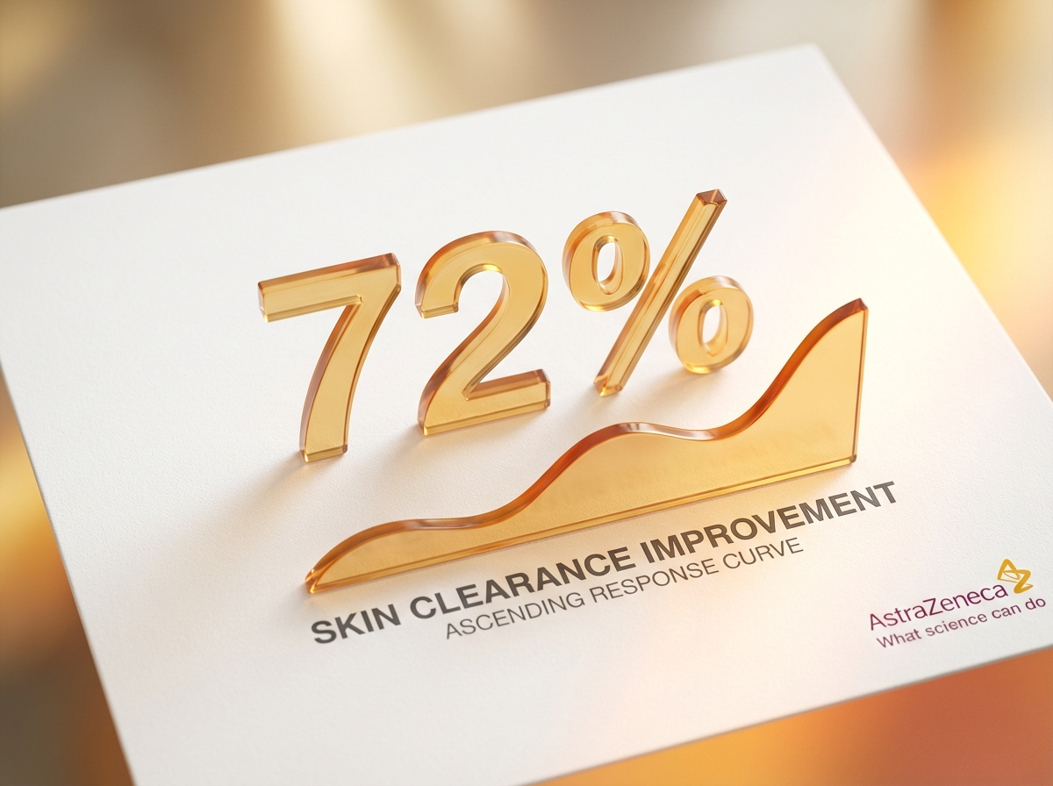
https://lumivex-images.pages.dev/tab-luminance1.jpeg
Usage: Efficacy — carousel slide 2
Slide heading: 67.4% achieved meaningful itch relief
Slide body: ≥4-point reduction in WI-NRS (worst itch) versus 20.8% with placebo at Week 24.³ ⁴
────────────────────────────────────────────────────────────
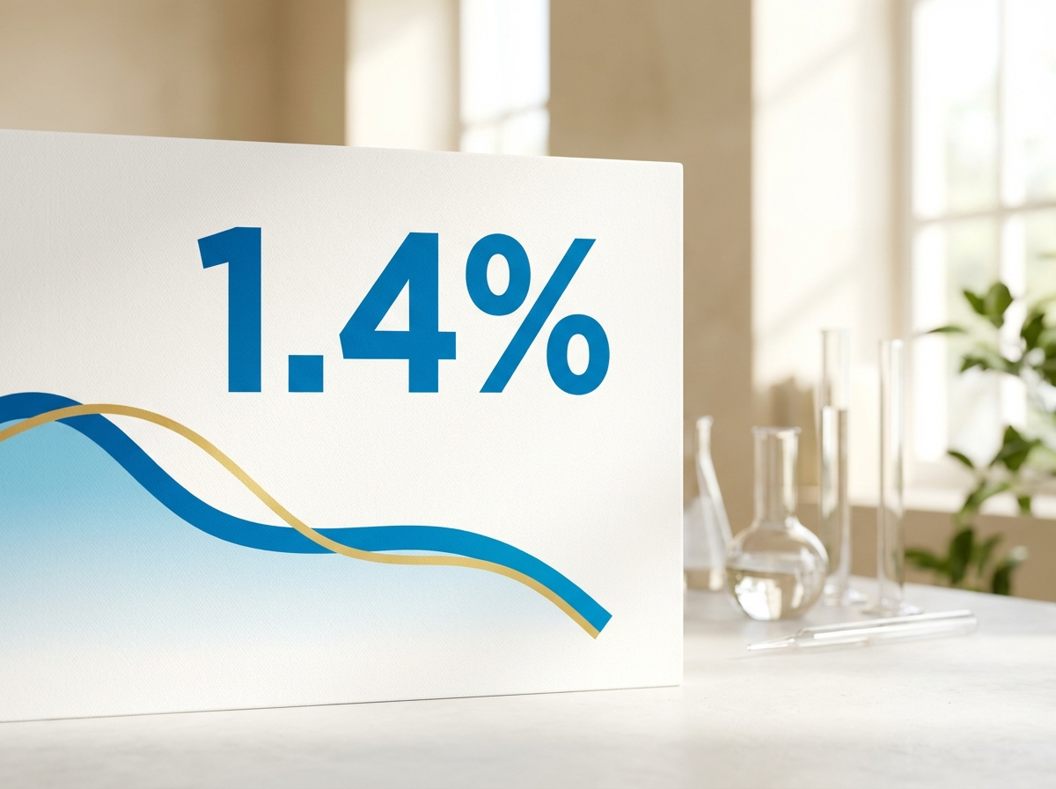
https://zenturis-images.pages.dev/tab-zenith1.jpeg
Usage: Efficacy — carousel slide 3
Slide heading: 61.8% nodule reduction ≥75%
Slide body: Reduction in active nodule count versus 18.4% with placebo at Week 24.³ ⁴
────────────────────────────────────────────────────────────
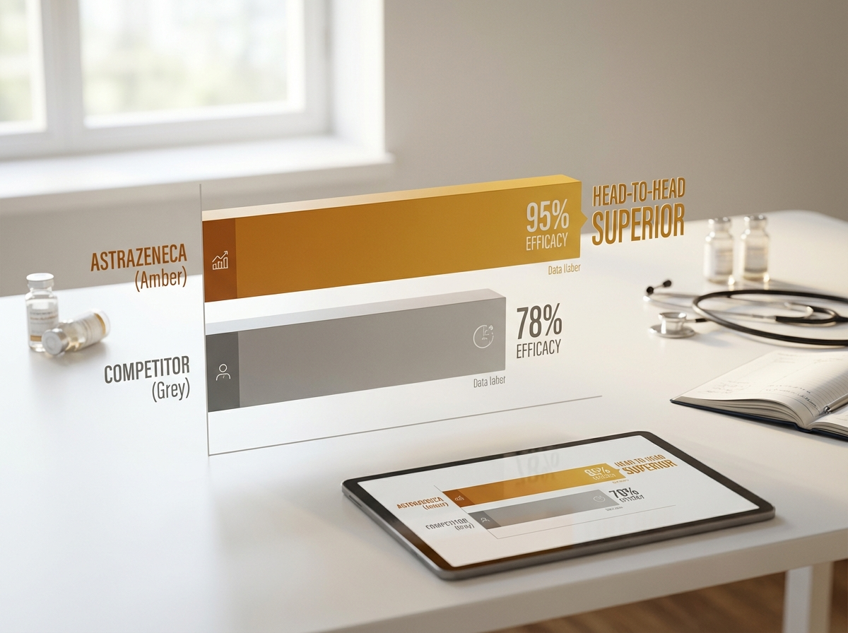
https://lumivex-images.pages.dev/tab-luminance2.jpeg
Usage: Efficacy — carousel slide 4
Slide heading: Itch relief as early as Week 2
Slide body: Meaningful WI-NRS reduction observed from Week 2, with statistically significant separation from placebo from Week 4 onward.³ ⁴
────────────────────────────────────────────────────────────

Section 3 — Primary endpoint detail (two-column) | highlight background
Block: columns-teaser
Section metadata: Style: highlight


https://eluvion-images.pages.dev/trial1-results.jpeg
Usage: Efficacy — primary endpoint
Heading: Primary endpoint — IGA-PN 0/1 at Week 24
Body text: 58.3% of patients treated with NYVEX achieved an IGA-PN score of 0 (clear) or 1 (almost clear) at Week 24, compared with 16.1% of patients receiving placebo (p < 0.0001). RESOLVE-1 and RESOLVE-2 were two independent Phase III trials with consistent results across both studies.³ ⁴
────────────────────────────────────────────────────────────

Section 4 — Full results table | light background
Block: table-data
Section metadata: Style: light
Endpoint (Week 24) | NYVEX | Placebo
IGA-PN 0/1 (clear or almost clear) | 58.3% | 16.1% (p < 0.0001)
≥4-point reduction in WI-NRS (worst itch) | 67.4% | 20.8%
DLQI 0/1 (no impact on quality of life) | 44.1% | 11.3%
Reduction in active nodule count ≥75% | 61.8% | 18.4%
Sleep disturbance NRS improvement ≥3 pts | 55.2% | 17.9%

[Note: Full results table with confidence intervals requires medical review]
────────────────────────────────────────────────────────────

Section 5 — Quality of life outcomes (two-column)
Block: columns-teaser


https://vitessa-images.pages.dev/contact-support.jpeg
Usage: Efficacy — QoL section
Heading: Impact on quality of life and sleep
Body text: 44.1% of patients achieved DLQI 0/1 (no impact on quality of life) at Week 24 versus 11.3% with placebo. Sleep disturbance also improved, with 55.2% achieving ≥3-point improvement on the sleep NRS versus 17.9% with placebo.³ ⁴
Call to action: View safety profile → /nyvex/safety
────────────────────────────────────────────────────────────

Section 6 — Prescribing information footer
Block: accordion | Expandable: PI | AE Reporting | References

Page metadata
Title: Efficacy Data | NYVEX (nyvexabart) | RESOLVE Phase III | AstraZeneca UK
Description: RESOLVE Phase III clinical data for NYVEX (nyvexabart) in moderate-to-severe prurigo nodularis. 58.3% achieved clear or almost clear skin at Week 24 vs 16.1% placebo.

PAGE 3: Safety
URL path: /nyvex/safety
────────────────────────────────────────────────────────────

Section 1 — Page header (text only)
Block: title
Heading: Safety profile of NYVEX® (nyvexabart)
Body text: Evaluated across the RESOLVE Phase III programme in 612 adults with moderate-to-severe prurigo nodularis³ ⁴
────────────────────────────────────────────────────────────

Section 2 — Safety summary (centred text) | light background
Block: introduction
Section metadata: Style: light
Heading: Safety profile consistent with the mechanism of action
Body text: The overall safety profile of NYVEX was consistent with selective IL-31Rα blockade. No broad immunosuppressive effects were observed.³ ⁴
────────────────────────────────────────────────────────────

Section 3 — Common adverse events table | highlight background
Block: table-data
Section metadata: Style: highlight
Adverse event (≥5% in NYVEX arm) | NYVEX | Placebo
Injection site reactions | 8.4% | [PLACEHOLDER]
Nasopharyngitis | 7.1% | [PLACEHOLDER]
Headache | 5.6% | [PLACEHOLDER]

────────────────────────────────────────────────────────────

Section 4 — Key safety findings (three equal columns) | light background
Block: cards-teaser
Section metadata: Style: light

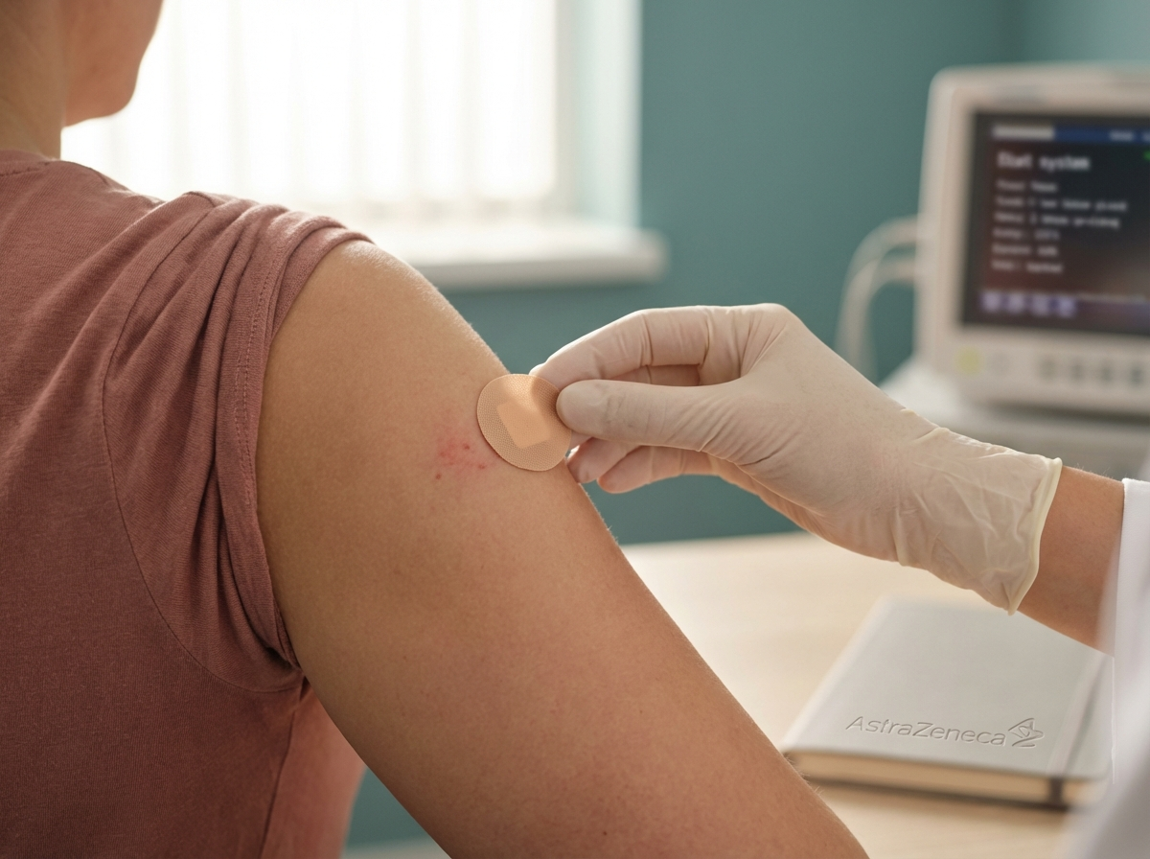
https://vitessa-images.pages.dev/safety-injection.jpeg
Usage: Safety — ISR card
Card heading: Injection site reactions
Card body: The most commonly reported adverse event (8.4%). Injection site reactions were generally mild and did not lead to treatment discontinuation.³ ⁴
────────────────────────────────────────────────────────────

https://novapril-images.pages.dev/safety-monitoring.jpeg
Usage: Safety — infections card
Card heading: No increase in serious infections
Card body: No meaningful increase in serious infections, malignancies, or major cardiovascular events was observed compared to placebo.³ ⁴
────────────────────────────────────────────────────────────
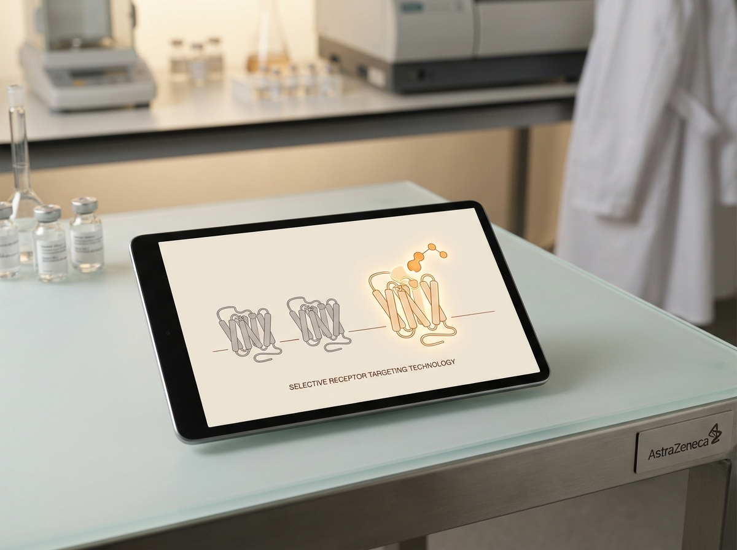
https://lumivex-images.pages.dev/card-selectivity.jpeg
Usage: Safety — selectivity card
Card heading: Selective IL-31Rα targeting
Card body: Conjunctivitis, a class effect of IL-4/IL-13 pathway inhibitors, was not observed at increased rates — consistent with NYVEX's selective mechanism.¹
────────────────────────────────────────────────────────────

Section 5 — Prescribing information footer
Block: accordion | Expandable: PI | AE Reporting | References

Page metadata
Title: Safety Profile | NYVEX (nyvexabart) | AstraZeneca UK
Description: Safety data for NYVEX (nyvexabart) from the RESOLVE Phase III programme. Most common adverse events were injection site reactions, nasopharyngitis, and headache.

PAGE 4: Dosing & Administration
URL path: /nyvex/dosing
────────────────────────────────────────────────────────────

Section 1 — Page header (text only)
Block: title
Heading: Dosing and administration of NYVEX® (nyvexabart)
Body text: Simple once-monthly subcutaneous injection via prefilled autoinjector¹
────────────────────────────────────────────────────────────

Section 2 — Dosing regimen (two-column) | highlight background
Block: columns-teaser
Section metadata: Style: highlight

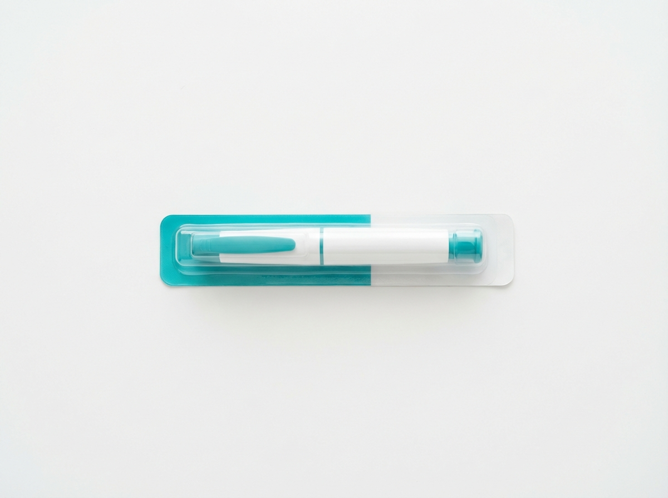
https://treluxia-images.pages.dev/columns-dosing.jpeg
Usage: Dosing — schedule
Heading: Dosing schedule
Body text: Loading dose (Week 0): 360 mg administered as two consecutive 180 mg subcutaneous injections. Maintenance dose: 180 mg subcutaneously once every 4 weeks, starting from Week 4. NYVEX is supplied as a prefilled autoinjector intended for self-administration after appropriate training.¹
────────────────────────────────────────────────────────────

Section 3 — Administration details (expandable sections) | light background
Block: accordion
Section metadata: Style: light

Panel 1: "Injection site guidance"
Body text: NYVEX should be injected subcutaneously into the thigh, abdomen (avoiding the 5 cm area around the navel), or upper arm (if administered by a caregiver). Injection sites should be rotated with each dose. Do not inject into areas where the skin is tender, bruised, red, or hard.¹

Panel 2: "Storage conditions"
Body text: Store in a refrigerator (2–8°C). Do not freeze. Keep in the outer carton to protect from light. Prior to use, NYVEX may be kept at room temperature (up to 25°C) for a maximum of 14 days. [PLACEHOLDER — confirm storage details from SmPC]

Panel 3: "Preparation steps"
Body text: Remove the autoinjector from the refrigerator and allow to reach room temperature for approximately 30 minutes before use. Do not warm by any other means. Inspect visually — the solution should be clear to slightly opalescent, colourless to pale yellow. Do not use if the solution is cloudy, discoloured, or contains particles. [PLACEHOLDER — confirm from IFU]

Panel 4: "Missed dose guidance"
Body text: If a dose is missed, administer as soon as possible. Then resume dosing at the regular scheduled time. [PLACEHOLDER — confirm missed dose window from SmPC]
────────────────────────────────────────────────────────────

Section 4 — Patient training (two-column)
Block: columns-teaser

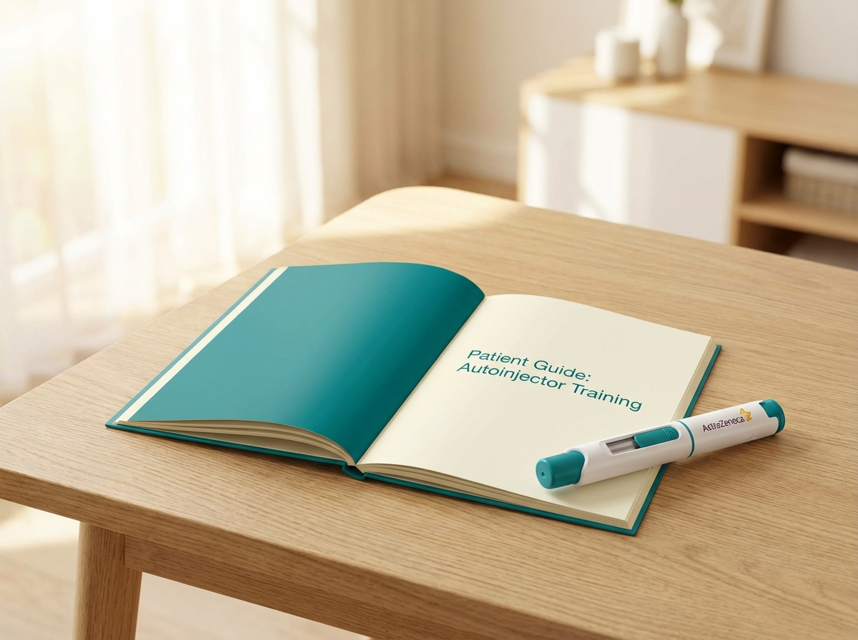
https://vitessa-images.pages.dev/resource-training.jpeg
Usage: Dosing — patient training
Heading: Patient training and support
Body text: Patients should receive training on proper subcutaneous injection technique before self-administering NYVEX. An Instructions for Use (IFU) document is provided with each autoinjector.
Call to action: Access patient resources → /nyvex/patient-support
────────────────────────────────────────────────────────────

Section 5 — Prescribing information footer
Block: accordion | Expandable: PI | AE Reporting | References

Page metadata
Title: Dosing & Administration | NYVEX (nyvexabart) | AstraZeneca UK
Description: NYVEX dosing schedule, injection guidance, storage conditions, and preparation steps. 180 mg once every 4 weeks via prefilled autoinjector after a 360 mg loading dose.

PAGE 5: Patient Support
URL path: /nyvex/patient-support
────────────────────────────────────────────────────────────

Section 1 — Page header (text only)
Block: title
Heading: Patient support for NYVEX® (nyvexabart)
Body text: Resources to support your patients starting and continuing treatment
────────────────────────────────────────────────────────────

Section 2 — Support programmes (three equal columns) | light background
Block: cards-teaser
Section metadata: Style: light

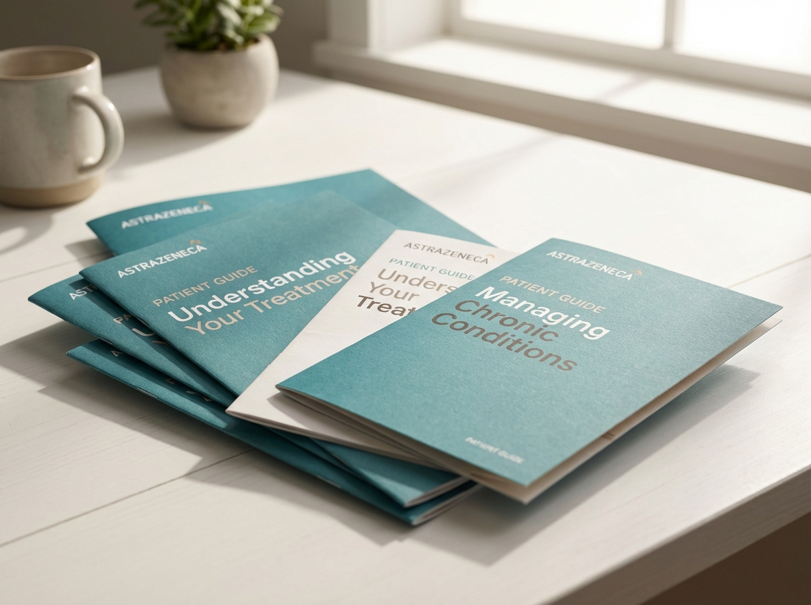
https://novapril-images.pages.dev/resource-patient.jpeg
Usage: Patient Support — copay card
Card heading: Co-pay assistance programme
Card body: [PLACEHOLDER — copay programme details. Include eligibility criteria, enrolment process, and contact information when available.]
Card link: [PLACEHOLDER — enrolment link]
────────────────────────────────────────────────────────────

https://novapril-images.pages.dev/contact-support.jpeg
Usage: Patient Support — hub card
Card heading: Patient hub enrolment
Card body: [PLACEHOLDER — patient hub/support programme details. Include what the hub provides: injection training, adherence support, nurse follow-up.]
Card link: [PLACEHOLDER — hub link]
────────────────────────────────────────────────────────────

https://vitessa-images.pages.dev/resource-training.jpeg
Usage: Patient Support — training card
Card heading: Injection training resources
Card body: Training materials for patients and caregivers on how to use the NYVEX prefilled autoinjector. Includes step-by-step guides and instructional videos.
Card link: View dosing guide → /nyvex/dosing
────────────────────────────────────────────────────────────

Section 3 — Patient selection (two-column) | highlight background
Block: columns-teaser
Section metadata: Style: highlight


https://novapril-images.pages.dev/hcp-consultation.jpeg
Usage: Patient Support — patient selection
Heading: Patient selection checklist
Body text: NYVEX is indicated for adults with moderate-to-severe prurigo nodularis (IGA-PN ≥ 3, minimum 20 nodules) whose disease is inadequately controlled with topical therapies. Consider NYVEX for patients experiencing significant itch burden, sleep disruption, or quality of life impairment despite optimised topical treatment.¹
Call to action: Download patient selection guide → /nyvex/resources
────────────────────────────────────────────────────────────

Section 4 — Prescribing information footer
Block: accordion | Expandable: PI | AE Reporting | References

Page metadata
Title: Patient Support | NYVEX (nyvexabart) | AstraZeneca UK
Description: Patient support programmes for NYVEX including co-pay assistance, hub enrolment, and injection training resources for prurigo nodularis patients.

PAGE 6: Resources
URL path: /nyvex/resources
────────────────────────────────────────────────────────────

Section 1 — Page header (text only)
Block: title
Heading: Resources for healthcare professionals
Body text: Prescribing information, clinical resources, and educational materials for NYVEX® (nyvexabart)
────────────────────────────────────────────────────────────

Section 2 — Resource cards (three equal columns) | light background
Block: cards-teaser
Section metadata: Style: light

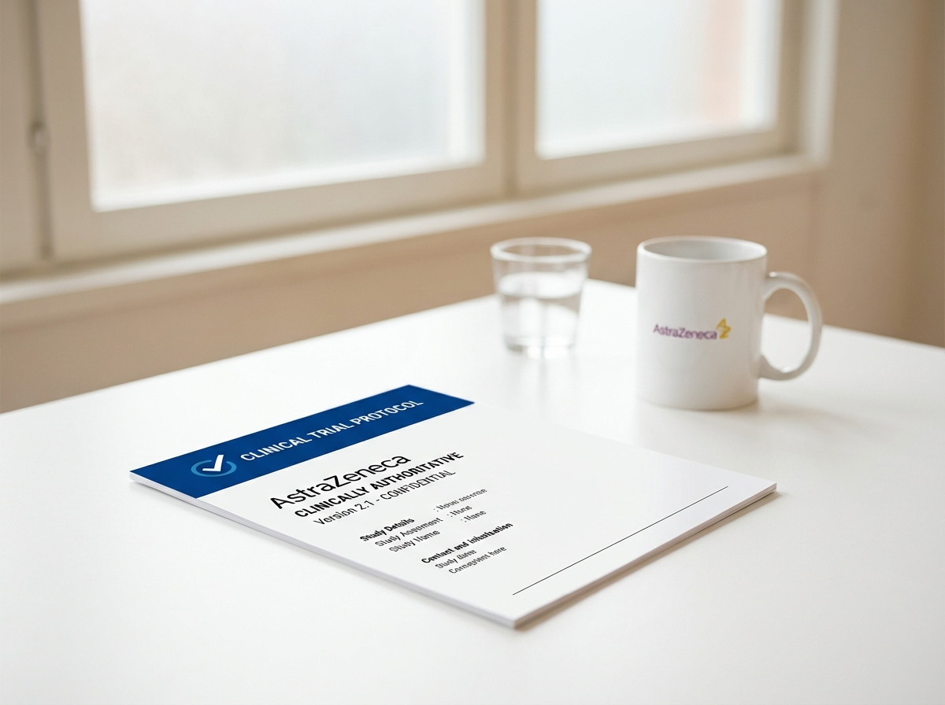
https://eluvion-images.pages.dev/resource-prescribing.jpeg
Usage: Resources — PI card
Card heading: Prescribing Information
Card body: Full Summary of Product Characteristics and Patient Information Leaflet for NYVEX (nyvexabart).
Card link: Download PI (PDF) → [PLACEHOLDER — PI PDF URL]
────────────────────────────────────────────────────────────

https://eluvion-images.pages.dev/resource-clinical.jpeg
Usage: Resources — patient selection guide
Card heading: Patient selection guide
Card body: A practical guide to identifying patients who may benefit from NYVEX treatment, including clinical criteria and assessment tools.
Card link: Download guide → [PLACEHOLDER — guide PDF URL]
────────────────────────────────────────────────────────────
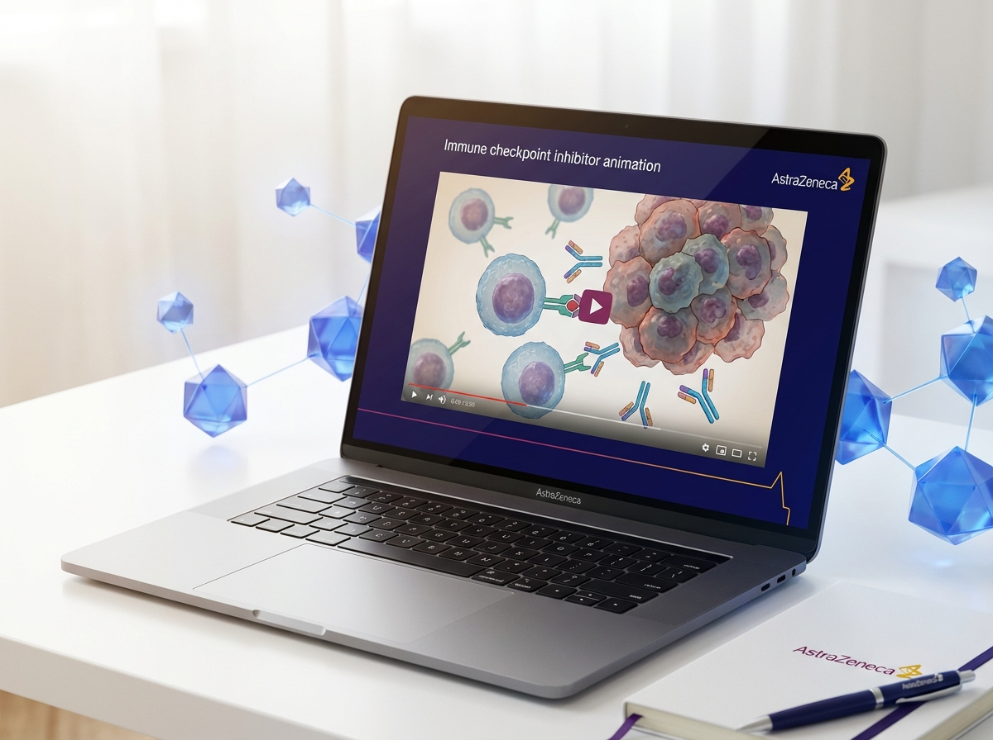
https://revantha-images.pages.dev/resource-education.jpeg
Usage: Resources — CME card
Card heading: CME and medical education
Card body: Links to continuing medical education modules, webinars, and published literature relevant to prurigo nodularis and IL-31 pathway biology.
Card link: Explore CME resources → [PLACEHOLDER — CME links]
────────────────────────────────────────────────────────────

Section 3 — Contact (centred text) | highlight background
Block: introduction
Section metadata: Style: highlight
Heading: Medical information enquiries
Body text: For medical information about NYVEX or any AstraZeneca product, visit contactazmedical.astrazeneca.com or call 0800 783 0033.
────────────────────────────────────────────────────────────

Section 4 — Prescribing information footer
Block: accordion | Expandable: PI | AE Reporting | References

Page metadata
Title: HCP Resources | NYVEX (nyvexabart) | AstraZeneca UK
Description: Prescribing information, patient selection guide, and CME resources for NYVEX (nyvexabart). Access clinical materials for prurigo nodularis management.

10. Footer Content
The footer must appear on every page and contain:
- Logo: AstraZeneca logo (linked to /nyvex/)
- Approval code: [GB-XXXXX] | DOP: [Month Year]
- Copyright: © [Year] AstraZeneca. All rights reserved. NYVEX is a registered trademark of the AstraZeneca group of companies.
- Page links: Efficacy | Safety | Dosing & Administration | Patient Support | Resources
- Regulatory links: Report Adverse Event (https://yellowcard.mhra.gov.uk/) | Medical Information (https://contactazmedical.astrazeneca.com/) | Privacy Policy (https://www.astrazeneca.co.uk/our-company/privacy-notice.html) | Terms of Use (https://www.astrazeneca.co.uk/our-company/terms-of-use.html) | Accessibility (https://www.astrazeneca.co.uk/accessibility.html)
- Date of preparation: Date of Preparation: [Month Year]
────────────────────────────────────────────────────────────

11. Image Assets
All images reused from existing site CDNs. No new images required for initial build.
Filename | Usage | Source CDN URL
hero-home.jpeg | Home — hero | https://treluxia-images.pages.dev/hero-home.jpeg
columns-moa.jpeg | Home — MoA teaser | https://lumivex-images.pages.dev/columns-moa.jpeg
card-efficacy.jpeg | Home — itch card | https://vitessa-images.pages.dev/card-efficacy.jpeg
card-safety.jpeg | Home — safety card | https://novapril-images.pages.dev/card-safety.jpeg
card-clinical-data.jpeg | Home — dosing card | https://treluxia-images.pages.dev/card-clinical-data.jpeg
tab-luminos1.jpeg | Efficacy — slide 1 | https://treluxia-images.pages.dev/tab-luminos1.jpeg
tab-luminance1.jpeg | Efficacy — slide 2 | https://lumivex-images.pages.dev/tab-luminance1.jpeg
tab-zenith1.jpeg | Efficacy — slide 3 | https://zenturis-images.pages.dev/tab-zenith1.jpeg
tab-luminance2.jpeg | Efficacy — slide 4 | https://lumivex-images.pages.dev/tab-luminance2.jpeg
trial1-results.jpeg | Efficacy — primary | https://eluvion-images.pages.dev/trial1-results.jpeg
contact-support.jpeg | Efficacy — QoL | https://vitessa-images.pages.dev/contact-support.jpeg
safety-injection.jpeg | Safety — ISR card | https://vitessa-images.pages.dev/safety-injection.jpeg
safety-monitoring.jpeg | Safety — infections | https://novapril-images.pages.dev/safety-monitoring.jpeg
card-selectivity.jpeg | Safety — selectivity | https://lumivex-images.pages.dev/card-selectivity.jpeg
columns-dosing.jpeg | Dosing — schedule | https://treluxia-images.pages.dev/columns-dosing.jpeg
resource-training.jpeg | Dosing — training | https://vitessa-images.pages.dev/resource-training.jpeg
resource-patient.jpeg | Support — copay | https://novapril-images.pages.dev/resource-patient.jpeg
contact-support.jpeg | Support — hub | https://novapril-images.pages.dev/contact-support.jpeg
hcp-consultation.jpeg | Support — selection | https://novapril-images.pages.dev/hcp-consultation.jpeg
resource-prescribing.jpeg | Resources — PI | https://eluvion-images.pages.dev/resource-prescribing.jpeg
resource-clinical.jpeg | Resources — guide | https://eluvion-images.pages.dev/resource-clinical.jpeg
resource-education.jpeg | Resources — CME | https://revantha-images.pages.dev/resource-education.jpeg

────────────────────────────────────────────────────────────

12. Imagery Direction
Per the original briefing, all imagery must:
- Reflect the clinical reality of prurigo nodularis without sensationalising the disease
- Include diverse skin tones — PN disproportionately affects people with skin of colour
- Use dermatology clinical settings for HCP imagery — avoid generic stock
- Keep abstract/conceptual imagery clean and scientifically grounded
- Maintain a restrained, professional colour palette — cool neutral base with slate teal accent
- Avoid lifestyle aspiration photography (running on beaches, family gatherings in golden light)
- Avoid nodule close-ups used as decorative or emotive devices

If reused images appear too generic for this disease area, three contingency images should be generated:
Filename | Usage | Description
hero-home.jpeg | Home hero | [GENERATE] Tier 2: Dermatologist in consultation room reviewing patient notes, clinical but warm lighting, diverse representation
card-pn-patient.jpeg | Efficacy card | [GENERATE] Tier 2: Patient with skin of colour in everyday setting, arms relaxed and visible, natural light, expressing relief
moa-il31-pathway.jpeg | MoA diagram | [GENERATE] Tier 3: Clean scientific diagram showing IL-31/IL-31Rα pathway on sensory neuron, professional illustration style

