AstraZeneca UK
TAVEX
(tavexirel)
HCP Website Briefing
AEM Edge Delivery Services

Approval Code: GB-98765 | Date of Preparation: March 2026

Drug Profile

- Brand name: TAVEX
- Generic name: tavexirel
- Class: Selective oral JAK1 inhibitor (Janus kinase 1)
- Indication: Treatment of adult patients with moderately to severely active rheumatoid arthritis (RA) who have had an inadequate response or intolerance to one or more disease-modifying antirheumatic drugs (DMARDs)
- Extended indication: Extended indication: Treatment of active psoriatic arthritis (PsA) in adults who have had an inadequate response or intolerance to a prior DMARD therapy
- Brand colour: Amber Teal #0D7377
- Approval: MHRA approved, January 2026

Mechanism of Action
Tavexirel is a selective, reversible inhibitor of Janus kinase 1 (JAK1), a key intracellular signalling enzyme that mediates the activity of multiple pro-inflammatory cytokines implicated in the pathogenesis of rheumatoid arthritis and psoriatic arthritis. By preferentially inhibiting JAK1 over JAK2, JAK3, and TYK2, tavexirel:
- Blocks IL-6, IL-7, IL-15, and IFN-gamma signalling — key drivers of synovial inflammation and joint destruction
- Reduces T-cell activation and B-cell differentiation, attenuating autoimmune-driven tissue damage
- Preserves haematopoietic and immune homeostasis by minimising JAK2 and JAK3 inhibition
- Achieves rapid onset of action within days, with sustained disease control through continuous oral dosing
The selectivity ratio for JAK1 over JAK2 is approximately 30-fold, resulting in a favourable haematological safety profile while maintaining robust anti-inflammatory efficacy.

Dosing
- Formulation: Film-coated tablets: 100 mg and 200 mg strengths
- RA dose: 200 mg once daily with or without food
- PsA dose: 200 mg once daily, in combination with a conventional synthetic DMARD (csDMARD)
- Dose adjustment: 100 mg once daily for patients with moderate renal impairment (eGFR 30-60 mL/min) or when co-administered with strong CYP3A4 inhibitors
- Contraindication: Not recommended in severe hepatic impairment or severe renal impairment (eGFR <30 mL/min)

Clinical Programme: RESOLVE

RESOLVE-1 (Phase III, pivotal — RA, inadequate response to MTX)
- Design: Randomised, double-blind, placebo-controlled, multicentre
- Population: 1,247 adults with moderately to severely active RA despite stable methotrexate (MTX), for ≥12 weeks
- Primary endpoints: ACR20 at Week 12 and change from baseline in DAS28-CRP at Week 24

Key Results — RESOLVE-1
Endpoint | TAVEX 200 mg + MTX (n=416) | Placebo + MTX (n=415) | Significance
ACR20 at Week 12 (primary) | 71.4% | 35.8% | P<0.001
ACR50 at Week 12 | 43.2% | 14.6% | P<0.001
ACR70 at Week 12 | 21.8% | 5.3% | P<0.001
DAS28-CRP change at Wk 24 (co-primary) | -2.89 | -1.24 | P<0.001
DAS28-CRP remission (<2.6) at Wk 24 | 38.7% | 9.2% | P<0.001
HAQ-DI change at Week 12 | -0.62 | -0.28 | P<0.001
Radiographic non-progression at Wk 52 | 89.3% | 71.6% | P<0.001

RESOLVE-2 (Phase III — RA, inadequate response to biologics)
- Design: Randomised, double-blind, placebo-controlled, multicentre
- Population: 684 adults with active RA who had inadequate response or intolerance to ≥1 bDMARD
- Primary endpoint: ACR20 at Week 12
Endpoint | TAVEX 200 mg + MTX (n=342) | Placebo + MTX (n=342) | Significance
ACR20 at Week 12 (primary) | 64.2% | 28.1% | P<0.001
ACR50 at Week 12 | 35.7% | 11.9% | P<0.001
ACR70 at Week 12 | 16.4% | 3.8% | P<0.001
DAS28-CRP change at Week 24 | -2.51 | -0.98 | P<0.001
DAS28-CRP remission (<2.6) at Wk 24 | 29.4% | 6.7% | P<0.001

Safety Profile (Pooled data, n=1,931)

Most common adverse events (≥5%)
Adverse Event | TAVEX (n=1,287) | Placebo (n=644)
Upper respiratory tract infection | 14.2% | 11.8%
Nausea | 8.7% | 4.3%
Headache | 7.4% | 5.1%
Urinary tract infection | 5.8% | 4.6%
Elevated CPK | 5.3% | 1.2%
Herpes zoster | 3.8% | 0.9%
Neutropenia | 3.2% | 0.6%

Key safety findings
- Serious infections: 2.8% vs 2.1% (most common: pneumonia, cellulitis)
- Herpes zoster: 3.8% vs 0.9% (mostly non-serious, dermatomal)
- Venous thromboembolism: 0.4% vs 0.3% (no imbalance observed)
- Major adverse cardiovascular events (MACE): 0.3% vs 0.2%
- Malignancy (excluding NMSC): 0.5% vs 0.4%
- Serious adverse events: 8.4% vs 7.9%
- Discontinuation due to AEs: 4.2% vs 3.1%

Special populations
- Pregnancy: Contraindicated. Effective contraception required during treatment and for 1 week after the last dose.
- Breastfeeding: Not recommended during treatment.
- Elderly (≥65 years): No dose adjustment required. No clinically meaningful differences in efficacy.
- Renal impairment: 100 mg once daily for moderate impairment. Not recommended in severe impairment.
- Hepatic impairment: Not recommended in severe hepatic impairment. No adjustment for mild-to-moderate.

Page Content

Page 1: Home (index.plain.html)

Section 1 — Hero
Block: hero-teaser

Image: hero-home.jpeg
CDN URL: https://revantha-images.pages.dev/hero-home.jpeg
Source: revantha site | Double-exposure portrait, man silhouette filled with scientific imagery
TAVEX (tavexirel)
Selective oral JAK1 inhibitor for the treatment of moderately to severely active rheumatoid arthritis in adults with inadequate response to DMARDs.¹
[Explore efficacy data](/tavex/efficacy)

Section 2 — Disease Burden Introduction
Block: introduction | Section metadata: Style: light
Rheumatoid arthritis: unmet need persists
Despite the availability of biologic DMARDs, approximately 40% of patients with RA fail to achieve low disease activity with current therapies, and many experience loss of response over time.¹ ² There remains a significant need for effective, convenient oral therapies that provide rapid and sustained disease control.

Section 3 — Key Navigation Cards
Block: cards-teaser
Card 1:

Image: card-efficacy.jpeg
CDN URL: https://revantha-images.pages.dev/card-efficacy.jpeg
Source: revantha site | Abstract data visualisation in blue and white
Rapid and sustained disease control
71% of patients achieved ACR20 at Week 12 in the RESOLVE-1 trial, with sustained improvements through Week 52.¹
[View efficacy data](/tavex/efficacy)
Card 2:

Image: card-safety.jpeg
CDN URL: https://novapril-images.pages.dev/card-safety.jpeg
Source: novapril site | Healthcare professional with patient monitoring
Well-characterised safety profile
The safety profile of TAVEX was consistent across the RESOLVE clinical programme, with a low rate of treatment discontinuation due to adverse events.¹
[Review safety profile](/tavex/safety)
Card 3:
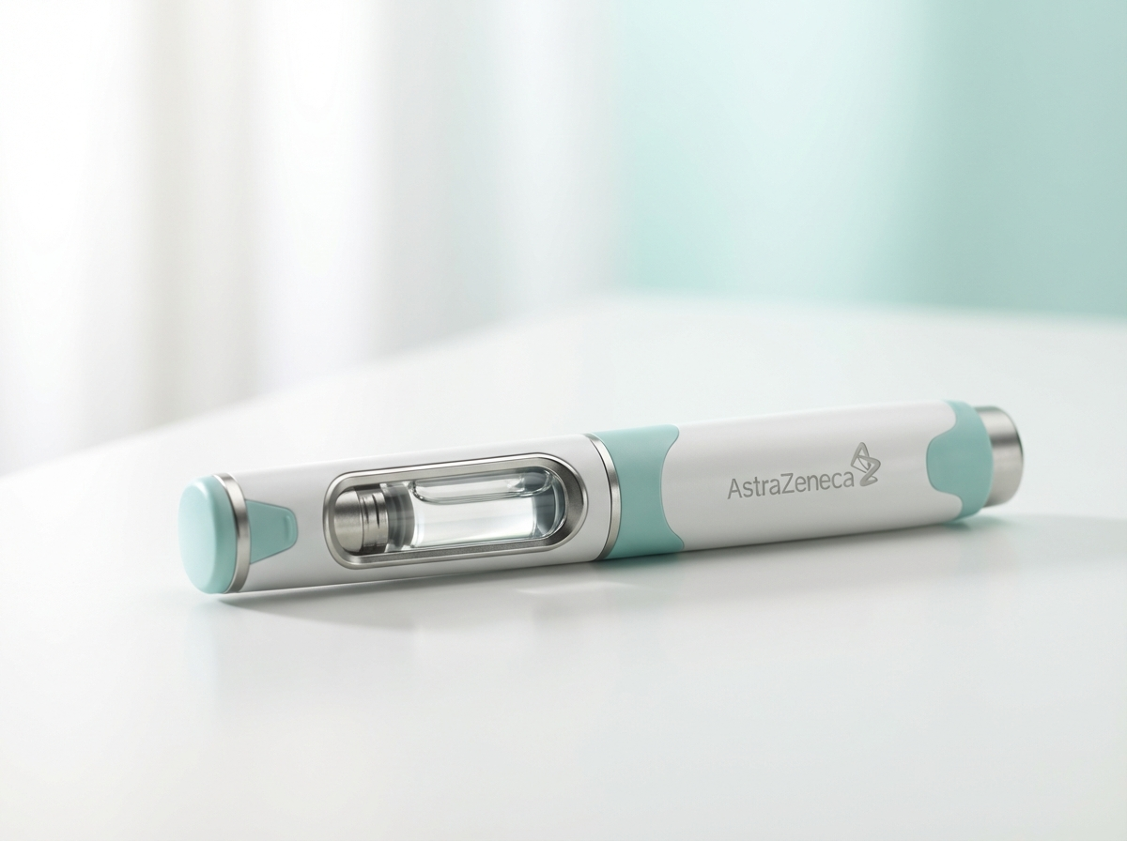
Image: card-dosing.jpeg
CDN URL: https://vitessa-images.pages.dev/card-dosing.jpeg
Source: vitessa site | Product photography, clean background
Simple once-daily oral dosing
TAVEX 200 mg once daily — a convenient oral tablet taken with or without food, with no injection or infusion required.¹
[See dosing guide](/tavex/dosing)

Section 4 — Mechanism of Action Teaser
Block: columns-teaser | Section metadata: Style: highlight

Image: moa-preview.jpeg
CDN URL: https://eluvion-images.pages.dev/moa-preview.jpeg
Source: eluvion site | Molecular pathway illustration
Selective JAK1 inhibition
TAVEX preferentially inhibits JAK1, blocking key pro-inflammatory cytokine signalling while preserving immune and haematopoietic homeostasis through minimal JAK2/JAK3 interference.¹
[Explore mechanism of action](/tavex/mechanism-of-action)

Section 5 — Prescribing Information Accordion
Block: accordion
Prescribing Information | TAVEX (tavexirel) Prescribing Information. Please refer to the full Summary of Product Characteristics (SmPC) before prescribing. TAVEX 100 mg and 200 mg film-coated tablets. Indication: Treatment of moderately to severely active rheumatoid arthritis in adults with inadequate response or intolerance to one or more DMARDs. Treatment of active psoriatic arthritis in adults with inadequate response or intolerance to a prior DMARD therapy.
Adverse Event Reporting | Adverse events should be reported. Reporting forms and information can be found at www.mhra.gov.uk/yellowcard or search for MHRA Yellow Card in the Google Play or Apple App Store. Adverse events should also be reported to AstraZeneca by visiting https://contactazmedical.astrazeneca.com/ or by calling 0800 783 0033.
References | 1. TAVEX (tavexirel) Summary of Product Characteristics. AstraZeneca UK Ltd. 2. Smolen JS, et al. Lancet. 2023;401:1551-1568. 3. RESOLVE-1 Study Group. N Engl J Med. 2025;392(18):1712-1724. 4. RESOLVE-2 Study Group. Ann Rheum Dis. 2025;84(9):1289-1301. 5. Aletaha D, et al. Ann Rheum Dis. 2010;69(9):1580-1588.
Page Metadata:
Title | Tavex (tavexirel) | HCP Resources | AstraZeneca UK
Description | TAVEX (tavexirel) is a selective oral JAK1 inhibitor for the treatment of rheumatoid arthritis. Explore efficacy data, safety profile, and dosing information.
Approval Code | GB-98765 | DOP: March 2026

Page 2: Efficacy (efficacy.plain.html)

Section 1 — Hero
Block: hero-teaser

Image: hero-efficacy.jpeg
CDN URL: https://eluvion-images.pages.dev/hero-efficacy.jpeg
Source: eluvion site | Double-exposure portrait with data visualisation elements
Proven efficacy across the RESOLVE programme
TAVEX demonstrated rapid, statistically significant improvements in ACR response rates and disease activity scores across two pivotal Phase III trials in rheumatoid arthritis.¹ ²

Section 2 — RESOLVE Programme Introduction
Block: introduction
The RESOLVE clinical programme
The RESOLVE programme evaluated the efficacy and safety of TAVEX in over 1,900 patients with moderately to severely active rheumatoid arthritis across two pivotal Phase III randomised, placebo-controlled trials.¹ ²

Section 3 — RESOLVE-1 Results
Block: columns-teaser
RESOLVE-1: MTX-inadequate responders
In RESOLVE-1, patients treated with TAVEX + MTX achieved an ACR20 response rate of 71.4% at Week 12, compared with 35.8% for placebo + MTX (P<0.001). DAS28-CRP remission at Week 24 was achieved by 38.7% vs 9.2%.¹
[View full RESOLVE-1 data](/tavex/efficacy)

Section 4 — RESOLVE-1 Endpoints Table
Block: table-data | Section metadata: Style: light
(Full RESOLVE-1 endpoints table — see Clinical Programme section above)

Section 5 — RESOLVE-2 Results
Block: columns-teaser
RESOLVE-2: Biologic-inadequate responders
In the difficult-to-treat biologic-inadequate population, TAVEX + MTX achieved an ACR20 response rate of 64.2% at Week 12, compared with 28.1% for placebo (P<0.001). DAS28-CRP remission at Week 24: 29.4% vs 6.7%.²
[View full RESOLVE-2 data](/tavex/efficacy)

Section 6 — Prescribing Information Accordion
Block: accordion (same as Home page)

Page 3: Safety (safety.plain.html)

Section 1 — Hero
Block: hero-teaser

Image: hero-safety.jpeg
CDN URL: https://novapril-images.pages.dev/hero-safety.jpeg
Source: novapril site | Warm lifestyle photograph, patient in everyday setting
Safety profile of TAVEX
The safety of TAVEX was evaluated in 1,287 patients with rheumatoid arthritis across the RESOLVE clinical programme, with a median treatment duration of 11.2 months.¹ ²

Section 2 — Safety Overview Introduction
Block: introduction | Section metadata: Style: light
Well-characterised safety profile
The overall safety profile of TAVEX was consistent with the known class effects of JAK inhibitors. The rate of serious adverse events was comparable between treatment groups (8.4% vs 7.9%).¹ ²

Section 3 — Adverse Events Table
Block: table-data
(Full adverse events table — see Safety Profile section above)

Section 4 — Key Safety Considerations
Block: columns-teaser | Section metadata: Style: highlight
Important safety considerations
Infections: Serious infections occurred in 2.8% of patients. Do not initiate TAVEX during active, serious infections. Monitor for signs and symptoms of infection during and after treatment. Interrupt treatment if a serious infection develops.¹
Herpes zoster: Risk increased (3.8% vs 0.9%). Consider vaccination prior to starting treatment.¹
Haematological monitoring: Monitor neutrophil count, lymphocyte count, and haemoglobin at baseline and during treatment. Do not initiate if ANC <1,000/mm³, ALC <500/mm³, or Hb <8 g/dL.¹
Lipids: Monitor lipid parameters 12 weeks after initiation. Manage hyperlipidaemia per clinical guidelines.¹
[Review full prescribing information](/tavex/resources)

Section 5 — Prescribing Information Accordion
Block: accordion (same as Home page)

Page 4: Dosing (dosing.plain.html)

Section 1 — Hero
Block: hero-teaser
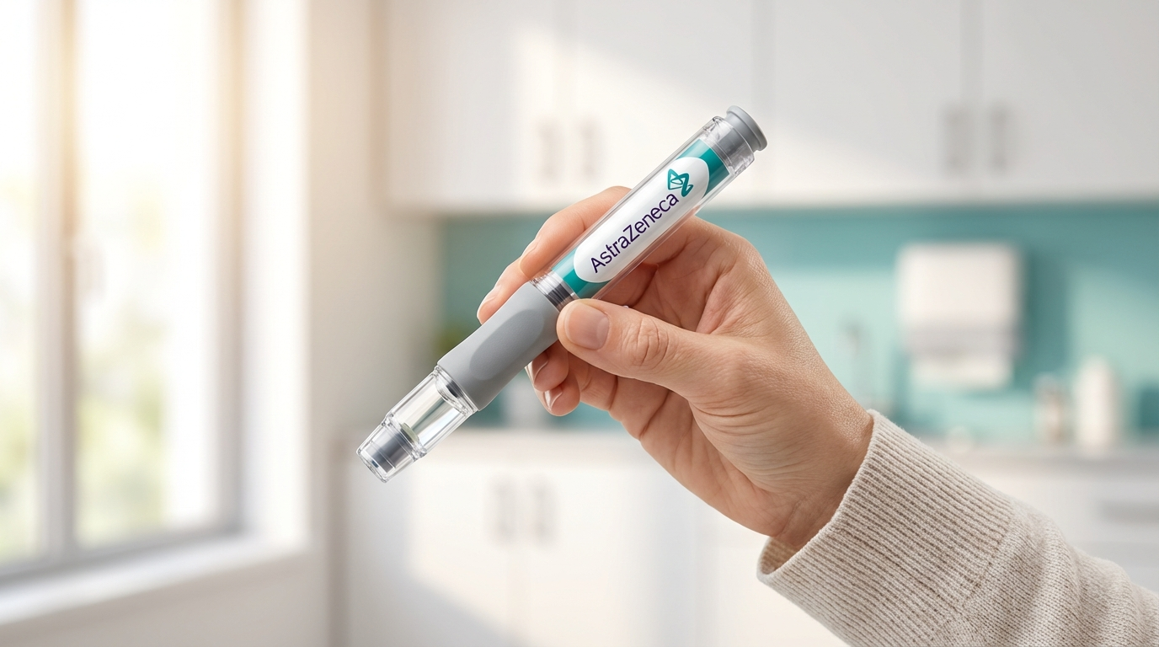
Image: hero-dosing.jpeg
CDN URL: https://vitessa-images.pages.dev/hero-dosing.jpeg
Source: vitessa site | Clean product/device photography in clinical setting
Simple once-daily oral dosing
TAVEX 200 mg once daily — a convenient oral tablet that can be taken with or without food.¹

Section 2 — Dosing Overview
Block: introduction | Section metadata: Style: light
Dosing regimen
TAVEX offers a simple fixed-dose oral regimen with no titration required. The 200 mg once-daily dose provides consistent therapeutic drug levels throughout the day.¹

Section 3 — RA Dosing
Block: columns-teaser
Rheumatoid arthritis dosing
Recommended dose: TAVEX 200 mg once daily.¹
TAVEX may be used as monotherapy or in combination with methotrexate or other conventional synthetic DMARDs.¹
For patients with moderate renal impairment (eGFR 30-60 mL/min) or receiving strong CYP3A4 inhibitors, reduce dose to 100 mg once daily.¹

Section 4 — PsA Dosing
Block: columns-teaser | Section metadata: Style: highlight
Psoriatic arthritis dosing
Recommended dose: TAVEX 200 mg once daily, in combination with a conventional synthetic DMARD (e.g. methotrexate).¹
The same dose adjustments apply for renal impairment and concomitant CYP3A4 inhibitors.¹

Section 5 — Monitoring
Block: columns-teaser
Laboratory monitoring
Full blood count: At baseline, after 4 weeks, then every 3 months.¹
Liver function: At baseline, then as clinically indicated. Interrupt treatment if ALT/AST >5x ULN.¹
Lipids: At 12 weeks after initiation. Manage hyperlipidaemia per clinical guidelines.¹
Viral hepatitis screening: Screen for hepatitis B and C before starting treatment.¹

Section 6 — Prescribing Information Accordion
Block: accordion (same as Home page)

Page 5: Mechanism of Action (mechanism-of-action.plain.html)

Section 1 — Hero
Block: hero-teaser

Image: hero-moa.jpeg
CDN URL: https://eluvion-images.pages.dev/hero-moa.jpeg
Source: eluvion site | Abstract molecular/scientific illustration, dark background
Selective JAK1 inhibition
TAVEX preferentially targets JAK1, blocking the signalling of key pro-inflammatory cytokines while minimising effects on JAK2, JAK3, and TYK2.¹

Section 2 — JAK-STAT Pathway Introduction
Block: introduction | Section metadata: Style: light
The JAK-STAT signalling pathway
The Janus kinase (JAK)-Signal Transducer and Activator of Transcription (STAT) pathway is a critical intracellular signalling cascade that mediates the biological effects of numerous cytokines, interferons, and growth factors involved in immune regulation, haematopoiesis, and inflammation.¹ ³

Section 3 — JAK1 in RA
Block: columns-teaser
JAK1: a central node in RA pathogenesis
JAK1 pairs with other JAK family members to transduce signals from IL-6, IL-7, IL-15, IFN-gamma, and other cytokines that drive the chronic synovial inflammation and joint destruction characteristic of RA. JAK1 inhibition attenuates these pathways, reducing inflammatory cell activation and joint damage.¹ ³

Section 4 — Selectivity Advantage
Block: columns-teaser | Section metadata: Style: highlight
The selectivity advantage
TAVEX demonstrates approximately 30-fold selectivity for JAK1 over JAK2. This selectivity is clinically meaningful: JAK2 mediates erythropoietin and thrombopoietin signalling, so minimising JAK2 inhibition reduces the risk of anaemia and thrombocytopenia.¹
JAK3 inhibition is similarly minimised, preserving aspects of adaptive immunity mediated by JAK3-dependent cytokines (IL-2, IL-4, IL-21).¹
[View RESOLVE clinical data](/tavex/efficacy)

Section 5 — Prescribing Information Accordion
Block: accordion (same as Home page)

Page 6: Resources (resources.plain.html)

Section 1 — Hero
Block: hero-teaser

Image: hero-resources.jpeg
CDN URL: https://lumivex-images.pages.dev/hero-efficacy.jpeg
Source: lumivex site | HCP reviewing materials, warm editorial pharmaceutical style
Resources for you and your patients
Access prescribing information, patient support materials, and educational resources to support your patients treated with TAVEX.

Section 2 — Resources Introduction
Block: introduction | Section metadata: Style: light
Supporting you and your patients
We are committed to providing rheumatology healthcare professionals with the tools and resources needed to support patients treated with TAVEX. Explore the materials below to find prescribing guides, patient education resources, and clinical support materials.

Section 3 — Resource Cards
Block: cards-teaser
Card 1: Prescribing information — Access the full SmPC, patient information leaflet, and dosing quick reference guide.
Card 2: Patient support materials — Download patient-friendly guides explaining RA, the TAVEX treatment process, and managing side effects.
Card 3: Educational videos — Watch mechanism of action animations, RESOLVE clinical data presentations, and expert-led discussions.

Section 4 — Contact and Medical Information
Block: columns-teaser | Section metadata: Style: highlight
Medical information and support
For medical information enquiries about TAVEX, please contact AstraZeneca Medical Information:
Telephone: 0800 783 0033
Email: medicalinformationuk@astrazeneca.com
Website: contactazmedical.astrazeneca.com
Our medical information team is available Monday to Friday, 9:00 AM to 5:00 PM.

Section 5 — Prescribing Information Accordion
Block: accordion (same as Home page)

Navigation
Top bar: Contact Us | AZ Employee Login
Logo: AstraZeneca logo (CDN)
Nav items: Home | Efficacy | Safety | Dosing | Mechanism of Action | Resources
Right: Search icon | Login CTA
All nav links prefixed with /tavex/

Footer
Logo: AstraZeneca logo (CDN)
Approval code: GB-98765 | DOP: March 2026
Copyright: © AstraZeneca 2026. All rights reserved.
Page links: Home | Efficacy | Safety | Dosing | Mechanism of Action | Resources
Regulatory links:
Report Adverse Event → https://yellowcard.mhra.gov.uk/
Medical Information → https://contactazmedical.astrazeneca.com/
Privacy Policy → https://www.astrazeneca.co.uk/our-company/privacy-notice.html
Terms of Use → https://www.astrazeneca.co.uk/our-company/terms-of-use.html
Accessibility → https://www.astrazeneca.co.uk/accessibility.html
Date of Preparation: March 2026

Image Reference — Reused CDN Assets
All images below are reused from existing site CDNs. No new image generation is required.

hero-home.jpeg

Image: hero-home.jpeg
CDN URL: https://revantha-images.pages.dev/hero-home.jpeg
Source: revantha site | Double-exposure portrait, man silhouette filled with scientific imagery

hero-efficacy.jpeg

Image: hero-efficacy.jpeg
CDN URL: https://eluvion-images.pages.dev/hero-efficacy.jpeg
Source: eluvion site | Double-exposure portrait with data visualisation elements

hero-safety.jpeg

Image: hero-safety.jpeg
CDN URL: https://novapril-images.pages.dev/hero-safety.jpeg
Source: novapril site | Warm lifestyle photograph, patient in everyday setting

hero-dosing.jpeg

Image: hero-dosing.jpeg
CDN URL: https://vitessa-images.pages.dev/hero-dosing.jpeg
Source: vitessa site | Clean product/device photography in clinical setting

hero-moa.jpeg

Image: hero-moa.jpeg
CDN URL: https://eluvion-images.pages.dev/hero-moa.jpeg
Source: eluvion site | Abstract molecular/scientific illustration, dark background

hero-resources.jpeg

Image: hero-resources.jpeg
CDN URL: https://lumivex-images.pages.dev/hero-efficacy.jpeg
Source: lumivex site | HCP reviewing materials, warm editorial pharmaceutical style

card-efficacy.jpeg

Image: card-efficacy.jpeg
CDN URL: https://revantha-images.pages.dev/card-efficacy.jpeg
Source: revantha site | Abstract data visualisation in blue and white

card-safety.jpeg

Image: card-safety.jpeg
CDN URL: https://novapril-images.pages.dev/card-safety.jpeg
Source: novapril site | Healthcare professional with patient monitoring

card-dosing.jpeg

Image: card-dosing.jpeg
CDN URL: https://vitessa-images.pages.dev/card-dosing.jpeg
Source: vitessa site | Product photography, clean background

moa-preview.jpeg

Image: moa-preview.jpeg
CDN URL: https://eluvion-images.pages.dev/moa-preview.jpeg
Source: eluvion site | Molecular pathway illustration

