Zenturis (zenturigliptin) — Website Briefing
Document type: Final approved marketing brief for HCP website build Prepared by: Marketing — UK Diabetes Franchise Approval status: MLR-approved copy — do not modify Date: March 2026

1. Drug Profile
Field | Detail
Brand name | Zenturis
Generic name | zenturigliptin
Drug class | Oral GLP-1 receptor agonist (non-peptide small molecule)
Indication | Treatment of adults with insufficiently controlled type 2 diabetes mellitus as an adjunct to diet and exercise, as monotherapy when metformin is not tolerated, or in combination with other medicinal products for the treatment of diabetes
Extended indication | Reduction of major adverse cardiovascular events (cardiovascular death, non-fatal myocardial infarction, non-fatal stroke) in adults with type 2 diabetes mellitus and established cardiovascular disease or multiple cardiovascular risk factors
Formulation | 14 mg film-coated tablet
Dosing | One tablet once weekly, taken in the morning on an empty stomach with a sip of water
Approval | MHRA — January 2026
Brand colour | Mediterranean Blue #2E6BA4
Approval code | GB-82917

2. Mechanism of Action
Zenturigliptin is a first-in-class oral, non-peptide GLP-1 receptor agonist. Unlike injectable GLP-1 receptor agonists that are peptide-based and require subcutaneous administration, zenturigliptin is a small molecule designed for oral bioavailability through a novel absorption-enhancing formulation.
Zenturigliptin binds to and activates the GLP-1 receptor on pancreatic beta cells, stimulating glucose-dependent insulin secretion and suppressing inappropriately elevated glucagon secretion. It also slows gastric emptying and promotes satiety through central mechanisms, contributing to weight reduction.
The glucose-dependent mechanism of insulin secretion means the risk of hypoglycaemia is inherently low when used as monotherapy or in combination with metformin.

3. Clinical Programme

ZENITH-1: Glycaemic control vs placebo (add-on to metformin)
- Design: Phase III, randomised, double-blind, placebo-controlled, 52-week trial
- Population: 1,246 adults with T2DM inadequately controlled on metformin (HbA1c 7.0–10.5%)
- Primary endpoint: Change in HbA1c from baseline at Week 26
- Key results:
  - HbA1c change from baseline: −1.4% (zenturigliptin) vs −0.3% (placebo); estimated treatment difference −1.1% (95% CI: −1.3 to −0.9; P<0.001)
  - Proportion achieving HbA1c <7.0%: 72% vs 28% (P<0.001)
  - Body weight change: −5.2 kg vs −1.1 kg; difference −4.1 kg (95% CI: −4.8 to −3.4; P<0.001)
  - Fasting plasma glucose change: −2.1 mmol/L vs −0.4 mmol/L (P<0.001)
- Publication: Harrison et al. Lancet Diabetes Endocrinol 2025; 13(4): 312–325.

ZENITH-2: Non-inferiority vs injectable semaglutide 1 mg
- Design: Phase III, randomised, open-label, active-controlled, 52-week trial
- Population: 1,834 adults with T2DM inadequately controlled on metformin ± sulfonylurea (HbA1c 7.0–10.5%)
- Primary endpoint: Change in HbA1c from baseline at Week 52, non-inferiority margin 0.3%
- Key results:
  - HbA1c change from baseline: −1.3% (zenturigliptin) vs −1.4% (semaglutide 1 mg); estimated treatment difference 0.1% (95% CI: −0.1 to 0.2); non-inferiority confirmed (P<0.001)
  - Proportion achieving HbA1c <7.0%: 68% vs 71%
  - Body weight change: −4.8 kg vs −5.5 kg
  - Patient preference (pre-specified exploratory): 81% preferred oral administration
  - Treatment satisfaction (DTSQ): significantly higher with zenturigliptin (P=0.003)
- Publication: Chen et al. N Engl J Med 2025; 392(18): 1697–1710.

ZENITH-3: Cardiovascular outcomes trial
- Design: Phase III, randomised, double-blind, placebo-controlled, event-driven cardiovascular outcomes trial
- Population: 8,246 adults with T2DM and established cardiovascular disease or multiple cardiovascular risk factors
- Median follow-up: 3.2 years
- Primary endpoint: First occurrence of MACE (composite of cardiovascular death, non-fatal myocardial infarction, non-fatal stroke)
- Key results:
  - MACE: HR 0.82 (95% CI: 0.70–0.96; P=0.013) — 18% relative risk reduction
  - Cardiovascular death: HR 0.78 (95% CI: 0.62–0.98; P=0.031)
  - Non-fatal MI: HR 0.86 (95% CI: 0.69–1.07; P=0.18)
  - Non-fatal stroke: HR 0.81 (95% CI: 0.60–1.10; P=0.18)
  - All-cause mortality: HR 0.85 (95% CI: 0.71–1.02; P=0.08)
- Publication: Mehta et al. N Engl J Med 2025; 393(2): 134–148.

4. Safety Profile

Pooled adverse events (ZENITH-1, -2, -3; N=5,663 zenturigliptin)
Adverse event | Zenturigliptin (%) | Comparator (%)
Nausea | 16.2 | 4.1
Diarrhoea | 11.4 | 5.3
Decreased appetite | 8.1 | 2.2
Vomiting | 5.7 | 1.8
Constipation | 4.3 | 2.9
Abdominal pain | 3.8 | 2.1
ALT elevation (>3× ULN) | 3.1 | 1.4
Headache | 2.9 | 2.7
Dizziness | 2.1 | 1.6

Key safety findings
- Gastrointestinal events: Most common class of AEs. Typically mild to moderate in severity, occurring within the first 4–8 weeks of treatment and declining with continued use. Discontinuation due to GI events: 4.2%.
- Hepatic effects: Transient ALT elevations >3× ULN occurred in 3.1% of patients. Liver function tests should be performed prior to initiation and periodically thereafter. Discontinue if ALT >3× ULN accompanied by symptoms or bilirubin elevation.
- Hypoglycaemia: Low risk as monotherapy or with metformin (documented hypoglycaemia: 1.2%). Risk increased when co-administered with sulfonylureas (7.8%) or insulin (12.4%). Dose reduction of concomitant sulfonylurea or insulin may be required.
- Pancreatitis: Acute pancreatitis reported in 0.1% of patients. Discontinue if pancreatitis is suspected; do not restart.

Special populations
- Renal impairment: No dose adjustment required for mild or moderate renal impairment (eGFR 30–89 mL/min/1.73m²). Not recommended in severe renal impairment (eGFR <30) or end-stage renal disease due to limited data.
- Hepatic impairment: No dose adjustment in mild hepatic impairment (Child-Pugh A). Caution in moderate impairment (Child-Pugh B). Not recommended in severe impairment (Child-Pugh C).
- Elderly (≥65 years): No dose adjustment required. Clinical experience in patients ≥75 years is limited.

5. Prescribing Information (abbreviated — for every page footer)
ZENTURIS (zenturigliptin) 14 mg film-coated tablets. Please refer to the Summary of Product Characteristics (SmPC) before prescribing. Indication: Treatment of adults with insufficiently controlled type 2 diabetes mellitus as an adjunct to diet and exercise. Dosage and administration: 14 mg once weekly, taken in the morning on an empty stomach with a sip of plain water. The tablet must be swallowed whole and not crushed, chewed, or split. No food, drink, or other oral medicinal products should be taken for at least 30 minutes after administration. Contraindications: Hypersensitivity to zenturigliptin or any excipient. Personal or family history of medullary thyroid carcinoma or Multiple Endocrine Neoplasia syndrome type 2. Warnings and precautions: Not recommended in patients with severe renal impairment (eGFR <30 mL/min/1.73m²). Monitor liver function tests prior to initiation and periodically thereafter. Not a substitute for insulin. Pancreatitis: discontinue if suspected. Pregnancy and lactation: Not recommended. Side effects: Very common (≥1/10): nausea, diarrhoea. Common (≥1/100 to <1/10): vomiting, decreased appetite, constipation, abdominal pain, ALT increase, headache. Legal category: POM. Pack and price: 4 tablets (28-day supply): £185.64. Marketing authorisation holder: AstraZeneca UK Ltd. MA number: PLGB 17901/0486. Full prescribing information available from: AstraZeneca UK Ltd, 2 Pancras Square, London N1C 4AG. GB-82917 | DOP: March 2026.

6. Adverse Event Reporting (for every page footer)
Adverse events should be reported. Reporting forms and information can be found at www.mhra.gov.uk/yellowcard or search for MHRA Yellow Card in the Google Play or Apple App Store. Adverse events should also be reported to AstraZeneca by visiting contactazmedical.astrazeneca.com or by calling 0800 783 0033.

7. References (for every page footer)
- Harrison et al. Lancet Diabetes Endocrinol 2025; 13(4): 312–325.
- Chen et al. N Engl J Med 2025; 392(18): 1697–1710.
- Mehta et al. N Engl J Med 2025; 393(2): 134–148.
- Zenturis (zenturigliptin) Summary of Product Characteristics. AstraZeneca UK Ltd. January 2026.

8. Site Navigation
Top bar links: Contact Us (https://www.astrazeneca.co.uk/contact-us.html) | AZ Employee Login (https://login.astrazeneca.com)
Main navigation pages: Efficacy | Safety | Dosing | Resources
Utility: Search | Login

9. Page Content
IMPORTANT: All copy below is final and MLR-approved. It must be used exactly as written — do not modify, rephrase, or abbreviate any text. All superscript reference numbers, statistical values, and regulatory language must be reproduced verbatim.
Each page must end with expandable sections for Prescribing Information, Adverse Event Reporting, and References (see sections 5, 6, and 7 above).

PAGE 1: Home
URL path: /zenturis/

Section 1 — Hero (full-width image with text overlay)
Image:
 https://zenturis-images.pages.dev/hero-home.jpeg
Heading: Zenturis (zenturigliptin): the first oral weekly GLP-1 receptor agonist
Body text: A new era in type 2 diabetes management — the proven efficacy of GLP-1 receptor agonism, now in a convenient once-weekly oral tablet.¹
Call to action: Explore the clinical evidence → /zenturis/efficacy

Section 2 — Three key benefit cards (equal columns)
Card 1:
 https://zenturis-images.pages.dev/card-efficacy.jpeg
Card heading: Proven glycaemic control
Card body: 1.4% HbA1c reduction from baseline at 26 weeks vs placebo, with 72% of patients achieving HbA1c <7.0%.¹
Card link: View efficacy data → /zenturis/efficacy

Card 2:
 https://zenturis-images.pages.dev/card-safety.jpeg
Card heading: Well-characterised safety profile
Card body: Consistent safety across three Phase III trials with over 5,600 patients, with a low risk of hypoglycaemia when used with metformin.¹⁻³
Card link: Review safety data → /zenturis/safety

Card 3:
 https://zenturis-images.pages.dev/card-dosing.jpeg
Card heading: Once-weekly oral convenience
Card body: A single 14 mg tablet taken once weekly — offering GLP-1 receptor agonist efficacy without the need for injections.¹
Card link: View dosing information → /zenturis/dosing

Section 3 — Mechanism of action teaser (two-column: image left, text right) | highlighted background
Image:
 https://zenturis-images.pages.dev/columns-moa.jpeg
Heading: A novel approach to GLP-1 receptor agonism
Body text: Zenturigliptin is a first-in-class oral, non-peptide GLP-1 receptor agonist. It activates the GLP-1 receptor to stimulate glucose-dependent insulin secretion, suppress glucagon, slow gastric emptying, and promote satiety — through a convenient once-weekly oral tablet.¹
Call to action: Explore the mechanism of action → /zenturis/efficacy

Section 4 — Prescribing information footer
Expandable sections for: Prescribing Information | Adverse Event Reporting | References (Use approved text from sections 5, 6, and 7 above)

Page metadata
- Title: Zenturis (zenturigliptin) | Oral GLP-1 RA for Type 2 Diabetes | AstraZeneca UK
- Description: Zenturis (zenturigliptin) is a first-in-class oral, once-weekly GLP-1 receptor agonist for adults with type 2 diabetes. Explore efficacy, safety, and dosing information for UK healthcare professionals.

PAGE 2: Efficacy
URL path: /zenturis/efficacy

Section 1 — Hero (full-width image with text overlay)
Image:
 https://zenturis-images.pages.dev/hero-efficacy.jpeg
Heading: Clinical evidence for Zenturis
Body text: The ZENITH clinical programme evaluated zenturigliptin across three pivotal Phase III trials in over 11,300 adults with type 2 diabetes.¹⁻³

Section 2 — Programme overview (centred text) | light background
Heading: The ZENITH clinical programme
Body text: Zenturigliptin was evaluated in three randomised Phase III trials: ZENITH-1 assessed glycaemic control and weight reduction versus placebo; ZENITH-2 demonstrated non-inferiority to injectable semaglutide 1 mg; and ZENITH-3 established cardiovascular benefit in a dedicated outcomes trial.¹⁻³

Section 3 — Clinical data (two tabs)
Tab 1: “ZENITH-1: Glycaemic control”
Image:
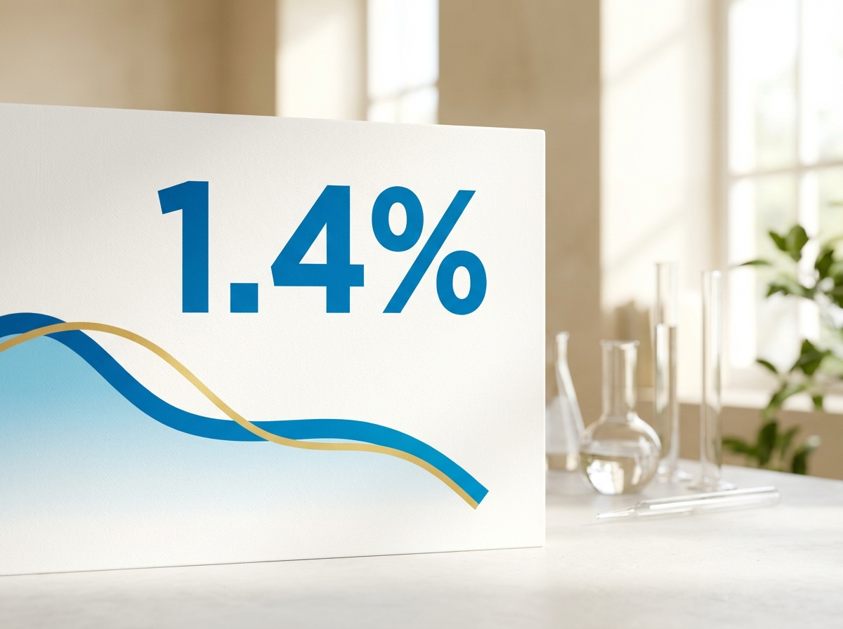 https://zenturis-images.pages.dev/tab-zenith1.jpeg
Heading: Superior HbA1c reduction versus placebo
Body text: In ZENITH-1, a 52-week randomised, double-blind, placebo-controlled trial in 1,246 adults with T2DM inadequately controlled on metformin, zenturigliptin 14 mg demonstrated significantly greater reductions in HbA1c from baseline versus placebo at Week 26.¹
Data table:
Endpoint | Zenturigliptin 14 mg (n=623) | Placebo (n=623) | Difference (95% CI)
HbA1c change from baseline (%, primary) | −1.4 | −0.3 | −1.1 (−1.3 to −0.9); P<0.001
Proportion achieving HbA1c <7.0% | 72% | 28% | P<0.001
Body weight change (kg) | −5.2 | −1.1 | −4.1 (−4.8 to −3.4); P<0.001
Fasting plasma glucose change (mmol/L) | −2.1 | −0.4 | P<0.001
Footnote text: The primary endpoint was met with statistical significance. Clinically meaningful weight reduction was observed as a key secondary endpoint.¹

Tab 2: “ZENITH-2: Non-inferiority vs semaglutide”
Image:
 https://zenturis-images.pages.dev/tab-zenith2.jpeg
Heading: Non-inferior to injectable semaglutide 1 mg
Body text: In ZENITH-2, a 52-week randomised, open-label, active-controlled trial in 1,834 adults with T2DM inadequately controlled on metformin ± sulfonylurea, zenturigliptin 14 mg demonstrated non-inferior HbA1c reduction compared with injectable semaglutide 1 mg.²
Data table:
Endpoint | Zenturigliptin 14 mg (n=917) | Semaglutide 1 mg SC (n=917) | Difference (95% CI)
HbA1c change from baseline (%, primary) | −1.3 | −1.4 | 0.1 (−0.1 to 0.2); non-inferiority confirmed
Proportion achieving HbA1c <7.0% | 68% | 71% | —
Body weight change (kg) | −4.8 | −5.5 | —
Patient preference for oral route | 81% of patients expressed preference for oral administration (P<0.001)
Footnote text: Zenturigliptin achieved non-inferior glycaemic control to injectable semaglutide 1 mg, with significantly higher patient satisfaction and preference for the oral route of administration.²

Section 4 — Cardiovascular outcomes (two-column: image left, text right) | highlighted background
Image:
 https://zenturis-images.pages.dev/columns-cv.jpeg
Heading: Cardiovascular risk reduction demonstrated in ZENITH-3
Body text: In the dedicated cardiovascular outcomes trial (ZENITH-3), zenturigliptin demonstrated an 18% relative risk reduction in the composite of cardiovascular death, non-fatal myocardial infarction, and non-fatal stroke versus placebo (HR 0.82; 95% CI: 0.70–0.96; P=0.013) in 8,246 adults with T2DM and established cardiovascular disease or multiple cardiovascular risk factors over a median follow-up of 3.2 years.³
Cardiovascular death was reduced by 22% (HR 0.78; 95% CI: 0.62–0.98; P=0.031).³
Call to action: Review the full safety profile → /zenturis/safety

Section 5 — Prescribing information footer
Expandable sections for: Prescribing Information | Adverse Event Reporting | References (Use approved text from sections 5, 6, and 7 above)

Page metadata
- Title: Efficacy | Zenturis (zenturigliptin) | ZENITH Clinical Data | AstraZeneca UK
- Description: Explore the ZENITH clinical programme for Zenturis (zenturigliptin) — Phase III data on HbA1c reduction, weight loss, non-inferiority vs semaglutide, and cardiovascular outcomes in type 2 diabetes.

PAGE 3: Safety
URL path: /zenturis/safety

Section 1 — Page header (text only, no image)
Heading: Safety profile
Body text: Zenturigliptin has been evaluated for safety in over 5,600 patients across the ZENITH Phase III clinical programme.¹⁻³

Section 2 — Safety overview (centred text) | light background
Heading: A well-characterised safety profile across three pivotal trials
Body text: The most commonly reported adverse events with zenturigliptin were gastrointestinal in nature. These were typically mild to moderate, occurred early in treatment, and declined with continued use. The overall discontinuation rate due to adverse events was 6.8%.¹⁻³

Section 3 — Three key safety consideration cards (equal columns)
Card 1:
 https://zenturis-images.pages.dev/card-gi.jpeg
Card heading: Gastrointestinal tolerability
Card body: Nausea (16.2%) and diarrhoea (11.4%) were the most common adverse events. GI events were typically mild to moderate, occurring within the first 4–8 weeks and declining with continued treatment. Discontinuation due to GI events occurred in 4.2% of patients.¹⁻³

Card 2:
 https://zenturis-images.pages.dev/card-hepatic.jpeg
Card heading: Hepatic monitoring
Card body: Transient ALT elevations >3× ULN were observed in 3.1% of patients. Liver function tests should be performed prior to initiation and periodically thereafter. Discontinue zenturigliptin if ALT >3× ULN is accompanied by symptoms or bilirubin elevation.⁴

Card 3:
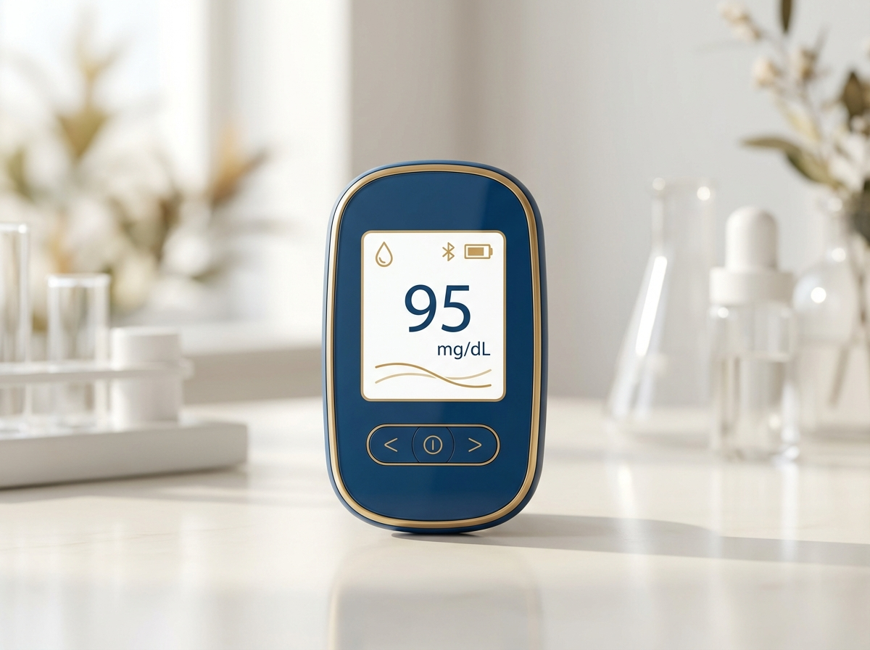 https://zenturis-images.pages.dev/card-hypo.jpeg
Card heading: Low hypoglycaemia risk
Card body: Documented hypoglycaemia occurred in only 1.2% of patients receiving zenturigliptin with metformin. Risk is increased with concomitant sulfonylureas (7.8%) or insulin (12.4%). Dose reduction of sulfonylurea or insulin may be required.¹⁻³

Section 4 — Adverse event summary table | light background
Heading: Pooled adverse event data from the ZENITH programme¹⁻³
Table:
Adverse event | Zenturigliptin 14 mg (%) | Comparator (%)
Nausea | 16.2 | 4.1
Diarrhoea | 11.4 | 5.3
Decreased appetite | 8.1 | 2.2
Vomiting | 5.7 | 1.8
Constipation | 4.3 | 2.9
Abdominal pain | 3.8 | 2.1
ALT elevation (>3× ULN) | 3.1 | 1.4
Headache | 2.9 | 2.7
Dizziness | 2.1 | 1.6

Section 5 — Special populations (two-column: image left, text right) | highlighted background
Image:
 https://zenturis-images.pages.dev/columns-special-pops.jpeg
Heading: Special populations
Body text: Renal impairment: No dose adjustment is required for patients with mild or moderate renal impairment (eGFR 30–89 mL/min/1.73m²). Zenturigliptin is not recommended in patients with severe renal impairment (eGFR <30 mL/min/1.73m²) or end-stage renal disease due to limited clinical data.⁴
Hepatic impairment: No dose adjustment is required in mild hepatic impairment (Child-Pugh A). Caution is advised in moderate hepatic impairment (Child-Pugh B). Zenturigliptin is not recommended in severe hepatic impairment (Child-Pugh C).⁴
Elderly (≥65 years): No dose adjustment is required. Clinical experience in patients aged ≥75 years is limited; use with caution in this population.⁴

Section 6 — Prescribing information footer
Expandable sections for: Prescribing Information | Adverse Event Reporting | References (Use approved text from sections 5, 6, and 7 above)

Page metadata
- Title: Safety | Zenturis (zenturigliptin) | Adverse Events & Monitoring | AstraZeneca UK
- Description: Review the safety profile of Zenturis (zenturigliptin) including pooled adverse event data, GI tolerability, hepatic monitoring guidance, and special population recommendations.

PAGE 4: Dosing
URL path: /zenturis/dosing

Section 1 — Page header (text only, no image)
Heading: Dosing and administration
Body text: Zenturigliptin is taken as a single 14 mg tablet once weekly — the first oral GLP-1 receptor agonist that does not require injection.⁴

Section 2 — How to take Zenturis (two-column: image left, text right) | light background
Image:
 https://zenturis-images.pages.dev/columns-admin.jpeg
Heading: How to take Zenturis
Body text: Zenturigliptin 14 mg should be taken once weekly, on the same day each week, in the morning on an empty stomach.⁴
The tablet should be swallowed whole with a sip of plain water (up to 120 mL). Patients should not eat, drink, or take other oral medicinal products for at least 30 minutes after taking zenturigliptin.⁴
The tablet must not be crushed, chewed, or split, as this may affect absorption.⁴

Section 3 — Dosing schedule and missed doses (two-column: image left, text right)
Image:
 https://zenturis-images.pages.dev/columns-dose-adjust.jpeg
Heading: Dosing schedule and missed doses
Body text: Fixed dose: Zenturigliptin is prescribed at a fixed dose of 14 mg once weekly. No dose titration is required.⁴
Missed dose: If a dose is missed, it should be taken as soon as possible, provided there are at least 3 days (72 hours) before the next scheduled dose. If fewer than 3 days remain, the missed dose should be skipped and the next dose taken on the regularly scheduled day.⁴
Day change: The day of weekly administration may be changed, provided there are at least 3 days between two doses.⁴

Section 4 — Use with other diabetes medicines (centred text) | highlighted background
Heading: Use with other diabetes medicines
Body text: Zenturigliptin can be used as monotherapy (when metformin is not tolerated) or in combination with metformin, sulfonylureas, SGLT2 inhibitors, or basal insulin. When combined with a sulfonylurea or insulin, a dose reduction of the sulfonylurea or insulin may be required to reduce the risk of hypoglycaemia. Zenturigliptin should not be used in combination with other GLP-1 receptor agonists or DPP-4 inhibitors.⁴

Section 5 — Prescribing information footer
Expandable sections for: Prescribing Information | Adverse Event Reporting | References (Use approved text from sections 5, 6, and 7 above)

Page metadata
- Title: Dosing | Zenturis (zenturigliptin) | Administration & Missed Doses | AstraZeneca UK
- Description: Dosing and administration guidance for Zenturis (zenturigliptin) 14 mg once-weekly oral tablet, including how to take, missed dose advice, and concomitant medication recommendations.

PAGE 5: Resources
URL path: /zenturis/resources

Section 1 — Page header (text only, no image)
Heading: Resources
Body text: Access prescribing guides, patient materials, and clinical data summaries to support your practice.

Section 2 — Three resource cards (equal columns) | light background
Card 1:
 https://zenturis-images.pages.dev/card-prescribing.jpeg
Card heading: Prescribing guide
Card body: A concise guide covering indication, dosing, contraindications, monitoring requirements, and key safety information for Zenturis. Designed for quick reference in clinical practice.
Card link: Download prescribing guide → /zenturis/resources

Card 2:
 https://zenturis-images.pages.dev/card-patient-guide.jpeg
Card heading: Patient guide
Card body: A patient-friendly guide explaining how to take Zenturis, what to expect during the first weeks of treatment, and when to seek medical advice. Available to share during consultations.
Card link: Download patient guide → /zenturis/resources

Card 3:
 https://zenturis-images.pages.dev/card-clinical-data.jpeg
Card heading: ZENITH clinical data summary
Card body: A comprehensive summary of key efficacy and safety data from the ZENITH-1, ZENITH-2, and ZENITH-3 Phase III clinical trials, including primary and secondary endpoint results.
Card link: Download clinical data summary → /zenturis/resources

Section 3 — Prescribing information footer
Expandable sections for: Prescribing Information | Adverse Event Reporting | References (Use approved text from sections 5, 6, and 7 above)

Page metadata
- Title: Resources | Zenturis (zenturigliptin) | Prescribing & Patient Guides | AstraZeneca UK
- Description: Download prescribing guides, patient materials, and clinical data summaries for Zenturis (zenturigliptin) to support clinical decision-making in type 2 diabetes management.

10. Footer Content
Row 1 — Brand: AstraZeneca logo | GB-82917 | DOP: March 2026 | © 2026 AstraZeneca. All rights reserved.
Row 2 — Site links: Efficacy | Safety | Dosing | Resources
Row 3 — Regulatory links: Report Adverse Event (https://yellowcard.mhra.gov.uk/) | Medical Information (https://contactazmedical.astrazeneca.com/) | Privacy Policy (https://www.astrazeneca.co.uk/our-company/privacy-notice.html) | Terms of Use (https://www.astrazeneca.co.uk/our-company/terms-of-use.html) | Accessibility (https://www.astrazeneca.co.uk/accessibility.html)
Row 4 — Date: Date of Preparation: March 2026

11. Image Assets
All images have been generated and are available on CDN at https://zenturis-images.pages.dev/.
# | Filename | Dimensions | CDN URL | Used on
1 | hero-home.jpeg | 1440×810 | https://zenturis-images.pages.dev/hero-home.jpeg | Home — hero
2 | hero-efficacy.jpeg | 1440×810 | https://zenturis-images.pages.dev/hero-efficacy.jpeg | Efficacy — hero
3 | card-efficacy.jpeg | 800×600 | https://zenturis-images.pages.dev/card-efficacy.jpeg | Home — benefit card
4 | card-safety.jpeg | 800×600 | https://zenturis-images.pages.dev/card-safety.jpeg | Home — benefit card
5 | card-dosing.jpeg | 800×600 | https://zenturis-images.pages.dev/card-dosing.jpeg | Home — benefit card
6 | columns-moa.jpeg | 800×600 | https://zenturis-images.pages.dev/columns-moa.jpeg | Home — MoA teaser
7 | tab-zenith1.jpeg | 800×600 | https://zenturis-images.pages.dev/tab-zenith1.jpeg | Efficacy — ZENITH-1 tab
8 | tab-zenith2.jpeg | 800×600 | https://zenturis-images.pages.dev/tab-zenith2.jpeg | Efficacy — ZENITH-2 tab
9 | columns-cv.jpeg | 800×600 | https://zenturis-images.pages.dev/columns-cv.jpeg | Efficacy — CV outcomes
10 | card-gi.jpeg | 800×600 | https://zenturis-images.pages.dev/card-gi.jpeg | Safety — GI card
11 | card-hepatic.jpeg | 800×600 | https://zenturis-images.pages.dev/card-hepatic.jpeg | Safety — hepatic card
12 | card-hypo.jpeg | 800×600 | https://zenturis-images.pages.dev/card-hypo.jpeg | Safety — hypo card
13 | columns-special-pops.jpeg | 800×600 | https://zenturis-images.pages.dev/columns-special-pops.jpeg | Safety — special pops
14 | columns-admin.jpeg | 800×600 | https://zenturis-images.pages.dev/columns-admin.jpeg | Dosing — administration
15 | columns-dose-adjust.jpeg | 800×600 | https://zenturis-images.pages.dev/columns-dose-adjust.jpeg | Dosing — schedule
16 | card-prescribing.jpeg | 800×600 | https://zenturis-images.pages.dev/card-prescribing.jpeg | Resources — prescribing
17 | card-patient-guide.jpeg | 800×600 | https://zenturis-images.pages.dev/card-patient-guide.jpeg | Resources — patient guide
18 | card-clinical-data.jpeg | 800×600 | https://zenturis-images.pages.dev/card-clinical-data.jpeg | Resources — clinical data
Shared assets (also on CDN): - AstraZeneca logo: https://zenturis-images.pages.dev/astrazeneca-logo.svg - Search icon: https://zenturis-images.pages.dev/search.svg

