TRION®▼
(trionafenib)

Website Briefing

Precision where it matters.

Document type: Final approved marketing brief for HCP website build
Prepared by: Marketing — UK Oncology Franchise
Approval status: MLR-approved copy — do not modify
Date: March 2026
Approval code: GB-11583 | DOP: March 2026

Contents
1. Drug Profile
2. Mechanism of Action
3. Clinical Programme: TRIFORCE
4. Safety Profile
5. Prescribing Information
6. Adverse Event Reporting
7. References
8. Site Navigation
9. Page Content
Page 1: Home
Page 2: TRIFORCE Data
Page 3: Safety
Page 4: Dosing & Administration
Page 5: How TRION Works
Page 6: Resources
10. Footer Content
11. Image Assets

1. Drug Profile
Field | Detail
Brand name | TRION®▼
Generic name | trionafenib
Drug class | Selective covalent KRAS G12C inhibitor
Indication | Monotherapy for the treatment of adult patients with locally advanced or metastatic non-small cell lung cancer (NSCLC) harbouring a KRAS G12C mutation, who have progressed on or after at least one prior line of systemic therapy
Biomarker requirement | KRAS G12C mutation confirmed by a validated test on tumour tissue or circulating tumour DNA (ctDNA)
Formulation | 200 mg film-coated tablet
Dosing | 200 mg orally twice daily, with food
Approval | MHRA — February 2026
Black triangle status | ▼ Additional monitoring required — subject to enhanced pharmacovigilance
Brand colour | Deep Purple #6A1B9A
Accent colour | Teal #00827F
Approval code | GB-11583

TRION brand rule: TRION always appears in capitals, with ®▼ on first mention per page. Generic name (trionafenib) appears in lowercase parentheses on first mention. The black triangle (▼) must accompany TRION on every first mention. The approved tagline "Precision where it matters." may only be used verbatim — no variations permitted.
────────────────────────────────────────────────────────────

2. Mechanism of Action
Trionafenib is a potent, selective, covalent inhibitor of KRAS G12C, the most prevalent KRAS mutation in non-small cell lung cancer. KRAS G12C occurs in approximately 13% of NSCLC adenocarcinomas and drives tumour proliferation and survival through constitutive activation of the RAS–MAPK signalling pathway.
The KRAS G12C mutation introduces a reactive cysteine residue (Cys12) adjacent to the nucleotide binding pocket. Trionafenib exploits this neoantigen by forming an irreversible covalent bond with Cys12 when KRAS G12C is in its GDP-bound (inactive) state. This covalent modification locks KRAS in the inactive conformation, preventing the GDP-to-GTP exchange required for RAS activation.¹ ²
By selectively targeting KRAS G12C, trionafenib inhibits the following oncogenic signalling cascades:
- RAS–RAF–MEK–ERK pathway: the primary mitogenic signalling axis driving tumour cell proliferation
- PI3K–AKT–mTOR pathway: a survival and anti-apoptotic pathway frequently co-activated in KRAS-mutant NSCLC
- RAL–GDS signalling: implicated in cell migration, vesicular trafficking, and metastatic potential
- KRAS-dependent immune evasion: restoration of tumour antigen presentation and T-cell recognition following KRAS inactivation
Trionafenib achieves deeper and more sustained KRAS G12C target occupancy than first-generation inhibitors through a novel binding interaction with the Switch II pocket, resulting in prolonged pathway suppression and enhanced anti-tumour activity. Preclinical data demonstrate that trionafenib retains activity against common adaptive resistance mechanisms, including feedback reactivation through receptor tyrosine kinases (RTKs) and SHP2-mediated RAS cycling.¹ ² ⁵
────────────────────────────────────────────────────────────

3. Clinical Programme: TRIFORCE

TRIFORCE-1 (Phase III, pivotal — Second-line KRAS G12C NSCLC)
Design: Randomised, open-label, active-controlled Phase III trial
Population: 802 adults with locally advanced or metastatic NSCLC harbouring a KRAS G12C mutation (confirmed centrally), who had progressed on or after one prior line of platinum-based chemotherapy with or without anti-PD-(L)1 therapy
Duration: Treated until disease progression, unacceptable toxicity, or withdrawal of consent; median follow-up 15.2 months
Comparator: Docetaxel 75 mg/m² IV every 3 weeks
Primary endpoint: Overall survival (OS)
Key secondary endpoints: Progression-free survival (PFS) by blinded independent central review (BICR); confirmed objective response rate (ORR); duration of response (DoR); patient-reported outcomes (EORTC QLQ-LC13)
Publication: Marchetti et al. N Engl J Med 2025; 393(22): 2081–2093

Key results:
Endpoint | TRION 200 mg BD (n=401) | Docetaxel (n=401) | Treatment effect
Overall survival (primary) | Median 14.8 months | Median 10.4 months | HR 0.66 (0.54–0.80); P<0.001
12-month OS rate | 58.3% | 43.6% | Δ 14.7% (8.1–21.3)
Progression-free survival (BICR) | Median 7.8 months | Median 4.1 months | HR 0.52 (0.44–0.62); P<0.001
Confirmed ORR (BICR) | 42.1% | 13.7% | Δ 28.4% (22.6–34.2); P<0.001
Complete response | 3.2% | 0.5% | —
Median DoR (BICR) | 11.3 months | 6.1 months | —
Disease control rate | 82.5% | 56.6% | Δ 25.9% (19.8–32.0); P<0.001
Symptom improvement (QLQ-LC13 cough) | 48.2% | 28.1% | P<0.001

TRIFORCE-LUNG (Phase II — Intracranial activity in brain metastases)
Design: Open-label, single-arm, multicentre Phase II trial
Population: 146 adults with KRAS G12C-mutant NSCLC and measurable brain metastases (≥1 lesion ≥10 mm), who had progressed on ≥1 prior systemic therapy; patients with untreated or progressing brain metastases were eligible
Duration: Treated until disease progression or unacceptable toxicity; median follow-up 12.4 months
Primary endpoint: Intracranial confirmed objective response rate (IC-ORR) by BICR using modified RANO-BM criteria
Key secondary endpoints: Intracranial disease control rate (IC-DCR); intracranial PFS; overall ORR; concordance between intracranial and extracranial responses; overall survival
Publication: Kim et al. Lancet Oncol 2026; 27(3): 341–352

Key results:
Endpoint | TRION 200 mg BD (n=146) | 95% CI
IC-ORR (primary) | 37.0% | 29.2–45.3%
IC complete response | 8.2% | 4.3–14.0%
IC disease control rate | 74.7% | 66.8–81.6%
Median IC-PFS | 6.9 months | 5.4–8.8 months
Overall ORR (extracranial) | 39.0% | 31.1–47.4%
IC–extracranial concordance | 78.1% | 70.3–84.6%
Median OS | 13.2 months | 10.8–16.4 months
12-month OS rate | 54.1% | 45.5–62.0%
Note: TRIFORCE-LUNG included patients with both previously treated and untreated brain metastases. IC-ORR was 42.1% in untreated brain metastases (n=76) vs 31.4% in previously treated (n=70).
────────────────────────────────────────────────────────────

4. Safety Profile (Pooled TRIFORCE data, N=547 TRION)

Most common adverse events (≥10%)
Adverse event | All grades (%) | Grade ≥3 (%)
Diarrhoea | 62.3 | 8.4
Nausea | 44.8 | 2.6
Fatigue | 38.1 | 5.3
Vomiting | 27.4 | 2.0
ALT increased | 24.6 | 6.4
AST increased | 22.8 | 4.8
Decreased appetite | 21.5 | 1.8
Arthralgia | 15.2 | 0.7
Rash | 14.6 | 1.3
Peripheral oedema | 12.4 | 0.5
Cough | 11.8 | 0.2
Anaemia | 10.9 | 3.1

Hepatotoxicity
ALT elevations >3× ULN occurred in 6.4% of TRION-treated patients; ALT >5× ULN in 2.4%. AST elevations >3× ULN occurred in 4.8%. One case (0.2%) met Hy’s Law criteria and resolved upon treatment discontinuation. Median time to onset of grade ≥3 transaminase elevation was 6 weeks (range 2–18 weeks). In all cases managed with dose modification (interruption or reduction to 200 mg once daily), transaminases returned to grade ≤1 within a median of 14 days.³
Hepatic monitoring: Assess ALT, AST, and bilirubin before initiation, every 2 weeks for the first 3 months, then monthly thereafter, and as clinically indicated. Dose modification guidance is provided in the SmPC.³

Gastrointestinal events
Diarrhoea was the most frequent adverse event (62.3% all grades; 8.4% grade ≥3). Median onset was 12 days after treatment initiation. Grade ≥3 diarrhoea was managed with dose interruption (median 5 days) followed by dose reduction in 3.2% of patients. Prophylactic or early loperamide is recommended. Nausea (44.8%) and vomiting (27.4%) were predominantly grade 1–2 and manageable with standard anti-emetics.³

QTc prolongation
QTcF increase >60 ms from baseline occurred in 1.8% of patients. QTcF >500 ms was observed in 0.7%. No torsades de pointes or sudden cardiac deaths were reported. Avoid TRION in patients with baseline QTcF >470 ms. Correct electrolyte abnormalities (potassium, magnesium) before initiation. ECG monitoring recommended at baseline, Week 4, and as clinically indicated.³

Key safety findings
Serious adverse events: 28.3% (most common: pneumonia 4.2%, diarrhoea 2.6%, pneumonitis 1.8%)
Treatment discontinuation due to AEs: 9.7% (hepatotoxicity 2.4%, pneumonitis 1.5%, diarrhoea 1.3%)
Dose reductions: 22.1% (diarrhoea 7.8%, hepatotoxicity 5.1%, fatigue 3.6%)
Dose interruptions: 38.6%
Fatal AEs: 2.4% (1.6% considered disease-related; 0.5% possibly treatment-related: pneumonitis n=2, hepatic failure n=1)
Interstitial lung disease/pneumonitis: 3.8% all grades; 1.8% grade ≥3. Median onset 8.2 weeks. Permanently discontinue for grade ≥2³

Special populations
- Elderly (≥65 years): 42% of TRIFORCE-1 patients were ≥65 years. Efficacy was consistent (OS HR 0.64 in ≥65 subgroup). Grade ≥3 AEs were modestly higher (52% vs 44% in <65 years), primarily driven by fatigue and hepatotoxicity. No dose adjustment required.³
- Renal impairment: Mild to moderate renal impairment (CrCl 30–89 mL/min) does not require dose adjustment. Not studied in severe renal impairment (CrCl <30 mL/min) or dialysis.³
- Hepatic impairment: Not recommended in moderate or severe hepatic impairment (Child-Pugh B or C). No dose adjustment for mild hepatic impairment (Child-Pugh A).³
- Reproductive toxicity: Trionafenib was embryotoxic and teratogenic in animal studies. Women of childbearing potential must use effective contraception during treatment and for 7 days after the last dose. Men with female partners of childbearing potential must use effective contraception during treatment and for 14 days after the last dose.³
────────────────────────────────────────────────────────────

5. Prescribing Information (abbreviated — for every page footer)
TRION▼ (trionafenib) 200 mg film-coated tablets. Please refer to the Summary of Product Characteristics (SmPC) before prescribing. Indication: Monotherapy for the treatment of adult patients with locally advanced or metastatic non-small cell lung cancer harbouring a KRAS G12C mutation, who have progressed on or after at least one prior line of systemic therapy. KRAS G12C mutation must be confirmed by a validated test. Dosage and administration: 200 mg orally twice daily with food. Swallow whole; do not crush or chew. If a dose is missed by more than 6 hours, skip that dose and take the next scheduled dose. Dose modifications: Reduce to 200 mg once daily for grade ≥3 adverse reactions per SmPC guidance. Permanently discontinue for grade ≥2 ILD/pneumonitis or recurrent grade 4 hepatotoxicity. Contraindications: Hypersensitivity to trionafenib or excipients. Concomitant use of strong CYP3A4 inducers. Baseline QTcF >470 ms. Warnings and precautions: Hepatotoxicity: Monitor ALT, AST, bilirubin before initiation, every 2 weeks for 3 months, then monthly. ILD/Pneumonitis: Monitor for new or worsening respiratory symptoms. QTc prolongation: ECG at baseline and Week 4. Correct electrolytes before initiation. Interactions: Avoid strong CYP3A4 inducers (rifampicin, phenytoin, carbamazepine, St John’s wort). Caution with moderate CYP3A4 inhibitors; consider dose reduction to 200 mg once daily. Avoid concomitant QT-prolonging medications. Side effects: Very common (≥1/10): diarrhoea, nausea, fatigue, vomiting, ALT/AST increased, decreased appetite, arthralgia, rash, peripheral oedema, cough, anaemia. Common (≥1/100 to <1/10): pneumonitis/ILD, QTcF prolongation, renal impairment. Legal category: POM. Pack and price: 120 tablets (200 mg): £5,280.00. Marketing authorisation holder: AstraZeneca UK Ltd. MA number: PLGB 17901/0734. Full prescribing information available from: AstraZeneca UK Ltd, 2 Pancras Square, London N1C 4AG. GB-11583 | DOP: March 2026.
────────────────────────────────────────────────────────────

6. Adverse Event Reporting (for every page footer)
Adverse events should be reported. Reporting forms and information can be found at www.mhra.gov.uk/yellowcard or search for MHRA Yellow Card in the Google Play or Apple App Store. Adverse events should also be reported to AstraZeneca by visiting contactazmedical.astrazeneca.com or by calling 0800 783 0033.
────────────────────────────────────────────────────────────

7. References (for every page footer)
1. Marchetti et al. N Engl J Med 2025; 393(22): 2081–2093.
2. Kim et al. Lancet Oncol 2026; 27(3): 341–352.
3. TRION (trionafenib) Summary of Product Characteristics. AstraZeneca UK Ltd. February 2026.
4. Canon J, et al. Nature 2019; 575(7781): 217–223.
5. Skoulidis F, et al. N Engl J Med 2021; 384(25): 2371–2381.
────────────────────────────────────────────────────────────

8. Site Navigation
Top bar links: Contact Us (https://www.astrazeneca.co.uk/contact-us.html) | AZ Employee Login (https://login.astrazeneca.com)
Main navigation pages: TRIFORCE Data | Safety | Dosing & Administration | How TRION Works | Resources
Utility: Search | Login

9. Page Content
IMPORTANT: All copy below is final and MLR-approved. It must be used exactly as written — do not modify, rephrase, or abbreviate any text. All superscript reference numbers, statistical values, and regulatory language must be reproduced verbatim.
Each page must end with expandable sections for Prescribing Information, Adverse Event Reporting, and References (see sections 5, 6, and 7 above).
TRION brand rule: TRION always appears in capitals, with ®▼ on first mention per page. Generic name (trionafenib) in lowercase parentheses on first mention. Black triangle (▼) mandatory on every first mention. Tagline "Precision where it matters." verbatim only.
────────────────────────────────────────────────────────────

PAGE 1: Home
URL path: /trion/
────────────────────────────────────────────────────────────

Section 1 — Hero (full-width image with text overlay)
Block: hero-teaser


https://velox-images.pages.dev/hero-home.jpeg
Usage: Home — hero
Heading: TRION®▼ (trionafenib)
Body text: A selective oral KRAS G12C inhibitor for previously treated locally advanced or metastatic NSCLC. 42% confirmed objective response rate with a median overall survival of 14.8 months versus 10.4 months with docetaxel. Precision where it matters.¹
Call to action: Explore the TRIFORCE data → /trion/triforce-data
────────────────────────────────────────────────────────────

Section 2 — Three key benefit cards (equal columns)
Block: cards-teaser


https://velox-images.pages.dev/card-stroke.jpeg
Usage: Home — objective response rate card
Card heading: 42% confirmed objective response rate
Card body: In TRIFORCE-1, TRION demonstrated a confirmed ORR of 42.1% by blinded independent central review (vs 13.7% with docetaxel; P<0.001), including a 3.2% complete response rate, in adult patients with previously treated KRAS G12C-mutant NSCLC.¹
Card link: View TRIFORCE data → /trion/triforce-data
────────────────────────────────────────────────────────────

https://velox-images.pages.dev/card-bleeding.jpeg
Usage: Home — progression-free survival card
Card heading: Significant overall survival benefit
Card body: TRION significantly improved median overall survival to 14.8 months versus 10.4 months with docetaxel (HR 0.66; 95% CI: 0.54–0.80; P<0.001) — the first KRAS G12C inhibitor to demonstrate a statistically significant overall survival advantage in a randomised Phase III trial.¹
Card link: Explore survival outcomes → /trion/triforce-data
────────────────────────────────────────────────────────────

https://velox-images.pages.dev/card-dosing.jpeg
Usage: Home — oral dosing convenience card
Card heading: Convenient oral dosing
Card body: 200 mg orally twice daily, taken with food. An oral targeted therapy offering patients an alternative to IV chemotherapy, with a manageable adverse event profile and established dose modification guidance for the most common treatment-related events.³
Card link: View dosing information → /trion/dosing
────────────────────────────────────────────────────────────

Section 3 — Disease context (centred text) | light background
Block: introduction
Section metadata: Style: light
Heading: KRAS G12C: the most prevalent actionable KRAS mutation in NSCLC
Body text: KRAS mutations are the most frequent oncogenic driver in NSCLC, occurring in approximately 25–30% of lung adenocarcinomas. KRAS G12C is the predominant KRAS mutation subtype, present in approximately 13% of NSCLC adenocarcinomas. Historically considered undruggable, KRAS G12C can now be selectively targeted by covalent inhibitors that exploit the unique cysteine residue at position 12. Despite advances with first-generation inhibitors, outcomes remain suboptimal with limited overall survival benefit, underscoring the need for more effective KRAS G12C-directed therapies.⁴ ⁵
────────────────────────────────────────────────────────────

Section 4 — Mechanism teaser (two-column: image left, text right) | highlight background
Block: columns-teaser
Section metadata: Style: highlight

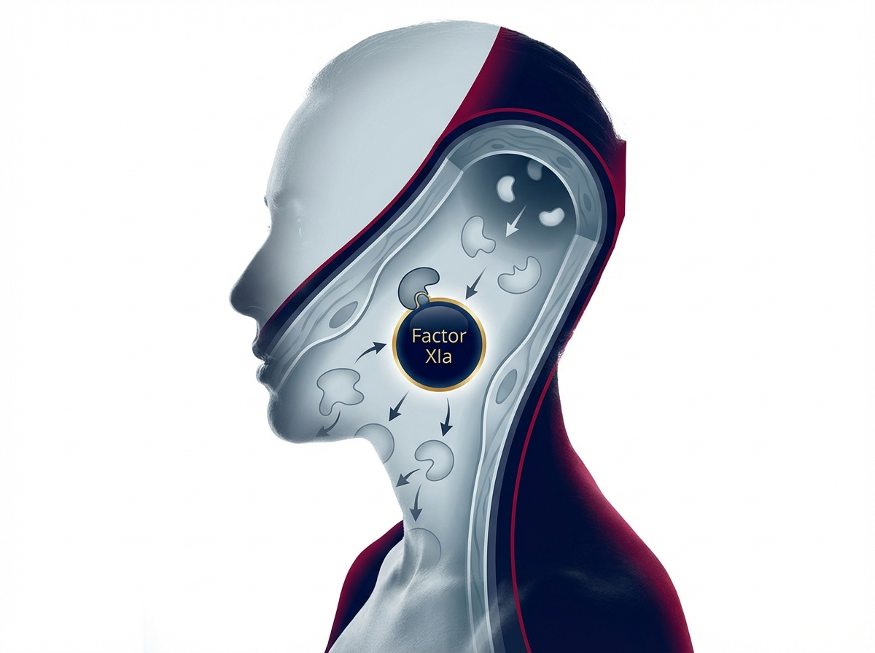
https://velox-images.pages.dev/columns-moa-preview.jpeg
Usage: Home — MoA teaser
Heading: Deep and sustained KRAS G12C target engagement
Body text: Trionafenib forms an irreversible covalent bond with the mutant cysteine residue on KRAS G12C, locking the oncoprotein in its inactive GDP-bound state and shutting down the RAS–MAPK signalling cascade. A novel Switch II pocket interaction delivers deeper and more sustained target occupancy than first-generation KRAS G12C inhibitors.³ ⁵
Call to action: Explore how TRION works → /trion/how-trion-works
────────────────────────────────────────────────────────────

Section 5 — Prescribing information footer
Block: accordion
Expandable sections for: Prescribing Information | Adverse Event Reporting | References (Use approved text from sections 5, 6, and 7 above)

Page metadata
Title: TRION (trionafenib) | KRAS G12C Inhibitor for NSCLC | AstraZeneca UK
Description: TRION (trionafenib) is a selective oral KRAS G12C inhibitor for locally advanced or metastatic NSCLC. Explore TRIFORCE clinical data, safety, and dosing for UK healthcare professionals.

PAGE 2: TRIFORCE Data
URL path: /trion/triforce-data
────────────────────────────────────────────────────────────

Section 1 — Hero (full-width image with text overlay)
Block: hero-teaser


https://velox-images.pages.dev/hero-efficacy.jpeg
Usage: TRIFORCE Data — hero
Heading: The TRIFORCE clinical programme
Body text: TRION®▼ (trionafenib) demonstrated significant overall survival benefit and intracranial activity across two clinical trials in patients with KRAS G12C-mutant NSCLC.¹ ²
────────────────────────────────────────────────────────────

Section 2 — Programme overview (centred text) | light background
Block: introduction
Section metadata: Style: light
Heading: Addressing unmet needs in KRAS G12C-mutant NSCLC
Body text: TRIFORCE-1 was the first Phase III trial to demonstrate a statistically significant overall survival benefit for a KRAS G12C inhibitor versus standard of care in previously treated NSCLC. TRIFORCE-LUNG evaluated intracranial activity in patients with measurable brain metastases — an area of critical unmet need, as brain metastases occur in up to 40% of patients with advanced NSCLC and are associated with poor prognosis and limited treatment options.¹ ²
────────────────────────────────────────────────────────────

Section 3 — Clinical data (two tabs)
Block: tabs-large

Tab 1: "TRIFORCE-1: Overall survival"

https://velox-images.pages.dev/tab-velocity-af.jpeg
Usage: TRIFORCE Data — TRIFORCE-1 tab
Heading: TRIFORCE-1: The first KRAS G12C inhibitor to demonstrate an OS benefit
Body text: TRIFORCE-1 was a randomised, open-label, Phase III trial comparing TRION 200 mg twice daily with docetaxel 75 mg/m² IV Q3W in 802 adults with previously treated KRAS G12C-mutant locally advanced or metastatic NSCLC. Over a median follow-up of 15.2 months, TRION demonstrated a statistically significant improvement in the primary endpoint of overall survival: median OS 14.8 months vs 10.4 months (HR 0.66; 95% CI: 0.54–0.80; P<0.001).¹

Body text (continued): TRION significantly improved progression-free survival (median 7.8 vs 4.1 months; HR 0.52; P<0.001) and confirmed objective response rate (42.1% vs 13.7%; P<0.001) by blinded independent central review. The median duration of response was 11.3 months. The disease control rate was 82.5% with TRION vs 56.6% with docetaxel. Patient-reported symptoms also improved significantly, with 48.2% of TRION patients reporting improvement in cough (vs 28.1%; P<0.001).¹
Data table:
Endpoint | TRION (n=401) | Docetaxel (n=401) | Treatment effect
Overall survival | 14.8 months | 10.4 months | HR 0.66 (0.54–0.80); P<0.001
12-month OS rate | 58.3% | 43.6% | Δ 14.7% (8.1–21.3)
PFS (BICR) | 7.8 months | 4.1 months | HR 0.52 (0.44–0.62); P<0.001
Confirmed ORR (BICR) | 42.1% | 13.7% | Δ 28.4% (22.6–34.2); P<0.001
Disease control rate | 82.5% | 56.6% | Δ 25.9% (19.8–32.0); P<0.001
────────────────────────────────────────────────────────────
Tab 2: "TRIFORCE-LUNG: Intracranial activity"
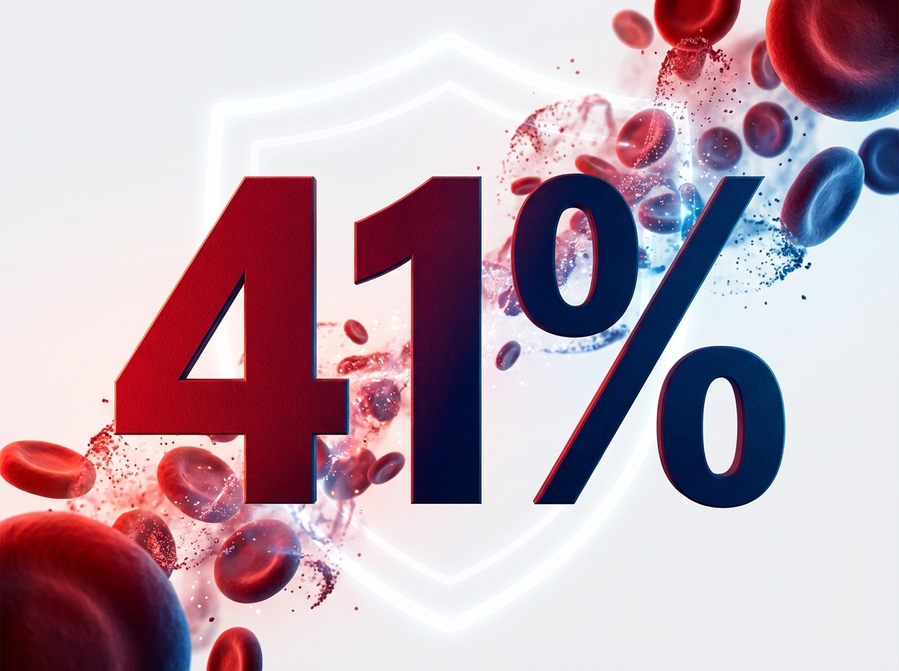
https://velox-images.pages.dev/tab-velocity-bleed.jpeg
Usage: TRIFORCE Data — TRIFORCE-LUNG tab
Heading: TRIFORCE-LUNG: Meaningful intracranial activity in brain metastases
Body text: TRIFORCE-LUNG was an open-label, single-arm Phase II trial in 146 adults with KRAS G12C-mutant NSCLC and measurable brain metastases (≥1 lesion ≥10 mm), including patients with untreated or progressing CNS disease.²

Body text (continued): TRION achieved an intracranial confirmed ORR of 37.0% (95% CI: 29.2–45.3%), including 8.2% intracranial complete responses. The intracranial disease control rate was 74.7%. Intracranial PFS was a median of 6.9 months. Notably, the intracranial response rate was higher in patients with previously untreated brain metastases (42.1%) compared with previously treated lesions (31.4%), suggesting meaningful CNS penetration. Intracranial and extracranial responses were concordant in 78.1% of patients.²
Data table:
Endpoint | TRION (n=146) | 95% CI
IC-ORR (primary) | 37.0% | 29.2–45.3%
IC complete response | 8.2% | 4.3–14.0%
IC disease control rate | 74.7% | 66.8–81.6%
Median IC-PFS | 6.9 months | 5.4–8.8 months
Overall ORR | 39.0% | 31.1–47.4%
────────────────────────────────────────────────────────────

Section 4 — Prescribing information footer
Block: accordion | Expandable: PI | AE Reporting | References

Page metadata
Title: TRIFORCE Data | TRION (trionafenib) | OS & Intracranial Activity in NSCLC | AstraZeneca UK
Description: Explore the TRIFORCE clinical programme for TRION (trionafenib) — Phase III overall survival benefit and intracranial activity in KRAS G12C-mutant non-small cell lung cancer.

PAGE 3: Safety
URL path: /trion/safety
────────────────────────────────────────────────────────────

Section 1 — Page header (text only, no image)
Block: title
Heading: Safety profile of TRION
Body text: TRION®▼ (trionafenib) has been evaluated in 547 patients across the TRIFORCE clinical programme, with a well-characterised safety profile and established dose modification guidance.¹ ² ³
────────────────────────────────────────────────────────────

Section 2 — Key safety message (centred text) | highlight background
Block: introduction
Section metadata: Style: highlight
Heading: A manageable safety profile with established dose modification guidance
Body text: The most common adverse events with TRION are gastrointestinal (diarrhoea, nausea, vomiting) and hepatotoxicity (transaminase elevations), which are manageable with standard supportive care and protocol-defined dose modifications. Treatment discontinuation due to adverse events occurred in 9.7% of patients. Hepatic function should be monitored regularly, and patients should be counselled on early recognition and management of diarrhoea.³
────────────────────────────────────────────────────────────

Section 3 — Safety topic cards (three equal columns)
Block: cards-teaser


https://velox-images.pages.dev/card-bleeding-events.jpeg
Usage: Safety — hepatotoxicity card
Card heading: Hepatotoxicity
Card body: Grade ≥3 ALT elevation occurred in 6.4% of TRION-treated patients; grade ≥3 AST elevation in 4.8%. Median onset: 6 weeks. In all cases managed with dose modification, transaminases returned to grade ≤1 within a median of 14 days. Monitor ALT, AST, and bilirubin every 2 weeks for 3 months, then monthly.³
────────────────────────────────────────────────────────────
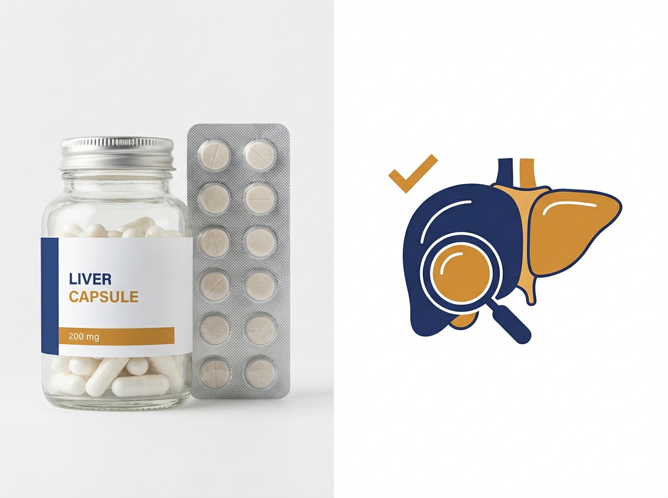
https://velox-images.pages.dev/card-hepatic.jpeg
Usage: Safety — GI events card
Card heading: Gastrointestinal events
Card body: Diarrhoea was the most frequent adverse event (62.3% all grades; 8.4% grade ≥3). Nausea (44.8%) and vomiting (27.4%) were predominantly grade 1–2. Grade ≥3 diarrhoea was managed with dose interruption (median 5 days). Prophylactic or early loperamide is recommended. Standard anti-emetics are effective for nausea and vomiting.³
────────────────────────────────────────────────────────────
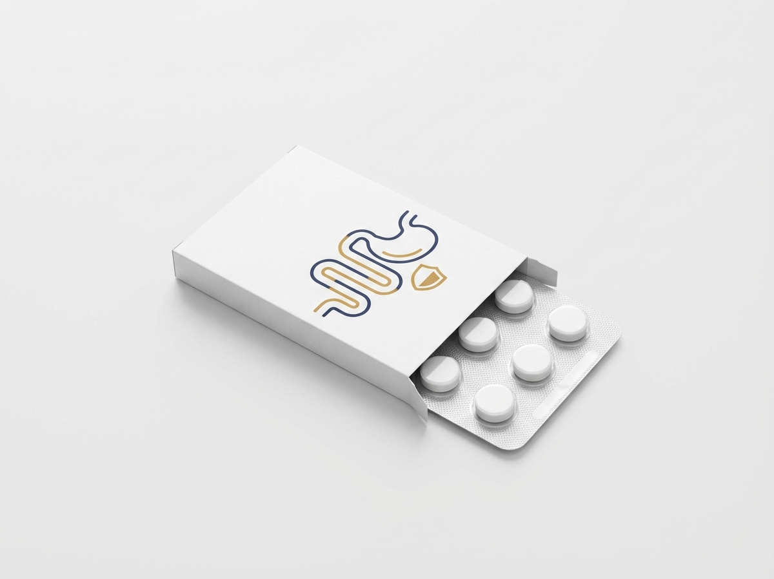
https://velox-images.pages.dev/card-gi-events.jpeg
Usage: Safety — QTc monitoring card
Card heading: QTc prolongation
Card body: QTcF increase >60 ms from baseline: 1.8%. QTcF >500 ms: 0.7%. No torsades de pointes or sudden cardiac deaths were reported. Avoid use if baseline QTcF >470 ms. Correct electrolyte abnormalities before initiation. ECG at baseline, Week 4, and as clinically indicated.³
────────────────────────────────────────────────────────────

Section 4 — Adverse events table | light background
Block: table-data
Section metadata: Style: light
Heading: Most common adverse events (≥10%) — pooled TRIFORCE data
Adverse event | All grades (%) | Grade ≥3 (%)
Diarrhoea | 62.3 | 8.4
Nausea | 44.8 | 2.6
Fatigue | 38.1 | 5.3
Vomiting | 27.4 | 2.0
ALT increased | 24.6 | 6.4
AST increased | 22.8 | 4.8
Decreased appetite | 21.5 | 1.8
Arthralgia | 15.2 | 0.7
Rash | 14.6 | 1.3
Peripheral oedema | 12.4 | 0.5
Cough | 11.8 | 0.2
Anaemia | 10.9 | 3.1
────────────────────────────────────────────────────────────

Section 5 — ILD/Pneumonitis warning (centred text)
Block: introduction
Heading: Interstitial lung disease / pneumonitis
Body text: ILD/pneumonitis occurred in 3.8% of TRION-treated patients (1.8% grade ≥3). Median time to onset was 8.2 weeks. Two fatal cases of pneumonitis were reported (0.4%), both assessed as possibly treatment-related. Monitor patients for new or worsening respiratory symptoms (dyspnoea, cough, fever). Withhold TRION for suspected ILD/pneumonitis pending investigation. Permanently discontinue for confirmed grade ≥2 ILD/pneumonitis.³
────────────────────────────────────────────────────────────

Section 6 — Prescribing information footer
Block: accordion | Expandable: PI | AE Reporting | References

Page metadata
Title: Safety Profile | TRION (trionafenib) | Adverse Events & Monitoring | AstraZeneca UK
Description: Review the safety profile of TRION (trionafenib), including hepatotoxicity, GI events, QTc monitoring, and ILD/pneumonitis guidance from the TRIFORCE clinical programme.

PAGE 4: Dosing & Administration
URL path: /trion/dosing
────────────────────────────────────────────────────────────

Section 1 — Page header (text only, no image)
Block: title
Heading: Dosing and administration
Body text: TRION®▼ (trionafenib) 200 mg twice daily, taken orally with food. Dose modification guidance is established for the most common treatment-related adverse events.³
────────────────────────────────────────────────────────────

Section 2 — Key dosing message (centred text) | highlight background
Block: introduction
Section metadata: Style: highlight
Heading: Oral targeted therapy with clear dose modification pathways
Body text: TRION offers patients a convenient oral alternative to intravenous chemotherapy. The recommended starting dose is 200 mg twice daily with food. If dose reduction is required for adverse events, reduce to 200 mg once daily. Clear dose interruption and reduction criteria are defined in the SmPC for hepatotoxicity, diarrhoea, QTc prolongation, and other treatment-emergent events.³
────────────────────────────────────────────────────────────

Section 3 — Dosing details (two-column: image left, text right)
Block: columns-teaser


https://velox-images.pages.dev/columns-dosing.jpeg
Usage: Dosing — twice-daily regimen
Heading: Recommended dose and administration
Body text: The recommended dose of TRION is 200 mg (one tablet) taken orally twice daily, approximately 12 hours apart, with food. Tablets should be swallowed whole and must not be crushed or chewed. If a dose is missed by more than 6 hours from the scheduled time, skip that dose and take the next dose at the regular time. Do not take a double dose.³

Body text (continued): Dose modification for adverse events: For grade ≥3 hepatotoxicity (ALT or AST >5× ULN), withhold until resolution to grade ≤1, then resume at 200 mg once daily. For grade ≥3 diarrhoea despite optimal medical management, withhold until resolution to grade ≤1, then resume at the same or reduced dose. For QTcF >500 ms, withhold until QTcF returns to ≤470 ms and resume at 200 mg once daily. Permanently discontinue for recurrent grade 4 hepatotoxicity or confirmed grade ≥2 ILD/pneumonitis.³
────────────────────────────────────────────────────────────

Section 4 — Monitoring requirements (two-column: image left, text right) | light background
Block: columns-teaser
Section metadata: Style: light


https://velox-images.pages.dev/columns-monitoring.jpeg
Usage: Dosing — monitoring requirements
Heading: Monitoring and pre-treatment assessment
Body text: Before initiation: Confirm KRAS G12C mutation by validated test. Assess hepatic function (ALT, AST, bilirubin). Obtain ECG (QTcF must be ≤470 ms). Correct electrolyte abnormalities (potassium, magnesium, calcium). Assess pregnancy status in women of childbearing potential.³

Body text (continued): During treatment: Monitor ALT, AST, and bilirubin every 2 weeks for the first 3 months, then monthly thereafter and as clinically indicated. Repeat ECG at Week 4 and as clinically indicated. Assess renal function periodically. Monitor for respiratory symptoms (cough, dyspnoea, fever) at each visit — investigate promptly if ILD/pneumonitis is suspected.³
────────────────────────────────────────────────────────────

Section 5 — Drug interactions (centred text)
Block: introduction
Heading: Key drug interactions
Body text: Contraindicated: Strong CYP3A4 inducers (rifampicin, carbamazepine, phenytoin, St John’s wort) — may significantly reduce trionafenib plasma concentrations and efficacy. Caution: Moderate CYP3A4 inhibitors (erythromycin, diltiazem, fluconazole) increase trionafenib exposure approximately 1.6-fold; consider dose reduction to 200 mg once daily if concomitant use is unavoidable. Strong CYP3A4 inhibitors (ketoconazole, itraconazole) increase exposure approximately 2.4-fold; avoid concomitant use. Avoid QT-prolonging medications where possible; if concomitant use is required, increase ECG monitoring frequency.³
────────────────────────────────────────────────────────────

Section 6 — Prescribing information footer
Block: accordion | Expandable: PI | AE Reporting | References

Page metadata
Title: Dosing & Administration | TRION (trionafenib) | 200 mg BD Oral | AstraZeneca UK
Description: TRION (trionafenib) dosing and administration: 200 mg twice daily with food. Dose modification guidance, monitoring requirements, and drug interaction information for UK healthcare professionals.

PAGE 5: How TRION Works
URL path: /trion/how-trion-works
────────────────────────────────────────────────────────────

Section 1 — Hero (full-width image with text overlay)
Block: hero-teaser


https://velox-images.pages.dev/hero-moa.jpeg
Usage: How TRION Works — hero
Heading: How TRION works
Body text: TRION®▼ (trionafenib) is a selective covalent KRAS G12C inhibitor that locks the KRAS oncoprotein in its inactive state, shutting down tumour-driving signalling.³ ⁵
────────────────────────────────────────────────────────────

Section 2 — KRAS biology (centred text) | light background
Block: introduction
Section metadata: Style: light
Heading: KRAS: a master switch in cancer signalling
Body text: KRAS is a GTPase that acts as a molecular switch, cycling between an active GTP-bound state and an inactive GDP-bound state. In normal cells, KRAS activation is tightly regulated by guanine nucleotide exchange factors (GEFs) and GTPase-activating proteins (GAPs). The G12C mutation impairs GAP-mediated GTP hydrolysis, trapping KRAS in its active state and driving constitutive activation of the RAS–MAPK, PI3K–AKT, and RAL–GDS signalling pathways — promoting tumour cell proliferation, survival, and immune evasion.⁴ ⁵
────────────────────────────────────────────────────────────

Section 3 — Mechanism detail (two-column: image left, text right) | highlight background
Block: columns-teaser
Section metadata: Style: highlight


https://velox-images.pages.dev/columns-moa-preview.jpeg
Usage: Home — MoA teaser
Heading: Covalent trapping of KRAS G12C in the inactive state
Body text: Trionafenib exploits the mutant cysteine at position 12 — a neoantigen unique to KRAS G12C that is absent from wild-type KRAS. When KRAS G12C cycles transiently to its GDP-bound (inactive) state, trionafenib enters the Switch II pocket and forms an irreversible covalent bond with Cys12. This locks KRAS in the inactive conformation, preventing GEF-mediated GDP-to-GTP exchange and permanently silencing RAS signalling in that molecule.³ ⁵

Body text (continued): Trionafenib’s enhanced Switch II pocket binding achieves deeper target occupancy than first-generation KRAS G12C inhibitors, overcoming adaptive resistance mechanisms including RTK-mediated feedback reactivation and SHP2-dependent RAS cycling. The result is more complete and sustained suppression of the RAS–MAPK pathway, which correlates with the improved response rates and survival outcomes observed in the TRIFORCE programme.³ ⁵
Call to action: View the TRIFORCE clinical data → /trion/triforce-data
────────────────────────────────────────────────────────────

Section 4 — Immune modulation (centred text)
Block: introduction
Heading: Beyond direct anti-tumour activity: immune reactivation
Body text: KRAS G12C inhibition has been shown to modulate the tumour immune microenvironment, restoring MHC class I expression on tumour cells and enhancing T-cell-mediated anti-tumour immunity. Preclinical models demonstrate that trionafenib increases tumour-infiltrating CD8+ T-cells and synergises with anti-PD-1 checkpoint inhibition. These findings provide the scientific rationale for ongoing combination studies evaluating TRION with immunotherapy.⁴ ⁵
────────────────────────────────────────────────────────────

Section 5 — Prescribing information footer
Block: accordion | Expandable: PI | AE Reporting | References

Page metadata
Title: How TRION Works | KRAS G12C Covalent Inhibition | Mechanism of Action | AstraZeneca UK
Description: Understand how TRION (trionafenib) selectively inhibits KRAS G12C through covalent binding, shutting down RAS–MAPK signalling and modulating anti-tumour immunity in NSCLC.

PAGE 6: Resources
URL path: /trion/resources
────────────────────────────────────────────────────────────

Section 1 — Page header (text only, no image)
Block: title
Heading: Resources for healthcare professionals
Body text: Access prescribing guides, KRAS testing information, clinical data summaries, and patient support materials for TRION®▼ (trionafenib). All materials are provided for UK healthcare professionals only.³
────────────────────────────────────────────────────────────

Section 2 — Resource cards (three equal columns)
Block: cards-teaser


https://velox-images.pages.dev/card-prescribing.jpeg
Usage: Resources — prescribing guide card
Card heading: Prescribing and dose modification guide
Card body: A comprehensive clinical guide covering indication, KRAS G12C testing requirements, dosing, dose modification criteria for hepatotoxicity, diarrhoea, and QTc prolongation, monitoring schedules, and drug interactions. Designed for rapid reference in oncology clinics.³
Card link: Download prescribing guide → [PDF link]
────────────────────────────────────────────────────────────
Card heading: KRAS G12C testing pathway
Card body: Information on KRAS G12C testing methodologies, including tissue-based NGS panels and ctDNA liquid biopsy options. Guidance on testing workflows, turnaround times, and recommended UK Genomic Medicine Service laboratories.³
Card link: Download testing guide → [PDF link]
────────────────────────────────────────────────────────────
Card heading: TRIFORCE clinical data summary
Card body: Summary of key efficacy and safety data from TRIFORCE-1 and TRIFORCE-LUNG, including headline statistics, Kaplan-Meier curves, subgroup forest plots, and waterfall plots. A comprehensive overview of the clinical evidence supporting TRION.¹ ²
Card link: Download data summary → [PDF link]
────────────────────────────────────────────────────────────

Section 3 — Contact (centred text) | light background
Block: introduction
Section metadata: Style: light
Heading: Medical information and support
Body text: For medical information enquiries about TRION, please contact AstraZeneca Medical Information: Telephone: 0800 783 0033 | Email: medicalinformationuk@astrazeneca.com | Online: contactazmedical.astrazeneca.com
────────────────────────────────────────────────────────────

Section 4 — Prescribing information footer
Block: accordion | Expandable: PI | AE Reporting | References

Page metadata
Title: Resources | TRION (trionafenib) | KRAS Testing & Prescribing Guides | AstraZeneca UK
Description: Access prescribing guides, KRAS G12C testing pathways, TRIFORCE clinical data summaries, and support materials for TRION (trionafenib). For UK healthcare professionals only.

10. Footer Content
The footer must appear on every page and contain the following elements:
Logo: AstraZeneca logo (linked to /trion/)
Approval code: GB-11583 | DOP: March 2026
Copyright: © 2026 AstraZeneca. All rights reserved. TRION is a registered trademark of the AstraZeneca group of companies.
Page links: TRIFORCE Data | Safety | Dosing & Administration | How TRION Works | Resources
Regulatory links: Report Adverse Event (https://yellowcard.mhra.gov.uk/) | Medical Information (https://contactazmedical.astrazeneca.com/) | Privacy Policy (https://www.astrazeneca.co.uk/our-company/privacy-notice.html) | Terms of Use (https://www.astrazeneca.co.uk/our-company/terms-of-use.html) | Accessibility (https://www.astrazeneca.co.uk/accessibility.html)
Date of preparation: Date of Preparation: March 2026
────────────────────────────────────────────────────────────

11. Image Assets
All images are sourced from the shared CDN: https://velox-images.pages.dev/
Note: TRION reuses images originally generated for the VELOX website. The dramatic, abstract visual style is well-suited to oncology contexts.

Complete image manifest:

Filename | Usage | CDN URL
hero-home.jpeg | Home — hero | https://velox-images.pages.dev/hero-home.jpeg
hero-efficacy.jpeg | TRIFORCE Data — hero | https://velox-images.pages.dev/hero-efficacy.jpeg
hero-moa.jpeg | How TRION Works — hero | https://velox-images.pages.dev/hero-moa.jpeg
card-stroke.jpeg | Home — objective response rate card | https://velox-images.pages.dev/card-stroke.jpeg
card-bleeding.jpeg | Home — progression-free survival card | https://velox-images.pages.dev/card-bleeding.jpeg
card-dosing.jpeg | Home — oral dosing convenience card | https://velox-images.pages.dev/card-dosing.jpeg
columns-moa-preview.jpeg | Home — MoA teaser | https://velox-images.pages.dev/columns-moa-preview.jpeg
tab-velocity-af.jpeg | TRIFORCE Data — TRIFORCE-1 tab | https://velox-images.pages.dev/tab-velocity-af.jpeg
tab-velocity-bleed.jpeg | TRIFORCE Data — TRIFORCE-LUNG tab | https://velox-images.pages.dev/tab-velocity-bleed.jpeg
card-bleeding-events.jpeg | Safety — hepatotoxicity card | https://velox-images.pages.dev/card-bleeding-events.jpeg
card-hepatic.jpeg | Safety — GI events card | https://velox-images.pages.dev/card-hepatic.jpeg
card-gi-events.jpeg | Safety — QTc monitoring card | https://velox-images.pages.dev/card-gi-events.jpeg
columns-dosing.jpeg | Dosing — twice-daily regimen | https://velox-images.pages.dev/columns-dosing.jpeg
columns-monitoring.jpeg | Dosing — monitoring requirements | https://velox-images.pages.dev/columns-monitoring.jpeg
card-prescribing.jpeg | Resources — prescribing guide card | https://velox-images.pages.dev/card-prescribing.jpeg

Image previews
Visual previews of all 15 images:

hero-home.jpeg — Home — hero

https://velox-images.pages.dev/hero-home.jpeg
Usage: Home — hero

hero-efficacy.jpeg — TRIFORCE Data — hero

https://velox-images.pages.dev/hero-efficacy.jpeg
Usage: TRIFORCE Data — hero

hero-moa.jpeg — How TRION Works — hero

https://velox-images.pages.dev/hero-moa.jpeg
Usage: How TRION Works — hero

card-stroke.jpeg — Home — objective response rate card

https://velox-images.pages.dev/card-stroke.jpeg
Usage: Home — objective response rate card

card-bleeding.jpeg — Home — progression-free survival card

https://velox-images.pages.dev/card-bleeding.jpeg
Usage: Home — progression-free survival card

card-dosing.jpeg — Home — oral dosing convenience card

https://velox-images.pages.dev/card-dosing.jpeg
Usage: Home — oral dosing convenience card

columns-moa-preview.jpeg — Home — MoA teaser

https://velox-images.pages.dev/columns-moa-preview.jpeg
Usage: Home — MoA teaser

tab-velocity-af.jpeg — TRIFORCE Data — TRIFORCE-1 tab

https://velox-images.pages.dev/tab-velocity-af.jpeg
Usage: TRIFORCE Data — TRIFORCE-1 tab

tab-velocity-bleed.jpeg — TRIFORCE Data — TRIFORCE-LUNG tab

https://velox-images.pages.dev/tab-velocity-bleed.jpeg
Usage: TRIFORCE Data — TRIFORCE-LUNG tab

card-bleeding-events.jpeg — Safety — hepatotoxicity card

https://velox-images.pages.dev/card-bleeding-events.jpeg
Usage: Safety — hepatotoxicity card

card-hepatic.jpeg — Safety — GI events card

https://velox-images.pages.dev/card-hepatic.jpeg
Usage: Safety — GI events card

card-gi-events.jpeg — Safety — QTc monitoring card

https://velox-images.pages.dev/card-gi-events.jpeg
Usage: Safety — QTc monitoring card

columns-dosing.jpeg — Dosing — twice-daily regimen

https://velox-images.pages.dev/columns-dosing.jpeg
Usage: Dosing — twice-daily regimen

columns-monitoring.jpeg — Dosing — monitoring requirements

https://velox-images.pages.dev/columns-monitoring.jpeg
Usage: Dosing — monitoring requirements

card-prescribing.jpeg — Resources — prescribing guide card

https://velox-images.pages.dev/card-prescribing.jpeg
Usage: Resources — prescribing guide card

