VELOX®
(veloxaban)

Website Briefing

Protection without compromise.

Document type: Final approved marketing brief for HCP website build
Prepared by: Marketing — UK Cardiovascular Franchise
Approval status: MLR-approved copy — do not modify
Date: March 2026
Approval code: GB-10247 | DOP: March 2026

Contents
1. Drug Profile
2. Mechanism of Action
3. Clinical Programme: VELOCITY
4. Safety Profile
5. Prescribing Information
6. Adverse Event Reporting
7. References
8. Site Navigation
9. Page Content
Page 1: Home
Page 2: VELOCITY Data
Page 3: Safety
Page 4: Dosing & Administration
Page 5: How VELOX Works
Page 6: Resources
10. Footer Content
11. Image Assets

1. Drug Profile
Field | Detail
Brand name | VELOX®
Generic name | veloxaban
Drug class | Selective oral Factor XIa inhibitor
Indication | Prevention of stroke and systemic embolism in adult patients with non-valvular atrial fibrillation (NVAF) with one or more risk factors for stroke
Formulation | 40 mg film-coated tablet
Dosing | One 40 mg tablet once daily, with or without food
Approval | MHRA — January 2026
Brand colour | Deep Navy #1A365D
Accent colour | Crimson Red #C62828
Approval code | GB-10247

VELOX brand rule: VELOX always appears in capitals, with ® on first mention per page. Generic name (veloxaban) appears in lowercase parentheses on first mention. The approved tagline "Protection without compromise." may only be used verbatim — no variations permitted.
────────────────────────────────────────────────────────────

2. Mechanism of Action
Veloxaban is a first-in-class, selective, oral small-molecule inhibitor of activated Factor XI (Factor XIa). Factor XIa plays a central role in the amplification phase of the coagulation cascade, propagating thrombin generation through the intrinsic pathway without significantly affecting the extrinsic (tissue factor) pathway responsible for normal haemostasis.
The coagulation cascade comprises two converging pathways. The extrinsic pathway, initiated by tissue factor exposure at sites of vascular injury, is essential for physiological haemostasis — the body’s primary defence against bleeding. The intrinsic pathway, driven by contact activation and amplified by Factor XIa, contributes disproportionately to pathological thrombus formation (e.g. in atrial fibrillation, venous thromboembolism) while playing a lesser role in surgical or traumatic haemostasis.¹ ²
By selectively inhibiting Factor XIa, veloxaban achieves potent antithrombotic efficacy through the following mechanisms:
- Suppression of thrombin amplification via the intrinsic (contact) pathway
- Reduction of fibrin-rich thrombus propagation in low-shear environments (e.g. left atrial appendage in AF)
- Attenuation of Factor XIa-driven platelet activation, reducing platelet-dependent thrombin generation
- Preservation of the extrinsic (tissue factor) pathway, maintaining physiological haemostasis at sites of vascular injury
This selective mechanism separates antithrombotic efficacy from bleeding risk — a limitation of current Factor Xa and direct thrombin inhibitors, which inhibit components common to both pathological and physiological coagulation. Clinical genetic evidence supports this approach: individuals with inherited Factor XI deficiency demonstrate protection from thrombotic events with only mild bleeding tendency, unlike deficiencies in Factor X or prothrombin.¹ ² ⁵
────────────────────────────────────────────────────────────

3. Clinical Programme: VELOCITY

VELOCITY-AF (Phase III, pivotal — Stroke prevention in atrial fibrillation)
Design: Randomised, double-blind, double-dummy, active-controlled, non-inferiority Phase III trial with pre-specified superiority testing for major bleeding
Population: 14,228 adults with non-valvular atrial fibrillation and CHA₂DS₂-VASc score ≥2 (men) or ≥3 (women)
Duration: Median 24 months on treatment (event-driven; minimum 12 months per patient)
Comparator: Rivaroxaban 20 mg once daily (15 mg once daily for CrCl 30–49 mL/min)
Primary efficacy endpoint: Time to first stroke (ischaemic or haemorrhagic) or systemic embolism
Primary safety endpoint: Time to first ISTH major bleeding event
Key secondary endpoints: All-cause mortality; composite of stroke, systemic embolism, MI, or cardiovascular death; net clinical benefit (composite of stroke/SE/major bleeding/all-cause death); intracranial haemorrhage
Publication: Whitfield et al. N Engl J Med 2025; 393(8): 702–715

Key results:
Endpoint | VELOX 40 mg (n=7,114) | Rivaroxaban (n=7,114) | Treatment effect
Stroke or SE (primary efficacy) | 1.68%/year | 1.72%/year | HR 0.97 (0.83–1.14); P<0.001 for non-inferiority
Ischaemic stroke | 1.32%/year | 1.38%/year | HR 0.96 (0.80–1.15)
Haemorrhagic stroke | 0.18%/year | 0.31%/year | HR 0.58 (0.38–0.88); P=0.011
ISTH major bleeding (primary safety) | 1.52%/year | 2.58%/year | HR 0.59 (0.50–0.69); P<0.001
Intracranial haemorrhage | 0.21%/year | 0.52%/year | HR 0.40 (0.28–0.58); P<0.001
GI major bleeding | 0.62%/year | 1.04%/year | HR 0.60 (0.47–0.76); P<0.001
All-cause mortality | 3.14%/year | 3.38%/year | HR 0.93 (0.83–1.04); P=0.21
Net clinical benefit* | 4.42%/year | 5.61%/year | HR 0.79 (0.72–0.87); P<0.001
*Net clinical benefit = composite of stroke/SE, major bleeding, and all-cause death.

VELOCITY-BLEED (Phase III — Bleeding safety in high-risk AF patients)
Design: Randomised, double-blind, active-controlled Phase III trial in patients at elevated bleeding risk
Population: 4,612 adults with NVAF and at least one additional bleeding risk factor (age ≥80; CrCl 30–49 mL/min; history of GI bleeding; concomitant antiplatelet therapy; HAS-BLED score ≥3)
Duration: 52 weeks on treatment
Comparator: Apixaban 5 mg twice daily (2.5 mg twice daily per label)
Primary endpoint: ISTH major or clinically relevant non-major (CRNM) bleeding events over 52 weeks
Key secondary endpoints: ISTH major bleeding alone; stroke or SE; net clinical benefit; time to first CRNM bleeding
Publication: Nakamura et al. Lancet 2026; 407(10329): 445–458

Key results:
Endpoint | VELOX 40 mg (n=2,306) | Apixaban (n=2,306) | Treatment effect
Major or CRNM bleeding (primary) | 4.12% | 6.97% | HR 0.59 (0.49–0.71); P<0.001
ISTH major bleeding | 1.34% | 2.28% | HR 0.59 (0.42–0.82); P=0.002
Stroke or SE | 1.82% | 1.74% | HR 1.05 (0.77–1.42); P=0.76 (non-inferior)
Intracranial haemorrhage | 0.22% | 0.48% | HR 0.46 (0.23–0.90); P=0.024
GI bleeding (major + CRNM) | 1.74% | 2.89% | HR 0.60 (0.44–0.82); P=0.001
Net clinical benefit | 6.81% | 8.92% | HR 0.76 (0.66–0.88); P<0.001
────────────────────────────────────────────────────────────

4. Safety Profile (Pooled VELOCITY data, N=9,420 VELOX)

Most common adverse events (≥2%)
Adverse event | VELOX (%) | Comparator (%)
Nasopharyngitis | 7.2 | 7.0
Epistaxis | 4.8 | 5.6
Contusion/bruising | 4.1 | 5.9
Gingival bleeding | 3.4 | 4.2
Haematuria | 2.8 | 3.7
Dizziness | 2.6 | 2.4
Dyspepsia | 2.3 | 2.1
Diarrhoea | 2.1 | 1.9

Bleeding events (pooled VELOCITY-AF + VELOCITY-BLEED)
VELOX demonstrated a consistently lower bleeding rate across all categories compared with established Factor Xa inhibitors. ISTH major bleeding occurred in 1.52%/year (VELOCITY-AF) and 1.34% (VELOCITY-BLEED) of VELOX-treated patients, representing 41% relative risk reductions versus rivaroxaban and apixaban respectively. Intracranial haemorrhage, the most feared complication of anticoagulation, was reduced by 54–60% with VELOX across both trials.¹ ²

Hepatic safety
ALT elevations >3× ULN occurred in 1.1% of VELOX-treated patients vs 0.9% comparator across pooled data. No cases of Hy’s Law were observed. Routine hepatic monitoring is not required, but liver function should be assessed prior to initiation and if clinically indicated during treatment.³

Key safety findings
Serious adverse events: 12.4% VELOX vs 13.8% comparator (driven by fewer bleeding-related hospitalisations)
Treatment discontinuation due to AEs: 4.8% vs 5.4%
All-cause mortality: 3.14%/year vs 3.38%/year in VELOCITY-AF (HR 0.93; P=0.21)
Myocardial infarction: 0.84%/year vs 0.91%/year (no increase in coronary events)
Drug interactions: Strong dual CYP3A4/P-gp inhibitors (ketoconazole, ritonavir) increase veloxaban exposure ~2.1-fold; avoid concomitant use. Moderate CYP3A4 inhibitors (diltiazem, erythromycin): no dose adjustment required³
Renal impairment: No dose adjustment for CrCl ≥30 mL/min. Not studied in CrCl <30 mL/min or dialysis. Contraindicated in CrCl <15 mL/min³

Special populations
- Elderly (≥75 years): 38% of VELOCITY-AF patients were ≥75 years. Efficacy and safety consistent with the overall population. No dose adjustment required.³
- Renal impairment (CrCl 30–49 mL/min): No dose reduction required (unlike rivaroxaban). In the renal impairment subgroup of VELOCITY-AF, major bleeding was 1.64%/year vs 3.12%/year for rivaroxaban.¹ ³
- Low body weight (<60 kg): Exposure modestly increased (1.3-fold). No dose adjustment required based on VELOCITY-AF subgroup analysis showing consistent efficacy and safety.³
- Hepatic impairment: Not recommended in Child-Pugh C. No dose adjustment for Child-Pugh A or B.³
- Concomitant antiplatelet therapy: 14% of VELOCITY-AF patients received aspirin. Bleeding increase with dual therapy was smaller with VELOX than rivaroxaban. Triple therapy (DAPT + anticoagulant) was excluded from trials.³
────────────────────────────────────────────────────────────

5. Prescribing Information (abbreviated — for every page footer)
VELOX (veloxaban) 40 mg film-coated tablets. Please refer to the Summary of Product Characteristics (SmPC) before prescribing. Indication: Prevention of stroke and systemic embolism in adult patients with non-valvular atrial fibrillation with one or more risk factors for stroke (prior stroke/TIA/SE, age ≥75 years, hypertension, diabetes mellitus, heart failure NYHA ≥II). Dosage and administration: 40 mg once daily, with or without food. Swallow whole; do not crush, split, or chew. No dose adjustment required for age, body weight, or renal impairment (CrCl ≥30 mL/min). Contraindicated in CrCl <15 mL/min. Contraindications: Hypersensitivity to veloxaban or excipients; active clinically significant bleeding; hepatic disease associated with coagulopathy (Child-Pugh C); concomitant treatment with strong dual CYP3A4/P-gp inhibitors; lesion or condition at significant risk of major bleeding; prosthetic heart valve requiring anticoagulant treatment. Warnings and precautions: Assess renal function before initiation and when clinically indicated during treatment. Discontinue if severe hepatic impairment develops. If switching from a vitamin K antagonist, discontinue VKA and start VELOX when INR <2.0. Reversal: No specific antidote; andexanet alfa is not expected to reverse veloxaban. Manage major bleeding with standard supportive measures and consider prothrombin complex concentrate. Interactions: Avoid strong dual CYP3A4/P-gp inhibitors (ketoconazole, itraconazole, ritonavir). Strong CYP3A4/P-gp inducers (rifampicin, carbamazepine, phenytoin) may reduce efficacy; avoid concomitant use. Side effects: Common (≥1/100 to <1/10): epistaxis, contusion, gingival bleeding, haematuria. Uncommon (≥1/1000 to <1/100): intracranial haemorrhage, gastrointestinal haemorrhage, ALT increase. Legal category: POM. Pack and price: 28 tablets (40 mg): £58.80; 56 tablets (40 mg): £117.60. Marketing authorisation holder: AstraZeneca UK Ltd. MA number: PLGB 17901/0721. Full prescribing information available from: AstraZeneca UK Ltd, 2 Pancras Square, London N1C 4AG. GB-10247 | DOP: March 2026.
────────────────────────────────────────────────────────────

6. Adverse Event Reporting (for every page footer)
Adverse events should be reported. Reporting forms and information can be found at www.mhra.gov.uk/yellowcard or search for MHRA Yellow Card in the Google Play or Apple App Store. Adverse events should also be reported to AstraZeneca by visiting contactazmedical.astrazeneca.com or by calling 0800 783 0033.
────────────────────────────────────────────────────────────

7. References (for every page footer)
1. Whitfield et al. N Engl J Med 2025; 393(8): 702–715.
2. Nakamura et al. Lancet 2026; 407(10329): 445–458.
3. VELOX (veloxaban) Summary of Product Characteristics. AstraZeneca UK Ltd. January 2026.
4. Weitz JI, Fredenburgh JC. J Clin Invest 2022; 132(7): e157706.
5. Grünberg M, et al. Blood 2021; 137(6): 767–778.
────────────────────────────────────────────────────────────

8. Site Navigation
Top bar links: Contact Us (https://www.astrazeneca.co.uk/contact-us.html) | AZ Employee Login (https://login.astrazeneca.com)
Main navigation pages: VELOCITY Data | Safety | Dosing & Administration | How VELOX Works | Resources
Utility: Search | Login

9. Page Content
IMPORTANT: All copy below is final and MLR-approved. It must be used exactly as written — do not modify, rephrase, or abbreviate any text. All superscript reference numbers, statistical values, and regulatory language must be reproduced verbatim.
Each page must end with expandable sections for Prescribing Information, Adverse Event Reporting, and References (see sections 5, 6, and 7 above).
VELOX brand rule: VELOX always appears in capitals, with ® on first mention per page. Generic name (veloxaban) in lowercase parentheses on first mention. Tagline "Protection without compromise." verbatim only.
────────────────────────────────────────────────────────────

PAGE 1: Home
URL path: /velox/
────────────────────────────────────────────────────────────

Section 1 — Hero (full-width image with text overlay)
Block: hero-teaser


https://velox-images.pages.dev/hero-home.jpeg
Usage: Home — hero
Heading: VELOX® (veloxaban)
Body text: The first oral Factor XIa inhibitor for stroke prevention in atrial fibrillation. Non-inferior stroke protection with 41% fewer major bleeds versus rivaroxaban. Protection without compromise.¹
Call to action: Explore the VELOCITY data → /velox/velocity-data
────────────────────────────────────────────────────────────

Section 2 — Three key benefit cards (equal columns)
Block: cards-teaser


https://velox-images.pages.dev/card-stroke.jpeg
Usage: Home — stroke reduction card
Card heading: Non-inferior stroke prevention
Card body: In VELOCITY-AF, VELOX demonstrated non-inferior efficacy to rivaroxaban for the prevention of stroke and systemic embolism (HR 0.97; 95% CI: 0.83–1.14; P<0.001 for non-inferiority), in 14,228 patients with non-valvular atrial fibrillation over a median 24-month treatment period.¹
Card link: View VELOCITY data → /velox/velocity-data
────────────────────────────────────────────────────────────

https://velox-images.pages.dev/card-bleeding.jpeg
Usage: Home — bleeding safety card
Card heading: 41% fewer major bleeding events
Card body: VELOX significantly reduced ISTH major bleeding by 41% versus rivaroxaban (HR 0.59; 95% CI: 0.50–0.69; P<0.001). Intracranial haemorrhage was reduced by 60% (HR 0.40; P<0.001) and gastrointestinal major bleeding by 40% (HR 0.60; P<0.001).¹
Card link: Explore safety profile → /velox/safety
────────────────────────────────────────────────────────────

https://velox-images.pages.dev/card-dosing.jpeg
Usage: Home — dosing simplicity card
Card heading: Simple once-daily dosing
Card body: One 40 mg tablet once daily, with or without food. No dose adjustment for age, body weight, or renal impairment (CrCl ≥30 mL/min). A simplified regimen designed to support adherence and reduce prescribing complexity.³
Card link: View dosing information → /velox/dosing
────────────────────────────────────────────────────────────

Section 3 — Disease context (centred text) | light background
Block: introduction
Section metadata: Style: light
Heading: The bleeding dilemma in atrial fibrillation
Body text: Atrial fibrillation affects over 1.4 million people in the UK and is a leading cause of ischaemic stroke.⁴ While direct oral anticoagulants have transformed stroke prevention, major bleeding remains the principal safety concern and the most common reason for treatment discontinuation or dose reduction in clinical practice. Factor XIa inhibition offers a fundamentally different approach: targeting pathological thrombosis through the intrinsic coagulation pathway while preserving haemostatic capacity.⁴ ⁵
────────────────────────────────────────────────────────────

Section 4 — Mechanism teaser (two-column: image left, text right) | highlight background
Block: columns-teaser
Section metadata: Style: highlight

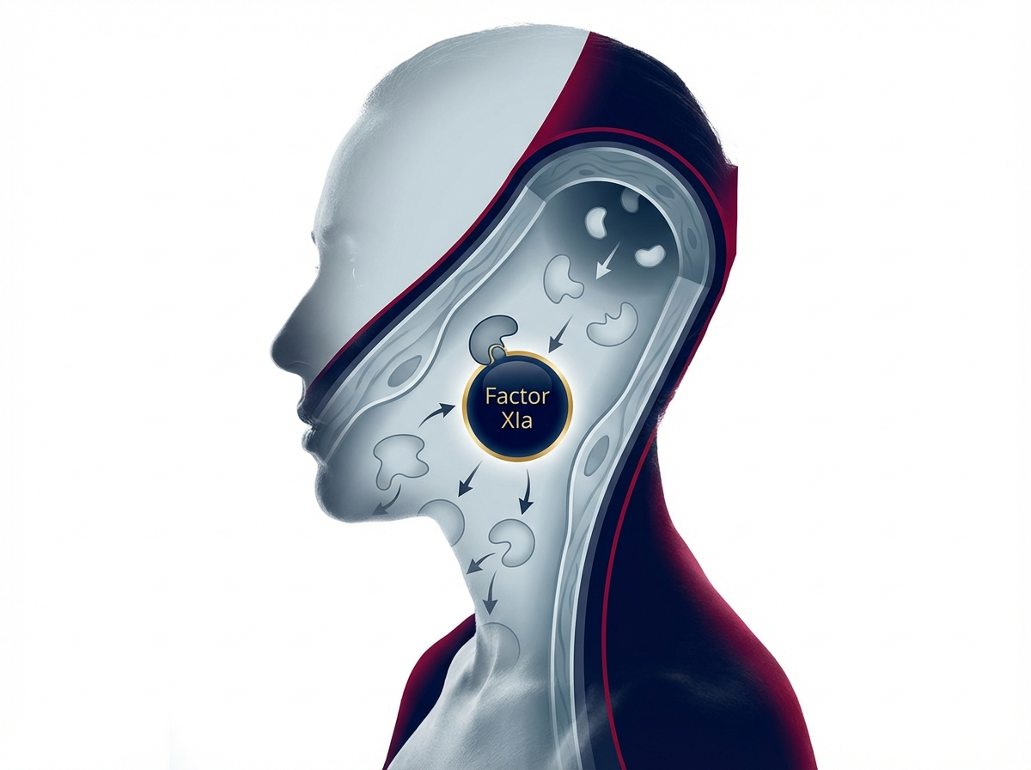
https://velox-images.pages.dev/columns-moa-preview.jpeg
Usage: Home — MoA teaser
Heading: Separating thrombosis from haemostasis
Body text: Factor XIa amplifies pathological thrombus formation through the intrinsic coagulation pathway, but plays a limited role in haemostasis at sites of vascular injury. By selectively inhibiting Factor XIa, VELOX provides potent antithrombotic protection while preserving the extrinsic pathway that maintains normal blood clotting.³ ⁵
Call to action: Explore how VELOX works → /velox/how-velox-works
────────────────────────────────────────────────────────────

Section 5 — Prescribing information footer
Block: accordion
Expandable sections for: Prescribing Information | Adverse Event Reporting | References (Use approved text from sections 5, 6, and 7 above)

Page metadata
Title: VELOX (veloxaban) | Stroke Prevention in AF | AstraZeneca UK
Description: VELOX (veloxaban) is a first-in-class oral Factor XIa inhibitor for stroke prevention in non-valvular atrial fibrillation. Explore VELOCITY clinical data, safety, and dosing for UK healthcare professionals.

PAGE 2: VELOCITY Data
URL path: /velox/velocity-data
────────────────────────────────────────────────────────────

Section 1 — Hero (full-width image with text overlay)
Block: hero-teaser


https://velox-images.pages.dev/hero-efficacy.jpeg
Usage: VELOCITY Data — hero
Heading: The VELOCITY clinical programme
Body text: VELOX® (veloxaban) was evaluated in over 18,000 patients across two landmark Phase III trials, demonstrating non-inferior stroke prevention with significantly fewer bleeding events than established Factor Xa inhibitors.¹ ²
────────────────────────────────────────────────────────────

Section 2 — Programme overview (centred text) | light background
Block: introduction
Section metadata: Style: light
Heading: Redefining the anticoagulation risk–benefit balance
Body text: The VELOCITY programme was designed to evaluate whether selective Factor XIa inhibition can maintain effective stroke prevention while fundamentally reducing bleeding risk. VELOCITY-AF assessed stroke prevention in 14,228 patients with NVAF against rivaroxaban. VELOCITY-BLEED assessed bleeding safety in 4,612 high-risk AF patients against apixaban — the comparator with the lowest established bleeding rate among Factor Xa inhibitors.¹ ²
────────────────────────────────────────────────────────────

Section 3 — Clinical data (two tabs)
Block: tabs-large

Tab 1: "VELOCITY-AF: Stroke prevention"

https://velox-images.pages.dev/tab-velocity-af.jpeg
Usage: VELOCITY Data — AF stroke tab
Heading: VELOCITY-AF: Non-inferior stroke prevention, 41% fewer major bleeds
Body text: VELOCITY-AF was a randomised, double-blind, double-dummy, active-controlled trial comparing VELOX 40 mg once daily with rivaroxaban 20 mg once daily in 14,228 adults with non-valvular atrial fibrillation and CHA₂DS₂-VASc score ≥2 (men) or ≥3 (women), treated for a median of 24 months.¹

Body text (continued): VELOX met its primary efficacy endpoint, demonstrating non-inferiority to rivaroxaban for the prevention of stroke and systemic embolism (1.68%/year vs 1.72%/year; HR 0.97; 95% CI: 0.83–1.14; P<0.001 for non-inferiority). Haemorrhagic stroke was reduced by 42% (HR 0.58; P=0.011). For the primary safety endpoint, ISTH major bleeding was reduced by 41% (1.52%/year vs 2.58%/year; HR 0.59; P<0.001). Intracranial haemorrhage was reduced by 60% (HR 0.40; P<0.001) and GI major bleeding by 40% (HR 0.60; P<0.001). The net clinical benefit composite favoured VELOX (HR 0.79; P<0.001).¹
Data table:
Endpoint | VELOX (n=7,114) | Rivaroxaban (n=7,114) | Treatment effect
Stroke or SE | 1.68%/year | 1.72%/year | HR 0.97 (0.83–1.14); P⁠NI<0.001
ISTH major bleeding | 1.52%/year | 2.58%/year | HR 0.59 (0.50–0.69); P<0.001
Intracranial haemorrhage | 0.21%/year | 0.52%/year | HR 0.40 (0.28–0.58); P<0.001
GI major bleeding | 0.62%/year | 1.04%/year | HR 0.60 (0.47–0.76); P<0.001
Net clinical benefit | 4.42%/year | 5.61%/year | HR 0.79 (0.72–0.87); P<0.001
────────────────────────────────────────────────────────────
Tab 2: "VELOCITY-BLEED: Bleeding safety in high-risk patients"
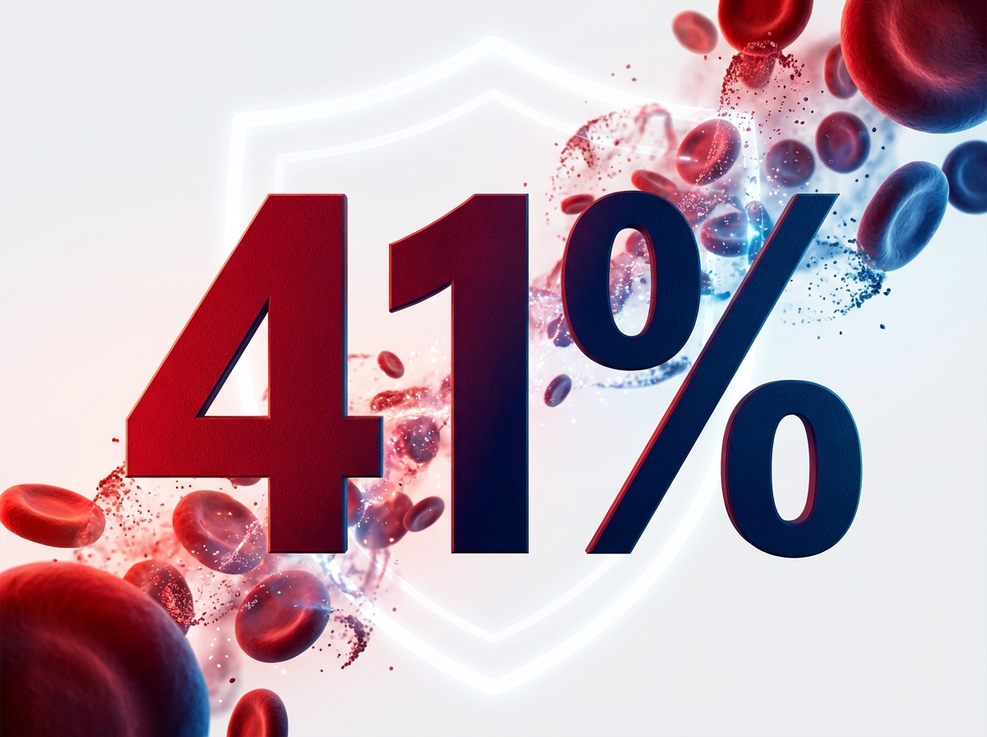
https://velox-images.pages.dev/tab-velocity-bleed.jpeg
Usage: VELOCITY Data — bleeding safety tab
Heading: VELOCITY-BLEED: Superior bleeding safety in high-risk AF patients
Body text: VELOCITY-BLEED was a randomised, double-blind, active-controlled trial comparing VELOX 40 mg once daily with apixaban (5 mg or 2.5 mg twice daily per label) in 4,612 adults with NVAF and at least one additional bleeding risk factor (age ≥80; CrCl 30–49 mL/min; history of GI bleeding; concomitant antiplatelet; HAS-BLED ≥3) over 52 weeks.²

Body text (continued): VELOX demonstrated a 41% reduction in the primary endpoint of ISTH major or clinically relevant non-major bleeding versus apixaban (4.12% vs 6.97%; HR 0.59; 95% CI: 0.49–0.71; P<0.001). Major bleeding alone was reduced by 41% (HR 0.59; P=0.002). Intracranial haemorrhage was reduced by 54% (HR 0.46; P=0.024). Stroke and systemic embolism rates were non-inferior to apixaban (1.82% vs 1.74%; HR 1.05; 95% CI: 0.77–1.42). The net clinical benefit favoured VELOX (HR 0.76; P<0.001).²
Data table:
Endpoint | VELOX (n=2,306) | Apixaban (n=2,306) | Treatment effect
Major or CRNM bleeding | 4.12% | 6.97% | HR 0.59 (0.49–0.71); P<0.001
ISTH major bleeding | 1.34% | 2.28% | HR 0.59 (0.42–0.82); P=0.002
Stroke or SE | 1.82% | 1.74% | HR 1.05 (0.77–1.42); non-inferior
Intracranial haemorrhage | 0.22% | 0.48% | HR 0.46 (0.23–0.90); P=0.024
Net clinical benefit | 6.81% | 8.92% | HR 0.76 (0.66–0.88); P<0.001
────────────────────────────────────────────────────────────

Section 4 — Prescribing information footer
Block: accordion | Expandable: PI | AE Reporting | References

Page metadata
Title: VELOCITY Data | VELOX (veloxaban) | Stroke Prevention & Bleeding Safety | AstraZeneca UK
Description: Explore the VELOCITY clinical programme for VELOX (veloxaban) — Phase III stroke prevention and bleeding safety data in patients with non-valvular atrial fibrillation.

PAGE 3: Safety
URL path: /velox/safety
────────────────────────────────────────────────────────────

Section 1 — Page header (text only, no image)
Block: title
Heading: Safety profile of VELOX
Body text: VELOX® (veloxaban) has been evaluated in over 9,400 patients across the VELOCITY clinical programme, with treatment durations of up to 24 months.¹ ² ³
────────────────────────────────────────────────────────────

Section 2 — Key safety message (centred text) | highlight background
Block: introduction
Section metadata: Style: highlight
Heading: A new safety paradigm in anticoagulation
Body text: By targeting Factor XIa — a key driver of pathological thrombus formation that plays a limited role in normal haemostasis — VELOX achieves a fundamentally different safety profile from established anticoagulants. In VELOCITY-AF, serious adverse events were lower with VELOX than rivaroxaban (12.4% vs 13.8%), driven primarily by fewer bleeding-related hospitalisations. Treatment discontinuation due to adverse events was low (4.8% vs 5.4%).¹ ² ³
────────────────────────────────────────────────────────────

Section 3 — Safety topic cards (three equal columns)
Block: cards-teaser


https://velox-images.pages.dev/card-bleeding-events.jpeg
Usage: Safety — bleeding events card
Card heading: Bleeding events
Card body: ISTH major bleeding: 1.52%/year (VELOX) vs 2.58%/year (rivaroxaban) in VELOCITY-AF (HR 0.59; P<0.001). In the high-bleeding-risk VELOCITY-BLEED population, major or CRNM bleeding was 4.12% vs 6.97% vs apixaban (HR 0.59; P<0.001). Intracranial haemorrhage was reduced by 54–60% across both trials.¹ ²
────────────────────────────────────────────────────────────
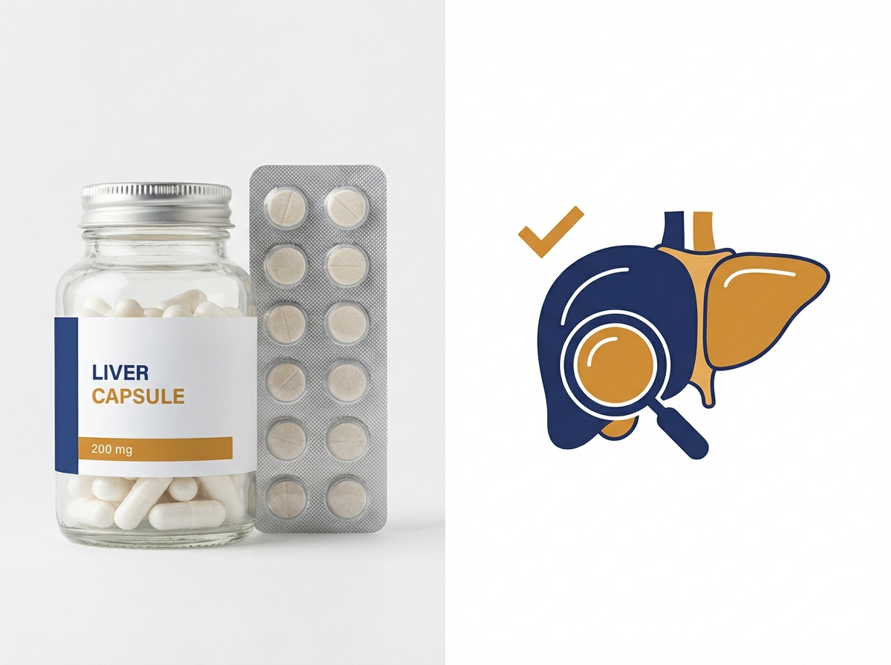
https://velox-images.pages.dev/card-hepatic.jpeg
Usage: Safety — hepatic monitoring card
Card heading: Hepatic safety
Card body: ALT elevations >3× ULN occurred in 1.1% of VELOX-treated patients across pooled VELOCITY data, comparable to 0.9% with comparators. No cases meeting Hy’s Law criteria were observed. Routine hepatic monitoring is not required; assess liver function before initiation and as clinically indicated.³
────────────────────────────────────────────────────────────
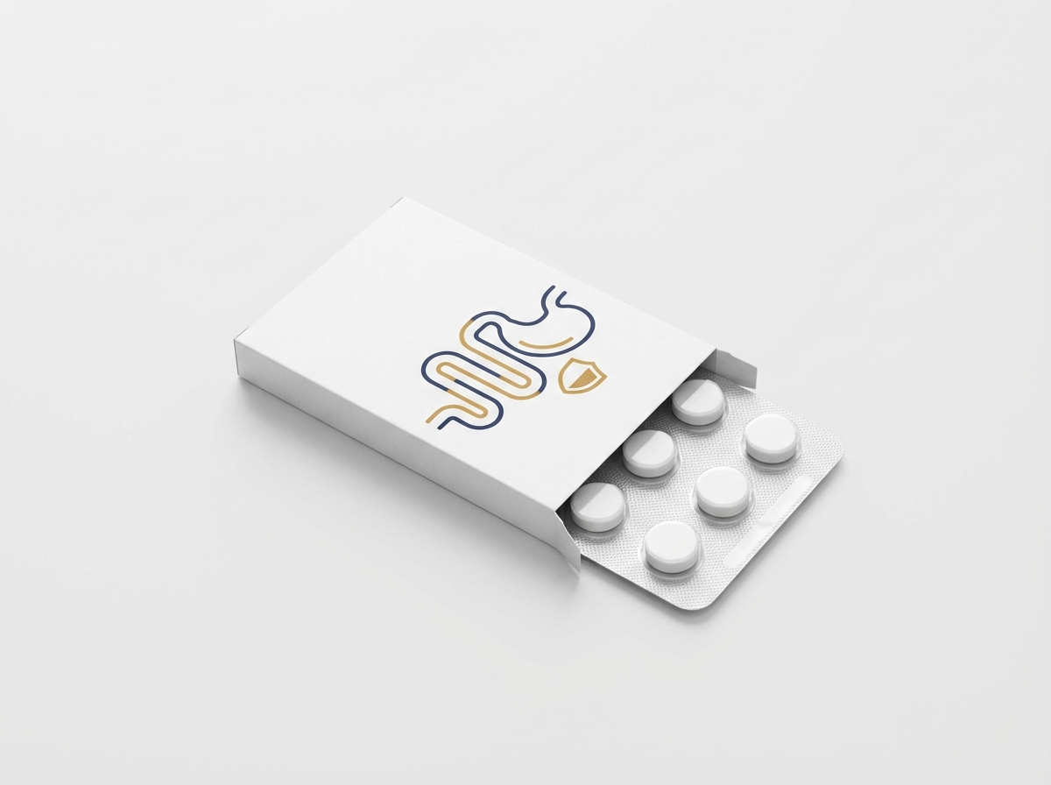
https://velox-images.pages.dev/card-gi-events.jpeg
Usage: Safety — GI events card
Card heading: Gastrointestinal events
Card body: Dyspepsia (2.3%) and diarrhoea (2.1%) were the most common non-bleeding GI adverse events. GI major bleeding was reduced by 40% versus rivaroxaban in VELOCITY-AF (0.62%/year vs 1.04%/year; HR 0.60; P<0.001) and by 40% versus apixaban in VELOCITY-BLEED (HR 0.60; P=0.001).¹ ²
────────────────────────────────────────────────────────────

Section 4 — Adverse events table | light background
Block: table-data
Section metadata: Style: light
Heading: Most common adverse events (≥2%) — pooled VELOCITY data
Adverse event | VELOX (%) | Comparator (%)
Nasopharyngitis | 7.2 | 7.0
Epistaxis | 4.8 | 5.6
Contusion/bruising | 4.1 | 5.9
Gingival bleeding | 3.4 | 4.2
Haematuria | 2.8 | 3.7
Dizziness | 2.6 | 2.4
Dyspepsia | 2.3 | 2.1
Diarrhoea | 2.1 | 1.9
────────────────────────────────────────────────────────────

Section 5 — Special populations (two-column: image left, text right)
Block: columns-teaser
Heading: Consistent safety across key subgroups
Body text: In VELOCITY-AF, the bleeding benefit of VELOX over rivaroxaban was consistent across pre-specified subgroups including patients aged ≥75 years, those with moderate renal impairment (CrCl 30–49 mL/min), patients receiving concomitant antiplatelet therapy, and those with prior GI bleeding. In every subgroup, major bleeding rates were numerically or significantly lower with VELOX while stroke prevention efficacy was maintained.¹ ³
────────────────────────────────────────────────────────────

Section 6 — Prescribing information footer
Block: accordion | Expandable: PI | AE Reporting | References

Page metadata
Title: Safety Profile | VELOX (veloxaban) | Bleeding & Adverse Events | AstraZeneca UK
Description: Review the safety profile of VELOX (veloxaban), including bleeding events, hepatic safety, and adverse event data from the VELOCITY clinical programme in over 9,400 patients with atrial fibrillation.

PAGE 4: Dosing & Administration
URL path: /velox/dosing
────────────────────────────────────────────────────────────

Section 1 — Page header (text only, no image)
Block: title
Heading: Dosing and administration
Body text: VELOX® (veloxaban) offers a simplified dosing regimen with no routine dose adjustments required for age, body weight, or renal function (CrCl ≥30 mL/min).³
────────────────────────────────────────────────────────────

Section 2 — Key dosing message (centred text) | highlight background
Block: introduction
Section metadata: Style: highlight
Heading: One dose. Once daily. No routine adjustments.
Body text: VELOX 40 mg once daily — taken with or without food. Unlike current DOACs, no dose reduction is required for moderate renal impairment, advanced age, or low body weight, reducing prescribing complexity and the risk of inappropriate dose modifications.³
────────────────────────────────────────────────────────────

Section 3 — Dosing details (two-column: image left, text right)
Block: columns-teaser


https://velox-images.pages.dev/columns-dosing.jpeg
Usage: Dosing — once-daily regimen
Heading: Recommended dose
Body text: The recommended dose of VELOX is 40 mg (one tablet) taken orally once daily, with or without food. Tablets should be swallowed whole and must not be crushed, split, or chewed. If a dose is missed, it should be taken as soon as remembered on the same day. Do not take a double dose to make up for a missed dose.³

Body text (continued): No dose adjustment is required for: age (including patients ≥75 and ≥80 years); body weight (including <60 kg and >120 kg); moderate renal impairment (CrCl 30–49 mL/min); mild to moderate hepatic impairment (Child-Pugh A or B). VELOX is contraindicated in patients with CrCl <15 mL/min and is not recommended in CrCl 15–29 mL/min due to lack of clinical data.³
────────────────────────────────────────────────────────────

Section 4 — Monitoring (two-column: image left, text right) | light background
Block: columns-teaser
Section metadata: Style: light


https://velox-images.pages.dev/columns-monitoring.jpeg
Usage: Dosing — monitoring
Heading: Monitoring and practical considerations
Body text: Routine coagulation monitoring is not required with VELOX. Assess renal function (CrCl) before initiation and at least annually during treatment, or more frequently if clinically indicated (acute illness, dehydration, intercurrent renal disease). Assess hepatic function before initiation; routine hepatic monitoring during treatment is not required.³

Body text (continued): Switching from warfarin: Discontinue warfarin and start VELOX when INR falls below 2.0. Switching from rivaroxaban, apixaban, edoxaban, or dabigatran: Start VELOX at the time of the next scheduled dose of the previous anticoagulant. Perioperative management: Discontinue VELOX at least 24 hours before elective surgery with standard bleeding risk, or 48 hours for high-bleeding-risk procedures. Resume when adequate haemostasis is established, typically within 24 hours post-procedure.³
────────────────────────────────────────────────────────────

Section 5 — Drug interactions (centred text)
Block: introduction
Heading: Key drug interactions
Body text: Avoid concomitant use with strong dual CYP3A4/P-gp inhibitors (ketoconazole, itraconazole, ritonavir, lopinavir) — these increase veloxaban exposure approximately 2.1-fold. Avoid strong CYP3A4/P-gp inducers (rifampicin, carbamazepine, phenytoin, St John’s wort) as these may reduce efficacy. No dose adjustment is required with moderate CYP3A4 inhibitors (diltiazem, verapamil, erythromycin) or with PPIs, H₂-receptor antagonists, or antacids.³
────────────────────────────────────────────────────────────

Section 6 — Prescribing information footer
Block: accordion | Expandable: PI | AE Reporting | References

Page metadata
Title: Dosing & Administration | VELOX (veloxaban) | Once Daily, No Adjustments | AstraZeneca UK
Description: VELOX (veloxaban) dosing and administration guide: 40 mg once daily with no routine dose adjustments for age, weight, or renal function. Switching, monitoring, and drug interaction guidance for UK healthcare professionals.

PAGE 5: How VELOX Works
URL path: /velox/how-velox-works
────────────────────────────────────────────────────────────

Section 1 — Hero (full-width image with text overlay)
Block: hero-teaser


https://velox-images.pages.dev/hero-moa.jpeg
Usage: How VELOX Works — hero
Heading: How VELOX works
Body text: VELOX® (veloxaban) is a first-in-class selective oral Factor XIa inhibitor that separates antithrombotic efficacy from haemostatic impairment — a new approach to anticoagulation.³ ⁵
────────────────────────────────────────────────────────────

Section 2 — Disease context (centred text) | light background
Block: introduction
Section metadata: Style: light
Heading: The coagulation cascade: two pathways, one clinical dilemma
Body text: Current anticoagulants (Factor Xa and direct thrombin inhibitors) target components shared by both pathological thrombosis and physiological haemostasis, inherently coupling antithrombotic efficacy to bleeding risk. The intrinsic coagulation pathway — amplified by Factor XIa — contributes disproportionately to pathological thrombus formation (as seen in AF, VTE, and arterial thrombosis) while playing a limited role in the haemostatic response to vascular injury. Clinical genetic evidence confirms this: inherited Factor XI deficiency protects against thrombotic events with only mild bleeding tendency.⁴ ⁵
────────────────────────────────────────────────────────────

Section 3 — Mechanism detail (two-column: image left, text right) | highlight background
Block: columns-teaser
Section metadata: Style: highlight


https://velox-images.pages.dev/columns-moa-preview.jpeg
Usage: Home — MoA teaser
Heading: Selective Factor XIa inhibition: targeting the amplification loop
Body text: Veloxaban binds selectively to the active site of Factor XIa with high affinity (Ki = 0.2 nM), suppressing thrombin amplification through the intrinsic pathway without affecting Factor Xa, thrombin, or other serine proteases in the coagulation cascade. This selective inhibition reduces fibrin-rich thrombus propagation in the low-shear environment of the left atrial appendage — the primary site of thrombus formation in AF — and attenuates Factor XIa-driven platelet activation.³ ⁵

Body text (continued): Critically, veloxaban preserves the extrinsic (tissue factor) pathway, which is responsible for initiating haemostasis at sites of vascular injury. This mechanistic separation is the pharmacological basis for the reduced bleeding observed across the VELOCITY programme, including the clinically important categories of intracranial haemorrhage and gastrointestinal bleeding.³ ⁵
Call to action: View the VELOCITY bleeding data → /velox/safety
────────────────────────────────────────────────────────────

Section 4 — Key pharmacological properties (centred text)
Block: introduction
Heading: Pharmacological profile
Body text: Oral bioavailability: ~72%, not significantly affected by food. Time to peak plasma concentration (Tmax): 2–3 hours. Elimination half-life: 10–14 hours, supporting once-daily dosing. Metabolism: Primarily hepatic via CYP3A4, with minor renal excretion (~25% of administered dose). Protein binding: 92%. No clinically significant effect on PT, aPTT, or anti-Factor Xa assays at therapeutic concentrations, minimising interference with routine coagulation monitoring.³
────────────────────────────────────────────────────────────

Section 5 — Prescribing information footer
Block: accordion | Expandable: PI | AE Reporting | References

Page metadata
Title: How VELOX Works | Factor XIa Inhibition | Mechanism of Action | AstraZeneca UK
Description: Understand how VELOX (veloxaban) selectively inhibits Factor XIa to separate antithrombotic efficacy from bleeding risk — a new mechanism of action in anticoagulation for atrial fibrillation.

PAGE 6: Resources
URL path: /velox/resources
────────────────────────────────────────────────────────────

Section 1 — Page header (text only, no image)
Block: title
Heading: Resources for healthcare professionals
Body text: Access prescribing guides, clinical data summaries, and patient support materials for VELOX® (veloxaban). All materials are provided for UK healthcare professionals only.³
────────────────────────────────────────────────────────────

Section 2 — Resource cards (three equal columns)
Block: cards-teaser

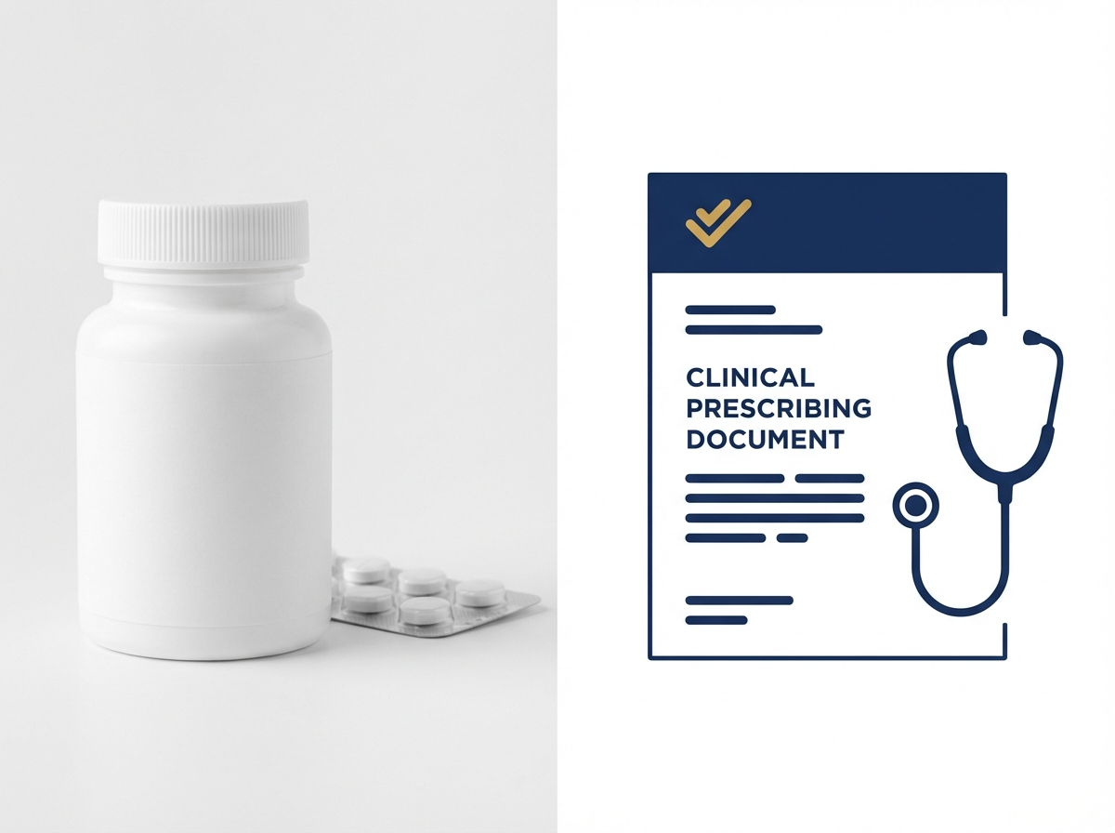
https://velox-images.pages.dev/card-prescribing.jpeg
Usage: Resources — prescribing guide card
Card heading: Prescribing guide
Card body: A concise clinical guide covering indication, dosing, switching, monitoring, drug interactions, special populations, and perioperative management. Designed for quick reference in clinical practice.³
Card link: Download prescribing guide → [PDF link]
────────────────────────────────────────────────────────────
Card heading: VELOCITY clinical data summary
Card body: Summary of key efficacy and safety results from VELOCITY-AF and VELOCITY-BLEED, including headline statistics, data tables, and subgroup analyses. A comprehensive overview of the clinical evidence supporting VELOX.¹ ²
Card link: Download data summary → [PDF link]
────────────────────────────────────────────────────────────
Card heading: Patient support materials
Card body: Patient-facing materials to support treatment initiation conversations, including a VELOX patient information leaflet, dosing reminder card, and switching guidance card for patients transitioning from other anticoagulants.
Card link: Download patient materials → [PDF link]
────────────────────────────────────────────────────────────

Section 3 — Contact (centred text) | light background
Block: introduction
Section metadata: Style: light
Heading: Medical information and support
Body text: For medical information enquiries about VELOX, please contact AstraZeneca Medical Information: Telephone: 0800 783 0033 | Email: medicalinformationuk@astrazeneca.com | Online: contactazmedical.astrazeneca.com
────────────────────────────────────────────────────────────

Section 4 — Prescribing information footer
Block: accordion | Expandable: PI | AE Reporting | References

Page metadata
Title: Resources | VELOX (veloxaban) | Prescribing Guides & Patient Materials | AstraZeneca UK
Description: Access prescribing guides, VELOCITY clinical data summaries, and patient support materials for VELOX (veloxaban). For UK healthcare professionals only.

10. Footer Content
The footer must appear on every page and contain the following elements:
Logo: AstraZeneca logo (linked to /velox/)
Approval code: GB-10247 | DOP: March 2026
Copyright: © 2026 AstraZeneca. All rights reserved. VELOX is a registered trademark of the AstraZeneca group of companies.
Page links: VELOCITY Data | Safety | Dosing & Administration | How VELOX Works | Resources
Regulatory links: Report Adverse Event (https://yellowcard.mhra.gov.uk/) | Medical Information (https://contactazmedical.astrazeneca.com/) | Privacy Policy (https://www.astrazeneca.co.uk/our-company/privacy-notice.html) | Terms of Use (https://www.astrazeneca.co.uk/our-company/terms-of-use.html) | Accessibility (https://www.astrazeneca.co.uk/accessibility.html)
Date of preparation: Date of Preparation: March 2026
────────────────────────────────────────────────────────────

11. Image Assets
All images are hosted on the VELOX CDN: https://velox-images.pages.dev/

Complete image manifest:

Filename | Usage | CDN URL
hero-home.jpeg | Home — hero | https://velox-images.pages.dev/hero-home.jpeg
hero-efficacy.jpeg | VELOCITY Data — hero | https://velox-images.pages.dev/hero-efficacy.jpeg
hero-moa.jpeg | How VELOX Works — hero | https://velox-images.pages.dev/hero-moa.jpeg
card-stroke.jpeg | Home — stroke reduction card | https://velox-images.pages.dev/card-stroke.jpeg
card-bleeding.jpeg | Home — bleeding safety card | https://velox-images.pages.dev/card-bleeding.jpeg
card-dosing.jpeg | Home — dosing simplicity card | https://velox-images.pages.dev/card-dosing.jpeg
columns-moa-preview.jpeg | Home — MoA teaser | https://velox-images.pages.dev/columns-moa-preview.jpeg
tab-velocity-af.jpeg | VELOCITY Data — AF stroke tab | https://velox-images.pages.dev/tab-velocity-af.jpeg
tab-velocity-bleed.jpeg | VELOCITY Data — bleeding safety tab | https://velox-images.pages.dev/tab-velocity-bleed.jpeg
card-bleeding-events.jpeg | Safety — bleeding events card | https://velox-images.pages.dev/card-bleeding-events.jpeg
card-hepatic.jpeg | Safety — hepatic monitoring card | https://velox-images.pages.dev/card-hepatic.jpeg
card-gi-events.jpeg | Safety — GI events card | https://velox-images.pages.dev/card-gi-events.jpeg
columns-dosing.jpeg | Dosing — once-daily regimen | https://velox-images.pages.dev/columns-dosing.jpeg
columns-monitoring.jpeg | Dosing — monitoring | https://velox-images.pages.dev/columns-monitoring.jpeg
card-prescribing.jpeg | Resources — prescribing guide card | https://velox-images.pages.dev/card-prescribing.jpeg

Image previews
Visual previews of all 15 generated images:

hero-home.jpeg — Home — hero

https://velox-images.pages.dev/hero-home.jpeg
Usage: Home — hero

hero-efficacy.jpeg — VELOCITY Data — hero

https://velox-images.pages.dev/hero-efficacy.jpeg
Usage: VELOCITY Data — hero

hero-moa.jpeg — How VELOX Works — hero

https://velox-images.pages.dev/hero-moa.jpeg
Usage: How VELOX Works — hero

card-stroke.jpeg — Home — stroke reduction card

https://velox-images.pages.dev/card-stroke.jpeg
Usage: Home — stroke reduction card

card-bleeding.jpeg — Home — bleeding safety card

https://velox-images.pages.dev/card-bleeding.jpeg
Usage: Home — bleeding safety card

card-dosing.jpeg — Home — dosing simplicity card

https://velox-images.pages.dev/card-dosing.jpeg
Usage: Home — dosing simplicity card

columns-moa-preview.jpeg — Home — MoA teaser

https://velox-images.pages.dev/columns-moa-preview.jpeg
Usage: Home — MoA teaser

tab-velocity-af.jpeg — VELOCITY Data — AF stroke tab

https://velox-images.pages.dev/tab-velocity-af.jpeg
Usage: VELOCITY Data — AF stroke tab

tab-velocity-bleed.jpeg — VELOCITY Data — bleeding safety tab

https://velox-images.pages.dev/tab-velocity-bleed.jpeg
Usage: VELOCITY Data — bleeding safety tab

card-bleeding-events.jpeg — Safety — bleeding events card

https://velox-images.pages.dev/card-bleeding-events.jpeg
Usage: Safety — bleeding events card

card-hepatic.jpeg — Safety — hepatic monitoring card

https://velox-images.pages.dev/card-hepatic.jpeg
Usage: Safety — hepatic monitoring card

card-gi-events.jpeg — Safety — GI events card

https://velox-images.pages.dev/card-gi-events.jpeg
Usage: Safety — GI events card

columns-dosing.jpeg — Dosing — once-daily regimen

https://velox-images.pages.dev/columns-dosing.jpeg
Usage: Dosing — once-daily regimen

columns-monitoring.jpeg — Dosing — monitoring

https://velox-images.pages.dev/columns-monitoring.jpeg
Usage: Dosing — monitoring

card-prescribing.jpeg — Resources — prescribing guide card

https://velox-images.pages.dev/card-prescribing.jpeg
Usage: Resources — prescribing guide card

