AXURA®▼
(axurelimab)

Website Briefing

Reclaim your days.

Document type: Final approved marketing brief for HCP website build
Prepared by: Marketing — UK Immunology Franchise
Approval status: MLR-approved copy — do not modify
Date: March 2026
Approval code: GB-12091 | DOP: March 2026

Contents
1. Drug Profile
2. Mechanism of Action
3. Clinical Programme: AURORA
4. Safety Profile
5. Prescribing Information
6. Adverse Event Reporting
7. References
8. Site Navigation
9. Page Content
Page 1: Home
Page 2: AURORA Data
Page 3: Living with Lupus
Page 4: Safety & Monitoring
Page 5: How AXURA Works
Page 6: HCP Resources
10. Footer Content
11. Image Assets

1. Drug Profile
Field | Detail
Brand name | AXURA®▼
Generic name | axurelimab
Drug class | Humanised anti-CD38 monoclonal antibody (IgG1κ)
Indication | Add-on therapy for the treatment of adult patients with active systemic lupus erythematosus (SLE) who are seropositive (anti-dsDNA positive and/or low complement) and have an inadequate response to standard therapy
Secondary indication | Add-on therapy for adult patients with active lupus nephritis (Class III, IV, or V) who are receiving standard immunosuppressive treatment
Formulation | 300 mg/2 mL solution for subcutaneous injection in pre-filled syringe
Dosing | 300 mg subcutaneous injection once every 2 weeks for the first 3 doses, then 300 mg every 4 weeks
Approval | MHRA — February 2026
Black triangle status | ▼ Additional monitoring required
Brand colour | Deep Teal #006D6F
Accent colour | Warm Gold #EFAB00
Approval code | GB-12091

AXURA brand rule: AXURA always appears in capitals, with ®▼ on first mention per page. Generic name (axurelimab) appears in lowercase parentheses on first mention. The black triangle (▼) must accompany AXURA on every first mention. The approved tagline "Reclaim your days." may only be used verbatim — no variations permitted.
────────────────────────────────────────────────────────────

2. Mechanism of Action
Axurelimab is a humanised IgG1κ monoclonal antibody that binds with high affinity to CD38, a type II transmembrane glycoprotein highly expressed on long-lived plasma cells, plasmablasts, and a subset of activated B-cells. CD38 is also expressed on natural killer (NK) cells and subsets of T-cells, but at lower density.
In systemic lupus erythematosus, autoreactive long-lived plasma cells residing in bone marrow and inflamed tissues are the primary source of pathogenic autoantibodies (anti-dsDNA, anti-Smith, anti-Ro/SSA). These cells are resistant to conventional immunosuppression, B-cell-depleting therapies (anti-CD20), and belimumab (anti-BAFF), because long-lived plasma cells do not express CD20 and survive independently of BAFF.¹ ²
By targeting CD38, axurelimab depletes the autoantibody-producing cells that drive SLE through the following mechanisms:
- Antibody-dependent cellular cytotoxicity (ADCC) of CD38-high long-lived plasma cells and plasmablasts
- Complement-dependent cytotoxicity (CDC) against CD38-expressing autoantibody-secreting cells
- Antibody-dependent cellular phagocytosis (ADCP) by macrophages
- Depletion of CD38-high short-lived plasmablasts, reducing the immediate supply of newly secreted autoantibodies
- Reduction of CD38-expressing regulatory cell populations is minimal due to lower CD38 density on these cells
This targeted depletion of autoantibody-secreting cells produces rapid and sustained reductions in anti-dsDNA titres, normalisation of complement (C3, C4), and consequent reduction in immune-complex-mediated tissue damage across multiple organ systems. Unlike B-cell depletion strategies targeting CD20, anti-CD38 therapy directly eliminates the terminally differentiated cells responsible for autoantibody production.¹ ² ⁵
────────────────────────────────────────────────────────────

3. Clinical Programme: AURORA

AURORA-1 (Phase III, pivotal — Active SLE)
Design: Randomised, double-blind, placebo-controlled, parallel-group Phase III trial
Population: 768 adults with active SLE (SLEDAI-2K ≥6, seropositive: anti-dsDNA ≥30 IU/mL and/or low C3/C4) despite standard of care (antimalarials, corticosteroids ≤10 mg/day prednisolone, and/or immunosuppressants)
Duration: 52 weeks on treatment + 12-week safety follow-up
Primary endpoint: SRI-4 response at Week 52 (SLEDAI-2K improvement ≥4 points, no BILAG A flare, no PGA worsening >0.3)
Key secondary endpoints: Time to first severe SLE flare (BILAG A); proportion achieving sustained glucocorticoid reduction to ≤7.5 mg/day prednisolone; anti-dsDNA change from baseline; C3/C4 normalisation; BICLA response at Week 52; FACIT-Fatigue improvement
Publication: Rodriguez-Pintó et al. N Engl J Med 2025; 393(18): 1698–1711

Key results:
Endpoint | AXURA (n=384) | Placebo (n=384) | Treatment effect
SRI-4 at Week 52 (primary) | 61.7% | 35.9% | Δ 25.8% (19.2–32.4); P<0.001
BICLA response at Week 52 | 54.4% | 30.5% | Δ 23.9% (17.4–30.4); P<0.001
Severe flare (BILAG A) through Week 52 | 8.9% | 21.6% | HR 0.38 (0.25–0.57); P<0.001
GC reduction to ≤7.5 mg/day (among those on >7.5 mg at baseline) | 68.2% | 42.1% | OR 2.93 (1.97–4.36); P<0.001
Anti-dsDNA reduction at Week 52 | −64.1% | −8.3% | P<0.001
C3 normalisation at Week 52 | 72.8% | 31.4% | P<0.001
FACIT-Fatigue improvement ≥4 points | 52.3% | 33.6% | Δ 18.7% (12.1–25.3); P<0.001

AURORA-LN (Phase III — Active lupus nephritis)
Design: Randomised, double-blind, placebo-controlled Phase III trial
Population: 354 adults with biopsy-proven active lupus nephritis (Class III, IV, or V, alone or in combination) receiving mycophenolate mofetil (MMF) + low-dose glucocorticoids as background standard of care
Duration: 52 weeks on treatment
Primary endpoint: Complete renal response (CRR) at Week 52 (uPCR <0.5 g/g, eGFR within 10% of pre-flare value or ≥90 mL/min/1.73m², no rescue therapy)
Key secondary endpoints: Overall renal response (ORR: complete or partial); time to first CRR; uPCR change from baseline; renal flare rate; sustained CRR (Weeks 36–52)
Publication: Chen et al. Lancet 2026; 407(10335): 891–904

Key results:
Endpoint | AXURA + SoC (n=177) | Placebo + SoC (n=177) | Treatment effect
CRR at Week 52 (primary) | 43.5% | 22.0% | Δ 21.5% (12.3–30.7); P<0.001
Overall renal response at Week 52 | 71.2% | 49.2% | Δ 22.0% (12.4–31.6); P<0.001
Sustained CRR (Weeks 36–52) | 34.5% | 14.7% | Δ 19.8% (11.2–28.4); P<0.001
Median time to first CRR | 24 weeks | Not reached | HR 2.14 (1.52–3.01); P<0.001
Renal flare through Week 52 | 5.6% | 16.9% | HR 0.31 (0.15–0.64); P=0.001
uPCR change at Week 52 | −71.4% | −38.2% | P<0.001
────────────────────────────────────────────────────────────

4. Safety Profile (Pooled AURORA data, N=561 AXURA)

Most common adverse events (≥5%)
Adverse event | AXURA (%) | Placebo (%)
Upper respiratory tract infection | 18.4 | 16.2
Injection site reactions | 14.8 | 3.6
Urinary tract infection | 11.2 | 9.8
Nasopharyngitis | 10.6 | 9.4
Headache | 8.4 | 7.1
Diarrhoea | 7.2 | 5.8
Herpes zoster | 6.8 | 2.4
Arthralgia | 6.1 | 5.4
Nausea | 5.6 | 4.2
Bronchitis | 5.4 | 4.1

Infections
Overall infections occurred in 52.4% of AXURA-treated patients vs 46.8% placebo. Serious infections occurred in 6.2% vs 5.4%. The most common serious infections were pneumonia (1.4%), urinary tract infection (0.9%), and herpes zoster (0.7%). No opportunistic infections or cases of progressive multifocal leukoencephalopathy (PML) were reported. Herpes zoster was more frequent with AXURA (6.8% vs 2.4%); prophylactic vaccination with recombinant zoster vaccine is recommended before or during treatment where clinically appropriate.³

Immunoglobulin levels
As CD38 is expressed on immunoglobulin-secreting plasma cells, reductions in serum immunoglobulin levels are expected with axurelimab. IgG levels decreased by a median of 18.4% at Week 52 from baseline. IgG levels below the lower limit of normal (<6.0 g/L) occurred in 12.3% of AXURA-treated patients vs 3.1% placebo. IgG <4.0 g/L occurred in 2.1%. Monitor serum immunoglobulins (IgG, IgA, IgM) before initiation, at Week 12, Week 24, and every 6 months thereafter. Consider withholding treatment if IgG <4.0 g/L with concurrent serious or recurrent infections.³

Injection site reactions
Injection site reactions (ISRs) occurred in 14.8% of AXURA patients vs 3.6% placebo. Most were mild (grade 1: erythema, pruritus, swelling) and occurred during the loading phase (first 3 doses). No ISRs led to treatment discontinuation. ISR frequency decreased with successive injections: 12.1% at dose 1, 6.4% at dose 2, 3.8% at dose 3, and <2% at subsequent doses.³

Key safety findings
Serious adverse events: 14.1% AXURA vs 13.6% placebo
Treatment discontinuation due to AEs: 4.3% vs 3.8%
All-cause mortality: 0.4% vs 0.5% (no drug-related deaths)
Malignancy: 0.5% vs 0.3% (no signal; all were non-melanoma skin cancer in patients on concomitant immunosuppression)
Cytopenias: Grade ≥3 neutropenia 1.4% vs 0.8%; grade ≥3 thrombocytopenia 0.5% vs 0.3%. Monitor FBC at baseline and periodically³
Hepatitis B reactivation: No cases reported; however, screen for HBV before initiation and do not initiate in active HBV infection³
Immunogenicity: Treatment-emergent ADAs in 3.6%; neutralising antibodies in 0.9%. No clinically meaningful impact on PK, efficacy, or safety³

Special populations
- Elderly (≥65 years): Limited data (5% of AURORA-1 population). No dose adjustment required. Use with caution given increased baseline infection risk.³
- Renal impairment: No dose adjustment required. AURORA-LN enrolled patients with eGFR ≥30 mL/min/1.73m². Not studied in eGFR <30.³
- Hepatic impairment: Not studied in moderate or severe hepatic impairment. No dose adjustment for mild impairment.³
- Pregnancy and lactation: Axurelimab is a monoclonal antibody and is expected to cross the placental barrier during the second and third trimesters. No adequate data in pregnant women. Women of childbearing potential should use effective contraception during treatment and for 6 months after the last dose. Not recommended during breastfeeding.³
- Vaccinations: Complete all vaccinations, including recombinant zoster vaccine, before initiating axurelimab where possible. Avoid live vaccines during treatment and for 6 months after the last dose.³
────────────────────────────────────────────────────────────

5. Prescribing Information (abbreviated — for every page footer)
AXURA▼ (axurelimab) 300 mg/2 mL solution for subcutaneous injection in pre-filled syringe. Please refer to the Summary of Product Characteristics (SmPC) before prescribing. Indication: Add-on therapy for the treatment of adult patients with active systemic lupus erythematosus (SLE) who are seropositive (anti-dsDNA positive and/or low complement) and have an inadequate response to standard therapy. Also indicated as add-on therapy for active lupus nephritis (Class III, IV, or V) receiving standard immunosuppressive treatment. Dosage and administration: 300 mg SC every 2 weeks for the first 3 doses (loading), then 300 mg SC every 4 weeks (maintenance). Administer into the thigh, abdomen (excluding 5 cm around the navel), or upper arm. Rotate injection sites. Contraindications: Hypersensitivity to axurelimab or excipients; active severe infections; active hepatitis B infection. Warnings and precautions: Infections: Do not initiate during active infections. Screen for TB and HBV before initiation. Vaccinate against herpes zoster where possible. Immunoglobulins: Monitor IgG, IgA, IgM before initiation and regularly during treatment. Consider withholding if IgG <4.0 g/L with recurrent serious infections. Live vaccines: Avoid during treatment and for 6 months after last dose. Side effects: Very common (≥1/10): upper respiratory tract infection, injection site reactions, UTI, nasopharyngitis. Common (≥1/100 to <1/10): herpes zoster, headache, diarrhoea, nausea, arthralgia, bronchitis, IgG decrease. Legal category: POM. Pack and price: 1 pre-filled syringe (300 mg): £872.00. Marketing authorisation holder: AstraZeneca UK Ltd. MA number: PLGB 17901/0741. Full prescribing information available from: AstraZeneca UK Ltd, 2 Pancras Square, London N1C 4AG. GB-12091 | DOP: March 2026.
────────────────────────────────────────────────────────────

6. Adverse Event Reporting (for every page footer)
Adverse events should be reported. Reporting forms and information can be found at www.mhra.gov.uk/yellowcard or search for MHRA Yellow Card in the Google Play or Apple App Store. Adverse events should also be reported to AstraZeneca by visiting contactazmedical.astrazeneca.com or by calling 0800 783 0033.
────────────────────────────────────────────────────────────

7. References (for every page footer)
1. Rodriguez-Pintó et al. N Engl J Med 2025; 393(18): 1698–1711.
2. Chen et al. Lancet 2026; 407(10335): 891–904.
3. AXURA (axurelimab) Summary of Product Characteristics. AstraZeneca UK Ltd. February 2026.
4. Ostendorf L, et al. Ann Rheum Dis 2023; 82(9): 1162–1170.
5. Alexander T, et al. N Engl J Med 2023; 388(15): 1385–1395.
────────────────────────────────────────────────────────────

8. Site Navigation
Top bar links: Contact Us (https://www.astrazeneca.co.uk/contact-us.html) | AZ Employee Login (https://login.astrazeneca.com)
Main navigation pages: AURORA Data | Living with Lupus | Safety & Monitoring | How AXURA Works | HCP Resources
Utility: Search | Login

9. Page Content
IMPORTANT: All copy below is final and MLR-approved. It must be used exactly as written — do not modify, rephrase, or abbreviate any text. All superscript reference numbers, statistical values, and regulatory language must be reproduced verbatim.
Each page must end with expandable sections for Prescribing Information, Adverse Event Reporting, and References (see sections 5, 6, and 7 above).
AXURA brand rule: AXURA always appears in capitals, with ®▼ on first mention per page. Generic name (axurelimab) in lowercase parentheses on first mention. Black triangle (▼) mandatory on every first mention. Tagline "Reclaim your days." verbatim only.
────────────────────────────────────────────────────────────

PAGE 1: Home
URL path: /axura/
────────────────────────────────────────────────────────────

Section 1 — Hero (full-width image with text overlay)
Block: hero-teaser


https://velox-images.pages.dev/hero-home.jpeg
Usage: Home — hero
Heading: AXURA®▼ (axurelimab)
Body text: The first anti-CD38 therapy for systemic lupus erythematosus. Targeting the source of pathogenic autoantibodies for rapid, sustained disease control. Reclaim your days.¹
Call to action: Explore the AURORA data → /axura/aurora-data
────────────────────────────────────────────────────────────

Section 2 — Three key benefit cards (equal columns)
Block: cards-teaser


https://velox-images.pages.dev/card-stroke.jpeg
Usage: Home — SRI-4 response card
Card heading: 62% SRI-4 response at one year
Card body: In AURORA-1, 61.7% of patients achieved an SRI-4 response at Week 52 with AXURA versus 35.9% with placebo (Δ 25.8%; P<0.001), demonstrating clinically meaningful disease control across multiple organ domains.¹
Card link: View AURORA data → /axura/aurora-data
────────────────────────────────────────────────────────────

https://velox-images.pages.dev/card-bleeding.jpeg
Usage: Home — flare reduction card
Card heading: 62% reduction in severe flares
Card body: AXURA reduced the risk of severe SLE flares (BILAG A) by 62% versus placebo through Week 52 (HR 0.38; P<0.001). Only 8.9% of AXURA-treated patients experienced a severe flare, compared with 21.6% receiving placebo.¹
Card link: Explore flare reduction data → /axura/aurora-data
────────────────────────────────────────────────────────────
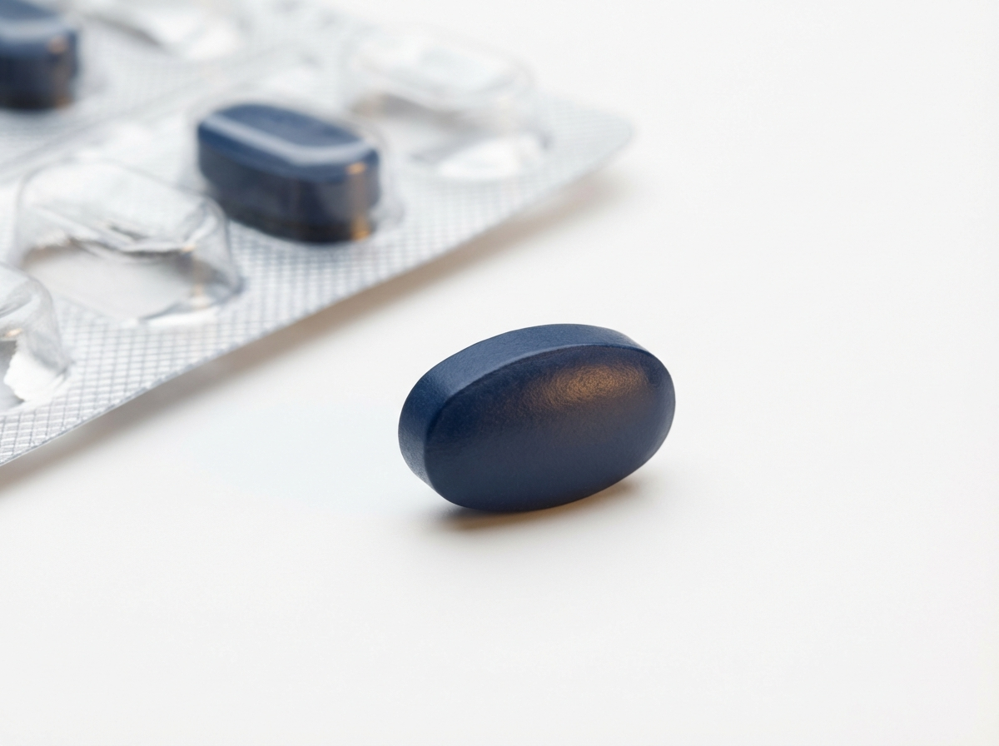
https://velox-images.pages.dev/card-dosing.jpeg
Usage: Home — subcutaneous dosing card
Card heading: Subcutaneous self-injection every 4 weeks
Card body: After a brief loading phase (3 fortnightly doses), AXURA is administered as a single subcutaneous injection every 4 weeks. Patients can self-inject at home after appropriate training, supporting treatment convenience and autonomy.³
Card link: View dosing information → /axura/safety-monitoring
────────────────────────────────────────────────────────────

Section 3 — MoA teaser (two-column: image left, text right) | highlight background
Block: columns-teaser
Section metadata: Style: highlight

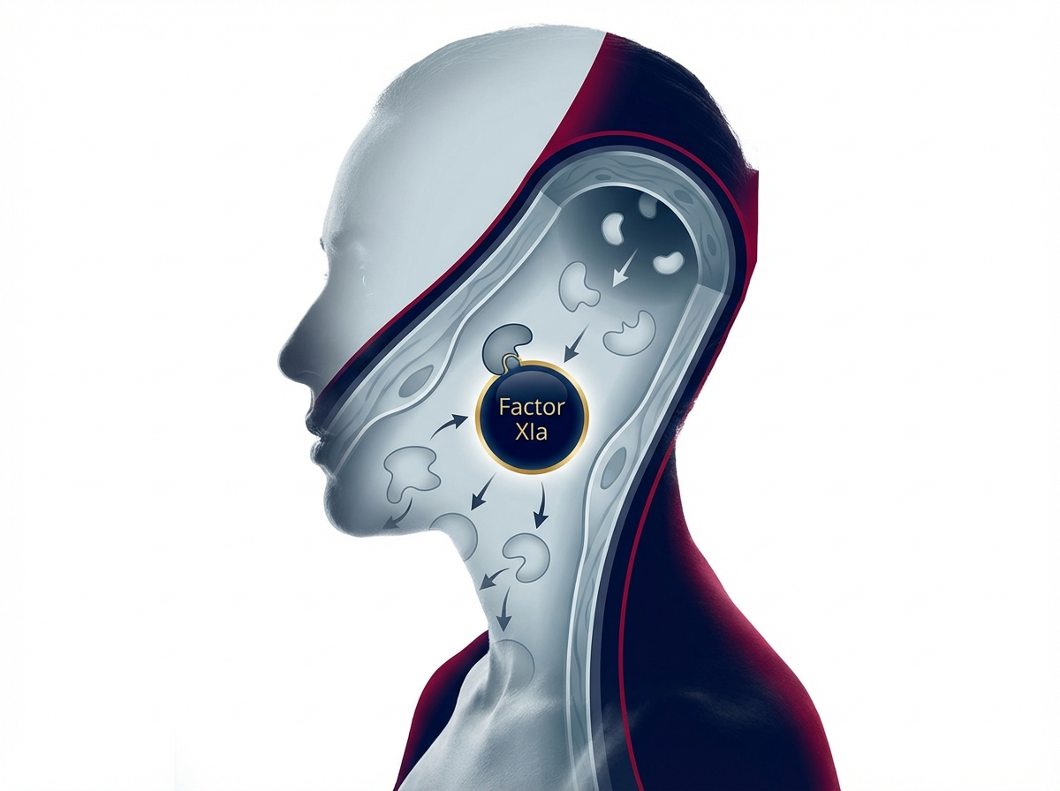
https://velox-images.pages.dev/columns-moa-preview.jpeg
Usage: Home — MoA teaser
Heading: Targeting the source: CD38 and the long-lived plasma cell
Body text: Long-lived plasma cells are the primary source of pathogenic autoantibodies in SLE, yet they are resistant to conventional immunosuppression and B-cell depletion. AXURA targets CD38 — highly expressed on these cells — to deplete the autoantibody factory at its origin.³ ⁵
Call to action: Explore how AXURA works → /axura/how-axura-works
────────────────────────────────────────────────────────────

Section 4 — Prescribing information footer
Block: accordion
Expandable sections for: Prescribing Information | Adverse Event Reporting | References (Use approved text from sections 5, 6, and 7 above)

Page metadata
Title: AXURA (axurelimab) | Anti-CD38 Therapy for SLE | AstraZeneca UK
Description: AXURA (axurelimab) is a first-in-class anti-CD38 monoclonal antibody for active systemic lupus erythematosus and lupus nephritis. Explore AURORA clinical data, safety, and dosing for UK healthcare professionals.

PAGE 2: AURORA Data
URL path: /axura/aurora-data
────────────────────────────────────────────────────────────

Section 1 — Page introduction (centred text, no image)
Block: title
Heading: The AURORA clinical programme
Body text: AXURA®▼ (axurelimab) was evaluated in two Phase III trials encompassing the two major clinical presentations of lupus: systemic disease (AURORA-1) and renal involvement (AURORA-LN).¹ ²
────────────────────────────────────────────────────────────

Section 2 — Biomarker response carousel (3 slides) | light background
Block: carousel-teaser
Section metadata: Style: light
Slide 1:
Heading: 64% reduction in anti-dsDNA antibodies at Week 52
Body text: AXURA produced a median 64.1% reduction in anti-dsDNA titres from baseline at Week 52, compared with 8.3% in the placebo group (P<0.001). Rapid reductions were observed from Week 4, consistent with depletion of autoantibody-secreting plasma cells.¹
Slide 2:
Heading: 73% of patients achieved complement normalisation
Body text: C3 normalisation was achieved in 72.8% of AXURA-treated patients with low baseline C3, compared with 31.4% with placebo (P<0.001). Complement recovery correlated with clinical response and reduced flare risk.¹
Slide 3:
Heading: 68% achieved glucocorticoid reduction to ≤7.5 mg/day
Body text: Among patients receiving >7.5 mg/day prednisolone at baseline, 68.2% of AXURA patients achieved sustained dose reduction to ≤7.5 mg/day by Week 52, versus 42.1% with placebo (OR 2.93; P<0.001) — reducing cumulative steroid burden.¹
────────────────────────────────────────────────────────────

Section 3 — Clinical data (two tabs)
Block: tabs-large

Tab 1: "AURORA-1: Systemic SLE"

https://velox-images.pages.dev/tab-velocity-af.jpeg
Usage: AURORA Data — AURORA-1 tab
Heading: AURORA-1: Clinically meaningful disease control across organ systems
Body text: AURORA-1 was a randomised, double-blind, placebo-controlled trial in 768 adults with active seropositive SLE (SLEDAI-2K ≥6) despite standard of care. AXURA achieved the primary endpoint of SRI-4 response at Week 52 in 61.7% vs 35.9% (Δ 25.8%; P<0.001). BICLA response was achieved in 54.4% vs 30.5% (P<0.001). Severe flares (BILAG A) were reduced by 62% (HR 0.38; P<0.001). Notably, clinical response was accompanied by rapid and sustained normalisation of serological biomarkers (anti-dsDNA, complement), supporting a disease-modifying rather than purely symptomatic mechanism.¹
Data table:
Endpoint | AXURA (n=384) | Placebo (n=384) | Treatment effect
SRI-4 at Week 52 | 61.7% | 35.9% | Δ 25.8%; P<0.001
BICLA at Week 52 | 54.4% | 30.5% | Δ 23.9%; P<0.001
Severe flare (BILAG A) | 8.9% | 21.6% | HR 0.38; P<0.001
GC ≤7.5 mg/day | 68.2% | 42.1% | OR 2.93; P<0.001
Anti-dsDNA reduction | −64.1% | −8.3% | P<0.001
────────────────────────────────────────────────────────────
Tab 2: "AURORA-LN: Lupus nephritis"
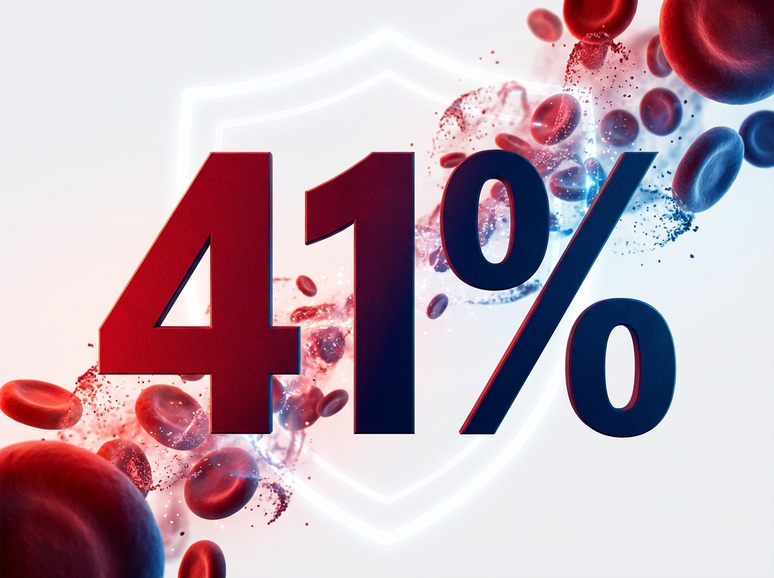
https://velox-images.pages.dev/tab-velocity-bleed.jpeg
Usage: AURORA Data — AURORA-LN tab
Heading: AURORA-LN: Doubling the rate of complete renal response
Body text: AURORA-LN was a randomised, double-blind, placebo-controlled trial in 354 adults with biopsy-proven active lupus nephritis (Class III, IV, or V) on background MMF + glucocorticoids. AXURA nearly doubled the rate of complete renal response at Week 52: 43.5% vs 22.0% (Δ 21.5%; P<0.001). The overall renal response rate was 71.2% vs 49.2% (P<0.001). Renal flares were reduced by 69% (HR 0.31; P=0.001). Proteinuria (uPCR) decreased by 71.4% with AXURA vs 38.2% with placebo.²
Data table:
Endpoint | AXURA + SoC (n=177) | Placebo + SoC (n=177) | Effect
CRR at Week 52 | 43.5% | 22.0% | Δ 21.5%; P<0.001
Overall renal response | 71.2% | 49.2% | Δ 22.0%; P<0.001
Sustained CRR (Wk 36–52) | 34.5% | 14.7% | Δ 19.8%; P<0.001
Renal flare | 5.6% | 16.9% | HR 0.31; P=0.001
uPCR change | −71.4% | −38.2% | P<0.001
────────────────────────────────────────────────────────────

Section 4 — Prescribing information footer
Block: accordion | Expandable: PI | AE Reporting | References

Page metadata
Title: AURORA Data | AXURA (axurelimab) | SLE & Lupus Nephritis Results | AstraZeneca UK
Description: Explore the AURORA clinical programme for AXURA (axurelimab) — Phase III SRI-4 response in active SLE and complete renal response in lupus nephritis.

PAGE 3: Living with Lupus
URL path: /axura/living-with-lupus
────────────────────────────────────────────────────────────

Section 1 — Hero (full-width image with text overlay)
Block: hero-teaser


https://velox-images.pages.dev/hero-efficacy.jpeg
Usage: Living with Lupus — hero
Heading: Understanding the burden of SLE
Body text: Systemic lupus erythematosus is a chronic, relapsing autoimmune disease that can affect virtually every organ system. For many patients, the unpredictable cycle of flares and the cumulative toxicity of long-term corticosteroids define their experience of living with lupus.⁴
────────────────────────────────────────────────────────────

Section 2 — Disease burden (3-column cards)
Block: cards-teaser

https://velox-images.pages.dev/card-bleeding-events.jpeg
Usage: Safety & Monitoring — infusion/injection reactions card
Card heading: The flare cycle
Card body: Up to 65% of SLE patients experience at least one flare per year despite standard therapy. Severe flares (BILAG A) require hospitalisation, high-dose corticosteroids, or cyclophosphamide, and are associated with irreversible organ damage accumulation.⁴
────────────────────────────────────────────────────────────
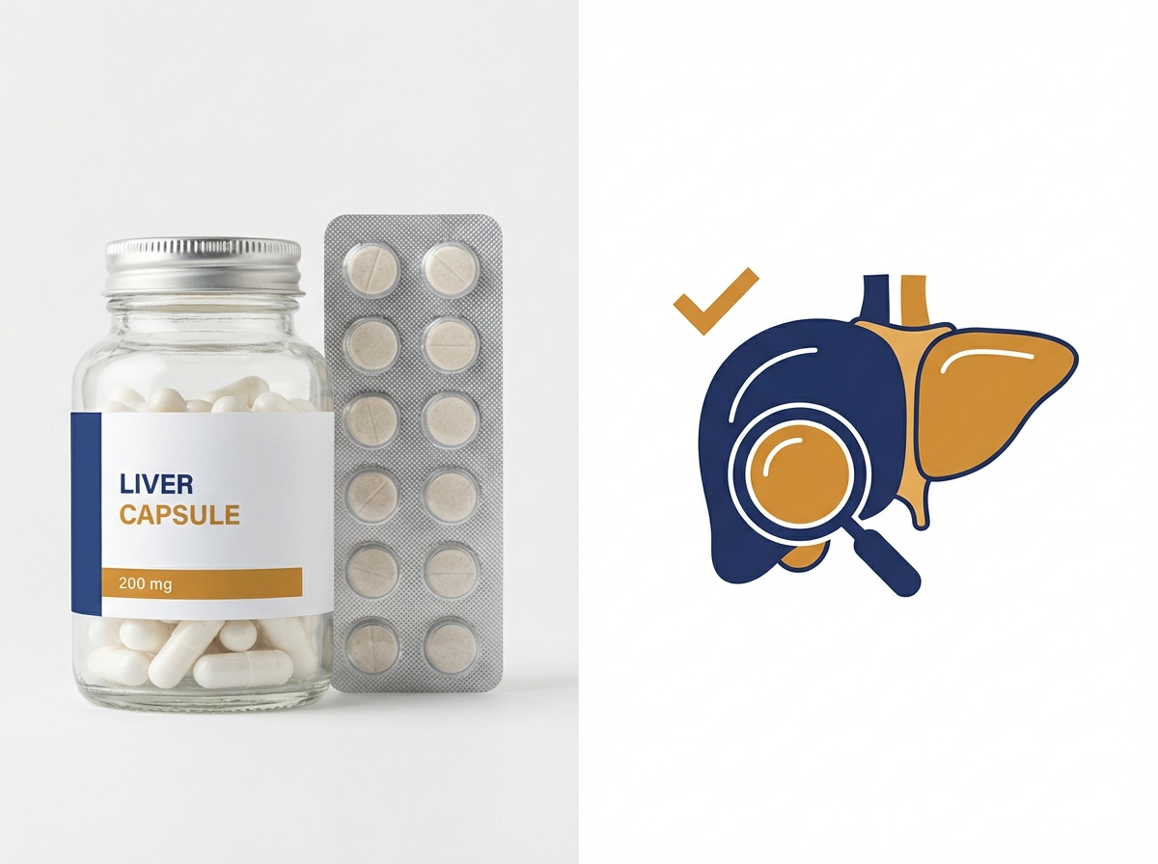
https://velox-images.pages.dev/card-hepatic.jpeg
Usage: Safety & Monitoring — immunoglobulin monitoring card
Card heading: Steroid burden
Card body: Over 50% of SLE patients require chronic glucocorticoids. Cumulative steroid exposure drives organ damage (osteoporosis, avascular necrosis, diabetes, cataracts, cardiovascular disease) independently of lupus activity, creating a therapeutic dilemma.⁴
────────────────────────────────────────────────────────────
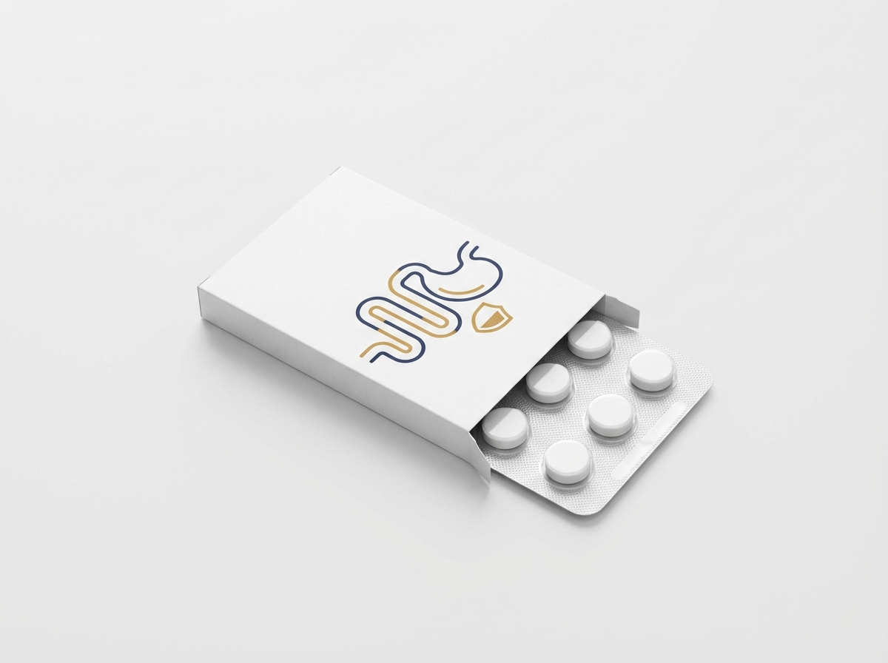
https://velox-images.pages.dev/card-gi-events.jpeg
Usage: Safety & Monitoring — infection risk card
Card heading: Lupus nephritis
Card body: Up to 50% of SLE patients develop lupus nephritis during their disease course. Despite standard immunosuppression, only 20–30% achieve complete renal response at one year, and up to 20% progress to end-stage renal disease within 10 years.⁴
────────────────────────────────────────────────────────────

Section 3 — Autoantibody context (two-column: image left, text right) | light background
Block: columns-teaser
Section metadata: Style: light


https://velox-images.pages.dev/columns-monitoring.jpeg
Usage: Safety & Monitoring — monitoring schedule
Heading: Why autoantibodies persist despite treatment
Body text: Long-lived plasma cells in the bone marrow continuously secrete pathogenic autoantibodies (anti-dsDNA, anti-Smith, anti-C1q) that drive immune-complex deposition and complement activation across multiple organ systems. These cells are resistant to conventional immunosuppressants and anti-CD20 B-cell depletion because they are terminally differentiated and survive independently of B-cell survival signals (BAFF). Targeting CD38 — a surface marker highly expressed on long-lived plasma cells — offers a direct route to eliminating the autoantibody source.⁴ ⁵
Call to action: Explore how AXURA works → /axura/how-axura-works
────────────────────────────────────────────────────────────

Section 4 — Fatigue and quality of life (centred text) | highlight background
Block: introduction
Section metadata: Style: highlight
Heading: Fatigue: the invisible burden of lupus
Body text: Fatigue is the most commonly reported symptom in SLE, affecting over 80% of patients and frequently rated as the most disabling aspect of the disease. In AURORA-1, 52.3% of AXURA patients reported clinically meaningful improvement in FACIT-Fatigue (≥4-point increase) at Week 52, compared with 33.6% with placebo (Δ 18.7%; P<0.001) — reflecting the systemic impact of reducing autoantibody-mediated inflammation.¹
────────────────────────────────────────────────────────────

Section 5 — Prescribing information footer
Block: accordion | Expandable: PI | AE Reporting | References

Page metadata
Title: Living with Lupus | Disease Burden & Unmet Need | AXURA | AstraZeneca UK
Description: Understand the burden of systemic lupus erythematosus — the flare cycle, steroid toxicity, lupus nephritis, and the persistent role of autoantibodies in driving disease activity.

PAGE 4: Safety & Monitoring
URL path: /axura/safety-monitoring
────────────────────────────────────────────────────────────

Section 1 — Page header (text only, no image)
Block: title
Heading: Safety, monitoring, and dosing
Body text: AXURA®▼ (axurelimab) has been evaluated in 561 patients across the AURORA clinical programme. Subcutaneous dosing with regular immunoglobulin monitoring supports safe, convenient long-term treatment.¹ ² ³
────────────────────────────────────────────────────────────

Section 2 — Dosing regimen (two-column: image left, text right) | highlight background
Block: columns-teaser
Section metadata: Style: highlight


https://velox-images.pages.dev/columns-dosing.jpeg
Usage: Dosing & Administration — SC injection at home
Heading: Loading and maintenance dosing
Body text: Loading phase: AXURA 300 mg subcutaneous injection every 2 weeks for the first 3 doses (Weeks 0, 2, and 4). Maintenance phase: 300 mg subcutaneous injection every 4 weeks thereafter. Administer into the thigh, abdomen (excluding 5 cm around the navel), or upper arm (if administered by a caregiver). Rotate injection sites. Patients may self-inject at home after appropriate training by a healthcare professional.³
────────────────────────────────────────────────────────────

Section 3 — Key safety considerations (three equal columns)
Block: cards-teaser


https://velox-images.pages.dev/card-bleeding-events.jpeg
Usage: Safety & Monitoring — infusion/injection reactions card
Card heading: Injection site reactions
Card body: ISRs occurred in 14.8% of AXURA patients (most grade 1: erythema, pruritus). Frequency decreased with successive doses: 12.1% at dose 1 to <2% at doses ≥4. No ISR led to discontinuation. Pre-treatment with paracetamol or antihistamine is not routinely required.³
────────────────────────────────────────────────────────────

https://velox-images.pages.dev/card-hepatic.jpeg
Usage: Safety & Monitoring — immunoglobulin monitoring card
Card heading: Immunoglobulin monitoring
Card body: IgG levels decrease by ~18% at Week 52 (expected pharmacological effect). IgG <6.0 g/L in 12.3% of patients; IgG <4.0 g/L in 2.1%. Monitor IgG, IgA, IgM at baseline, Week 12, Week 24, and every 6 months. Consider withholding if IgG <4.0 g/L with concurrent serious or recurrent infections.³
────────────────────────────────────────────────────────────

https://velox-images.pages.dev/card-gi-events.jpeg
Usage: Safety & Monitoring — infection risk card
Card heading: Infection risk
Card body: Serious infections: 6.2% vs 5.4% placebo. Herpes zoster: 6.8% vs 2.4%. Recommend recombinant zoster vaccination before or during treatment. Screen for TB and HBV before initiation. Do not initiate during active infections. No opportunistic infections or PML cases were observed.³
────────────────────────────────────────────────────────────

Section 4 — Monitoring schedule table | light background
Block: table-data
Section metadata: Style: light
Heading: Recommended monitoring schedule
Assessment | Baseline | Week 12 | Week 24 | Every 6 months | As indicated
Immunoglobulins (IgG, IgA, IgM) | ✓ | ✓ | ✓ | ✓ | ✓
Full blood count | ✓ | ✓ |  | ✓ | ✓
Renal function (eGFR, uPCR) | ✓ | ✓ | ✓ | ✓ | ✓
Hepatitis B screening | ✓
TB screening | ✓
Complement (C3, C4) | ✓ | ✓ | ✓ | ✓
Anti-dsDNA titre | ✓ | ✓ | ✓ | ✓
Vaccination status | ✓
────────────────────────────────────────────────────────────

Section 5 — Practical considerations (two-column: image left, text right)
Block: columns-teaser


https://velox-images.pages.dev/columns-monitoring.jpeg
Usage: Safety & Monitoring — monitoring schedule
Heading: Pre-treatment checklist and vaccination guidance
Body text: Before initiating AXURA: Complete all age-appropriate vaccinations, including recombinant zoster vaccine (Shingrix) where possible. Screen for active infections, TB (interferon-gamma release assay or tuberculin skin test), and hepatitis B (HBsAg, anti-HBc, HBV DNA if positive). Assess baseline immunoglobulins, FBC, renal function, and complement/anti-dsDNA. Ensure effective contraception in women of childbearing potential. AXURA may be initiated alongside existing standard of care (antimalarials, immunosuppressants, low-dose glucocorticoids) without washout.³
────────────────────────────────────────────────────────────

Section 6 — Prescribing information footer
Block: accordion | Expandable: PI | AE Reporting | References

Page metadata
Title: Safety & Monitoring | AXURA (axurelimab) | Dosing, ISRs, Immunoglobulins | AstraZeneca UK
Description: AXURA (axurelimab) safety profile, dosing regimen, monitoring schedule, and practical guidance for UK healthcare professionals managing SLE and lupus nephritis.

PAGE 5: How AXURA Works
URL path: /axura/how-axura-works
────────────────────────────────────────────────────────────

Section 1 — Hero (full-width image with text overlay)
Block: hero-teaser


https://velox-images.pages.dev/hero-moa.jpeg
Usage: How AXURA Works — hero
Heading: How AXURA works
Body text: AXURA®▼ (axurelimab) targets CD38 to deplete the autoantibody-secreting cells that conventional therapies cannot reach — a fundamentally different approach to treating the root cause of SLE.³ ⁵
────────────────────────────────────────────────────────────

Section 2 — Three-step mechanism (accordion FAQ)
Block: accordion
Panel 1: "Why do current therapies leave autoantibodies unchecked?"
Body text: Conventional immunosuppressants (azathioprine, MMF, cyclophosphamide) suppress active immune cell proliferation but do not deplete terminally differentiated long-lived plasma cells. Anti-CD20 therapies (rituximab) deplete B-cells but spare plasma cells, which lack CD20 expression. Anti-BAFF therapies (belimumab) block B-cell survival signals but long-lived plasma cells survive independently of BAFF. The result: pathogenic autoantibodies persist even during apparent clinical remission, driving subclinical inflammation and damage accrual.⁴ ⁵
Panel 2: "How does AXURA target autoantibody-producing cells?"
Body text: CD38 is a transmembrane glycoprotein highly expressed on long-lived plasma cells and plasmablasts — the cells directly responsible for secreting pathogenic autoantibodies. Axurelimab binds to CD38 and eliminates these cells through ADCC, CDC, and ADCP. Unlike CD20 or BAFF-targeted therapies, anti-CD38 directly reaches the terminally differentiated compartment responsible for autoantibody production.³ ⁵
Panel 3: "What happens after plasma cell depletion?"
Body text: Depletion of CD38-high autoantibody-secreting cells produces rapid reductions in pathogenic autoantibody titres (anti-dsDNA decreased by 64% at Week 52). Downstream, reduced immune-complex formation leads to complement recovery (C3 normalisation in 73% of patients), decreased tissue inflammation, and reduced organ damage accrual. Protective immunoglobulin levels are maintained in the majority of patients because memory B-cells and newly generated non-autoreactive plasma cells replenish the normal antibody repertoire.¹ ³
────────────────────────────────────────────────────────────

Section 3 — Visual mechanism (two-column: image left, text right) | highlight background
Block: columns-teaser
Section metadata: Style: highlight


https://velox-images.pages.dev/columns-moa-preview.jpeg
Usage: Home — MoA teaser
Heading: From plasma cell depletion to clinical remission
Body text: AXURA depletes CD38-high long-lived plasma cells and plasmablasts → pathogenic autoantibody titres fall rapidly (anti-dsDNA −64% at Week 52) → immune-complex formation decreases → complement consumption reverses (C3 normalisation 73%) → tissue inflammation resolves → clinical response (SRI-4 62%, severe flare reduction 62%). This mechanistic cascade provides a disease-modifying rationale for anti-CD38 therapy in SLE.¹ ³ ⁵
Call to action: View the AURORA clinical data → /axura/aurora-data
────────────────────────────────────────────────────────────

Section 4 — Prescribing information footer
Block: accordion | Expandable: PI | AE Reporting | References

Page metadata
Title: How AXURA Works | Anti-CD38 Mechanism | Plasma Cell Depletion | AstraZeneca UK
Description: Understand how AXURA (axurelimab) targets CD38 on long-lived plasma cells to deplete pathogenic autoantibodies and achieve disease control in systemic lupus erythematosus.

PAGE 6: HCP Resources
URL path: /axura/resources
────────────────────────────────────────────────────────────

Section 1 — Page header (text only, no image)
Block: title
Heading: Resources for healthcare professionals
Body text: Access prescribing information, monitoring guides, clinical data summaries, and patient support resources for AXURA®▼ (axurelimab). All materials are provided for UK healthcare professionals only.³
────────────────────────────────────────────────────────────

Section 2 — Resource cards (three equal columns)
Block: cards-teaser

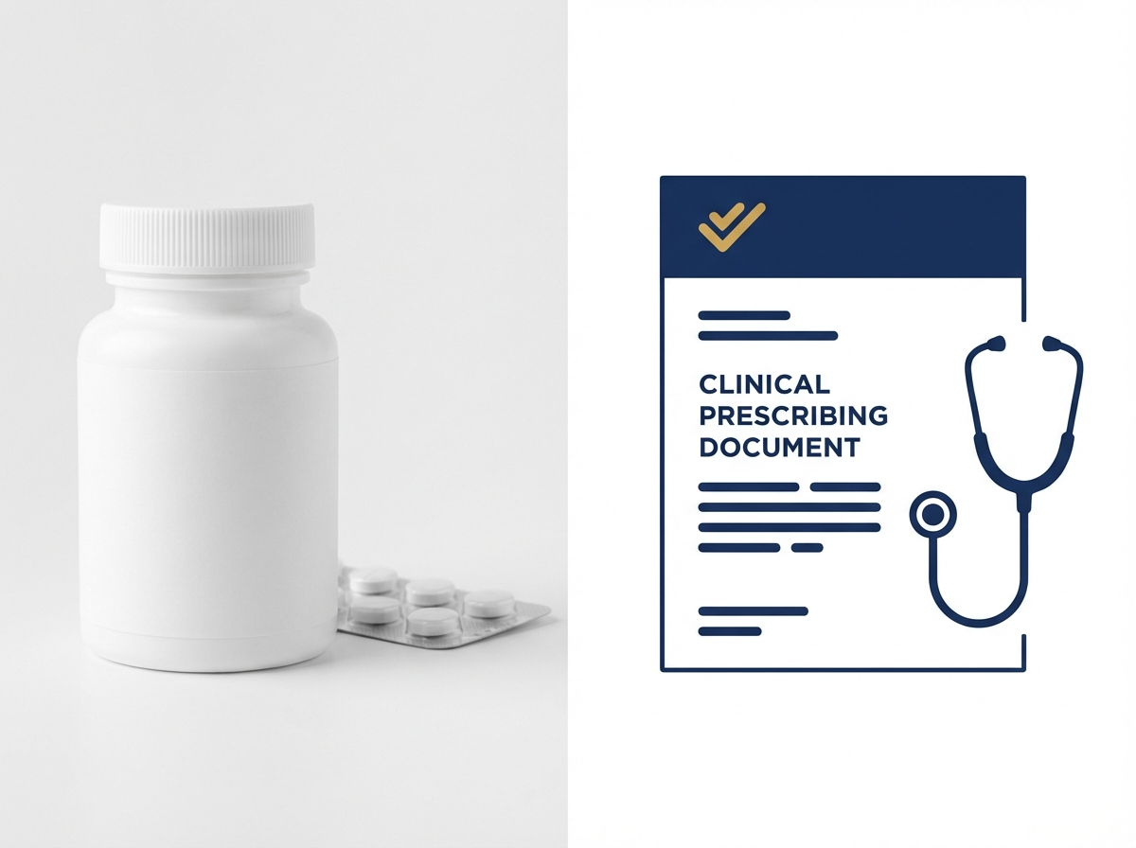
https://velox-images.pages.dev/card-prescribing.jpeg
Usage: HCP Resources — prescribing guide card
Card heading: Prescribing and monitoring guide
Card body: Comprehensive clinical guide covering indication, dosing regimen, immunoglobulin monitoring schedule, injection site rotation, vaccination requirements, and special populations guidance. Includes a detachable monitoring checklist for patient notes.³
Card link: Download prescribing guide → [PDF link]
────────────────────────────────────────────────────────────
Card heading: AURORA clinical data summary
Card body: Summary of key efficacy and safety data from AURORA-1 and AURORA-LN, including headline results, response curves, biomarker kinetics, and subgroup analyses. Suitable for use in MDT discussions and clinic preparation.¹ ²
Card link: Download data summary → [PDF link]
────────────────────────────────────────────────────────────
Card heading: Patient self-injection training guide
Card body: Step-by-step illustrated guide for training patients in subcutaneous self-injection with AXURA pre-filled syringe. Covers preparation, site selection, technique, storage, and sharps disposal. Includes a companion patient-facing leaflet.
Card link: Download training guide → [PDF link]
────────────────────────────────────────────────────────────

Section 3 — Contact (centred text) | light background
Block: introduction
Section metadata: Style: light
Heading: Medical information and support
Body text: For medical information enquiries about AXURA, please contact AstraZeneca Medical Information: Telephone: 0800 783 0033 | Email: medicalinformationuk@astrazeneca.com | Online: contactazmedical.astrazeneca.com
────────────────────────────────────────────────────────────

Section 4 — Prescribing information footer
Block: accordion | Expandable: PI | AE Reporting | References

Page metadata
Title: HCP Resources | AXURA (axurelimab) | Prescribing & Monitoring Guides | AstraZeneca UK
Description: Access prescribing and monitoring guides, AURORA clinical data summaries, and patient self-injection training materials for AXURA (axurelimab). For UK healthcare professionals only.

10. Footer Content
The footer must appear on every page and contain the following elements:
Logo: AstraZeneca logo (linked to /axura/)
Approval code: GB-12091 | DOP: March 2026
Copyright: © 2026 AstraZeneca. All rights reserved. AXURA is a registered trademark of the AstraZeneca group of companies.
Page links: AURORA Data | Living with Lupus | Safety & Monitoring | How AXURA Works | HCP Resources
Regulatory links: Report Adverse Event (https://yellowcard.mhra.gov.uk/) | Medical Information (https://contactazmedical.astrazeneca.com/) | Privacy Policy (https://www.astrazeneca.co.uk/our-company/privacy-notice.html) | Terms of Use (https://www.astrazeneca.co.uk/our-company/terms-of-use.html) | Accessibility (https://www.astrazeneca.co.uk/accessibility.html)
Date of preparation: Date of Preparation: March 2026
────────────────────────────────────────────────────────────

11. Image Assets
All images sourced from shared CDN: https://velox-images.pages.dev/
Note: AXURA reuses images originally generated for the VELOX website. The abstract and lifestyle imagery is versatile across immunology contexts.

Complete image manifest:

Filename | Usage | CDN URL
hero-home.jpeg | Home — hero | https://velox-images.pages.dev/hero-home.jpeg
hero-efficacy.jpeg | Living with Lupus — hero | https://velox-images.pages.dev/hero-efficacy.jpeg
hero-moa.jpeg | How AXURA Works — hero | https://velox-images.pages.dev/hero-moa.jpeg
card-stroke.jpeg | Home — SRI-4 response card | https://velox-images.pages.dev/card-stroke.jpeg
card-bleeding.jpeg | Home — flare reduction card | https://velox-images.pages.dev/card-bleeding.jpeg
card-dosing.jpeg | Home — subcutaneous dosing card | https://velox-images.pages.dev/card-dosing.jpeg
columns-moa-preview.jpeg | Home — MoA teaser | https://velox-images.pages.dev/columns-moa-preview.jpeg
tab-velocity-af.jpeg | AURORA Data — AURORA-1 tab | https://velox-images.pages.dev/tab-velocity-af.jpeg
tab-velocity-bleed.jpeg | AURORA Data — AURORA-LN tab | https://velox-images.pages.dev/tab-velocity-bleed.jpeg
card-bleeding-events.jpeg | Safety & Monitoring — infusion/injection reactions card | https://velox-images.pages.dev/card-bleeding-events.jpeg
card-hepatic.jpeg | Safety & Monitoring — immunoglobulin monitoring card | https://velox-images.pages.dev/card-hepatic.jpeg
card-gi-events.jpeg | Safety & Monitoring — infection risk card | https://velox-images.pages.dev/card-gi-events.jpeg
columns-dosing.jpeg | Dosing & Administration — SC injection at home | https://velox-images.pages.dev/columns-dosing.jpeg
columns-monitoring.jpeg | Safety & Monitoring — monitoring schedule | https://velox-images.pages.dev/columns-monitoring.jpeg
card-prescribing.jpeg | HCP Resources — prescribing guide card | https://velox-images.pages.dev/card-prescribing.jpeg

Image previews
Visual previews of all 15 images:

hero-home.jpeg — Home — hero

https://velox-images.pages.dev/hero-home.jpeg
Usage: Home — hero

hero-efficacy.jpeg — Living with Lupus — hero

https://velox-images.pages.dev/hero-efficacy.jpeg
Usage: Living with Lupus — hero

hero-moa.jpeg — How AXURA Works — hero

https://velox-images.pages.dev/hero-moa.jpeg
Usage: How AXURA Works — hero

card-stroke.jpeg — Home — SRI-4 response card

https://velox-images.pages.dev/card-stroke.jpeg
Usage: Home — SRI-4 response card

card-bleeding.jpeg — Home — flare reduction card

https://velox-images.pages.dev/card-bleeding.jpeg
Usage: Home — flare reduction card

card-dosing.jpeg — Home — subcutaneous dosing card

https://velox-images.pages.dev/card-dosing.jpeg
Usage: Home — subcutaneous dosing card

columns-moa-preview.jpeg — Home — MoA teaser

https://velox-images.pages.dev/columns-moa-preview.jpeg
Usage: Home — MoA teaser

tab-velocity-af.jpeg — AURORA Data — AURORA-1 tab

https://velox-images.pages.dev/tab-velocity-af.jpeg
Usage: AURORA Data — AURORA-1 tab

tab-velocity-bleed.jpeg — AURORA Data — AURORA-LN tab

https://velox-images.pages.dev/tab-velocity-bleed.jpeg
Usage: AURORA Data — AURORA-LN tab

card-bleeding-events.jpeg — Safety & Monitoring — infusion/injection reactions card

https://velox-images.pages.dev/card-bleeding-events.jpeg
Usage: Safety & Monitoring — infusion/injection reactions card

card-hepatic.jpeg — Safety & Monitoring — immunoglobulin monitoring card

https://velox-images.pages.dev/card-hepatic.jpeg
Usage: Safety & Monitoring — immunoglobulin monitoring card

card-gi-events.jpeg — Safety & Monitoring — infection risk card

https://velox-images.pages.dev/card-gi-events.jpeg
Usage: Safety & Monitoring — infection risk card

columns-dosing.jpeg — Dosing & Administration — SC injection at home

https://velox-images.pages.dev/columns-dosing.jpeg
Usage: Dosing & Administration — SC injection at home

columns-monitoring.jpeg — Safety & Monitoring — monitoring schedule

https://velox-images.pages.dev/columns-monitoring.jpeg
Usage: Safety & Monitoring — monitoring schedule

card-prescribing.jpeg — HCP Resources — prescribing guide card

https://velox-images.pages.dev/card-prescribing.jpeg
Usage: HCP Resources — prescribing guide card

