LUMIVEX®
(lumvecitinib)

Website Briefing

Document type: Final approved marketing brief for HCP website build
Prepared by: Marketing — UK Dermatology Franchise
Approval status: MLR-approved copy — do not modify
Date: March 2026
Approval code: GB-94281 | DOP: March 2026

Contents
1. Drug Profile
2. Mechanism of Action
3. Clinical Programme: LUMINANCE
4. Safety Profile
5. Prescribing Information
6. Adverse Event Reporting
7. References
8. Site Navigation
9. Page Content
Page 1: Home
Page 2: Efficacy
Page 3: Safety
Page 4: Dosing & Administration
Page 5: Mechanism of Action
Page 6: Resources
10. Footer Content
11. Image Assets

1. Drug Profile
Field | Detail
Brand name | LUMIVEX®
Generic name | lumvecitinib
Drug class | Selective allosteric tyrosine kinase 2 (TYK2) inhibitor
Indication | Treatment of adults with moderate-to-severe plaque psoriasis who are candidates for systemic therapy
Formulation | 6 mg film-coated tablet
Dosing | One tablet once daily, with or without food
Approval | MHRA — February 2026
Brand colour | Luminous Amber #D4851F
Approval code | GB-94281

────────────────────────────────────────────────────────────

2. Mechanism of Action
Lumvecitinib is a selective allosteric inhibitor of tyrosine kinase 2 (TYK2), binding to the pseudokinase (JH2) regulatory domain rather than the catalytic (JH1) domain. This allosteric mechanism confers high selectivity for TYK2 over JAK1, JAK2, and JAK3, minimising the haematological and immunosuppressive effects associated with pan-JAK inhibition.
TYK2 mediates intracellular signalling through the IL-23, IL-12, and type I interferon (IFN) receptors — key drivers of the Th17 and Th1 immune responses that underlie psoriatic inflammation. IL-23 activates TYK2, which phosphorylates STAT3, promoting Th17 cell differentiation and IL-17A/F production. IL-17 drives keratinocyte hyperproliferation, neutrophil recruitment, and the characteristic epidermal thickening of plaque psoriasis.
By selectively inhibiting TYK2, lumvecitinib reduces IL-23-dependent Th17 cell activation and IL-17 production, normalising keratinocyte proliferation and resolving psoriatic plaques. The selective mechanism preserves JAK1/2/3-mediated haematopoiesis and broader immune surveillance, resulting in a favourable tolerability profile distinct from non-selective JAK inhibitors.
────────────────────────────────────────────────────────────

3. Clinical Programme: LUMINANCE

LUMINANCE-1: Efficacy vs placebo
Design: Phase III, randomised, double-blind, placebo-controlled, 52-week trial
Population: 1,020 adults with moderate-to-severe plaque psoriasis (BSA ≥10%, PASI ≥12, IGA ≥3), inadequate response or intolerance to ≥1 conventional systemic therapy
Primary endpoint: Proportion achieving PASI 75 response at Week 16
Key secondary: PASI 90, IGA 0/1 at Week 16; PASI 75 maintenance at Week 52
Publication: Morrison et al. N Engl J Med 2025; 392(12): 1089–1101

Key results:
Endpoint | Lumvecitinib 6 mg (n=510) | Placebo (n=510) | Difference (95% CI)
PASI 75 at Week 16 (primary) | 72.4% | 8.6% | 63.8% (58.9 to 68.7); P<0.001
PASI 90 at Week 16 | 48.1% | 3.2% | 44.9% (40.3 to 49.5); P<0.001
PASI 100 at Week 16 | 24.7% | 1.0% | 23.7% (19.8 to 27.6); P<0.001
IGA 0/1 at Week 16 | 54.3% | 7.1% | 47.2% (42.4 to 52.0); P<0.001
PASI 75 at Week 52 | 84.6%* | — | *of Week 16 PASI 75 responders
DLQI 0/1 at Week 16 | 41.8% | 5.9% | 35.9% (31.3 to 40.5); P<0.001

LUMINANCE-2: Superiority vs adalimumab
Design: Phase III, randomised, double-blind, double-dummy, active-controlled, 52-week trial
Population: 1,428 biologic-naïve adults with moderate-to-severe plaque psoriasis (BSA ≥10%, PASI ≥12, IGA ≥3)
Primary endpoint: PASI 90 response at Week 16 (non-inferiority margin 10%, with pre-specified superiority test)
Publication: Park et al. Lancet 2025; 405(10478): 823–836

Key results:
Endpoint | Lumvecitinib 6 mg (n=714) | Adalimumab 40 mg (n=714) | Difference (95% CI)
PASI 90 at Week 16 (primary) | 52.8% | 38.2% | 14.6% (9.5 to 19.7); P<0.001 superiority
PASI 75 at Week 16 | 78.1% | 65.4% | 12.7% (8.0 to 17.4); P<0.001
IGA 0/1 at Week 16 | 59.2% | 43.8% | 15.4% (10.4 to 20.4); P<0.001
PASI 90 at Week 52 | 61.4% | 34.7% | 26.7% (21.9 to 31.5); P<0.001
DLQI 0/1 at Week 16 | 46.3% | 33.1% | 13.2% (8.4 to 18.0); P<0.001

LUMINANCE-3: Long-term safety and efficacy (open-label extension)
Design: Open-label extension of LUMINANCE-1 and -2, up to 3 years
Population: 2,186 patients who completed parent trials
Publication: Morrison et al. Br J Dermatol 2026; 194(2): 412–425

Key results:
- PASI 90 maintained at Week 148: 67.3% (observed cases)
- No new safety signals identified through 148 weeks of continuous treatment
- Serious infection rate: stable at 1.0–1.3 per 100 patient-years across all three years
- No increase in opportunistic infections, herpes zoster reactivation, or tuberculosis
- Malignancy rates: comparable to age- and sex-matched general psoriasis population
- No clinically meaningful changes in haematological parameters, lipid profiles, or hepatic function tests
- Treatment satisfaction (DLQI 0/1) maintained in 52.6% at Week 148
────────────────────────────────────────────────────────────

4. Safety Profile

Pooled adverse events (LUMINANCE-1 and -2; N=1,224 lumvecitinib)
Adverse event | Lumvecitinib 6 mg (%) | Comparator (%)
Upper respiratory tract infection | 8.4 | 7.2
Nasopharyngitis | 6.1 | 5.8
Headache | 4.7 | 4.1
Acne | 3.9 | 0.8
Diarrhoea | 3.1 | 2.4
Herpes zoster | 1.4 | 0.6
CPK elevation (>5× ULN) | 1.2 | 0.5
Folliculitis | 1.1 | 0.4
ALT elevation (>3× ULN) | 0.8 | 0.4

Key safety findings
Infections: Upper respiratory tract infections and nasopharyngitis were the most common adverse events. Serious infections occurred in 1.1% vs 0.9% of patients. No opportunistic infections were reported in controlled trials. Herpes zoster occurred in 1.4% of lumvecitinib-treated patients; all cases were non-serious, dermatomal, and did not require treatment discontinuation.¹⁻³
Haematological effects: No clinically meaningful changes in haemoglobin, neutrophil, lymphocyte, or platelet counts were observed. Unlike non-selective JAK inhibitors, lumvecitinib did not cause dose-dependent cytopenias, consistent with its selective TYK2 mechanism.¹⁻³
Hepatic effects: ALT elevations >3× ULN occurred in 0.8% of patients. No cases met criteria for drug-induced liver injury (Hy's Law). Liver function tests should be performed prior to initiation and periodically during treatment.⁴
Malignancy: Non-melanoma skin cancer (NMSC) was reported in 0.2% of patients, consistent with background rates in the psoriasis population. No lymphomas were reported. Long-term data from LUMINANCE-3 (up to 148 weeks) showed no increase in malignancy rates over time.¹⁻³
Cardiovascular safety: No major adverse cardiovascular events (MACE) signal was identified. No venous thromboembolism (VTE) signal was detected. Lipid parameters remained stable throughout treatment.¹⁻³

Special populations
- Renal impairment: No dose adjustment is required for patients with mild or moderate renal impairment (eGFR ≥30 mL/min/1.73m²). Lumvecitinib has not been studied in patients with severe renal impairment (eGFR <30 mL/min/1.73m²) or end-stage renal disease.⁴
- Hepatic impairment: No dose adjustment is required in mild hepatic impairment (Child-Pugh A). Lumvecitinib is not recommended in patients with moderate (Child-Pugh B) or severe (Child-Pugh C) hepatic impairment due to insufficient clinical data.⁴
- Elderly (≥65 years): No dose adjustment is required. Clinical experience in patients aged ≥75 years is limited; use with caution in this population.⁴
- Pregnancy and lactation: Lumvecitinib is contraindicated in pregnancy. Women of childbearing potential must use effective contraception during treatment and for 4 weeks after the last dose. It is not known whether lumvecitinib is excreted in human milk; a decision must be made whether to discontinue breast-feeding or to discontinue therapy.⁴
────────────────────────────────────────────────────────────

5. Prescribing Information (abbreviated — for every page footer)
LUMIVEX (lumvecitinib) 6 mg film-coated tablets. Please refer to the Summary of Product Characteristics (SmPC) before prescribing. Indication: Treatment of adults with moderate-to-severe plaque psoriasis who are candidates for systemic therapy. Dosage and administration: 6 mg once daily, with or without food. The tablet should be swallowed whole. Contraindications: Hypersensitivity to lumvecitinib or any excipient. Active serious infections, including tuberculosis. Pregnancy. Warnings and precautions: Evaluate patients for tuberculosis prior to initiation. Monitor for signs and symptoms of infection during and after treatment. Perform liver function tests prior to initiation and periodically thereafter. Check complete blood count including absolute lymphocyte count, absolute neutrophil count, and haemoglobin prior to initiation and periodically during treatment. Assess lipid parameters 12 weeks after initiation. Not recommended in combination with biological immunomodulators or other potent immunosuppressants. Interactions: Avoid concomitant use with strong CYP3A4 inducers. Side effects: Very common (≥1/10): none. Common (≥1/100 to <1/10): upper respiratory tract infection, nasopharyngitis, headache, acne, diarrhoea. Uncommon (≥1/1000 to <1/100): herpes zoster, CPK elevation, folliculitis, ALT increase. Legal category: POM. Pack and price: 28 tablets: £894.35. Marketing authorisation holder: AstraZeneca UK Ltd. MA number: PLGB 17901/0512. Full prescribing information available from: AstraZeneca UK Ltd, 2 Pancras Square, London N1C 4AG. GB-94281 | DOP: March 2026.
────────────────────────────────────────────────────────────

6. Adverse Event Reporting (for every page footer)
Adverse events should be reported. Reporting forms and information can be found at www.mhra.gov.uk/yellowcard or search for MHRA Yellow Card in the Google Play or Apple App Store. Adverse events should also be reported to AstraZeneca by visiting contactazmedical.astrazeneca.com or by calling 0800 783 0033.
────────────────────────────────────────────────────────────

7. References (for every page footer)
1. Morrison et al. N Engl J Med 2025; 392(12): 1089–1101.
2. Park et al. Lancet 2025; 405(10478): 823–836.
3. Morrison et al. Br J Dermatol 2026; 194(2): 412–425.
4. Lumivex (lumvecitinib) Summary of Product Characteristics. AstraZeneca UK Ltd. February 2026.
────────────────────────────────────────────────────────────

8. Site Navigation
Top bar links: Contact Us (https://www.astrazeneca.co.uk/contact-us.html) | AZ Employee Login (https://login.astrazeneca.com)
Main navigation pages: Efficacy | Safety | Dosing | Mechanism of Action | Resources
Utility: Search | Login

9. Page Content
IMPORTANT: All copy below is final and MLR-approved. It must be used exactly as written — do not modify, rephrase, or abbreviate any text. All superscript reference numbers, statistical values, and regulatory language must be reproduced verbatim.
Each page must end with expandable sections for Prescribing Information, Adverse Event Reporting, and References (see sections 5, 6, and 7 above).
────────────────────────────────────────────────────────────

PAGE 1: Home
URL path: /lumivex/
────────────────────────────────────────────────────────────

Section 1 — Hero (full-width image with text overlay)
Block: hero-teaser


https://lumivex-images.pages.dev/hero-home.jpeg
Heading: LUMIVEX® (lumvecitinib): selective TYK2 inhibition for clearer skin
Body text: A new standard in plaque psoriasis — the first selective allosteric TYK2 inhibitor to demonstrate superiority over adalimumab, with a once-daily oral tablet and a favourable tolerability profile distinct from non-selective JAK inhibition.¹˒²
Call to action: Explore the LUMINANCE data → /lumivex/efficacy
────────────────────────────────────────────────────────────

Section 2 — Three key benefit cards (equal columns)
Block: cards-teaser

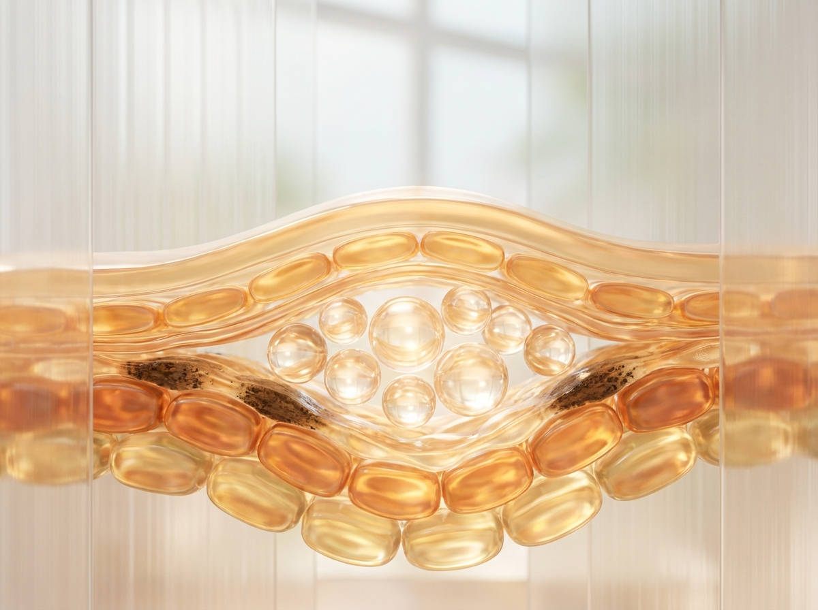
https://lumivex-images.pages.dev/card-efficacy.jpeg
Card heading: Superior skin clearance
Card body: 72.4% of patients achieved PASI 75 at Week 16 vs 8.6% with placebo (P<0.001). Nearly half achieved PASI 90 — clear or almost clear skin.¹
Card link: View efficacy data → /lumivex/efficacy
────────────────────────────────────────────────────────────

https://lumivex-images.pages.dev/card-safety.jpeg
Card heading: Favourable tolerability profile
Card body: Selective TYK2 inhibition with no dose-dependent cytopenias, no MACE signal, and no VTE signal — a differentiated safety profile across over 2,400 patients.¹⁻³
Card link: Review safety data → /lumivex/safety
────────────────────────────────────────────────────────────
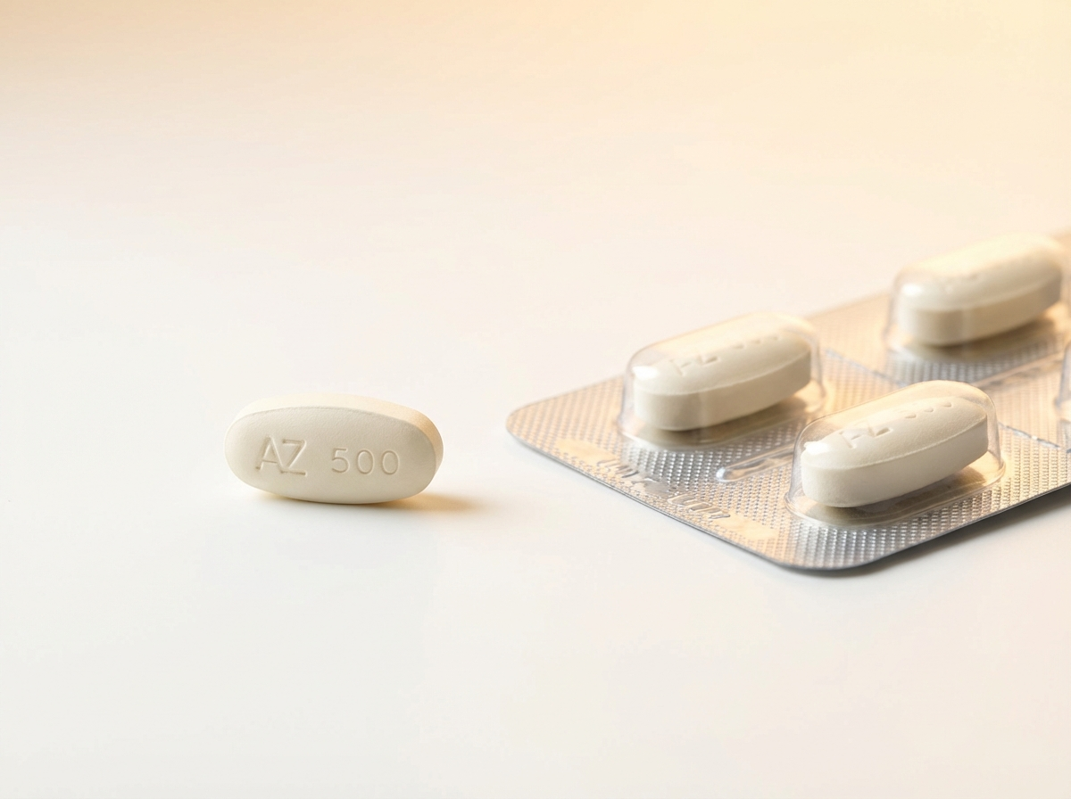
https://lumivex-images.pages.dev/card-dosing.jpeg
Card heading: Once-daily oral convenience
Card body: A single 6 mg tablet once daily, with or without food — no injection, no titration, no fasting requirement. Simplicity in a single oral dose.⁴
Card link: View dosing information → /lumivex/dosing
────────────────────────────────────────────────────────────

Section 3 — Disease context (centred text) | light background
Block: introduction | Section metadata: Style: light
Heading: The unmet need in plaque psoriasis
Body text: Plaque psoriasis affects approximately 1.8 million adults in the UK, with moderate-to-severe disease significantly impacting quality of life. Despite available treatments, many patients do not achieve or maintain adequate skin clearance — and concerns about injection burden, immunosuppression, and long-term safety remain barriers to treatment optimisation. There is a need for an effective oral therapy with a targeted mechanism and a well-characterised long-term safety profile.
────────────────────────────────────────────────────────────

Section 4 — Mechanism of action teaser (two-column) | highlighted background
Block: columns-teaser | Section metadata: Style: highlight

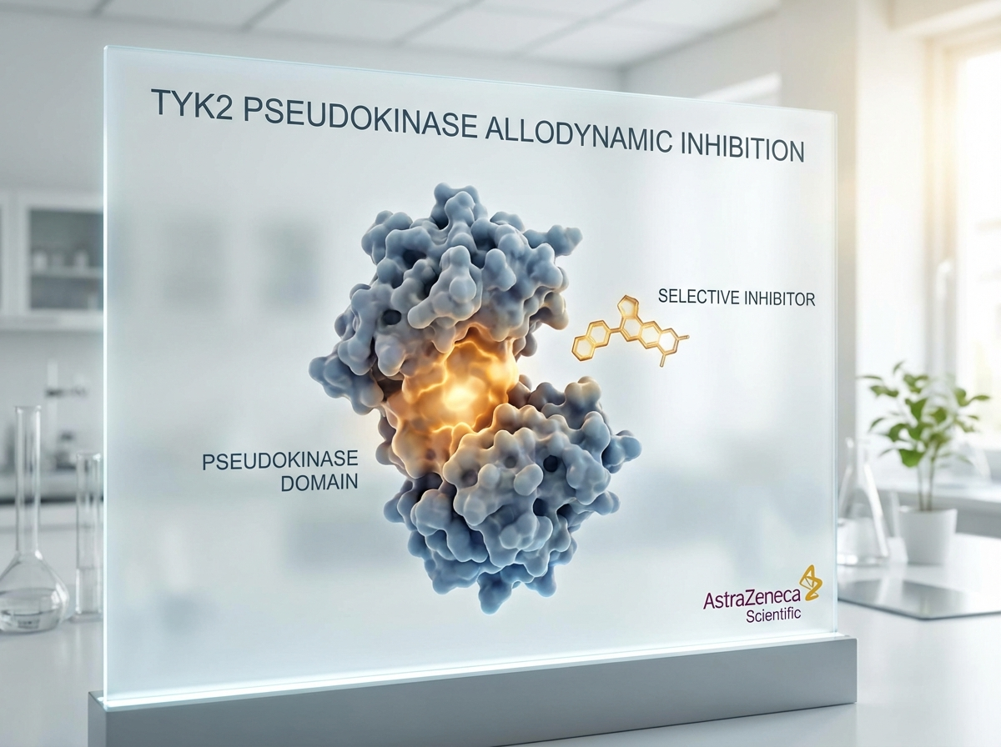
https://lumivex-images.pages.dev/columns-moa.jpeg
Heading: Selective TYK2 inhibition — a targeted approach
Body text: Lumvecitinib selectively binds the TYK2 pseudokinase (JH2) domain, inhibiting IL-23, IL-12, and type I IFN signalling without affecting JAK1/2/3-mediated pathways. This allosteric mechanism targets the key drivers of psoriatic inflammation while preserving broader immune surveillance.⁴
Call to action: Explore the mechanism of action → /lumivex/mechanism-of-action
────────────────────────────────────────────────────────────

Section 5 — Prescribing information footer
Block: accordion
Expandable sections for: Prescribing Information | Adverse Event Reporting | References (Use approved text from sections 5, 6, and 7 above)

Page metadata
Title: LUMIVEX® (lumvecitinib) | Selective TYK2 Inhibitor for Plaque Psoriasis | AstraZeneca UK
Description: LUMIVEX® (lumvecitinib) is a first-in-class selective allosteric TYK2 inhibitor for adults with moderate-to-severe plaque psoriasis. Explore efficacy, safety, and dosing information for UK healthcare professionals.

PAGE 2: Efficacy
URL path: /lumivex/efficacy
────────────────────────────────────────────────────────────

Section 1 — Hero (full-width image with text overlay)
Block: hero-teaser


https://lumivex-images.pages.dev/hero-efficacy.jpeg
Heading: Clinical evidence for LUMIVEX®
Body text: The LUMINANCE clinical programme evaluated lumvecitinib in three studies encompassing over 2,400 adults with moderate-to-severe plaque psoriasis, including head-to-head comparison with adalimumab and long-term data up to 148 weeks.¹⁻³
────────────────────────────────────────────────────────────

Section 2 — Programme overview (centred text) | light background
Block: introduction | Section metadata: Style: light
Heading: The LUMINANCE clinical programme
Body text: Lumvecitinib was evaluated in three studies: LUMINANCE-1 assessed skin clearance and quality-of-life improvement versus placebo; LUMINANCE-2 demonstrated superiority to adalimumab in biologic-naïve patients; and LUMINANCE-3, an open-label extension, confirmed sustained efficacy and long-term safety through 148 weeks of continuous treatment.¹⁻³
────────────────────────────────────────────────────────────

Section 3 — Clinical data (two tabs)
Block: tabs-large

Tab 1: "LUMINANCE-1: Skin clearance vs placebo"

https://lumivex-images.pages.dev/tab-luminance1.jpeg
Heading: Superior PASI 75 response versus placebo
Body text: In LUMINANCE-1, a 52-week randomised, double-blind, placebo-controlled trial in 1,020 adults with moderate-to-severe plaque psoriasis (BSA ≥10%, PASI ≥12, IGA ≥3), lumvecitinib 6 mg demonstrated significantly greater PASI 75 response versus placebo at Week 16, with sustained response through Week 52.¹
Data table:
Endpoint | Lumvecitinib 6 mg (n=510) | Placebo (n=510) | Difference (95% CI)
PASI 75 at Week 16 (primary) | 72.4% | 8.6% | 63.8% (58.9 to 68.7); P<0.001
PASI 90 at Week 16 | 48.1% | 3.2% | 44.9% (40.3 to 49.5); P<0.001
PASI 100 at Week 16 | 24.7% | 1.0% | 23.7% (19.8 to 27.6); P<0.001
IGA 0/1 at Week 16 | 54.3% | 7.1% | 47.2% (42.4 to 52.0); P<0.001
DLQI 0/1 at Week 16 | 41.8% | 5.9% | 35.9% (31.3 to 40.5); P<0.001

Footnote text: The primary endpoint was met with high statistical significance. PASI 90 and PASI 100 responses demonstrated deep skin clearance, and DLQI improvements confirmed meaningful quality-of-life benefit.¹
────────────────────────────────────────────────────────────
Tab 2: "LUMINANCE-2: Superiority vs adalimumab"
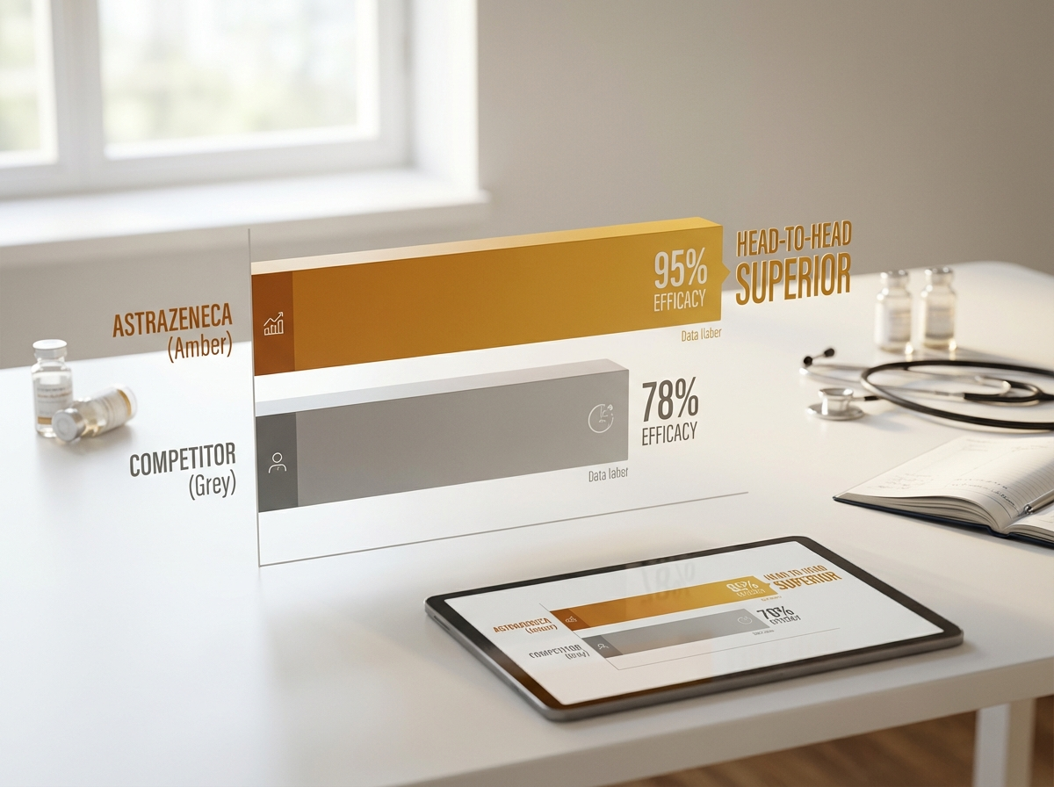
https://lumivex-images.pages.dev/tab-luminance2.jpeg
Heading: Superior to adalimumab at Week 16, with increasing benefit over time
Body text: In LUMINANCE-2, a 52-week randomised, double-blind, active-controlled trial in 1,428 biologic-naïve adults with moderate-to-severe plaque psoriasis, lumvecitinib 6 mg demonstrated superior PASI 90 response compared with adalimumab 40 mg at Week 16. The treatment difference increased further at Week 52, demonstrating durable superiority.²
Data table:
Endpoint | Lumvecitinib 6 mg (n=714) | Adalimumab 40 mg (n=714) | Difference (95% CI)
PASI 90 at Week 16 (primary) | 52.8% | 38.2% | 14.6% (9.5 to 19.7); P<0.001
PASI 75 at Week 16 | 78.1% | 65.4% | 12.7% (8.0 to 17.4); P<0.001
IGA 0/1 at Week 16 | 59.2% | 43.8% | 15.4% (10.4 to 20.4); P<0.001
PASI 90 at Week 52 | 61.4% | 34.7% | 26.7% (21.9 to 31.5); P<0.001
DLQI 0/1 at Week 52 | 52.1% | 28.9% | 23.2% (18.4 to 28.0); P<0.001

Footnote text: Lumvecitinib achieved superior skin clearance to adalimumab at Week 16, with the treatment difference widening at Week 52 — demonstrating both rapid onset and increasing efficacy over time.²
────────────────────────────────────────────────────────────

Section 4 — Long-term efficacy (two-column) | highlighted background
Block: columns-teaser | Section metadata: Style: highlight

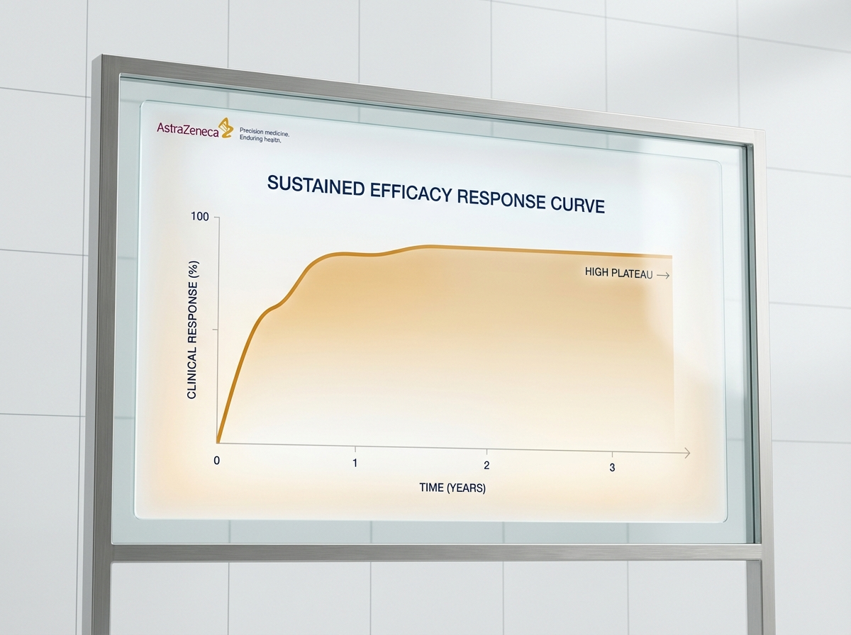
https://lumivex-images.pages.dev/columns-longterm.jpeg
Heading: Sustained response through 148 weeks in LUMINANCE-3
Body text: In the open-label extension study LUMINANCE-3, PASI 90 response was maintained in 67.3% of patients at Week 148 (observed cases), with no new safety signals identified over 3 years of continuous treatment. Quality-of-life benefit was sustained, with 52.6% of patients maintaining DLQI 0/1 at Week 148.³
Call to action: Review the full safety profile → /lumivex/safety
────────────────────────────────────────────────────────────

Section 5 — Prescribing information footer
Block: accordion | Expandable: PI | AE Reporting | References

Page metadata
Title: Efficacy | LUMIVEX® (lumvecitinib) | LUMINANCE Clinical Data | AstraZeneca UK
Description: Explore the LUMINANCE clinical programme for LUMIVEX® (lumvecitinib) — Phase III data on PASI 75/90/100 response, superiority vs adalimumab, and long-term efficacy up to 148 weeks in moderate-to-severe plaque psoriasis.

PAGE 3: Safety
URL path: /lumivex/safety
────────────────────────────────────────────────────────────

Section 1 — Page header (text only, no image)
Block: title
Heading: Safety profile
Body text: Lumvecitinib has been evaluated for safety in over 2,400 patients across the LUMINANCE clinical programme, including controlled and long-term open-label data up to 148 weeks.¹⁻³
────────────────────────────────────────────────────────────

Section 2 — Safety overview (centred text) | light background
Block: introduction | Section metadata: Style: light
Heading: A selective mechanism with a favourable tolerability profile
Body text: Lumvecitinib's selective allosteric TYK2 inhibition provides a distinct safety profile compared with non-selective JAK inhibitors. No dose-dependent cytopenias, no MACE signal, and no VTE signal were observed across the programme. The most commonly reported adverse events were upper respiratory tract infections and nasopharyngitis, consistent with the mild immunomodulatory profile expected from selective TYK2 blockade.¹⁻³
────────────────────────────────────────────────────────────

Section 3 — Three key safety consideration cards (equal columns)
Block: cards-teaser


https://lumivex-images.pages.dev/card-infections.jpeg
Card heading: Infection profile
Card body: URTI (8.4%) and nasopharyngitis (6.1%) were the most common adverse events. Serious infections occurred in 1.1% vs 0.9%. No opportunistic infections were reported in controlled trials. Herpes zoster occurred in 1.4%, all non-serious and dermatomal.¹⁻³
────────────────────────────────────────────────────────────
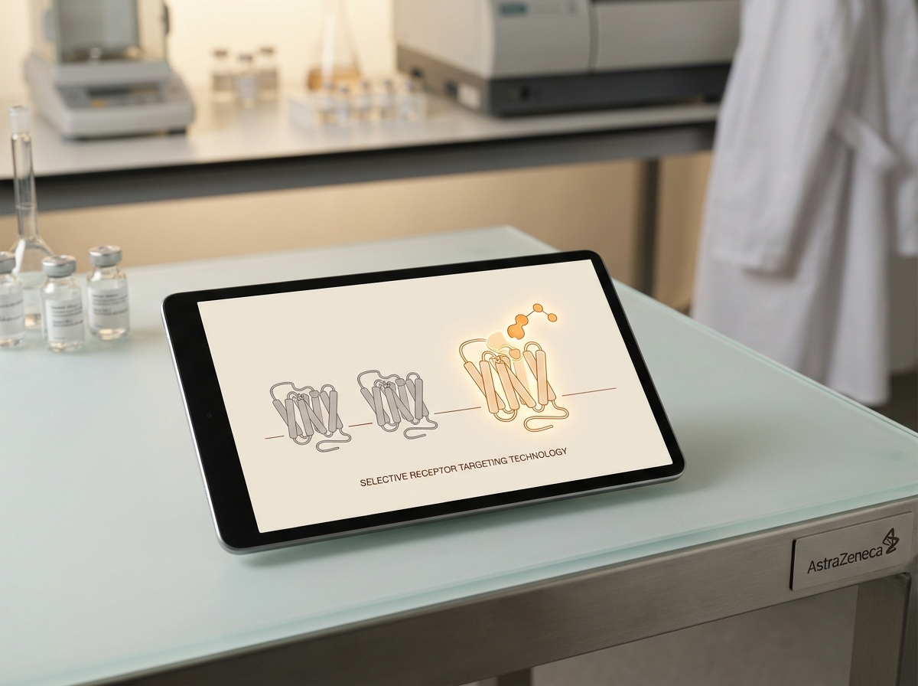
https://lumivex-images.pages.dev/card-selectivity.jpeg
Card heading: Selective TYK2 mechanism
Card body: No dose-dependent cytopenias observed — haemoglobin, neutrophil, lymphocyte, and platelet counts remained stable throughout treatment. This differentiates lumvecitinib from non-selective JAK inhibitors, reflecting its targeted allosteric mechanism.¹⁻³
────────────────────────────────────────────────────────────

https://lumivex-images.pages.dev/card-longterm-safety.jpeg
Card heading: Long-term safety (up to 148 weeks)
Card body: LUMINANCE-3 confirmed no new safety signals through 148 weeks. Serious infection rates remained stable (1.0–1.3/100 patient-years). No MACE or VTE signal. Malignancy rates comparable to the general psoriasis population. No increase in herpes zoster over time.³
────────────────────────────────────────────────────────────

Section 4 — Adverse event summary table | light background
Block: table-data | Section metadata: Style: light
Heading: Pooled adverse event data from the LUMINANCE programme¹⁻³
Adverse event | Lumvecitinib 6 mg (%) | Comparator (%)
Upper respiratory tract infection | 8.4 | 7.2
Nasopharyngitis | 6.1 | 5.8
Headache | 4.7 | 4.1
Acne | 3.9 | 0.8
Diarrhoea | 3.1 | 2.4
Herpes zoster | 1.4 | 0.6
CPK elevation (>5× ULN) | 1.2 | 0.5
Folliculitis | 1.1 | 0.4
ALT elevation (>3× ULN) | 0.8 | 0.4
────────────────────────────────────────────────────────────

Section 5 — Special populations (two-column) | highlighted background
Block: columns-teaser | Section metadata: Style: highlight


https://lumivex-images.pages.dev/columns-special-pops.jpeg
Heading: Special populations
Body text: Renal impairment: No dose adjustment is required for patients with mild or moderate renal impairment (eGFR ≥30 mL/min/1.73m²). Lumvecitinib has not been studied in patients with severe renal impairment (eGFR <30 mL/min/1.73m²).⁴
Hepatic impairment: No dose adjustment is required in mild hepatic impairment (Child-Pugh A). Lumvecitinib is not recommended in moderate (Child-Pugh B) or severe (Child-Pugh C) hepatic impairment.⁴
Elderly (≥65 years): No dose adjustment is required. Clinical experience in patients aged ≥75 years is limited; use with caution in this population.⁴
────────────────────────────────────────────────────────────

Section 6 — Prescribing information footer
Block: accordion | Expandable: PI | AE Reporting | References

Page metadata
Title: Safety | LUMIVEX® (lumvecitinib) | Adverse Events & Monitoring | AstraZeneca UK
Description: Review the safety profile of LUMIVEX® (lumvecitinib) including pooled adverse event data, infection rates, haematological safety, and long-term data up to 148 weeks in plaque psoriasis.

PAGE 4: Dosing & Administration
URL path: /lumivex/dosing
────────────────────────────────────────────────────────────

Section 1 — Page header (text only, no image)
Block: title
Heading: Dosing and administration
Body text: Lumvecitinib is prescribed at a fixed dose of 6 mg once daily — a simple oral regimen with no titration, no injection, and no fasting requirement.⁴
────────────────────────────────────────────────────────────

Section 2 — How to take LUMIVEX® (two-column) | light background
Block: columns-teaser | Section metadata: Style: light


https://lumivex-images.pages.dev/columns-admin.jpeg
Heading: How to take LUMIVEX®
Body text: Lumvecitinib 6 mg should be taken once daily, with or without food. The tablet should be swallowed whole with water.⁴
No dose titration is required. Treatment may be started at the full therapeutic dose of 6 mg from Day 1.⁴
If a dose is missed, the patient should take it as soon as they remember, unless it is almost time for the next dose. A double dose should not be taken to make up for a missed dose.⁴
────────────────────────────────────────────────────────────

Section 3 — Baseline and ongoing monitoring (two-column)
Block: columns-teaser


https://lumivex-images.pages.dev/columns-monitoring.jpeg
Heading: Monitoring recommendations
Body text: Prior to initiation: Evaluate for tuberculosis infection. Perform complete blood count (including absolute lymphocyte count, absolute neutrophil count, haemoglobin) and liver function tests. Ensure vaccinations are up to date, including herpes zoster vaccination where appropriate.⁴
During treatment: Monitor complete blood count and liver function tests periodically. Assess lipid parameters 12 weeks after initiation. Monitor for signs and symptoms of infection.⁴
Interruption: If a serious infection develops, interrupt treatment until the infection is controlled. Do not initiate treatment in patients with active serious infections.⁴
────────────────────────────────────────────────────────────

Section 4 — Use with other treatments (centred text) | highlighted background
Block: introduction | Section metadata: Style: highlight
Heading: Use with other psoriasis treatments
Body text: Lumvecitinib can be used as monotherapy or in combination with topical therapies (corticosteroids, vitamin D analogues). It is not recommended in combination with biological immunomodulators or other potent systemic immunosuppressants (e.g. ciclosporin, methotrexate at immunosuppressive doses) due to the possibility of additive immunosuppression. Avoid concomitant use with strong CYP3A4 inducers (e.g. rifampicin, phenytoin, carbamazepine, St John's Wort).⁴
────────────────────────────────────────────────────────────

Section 5 — Prescribing information footer
Block: accordion | Expandable: PI | AE Reporting | References

Page metadata
Title: Dosing | LUMIVEX® (lumvecitinib) | Administration & Monitoring | AstraZeneca UK
Description: Dosing and administration guidance for LUMIVEX® (lumvecitinib) 6 mg once-daily oral tablet, including monitoring recommendations and concomitant therapy guidance for plaque psoriasis.

PAGE 5: Mechanism of Action
URL path: /lumivex/mechanism-of-action
────────────────────────────────────────────────────────────

Section 1 — Hero (full-width image with text overlay)
Block: hero-teaser

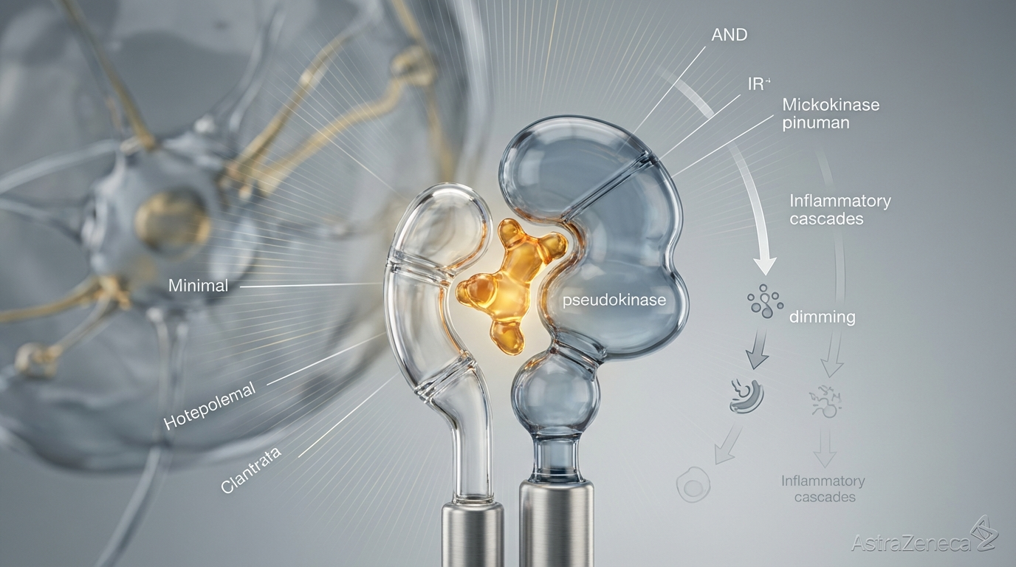
https://lumivex-images.pages.dev/hero-moa.jpeg
Heading: How LUMIVEX® works
Body text: Lumvecitinib is a selective allosteric TYK2 inhibitor that targets the pseudokinase (JH2) domain — blocking the IL-23, IL-12, and type I IFN signalling pathways that drive psoriatic inflammation, while preserving JAK1/2/3-mediated immune homeostasis.⁴
────────────────────────────────────────────────────────────

Section 2 — The psoriatic inflammatory cascade (two-column) | light background
Block: columns-teaser | Section metadata: Style: light

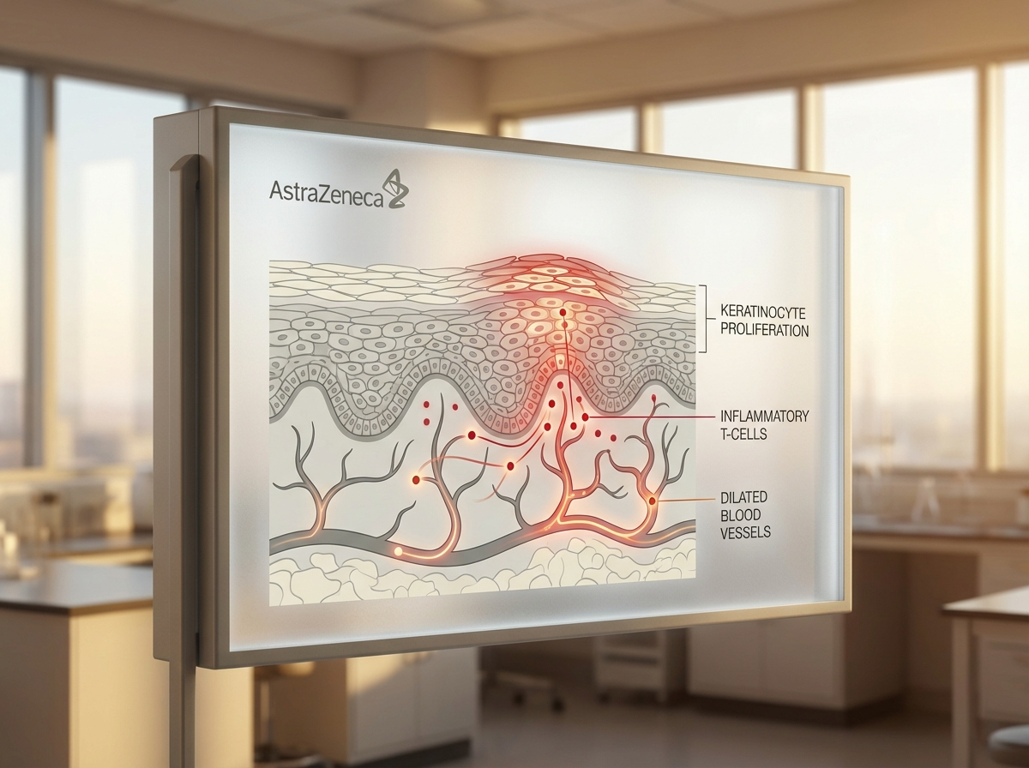
https://lumivex-images.pages.dev/psoriatic-inflammation.jpeg
Heading: The psoriatic inflammatory cascade
Body text: Plaque psoriasis is driven by a dysregulated immune response in which dendritic cells produce IL-23, activating T-helper 17 (Th17) cells to release IL-17A, IL-17F, and IL-22. These cytokines drive keratinocyte hyperproliferation, neutrophil recruitment, and the characteristic epidermal thickening, scaling, and erythema of psoriatic plaques. IL-12 further promotes Th1 cell differentiation and IFN-γ production, amplifying the inflammatory loop.⁴
────────────────────────────────────────────────────────────

Section 3 — The IL-23/TYK2 signalling axis (two-column)
Block: columns-teaser

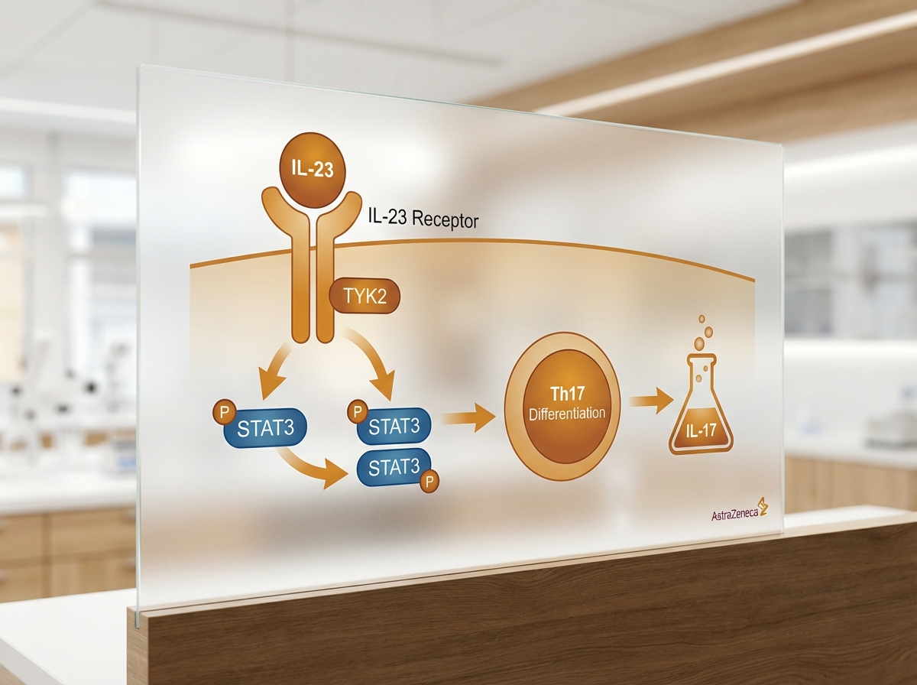
https://lumivex-images.pages.dev/tyk2-il23-cascade.jpeg
Heading: TYK2: a central kinase in psoriatic signalling
Body text: TYK2 is an intracellular kinase that mediates signal transduction downstream of the IL-23 receptor (paired with JAK2), the IL-12 receptor (paired with JAK2), and type I interferon receptors (paired with JAK1). When IL-23 binds its receptor, TYK2 phosphorylates STAT3, driving Th17 cell differentiation and IL-17 production — the central effector axis in plaque psoriasis. TYK2 genetic loss-of-function variants in humans are associated with protection from psoriasis, confirming TYK2 as a validated therapeutic target.⁴
────────────────────────────────────────────────────────────

Section 4 — Selective allosteric TYK2 inhibition (two-column) | highlighted background
Block: columns-teaser | Section metadata: Style: highlight

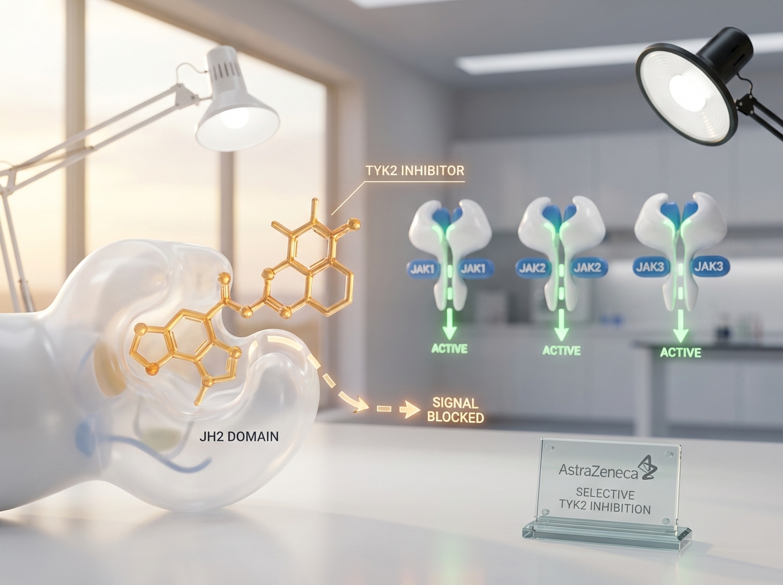
https://lumivex-images.pages.dev/lumivex-blockade.jpeg
Heading: How lumvecitinib selectively targets TYK2
Body text: Lumvecitinib binds to the pseudokinase (JH2) regulatory domain of TYK2, stabilising the enzyme in an inactive conformation. This allosteric mechanism is fundamentally different from ATP-competitive JAK inhibitors that bind the catalytic (JH1) domain shared across all four JAK family members.⁴
Because the JH2 domain is structurally unique to TYK2, lumvecitinib achieves >100-fold selectivity for TYK2 over JAK1, JAK2, and JAK3. This preserves JAK1-mediated cytokine signalling (e.g. IL-6, IFN-γ receptor), JAK2-mediated haematopoiesis (erythropoietin, thrombopoietin), and JAK3-mediated lymphocyte development — explaining the absence of dose-dependent cytopenias and the favourable tolerability profile observed in the LUMINANCE programme.¹⁻⁴
────────────────────────────────────────────────────────────

Section 5 — Prescribing information footer
Block: accordion | Expandable: PI | AE Reporting | References

Page metadata
Title: Mechanism of Action | LUMIVEX® (lumvecitinib) | TYK2 Inhibition | AstraZeneca UK
Description: Understand how LUMIVEX® (lumvecitinib) works — selective allosteric TYK2 inhibition targeting the IL-23/Th17 axis in plaque psoriasis while preserving JAK1/2/3-mediated immune homeostasis.

PAGE 6: Resources
URL path: /lumivex/resources
────────────────────────────────────────────────────────────

Section 1 — Page header (text only, no image)
Block: title
Heading: Resources
Body text: Access prescribing guides, patient materials, and clinical data summaries to support your practice.
────────────────────────────────────────────────────────────

Section 2 — Three resource cards (equal columns) | light background
Block: cards-teaser | Section metadata: Style: light

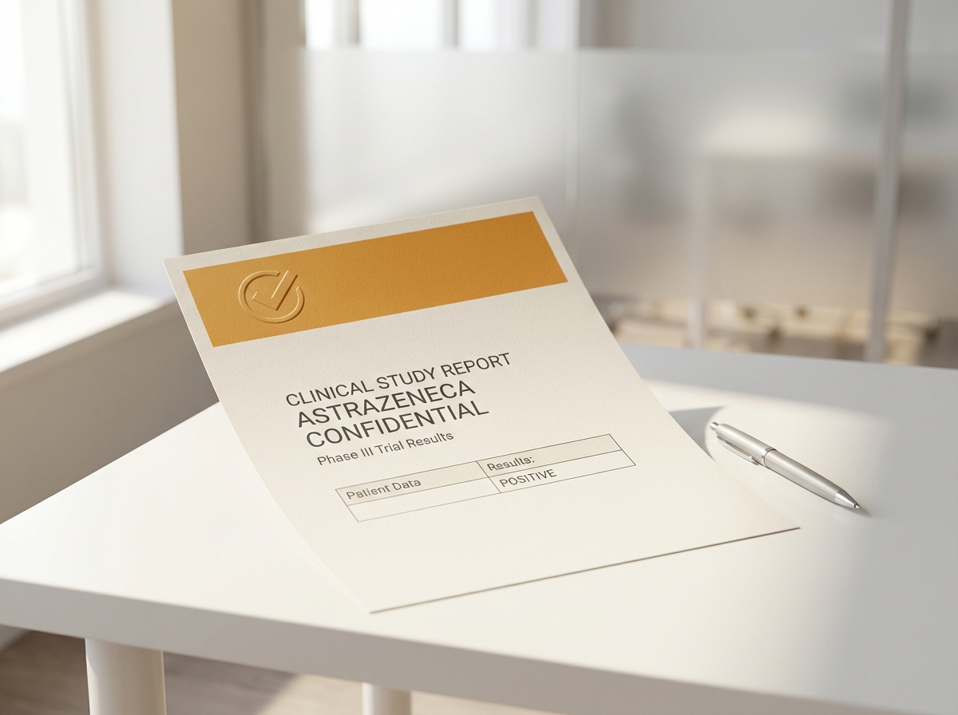
https://lumivex-images.pages.dev/card-prescribing.jpeg
Card heading: Prescribing guide
Card body: A concise guide covering indication, dosing, contraindications, monitoring requirements, and key safety information for LUMIVEX®. Designed for quick reference in clinical practice.
Card link: Download prescribing guide → /lumivex/resources
────────────────────────────────────────────────────────────

https://lumivex-images.pages.dev/card-patient-guide.jpeg
Card heading: Patient guide
Card body: A patient-friendly guide explaining how to take LUMIVEX®, what to expect during the first weeks of treatment, and when to contact their healthcare professional. Available to share during consultations.
Card link: Download patient guide → /lumivex/resources
────────────────────────────────────────────────────────────
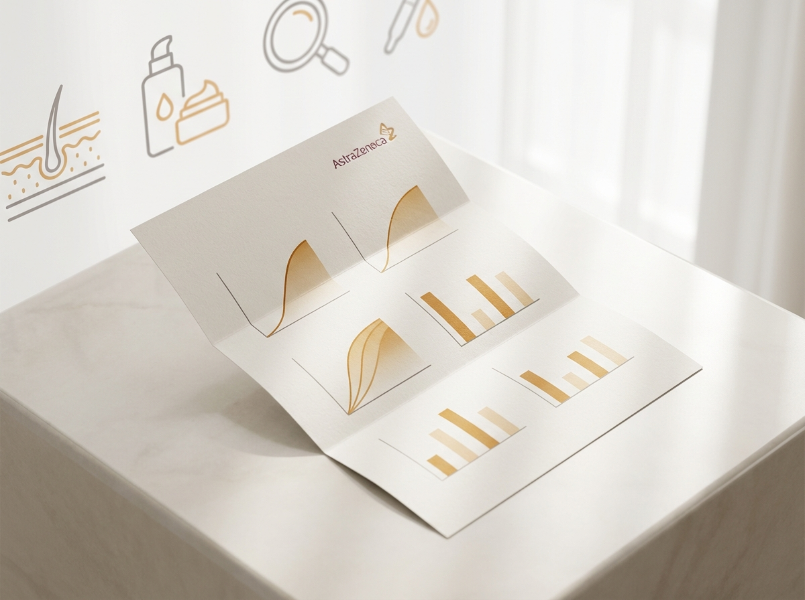
https://lumivex-images.pages.dev/card-clinical-data.jpeg
Card heading: LUMINANCE clinical data summary
Card body: A comprehensive summary of key efficacy and safety data from the LUMINANCE-1, LUMINANCE-2, and LUMINANCE-3 studies, including primary and secondary endpoint results and long-term data.
Card link: Download clinical data summary → /lumivex/resources
────────────────────────────────────────────────────────────

Section 3 — Medical information contact (two-column) | highlighted background
Block: columns-teaser | Section metadata: Style: highlight


https://lumivex-images.pages.dev/contact-support.jpeg
Heading: Need further information?
Body text: For medical information enquiries about LUMIVEX® (lumvecitinib), please contact AstraZeneca Medical Information:
Online: contactazmedical.astrazeneca.com
Telephone: 0800 783 0033
Our medical information team is available to support healthcare professionals with clinical questions, requests for published data, and product-related enquiries.
────────────────────────────────────────────────────────────

Section 4 — Prescribing information footer
Block: accordion | Expandable: PI | AE Reporting | References

Page metadata
Title: Resources | LUMIVEX® (lumvecitinib) | Prescribing & Patient Guides | AstraZeneca UK
Description: Download prescribing guides, patient materials, and clinical data summaries for LUMIVEX® (lumvecitinib) to support clinical decision-making in moderate-to-severe plaque psoriasis.

10. Footer Content
Row 1 — Brand: AstraZeneca logo | GB-94281 | DOP: March 2026 | © 2026 AstraZeneca. All rights reserved.
Row 2 — Site links: Efficacy | Safety | Dosing | Mechanism of Action | Resources
Row 3 — Regulatory links: Report Adverse Event (https://yellowcard.mhra.gov.uk/) | Medical Information (https://contactazmedical.astrazeneca.com/) | Privacy Policy (https://www.astrazeneca.co.uk/our-company/privacy-notice.html) | Terms of Use (https://www.astrazeneca.co.uk/our-company/terms-of-use.html) | Accessibility (https://www.astrazeneca.co.uk/accessibility.html)
Row 4 — Date: Date of Preparation: March 2026
────────────────────────────────────────────────────────────

11. Image Assets
All images are available on CDN at https://lumivex-images.pages.dev/

# | Filename | Dimensions | CDN URL | Used on
1 | hero-home.jpeg | 1440×810 | https://lumivex-images.pages.dev/hero-home.jpeg | Home — hero
2 | hero-efficacy.jpeg | 1440×810 | https://lumivex-images.pages.dev/hero-efficacy.jpeg | Efficacy — hero
3 | hero-moa.jpeg | 1440×810 | https://lumivex-images.pages.dev/hero-moa.jpeg | Mechanism of Action — hero
4 | card-efficacy.jpeg | 800×600 | https://lumivex-images.pages.dev/card-efficacy.jpeg | Home — benefit card
5 | card-safety.jpeg | 800×600 | https://lumivex-images.pages.dev/card-safety.jpeg | Home — benefit card
6 | card-dosing.jpeg | 800×600 | https://lumivex-images.pages.dev/card-dosing.jpeg | Home — benefit card
7 | columns-moa.jpeg | 800×600 | https://lumivex-images.pages.dev/columns-moa.jpeg | Home — MoA teaser
8 | tab-luminance1.jpeg | 800×600 | https://lumivex-images.pages.dev/tab-luminance1.jpeg | Efficacy — LUMINANCE-1 tab
9 | tab-luminance2.jpeg | 800×600 | https://lumivex-images.pages.dev/tab-luminance2.jpeg | Efficacy — LUMINANCE-2 tab
10 | columns-longterm.jpeg | 800×600 | https://lumivex-images.pages.dev/columns-longterm.jpeg | Efficacy — long-term data
11 | card-infections.jpeg | 800×600 | https://lumivex-images.pages.dev/card-infections.jpeg | Safety — infection card
12 | card-selectivity.jpeg | 800×600 | https://lumivex-images.pages.dev/card-selectivity.jpeg | Safety — selectivity card
13 | card-longterm-safety.jpeg | 800×600 | https://lumivex-images.pages.dev/card-longterm-safety.jpeg | Safety — long-term card
14 | columns-special-pops.jpeg | 800×600 | https://lumivex-images.pages.dev/columns-special-pops.jpeg | Safety — special populations
15 | columns-admin.jpeg | 800×600 | https://lumivex-images.pages.dev/columns-admin.jpeg | Dosing — administration
16 | columns-monitoring.jpeg | 800×600 | https://lumivex-images.pages.dev/columns-monitoring.jpeg | Dosing — monitoring
17 | psoriatic-inflammation.jpeg | 800×600 | https://lumivex-images.pages.dev/psoriatic-inflammation.jpeg | MoA — disease pathway
18 | tyk2-il23-cascade.jpeg | 800×600 | https://lumivex-images.pages.dev/tyk2-il23-cascade.jpeg | MoA — TYK2 cascade
19 | lumivex-blockade.jpeg | 800×600 | https://lumivex-images.pages.dev/lumivex-blockade.jpeg | MoA — drug mechanism
20 | card-prescribing.jpeg | 800×600 | https://lumivex-images.pages.dev/card-prescribing.jpeg | Resources — prescribing guide
21 | card-patient-guide.jpeg | 800×600 | https://lumivex-images.pages.dev/card-patient-guide.jpeg | Resources — patient guide
22 | card-clinical-data.jpeg | 800×600 | https://lumivex-images.pages.dev/card-clinical-data.jpeg | Resources — clinical data
23 | contact-support.jpeg | 800×600 | https://lumivex-images.pages.dev/contact-support.jpeg | Resources — contact

Shared assets (also on CDN):
• AstraZeneca logo: https://lumivex-images.pages.dev/astrazeneca-logo.png
• Search icon: https://lumivex-images.pages.dev/search.svg

GB-94281 | DOP: March 2026 | © 2026 AstraZeneca. All rights reserved.

