KLERA®
(klerafistat)

Website Briefing

Clearing the path to liver health.

Document type: Final approved marketing brief for HCP website build
Prepared by: Marketing — UK Metabolic & Hepatology Franchise
Approval status: MLR-approved copy — do not modify
Date: March 2026
Approval code: GB-13402 | DOP: March 2026

Contents
1. Drug Profile
2. Mechanism of Action
3. Clinical Programme: CLARITY
4. Safety Profile
5. Prescribing Information
6. Adverse Event Reporting
7. References
8. Site Navigation
9. Page Content
Page 1: Home
Page 2: Understanding MASH
Page 3: CLARITY Data
Page 4: How KLERA Works
Page 5: Safety, Dosing & Monitoring
Page 6: HCP Resources & Support
10. Footer Content
11. Image Assets

1. Drug Profile
Field | Detail
Brand name | KLERA®
Generic name | klerafistat
Drug class | Selective oral thyroid hormone receptor beta (THR-β) agonist
Indication | Treatment of adults with non-cirrhotic metabolic dysfunction-associated steatohepatitis (MASH) with moderate to advanced liver fibrosis (stage F2 or F3)
Biomarker context | Diagnosis confirmed by liver biopsy or validated non-invasive assessment (FibroScan® ≥8 kPa with NAS ≥4, or ELF ≥9.8)
Formulation | 80 mg and 100 mg film-coated tablets
Dosing | 80 mg once daily for the first 3 months, then 100 mg once daily thereafter
Approval | MHRA — January 2026
Brand colour | Forest Green #2E7D32
Accent colour | Warm Amber #D4851F
Approval code | GB-13402

KLERA brand rule: KLERA always appears in capitals, with ® on first mention per page. Generic name (klerafistat) appears in lowercase parentheses on first mention. The approved tagline "Clearing the path to liver health." may only be used verbatim — no variations permitted.
────────────────────────────────────────────────────────────

2. Mechanism of Action
Klerafistat is a liver-directed, selective agonist of thyroid hormone receptor beta (THR-β), the predominant thyroid hormone receptor isoform expressed in hepatocytes. THR-β activation in the liver regulates key metabolic processes including hepatic lipid metabolism, cholesterol homeostasis, and mitochondrial β-oxidation of fatty acids.
In MASH, hepatic steatosis (fat accumulation) drives lipotoxicity, oxidative stress, hepatocyte injury, and progressive inflammation leading to fibrogenesis. Current standard of care (lifestyle modification, weight loss) achieves histological improvement in a minority of patients, and no pharmacological therapy with a liver fibrosis endpoint had been approved in the UK prior to klerafistat.¹ ²
By selectively activating THR-β in the liver, klerafistat produces the following effects:
- Increased mitochondrial β-oxidation of hepatic free fatty acids, reducing intrahepatic triglyceride content
- Enhanced LDL receptor expression on hepatocytes, lowering circulating LDL-cholesterol
- Reduced de novo lipogenesis via suppression of SREBP-1c and ACC activity
- Decreased hepatic lipotoxic lipid species (diacylglycerols, ceramides), reducing hepatocyte injury signals
- Attenuation of hepatic stellate cell activation and collagen deposition through reduced lipotoxicity-driven inflammation
Critically, klerafistat achieves >30-fold selectivity for THR-β over THR-α, the isoform predominant in the heart and bone. This selectivity avoids the cardiac (tachycardia, arrhythmia) and skeletal (bone loss) effects of non-selective thyroid hormone action, enabling chronic therapeutic use.¹ ² ⁵
────────────────────────────────────────────────────────────

3. Clinical Programme: CLARITY

CLARITY-FIBROSIS (Phase III, pivotal — Fibrosis improvement in MASH)
Design: Randomised, double-blind, placebo-controlled Phase III trial
Population: 966 adults with biopsy-confirmed MASH (NAS ≥4 with each component ≥1) and liver fibrosis stage F2 or F3, with or without type 2 diabetes
Duration: 52 weeks on treatment with paired liver biopsies at baseline and Week 52
Primary endpoint: Proportion achieving ≥1-stage improvement in liver fibrosis without worsening of MASH (NAS) at Week 52
Key secondary endpoints: MASH resolution (ballooning 0, inflammation 0–1) without worsening of fibrosis; combined endpoint (≥1-stage fibrosis improvement AND MASH resolution); change in liver fat by MRI-PDFF; change in LDL-cholesterol; change in ELF score
Publication: Sanyal et al. N Engl J Med 2025; 393(4): 312–326

Key results:
Endpoint | KLERA 100 mg (n=483) | Placebo (n=483) | Treatment effect
≥1-stage fibrosis improvement without MASH worsening (primary) | 37.1% | 14.5% | Δ 22.6% (17.2–28.0); P<0.001
MASH resolution without fibrosis worsening | 44.2% | 16.8% | Δ 27.4% (21.8–33.0); P<0.001
Combined: fibrosis improvement + MASH resolution | 25.4% | 6.8% | Δ 18.6% (14.1–23.1); P<0.001
Liver fat reduction (MRI-PDFF, relative change) | −52.3% | −10.4% | P<0.001
LDL-cholesterol change at Week 52 | −18.7% | +1.2% | P<0.001
ELF score change at Week 52 | −0.72 | −0.08 | P<0.001
≥2-stage fibrosis improvement | 12.8% | 3.1% | Δ 9.7% (6.5–12.9); P<0.001

CLARITY-RESOLVE (Phase III — MASH resolution with metabolic benefits)
Design: Randomised, double-blind, placebo-controlled Phase III trial
Population: 748 adults with biopsy-confirmed MASH (NAS ≥4) and fibrosis stage F1–F3, with type 2 diabetes (HbA1c 7.0–10.0%)
Duration: 52 weeks on treatment with paired liver biopsies
Primary endpoint: MASH resolution (ballooning 0, inflammation 0–1) without worsening of fibrosis at Week 52
Key secondary endpoints: Fibrosis improvement ≥1 stage; combined endpoint; HbA1c change; body weight change; liver fat reduction; triglyceride and VLDL-cholesterol change
Publication: Harrison et al. Lancet 2026; 407(10321): 218–232

Key results:
Endpoint | KLERA 100 mg (n=374) | Placebo (n=374) | Treatment effect
MASH resolution without fibrosis worsening (primary) | 48.9% | 18.4% | Δ 30.5% (24.1–36.9); P<0.001
≥1-stage fibrosis improvement | 34.8% | 15.0% | Δ 19.8% (13.8–25.8); P<0.001
Combined: fibrosis improvement + MASH resolution | 24.6% | 7.5% | Δ 17.1% (12.2–22.0); P<0.001
Liver fat reduction (MRI-PDFF) | −58.1% | −12.8% | P<0.001
HbA1c change at Week 52 | −0.42% | −0.06% | Δ −0.36%; P<0.001
Body weight change | −2.4 kg | −0.3 kg | Δ −2.1 kg; P<0.001
Triglycerides change | −24.6% | −3.8% | P<0.001
LDL-cholesterol change | −16.9% | +0.8% | P<0.001
────────────────────────────────────────────────────────────

4. Safety Profile (Pooled CLARITY data, N=857 KLERA)

Most common adverse events (≥5%)
Adverse event | KLERA (%) | Placebo (%)
Diarrhoea | 26.4 | 12.1
Nausea | 18.7 | 8.3
Abdominal pain | 9.1 | 5.4
Weight loss | 7.8 | 2.1
Headache | 6.4 | 5.8
Fatigue | 5.9 | 4.2
Nasopharyngitis | 5.6 | 5.4

Thyroid and cardiac safety
Consistent with selective THR-β agonism, klerafistat produced modest reductions in serum TSH (median nadir −0.8 mIU/L at Week 12, stabilising within normal range in >94% of patients) and total T4 levels without clinically meaningful effects on free T4 or T3. No cases of clinical hyperthyroidism or thyrotoxicosis were reported.³
Cardiac safety was assessed by 24-hour Holter monitoring at Weeks 12 and 52 in a pre-specified sub-study (n=204). Mean resting heart rate increased by 1.8 bpm with KLERA vs 0.2 bpm placebo. No clinically significant arrhythmias, QTc prolongation, or MACE signal was observed. Atrial fibrillation occurred in 0.6% KLERA vs 0.5% placebo.³

Hepatic safety
Transient ALT elevations >3× ULN occurred in 3.8% of KLERA patients vs 1.9% placebo, predominantly during the dose-escalation phase (Weeks 1–12). These were asymptomatic, not associated with bilirubin elevation, and resolved with continued dosing in the majority of cases. No cases of drug-induced liver injury (DILI), Hy’s Law, or liver failure were observed. One patient (0.1%) discontinued due to persistent ALT elevation.³
Hepatic monitoring: Assess ALT, AST, alkaline phosphatase, and bilirubin before initiation, monthly for the first 3 months (dose-escalation phase), then every 3 months during maintenance.³

Gastrointestinal events
Diarrhoea (26.4%) and nausea (18.7%) were the most common adverse events, predominantly grade 1–2. Grade ≥3 diarrhoea occurred in 2.8% vs 0.6% placebo. GI events were most frequent during the first 4 weeks and typically self-limited. Dose-escalation from 80 mg to 100 mg at Month 3 was designed to mitigate GI intolerance. Treatment discontinuation due to GI events was 2.1%.³

Key safety findings
Serious adverse events: 7.2% KLERA vs 8.4% placebo
Treatment discontinuation due to AEs: 5.6% vs 3.4% (GI events 2.1%, ALT elevation 0.1%)
All-cause mortality: 0.1% vs 0.2% (no drug-related deaths)
MACE (adjudicated): 0.8% vs 0.7% (no signal; independent adjudication committee confirmed no cardiac safety concern)
Bone density (DXA at Week 52): No significant change in lumbar spine or femoral neck BMD with KLERA vs placebo, consistent with THR-β selectivity and sparing of THR-α in bone³
Gallbladder events: Cholelithiasis 1.6% vs 0.8%. Cholecystitis 0.5% vs 0.2%. Consistent with increased hepatic cholesterol clearance³

Special populations
- Type 2 diabetes: 58% of CLARITY-FIBROSIS and 100% of CLARITY-RESOLVE patients had T2D. HbA1c improved by 0.36% vs placebo. Hypoglycaemia was not increased. No dose adjustment for concurrent metformin, SGLT2 inhibitors, or GLP-1 RAs.³
- Elderly (≥65 years): 24% of pooled population. Efficacy and safety consistent with overall population. Increased GI sensitivity was observed (≥5% higher diarrhoea incidence). No dose adjustment required.³
- Renal impairment: No dose adjustment for eGFR ≥30 mL/min/1.73m². Not studied in eGFR <30.³
- Hepatic impairment: Indicated only in non-cirrhotic MASH (F2–F3). Contraindicated in decompensated cirrhosis (Child-Pugh B or C). Not studied in Child-Pugh A cirrhosis.³
- Pregnancy and lactation: Contraindicated in pregnancy. Animal studies showed embryofetal toxicity at supratherapeutic doses. Women of childbearing potential must use effective contraception during treatment and for 1 month after the last dose. Discontinue breastfeeding during treatment.³
────────────────────────────────────────────────────────────

5. Prescribing Information (abbreviated — for every page footer)
KLERA (klerafistat) 80 mg and 100 mg film-coated tablets. Please refer to the Summary of Product Characteristics (SmPC) before prescribing. Indication: Treatment of adults with non-cirrhotic metabolic dysfunction-associated steatohepatitis (MASH) with moderate to advanced liver fibrosis (stage F2 or F3). Dosage and administration: 80 mg once daily for the first 3 months, then 100 mg once daily, taken with food. Swallow whole; do not crush or chew. Contraindications: Hypersensitivity to klerafistat or excipients; pregnancy; decompensated cirrhosis (Child-Pugh B or C); active thyrotoxicosis. Warnings and precautions: Hepatotoxicity: Monitor LFTs before initiation, monthly for 3 months, then every 3 months. Gastrointestinal: Dose escalation designed to mitigate GI effects. Thyroid function: Monitor TSH at baseline and if clinically indicated. Gallbladder: Increased risk of cholelithiasis. Interactions: No clinically significant CYP interactions identified. Caution with bile acid sequestrants (cholestyramine, colesevelam): may reduce klerafistat absorption; administer KLERA ≥4 hours before or 4 hours after bile acid sequestrants. Caution with statins: additive LDL-lowering effect; monitor for myopathy. Side effects: Very common (≥1/10): diarrhoea, nausea. Common (≥1/100 to <1/10): abdominal pain, weight loss, headache, fatigue, ALT increased, cholelithiasis. Uncommon (≥1/1000 to <1/100): cholecystitis, TSH suppression. Legal category: POM. Pack and price: 28 tablets (80 mg): £476.00; 28 tablets (100 mg): £476.00. Marketing authorisation holder: AstraZeneca UK Ltd. MA number: PLGB 17901/0756. Full prescribing information available from: AstraZeneca UK Ltd, 2 Pancras Square, London N1C 4AG. GB-13402 | DOP: March 2026.
────────────────────────────────────────────────────────────

6. Adverse Event Reporting (for every page footer)
Adverse events should be reported. Reporting forms and information can be found at www.mhra.gov.uk/yellowcard or search for MHRA Yellow Card in the Google Play or Apple App Store. Adverse events should also be reported to AstraZeneca by visiting contactazmedical.astrazeneca.com or by calling 0800 783 0033.
────────────────────────────────────────────────────────────

7. References (for every page footer)
1. Sanyal et al. N Engl J Med 2025; 393(4): 312–326.
2. Harrison et al. Lancet 2026; 407(10321): 218–232.
3. KLERA (klerafistat) Summary of Product Characteristics. AstraZeneca UK Ltd. January 2026.
4. Younossi ZM, et al. Hepatology 2023; 77(4): 1335–1347.
5. Harrison SA, et al. N Engl J Med 2023; 389(13): 1169–1180.
────────────────────────────────────────────────────────────

8. Site Navigation
Top bar links: Contact Us (https://www.astrazeneca.co.uk/contact-us.html) | AZ Employee Login (https://login.astrazeneca.com)
Main navigation pages: Understanding MASH | CLARITY Data | How KLERA Works | Safety, Dosing & Monitoring | HCP Resources & Support
Utility: Search | Login

9. Page Content
IMPORTANT: All copy below is final and MLR-approved. It must be used exactly as written — do not modify, rephrase, or abbreviate any text. All superscript reference numbers, statistical values, and regulatory language must be reproduced verbatim.
Each page must end with expandable sections for Prescribing Information, Adverse Event Reporting, and References (see sections 5, 6, and 7 above).
KLERA brand rule: KLERA always appears in capitals, with ® on first mention per page. Generic name (klerafistat) in lowercase parentheses on first mention. Tagline "Clearing the path to liver health." verbatim only.
────────────────────────────────────────────────────────────

PAGE 1: Home
URL path: /klera/
────────────────────────────────────────────────────────────

Section 1 — Hero (full-width image with text overlay)
Block: hero-teaser


https://velox-images.pages.dev/hero-home.jpeg
Usage: Home — hero
Heading: KLERA® (klerafistat)
Body text: The first oral therapy approved to improve liver fibrosis in non-cirrhotic MASH. 37% of patients achieved fibrosis improvement at one year, with concomitant reductions in liver fat, LDL-cholesterol, and HbA1c. Clearing the path to liver health.¹
Call to action: Explore the CLARITY data → /klera/clarity-data
────────────────────────────────────────────────────────────

Section 2 — Three key benefit cards (equal columns)
Block: cards-teaser


https://velox-images.pages.dev/card-stroke.jpeg
Usage: Home — fibrosis improvement card
Card heading: 37% achieved fibrosis improvement
Card body: In CLARITY-FIBROSIS, 37.1% of patients achieved ≥1-stage fibrosis improvement without worsening of MASH at Week 52, compared with 14.5% placebo (Δ 22.6%; P<0.001). This is the first pharmacotherapy to demonstrate a fibrosis endpoint in a Phase III MASH trial.¹
Card link: View CLARITY data → /klera/clarity-data
────────────────────────────────────────────────────────────

https://velox-images.pages.dev/card-bleeding.jpeg
Usage: Home — MASH resolution card
Card heading: 49% achieved MASH resolution
Card body: In CLARITY-RESOLVE, 48.9% of patients with MASH and type 2 diabetes achieved histological MASH resolution without fibrosis worsening at Week 52, compared with 18.4% placebo (Δ 30.5%; P<0.001).²
Card link: Explore MASH resolution data → /klera/clarity-data
────────────────────────────────────────────────────────────

https://velox-images.pages.dev/card-dosing.jpeg
Usage: Home — oral once-daily card
Card heading: Oral once-daily with metabolic benefits
Card body: One tablet once daily with food. Beyond liver histology, KLERA reduced LDL-cholesterol by 19%, lowered triglycerides by 25%, and improved HbA1c by 0.36% in patients with type 2 diabetes — addressing the cardiometabolic comorbidities of MASH.¹ ² ³
Card link: View dosing information → /klera/safety-dosing-monitoring
────────────────────────────────────────────────────────────

Section 3 — MoA teaser (two-column: image left, text right) | highlight background
Block: columns-teaser
Section metadata: Style: highlight

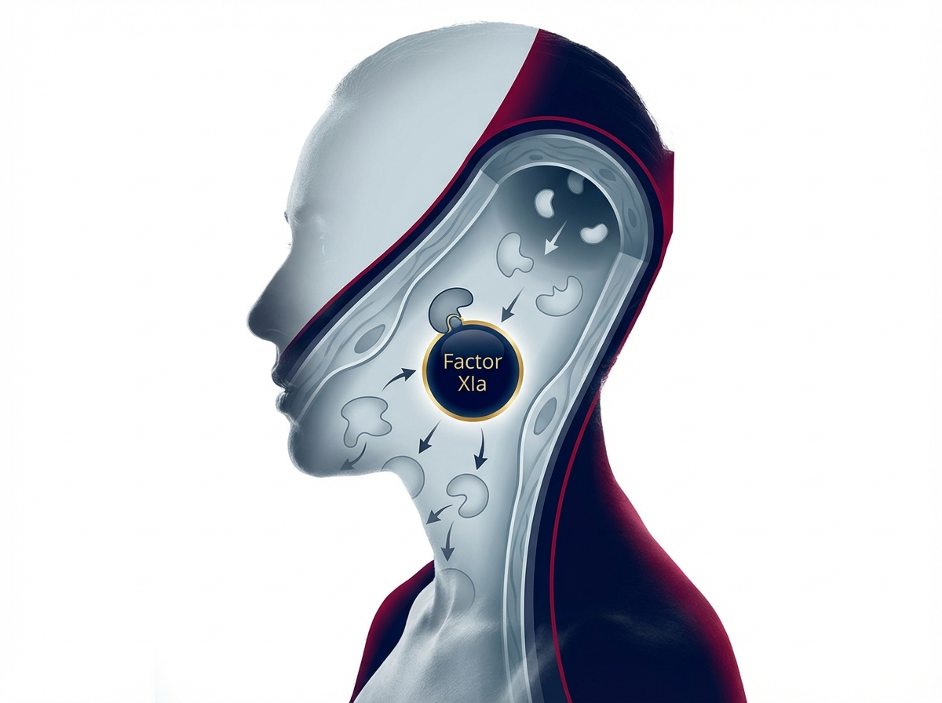
https://velox-images.pages.dev/columns-moa-preview.jpeg
Usage: Home — MoA teaser
Heading: Harnessing thyroid hormone biology to reverse liver damage
Body text: THR-β is the predominant thyroid hormone receptor in the liver. By selectively activating THR-β, KLERA enhances hepatic fat oxidation, reduces lipotoxicity, and attenuates fibrogenesis — without the cardiac and bone effects of non-selective thyroid hormone action.³ ⁵
Call to action: Explore how KLERA works → /klera/how-klera-works
────────────────────────────────────────────────────────────

Section 4 — Prescribing information footer
Block: accordion
Expandable sections for: Prescribing Information | Adverse Event Reporting | References

Page metadata
Title: KLERA (klerafistat) | Oral Treatment for MASH Liver Fibrosis | AstraZeneca UK
Description: KLERA (klerafistat) is the first oral THR-β agonist approved for non-cirrhotic MASH with liver fibrosis. Explore CLARITY clinical data, mechanism of action, and dosing for UK healthcare professionals.

PAGE 2: Understanding MASH
URL path: /klera/understanding-mash
────────────────────────────────────────────────────────────

Section 1 — Hero (full-width image with text overlay)
Block: hero-teaser


https://velox-images.pages.dev/hero-efficacy.jpeg
Usage: Understanding MASH — hero
Heading: MASH: the silent liver epidemic
Body text: Metabolic dysfunction-associated steatohepatitis affects an estimated 3–5% of the UK adult population. Most patients are undiagnosed until advanced fibrosis or cirrhosis develops, at which point treatment options are limited and prognosis is poor.⁴
────────────────────────────────────────────────────────────

Section 2 — Disease burden (three equal columns)
Block: cards-teaser


https://velox-images.pages.dev/card-bleeding-events.jpeg
Usage: Understanding MASH — progression card
Card heading: Progressive fibrosis
Card body: Fibrosis stage is the strongest independent predictor of liver-related mortality in MASH. Patients with stage F3 fibrosis have a 3.5-fold increased risk of liver-related death compared with F0–F1, and 10–15% progress to cirrhosis within 5 years.⁴
────────────────────────────────────────────────────────────
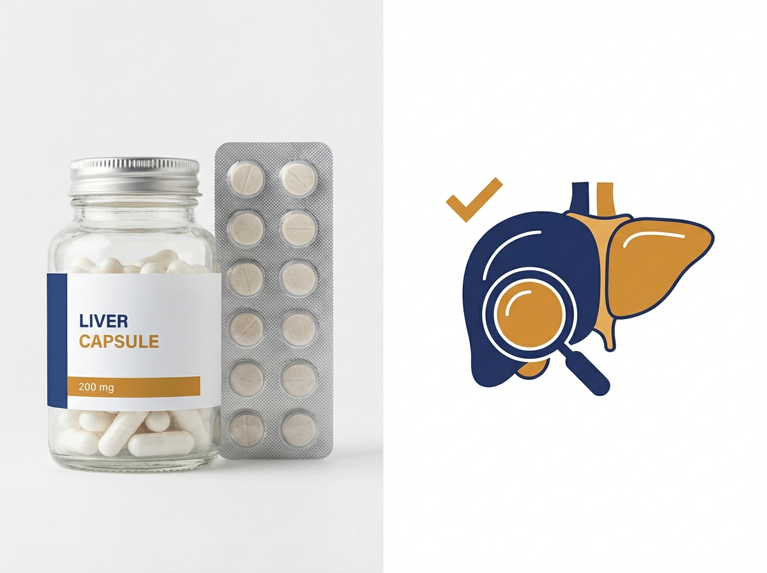
https://velox-images.pages.dev/card-hepatic.jpeg
Usage: Understanding MASH — comorbidity card
Card heading: Cardiometabolic comorbidity
Card body: MASH is intrinsically linked to the metabolic syndrome: over 70% of MASH patients have type 2 diabetes, dyslipidaemia, or both. Cardiovascular disease is the leading cause of death in patients with MASH, accounting for more deaths than liver-related events.⁴
────────────────────────────────────────────────────────────
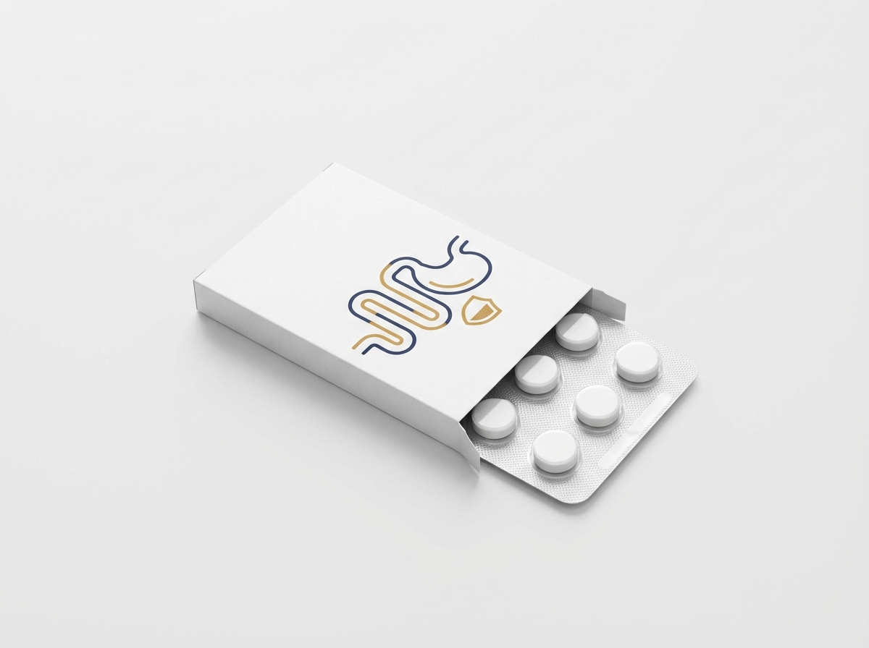
https://velox-images.pages.dev/card-gi-events.jpeg
Usage: Understanding MASH — diagnosis card
Card heading: Diagnostic challenges
Card body: MASH is often asymptomatic until advanced disease. Non-invasive biomarkers (FIB-4, ELF, FibroScan®) can identify patients at risk, but definitive MASH diagnosis and fibrosis staging historically required liver biopsy. Increasing use of non-invasive pathways is improving earlier identification of at-risk patients.⁴
────────────────────────────────────────────────────────────

Section 3 — MASH disease pathway (accordion FAQ) | light background
Block: accordion
Section metadata: Style: light
Panel 1: "From steatosis to steatohepatitis"
Body text: Hepatic steatosis (fat accumulation >5% of hepatocytes) is driven by insulin resistance, excess caloric intake, and impaired hepatic lipid metabolism. In a subset of patients, accumulated lipotoxic lipid species (diacylglycerols, ceramides, free cholesterol) trigger hepatocyte injury, activating inflammatory pathways (NF-κB, JNK) and driving the transition from benign steatosis to steatohepatitis (MASH). Histologically, MASH is defined by steatosis with hepatocyte ballooning and lobular inflammation.⁴ ⁵
Panel 2: "From inflammation to fibrosis"
Body text: Chronic hepatocyte injury in MASH activates hepatic stellate cells — the principal fibrogenic cells in the liver. Activated stellate cells deposit excess extracellular matrix (collagen, fibronectin), progressively distorting hepatic architecture. Fibrosis progresses through stages F1 (perisinusoidal) → F2 (portal/periportal) → F3 (bridging) → F4 (cirrhosis). Once cirrhosis develops, risk of decompensation, hepatocellular carcinoma, and liver transplant requirement increases substantially.⁴
Panel 3: "Why fibrosis stage determines prognosis"
Body text: Large meta-analyses demonstrate that fibrosis stage, not steatohepatitis activity, is the strongest predictor of all-cause and liver-related mortality in MASH. Each one-stage increase in fibrosis is associated with a 1.5–2.5-fold increased mortality risk. Fibrosis stage F3 (bridging fibrosis) represents a critical intervention window: advanced enough to carry significant prognostic risk, but potentially reversible with effective therapy before the architectural disruption of cirrhosis.⁴
────────────────────────────────────────────────────────────

Section 4 — Patient identification (centred text) | highlight background
Block: introduction
Section metadata: Style: highlight
Heading: Identifying patients who may benefit from KLERA
Body text: Consider KLERA for adults with confirmed MASH and stage F2 or F3 liver fibrosis. Non-invasive assessment pathways (FIB-4 → ELF or FibroScan) can identify patients with significant fibrosis in primary and secondary care. Liver biopsy remains the gold standard for staging but is not mandatory for treatment initiation when non-invasive markers are consistent with F2–F3 disease.³ ⁴
────────────────────────────────────────────────────────────

Section 5 — Prescribing information footer
Block: accordion | Expandable: PI | AE Reporting | References

Page metadata
Title: Understanding MASH | Liver Fibrosis & Disease Progression | KLERA | AstraZeneca UK
Description: Learn about metabolic dysfunction-associated steatohepatitis (MASH) — disease burden, fibrosis progression, cardiometabolic comorbidities, and patient identification pathways.

PAGE 3: CLARITY Data
URL path: /klera/clarity-data
────────────────────────────────────────────────────────────

Section 1 — Page header (text only, no image)
Block: title
Heading: The CLARITY clinical programme
Body text: KLERA® (klerafistat) was evaluated in over 1,700 patients across two biopsy-confirmed Phase III trials, demonstrating clinically meaningful liver histology improvement with concomitant cardiometabolic benefits.¹ ²
────────────────────────────────────────────────────────────

Section 2 — Headline statistics carousel (4 slides) | light background
Block: carousel-teaser
Section metadata: Style: light
Slide 1:
Heading: 37% achieved fibrosis improvement
In CLARITY-FIBROSIS, ≥1-stage fibrosis improvement without MASH worsening in 37.1% vs 14.5% placebo (Δ 22.6%; P<0.001).¹
Slide 2:
Heading: 49% achieved MASH resolution
In CLARITY-RESOLVE, MASH resolution without fibrosis worsening in 48.9% vs 18.4% placebo (Δ 30.5%; P<0.001).²
Slide 3:
Heading: 52% liver fat reduction
Relative reduction in hepatic fat content by MRI-PDFF: −52.3% with KLERA vs −10.4% placebo at Week 52 (P<0.001).¹
Slide 4:
Heading: 19% LDL-cholesterol reduction
LDL-cholesterol decreased by 18.7% with KLERA vs +1.2% with placebo at Week 52, addressing cardiovascular risk alongside liver disease (P<0.001).¹
────────────────────────────────────────────────────────────

Section 3 — Clinical data (two tabs)
Block: tabs-large

Tab 1: "CLARITY-FIBROSIS: Fibrosis improvement"

https://velox-images.pages.dev/tab-velocity-af.jpeg
Usage: CLARITY Data — CLARITY-FIBROSIS tab
Heading: CLARITY-FIBROSIS: The first Phase III trial to achieve a fibrosis endpoint in MASH
Body text: CLARITY-FIBROSIS was a randomised, double-blind, placebo-controlled trial in 966 adults with biopsy-confirmed MASH (NAS ≥4) and fibrosis stage F2 or F3, with or without type 2 diabetes. KLERA 100 mg once daily (after 80 mg run-in) was evaluated with paired liver biopsies at baseline and Week 52.¹

Body text (continued): The primary endpoint was met: 37.1% of KLERA patients achieved ≥1-stage fibrosis improvement without worsening of MASH, compared with 14.5% placebo (Δ 22.6%; P<0.001). MASH resolution was achieved in 44.2% vs 16.8% (P<0.001). The combined endpoint (fibrosis improvement AND MASH resolution) was achieved in 25.4% vs 6.8% (P<0.001). Notably, 12.8% of KLERA patients achieved ≥2-stage fibrosis improvement, suggesting the potential for substantial histological reversal in a subset of patients. Liver fat decreased by 52.3% (MRI-PDFF) and LDL-cholesterol by 18.7%.¹
Data table:
Endpoint | KLERA (n=483) | Placebo (n=483) | Effect
Fibrosis improvement (primary) | 37.1% | 14.5% | Δ 22.6%; P<0.001
MASH resolution | 44.2% | 16.8% | Δ 27.4%; P<0.001
Combined endpoint | 25.4% | 6.8% | Δ 18.6%; P<0.001
Liver fat (MRI-PDFF) | −52.3% | −10.4% | P<0.001
LDL-C change | −18.7% | +1.2% | P<0.001
────────────────────────────────────────────────────────────
Tab 2: "CLARITY-RESOLVE: MASH resolution with metabolic benefits"
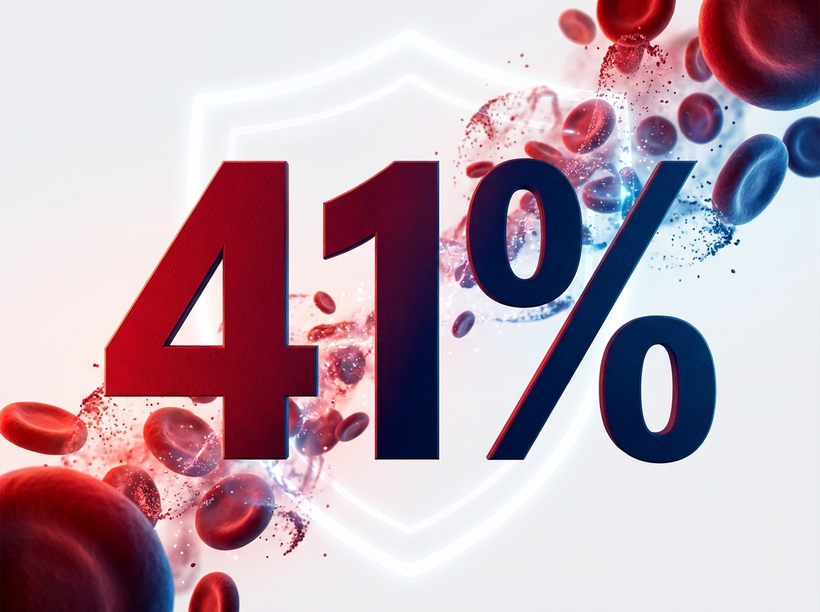
https://velox-images.pages.dev/tab-velocity-bleed.jpeg
Usage: CLARITY Data — CLARITY-RESOLVE tab
Heading: CLARITY-RESOLVE: MASH resolution and cardiometabolic improvement in T2D
Body text: CLARITY-RESOLVE was a randomised, double-blind, placebo-controlled trial in 748 adults with biopsy-confirmed MASH (NAS ≥4) and fibrosis stage F1–F3, all with type 2 diabetes (HbA1c 7.0–10.0%). This trial specifically assessed whether KLERA could address both liver histology and the metabolic comorbidities that drive morbidity in MASH.²

Body text (continued): KLERA achieved a MASH resolution rate of 48.9% vs 18.4% placebo (Δ 30.5%; P<0.001). Fibrosis improvement (≥1 stage) was achieved in 34.8% vs 15.0% (P<0.001). Beyond liver histology, KLERA improved HbA1c by 0.36% vs placebo, reduced body weight by 2.1 kg, lowered triglycerides by 24.6%, and reduced LDL-cholesterol by 16.9%. Liver fat decreased by 58.1% (MRI-PDFF). These cardiometabolic benefits address the multi-organ nature of MASH and its associated morbidity.²
Data table:
Endpoint | KLERA (n=374) | Placebo (n=374) | Effect
MASH resolution (primary) | 48.9% | 18.4% | Δ 30.5%; P<0.001
Fibrosis improvement | 34.8% | 15.0% | Δ 19.8%; P<0.001
HbA1c change | −0.42% | −0.06% | Δ −0.36%; P<0.001
Body weight | −2.4 kg | −0.3 kg | Δ −2.1 kg; P<0.001
Triglycerides | −24.6% | −3.8% | P<0.001
LDL-C change | −16.9% | +0.8% | P<0.001
────────────────────────────────────────────────────────────

Section 4 — Prescribing information footer
Block: accordion | Expandable: PI | AE Reporting | References

Page metadata
Title: CLARITY Data | KLERA (klerafistat) | Fibrosis & MASH Resolution | AstraZeneca UK
Description: Explore the CLARITY clinical programme for KLERA (klerafistat) — Phase III fibrosis improvement, MASH resolution, and cardiometabolic outcomes in adults with MASH and liver fibrosis.

PAGE 4: How KLERA Works
URL path: /klera/how-klera-works
────────────────────────────────────────────────────────────

Section 1 — Hero (full-width image with text overlay)
Block: hero-teaser


https://velox-images.pages.dev/hero-moa.jpeg
Usage: How KLERA Works — hero
Heading: How KLERA works
Body text: KLERA® (klerafistat) selectively activates thyroid hormone receptor beta in the liver, harnessing the body’s own metabolic machinery to clear hepatic fat and halt fibrosis progression.³ ⁵
────────────────────────────────────────────────────────────

Section 2 — THR biology (centred text) | light background
Block: introduction
Section metadata: Style: light
Heading: THR-β: the liver’s metabolic master switch
Body text: Thyroid hormones regulate hepatic metabolism through two receptor isoforms: THR-α (predominant in heart and bone) and THR-β (predominant in liver). THR-β activation in hepatocytes drives mitochondrial fatty acid β-oxidation, upregulates LDL receptor expression, and suppresses de novo lipogenesis. Patients with MASH frequently exhibit features of relative hepatic hypothyroidism — reduced intrahepatic T3 signalling despite normal systemic thyroid function — contributing to impaired hepatic lipid clearance.⁴ ⁵
────────────────────────────────────────────────────────────

Section 3 — Mechanism detail (two-column: image left, text right) | highlight background
Block: columns-teaser
Section metadata: Style: highlight


https://velox-images.pages.dev/columns-moa-preview.jpeg
Usage: Home — MoA teaser
Heading: Selective THR-β agonism: liver-directed fat clearance
Body text: Klerafistat binds to THR-β with >30-fold selectivity over THR-α. In the hepatocyte, THR-β activation upregulates mitochondrial β-oxidation enzymes (CPT1A, ACADL), increasing fatty acid catabolism and reducing intracellular triglyceride, diacylglycerol, and ceramide pools. Concurrently, de novo lipogenesis is suppressed through downregulation of SREBP-1c and ACC. The net effect is a >50% reduction in hepatic fat content within 12 weeks.³ ⁵

Body text (continued): Reduced lipotoxicity diminishes hepatocyte injury signals, attenuating the activation of hepatic stellate cells and slowing collagen deposition. Additionally, KLERA upregulates hepatic LDL receptor expression, lowering circulating LDL-cholesterol by ~19% and addressing the cardiovascular risk that is the leading cause of death in MASH patients. THR-α sparing preserves cardiac rhythm and bone density, enabling chronic use.³ ⁵
Call to action: View the CLARITY data → /klera/clarity-data
────────────────────────────────────────────────────────────

Section 4 — THR-β selectivity (centred text)
Block: introduction
Heading: >30-fold selectivity for THR-β over THR-α
Body text: Non-selective thyroid hormone action causes tachycardia, atrial fibrillation, and accelerated bone turnover. KLERA achieves >30-fold selectivity for the liver-predominant THR-β isoform, sparing THR-α-mediated effects. In CLARITY, mean heart rate increased by only 1.8 bpm vs 0.2 bpm placebo, no arrhythmia signal was detected, and bone mineral density was unchanged at Week 52.³
────────────────────────────────────────────────────────────

Section 5 — Prescribing information footer
Block: accordion | Expandable: PI | AE Reporting | References

Page metadata
Title: How KLERA Works | THR-β Agonist Mechanism | Liver-Directed Therapy | AstraZeneca UK
Description: Understand how KLERA (klerafistat) selectively activates THR-β in the liver to clear hepatic fat, reduce lipotoxicity, and improve fibrosis in MASH.

PAGE 5: Safety, Dosing & Monitoring
URL path: /klera/safety-dosing-monitoring
────────────────────────────────────────────────────────────

Section 1 — Page header (text only, no image)
Block: title
Heading: Safety, dosing, and monitoring
Body text: KLERA® (klerafistat) has been evaluated in 857 patients across the CLARITY clinical programme. A simple oral once-daily regimen with dose escalation and structured hepatic monitoring supports safe long-term treatment.¹ ² ³
────────────────────────────────────────────────────────────

Section 2 — Dosing regimen (two-column: image left, text right) | highlight background
Block: columns-teaser
Section metadata: Style: highlight


https://velox-images.pages.dev/columns-dosing.jpeg
Usage: Safety, Dosing & Monitoring — daily regimen
Heading: Dose escalation for tolerability
Body text: Month 1–3: KLERA 80 mg once daily with food. Month 4 onwards: increase to 100 mg once daily with food. This dose-escalation approach was designed to mitigate gastrointestinal adverse events during treatment initiation. Tablets should be swallowed whole. If a dose is missed, take it as soon as remembered on the same day; do not double-dose.³
────────────────────────────────────────────────────────────

Section 3 — Key safety topics (three equal columns)
Block: cards-teaser


https://velox-images.pages.dev/card-bleeding-events.jpeg
Usage: Understanding MASH — progression card
Card heading: Gastrointestinal events
Card body: Diarrhoea (26.4%) and nausea (18.7%) were the most common AEs, predominantly grade 1–2 and most frequent during the first 4 weeks. Grade ≥3 diarrhoea: 2.8%. Treatment discontinuation due to GI events: 2.1%. Dose-escalation mitigates GI intolerance.³
────────────────────────────────────────────────────────────

https://velox-images.pages.dev/card-hepatic.jpeg
Usage: Understanding MASH — comorbidity card
Card heading: Hepatic safety
Card body: Transient ALT >3× ULN in 3.8% (vs 1.9% placebo), predominantly during dose escalation. Asymptomatic, no bilirubin elevation, resolved with continued dosing in most cases. No DILI or Hy’s Law cases. Monitor LFTs monthly for 3 months, then quarterly.³
────────────────────────────────────────────────────────────

https://velox-images.pages.dev/card-gi-events.jpeg
Usage: Understanding MASH — diagnosis card
Card heading: Thyroid and cardiac safety
Card body: TSH suppression was modest (−0.8 mIU/L nadir at Week 12); >94% remained within normal range. No clinical thyrotoxicosis. Mean heart rate +1.8 bpm. No arrhythmia or QTc signal. Bone density unchanged at Week 52, confirming THR-α sparing.³
────────────────────────────────────────────────────────────

Section 4 — Monitoring schedule table | light background
Block: table-data
Section metadata: Style: light
Heading: Recommended monitoring schedule
Assessment | Baseline | Month 1 | Month 2 | Month 3 | Every 3 months
ALT, AST, ALP, bilirubin | ✓ | ✓ | ✓ | ✓ | ✓
TSH | ✓ |  |  | ✓* | As indicated
Lipid panel (LDL-C, TG) | ✓ |  |  | ✓ | ✓
HbA1c (if T2D) | ✓ |  |  | ✓ | ✓
eGFR | ✓ |  |  |  | ✓
Weight | ✓ | ✓ | ✓ | ✓ | ✓
Pregnancy test (if applicable) | ✓
FibroScan / ELF (optional) | ✓ |  |  |  | Every 12 months
*Reassess TSH at Month 3 (end of 80 mg dose phase). Monitor further only if clinically indicated.
────────────────────────────────────────────────────────────

Section 5 — Practical guidance (two-column: image left, text right)
Block: columns-teaser


https://velox-images.pages.dev/columns-monitoring.jpeg
Usage: Safety, Dosing & Monitoring — hepatic monitoring
Heading: Drug interactions and co-prescribing considerations
Body text: No clinically significant CYP-mediated drug interactions have been identified. Bile acid sequestrants (cholestyramine, colesevelam) may reduce klerafistat absorption: administer KLERA ≥4 hours before or after bile acid sequestrants. Statins: additive LDL-lowering; monitor for myopathy symptoms at initiation. KLERA may be used alongside metformin, SGLT2 inhibitors, GLP-1 receptor agonists, and insulin without dose adjustment. Monitor for hypoglycaemia if HbA1c improvement leads to relative over-treatment of diabetes.³
────────────────────────────────────────────────────────────

Section 6 — Prescribing information footer
Block: accordion | Expandable: PI | AE Reporting | References

Page metadata
Title: Safety, Dosing & Monitoring | KLERA (klerafistat) | MASH Treatment | AstraZeneca UK
Description: KLERA (klerafistat) safety, dosing regimen with dose escalation, monitoring schedule, and drug interaction guidance for UK healthcare professionals managing MASH with liver fibrosis.

PAGE 6: HCP Resources & Support
URL path: /klera/resources
────────────────────────────────────────────────────────────

Section 1 — Page header (text only, no image)
Block: title
Heading: Resources and support for healthcare professionals
Body text: Access prescribing guides, MASH patient identification tools, CLARITY data summaries, and monitoring resources for KLERA® (klerafistat). All materials are provided for UK healthcare professionals only.³
────────────────────────────────────────────────────────────

Section 2 — Resource cards (three equal columns)
Block: cards-teaser


https://velox-images.pages.dev/card-prescribing.jpeg
Usage: HCP Resources — prescribing guide card
Card heading: Prescribing and monitoring guide
Card body: Comprehensive guide covering indication, dose escalation, LFT monitoring schedule, drug interactions, and special populations. Includes a detachable monitoring tracker for patient records.³
Card link: Download prescribing guide → [PDF link]
────────────────────────────────────────────────────────────
Card heading: MASH patient identification pathway
Card body: Non-invasive assessment algorithm for identifying patients with MASH and significant fibrosis (F2–F3) using FIB-4, ELF, and FibroScan. Designed for use in primary care, diabetology, and hepatology clinics to streamline referral and treatment initiation.⁴
Card link: Download pathway tool → [PDF link]
────────────────────────────────────────────────────────────
Card heading: CLARITY clinical data summary
Card body: Summary of key histological, metabolic, and safety results from CLARITY-FIBROSIS and CLARITY-RESOLVE, including data tables, response curves, and subgroup analyses by fibrosis stage and T2D status.¹ ²
Card link: Download data summary → [PDF link]
────────────────────────────────────────────────────────────

Section 3 — Contact and medical information (centred text) | light background
Block: introduction
Section metadata: Style: light
Heading: Medical information and support
Body text: For medical information enquiries about KLERA, please contact AstraZeneca Medical Information: Telephone: 0800 783 0033 | Email: medicalinformationuk@astrazeneca.com | Online: contactazmedical.astrazeneca.com
────────────────────────────────────────────────────────────

Section 4 — Prescribing information footer
Block: accordion | Expandable: PI | AE Reporting | References

Page metadata
Title: HCP Resources | KLERA (klerafistat) | MASH Guides & Clinical Data | AstraZeneca UK
Description: Access prescribing guides, MASH patient identification pathways, CLARITY clinical data summaries, and monitoring tools for KLERA (klerafistat). For UK healthcare professionals only.

10. Footer Content
The footer must appear on every page and contain the following elements:
Logo: AstraZeneca logo (linked to /klera/)
Approval code: GB-13402 | DOP: March 2026
Copyright: © 2026 AstraZeneca. All rights reserved. KLERA is a registered trademark of the AstraZeneca group of companies.
Page links: Understanding MASH | CLARITY Data | How KLERA Works | Safety, Dosing & Monitoring | HCP Resources & Support
Regulatory links: Report Adverse Event (https://yellowcard.mhra.gov.uk/) | Medical Information (https://contactazmedical.astrazeneca.com/) | Privacy Policy (https://www.astrazeneca.co.uk/our-company/privacy-notice.html) | Terms of Use (https://www.astrazeneca.co.uk/our-company/terms-of-use.html) | Accessibility (https://www.astrazeneca.co.uk/accessibility.html)
Date of preparation: Date of Preparation: March 2026
────────────────────────────────────────────────────────────

11. Image Assets
All images sourced from shared CDN: https://velox-images.pages.dev/
Note: KLERA reuses images originally generated for the VELOX website. The abstract and lifestyle imagery translates well to the hepatology/metabolic context.

Complete image manifest:

Filename | Usage | CDN URL
hero-home.jpeg | Home — hero | https://velox-images.pages.dev/hero-home.jpeg
hero-efficacy.jpeg | Understanding MASH — hero | https://velox-images.pages.dev/hero-efficacy.jpeg
hero-moa.jpeg | How KLERA Works — hero | https://velox-images.pages.dev/hero-moa.jpeg
card-stroke.jpeg | Home — fibrosis improvement card | https://velox-images.pages.dev/card-stroke.jpeg
card-bleeding.jpeg | Home — MASH resolution card | https://velox-images.pages.dev/card-bleeding.jpeg
card-dosing.jpeg | Home — oral once-daily card | https://velox-images.pages.dev/card-dosing.jpeg
columns-moa-preview.jpeg | Home — MoA teaser | https://velox-images.pages.dev/columns-moa-preview.jpeg
tab-velocity-af.jpeg | CLARITY Data — CLARITY-FIBROSIS tab | https://velox-images.pages.dev/tab-velocity-af.jpeg
tab-velocity-bleed.jpeg | CLARITY Data — CLARITY-RESOLVE tab | https://velox-images.pages.dev/tab-velocity-bleed.jpeg
card-bleeding-events.jpeg | Understanding MASH — progression card | https://velox-images.pages.dev/card-bleeding-events.jpeg
card-hepatic.jpeg | Understanding MASH — comorbidity card | https://velox-images.pages.dev/card-hepatic.jpeg
card-gi-events.jpeg | Understanding MASH — diagnosis card | https://velox-images.pages.dev/card-gi-events.jpeg
columns-dosing.jpeg | Safety, Dosing & Monitoring — daily regimen | https://velox-images.pages.dev/columns-dosing.jpeg
columns-monitoring.jpeg | Safety, Dosing & Monitoring — hepatic monitoring | https://velox-images.pages.dev/columns-monitoring.jpeg
card-prescribing.jpeg | HCP Resources — prescribing guide card | https://velox-images.pages.dev/card-prescribing.jpeg

Image previews
Visual previews of all 15 images:

hero-home.jpeg — Home — hero

https://velox-images.pages.dev/hero-home.jpeg
Usage: Home — hero

hero-efficacy.jpeg — Understanding MASH — hero

https://velox-images.pages.dev/hero-efficacy.jpeg
Usage: Understanding MASH — hero

hero-moa.jpeg — How KLERA Works — hero

https://velox-images.pages.dev/hero-moa.jpeg
Usage: How KLERA Works — hero

card-stroke.jpeg — Home — fibrosis improvement card

https://velox-images.pages.dev/card-stroke.jpeg
Usage: Home — fibrosis improvement card

card-bleeding.jpeg — Home — MASH resolution card

https://velox-images.pages.dev/card-bleeding.jpeg
Usage: Home — MASH resolution card

card-dosing.jpeg — Home — oral once-daily card

https://velox-images.pages.dev/card-dosing.jpeg
Usage: Home — oral once-daily card

columns-moa-preview.jpeg — Home — MoA teaser

https://velox-images.pages.dev/columns-moa-preview.jpeg
Usage: Home — MoA teaser

tab-velocity-af.jpeg — CLARITY Data — CLARITY-FIBROSIS tab

https://velox-images.pages.dev/tab-velocity-af.jpeg
Usage: CLARITY Data — CLARITY-FIBROSIS tab

tab-velocity-bleed.jpeg — CLARITY Data — CLARITY-RESOLVE tab

https://velox-images.pages.dev/tab-velocity-bleed.jpeg
Usage: CLARITY Data — CLARITY-RESOLVE tab

card-bleeding-events.jpeg — Understanding MASH — progression card

https://velox-images.pages.dev/card-bleeding-events.jpeg
Usage: Understanding MASH — progression card

card-hepatic.jpeg — Understanding MASH — comorbidity card

https://velox-images.pages.dev/card-hepatic.jpeg
Usage: Understanding MASH — comorbidity card

card-gi-events.jpeg — Understanding MASH — diagnosis card

https://velox-images.pages.dev/card-gi-events.jpeg
Usage: Understanding MASH — diagnosis card

columns-dosing.jpeg — Safety, Dosing & Monitoring — daily regimen

https://velox-images.pages.dev/columns-dosing.jpeg
Usage: Safety, Dosing & Monitoring — daily regimen

columns-monitoring.jpeg — Safety, Dosing & Monitoring — hepatic monitoring

https://velox-images.pages.dev/columns-monitoring.jpeg
Usage: Safety, Dosing & Monitoring — hepatic monitoring

card-prescribing.jpeg — HCP Resources — prescribing guide card

https://velox-images.pages.dev/card-prescribing.jpeg
Usage: HCP Resources — prescribing guide card

