TRELUXIA™
(trelimovab)

Website Briefing

Breathe beyond limits.

Document type: Final approved marketing brief for HCP website build
Prepared by: Marketing — UK Respiratory Franchise
Approval status: MLR-approved copy — do not modify
Date: March 2026
Approval code: GB-98204 | DOP: March 2026

Contents
1. Drug Profile
2. Mechanism of Action
3. Clinical Programme: LUMINOS
4. Safety Profile
5. Prescribing Information
6. Adverse Event Reporting
7. References
8. Site Navigation
9. Page Content
Page 1: Home
Page 2: LUMINOS Data
Page 3: Safety
Page 4: Dosing & Administration
Page 5: How TRELUXIA Works
Page 6: Resources
10. Footer Content
11. Image Assets

1. Drug Profile
Field | Detail
Brand name | TRELUXIA
Generic name | trelimovab
Drug class | Human monoclonal antibody targeting thymic stromal lymphopoietin (TSLP)
Indication | Add-on maintenance treatment for adults and adolescents aged ≥12 years with severe asthma that is inadequately controlled despite high-dose inhaled corticosteroids plus at least one additional controller, irrespective of inflammatory phenotype
Formulation | 210 mg/1.91 mL solution for injection in pre-filled syringe and pre-filled pen (autoinjector)
Dosing | 210 mg subcutaneous injection once every 4 weeks
Approval | MHRA — January 2026
Brand colour | Deep Teal #006B77
Accent colour | Sky Blue #4DADD9
Approval code | GB-98204

TRELUXIA brand rule: TRELUXIA always appears in capitals, with ™ on first mention per page. Generic name (trelimovab) appears in lowercase parentheses on first mention. The approved tagline "Breathe beyond limits." may only be used verbatim — no variations permitted.
────────────────────────────────────────────────────────────

2. Mechanism of Action
Trelimovab is a human immunoglobulin G2λ monoclonal antibody that specifically binds to thymic stromal lymphopoietin (TSLP), an epithelial cytokine released at the top of the inflammatory cascade in response to airway insults including allergens, viruses, pollutants, and other triggers.
TSLP is a key upstream initiator of airway inflammation in asthma. By binding directly to TSLP and preventing its interaction with the TSLP receptor complex (TSLPR/IL-7Rα), trelimovab inhibits multiple downstream inflammatory pathways:
- Eosinophilic inflammation via suppression of IL-5, IL-13, and eosinophil recruitment
- Type 2 (Th2) immune responses including IgE production and mast cell activation
- Non-type 2 inflammation including neutrophilic airway inflammation, mast cell cytokine release, and structural cell activation
- Airway remodelling through reduced subepithelial fibrosis and smooth muscle hypertrophy
Because TSLP acts upstream of multiple inflammatory pathways, trelimovab provides broad anti-inflammatory activity across the full spectrum of severe asthma phenotypes — including patients with low eosinophil counts and those without a clearly defined type 2 inflammatory biomarker signature.
────────────────────────────────────────────────────────────

3. Clinical Programme: LUMINOS

LUMINOS-1 (Phase III, pivotal — Exacerbation reduction in severe asthma)
Design: Randomised, double-blind, placebo-controlled, parallel-group Phase III trial
Population: 1,061 adults and adolescents aged ≥12 years with severe asthma inadequately controlled despite medium- or high-dose ICS plus at least one additional controller (LABA, LTRA, LAMA, or theophylline), with a history of ≥2 exacerbations in the prior 12 months
Duration: 52 weeks on treatment + 12-week follow-up
Primary endpoint: Annualised asthma exacerbation rate (AAER) over 52 weeks
Key secondary endpoints: Change from baseline in pre-bronchodilator FEV₁ at Week 52; Asthma Control Questionnaire-6 (ACQ-6) score change at Week 52; time to first exacerbation; AAER in subgroups by baseline eosinophil count
Publication: Harrison et al. N Engl J Med 2025; 392(14): 1318–1330

Key results:
Endpoint | TRELUXIA (n=529) | Placebo (n=532) | Treatment effect
AAER (overall population) | 0.93 | 2.10 | RR 0.44 (0.37–0.53); P<0.001
AAER (eos ≥300 cells/μL) | 0.85 | 2.26 | RR 0.38 (0.29–0.49); P<0.001
AAER (eos <300 cells/μL) | 1.14 | 1.92 | RR 0.59 (0.45–0.78); P<0.001
Pre-BD FEV₁ change at Week 52 | +0.29 L | +0.04 L | +0.25 L (0.18–0.32); P<0.001
ACQ-6 change at Week 52 | −1.55 | −1.07 | −0.48 (−0.62 to −0.34); P<0.001
Time to first exacerbation | Median not reached | 36 weeks | HR 0.52 (0.43–0.63); P<0.001
Exacerbations requiring hospitalisation/ER | 0.18 | 0.79 | RR 0.23 (0.15–0.35); P<0.001

LUMINOS-OCS (Phase III — Oral corticosteroid sparing in severe asthma)
Design: Randomised, double-blind, placebo-controlled Phase III trial
Population: 407 adults with severe asthma dependent on maintenance oral corticosteroids (≥5 mg prednisolone equivalent daily), receiving high-dose ICS plus additional controllers
Duration: 48 weeks (12-week OCS optimisation + 36-week OCS reduction phase)
Primary endpoint: Percentage reduction in OCS dose at Week 48 from the optimised baseline while maintaining asthma control
Key secondary endpoints: Proportion achieving ≥50% OCS reduction; proportion achieving complete OCS elimination; AAER during OCS reduction phase; ACQ-6 change at Week 48
Publication: Ventura et al. Lancet Respir Med 2026; 14(2): 112–125

Key results:
Endpoint | TRELUXIA (n=203) | Placebo (n=204) | Treatment effect
Median OCS dose reduction at Week 48 | −75% | −25% | OR 2.58 (1.79–3.72); P<0.001
≥50% OCS reduction | 71.4% | 41.7% | OR 3.49 (2.31–5.27); P<0.001
Complete OCS elimination | 37.9% | 10.8% | OR 5.07 (3.03–8.49); P<0.001
AAER during OCS reduction phase | 0.76 | 1.97 | RR 0.39 (0.28–0.53); P<0.001
ACQ-6 change at Week 48 | −1.41 | −0.68 | −0.73 (−0.97 to −0.49); P<0.001
────────────────────────────────────────────────────────────

4. Safety Profile (Pooled LUMINOS data, N=732 TRELUXIA)

Most common adverse events (≥2%)
Adverse event | TRELUXIA (%) | Placebo (%)
Nasopharyngitis | 10.4 | 9.8
Upper respiratory tract infection | 8.1 | 7.4
Headache | 6.7 | 5.2
Injection site reactions | 4.6 | 2.8
Arthralgia | 3.8 | 3.1
Back pain | 3.2 | 2.6
Pharyngitis | 2.9 | 2.5
Fatigue | 2.4 | 1.9

Injection site reactions
Injection site reactions (ISRs) occurred in 4.6% of TRELUXIA-treated patients vs 2.8% with placebo. The most common ISRs were erythema, pain, and swelling at the injection site. All ISRs were mild to moderate in severity. No ISR led to treatment discontinuation.³

Key safety findings
Serious adverse events: 8.4% TRELUXIA vs 11.2% placebo (driven by fewer asthma-related hospitalisations)
Treatment discontinuation due to AEs: 2.4% vs 3.1%
All-cause mortality: 0.1% vs 0.2% (no drug-related deaths)
Anaphylaxis: 3 events (0.4%) in TRELUXIA vs 0 in placebo. All occurred within 24 hours; resolved with standard treatment³
Malignancy: 0.3% vs 0.4% (no imbalance; no signal for increased risk)
Helminth infections: 0.4% vs 0.1%. Treat pre-existing infections before initiating TRELUXIA³
Immunogenicity: ADAs detected in 5.1%; neutralising antibodies in 1.2%. No impact on PK, efficacy, or safety³

Special populations
- Adolescents (12–17 years): Same dose as adults (210 mg Q4W). In LUMINOS-1, 63 adolescents received TRELUXIA; efficacy and safety were consistent with the overall adult population.³
- Elderly (≥65 years): No dose adjustment required. Limited data in patients ≥75 years. 11% of LUMINOS-1 patients were ≥65 years.³
- Renal and hepatic impairment: No dose adjustment for mild to moderate impairment. Not studied in severe renal impairment (eGFR <30 mL/min/1.73m²) or severe hepatic impairment.³
- Pregnancy and lactation: No adequate data in pregnant women. Human IgG crosses the placental barrier. Use only if potential benefit justifies potential risk. Unknown if excreted in human milk.³
────────────────────────────────────────────────────────────

5. Prescribing Information (abbreviated — for every page footer)
TRELUXIA (trelimovab) 210 mg/1.91 mL solution for injection in pre-filled syringe and pre-filled pen. Please refer to the Summary of Product Characteristics (SmPC) before prescribing. Indication: Add-on maintenance treatment for adults and adolescents aged ≥12 years with severe asthma that is inadequately controlled despite high-dose inhaled corticosteroids plus at least one additional controller, irrespective of inflammatory phenotype. Dosage and administration: 210 mg administered by subcutaneous injection once every 4 weeks. Administer into the thigh, abdomen (excluding 5 cm around the navel), or upper arm (if administered by a caregiver). Rotate injection sites. The first 3 doses should be administered under the supervision of a healthcare professional. Contraindications: Hypersensitivity to trelimovab or any excipient. Warnings and precautions: Do not use to treat acute asthma symptoms or acute exacerbations. Do not abruptly discontinue systemic or inhaled corticosteroids upon initiation. Hypersensitivity reactions including anaphylaxis have been reported. Treat pre-existing helminth infections before initiating. Interactions: No formal drug interaction studies conducted. No clinically significant interactions identified. Side effects: Very common (≥1/10): nasopharyngitis. Common (≥1/100 to <1/10): upper respiratory tract infection, headache, injection site reactions, arthralgia. Uncommon (≥1/1000 to <1/100): anaphylaxis, pharyngitis. Legal category: POM. Pack and price: 1 pre-filled syringe (210 mg): £1,267.00; 1 pre-filled pen (210 mg): £1,267.00. Marketing authorisation holder: AstraZeneca UK Ltd. MA number: PLGB 17901/0643. Full prescribing information available from: AstraZeneca UK Ltd, 2 Pancras Square, London N1C 4AG. GB-98204 | DOP: March 2026.
────────────────────────────────────────────────────────────

6. Adverse Event Reporting (for every page footer)
Adverse events should be reported. Reporting forms and information can be found at www.mhra.gov.uk/yellowcard or search for MHRA Yellow Card in the Google Play or Apple App Store. Adverse events should also be reported to AstraZeneca by visiting contactazmedical.astrazeneca.com or by calling 0800 783 0033.
────────────────────────────────────────────────────────────

7. References (for every page footer)
1. Harrison et al. N Engl J Med 2025; 392(14): 1318–1330.
2. Ventura et al. Lancet Respir Med 2026; 14(2): 112–125.
3. TRELUXIA (trelimovab) Summary of Product Characteristics. AstraZeneca UK Ltd. January 2026.
4. Global Initiative for Asthma (GINA). Global Strategy for Asthma Management and Prevention, 2025 Update.
5. Gauvreau GM, et al. N Engl J Med 2024; 370(22): 2102–2110.
────────────────────────────────────────────────────────────

8. Site Navigation
Top bar links: Contact Us (https://www.astrazeneca.co.uk/contact-us.html) | AZ Employee Login (https://login.astrazeneca.com)
Main navigation pages: LUMINOS Data | Safety | Dosing & Administration | How TRELUXIA Works | Resources
Utility: Search | Login

9. Page Content
IMPORTANT: All copy below is final and MLR-approved. It must be used exactly as written — do not modify, rephrase, or abbreviate any text. All superscript reference numbers, statistical values, and regulatory language must be reproduced verbatim.
Each page must end with expandable sections for Prescribing Information, Adverse Event Reporting, and References (see sections 5, 6, and 7 above).
TRELUXIA brand rule: TRELUXIA always appears in capitals, with ™ on first mention per page. Generic name (trelimovab) in lowercase parentheses on first mention. Tagline "Breathe beyond limits." verbatim only.
────────────────────────────────────────────────────────────

PAGE 1: Home
URL path: /treluxia/
────────────────────────────────────────────────────────────

Section 1 — Hero (full-width image with text overlay)
Block: hero-teaser


https://treluxia-images.pages.dev/hero-home.jpeg
Usage: Home — hero
Heading: TRELUXIA™ (trelimovab)
Body text: Broad anti-inflammatory control for adults and adolescents with severe uncontrolled asthma, irrespective of inflammatory phenotype. Breathe beyond limits.¹
Call to action: Explore the LUMINOS data → /treluxia/luminos-data
────────────────────────────────────────────────────────────

Section 2 — Three key benefit cards (equal columns)
Block: cards-teaser


https://treluxia-images.pages.dev/card-exacerbations.jpeg
Usage: Home — exacerbation reduction card
Card heading: 56% reduction in asthma exacerbations
Card body: In LUMINOS-1, TRELUXIA reduced the annualised asthma exacerbation rate by 56% versus placebo across the overall severe asthma population, irrespective of baseline eosinophil count or inflammatory phenotype (rate ratio 0.44; P<0.001).¹
Card link: View LUMINOS data → /treluxia/luminos-data
────────────────────────────────────────────────────────────
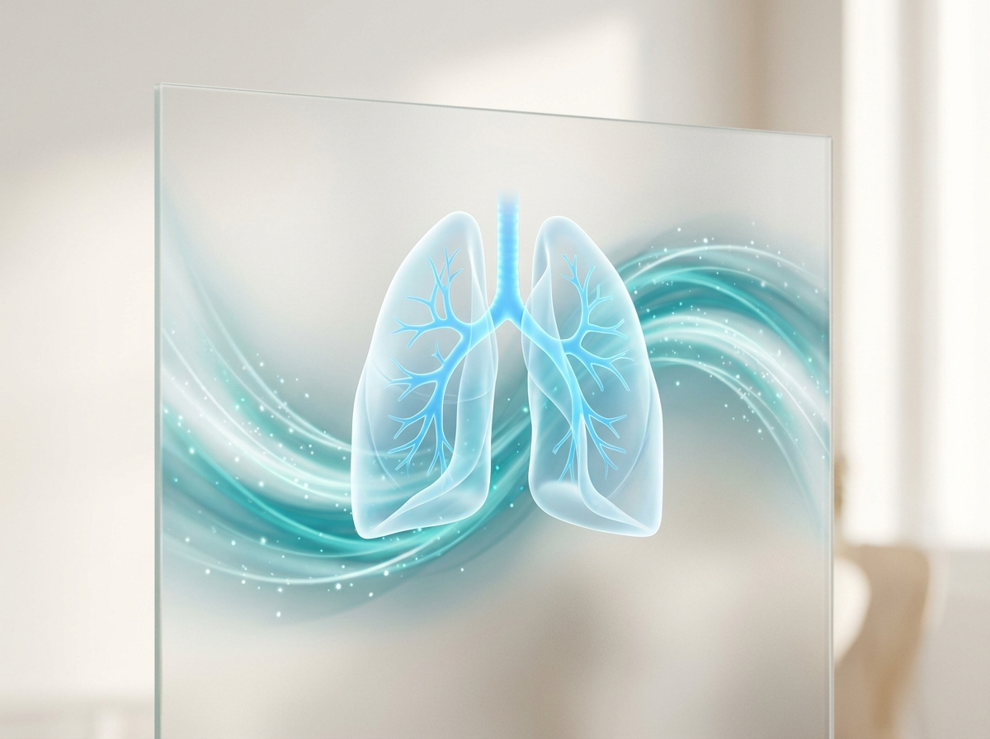
https://treluxia-images.pages.dev/card-lung-function.jpeg
Usage: Home — lung function card
Card heading: Clinically meaningful lung function improvement
Card body: TRELUXIA improved pre-bronchodilator FEV₁ by 0.25 L compared with placebo at Week 52 (P<0.001), demonstrating sustained and clinically meaningful improvement in airflow limitation alongside exacerbation reduction.¹
Card link: Explore lung function data → /treluxia/luminos-data
────────────────────────────────────────────────────────────

https://treluxia-images.pages.dev/card-ocs.jpeg
Usage: Home — OCS sparing card
Card heading: Enabling oral corticosteroid reduction
Card body: In LUMINOS-OCS, 71.4% of patients achieved ≥50% reduction in their maintenance oral corticosteroid dose with TRELUXIA, and 37.9% eliminated OCS completely while maintaining asthma control (P<0.001 for both).²
Card link: View OCS-sparing data → /treluxia/luminos-data
────────────────────────────────────────────────────────────

Section 3 — Disease context (centred text) | light background
Block: introduction
Section metadata: Style: light
Heading: Severe asthma: an unmet need beyond type 2 inflammation
Body text: Approximately 5–10% of adults with asthma have severe disease that remains uncontrolled despite optimised inhaler therapy.⁴ While existing biologics target specific type 2 inflammatory pathways, a significant proportion of patients with severe asthma do not have an elevated type 2 biomarker signature, or have mixed inflammatory phenotypes that respond incompletely to single-pathway inhibition. TSLP acts upstream of both type 2 and non-type 2 inflammatory cascades, representing a broader therapeutic target.⁵
────────────────────────────────────────────────────────────

Section 4 — Mechanism teaser (two-column: image left, text right) | highlight background
Block: columns-teaser
Section metadata: Style: highlight

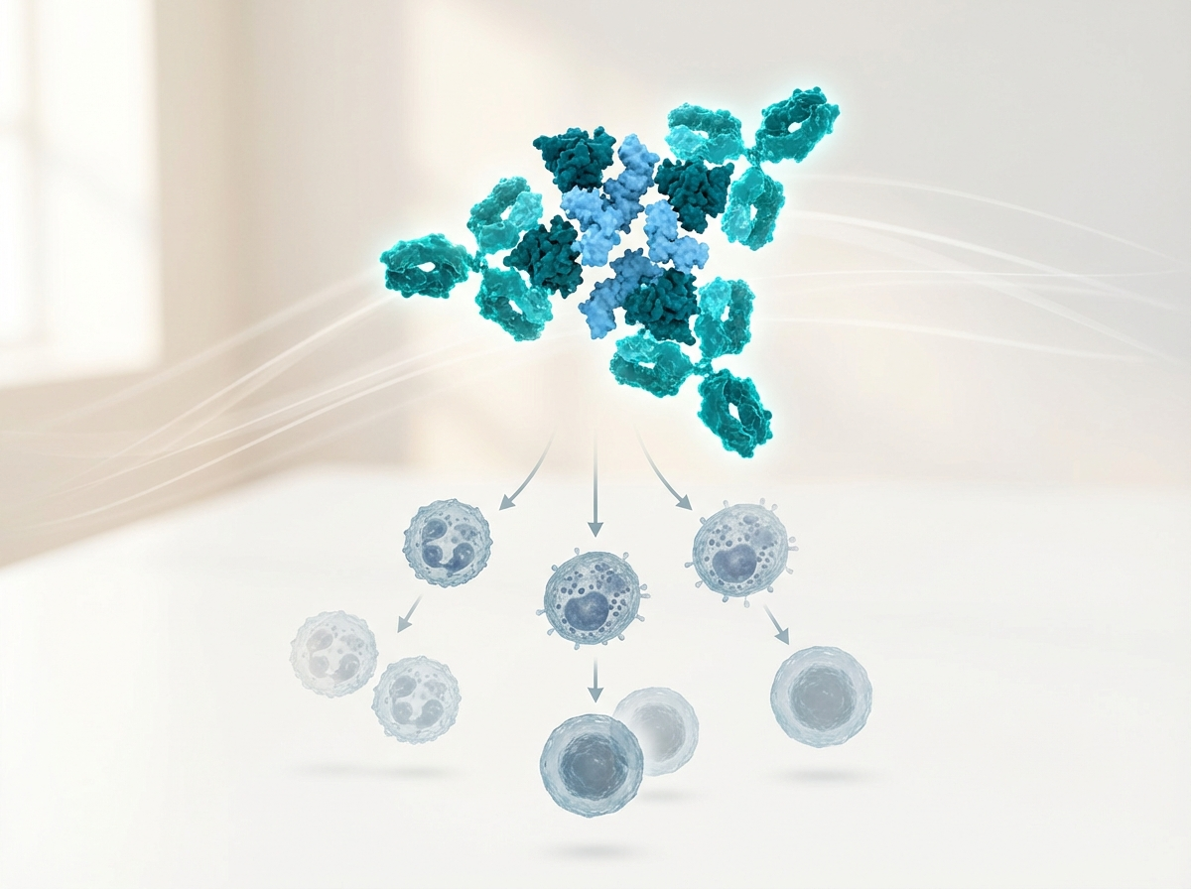
https://treluxia-images.pages.dev/columns-moa-preview.jpeg
Usage: Home — MoA teaser
Heading: Targeting TSLP: upstream control of airway inflammation
Body text: TSLP is an epithelial-derived cytokine released at the top of the asthma inflammatory cascade. By blocking TSLP, TRELUXIA inhibits multiple downstream pathways driving both eosinophilic and non-eosinophilic inflammation, providing broad anti-inflammatory control regardless of phenotype.³ ⁵
Call to action: Explore how TRELUXIA works → /treluxia/how-treluxia-works
────────────────────────────────────────────────────────────

Section 5 — Prescribing information footer
Block: accordion
Expandable sections for: Prescribing Information | Adverse Event Reporting | References (Use approved text from sections 5, 6, and 7 above)

Page metadata
Title: TRELUXIA (trelimovab) | Severe Asthma Treatment | AstraZeneca UK
Description: TRELUXIA (trelimovab) is a human anti-TSLP monoclonal antibody for adults and adolescents with severe uncontrolled asthma. Explore LUMINOS clinical data, safety, and dosing for UK healthcare professionals.

PAGE 2: LUMINOS Data
URL path: /treluxia/luminos-data
────────────────────────────────────────────────────────────

Section 1 — Hero (full-width image with text overlay)
Block: hero-teaser


https://treluxia-images.pages.dev/hero-efficacy.jpeg
Usage: LUMINOS Data — hero
Heading: The LUMINOS clinical programme
Body text: TRELUXIA™ (trelimovab) demonstrated significant exacerbation reduction, lung function improvement, and oral corticosteroid sparing across the full spectrum of severe asthma in two Phase III trials.¹ ²
────────────────────────────────────────────────────────────

Section 2 — Programme overview (centred text) | light background
Block: introduction
Section metadata: Style: light
Heading: Broad efficacy across severe asthma phenotypes
Body text: The LUMINOS programme evaluated trelimovab in two distinct severe asthma populations: LUMINOS-1 assessed exacerbation reduction and lung function in 1,061 adults and adolescents with uncontrolled severe asthma across all inflammatory phenotypes. LUMINOS-OCS assessed oral corticosteroid sparing in 407 adults with OCS-dependent severe asthma, demonstrating the potential to reduce the burden of chronic systemic corticosteroid use.¹ ²
────────────────────────────────────────────────────────────

Section 3 — Clinical data (two tabs)
Block: tabs-large

Tab 1: "LUMINOS-1: Exacerbation reduction"

https://treluxia-images.pages.dev/tab-luminos1.jpeg
Usage: LUMINOS Data — exacerbation tab
Heading: LUMINOS-1: 56% reduction in asthma exacerbations across all phenotypes
Body text: In LUMINOS-1, a randomised, double-blind, placebo-controlled trial in 1,061 adults and adolescents with severe asthma on medium- or high-dose ICS plus additional controllers, TRELUXIA reduced the annualised asthma exacerbation rate by 56% versus placebo across the overall population (rate ratio 0.44; 95% CI: 0.37–0.53; P<0.001). The benefit was observed irrespective of baseline blood eosinophil count: 62% reduction in patients with eosinophils ≥300 cells/μL (RR 0.38; P<0.001) and 41% reduction in patients with eosinophils <300 cells/μL (RR 0.59; P<0.001).¹

Body text (continued): TRELUXIA significantly improved pre-bronchodilator FEV₁ by 0.25 L at Week 52 versus placebo (P<0.001). Patients also reported clinically meaningful improvements in asthma symptom control (ACQ-6 difference: −0.48; P<0.001). Exacerbations requiring hospitalisation or emergency room visits were reduced by 77% (rate ratio 0.23; P<0.001).¹
Data table:
Endpoint | TRELUXIA (n=529) | Placebo (n=532) | Treatment effect
AAER (overall) | 0.93 | 2.10 | RR 0.44 (0.37–0.53); P<0.001
AAER (eos ≥300) | 0.85 | 2.26 | RR 0.38 (0.29–0.49); P<0.001
AAER (eos <300) | 1.14 | 1.92 | RR 0.59 (0.45–0.78); P<0.001
Pre-BD FEV₁ at Week 52 | +0.29 L | +0.04 L | +0.25 L (0.18–0.32); P<0.001
ACQ-6 at Week 52 | −1.55 | −1.07 | −0.48 (−0.62 to −0.34); P<0.001
────────────────────────────────────────────────────────────
Tab 2: "LUMINOS-OCS: Oral corticosteroid sparing"

https://treluxia-images.pages.dev/tab-luminos-ocs.jpeg
Usage: LUMINOS Data — OCS sparing tab
Heading: LUMINOS-OCS: Enabling steroid freedom for OCS-dependent patients
Body text: LUMINOS-OCS was a randomised, double-blind, placebo-controlled trial in 407 adults with severe asthma dependent on maintenance oral corticosteroids (≥5 mg prednisolone equivalent daily) receiving high-dose ICS plus additional controllers.²

Body text (continued): TRELUXIA enabled a median 75% reduction in OCS dose at Week 48, compared with 25% for placebo (odds ratio 2.58; P<0.001). Over one-third of TRELUXIA-treated patients (37.9%) achieved complete OCS elimination, compared with 10.8% of placebo patients (OR 5.07; P<0.001). Critically, OCS reduction was achieved while maintaining asthma control: the AAER during the OCS reduction phase was 61% lower with TRELUXIA than placebo (RR 0.39; P<0.001), and ACQ-6 scores improved significantly (difference: −0.73; P<0.001).²
Data table:
Endpoint | TRELUXIA (n=203) | Placebo (n=204) | Treatment effect
Median OCS reduction at Week 48 | −75% | −25% | OR 2.58 (1.79–3.72); P<0.001
≥50% OCS reduction | 71.4% | 41.7% | OR 3.49 (2.31–5.27); P<0.001
Complete OCS elimination | 37.9% | 10.8% | OR 5.07 (3.03–8.49); P<0.001
AAER during OCS reduction | 0.76 | 1.97 | RR 0.39 (0.28–0.53); P<0.001
ACQ-6 at Week 48 | −1.41 | −0.68 | −0.73 (−0.97 to −0.49); P<0.001
────────────────────────────────────────────────────────────

Section 4 — Prescribing information footer
Block: accordion | Expandable: PI | AE Reporting | References

Page metadata
Title: LUMINOS Data | TRELUXIA (trelimovab) | Exacerbation & OCS Outcomes | AstraZeneca UK
Description: Explore the LUMINOS clinical programme for TRELUXIA (trelimovab) — Phase III exacerbation reduction, lung function improvement, and oral corticosteroid sparing in adults and adolescents with severe asthma.

PAGE 3: Safety
URL path: /treluxia/safety
────────────────────────────────────────────────────────────

Section 1 — Page header (text only, no image)
Block: title
Heading: Safety profile of TRELUXIA
Body text: TRELUXIA™ (trelimovab) has been evaluated in over 700 patients across the LUMINOS clinical programme, with treatment durations of up to 52 weeks.¹ ² ³
────────────────────────────────────────────────────────────

Section 2 — Key safety message (centred text) | highlight background
Block: introduction
Section metadata: Style: highlight
Heading: A favourable safety profile consistent with a targeted biologic
Body text: The overall safety profile of TRELUXIA is consistent with expectations for a human IgG2 monoclonal antibody targeting an epithelial cytokine. Serious adverse events were lower with TRELUXIA than placebo (8.4% vs 11.2%), driven by fewer asthma-related hospitalisations. Treatment discontinuation due to adverse events was low (2.4% vs 3.1%). The most common adverse events were mild upper respiratory tract infections and injection site reactions.¹ ² ³
────────────────────────────────────────────────────────────

Section 3 — Safety overview (centred text) | light background
Block: introduction
Section metadata: Style: light
Heading: Safety profile across the LUMINOS programme
Body text: Across pooled LUMINOS data (N=732 TRELUXIA), the adverse event profile was dominated by common respiratory infections and mild injection site reactions. No clinically significant immunosuppression, malignancy signal, or cardiovascular safety concerns were identified. Anti-drug antibodies were detected in 5.1% of patients but had no impact on efficacy or safety. Anaphylaxis was rare (0.4%) and all events resolved with standard management.¹ ² ³
────────────────────────────────────────────────────────────

Section 4 — Adverse events table | light background
Block: table-data
Section metadata: Style: light
Adverse event | TRELUXIA (%) | Placebo (%)
Nasopharyngitis | 10.4 | 9.8
Upper respiratory tract infection | 8.1 | 7.4
Headache | 6.7 | 5.2
Injection site reactions | 4.6 | 2.8
Arthralgia | 3.8 | 3.1
Back pain | 3.2 | 2.6
Pharyngitis | 2.9 | 2.5
Fatigue | 2.4 | 1.9
────────────────────────────────────────────────────────────

Section 5 — Key safety consideration cards (equal columns)
Block: cards-teaser


https://treluxia-images.pages.dev/card-isr.jpeg
Usage: Safety — injection site reactions card
Card heading: Injection site reactions
Card body: Injection site reactions occurred in 4.6% of TRELUXIA-treated patients vs 2.8% with placebo. The most common were erythema, pain, and swelling. All ISRs were mild to moderate in severity. No injection site reaction led to treatment discontinuation.³
────────────────────────────────────────────────────────────

https://treluxia-images.pages.dev/card-anaphylaxis.jpeg
Usage: Safety — anaphylaxis card
Card heading: Anaphylaxis and hypersensitivity
Card body: Anaphylaxis was reported in 3 patients (0.4%) receiving TRELUXIA. All events occurred within 24 hours of injection and resolved with standard treatment. The first 3 doses should be administered under healthcare professional supervision. Patients should carry an adrenaline auto-injector for the duration of treatment.³
────────────────────────────────────────────────────────────

https://treluxia-images.pages.dev/card-infections.jpeg
Usage: Safety — infections card
Card heading: Infections and immunogenicity
Card body: Upper respiratory tract infections were the most common adverse events, occurring at similar rates in TRELUXIA and placebo groups. No clinically significant immunosuppression was observed. Anti-drug antibodies were detected in 5.1% but had no impact on efficacy, safety, or pharmacokinetics.¹ ³
────────────────────────────────────────────────────────────

Section 6 — Special populations (two-column: image left, text right) | highlight background
Block: columns-teaser
Section metadata: Style: highlight


https://treluxia-images.pages.dev/columns-special-pops.jpeg
Usage: Safety — special populations
Heading: Special populations
Body text: Adolescents (12–17 years): Same dose as adults (210 mg Q4W). In LUMINOS-1, 63 adolescents received TRELUXIA with consistent efficacy and safety.³
Elderly patients: No dose adjustment required in patients aged ≥65 years. 11% of LUMINOS-1 patients were ≥65 years.³
Pregnancy and fertility: TRELUXIA should only be used during pregnancy if the potential benefit justifies the potential risk to the foetus. Human IgG antibodies cross the placental barrier.³
Renal/hepatic impairment: No dose adjustment for mild to moderate impairment. Not studied in severe impairment.³
────────────────────────────────────────────────────────────

Section 7 — Prescribing information footer
Block: accordion | Expandable: PI | AE Reporting | References

Page metadata
Title: Safety | TRELUXIA (trelimovab) | Adverse Events & Monitoring | AstraZeneca UK
Description: Review the safety profile of TRELUXIA (trelimovab) including injection site reactions, anaphylaxis risk, infection rates, and special population recommendations for severe asthma.

PAGE 4: Dosing & Administration
URL path: /treluxia/dosing
────────────────────────────────────────────────────────────

Section 1 — Hero (full-width image with text overlay)
Block: hero-teaser


https://treluxia-images.pages.dev/hero-dosing.jpeg
Usage: Dosing — hero
Heading: Dosing and administration
Body text: TRELUXIA™ (trelimovab) offers a simple once-every-4-weeks subcutaneous injection for adults and adolescents with severe asthma, with the option for self-administration after initial supervised doses.³
────────────────────────────────────────────────────────────

Section 2 — Dosing regimen (two-column) | light background
Block: columns-teaser
Section metadata: Style: light

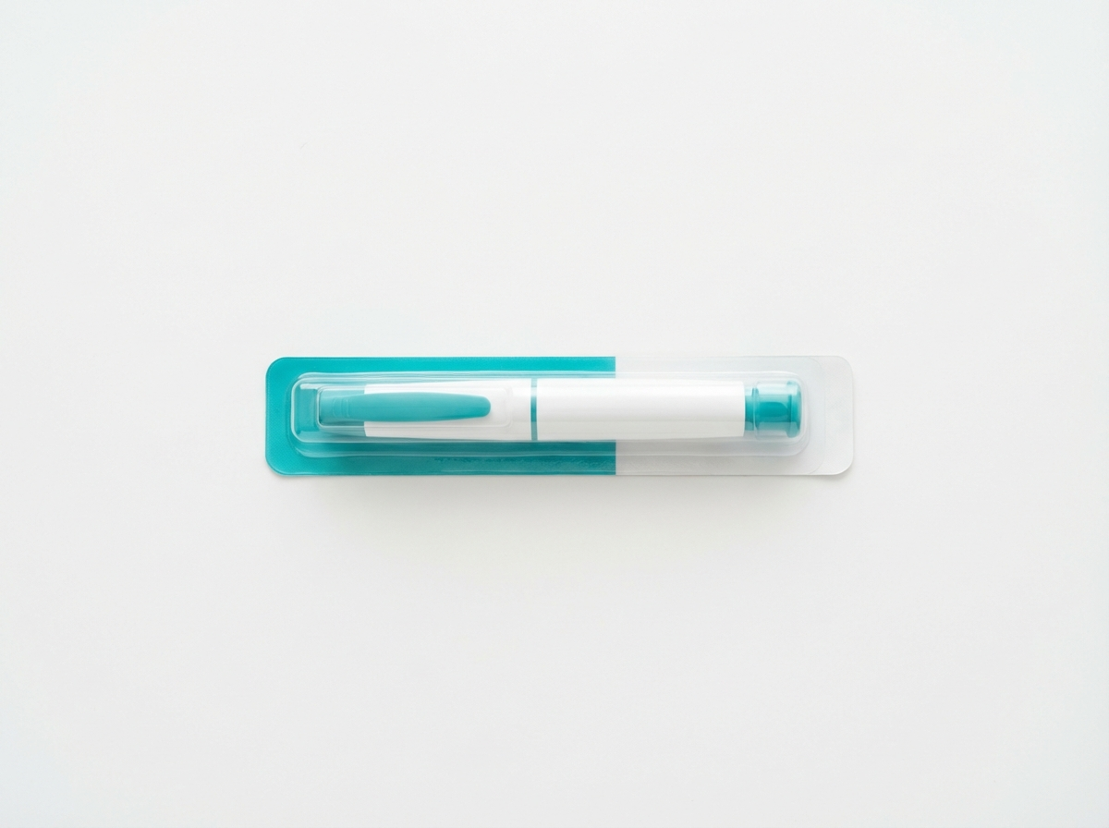
https://treluxia-images.pages.dev/columns-dosing.jpeg
Usage: Dosing — regimen
Heading: Simple dosing with no titration required
Body text: Dose: 210 mg subcutaneous injection once every 4 weeks (Q4W).³
No weight-based dosing adjustment required.³
No dose titration required — full therapeutic dose from Day 1.³
Same dose for adults and adolescents aged ≥12 years.³
Available as a pre-filled syringe or pre-filled pen (autoinjector) for patient convenience.³
────────────────────────────────────────────────────────────

Section 3 — Administration guidance (two-column)
Block: columns-teaser


https://treluxia-images.pages.dev/columns-admin.jpeg
Usage: Dosing — administration
Heading: Administration and self-injection guidance
Body text: The first 3 doses should be administered under the supervision of a healthcare professional. Thereafter, patients or caregivers may self-administer after training in subcutaneous injection technique.³
Injection sites: Thigh, abdomen (excluding 5 cm around the navel), or upper arm (if administered by caregiver). Rotate injection sites between doses.³
Allow TRELUXIA to reach room temperature (approximately 30 minutes) before injection. Do not use external heat sources. Do not shake.³
Do not inject into areas that are tender, bruised, erythematous, or indurated.³
────────────────────────────────────────────────────────────

Section 4 — Concomitant therapy and corticosteroid management (two-column) | highlight background
Block: columns-teaser
Section metadata: Style: highlight

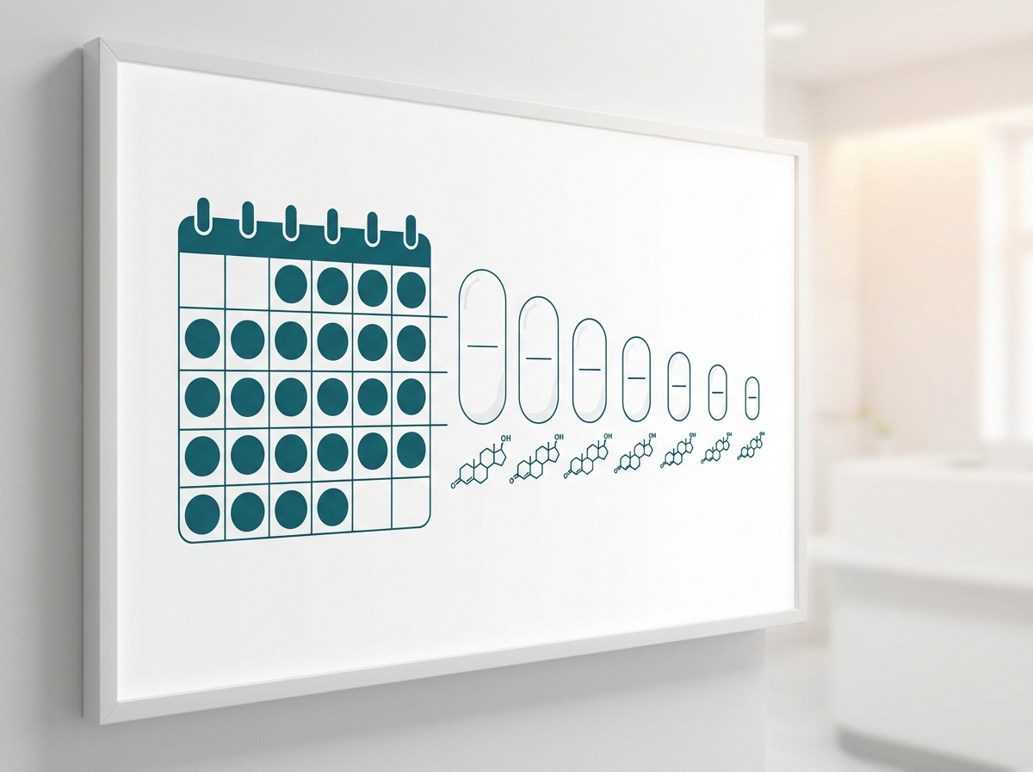
https://treluxia-images.pages.dev/columns-ocs-management.jpeg
Usage: Dosing — OCS management
Heading: Concomitant therapy and corticosteroid management
Body text: TRELUXIA should be added to existing maintenance asthma therapy. Do not abruptly discontinue inhaled corticosteroids or oral corticosteroids upon initiation.³
For patients receiving maintenance oral corticosteroids, reduction may be considered after at least 12 weeks of TRELUXIA treatment, under physician supervision. Reduce OCS dose gradually (no faster than 2.5 mg prednisolone equivalent per month) while monitoring asthma symptoms and exacerbation frequency.² ³
TRELUXIA may be used alongside ICS, LABA, LTRA, LAMA, theophylline, and oral corticosteroids. No clinically significant drug interactions have been identified.³
────────────────────────────────────────────────────────────

Section 5 — Prescribing information footer
Block: accordion | Expandable: PI | AE Reporting | References

Page metadata
Title: Dosing | TRELUXIA (trelimovab) | Q4W Subcutaneous Injection | AstraZeneca UK
Description: Dosing and administration guidance for TRELUXIA (trelimovab) including injection technique, self-administration training, concomitant therapy, and corticosteroid management in severe asthma.

PAGE 5: How TRELUXIA Works
URL path: /treluxia/how-treluxia-works
────────────────────────────────────────────────────────────

Section 1 — Hero (full-width image with text overlay)
Block: hero-teaser


https://treluxia-images.pages.dev/hero-moa.jpeg
Usage: How TRELUXIA Works — hero
Heading: Upstream control at the source of airway inflammation
Body text: TRELUXIA™ (trelimovab) blocks TSLP, an epithelial cytokine that initiates multiple inflammatory cascades in asthma — providing broad anti-inflammatory control beyond single-pathway biologics.³ ⁵
────────────────────────────────────────────────────────────

Section 2 — The TSLP pathway (two-column)
Block: columns-teaser

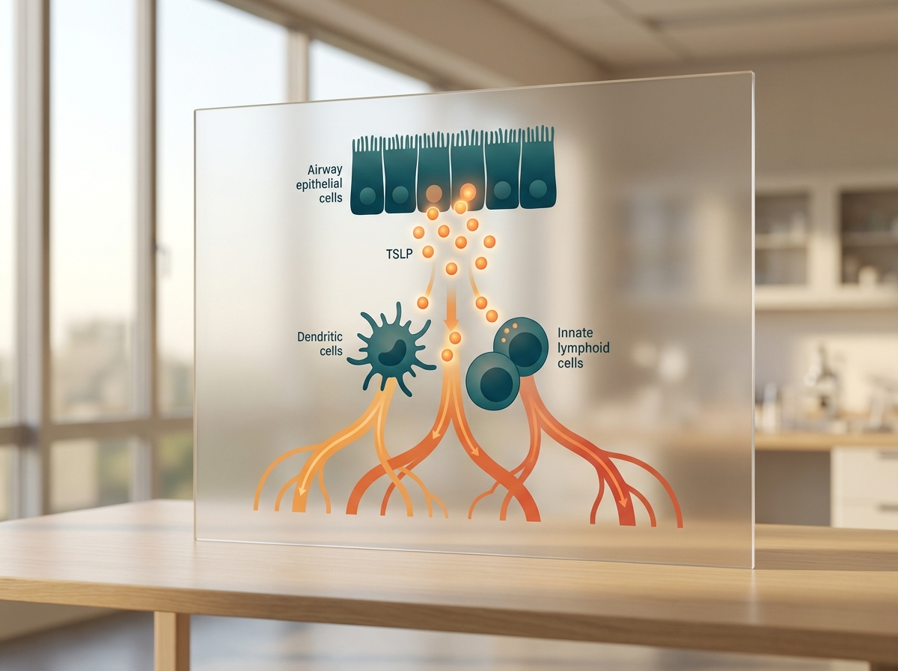
https://treluxia-images.pages.dev/columns-tslp-pathway.jpeg
Usage: MoA — TSLP pathway
Heading: TSLP: the upstream driver of severe asthma inflammation
Body text: Thymic stromal lymphopoietin (TSLP) is produced by airway epithelial cells in response to environmental triggers including allergens, viral infections, pollutants, and mechanical injury.⁵
Once released, TSLP activates dendritic cells and innate lymphoid cells (ILC2s), initiating a cascade of downstream inflammatory events: Th2 cell differentiation and IL-4/IL-5/IL-13 production, eosinophil recruitment and activation, IgE class switching and mast cell sensitisation, and structural cell activation driving airway remodelling.⁴ ⁵
Crucially, TSLP also drives non-type 2 inflammatory pathways including mast cell cytokine release and neutrophil-mediated inflammation, making it relevant across the full phenotypic spectrum of severe asthma.⁵
────────────────────────────────────────────────────────────

Section 3 — TRELUXIA mechanism (two-column) | highlight background
Block: columns-teaser
Section metadata: Style: highlight

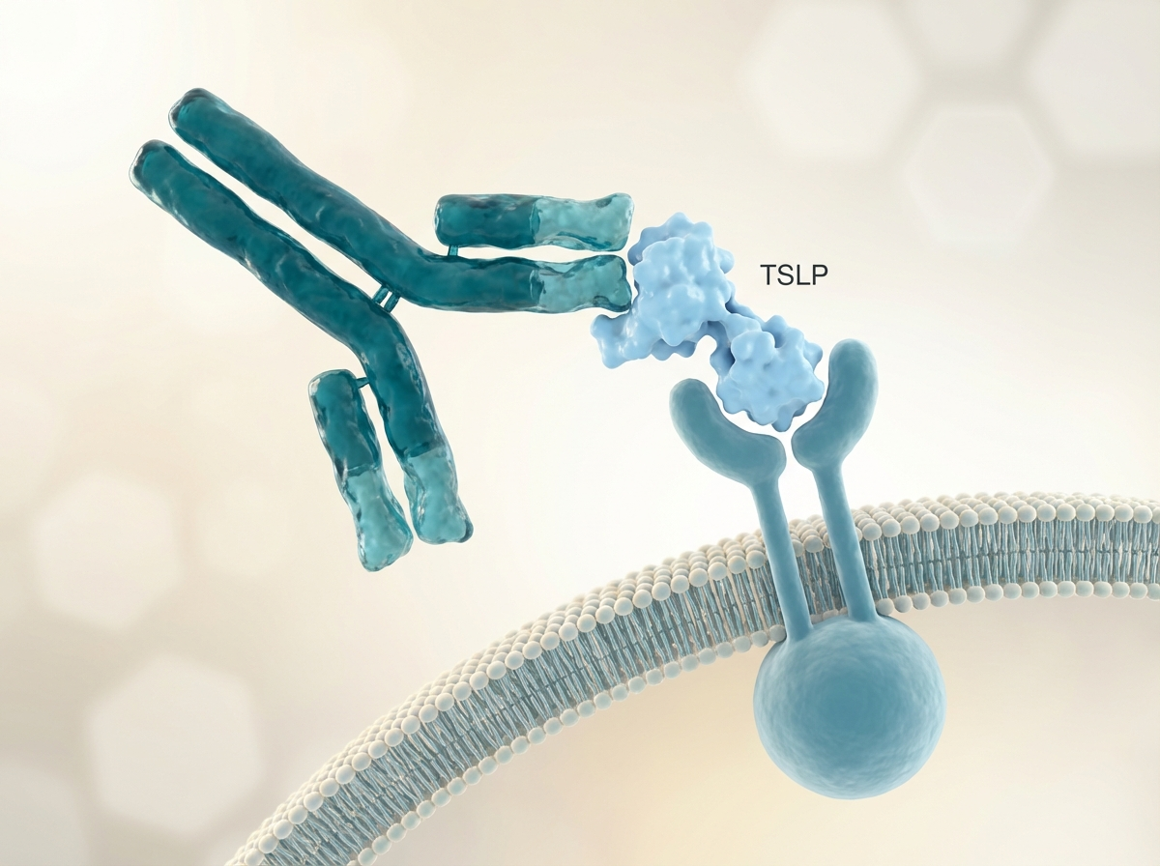
https://treluxia-images.pages.dev/columns-mechanism.jpeg
Usage: MoA — TRELUXIA mechanism
Heading: How TRELUXIA blocks TSLP signalling
Body text: Trelimovab is a human IgG2λ monoclonal antibody that binds specifically to TSLP, preventing its interaction with the heterodimeric TSLP receptor complex (TSLPR/IL-7Rα) on the surface of immune cells.³
By neutralising TSLP at the top of the inflammatory cascade, trelimovab inhibits the activation of downstream type 2 and non-type 2 pathways simultaneously — reducing eosinophilic inflammation, Th2 cytokine production, IgE synthesis, mast cell activation, and non-eosinophilic inflammatory mechanisms.³ ⁵
This broad upstream mechanism distinguishes TRELUXIA from biologics that target single downstream mediators (IL-5, IL-4/IL-13, IgE), enabling efficacy across all severe asthma phenotypes including those with low eosinophil counts and mixed inflammatory signatures.³
────────────────────────────────────────────────────────────

Section 4 — Positioning in the treatment pathway (two-column) | light background
Block: columns-teaser
Section metadata: Style: light

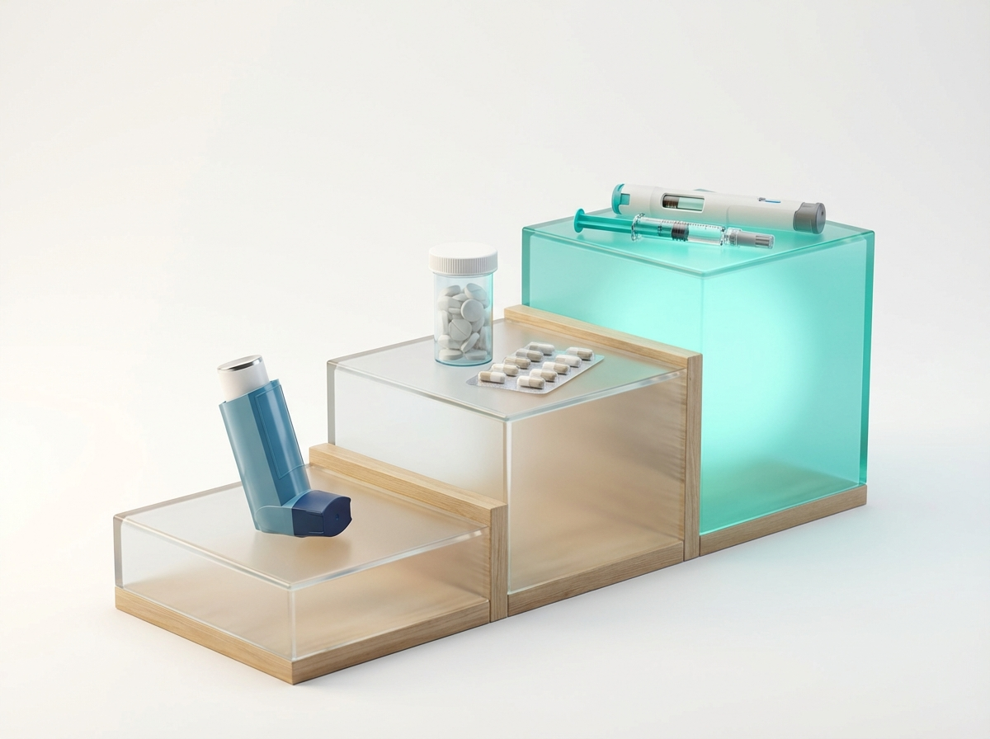
https://treluxia-images.pages.dev/columns-positioning.jpeg
Usage: MoA — treatment positioning
Heading: TRELUXIA in the severe asthma treatment pathway
Body text: Current guidelines recommend biologic therapy for patients with severe asthma that remains uncontrolled despite high-dose ICS plus additional controllers.⁴ Existing biologic options — anti-IL-5/5R, anti-IL-4/13, and anti-IgE — primarily target type 2 inflammatory pathways and require biomarker-based patient selection.⁴
TRELUXIA’s upstream TSLP blockade offers a complementary approach: it is indicated irrespective of inflammatory phenotype, providing a treatment option for patients across the entire severe asthma spectrum — including those who may not be eligible for or who have responded inadequately to existing biologics targeting single downstream pathways.³ ⁴
────────────────────────────────────────────────────────────

Section 5 — Prescribing information footer
Block: accordion | Expandable: PI | AE Reporting | References

Page metadata
Title: How TRELUXIA Works | Anti-TSLP Mechanism | Upstream Asthma Control | AstraZeneca UK
Description: Understand the mechanism of action of TRELUXIA (trelimovab) — an anti-TSLP monoclonal antibody providing broad upstream control of airway inflammation in severe asthma.

PAGE 6: Resources
URL path: /treluxia/resources
────────────────────────────────────────────────────────────

Section 1 — Page header (text only, no image)
Block: title
Heading: Resources for healthcare professionals
Body text: TRELUXIA™ (trelimovab) resources to support clinical decision-making and patient care in severe asthma.
────────────────────────────────────────────────────────────

Section 2 — Resource cards (equal columns)
Block: cards-teaser


https://treluxia-images.pages.dev/card-prescribing-guide.jpeg
Usage: Resources — prescribing guide card
Card heading: Prescribing guide
Card body: Download the TRELUXIA prescribing guide with dosing summary, injection technique checklist, monitoring recommendations, and concomitant therapy guidance for severe asthma in adults and adolescents.
Card link: Download prescribing guide (PDF)
────────────────────────────────────────────────────────────

https://treluxia-images.pages.dev/card-patient-materials.jpeg
Usage: Resources — patient materials card
Card heading: Patient support materials
Card body: Access patient-facing materials including the TRELUXIA self-injection guide, asthma action plan template, and OCS reduction diary to support shared decision-making and self-management.
Card link: View patient materials
────────────────────────────────────────────────────────────

https://treluxia-images.pages.dev/card-clinical-data.jpeg
Usage: Resources — clinical data card
Card heading: LUMINOS clinical data summary
Card body: Request the LUMINOS clinical data compendium with full trial results from LUMINOS-1 and LUMINOS-OCS, including subgroup analyses by eosinophil count, atopic status, and prior biologic use.
Card link: Request clinical data pack
────────────────────────────────────────────────────────────

Section 3 — Medical information contact (two-column) | highlight background
Block: columns-teaser
Section metadata: Style: highlight


https://treluxia-images.pages.dev/columns-contact.jpeg
Usage: Resources — contact
Heading: Medical information and support
Body text: For medical information enquiries about TRELUXIA, contact AstraZeneca Medical Information:
Online: contactazmedical.astrazeneca.com
Phone: 0800 783 0033
Email: medinfo.uk@astrazeneca.com
For adverse event reporting, visit www.mhra.gov.uk/yellowcard or contact AstraZeneca directly.
────────────────────────────────────────────────────────────

Section 4 — Prescribing information footer
Block: accordion | Expandable: PI | AE Reporting | References

Page metadata
Title: Resources | TRELUXIA (trelimovab) | HCP Support Materials | AstraZeneca UK
Description: Download prescribing guides, patient support materials, and clinical data summaries for TRELUXIA (trelimovab) in severe asthma. Contact AstraZeneca Medical Information for enquiries.

10. Footer Content
Row 1 — Brand: AstraZeneca logo | GB-98204 | DOP: March 2026 | © AstraZeneca 2026. TRELUXIA is a trademark of the AstraZeneca group of companies.
Row 2 — Site links: LUMINOS Data | Safety | Dosing & Administration | How TRELUXIA Works | Resources
Row 3 — Regulatory links: Report Adverse Event (https://yellowcard.mhra.gov.uk/) | Medical Information (https://contactazmedical.astrazeneca.com/) | Privacy Policy (https://www.astrazeneca.co.uk/our-company/privacy-notice.html) | Terms of Use (https://www.astrazeneca.co.uk/our-company/terms-of-use.html) | Accessibility (https://www.astrazeneca.co.uk/accessibility.html)
Row 4 — Date: Date of Preparation: March 2026
────────────────────────────────────────────────────────────

11. Image Assets
All images are generated using the AZ brand image pipeline and deployed to https://treluxia-images.pages.dev/. Each image is shown below with its CDN URL and usage context.

# | Filename | CDN URL | Dimensions | Usage
1 | hero-home.jpeg | https://treluxia-images.pages.dev/hero-home.jpeg | 1440×810 | Home — hero
2 | hero-efficacy.jpeg | https://treluxia-images.pages.dev/hero-efficacy.jpeg | 1440×810 | LUMINOS Data — hero
3 | hero-dosing.jpeg | https://treluxia-images.pages.dev/hero-dosing.jpeg | 1440×810 | Dosing — hero
4 | hero-moa.jpeg | https://treluxia-images.pages.dev/hero-moa.jpeg | 1440×810 | How TRELUXIA Works — hero
5 | card-exacerbations.jpeg | https://treluxia-images.pages.dev/card-exacerbations.jpeg | 800×600 | Home — exacerbation reduction card
6 | card-lung-function.jpeg | https://treluxia-images.pages.dev/card-lung-function.jpeg | 800×600 | Home — lung function card
7 | card-ocs.jpeg | https://treluxia-images.pages.dev/card-ocs.jpeg | 800×600 | Home — OCS sparing card
8 | card-isr.jpeg | https://treluxia-images.pages.dev/card-isr.jpeg | 800×600 | Safety — injection site reactions card
9 | card-anaphylaxis.jpeg | https://treluxia-images.pages.dev/card-anaphylaxis.jpeg | 800×600 | Safety — anaphylaxis card
10 | card-infections.jpeg | https://treluxia-images.pages.dev/card-infections.jpeg | 800×600 | Safety — infections card
11 | card-prescribing-guide.jpeg | https://treluxia-images.pages.dev/card-prescribing-guide.jpeg | 800×600 | Resources — prescribing guide card
12 | card-patient-materials.jpeg | https://treluxia-images.pages.dev/card-patient-materials.jpeg | 800×600 | Resources — patient materials card
13 | card-clinical-data.jpeg | https://treluxia-images.pages.dev/card-clinical-data.jpeg | 800×600 | Resources — clinical data card
14 | columns-moa-preview.jpeg | https://treluxia-images.pages.dev/columns-moa-preview.jpeg | 800×600 | Home — MoA teaser
15 | columns-dosing.jpeg | https://treluxia-images.pages.dev/columns-dosing.jpeg | 800×600 | Dosing — regimen
16 | columns-admin.jpeg | https://treluxia-images.pages.dev/columns-admin.jpeg | 800×600 | Dosing — administration
17 | columns-ocs-management.jpeg | https://treluxia-images.pages.dev/columns-ocs-management.jpeg | 800×600 | Dosing — OCS management
18 | columns-tslp-pathway.jpeg | https://treluxia-images.pages.dev/columns-tslp-pathway.jpeg | 800×600 | MoA — TSLP pathway
19 | columns-mechanism.jpeg | https://treluxia-images.pages.dev/columns-mechanism.jpeg | 800×600 | MoA — TRELUXIA mechanism
20 | columns-positioning.jpeg | https://treluxia-images.pages.dev/columns-positioning.jpeg | 800×600 | MoA — treatment positioning
21 | columns-special-pops.jpeg | https://treluxia-images.pages.dev/columns-special-pops.jpeg | 800×600 | Safety — special populations
22 | columns-contact.jpeg | https://treluxia-images.pages.dev/columns-contact.jpeg | 800×600 | Resources — contact
23 | tab-luminos1.jpeg | https://treluxia-images.pages.dev/tab-luminos1.jpeg | 800×600 | LUMINOS Data — exacerbation tab
24 | tab-luminos-ocs.jpeg | https://treluxia-images.pages.dev/tab-luminos-ocs.jpeg | 800×600 | LUMINOS Data — OCS sparing tab

Image previews

https://treluxia-images.pages.dev/hero-home.jpeg
Usage: Home — hero


https://treluxia-images.pages.dev/hero-efficacy.jpeg
Usage: LUMINOS Data — hero


https://treluxia-images.pages.dev/hero-dosing.jpeg
Usage: Dosing — hero


https://treluxia-images.pages.dev/hero-moa.jpeg
Usage: How TRELUXIA Works — hero


https://treluxia-images.pages.dev/card-exacerbations.jpeg
Usage: Home — exacerbation reduction card


https://treluxia-images.pages.dev/card-lung-function.jpeg
Usage: Home — lung function card


https://treluxia-images.pages.dev/card-ocs.jpeg
Usage: Home — OCS sparing card


https://treluxia-images.pages.dev/card-isr.jpeg
Usage: Safety — injection site reactions card


https://treluxia-images.pages.dev/card-anaphylaxis.jpeg
Usage: Safety — anaphylaxis card


https://treluxia-images.pages.dev/card-infections.jpeg
Usage: Safety — infections card


https://treluxia-images.pages.dev/card-prescribing-guide.jpeg
Usage: Resources — prescribing guide card


https://treluxia-images.pages.dev/card-patient-materials.jpeg
Usage: Resources — patient materials card


https://treluxia-images.pages.dev/card-clinical-data.jpeg
Usage: Resources — clinical data card


https://treluxia-images.pages.dev/columns-moa-preview.jpeg
Usage: Home — MoA teaser


https://treluxia-images.pages.dev/columns-dosing.jpeg
Usage: Dosing — regimen


https://treluxia-images.pages.dev/columns-admin.jpeg
Usage: Dosing — administration


https://treluxia-images.pages.dev/columns-ocs-management.jpeg
Usage: Dosing — OCS management


https://treluxia-images.pages.dev/columns-tslp-pathway.jpeg
Usage: MoA — TSLP pathway


https://treluxia-images.pages.dev/columns-mechanism.jpeg
Usage: MoA — TRELUXIA mechanism


https://treluxia-images.pages.dev/columns-positioning.jpeg
Usage: MoA — treatment positioning


https://treluxia-images.pages.dev/columns-special-pops.jpeg
Usage: Safety — special populations


https://treluxia-images.pages.dev/columns-contact.jpeg
Usage: Resources — contact


https://treluxia-images.pages.dev/tab-luminos1.jpeg
Usage: LUMINOS Data — exacerbation tab


https://treluxia-images.pages.dev/tab-luminos-ocs.jpeg
Usage: LUMINOS Data — OCS sparing tab

