SERANOVA™
(valinectra)

Website Briefing

Protecting what matters.

Document type: Final approved marketing brief for HCP website build
Prepared by: Marketing — UK Cardiorenal Franchise
Approval status: MLR-approved copy — do not modify
Date: March 2026
Approval code: GB-96017 | DOP: March 2026

Contents
1. Drug Profile
2. Mechanism of Action
3. Clinical Programme: RENOVA
4. Safety Profile
5. Prescribing Information
6. Adverse Event Reporting
7. References
8. Site Navigation
9. Page Content
Page 1: Home
Page 2: RENOVA Data
Page 3: Safety
Page 4: Dosing & Monitoring
Page 5: How SERANOVA Works
Page 6: Resources
10. Footer Content
11. Image Assets

1. Drug Profile
Field | Detail
Brand name | SERANOVA
Generic name | valinectra
Drug class | Non-steroidal selective mineralocorticoid receptor antagonist (ns-MRA)
Indication | Reduction of sustained eGFR decline, end-stage kidney disease, cardiovascular death, and hospitalisation for heart failure in adults with chronic kidney disease associated with type 2 diabetes mellitus
Extended indication | Reduction of cardiovascular death and hospitalisation for heart failure in adults with chronic kidney disease (eGFR 25–75 mL/min/1.73m² and UACR ≥30 mg/g) associated with type 2 diabetes mellitus
Formulation | 10 mg and 20 mg film-coated tablets
Dosing | 10 mg once daily, uptitrated to 20 mg once daily after 4 weeks based on serum potassium
Approval | MHRA — February 2026
Brand colour | Cerulean Blue #0072B2
Accent colour | Warm Amber #D4851F
Approval code | GB-96017

SERANOVA brand rule: SERANOVA always appears in capitals, with ™ on first mention per page. Generic name (valinectra) appears in lowercase parentheses on first mention. The approved tagline "Protecting what matters." may only be used verbatim — no variations permitted.
────────────────────────────────────────────────────────────

2. Mechanism of Action
Valinectra is a non-steroidal selective antagonist of the mineralocorticoid receptor (MR). Unlike steroidal MRAs such as spironolactone and eplerenone, valinectra binds to the MR ligand-binding domain with a distinct non-steroidal pharmacophore, conferring high selectivity for the MR over glucocorticoid, androgen, and progesterone receptors, thereby minimising off-target endocrine effects.
In chronic kidney disease associated with type 2 diabetes, persistent hyperglycaemia and haemodynamic stress drive excessive activation of the mineralocorticoid receptor in renal tubular epithelial cells, podocytes, mesangial cells, and cardiac fibroblasts. MR overactivation promotes:
- Renal fibrosis through pro-inflammatory and pro-fibrotic gene transcription (NF-κB, TGF-β, PAI-1)
- Podocyte injury and proteinuria via direct podocyte MR signalling
- Endothelial dysfunction and vascular inflammation
- Cardiac fibrosis and left ventricular remodelling
- Sodium retention and potassium excretion, contributing to volume overload and hypokalaemia correction
By selectively blocking MR activation, valinectra reduces inflammation-driven kidney injury, attenuates proteinuria, slows the decline in glomerular filtration rate, and provides cardiorenal protection — complementing the mechanisms of RAAS inhibitors, SGLT2 inhibitors, and GLP-1 receptor agonists in the comprehensive management of diabetic kidney disease.
────────────────────────────────────────────────────────────

3. Clinical Programme: RENOVA

RENOVA-CKD (Phase III, pivotal — Kidney outcomes in CKD + T2D)
Design: Randomised, double-blind, placebo-controlled, event-driven Phase III trial
Population: 7,352 adults with CKD (eGFR 25–75 mL/min/1.73m², UACR 30–5,000 mg/g) associated with type 2 diabetes, receiving maximum tolerated RAAS inhibition
Median follow-up: 3.4 years
Primary endpoint: Composite of sustained ≥57% eGFR decline from baseline, end-stage kidney disease (ESKD), renal death, or cardiovascular death
Key secondary endpoints: Composite of CV death or hospitalisation for heart failure (HHF); sustained ≥40% eGFR decline; total eGFR slope; change in UACR at Month 4
Publication: Nakamura et al. N Engl J Med 2025; 393(8): 712–726

Key results:
Endpoint | SERANOVA (n=3,676) | Placebo (n=3,676) | Treatment effect
Primary composite (kidney + CV death) | 504 events (13.7%) | 648 events (17.6%) | HR 0.77 (0.67–0.88); P<0.001
Sustained ≥57% eGFR decline or ESKD | 360 events (9.8%) | 474 events (12.9%) | HR 0.75 (0.64–0.87); P<0.001
CV death or HHF | 367 events (10.0%) | 446 events (12.1%) | HR 0.82 (0.71–0.94); P=0.005
Total eGFR slope (mL/min/1.73m²/year) | −2.1 | −3.8 | Difference: +1.7 (1.3 to 2.1); P<0.001
UACR change at Month 4 | −36% | −2% | Ratio 0.65 (0.61–0.70); P<0.001
All-cause mortality | 284 (7.7%) | 335 (9.1%) | HR 0.84 (0.72–0.99); P=0.034

RENOVA-HF (Phase III — Heart failure outcomes in CKD + T2D)
Design: Randomised, double-blind, placebo-controlled, event-driven Phase III trial
Population: 3,814 adults with heart failure (NYHA II–IV, LVEF ≤40%), CKD (eGFR 25–60 mL/min/1.73m²), and type 2 diabetes, receiving guideline-directed medical therapy
Median follow-up: 2.8 years
Primary endpoint: Composite of cardiovascular death or hospitalisation for heart failure
Publication: Tanaka et al. Lancet 2026; 407(10332): 245–259

Key results:
Endpoint | SERANOVA (n=1,907) | Placebo (n=1,907) | Treatment effect
Primary composite (CV death + HHF) | 374 events (19.6%) | 453 events (23.8%) | HR 0.82 (0.72–0.93); P=0.002
CV death | 186 (9.8%) | 224 (11.7%) | HR 0.83 (0.68–1.01); P=0.058
Hospitalisation for heart failure | 268 events | 331 events | HR 0.80 (0.68–0.94); P=0.007
Kansas City Cardiomyopathy Questionnaire (KCCQ-TSS) change at Month 12 | +4.8 points | +1.9 points | Difference: +2.9 (1.6 to 4.2); P<0.001
eGFR slope (mL/min/1.73m²/year) | −1.8 | −3.2 | Difference: +1.4 (0.9 to 1.9); P<0.001
────────────────────────────────────────────────────────────

4. Safety Profile (Pooled RENOVA data, N=5,583 SERANOVA)

Most common adverse events (≥2%)
Adverse event | SERANOVA (%) | Placebo (%)
Hyperkalaemia (any grade) | 8.6 | 3.2
Hypotension | 4.2 | 2.8
Hypokalaemia | 0.4 | 2.1
Dizziness | 3.1 | 2.4
Diarrhoea | 2.8 | 2.3
Nasopharyngitis | 2.6 | 2.7
Back pain | 2.3 | 2.0
Urinary tract infection | 2.1 | 1.9
Acute kidney injury | 1.8 | 1.4

Hyperkalaemia — the principal safety consideration
Hyperkalaemia is an expected pharmacological effect of mineralocorticoid receptor antagonism and was the most frequently reported adverse event with SERANOVA. Proactive serum potassium monitoring and protocol-defined dose adjustment guidance minimised clinical impact:³
- Serum potassium >5.5 mmol/L: 14.2% SERANOVA vs 6.3% placebo
- Serum potassium >6.0 mmol/L: 1.4% vs 0.3%
- Hyperkalaemia leading to hospitalisation: 1.1% vs 0.4%
- Hyperkalaemia leading to permanent discontinuation: 1.7% vs 0.4%
- No fatal hyperkalaemic events in either treatment group
- Median time to first hyperkalaemia event: 8 months
- Events were manageable with dose reduction (20 mg → 10 mg) and standard potassium-lowering measures

Key safety findings
Serious adverse events: 21.4% SERANOVA vs 23.8% placebo
Treatment discontinuation due to AEs: 6.2% vs 5.1% (driven primarily by hyperkalaemia)
All-cause mortality: 7.7% vs 9.1% (HR 0.84; numerical reduction favouring SERANOVA)
Acute kidney injury: 1.8% vs 1.4% (no imbalance in serious AKI events requiring dialysis)
Gynaecomastia: 0.1% vs 0.1% (no signal for anti-androgenic effects, consistent with non-steroidal mechanism)³
Hepatic events: ALT >3× ULN: 0.5% vs 0.4% (no cases meeting Hy’s Law criteria)³

Special populations
- Renal impairment: No dose adjustment for eGFR 25–75 mL/min/1.73m² (studied population). SERANOVA has not been studied in patients with eGFR <25 mL/min/1.73m² or on dialysis. Do not initiate if eGFR <25 mL/min/1.73m².⁴
- Hepatic impairment: No dose adjustment for mild hepatic impairment (Child-Pugh A). Use with caution in moderate hepatic impairment (Child-Pugh B). Contraindicated in severe hepatic impairment (Child-Pugh C).⁴
- Elderly (≥65 years): No dose adjustment required. 42% of RENOVA-CKD patients were ≥65 years; efficacy and safety were consistent with the overall population.⁴
- Pregnancy and lactation: Contraindicated in pregnancy. Women of childbearing potential must use effective contraception during treatment and for 1 week after the last dose. It is not known whether valinectra is excreted in human milk; a decision must be made whether to discontinue breastfeeding or discontinue therapy.⁴
────────────────────────────────────────────────────────────

5. Prescribing Information (abbreviated — for every page footer)
SERANOVA (valinectra) 10 mg and 20 mg film-coated tablets. Please refer to the Summary of Product Characteristics (SmPC) before prescribing. Indication: Reduction of sustained eGFR decline, end-stage kidney disease, cardiovascular death, and hospitalisation for heart failure in adults with chronic kidney disease associated with type 2 diabetes mellitus. Dosage and administration: Initiate at 10 mg once daily. Measure serum potassium before initiation and within 4 weeks. If serum potassium ≤4.8 mmol/L, uptitrate to 20 mg once daily. If serum potassium >4.8 to 5.0 mmol/L, maintain 10 mg. If serum potassium >5.0 mmol/L, withhold and recheck. Contraindications: Hypersensitivity to valinectra or any excipient. Concomitant use with strong CYP3A4 inhibitors (e.g. itraconazole, ketoconazole, ritonavir, clarithromycin). Addison’s disease. Severe hepatic impairment (Child-Pugh C). Warnings and precautions: Monitor serum potassium before initiation, at 4 weeks, and periodically thereafter. Interrupt treatment if potassium >5.5 mmol/L. Do not initiate if serum potassium >5.0 mmol/L or eGFR <25 mL/min/1.73m². Use with caution in patients receiving potassium-sparing diuretics or potassium supplements. An initial eGFR decline may occur upon treatment initiation; this is typically reversible and not a reason to discontinue. Interactions: Contraindicated with strong CYP3A4 inhibitors. Avoid grapefruit juice. Moderate CYP3A4 inhibitors: no dose adjustment required but monitor potassium more frequently. Side effects: Very common (≥1/10): none. Common (≥1/100 to <1/10): hyperkalaemia, hypotension. Uncommon (≥1/1000 to <1/100): dizziness, pruritus, hyponatraemia. Legal category: POM. Pack and price: 28 tablets (10 mg): £524.60; 28 tablets (20 mg): £524.60. Marketing authorisation holder: AstraZeneca UK Ltd. MA number: PLGB 17901/0527. Full prescribing information available from: AstraZeneca UK Ltd, 2 Pancras Square, London N1C 4AG. GB-96017 | DOP: March 2026.
────────────────────────────────────────────────────────────

6. Adverse Event Reporting (for every page footer)
Adverse events should be reported. Reporting forms and information can be found at www.mhra.gov.uk/yellowcard or search for MHRA Yellow Card in the Google Play or Apple App Store. Adverse events should also be reported to AstraZeneca by visiting contactazmedical.astrazeneca.com or by calling 0800 783 0033.
────────────────────────────────────────────────────────────

7. References (for every page footer)
1. Nakamura et al. N Engl J Med 2025; 393(8): 712–726.
2. Tanaka et al. Lancet 2026; 407(10332): 245–259.
3. SERANOVA (valinectra) Summary of Product Characteristics. AstraZeneca UK Ltd. February 2026.
4. Agarwal R, et al. Nat Rev Nephrol 2024; 20(6): 381–398.
5. Kidney Disease: Improving Global Outcomes (KDIGO) CKD Work Group. Kidney Int Suppl 2024; 14(4): S1–S127.
────────────────────────────────────────────────────────────

8. Site Navigation
Top bar links: Contact Us (https://www.astrazeneca.co.uk/contact-us.html) | AZ Employee Login (https://login.astrazeneca.com)
Main navigation pages: RENOVA Data | Safety | Dosing & Monitoring | How SERANOVA Works | Resources
Utility: Search | Login

9. Page Content
IMPORTANT: All copy below is final and MLR-approved. It must be used exactly as written — do not modify, rephrase, or abbreviate any text. All superscript reference numbers, statistical values, and regulatory language must be reproduced verbatim.
Each page must end with expandable sections for Prescribing Information, Adverse Event Reporting, and References (see sections 5, 6, and 7 above).
SERANOVA brand rule: SERANOVA always appears in capitals, with ™ on first mention per page. Generic name (valinectra) in lowercase parentheses on first mention. Tagline "Protecting what matters." verbatim only.
────────────────────────────────────────────────────────────

PAGE 1: Home
URL path: /seranova/
────────────────────────────────────────────────────────────

Section 1 — Hero (full-width image with text overlay)
Block: hero-teaser


https://novapril-images.pages.dev/hero-home.jpeg
Usage: Home — hero
Heading: SERANOVA™ (valinectra)
Body text: Cardiorenal protection for adults with chronic kidney disease and type 2 diabetes. Protecting what matters.¹
Call to action: Explore the RENOVA data → /seranova/renova-data
────────────────────────────────────────────────────────────

Section 2 — Three key benefit cards (equal columns)
Block: cards-teaser


https://eluvion-images.pages.dev/trial1-results.jpeg
Usage: Home — renal outcomes card
Card heading: 23% reduction in kidney disease progression
Card body: In RENOVA-CKD, SERANOVA reduced the risk of the composite kidney outcome (sustained ≥57% eGFR decline, ESKD, renal death, or CV death) by 23% compared with placebo in adults with CKD and type 2 diabetes receiving maximum tolerated RAAS inhibition (HR 0.77; P<0.001).¹
Card link: View RENOVA data → /seranova/renova-data
────────────────────────────────────────────────────────────

https://revantha-images.pages.dev/card-efficacy.jpeg
Usage: Home — CV outcomes card
Card heading: 18% reduction in cardiovascular events
Card body: SERANOVA reduced the composite of cardiovascular death or hospitalisation for heart failure by 18% in RENOVA-CKD (HR 0.82; P=0.005) and by 18% in RENOVA-HF in patients with coexisting heart failure (HR 0.82; P=0.002), demonstrating consistent cardiorenal benefit.¹²
Card link: Explore cardiovascular outcomes → /seranova/renova-data
────────────────────────────────────────────────────────────

https://zenturis-images.pages.dev/card-dosing.jpeg
Usage: Home — oral dosing card
Card heading: Once-daily oral tablet with simple titration
Card body: SERANOVA is initiated at 10 mg once daily and uptitrated to 20 mg after 4 weeks based on serum potassium. A simple oral regimen designed to complement existing guideline-directed therapy for diabetic kidney disease.³
Card link: View dosing guidance → /seranova/dosing
────────────────────────────────────────────────────────────

Section 3 — Disease context (centred text) | light background
Block: introduction
Section metadata: Style: light
Heading: Diabetic kidney disease: a growing cardiorenal challenge
Body text: Approximately 40% of adults with type 2 diabetes develop chronic kidney disease, and CKD in the context of diabetes is associated with a 2–3-fold increased risk of cardiovascular events and premature death.⁴ Despite RAAS inhibition, SGLT2 inhibitors, and glycaemic optimisation, residual risk of kidney disease progression and cardiovascular events remains substantial. Mineralocorticoid receptor overactivation is an independent driver of this residual risk, representing a distinct and complementary therapeutic target.⁵
────────────────────────────────────────────────────────────

Section 4 — Mechanism teaser (two-column: image left, text right) | highlight background
Block: columns-teaser
Section metadata: Style: highlight

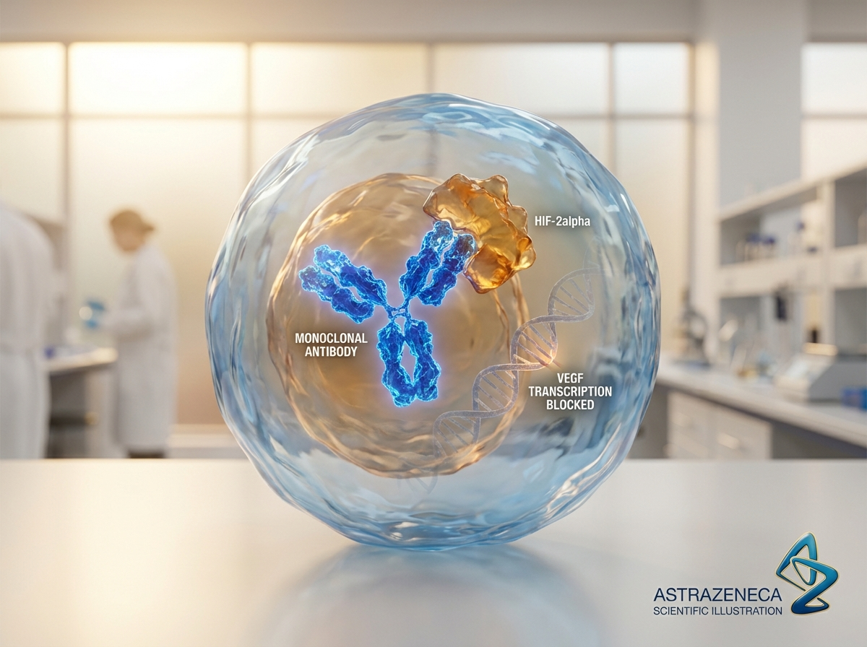
https://eluvion-images.pages.dev/drug-mechanism.jpeg
Usage: Home — MoA teaser
Heading: Targeting the mineralocorticoid receptor
Body text: Excessive MR activation in the kidney and heart drives inflammation, fibrosis, and organ damage in diabetic kidney disease. SERANOVA selectively blocks MR signalling with a non-steroidal mechanism, providing cardiorenal protection beyond RAAS inhibition alone.³
Call to action: Explore how SERANOVA works → /seranova/how-seranova-works
────────────────────────────────────────────────────────────

Section 5 — Prescribing information footer
Block: accordion
Expandable sections for: Prescribing Information | Adverse Event Reporting | References (Use approved text from sections 5, 6, and 7 above)

Page metadata
Title: SERANOVA (valinectra) | Cardiorenal Protection in CKD & T2D | AstraZeneca UK
Description: SERANOVA (valinectra) is a non-steroidal selective MRA for adults with chronic kidney disease associated with type 2 diabetes. Explore RENOVA clinical data, safety, and dosing for UK healthcare professionals.

PAGE 2: RENOVA Data
URL path: /seranova/renova-data
────────────────────────────────────────────────────────────

Section 1 — Hero (full-width image with text overlay)
Block: hero-teaser


https://zenturis-images.pages.dev/hero-efficacy.jpeg
Usage: RENOVA Data — hero
Heading: The RENOVA clinical programme
Body text: SERANOVA™ (valinectra) demonstrated significant kidney and cardiovascular protection in over 11,000 adults with chronic kidney disease and type 2 diabetes across two Phase III trials.¹ ²
────────────────────────────────────────────────────────────

Section 2 — Programme overview (centred text) | light background
Block: introduction
Section metadata: Style: light
Heading: Comprehensive cardiorenal evidence across two pivotal trials
Body text: The RENOVA programme evaluated valinectra in two distinct but complementary populations: RENOVA-CKD assessed kidney and cardiovascular outcomes in 7,352 adults with CKD and type 2 diabetes, establishing the primary indication. RENOVA-HF assessed cardiovascular outcomes in 3,814 adults with coexisting heart failure, CKD, and type 2 diabetes, extending the evidence to the highest-risk patients.¹ ²
────────────────────────────────────────────────────────────

Section 3 — Clinical data (two tabs)
Block: tabs-large

Tab 1: "RENOVA-CKD: Kidney outcomes"
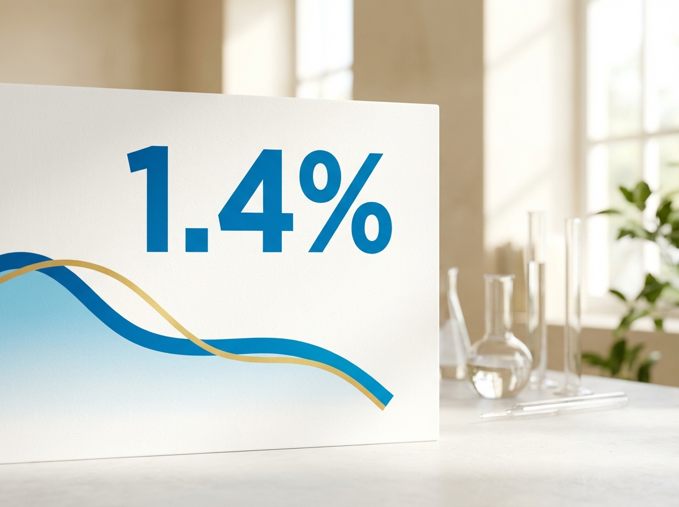
https://zenturis-images.pages.dev/tab-zenith1.jpeg
Usage: RENOVA Data — CKD tab
Heading: RENOVA-CKD: 23% reduction in the composite kidney outcome
Body text: In RENOVA-CKD, a randomised, double-blind, placebo-controlled trial in 7,352 adults with CKD (eGFR 25–75 mL/min/1.73m², UACR 30–5,000 mg/g) and type 2 diabetes on maximum tolerated RAAS inhibition, SERANOVA reduced the primary composite endpoint (sustained ≥57% eGFR decline, ESKD, renal death, or CV death) by 23% versus placebo (HR 0.77; 95% CI: 0.67–0.88; P<0.001).¹

Body text (continued): SERANOVA slowed the rate of kidney function decline, with a total eGFR slope of −2.1 vs −3.8 mL/min/1.73m²/year (difference: +1.7; P<0.001). Albuminuria was reduced by 36% from baseline at Month 4 (ratio 0.65; P<0.001). The cardiovascular co-primary endpoint (CV death or HHF) was also significantly reduced (HR 0.82; P=0.005).¹
Data table:
Endpoint | SERANOVA (n=3,676) | Placebo (n=3,676) | Treatment effect
Primary composite (kidney + CV death) | 13.7% | 17.6% | HR 0.77 (0.67–0.88); P<0.001
Sustained ≥57% eGFR decline or ESKD | 9.8% | 12.9% | HR 0.75 (0.64–0.87); P<0.001
CV death or HHF | 10.0% | 12.1% | HR 0.82 (0.71–0.94); P=0.005
eGFR slope (mL/min/1.73m²/yr) | −2.1 | −3.8 | +1.7 (1.3–2.1); P<0.001
UACR change at Month 4 | −36% | −2% | Ratio 0.65 (0.61–0.70); P<0.001
────────────────────────────────────────────────────────────
Tab 2: "RENOVA-HF: Heart failure outcomes"

https://zenturis-images.pages.dev/tab-zenith2.jpeg
Usage: RENOVA Data — HF tab
Heading: RENOVA-HF: 18% reduction in CV death or hospitalisation for heart failure
Body text: RENOVA-HF was a randomised, double-blind, placebo-controlled trial in 3,814 adults with heart failure (NYHA II–IV, LVEF ≤40%), CKD (eGFR 25–60 mL/min/1.73m²), and type 2 diabetes receiving guideline-directed medical therapy including RAAS inhibition and SGLT2 inhibitors.²

Body text (continued): SERANOVA reduced the primary composite of cardiovascular death or hospitalisation for heart failure by 18% (HR 0.82; 95% CI: 0.72–0.93; P=0.002). Hospitalisations for heart failure were reduced by 20% (HR 0.80; P=0.007). Patients reported clinically meaningful improvements in heart failure symptoms (KCCQ-TSS difference: +2.9 points; P<0.001). SERANOVA also slowed kidney function decline (eGFR slope: −1.8 vs −3.2 mL/min/1.73m²/year; P<0.001).²
Data table:
Endpoint | SERANOVA (n=1,907) | Placebo (n=1,907) | Treatment effect
CV death or HHF (primary) | 19.6% | 23.8% | HR 0.82 (0.72–0.93); P=0.002
HHF alone | 268 events | 331 events | HR 0.80 (0.68–0.94); P=0.007
CV death | 9.8% | 11.7% | HR 0.83 (0.68–1.01); P=0.058
KCCQ-TSS change at Month 12 | +4.8 | +1.9 | +2.9 (1.6–4.2); P<0.001
eGFR slope (mL/min/1.73m²/yr) | −1.8 | −3.2 | +1.4 (0.9–1.9); P<0.001
────────────────────────────────────────────────────────────

Section 4 — Prescribing information footer
Block: accordion | Expandable: PI | AE Reporting | References

Page metadata
Title: RENOVA Data | SERANOVA (valinectra) | Kidney & CV Outcomes | AstraZeneca UK
Description: Explore the RENOVA clinical programme for SERANOVA (valinectra) — Phase III kidney outcomes, cardiovascular protection, and heart failure data in adults with CKD and type 2 diabetes.

PAGE 3: Safety
URL path: /seranova/safety
────────────────────────────────────────────────────────────

Section 1 — Page header (text only, no image)
Block: title
Heading: Safety profile of SERANOVA
Body text: SERANOVA™ (valinectra) has been evaluated in over 5,500 patients across the RENOVA clinical programme, with a median follow-up of 3.4 years in RENOVA-CKD and 2.8 years in RENOVA-HF.¹ ² ³
────────────────────────────────────────────────────────────

Section 2 — Hyperkalaemia monitoring (centred text) | highlight background
Block: introduction
Section metadata: Style: highlight
Heading: Hyperkalaemia — monitoring and management
Body text: Hyperkalaemia is an expected pharmacological effect of mineralocorticoid receptor antagonism and is the principal safety consideration with SERANOVA. Measure serum potassium before initiation, within 4 weeks of starting or changing dose, and periodically thereafter. Use the potassium-guided dose titration algorithm to manage serum potassium levels. Withhold treatment if potassium exceeds 5.5 mmol/L and resume at the lower dose once potassium is ≤5.0 mmol/L.³
────────────────────────────────────────────────────────────

Section 3 — Safety overview (centred text) | light background
Block: introduction
Section metadata: Style: light
Heading: A well-characterised safety profile with proactive potassium management
Body text: Across the RENOVA programme, the safety profile of SERANOVA was consistent with selective non-steroidal MR antagonism. Serious adverse events were lower with SERANOVA than placebo (21.4% vs 23.8%), driven by fewer cardiovascular hospitalisations. Treatment discontinuation due to adverse events was 6.2% vs 5.1%, with hyperkalaemia being the most common reason for discontinuation (1.7%). No anti-androgenic effects (gynaecomastia, breast pain) were observed above placebo rates, consistent with the non-steroidal mechanism.¹ ² ³
────────────────────────────────────────────────────────────

Section 4 — Adverse events table | light background
Block: table-data
Section metadata: Style: light
Adverse event | SERANOVA (%) | Placebo (%)
Hyperkalaemia (any grade) | 8.6 | 3.2
Hypotension | 4.2 | 2.8
Dizziness | 3.1 | 2.4
Diarrhoea | 2.8 | 2.3
Nasopharyngitis | 2.6 | 2.7
Back pain | 2.3 | 2.0
Urinary tract infection | 2.1 | 1.9
Acute kidney injury | 1.8 | 1.4
────────────────────────────────────────────────────────────

Section 5 — Key safety consideration cards (equal columns)
Block: cards-teaser

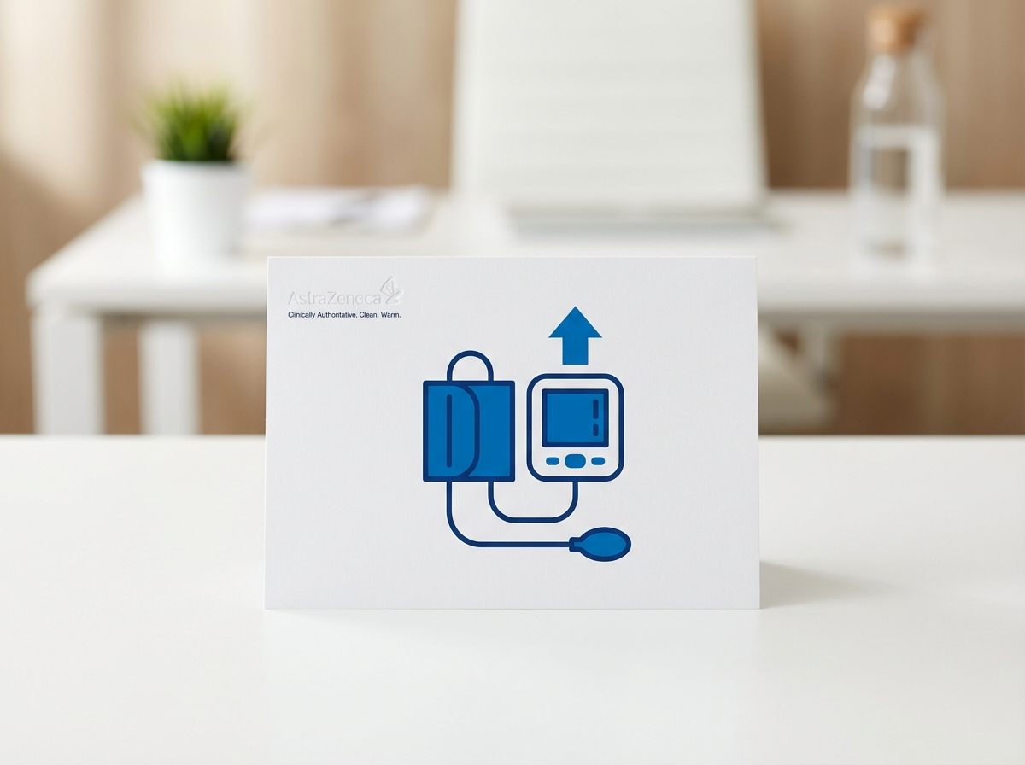
https://eluvion-images.pages.dev/safety-hypertension.jpeg
Usage: Safety — hyperkalaemia card
Card heading: Hyperkalaemia management
Card body: Hyperkalaemia (serum K⁺ >5.5 mmol/L) occurred in 14.2% of SERANOVA-treated patients vs 6.3% with placebo. Events were manageable through potassium-guided dose titration: withhold if K⁺ >5.5 mmol/L, resume at 10 mg when K⁺ ≤5.0 mmol/L. Hyperkalaemia leading to permanent discontinuation occurred in only 1.7%.³
────────────────────────────────────────────────────────────
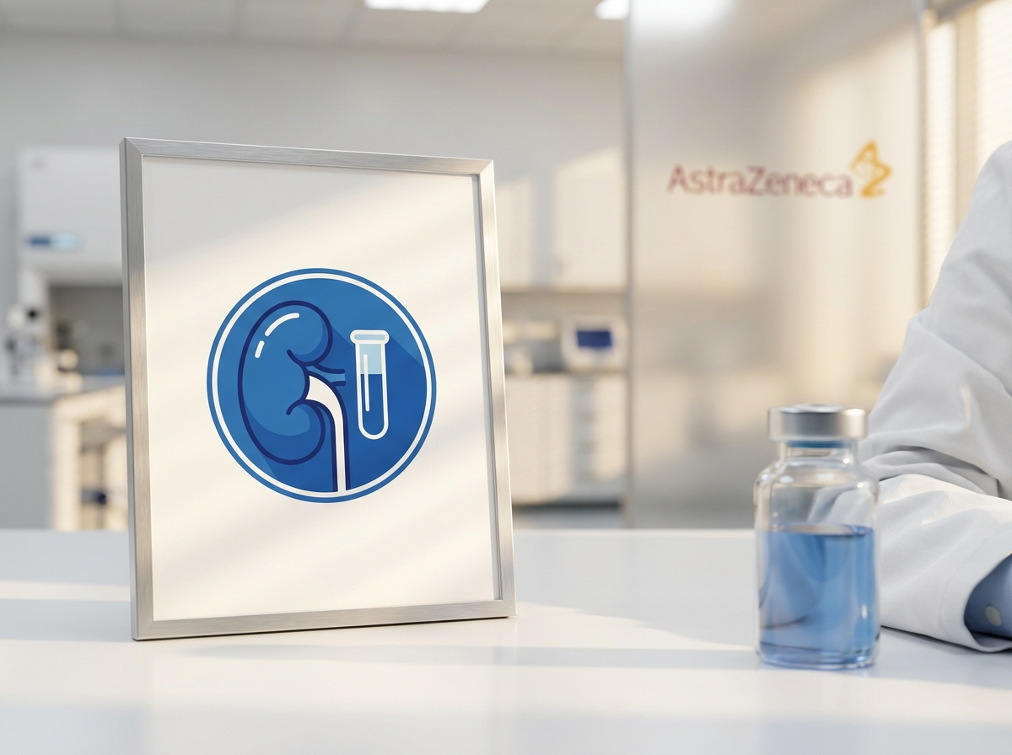
https://eluvion-images.pages.dev/safety-proteinuria.jpeg
Usage: Safety — renal function card
Card heading: Renal function considerations
Card body: An initial eGFR decline of approximately 2–4 mL/min/1.73m² may occur within the first 4 weeks of SERANOVA treatment. This haemodynamic effect is typically reversible and is not a reason to discontinue treatment. Over longer follow-up, SERANOVA slowed the chronic eGFR decline by 1.7 mL/min/1.73m²/year compared with placebo.¹ ³
────────────────────────────────────────────────────────────

https://vitessa-images.pages.dev/safety-zoster.jpeg
Usage: Safety — CV safety card
Card heading: Cardiovascular and metabolic safety
Card body: No increase in major adverse cardiovascular events was observed with SERANOVA. All-cause mortality was numerically lower with SERANOVA (7.7% vs 9.1%). Blood pressure reduction was modest (systolic −3 to −5 mmHg), and symptomatic hypotension was infrequent (4.2% vs 2.8%). No clinically significant effects on glycaemic control, lipid parameters, or body weight were observed.¹ ² ³
────────────────────────────────────────────────────────────

Section 6 — Special populations (two-column: image left, text right) | highlight background
Block: columns-teaser
Section metadata: Style: highlight


https://revantha-images.pages.dev/patient-support.jpeg
Usage: Safety — special populations
Heading: Special populations
Body text: Pregnancy and fertility: SERANOVA is contraindicated in pregnancy. Women of childbearing potential must use effective contraception during treatment and for 1 week after the last dose.³
Elderly patients: No dose adjustment required in patients aged ≥65 years. In RENOVA-CKD, 42% of patients were ≥65 years, with consistent efficacy and safety.³
Hepatic impairment: No dose adjustment for mild impairment (Child-Pugh A). Use with caution in moderate impairment. Contraindicated in severe impairment (Child-Pugh C).³
Renal impairment: Studied in eGFR 25–75 mL/min/1.73m². Do not initiate if eGFR <25 mL/min/1.73m². Not studied in patients on dialysis.³
────────────────────────────────────────────────────────────

Section 7 — Prescribing information footer
Block: accordion | Expandable: PI | AE Reporting | References

Page metadata
Title: Safety | SERANOVA (valinectra) | Hyperkalaemia & Monitoring | AstraZeneca UK
Description: Review the safety profile of SERANOVA (valinectra) including hyperkalaemia management, adverse event rates, and special population recommendations for adults with CKD and type 2 diabetes.

PAGE 4: Dosing & Monitoring
URL path: /seranova/dosing
────────────────────────────────────────────────────────────

Section 1 — Hero (full-width image with text overlay)
Block: hero-teaser

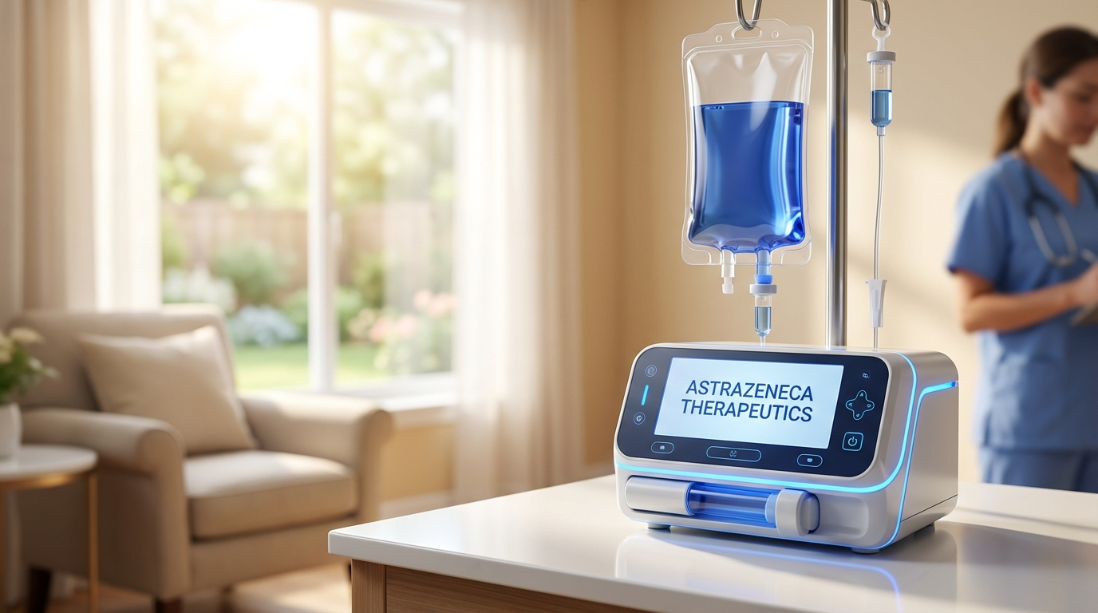
https://eluvion-images.pages.dev/hero-dosing.jpeg
Usage: Dosing — hero
Heading: Dosing and monitoring
Body text: SERANOVA™ (valinectra) uses a simple potassium-guided titration to optimise cardiorenal protection while managing the risk of hyperkalaemia.³
────────────────────────────────────────────────────────────

Section 2 — Potassium-guided titration (two-column) | light background
Block: columns-teaser
Section metadata: Style: light


https://zenturis-images.pages.dev/columns-dose-adjust.jpeg
Usage: Dosing — titration
Heading: Potassium-guided dose titration
Body text: Step 1 — Before initiation: Measure serum potassium. Do not initiate if K⁺ >5.0 mmol/L or eGFR <25 mL/min/1.73m².³
Step 2 — Initiate: Start SERANOVA 10 mg once daily.³
Step 3 — Check at 4 weeks: Measure serum potassium.³
Step 4 — Titrate based on potassium:
• K⁺ ≤4.8 mmol/L: Uptitrate to 20 mg once daily
• K⁺ >4.8 to 5.0 mmol/L: Maintain 10 mg once daily
• K⁺ >5.0 to 5.5 mmol/L: Maintain current dose; recheck in 4 weeks
• K⁺ >5.5 mmol/L: Withhold SERANOVA; recheck; resume 10 mg when K⁺ ≤5.0 mmol/L³
────────────────────────────────────────────────────────────

Section 3 — Administration guidance (two-column)
Block: columns-teaser


https://zenturis-images.pages.dev/columns-admin.jpeg
Usage: Dosing — administration
Heading: Administration and practical guidance
Body text: SERANOVA should be taken once daily, with or without food. Tablets should be swallowed whole with water.³
If a dose is missed, take it as soon as remembered on the same day. Do not take two doses on the same day to make up for a missed dose.³
SERANOVA may be prescribed alongside existing guideline-directed therapy including ACE inhibitors or ARBs, SGLT2 inhibitors, and GLP-1 receptor agonists. In the RENOVA programme, 97% of patients received concomitant RAAS inhibition, 59% received SGLT2 inhibitors, and 12% received GLP-1 RAs.¹
Do not use with strong CYP3A4 inhibitors (contraindicated) or with other potassium-sparing diuretics (use with caution).³
────────────────────────────────────────────────────────────

Section 4 — Ongoing monitoring (two-column) | highlight background
Block: columns-teaser
Section metadata: Style: highlight


https://lumivex-images.pages.dev/columns-monitoring.jpeg
Usage: Dosing — monitoring
Heading: Monitoring recommendations
Body text: Serum potassium: Measure before initiation, within 4 weeks of starting or dose change, and periodically thereafter. Additional monitoring is recommended during intercurrent illness, changes in concomitant medications affecting potassium, or changes in renal function.³
Renal function: Measure eGFR at baseline and periodically. An initial eGFR decline of 2–4 mL/min/1.73m² may occur within the first 4 weeks; this is typically haemodynamic and reversible. Continue treatment unless eGFR declines below 25 mL/min/1.73m² on two consecutive measurements.³
Hepatic function: Monitor liver function tests periodically during treatment.³
────────────────────────────────────────────────────────────

Section 5 — Prescribing information footer
Block: accordion | Expandable: PI | AE Reporting | References

Page metadata
Title: Dosing | SERANOVA (valinectra) | Potassium-Guided Titration | AstraZeneca UK
Description: Dosing and monitoring guidance for SERANOVA (valinectra) including potassium-guided titration, administration, concomitant therapy, and monitoring recommendations for CKD with type 2 diabetes.

PAGE 5: How SERANOVA Works
URL path: /seranova/how-seranova-works
────────────────────────────────────────────────────────────

Section 1 — Hero (full-width image with text overlay)
Block: hero-teaser

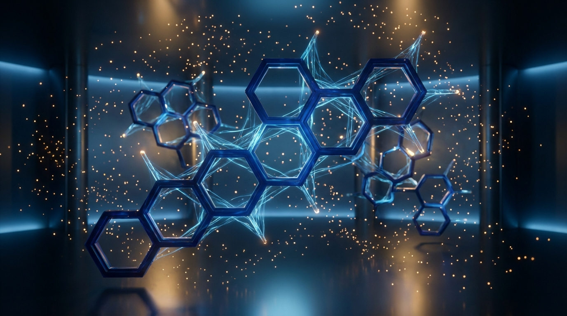
https://eluvion-images.pages.dev/hero-moa.jpeg
Usage: How SERANOVA Works — hero
Heading: Targeting the mineralocorticoid receptor in diabetic kidney disease
Body text: SERANOVA™ (valinectra) selectively blocks MR overactivation — an independent driver of kidney and cardiovascular damage in patients with CKD and type 2 diabetes, complementing RAAS inhibition and SGLT2 inhibitor therapy.³
────────────────────────────────────────────────────────────

Section 2 — The MR pathway in diabetic kidney disease (two-column)
Block: columns-teaser

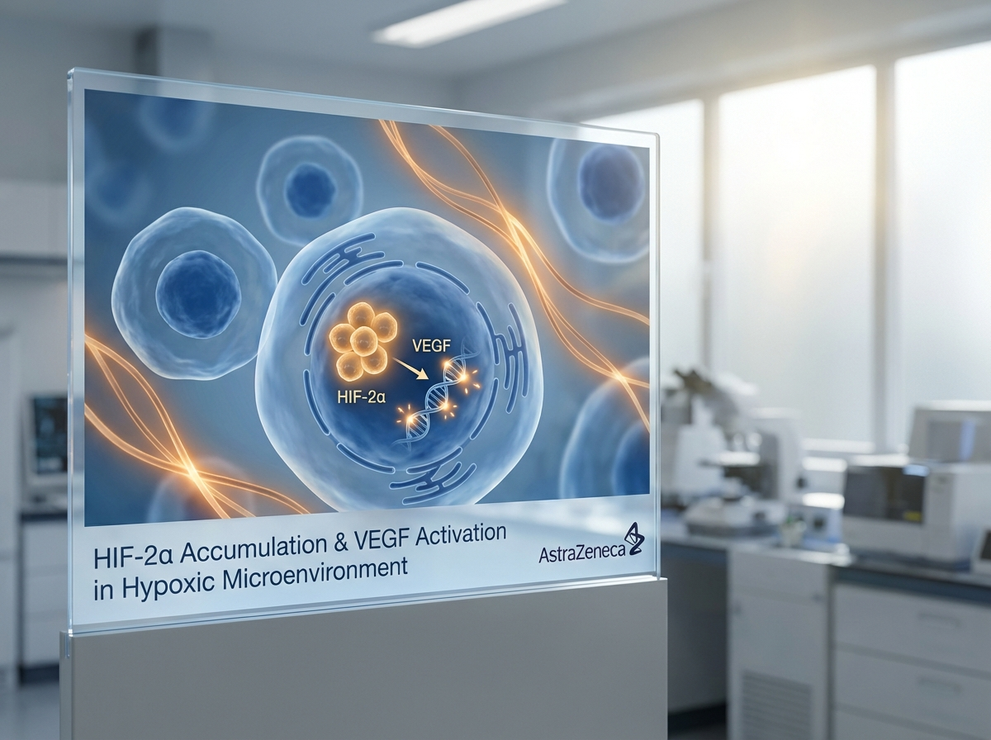
https://eluvion-images.pages.dev/pathway-disease.jpeg
Usage: MoA — kidney pathway
Heading: Why the mineralocorticoid receptor matters in CKD
Body text: In diabetic kidney disease, chronic hyperglycaemia, haemodynamic stress, and obesity drive excessive aldosterone production and inappropriate MR activation in renal and cardiac tissues — independent of angiotensin II levels.⁴ ⁵
MR overactivation promotes pro-inflammatory and pro-fibrotic signalling (via NF-κB, TGF-β, and PAI-1), leading to podocyte injury, proteinuria, tubular fibrosis, endothelial dysfunction, and cardiac remodelling. This MR-driven damage occurs even when patients are receiving maximum tolerated RAAS inhibition, representing a distinct and undertreated pathway of cardiorenal injury.⁴
────────────────────────────────────────────────────────────

Section 3 — SERANOVA mechanism (two-column) | highlight background
Block: columns-teaser
Section metadata: Style: highlight

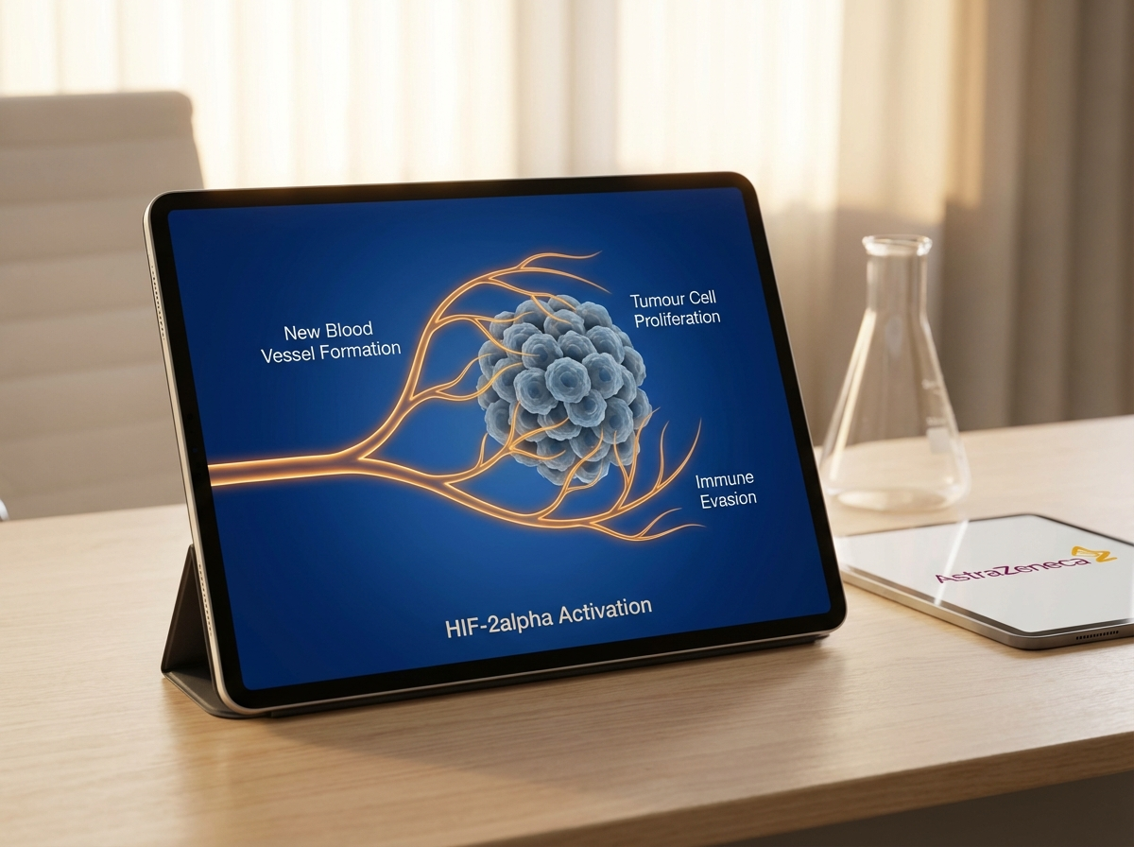
https://eluvion-images.pages.dev/pathway-cascade.jpeg
Usage: MoA — MR blockade
Heading: Selective non-steroidal MR antagonism
Body text: Valinectra binds to the mineralocorticoid receptor ligand-binding domain with a non-steroidal pharmacophore, providing:³
High selectivity for the MR over glucocorticoid, androgen, and progesterone receptors — avoiding the endocrine side effects (gynaecomastia, menstrual irregularity) associated with steroidal MRAs.³
Potent inhibition of MR-driven pro-inflammatory and pro-fibrotic gene transcription in renal tubular cells, podocytes, and cardiac fibroblasts.³
Reduction of proteinuria through direct podocyte protection and reduced glomerular MR signalling.³
Cardioprotection through attenuation of cardiac fibrosis, left ventricular remodelling, and endothelial dysfunction.³
────────────────────────────────────────────────────────────

Section 4 — Complementary to existing therapies (centred text) | light background
Block: introduction
Section metadata: Style: light
Heading: A complementary mechanism for comprehensive cardiorenal protection
Body text: SERANOVA addresses a distinct pathophysiological pathway: MR-driven inflammation and fibrosis that persists despite RAAS inhibition and SGLT2 inhibitor therapy. In the RENOVA programme, benefits were consistent regardless of background SGLT2 inhibitor use, confirming that MR antagonism provides additive cardiorenal protection.¹ ² Current KDIGO 2024 guidelines recommend considering non-steroidal MRAs as part of the comprehensive approach to reducing kidney disease progression and cardiovascular risk in patients with CKD and type 2 diabetes.⁵
Link: View RENOVA clinical data → /seranova/renova-data
────────────────────────────────────────────────────────────

Section 5 — Prescribing information footer
Block: accordion | Expandable: PI | AE Reporting | References

Page metadata
Title: How SERANOVA Works | Mechanism of Action | MR Antagonism | AstraZeneca UK
Description: Understand how SERANOVA (valinectra) selectively blocks the mineralocorticoid receptor to reduce kidney and cardiovascular damage in CKD with type 2 diabetes, complementing RAAS and SGLT2 inhibitor therapy.

PAGE 6: Resources
URL path: /seranova/resources
────────────────────────────────────────────────────────────

Section 1 — Page header (text only, no image)
Block: title
Heading: Resources for healthcare professionals
Body text: Access prescribing information, clinical data summaries, and patient support materials for SERANOVA™ (valinectra).
────────────────────────────────────────────────────────────

Section 2 — Resource cards (equal columns) | light background
Block: cards-teaser
Section metadata: Style: light


https://revantha-images.pages.dev/resource-prescribing.jpeg
Usage: Resources — prescribing card
Card heading: Prescribing guide
Card body: Access the full Summary of Product Characteristics, potassium-guided titration algorithm, and a quick reference card covering indication, dosing, contraindications, drug interactions, and monitoring requirements for SERANOVA.
Card link: Access prescribing information → /seranova/resources
────────────────────────────────────────────────────────────
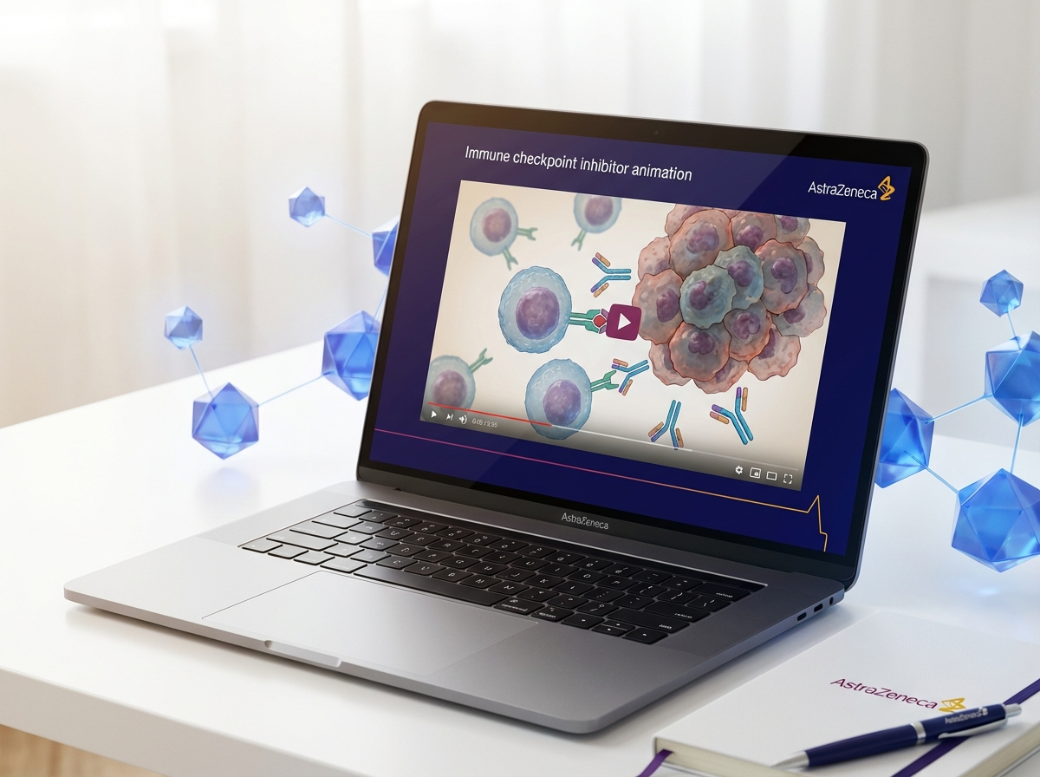
https://revantha-images.pages.dev/resource-education.jpeg
Usage: Resources — clinical data card
Card heading: RENOVA clinical data summaries
Card body: Concise summaries of the RENOVA-CKD and RENOVA-HF pivotal studies, including study design, key endpoints, kidney outcomes, cardiovascular data, and eGFR slope analyses in adults with CKD and type 2 diabetes.
Card link: Download study summaries → /seranova/resources
────────────────────────────────────────────────────────────

https://novapril-images.pages.dev/resource-patient.jpeg
Usage: Resources — patient materials card
Card heading: Patient support materials
Card body: Downloadable patient information leaflets, potassium monitoring diaries, and dietary guidance materials to support patients starting SERANOVA. Available in print-ready and digital formats.
Card link: Download patient materials → /seranova/resources
────────────────────────────────────────────────────────────

Section 3 — Medical information contact (two-column) | highlight background
Block: columns-teaser
Section metadata: Style: highlight


https://revantha-images.pages.dev/contact-support.jpeg
Usage: Resources — contact
Heading: Medical information and support
Body text: For medical information enquiries about SERANOVA, please contact AstraZeneca Medical Information:
Telephone: 0800 783 0033
Email: medicalinformationuk@astrazeneca.com
Website: contactazmedical.astrazeneca.com
Our medical information team is available Monday to Friday, 9:00 AM to 5:00 PM.
────────────────────────────────────────────────────────────

Section 4 — Prescribing information footer
Block: accordion | Expandable: PI | AE Reporting | References

Page metadata
Title: Resources | SERANOVA (valinectra) | Clinical Summaries & Guides | AstraZeneca UK
Description: Access prescribing information, RENOVA study summaries, and patient support materials for SERANOVA (valinectra) in CKD with type 2 diabetes.

10. Footer Content
Row 1 — Brand: AstraZeneca logo | GB-96017 | DOP: March 2026 | © 2026 AstraZeneca. All rights reserved.
Row 2 — Site links: RENOVA Data | Safety | Dosing & Monitoring | How SERANOVA Works | Resources
Row 3 — Regulatory links: Report Adverse Event (https://yellowcard.mhra.gov.uk/) | Medical Information (https://contactazmedical.astrazeneca.com/) | Privacy Policy (https://www.astrazeneca.co.uk/our-company/privacy-notice.html) | Terms of Use (https://www.astrazeneca.co.uk/our-company/terms-of-use.html) | Accessibility (https://www.astrazeneca.co.uk/accessibility.html)
Row 4 — Date: Date of Preparation: March 2026
────────────────────────────────────────────────────────────

11. Image Assets
All images are reused from existing AZ site CDN deployments. No new image generation is required. If a dedicated Seranova CDN is set up in future, images should be downloaded from the source URLs below and redeployed to https://seranova-images.pages.dev/.

# | Usage | Source CDN URL | Dimensions | Used on
1 | hero-home | https://novapril-images.pages.dev/hero-home.jpeg | 1440×810 | Home — hero
2 | hero-efficacy | https://zenturis-images.pages.dev/hero-efficacy.jpeg | 1440×810 | RENOVA Data — hero
3 | hero-dosing | https://eluvion-images.pages.dev/hero-dosing.jpeg | 1440×810 | Dosing — hero
4 | hero-moa | https://eluvion-images.pages.dev/hero-moa.jpeg | 1440×810 | How SERANOVA Works — hero
5 | card-renal | https://eluvion-images.pages.dev/trial1-results.jpeg | 800×600 | Home — renal outcomes card
6 | card-cv | https://revantha-images.pages.dev/card-efficacy.jpeg | 800×600 | Home — CV outcomes card
7 | card-oral | https://zenturis-images.pages.dev/card-dosing.jpeg | 800×600 | Home — oral dosing card
8 | card-hyperkalaemia | https://eluvion-images.pages.dev/safety-hypertension.jpeg | 800×600 | Safety — hyperkalaemia card
9 | card-renal-function | https://eluvion-images.pages.dev/safety-proteinuria.jpeg | 800×600 | Safety — renal function card
10 | card-cv-safety | https://vitessa-images.pages.dev/safety-zoster.jpeg | 800×600 | Safety — CV safety card
11 | card-prescribing | https://revantha-images.pages.dev/resource-prescribing.jpeg | 800×600 | Resources — prescribing card
12 | card-clinical-summary | https://revantha-images.pages.dev/resource-education.jpeg | 800×600 | Resources — clinical data card
13 | card-patient | https://novapril-images.pages.dev/resource-patient.jpeg | 800×600 | Resources — patient materials card
14 | columns-moa-preview | https://eluvion-images.pages.dev/drug-mechanism.jpeg | 800×600 | Home — MoA teaser
15 | columns-kidney-pathway | https://eluvion-images.pages.dev/pathway-disease.jpeg | 800×600 | MoA — kidney pathway
16 | columns-mr-blockade | https://eluvion-images.pages.dev/pathway-cascade.jpeg | 800×600 | MoA — MR blockade
17 | columns-dosing | https://zenturis-images.pages.dev/columns-dose-adjust.jpeg | 800×600 | Dosing — titration
18 | columns-admin | https://zenturis-images.pages.dev/columns-admin.jpeg | 800×600 | Dosing — administration
19 | columns-monitoring | https://lumivex-images.pages.dev/columns-monitoring.jpeg | 800×600 | Dosing — monitoring
20 | columns-special-pops | https://revantha-images.pages.dev/patient-support.jpeg | 800×600 | Safety — special populations
21 | columns-contact | https://revantha-images.pages.dev/contact-support.jpeg | 800×600 | Resources — contact
22 | tab-renova-ckd | https://zenturis-images.pages.dev/tab-zenith1.jpeg | 800×600 | RENOVA Data — CKD tab
23 | tab-renova-hf | https://zenturis-images.pages.dev/tab-zenith2.jpeg | 800×600 | RENOVA Data — HF tab
24 | astrazeneca-logo | https://novapril-images.pages.dev/astrazeneca-logo.svg | Various | Header/footer logo
25 | search | https://revantha-images.pages.dev/search.svg | Various | Header search icon

Source site cross-reference
- novapril-images.pages.dev: NOVAPRIL (SLE/Lupus) — Lifestyle portraits, kidney-related imagery
- zenturis-images.pages.dev: ZENTURIS (Type 2 Diabetes) — Metabolic data visualisations, tablet dosing
- eluvion-images.pages.dev: ELUVION (Renal Cell Carcinoma) — Renal/kidney mechanism imagery
- novatrel-images.pages.dev: NOVATREL (NSCLC) — Survival data viz, resource cards, editorial photography
- lumivex-images.pages.dev: LUMIVEX (Psoriasis) — Monitoring guidance imagery

