1. **URL:**

<https://phupa.000webhostapp.com/assigment_4.html>

1. **SEO:**

* <title>Exploria Vietnam - the beauty from Northeast Asia</title>
* <meta name="google-site-verification" content="mio5Ir5MdjYnHxPjiQpUVwMijzKYrOSsqj4CRIZ5x1k" />
* <meta name="description"

content="Vietnam attracts travelers for it’s natural beauty, with mountains and green rice fields in the north to the fascinating rivers of the Mekong Delta in the south. But with old traditions and long history, there is a lot more in Vietnam. It has many historical sites and ancient temples. Here is an overview of the most impressive and beautiful destinations in Vietnam!">

* <a class= 'link' href='\assigment_4_mocchau.html' title ='Moc Chau beauty'>
* <div class='image-1 col-7'><img src = '\picture\mocchau.jpg' alt='Moc-Chau-Vietnam'>

1. **Submit indexing:**

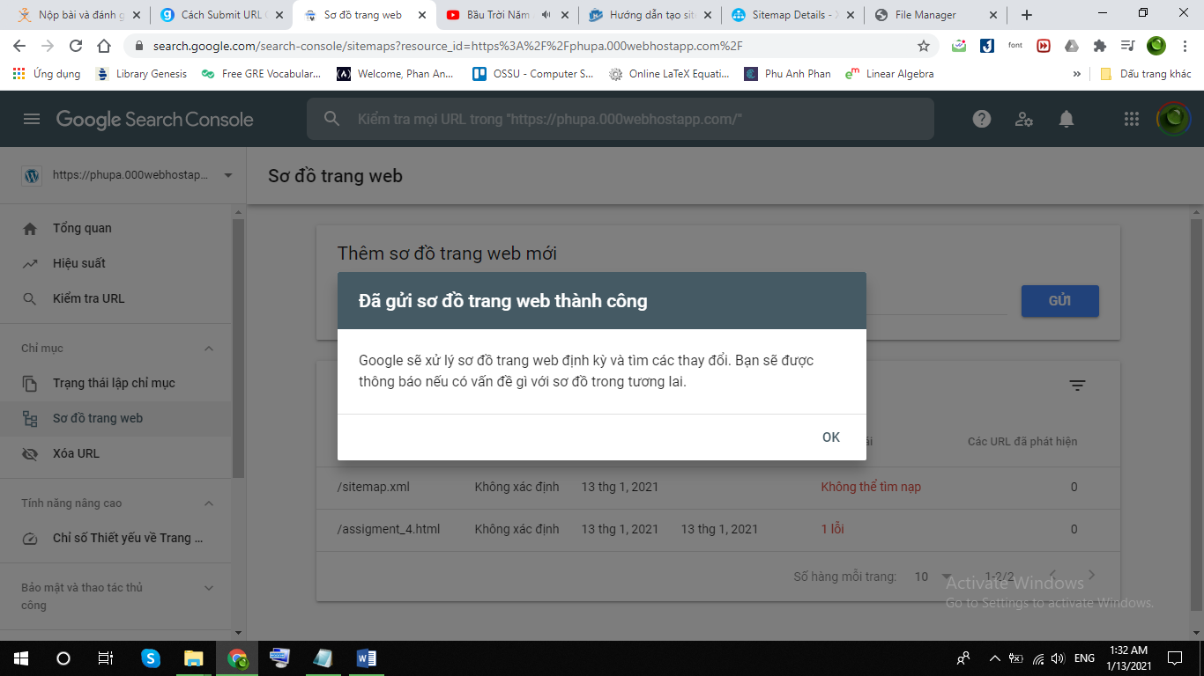

1. **Google Analytics:**

