Overlapping NMF와 Sparseness를 이용한 단일 채널 다성 음악의 음원 분리
김민제O, 최승진
포항공과대학교 컴퓨터공학과
{minjekimO, seungjin} @postech.ac.kr

Single Channel Polyphonic Music Separation Using Sparseness and Overlapping NMF
Minje KimO, Seungjin Choi
Department of Computer Science, POSTECH
Abstract
In this paper we present a method of separating musical instrument sound sources from their monaural mixture, where we take the harmonic structure of music into account and use the sparseness and the overlapping NMF [1] to select representative spectral basis vectors which are used to reconstruct unmixed sound. A method of spectral basis selection is illustrated and experimental results with monaural mixture of voice/cello and trumpet/viola are shown to confirm the validity of our proposed method.

1. Introduction
The nonnegative matrix factorization (NMF) [2] or its extended version, nonnegative matrix deconvolution (NMD) [3], was shown to be useful in polyphonic music description [4], in the extraction of multiple music sound sources [3], and in general sound classification [5]. On the other hand, a method based on multiple cause models and sparse coding was successfully applied to automatic music transcription [6]. Some of these methods regard each note as a source, which might be appropriate for music transcription and work for source separation in a very limited case.
In this paper we present a method for single channel polyphonic music separation, the main idea of which is to select a few representative spectral basis vectors using the sparseness and the overlapping NMF [1], which are used to reconstruct unmixed sound signals. We assume that the structure of harmonics of a musical instrument approximately remains the same, even if it is played at different pitches. This view allows us to reconstruct original sound using only a few representative spectral basis, through the overlapping NMF. We illustrate a method of spectral basis selection from the spectrogram of mixed sound and show how these basis vectors are used to restore unmixed sound. Promising results with monaural mixture of voice/cello and trumpet/viola are shown to confirm the validity of our proposed method.

2. Overlapping NMF
Nonnegative matrix factorization (NMF) is a simple but efficient factorization method for decomposing multivariate data into a linear combination of basis vectors with nonnegativity constraints for both basis and encoding matrix [2]. Given a nonnegative data matrix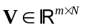(wh-
ere 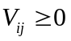), NMF seeks a factorization
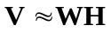, (1)
where 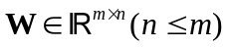 contains nonnegative basis vectors in its columns and 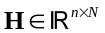 represents the nonnegative encoding variable matrix. Appropriate objective functions and associated multiplicative updating algorithms for NMF can be found in [7].
The overlapping NMF is an interesting extension of the original NMF, where transform-invariant representation and a sparseness constraint are incorporated with NMF [1]. Some of basis vectors computed by NMF could correspond to the transformed versions of a single representative basis vector. The basic idea of the overlapping NMF is to find such representative basis vectors such that fewer number of basis vectors could reconstruct observed data. Given a set of transformation matrices,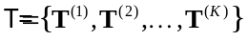, the overlapping NMF finds a nonnegative basis matrix  and a set of nonnegative encoding matrix 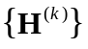(for 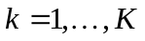) which minimizes
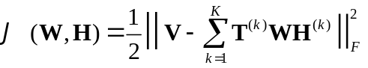, (2)
where 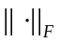 represents Frobenious norm. As in [7], the multiplicative updating rules for the overlapping NMF were derived in [1], which are summarized in Table 1.

3. Spectral Basis Selection
The goal of spectral basis selection is to choose a few representative vectors from 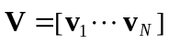 where  is the data matrix associated with the spectrogram of mixed sound. In other words, each column vector of V corresponds to the power spectrum of the mixed sound at
Table 1. Algorithm Outline: Overlapping NMF [1]
Step 1 | Calculate the reconstruction :  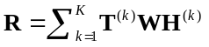.
Step 2 | Update the encoding matrix by  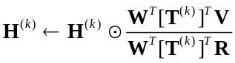, 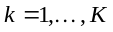, (3)  where denotes the Hadamard product and the division is carried out in an element-wise fashion.
Step 3 | Calculate the reconstruction again using the encoding matrix updated in Step 2, as in Step 1.
Step 4 | Update the basis matrix by  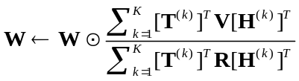. (4)

time 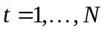. Selected representative vectors are fixed as basis vectors that are used to learn an associated encoding matrix through the overlapping NMF with the sparseness constraint, in order to reconstruct unmixed sound.
Our spectral basis selection method consists of two parts, which is summarized in Table 2. The first part is to select several candidate vectors from using a sparseness measure and a clustering technique. We use the sparseness measure proposed by Hoyer [8], described by
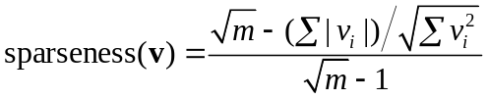, (5)
where is the ith element of the m-dimensional vector .
The first part of our spectral basis selection method starts with choosing a candidate vector that has the largest sparseness values (see Fig. 1 (d)). Then we estimate the location of fundamental frequency bin for each input vector, which corresponds to the lowest frequency bin above the mean value. Each input vector is aligned to the candidate vector such that the fundamental frequency bin appears at the same location as the candidate vector. Euclidean distances between these aligned input vectors and the candidate vectors are calculated and a hierarchical clustering method (or any other clustering methods) is applied to eliminate whatever vectors belong to a group which the candidate vector belongs to. This procedure is repeated until we choose a pre-specified number of candidate vectors. The repetition procedure produces several candidates, some of which are expected to represent a original musical instrument sound in such a way that a set of vertically-shifted basis restores the original sound.
The second part of our method is devoted for the final selection of representative spectral basis vectors from candidates obtained in the first part. Candidate vectors are regarded as input vectors for the overlapping NMF. For
Table 2. Spectral basis selection procedure.
Calculate the sparseness value of every input vector,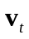, using (5);
Normalize every input vector;
repeat until the number of candidates < threshold
or all input vectors are eliminated
Select a candidate with the highest sparseness value;
Estimate the fundamental frequency bin for each input vector;
Align each input vector such that its frequency bin location is the same as the candidate;
Calculate Euclidean distances between the candidate and every input vector;
Cluster input vectors using Euclidean distances;
Eliminate input vectors in the cluster which the candidate belongs to;
end (repeat)
repeat for every possible combination of candidates
Set all candidate vectors as input vectors;
Select a combination of candidates;
Learn a encoding matrix, through the overlapping NMF,
with fixing these selected candidates as basis vectors;
Compute the reconstruction error of the overlapping NMF;
end (repeat)
Select the combination of candidates with the lowest reconstruction error;

every possible combination of candidates (for the case of 2 sources, 2 out of the number of candidates), we learn an associated encoding matrix with selected candidates fixed as basis vectors, and calculate the reconstruction error. Final representative spectral basis vectors are the ones which give the lowest reconstruction error.

4. Numerical Experiments
We show two simulation results for: (1) monaural mixture of voice and cello; (2) monaural mixture of trumpet and viola. We apply our spectral basis selection method with the overlapping NMF to these two data sets and experimental results are shown in Fig. 1 and 2.
The set of transformation matrices,, that we used, is
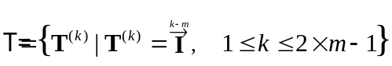, (6)
where is the identity matrix. For the case where 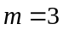 and 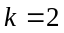, 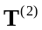is defined as
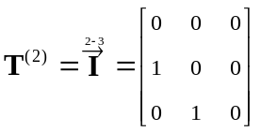. (7)
Multiplying a vector by these transformation matrices, leads to a set of vertically-shifted vectors.
As an additional experiment, we selected only a single shifted version of each basis vector at a given time which has the highest corresponding encoding value of all the possible vertical shifting and then unmixed with them. On the assumption that an instrument can not play multiple notes at a given time, that simple post-processing step could wipe out unwanted remaining sounds generated from other sources with some decrease of robustness. Additonal experimental results are shown in Fig 3.

5. Discussions
We have presented a method of spectral basis selection for single channel polyphonic music separation, where the harmonics, sparseness, clustering, and the overlapping NMF were used. Rather than learning spectral basis vectors from the data, our approach is to select a few representative spectral vectors among given data and fix them as basis vectors to learn associated encoding variables through the overlapping NMF, in order to restore unmixed sound. The success of our approach lies in the assumption that the distinguished timbre of a given musical instrument can be expressed by a transform-invariant time-frequency representation, even though their pitches are varying. A string instrument has multiple distinguished harmonic structures. In such a case, it is reasonable to assign a basis vector for each string.

Acknowledgments
This work was supported by ITEP Brain Neuroinformatics
Program and ETRI.

References
[1] Eggert, J., Wersing, H., K¨orner, E.: Transformation-invariant representation and NMF. In: Proc. Int’l Joint Conf. Neural Networks. (2004)
[2] Lee, D.D., Seung, H.S.: Learning the parts of objects by non-negative matrix factorization. Nature 401 (1999) 788–791
[3] Smaragdis, P.: Non-negative matrix factor deconvolution: Extraction of multiple sound sources from monophonic inputs. In: Proc. Int’l Conf. Independent Component Analysis and Blind Signal Separation, Granada, Spain (2004) 494–499
[4] Smaragdis, P., Brown, J.C.: Non-negative matrix factorization for polyphonic music transcription. In: Proc. IEEE Workshop on Applications of Signal Processing to Audio and Acoustics, New Paltz, NY (2003) 177–180
[5] Cho, Y.C., Choi, S.: Nonnegative features of spectro-temporal sounds for classfication. Pattern Recognition Letters (2005) in press.
[6] Plumbley, M.D., Abdallah, S.A., Bello, J.P., Davies, M.E., Monti, G., Sandler, M.B.: Automatic transcription and audio source separation. Cybernetics and Systems (2002) 603–627
[7] Lee, D.D., Seung, H.S.: Algorithms for non-negative matrix factorization. In: Advances in Neural Information Processing Systems. Volume 13., MIT Press (2001)
[8] Hoyer, P.O.: Non-negative matrix factorization with sparseness constraints. Journal of Machine Learning Research 5 (2004) 1457–1469
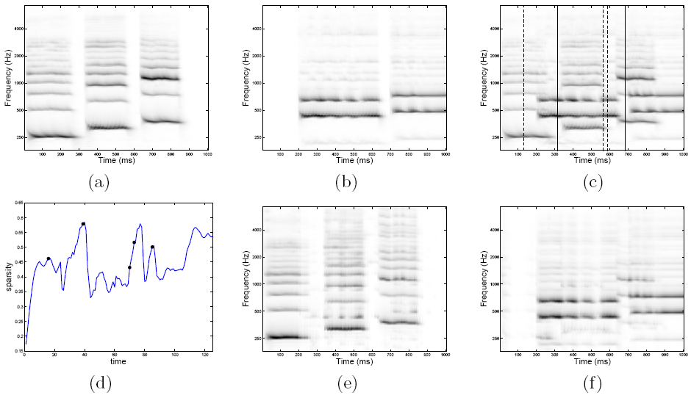Fig. 1. Spectrograms of original sound of voice and a single string of a cello are shown in (a) and (b), respectively. Horizontal bars reflect the structure of harmonics. One can see that every note is the vertically-shifted version of each other if their musical instrument sources are the same. Monaural mixture of voice and cello is shown in (c) where 5 candidate vectors selected by our algorithm in Table 1 are denoted by dotted or solid vertical lines. Two solid lines represent final representative spectral basis vectors which give the smallest reconstruction error in the overlapping NMF. Each of these two basis vectors is a representative one for voice and a string of cello. Associated sparseness values are shown in (d) where black dots on a graph are associated with the candidate vectors. Unmixed sound is shown in (e) and (f) for voice and cello, respectively.

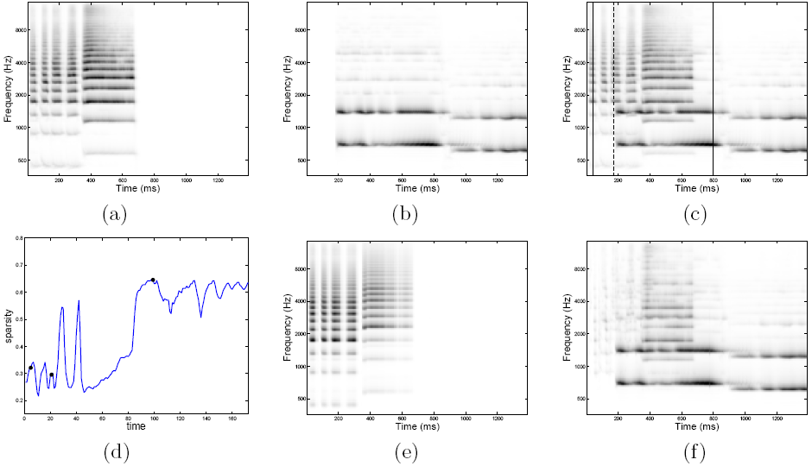
Fig. 2. Spectrograms of original sound of trumpet and a single string of a viola are shown in (a) and (b), respectively. Monaural mixture of trumpet and viola is shown in (c) where 3 candidate vectors selected by our algorithm in Table 1 are denoted by dotted or solid vertical lines. Two solid lines represent final representative spectral basis vectors which give the smallest reconstruction error in the overlapping NMF. Each of these two basis vectors is for trumpet and a string of viola. Associated sparseness values are shown in (d) where black dots on a graph are associated with the candidate vectors. Unmixed sound is shown in (e) and (f) for trumpet and viola, respectively.

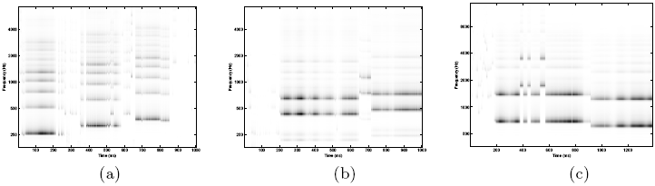
Fig. 3. Unmixed sounds using the highest encoding value, (a), (b) and (c) for voice, viola and cello respectively. Compare these results with Fig. 1 (e), Fig. 1 (f) and Fig. 2 (f) respectively. Result of trumpet is omitted.

