Feature Card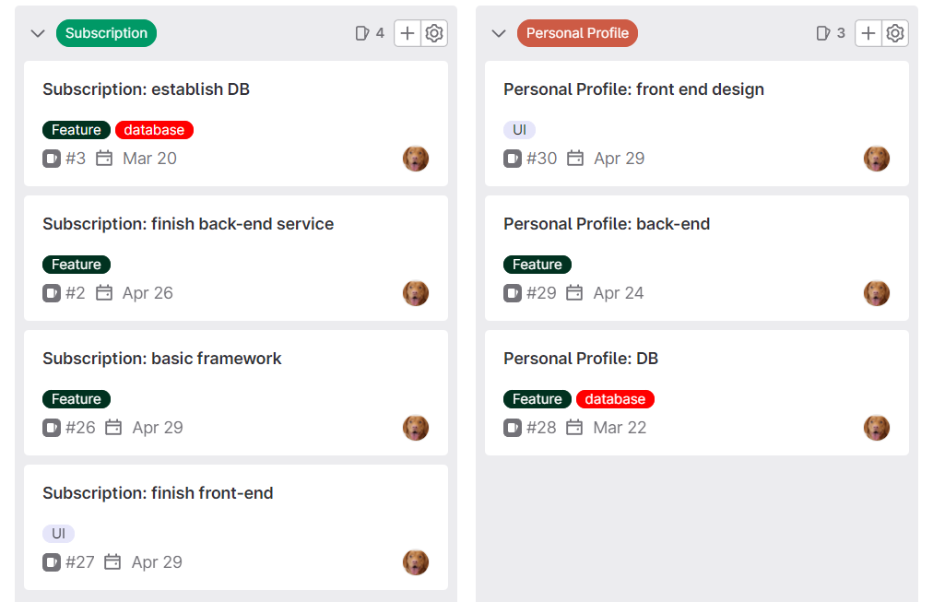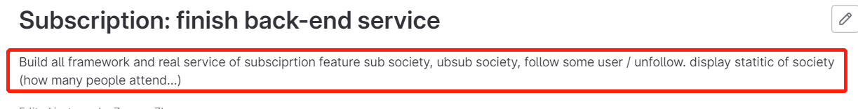

React Tech Report

React is an open source ‘JavaScript library’. This built-in library was made by Facebook. It contains some special ways to improve the efficiency of front-end. As well as every team member merely needs to master the basic knowledge of JavaScript in order to accomplish the deployment of React.

First, its modular structure boots the flexibility. It is much easier to maintain on codes, in turn, decreases the time consumption for whole group. Each group member can spend more time on other useful fields.

Compared to the native JavaScript, the reusability is a significant benefit. We do not need to waste lots of time on duplicated features. What’s more, if the particular part was mandatory to alter, it would not affect other part of application.

The most essential invention from React is the virtual Dom. For example, we want to edit a shopping trolley which is waiting for check out on the traditional JavaScript. We need to operate the DOM on that website. If the customer adds one more item in the list. The front-end needs to create a brand-new DOM for the website. Then, the website will display the new component with the information we want. Instead, react would only operate the virtual DOM which creates by itself. React will compare the update of information. After that, it will update the real DOM with the new piece of information. React never covers the whole component. Based on this idea, it high reduces the cost that needs to compute.

Code for import:

// import the core of react js library

import React from ‘react’;

// import the react dom

import ReactDom from ‘react-dom/client’;

Code for UI

// create basic layout (layout from ant) -> layout from ant

const {component you wish to display on website} = layout;

Preparation of tech stack

