This study explores online searches related to the History Center of Thessaloniki, examining both Greek and English queries from users in Greece and around the world. The main goal is to figure out how much interest there is in the History Center. We're using data from Google, covering the period from August 2019 to July 2023. To make the data easier to understand and visualize, we've applied a three-month rolling average.

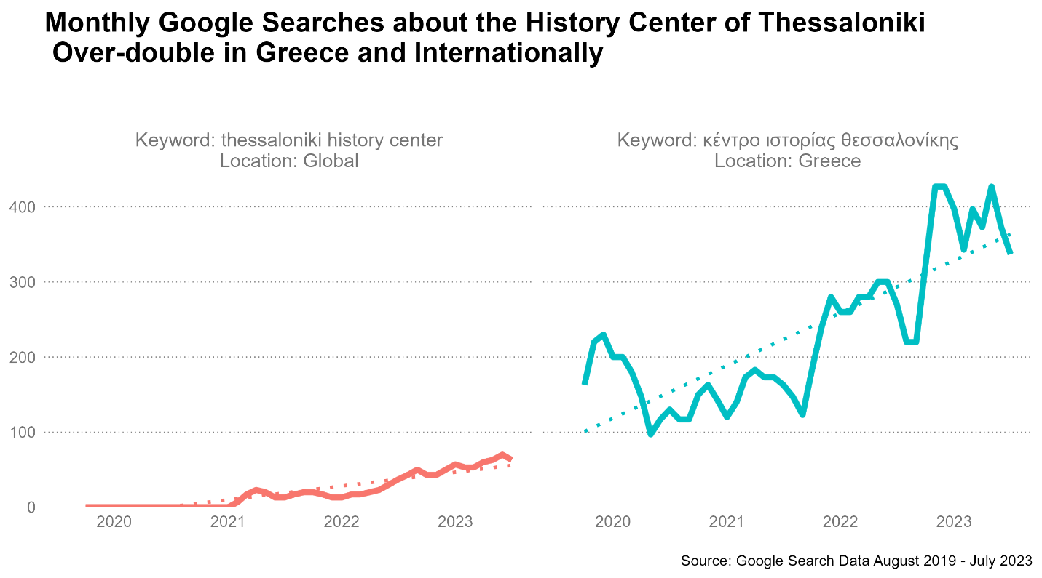

Our first chart shows a consistent uptrend in online searches about the History Center, both from users in Greece and internationally. While there was a predictable drop during the pandemic, interest has rebounded strongly since 2022, more than doubling compared to pre-pandemic levels.

What's particularly noteworthy is the lack of international searches prior to 2021. That has changed dramatically; if the current trend continues, we're looking at over 100 monthly searches about the History Center coming from outside Greece.

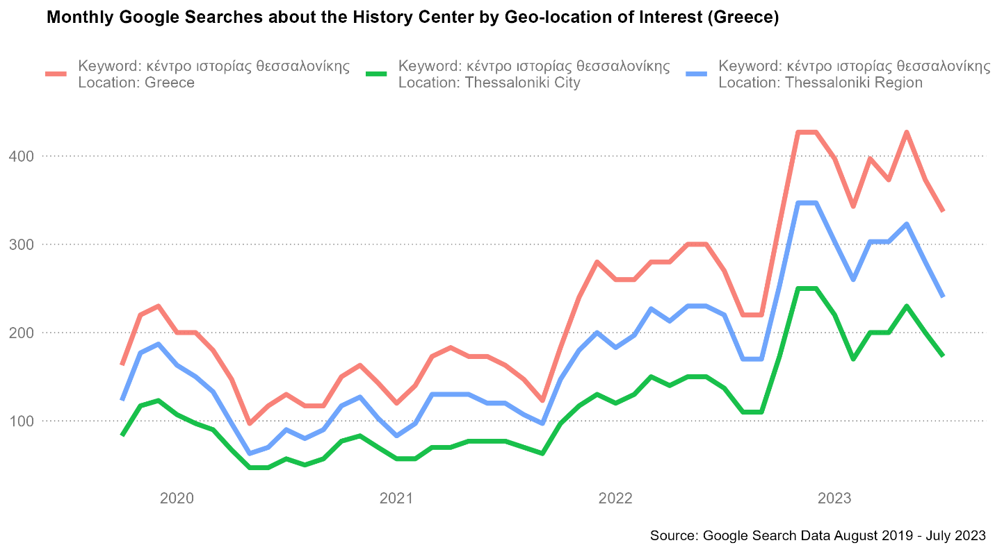

Turning our attention to Greece, most of the searches are coming from Thessaloniki and its surrounding metropolitan area. However, there's also a significant amount of interest from other parts of Greece, where users are actively searching for information on the History Center.

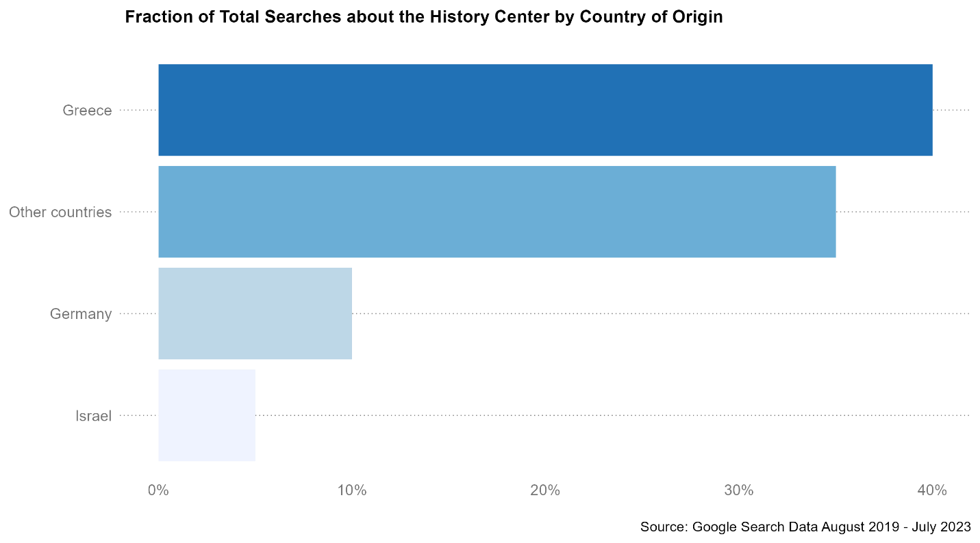

As for the international searches, it's not surprising that Greece leads. But what's interesting is the strong interest we're seeing from other countries, notably Germany and Israel.

The data and code supporting this research are publicly available on Github: https://github.com/papageorgiou/kith-search-data-analysis

Alex Papageorgiou is a seasoned market research consultant and a former Googler. He helps venture builders, founders, and marketers uncover new market opportunities by unlocking the full potential of consumer search data

website: [alex-papageo.com](http://alex-papageo.com/)

linkedin:  [linkedin.com/in/alexandrospapageorgiou](http://linkedin.com/in/alexandrospapageorgiou)