**How to Get Started with Demo**

1. Open your chrome web browser.
2. Check for MetaMask Web-Browser Extension:

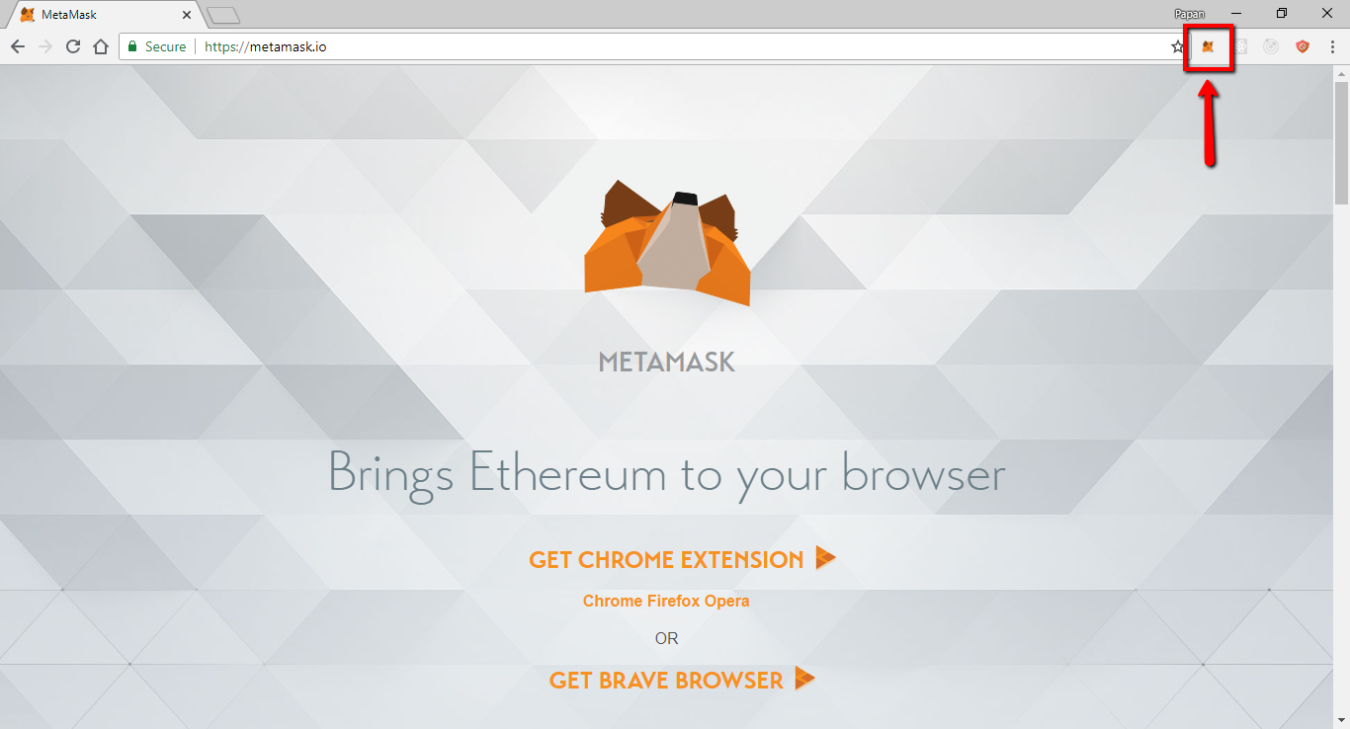

Note: you can download metamask for Chrome web browser by visiting this link <https://metamask.io/>

1. Click and open MetaMask Extension and login with your respective password.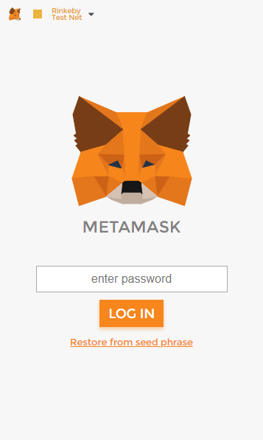
2. Make sure that Rinkeby Test network is selected and the account hold few Ether balance.

|  |  |
| --- | --- |
| 2018-07-25_1509.png | 2018-07-25_1510.png |

1. Open the Job demo link here <https://papandas.github.io/Jobs-Ethereum-PoC/> The account address should match with the account address from Metamask.

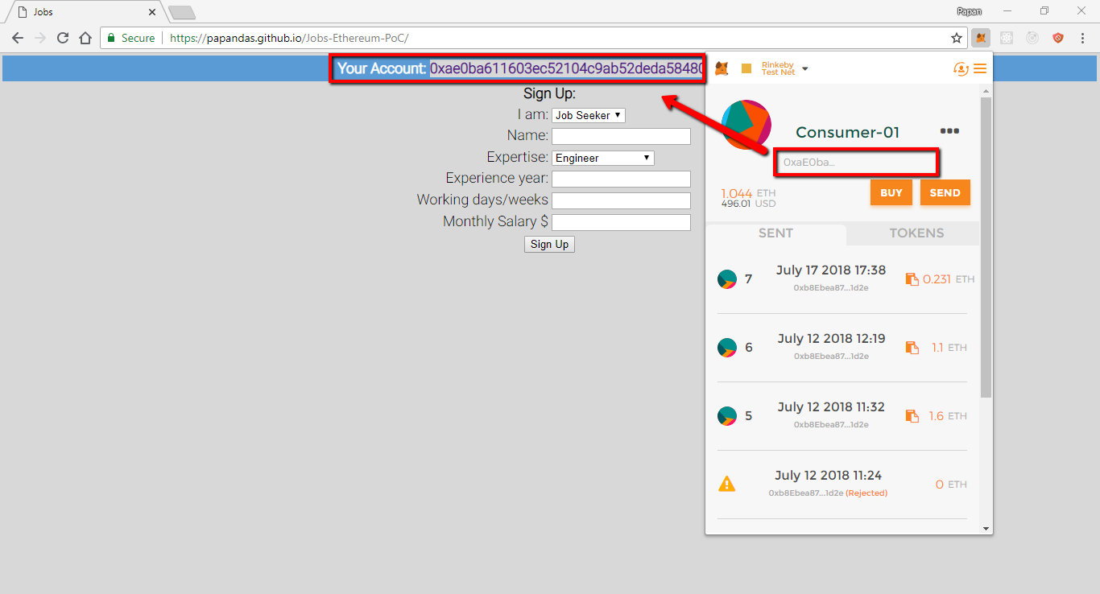

1. If you are not Sign-In, you will get to see Sign-In Page. Fill up your Sign-In form and submit the form.

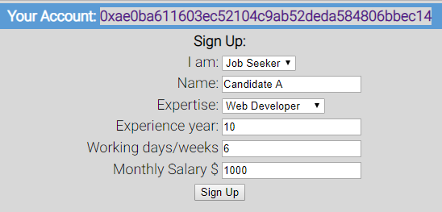

1. Click on Sign Up button and a MetaMask Notification window will pop-up. Click on “Submit” button.

Note: Reading data on blockchian is free, writing data on Ethereum Blockchain Network cost Gas which is paid in the form of Ether.

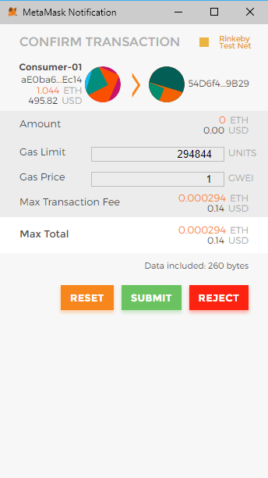

1. You may now refresh the page. The full layout of the page displays all the details of the Candidate.

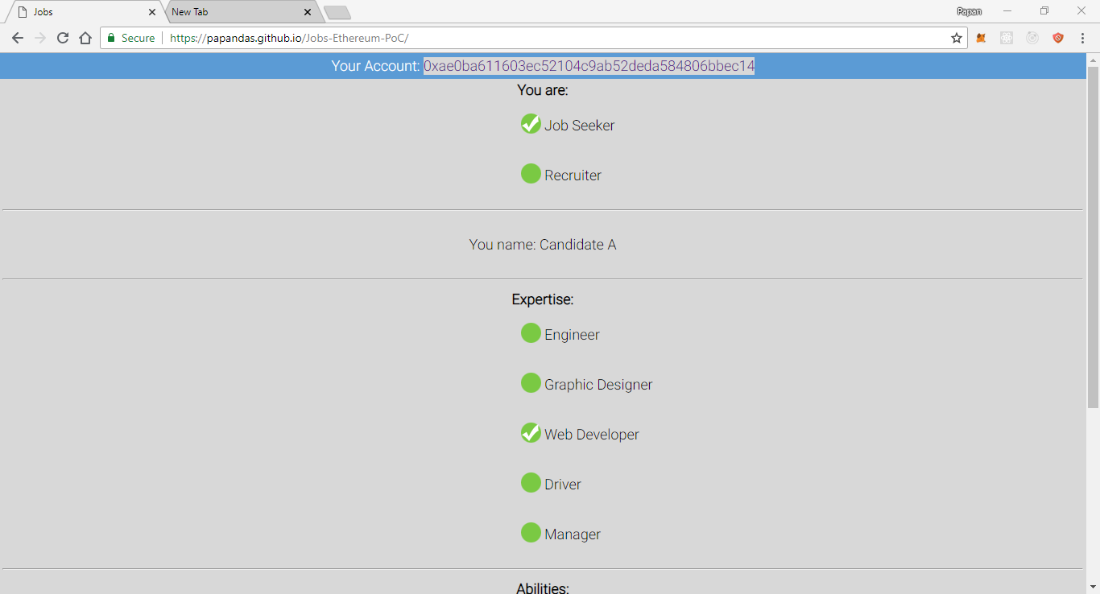

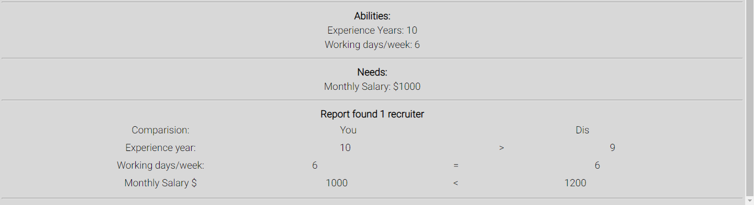

1. Change the Account from Metamask to a pre-saved (my case) Recruiter account. Refresh the page once more to load as a Recruiter Account.

|  |  |
| --- | --- |
| 2018-07-25_1531.png | 2018-07-25_1531_001.png |

1. Account details shows all the requested fields and comparison from the previously saved job-seeker.

