How to setup project

1. Tools required:
   1. VS Code: Download and Install from here <https://code.visualstudio.com/>
   2. NodeJS: Download and install from here <https://nodejs.org/en/>

|  |  |
| --- | --- |
| 2018-07-25_1604.png | 2018-07-25_1605.png |

1. Download and the save the Source Folder in your working/project directory
2. Open “NodeJS command prompt “

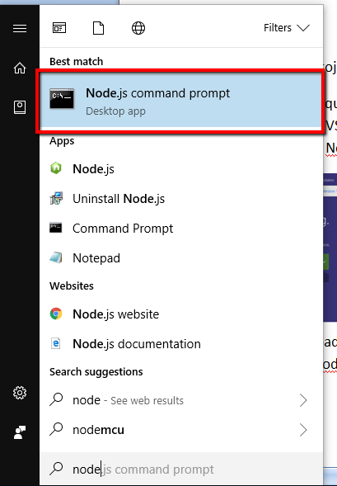

1. Navigate to your Project Directory. (In my case its “C:\xampp\htdocs\BLOCKCHAIN\Jobs-Ethereum-PoC\”)

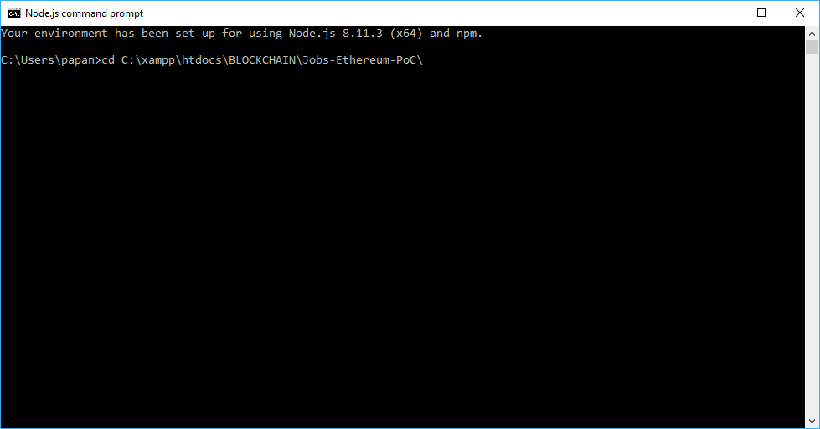

1. Run Command “npm install”. It will install all your dependency

2018-07-25_1612.png

1. Run Command “npm run dev”. It will setup your local server.

2018-07-25_1612_001.png

1. It will open the Web Browser and run the service in your browser

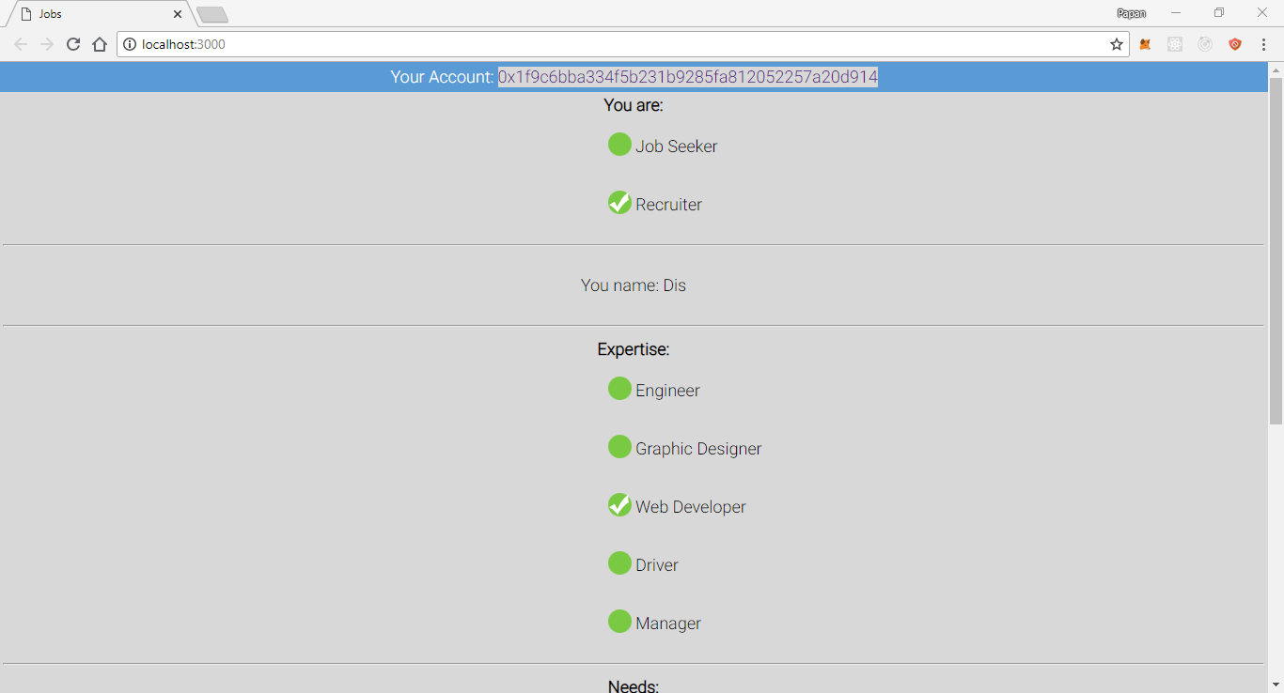

1. Kindly check the Metamask account and you are good to go.