LAB #1

**Task#1**

According to the table create a database to store these data.

|  |  |  |  |  |
| --- | --- | --- | --- | --- |
| **Student ID** | **First name** | **Last name** | **Email** | **Tel.** |
| 62100200121 | Somchai | Jaidee | Som@gmail.com | 024709881 |
| 62200200143 | Peter | Wong | peter@km.com | 0878111758 |
| 60100300151 | Wirat | Sae-Jiw |  |  |

See references

https://www.w3schools.com/sql/sql_create_db.asp

https://www.w3schools.com/sql/sql_create_table.asp

1. Create a new database

create database task1;

1. Create table

CREATE TABLE `task1`.`task_1` (

`StudentID` VARCHAR(45) NOT NULL,

`Firstname` VARCHAR(45) NOT NULL,

`Lastname` VARCHAR(45) NOT NULL,

`Email` VARCHAR(45) NULL,

`Tel` VARCHAR(45) NULL,

PRIMARY KEY (`Student ID`));

1. Insert data

insert into task_1 values('62100200121','Somchai','Jaidee','Som@gmail.com','024709881');

insert into task_1 values('62200200143','Peter','Wong','peter@km.com','0878111758');

insert into task_1 (StudentID,Firstname,Lastname) values ('60100300151','Wirat','Sae-Jiw');

1. List data in the table

select * from task_1;

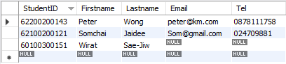

Task#2

According to the table create a database to store these data.

|  |  |  |  |  |  |  |
| --- | --- | --- | --- | --- | --- | --- |
| **Student ID** | **First name** | **Last name** | **Email** | **Tel.** | **Primary school** | **School address** |
| 62100200121 | Somchai | Jaidee | Som@gmail.com | 024709881 | Wat-wa | 11 Prachautid  Bangmod Bangkok |
| 62200200143 | Peter | Wong | peter@km.com | 0878111758 | Wat-wa | 11 Prachautid  Bangmod Bangkok |
| 60100300151 | Wirat | Sae-Jiw |  |  | Suan | 21/748 Lumtaklong  Nakorn |

1. Create a new database

create database task2;

1. Create table

CREATE TABLE `task2`.`primary_school` (

`SchoolID` INT NOT NULL,

`SchoolNAME` VARCHAR(45) NULL,

`Address` VARCHAR(45) NULL,

PRIMARY KEY (`SchoolID`),

UNIQUE INDEX `SchoolNAME_UNIQUE` (`SchoolNAME` ASC) VISIBLE,

UNIQUE INDEX `Address_UNIQUE` (`Address` ASC) VISIBLE);

CREATE TABLE `task2`.`students` (

`StudentID` VARCHAR(45) NOT NULL,

`Firstname` VARCHAR(45) NOT NULL,

`Lastname` VARCHAR(45) NOT NULL,

`Email` VARCHAR(45) NULL,

`Tel` VARCHAR(45) NULL,

`SchoolID` INT NOT NULL,

PRIMARY KEY (`StudentID`),

UNIQUE INDEX `Email_UNIQUE` (`Email` ASC) VISIBLE,

UNIQUE INDEX `Tel_UNIQUE` (`Tel` ASC) VISIBLE,

INDEX `School_IDX` (`SchoolID` ASC) INVISIBLE,

CONSTRAINT `SchoolID`

FOREIGN KEY (`SchoolID`)

REFERENCES `task2`.`primary_school` (`SchoolID`)

ON DELETE NO ACTION

ON UPDATE NO ACTION);

1. Insert data

insert into primary_school values(101,'Wat-wa','11 Prachautid Bangmod Bangkok');

insert into primary_school values(150,'Suan','21/748 Lumtaklong Nakorn');

insert into students values('62100200121','Somchai','Jaidee','Som@gmail.com','024709881',101);

insert into students values('62200200143','Peter','Wong','peter@km.com','0878111758',101);

insert into students(StudentID,Firstname,Lastname,SchoolID) values('60100300151','Wirat','Sae-Jiw',150);

1. List data in the table

select * from primary_school;

select * from students;

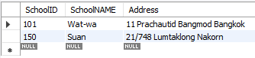

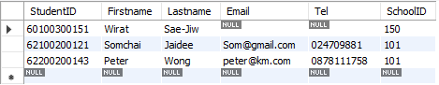

1. Export DDL script

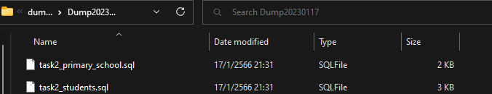

**Task#3**

1. Create a new database.

create database task3;

1. Create 3 tables: LECTURERS, COURSES, STUDENTS with the following columns:

LECTURERS: LECTURER_ID (PK), LECTURER_NAME, SPECIALIZATION, TELEPHONE

COURSES: COURSE_CODE (PK), COURSE_TITLE, CREDITS

STUDENTS: STUDENT_ID (PK), STUDENT_NAME, GPAX, DEPARTMENT

Use appropriate data types for each column.

1. CREATE TABLE `task3`.`lecturers` (

`LECTURER_ID` INT NOT NULL,

`LECTURER_NAME` VARCHAR(45) NOT NULL,

`SPECIALIZATION` VARCHAR(45) NOT NULL,

`TELEPHONE` VARCHAR(45) NULL,

PRIMARY KEY (`LECTURER_ID`),

UNIQUE INDEX `TELEPHONE_UNIQUE` (`TELEPHONE` ASC) VISIBLE);

2. CREATE TABLE `task3`.`courses` (

`COURSE_CODE` VARCHAR(45) NOT NULL,

`COURSE_TITLE` VARCHAR(45) NOT NULL,

`CREDITS` INT NOT NULL,

PRIMARY KEY (`COURSE_CODE`),

UNIQUE INDEX `COURSE_TITLE_UNIQUE` (`COURSE_TITLE` ASC) VISIBLE);

3. CREATE TABLE `task3`.`students` (

`STUDENT_ID` VARCHAR(45) NOT NULL,

`STUDENT_NAME` VARCHAR(45) NOT NULL,

`GPAX` DOUBLE NOT NULL,

`DEPARTMENT` VARCHAR(45) NOT NULL,

PRIMARY KEY (`STUDENT_ID`));

1. Insert at least 4 rows in each table using different forms of insertion statement. Insert null values in some columns of each table.

1. insert into lecturers values(101,'Anna','Art','011111111');

insert into lecturers(LECTURER_ID,LECTURER_NAME,SPECIALIZATION) values(102,'Edward','Mathematics');

insert into lecturers values(201,'David','English','0657419862');

insert into lecturers values(302,'Chujai','Music','0628469999');

2. insert into courses values('LNG220','Academic English','3');

insert into courses values('INT105','Basic SQL','1');

insert into courses values('INT104','Ux Design','3');

insert into courses values('INT103','Advanced Programming','3');

3. insert into students values('61130500010','Prajak','3.24','IT');

insert into students values('63130500049','Pepo','2.90','CS');

insert into students values('64130500075','Panda','3.99','IT');

insert into students values('63130500015','Pingpong','2.90','CS');

1. List data from each table.
   1. List all data from each table.

1.select * from lecturers;

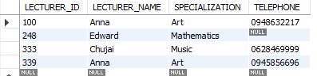

2. select * from courses;

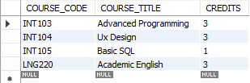

3. select * from students;

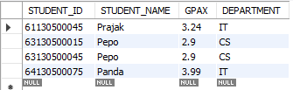

**Options**

* 1. List the student’s name that study in engineering department.
  2. List the lecturer’s name that do not specific the specialization.
  3. List the course title that has credits less than 3.
  4. List the lecturer that his/her name start with letter ‘a’.