I'm looking for the equipment or robot which are used to min or catch sea cucumber or sea urchin in sea water*.*
- we want to see the sea cucumber or sea urchin via in water camera and want to mine or catch them using some tools like robot arm.
- Give me the catalog for the products like these robot or equipment.
- Which one is the best in these products?
- Which one is the best in the best in price vs performance?
- How much is the price of each products?
- Download each product catalog in pdf format.
- Give me the video url which shows how these products work.
- Download each video and give me the link to download it.
For your project, the equipment you want is generally called an underwater remotely operated vehicle (ROV) with a live camera and a manipulator arm, or a subsea harvesting robot. It can let an operator see sea cucumbers or sea urchins on the seabed, position the robot above them, and collect them using a robotic claw, suction device, or specialized harvesting tool.
I would compare three types of equipment:
- Observation ROV + robotic arm: Best for seeing, identifying, and selectively collecting individual animals.
- Work-class ROV + manipulator: Best for deeper water, stronger tools, and more demanding operations, but much more expensive.
- Purpose-built harvesting ROV: Potentially the best option for repeated sea cucumber or sea urchin collection, provided the manufacturer can demonstrate that the collection tool works for your target species and seabed.
One important distinction: many underwater robots are sold for inspection, scientific research, or offshore maintenance. Having a camera and arm does not automatically mean a robot can harvest sea cucumbers or sea urchins effectively. Tool reach, seabed disturbance, suction or gripping strength, depth rating, and collection-basket capacity all matter.

1. Best products to consider
Prices below are in USD unless otherwise stated. These are current advertised prices where available; custom commercial ROVs and industrial systems may require a quotation.
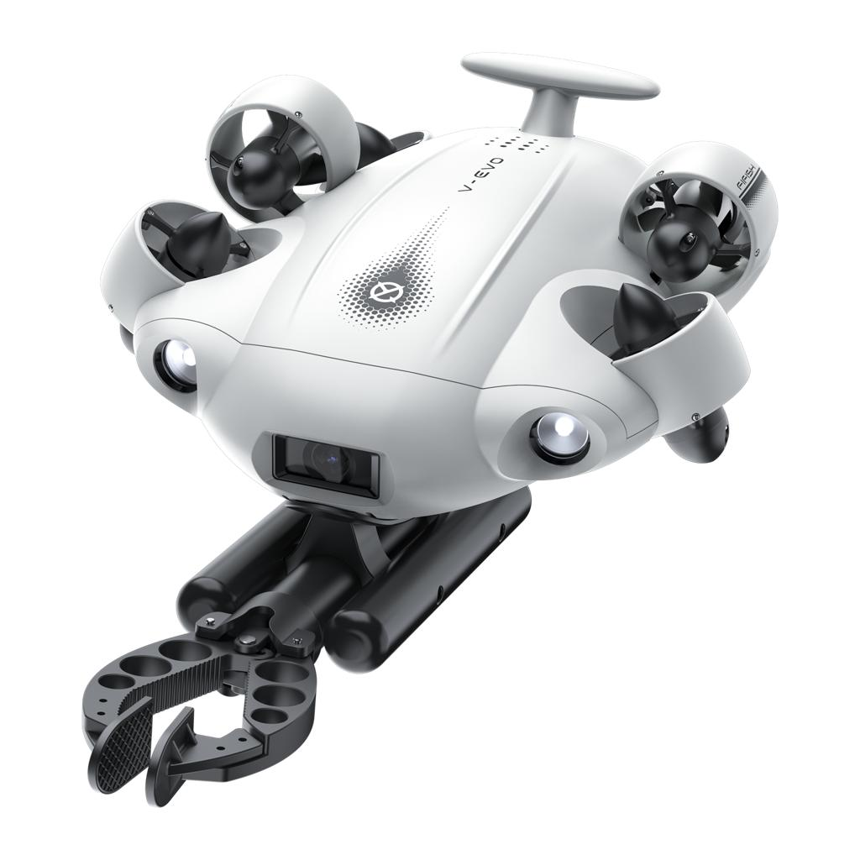

1. QYSEA FIFISH V-EVO
Best starter system

$1,699
ROV with arm package
- 4K camera, live underwater viewing, and omnidirectional movement.
- 100 m rated depth and up to 5,000 lumens of lighting.
- Optional robotic arm with up to 7 kgf grip strength.
- Compact and relatively easy to deploy from a small boat.
Best for: shallow-water trials, locating individual animals, and light collection.
Product and pricing · Official specifications and brochure
Arm manual and tutorial videos
Source: official product listing and specifications.

Underwater Drone with 4K@60fps Camera
+2
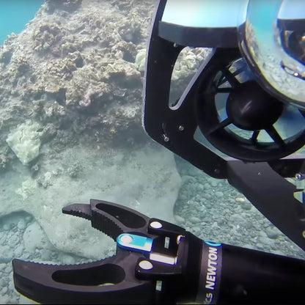

2. BlueROV2 + Newton Subsea Gripper
Best price vs. flexibility

About $3,620+
Approximate starting configuration
- Configurable ROV with live camera and lighting.
- Newton gripper rated to 300 m depth.
- Gripper advertised at $720; the ROV has historically been listed from $2,900, so confirm the current base price and options.
- Open architecture makes it attractive for custom claws, baskets, cameras, and collection tools.
Best for: building a research or harvesting prototype that can be modified as you learn.
Blue Robotics website · Gripper and price · Technical documents
Source: manufacturer gripper listing and ROV datasheet.

Blue Robotics
+2
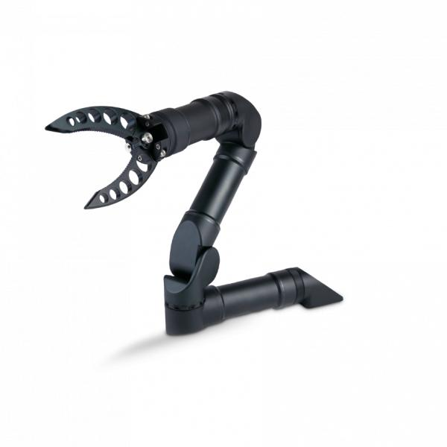

3. Charpie ROV + manipulator

$6,694+
Indicative combined entry price
- Advertised ROV configurations: approximately $5,679–$8,679.
- Single-function gripper: $1,015.
- Gripper depth rating of 300 m, with 142° opening and 10 kgf closing force advertised.
- Suitable if you want a more integrated commercial package.
Best for: comparing an assembled commercial solution with a DIY-configurable platform.
ROV products · Manipulator specifications and video
Source: advertised prices; confirm that the selected ROV includes the camera, tether, controller, and arm interface.

Charpie
+1
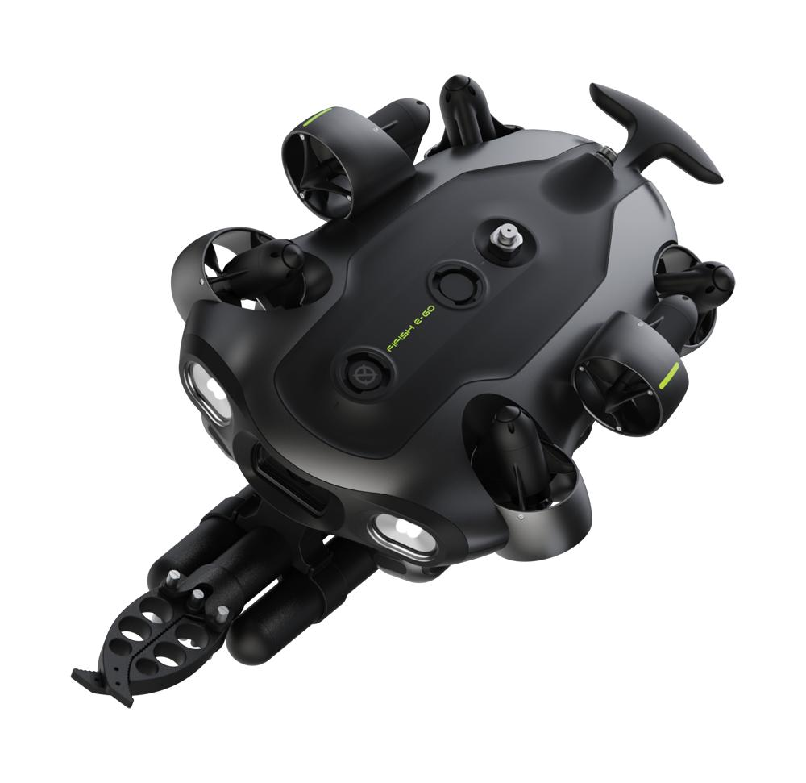

4. QYSEA FIFISH E-GO

Quote required
- Industrial-oriented modular platform.
- Advertised 200 m depth capability, swappable battery system, and up to 5 kg underwater payload.
- Compatible 2-finger robotic arm listed at $699.
Best for: longer-term commercial development and a more modular setup than a basic recreational ROV.
Official specifications and brochure · Arm price and specifications
Source: manufacturer's published product information.
4K Industrial ROV & Underwater Drone
+1
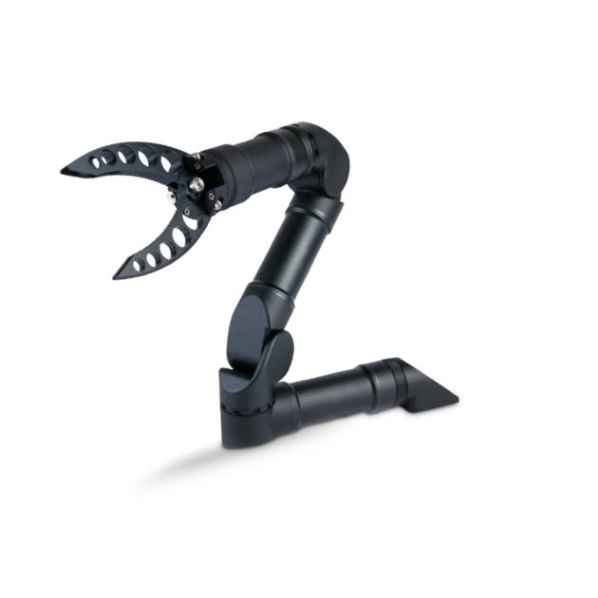

5. Reach Alpha

Quote required
- 0.4 m reach, 2 kg lift at full reach, and 300 m depth rating.
- Modular end effectors allow the gripping tool to be changed for different objects.
- Can integrate with compatible ROVs, including BlueROV2.
Best for: precise collection experiments where a simple gripper is not enough.
Official product catalogue PDFs · Specifications and integration options
Source: manufacturer and integration partner specifications.

Flyers & Catalogs
+1

2. Price comparison
System | Advertised or indicative price | Main advantage
FIFISH V-EVO + arm | $1,699 | Lowest-cost ready-to-use option in this shortlist
BlueROV2 + Newton gripper | About $3,620+ | Customization and development flexibility
Charpie ROV + gripper | About $6,694+ | Commercial configuration
FIFISH E-GO + arm | Quote required | Modular industrial platform
Compatible ROV + Reach Alpha | Quote required | More dexterous manipulation
These figures are not strictly like-for-like. Shipping, taxes, tether length, spare batteries, sonar, positioning equipment, storage baskets, and harvesting-tool development may change the total substantially.

3. Which is the best?
My recommendation depends on what you mean by best.
- Best overall for an initial field test: FIFISH V-EVO with the robotic arm. It offers a relatively low entry cost, a good camera, and a bundled arm. Its main limitation is that the arm is designed for light retrieval, not a proven commercial harvesting process.
- Best price versus performance for a custom project: BlueROV2 with the Newton gripper. The configurable architecture is useful if you plan to design a species-specific tool, collection basket, or improved camera system.
- Best starting point for a commercial-grade system: FIFISH E-GO or a compatible ROV fitted with a Reach Robotics manipulator, depending on the required working depth, payload, and tool precision.
For sea urchins, a simple claw may crush or damage the animal. For sea cucumbers, a claw may damage the body or grip poorly. I would investigate a soft-jaw collector or a purpose-built scoop and basket alongside the standard gripper.

4. Product catalogues and PDF downloads
These are the official manufacturer resources. Where the manufacturer provides a brochure PDF, use the PDF link; where it only provides online documentation, use the product documentation page.
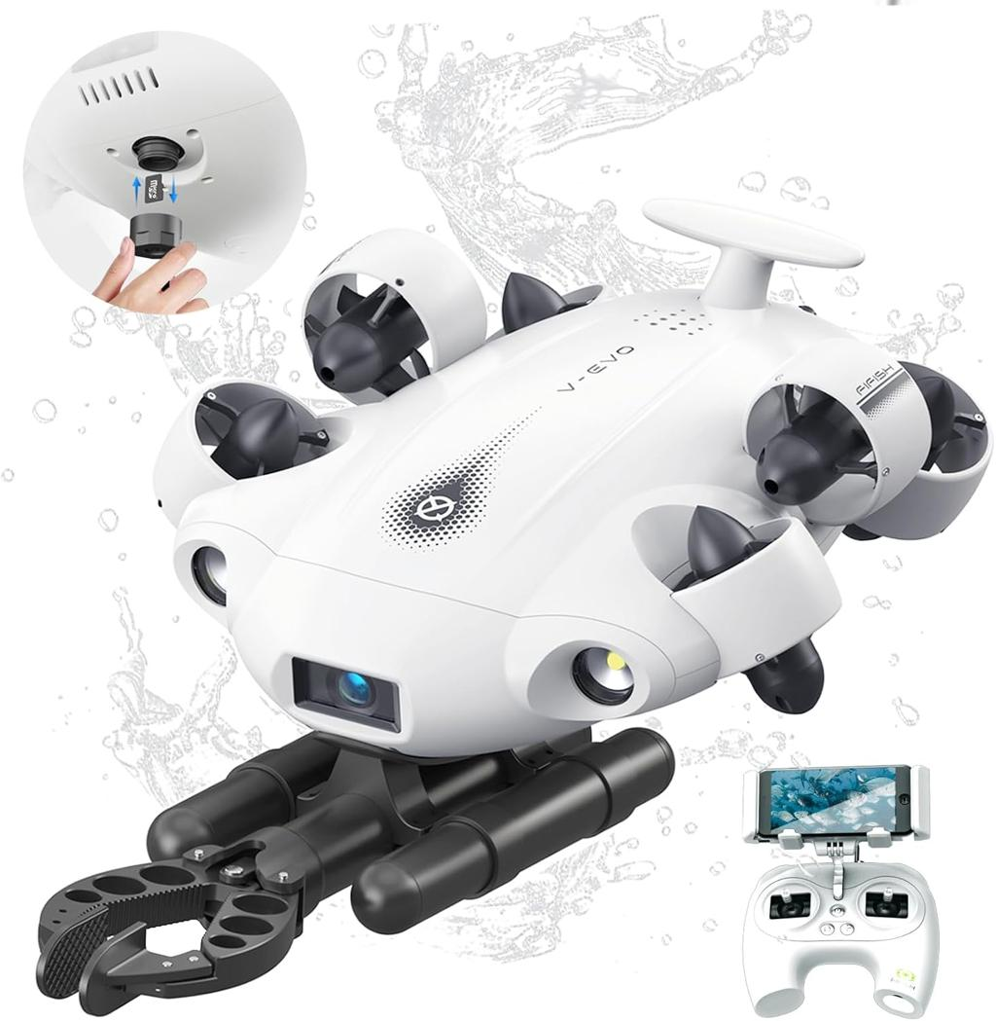
FIFISH V-EVO — product brochure
Product specifications and features
Open brochure PDF
Manuals and video tutorials
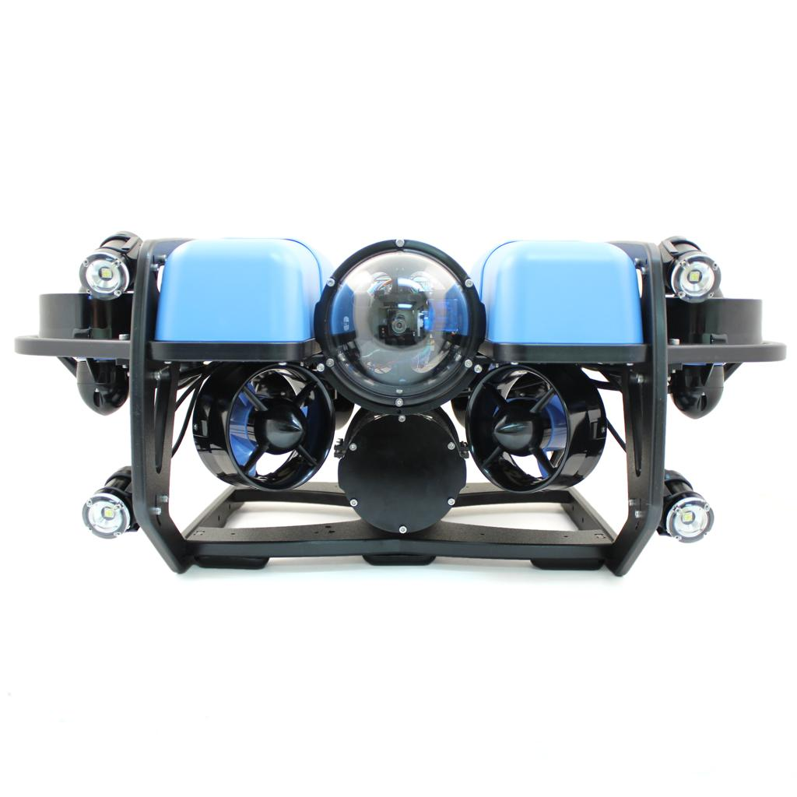
BlueROV2 — technical datasheet
Vehicle specifications, configuration and depth rating
Open datasheet PDF
Technical downloads and drawings
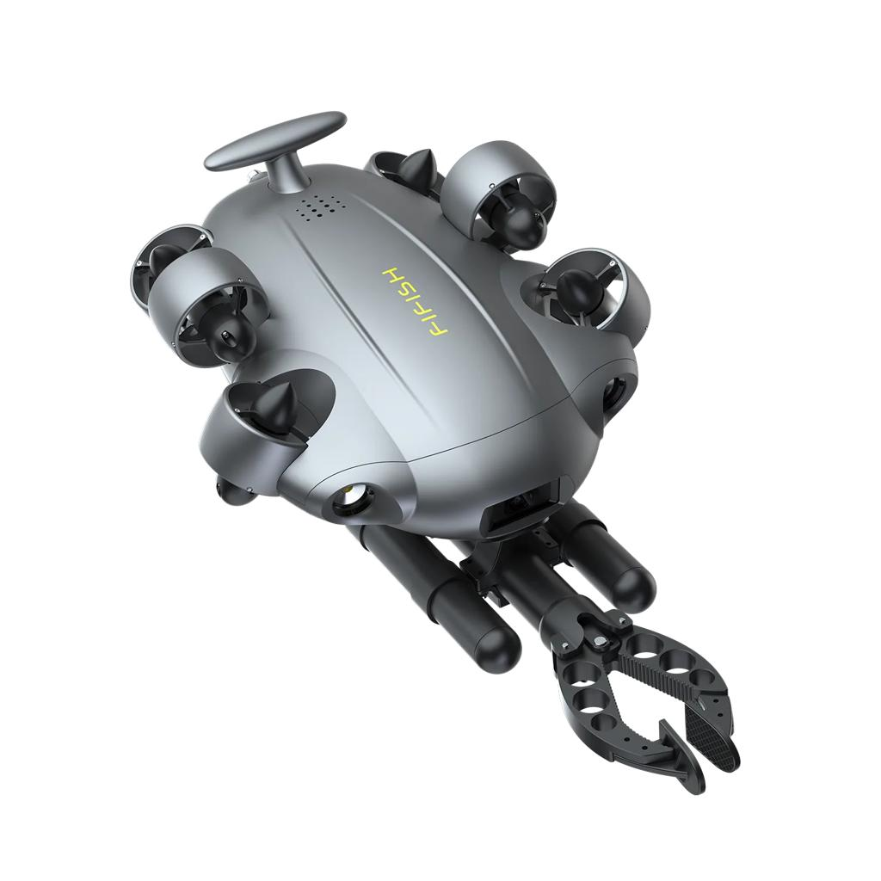
Charpie — ROV and gripper specifications
Product details and underwater demonstration clips
Manipulator product page
ROV product range
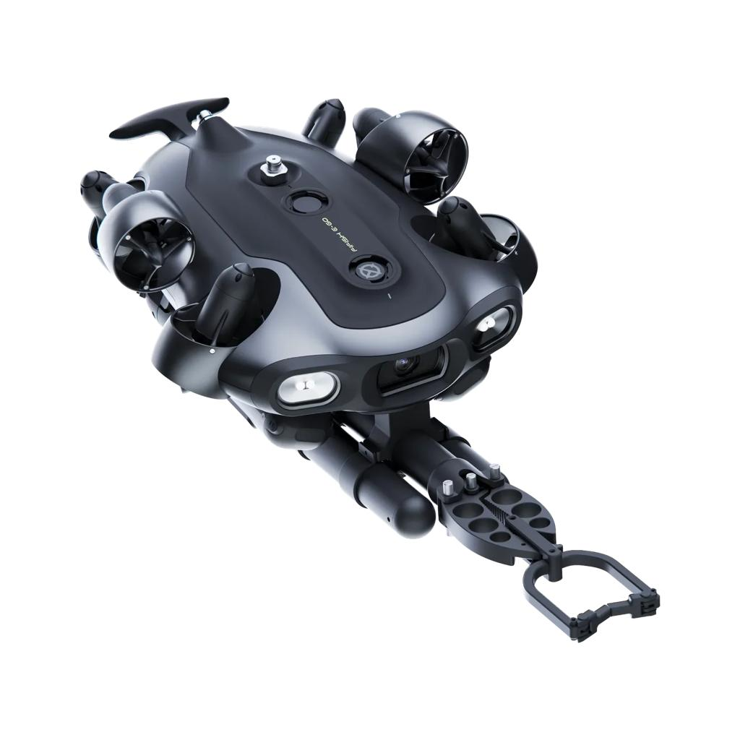
FIFISH E-GO — product brochure
Industrial ROV capabilities and configuration
Official brochure and specifications
Compatible arm specifications
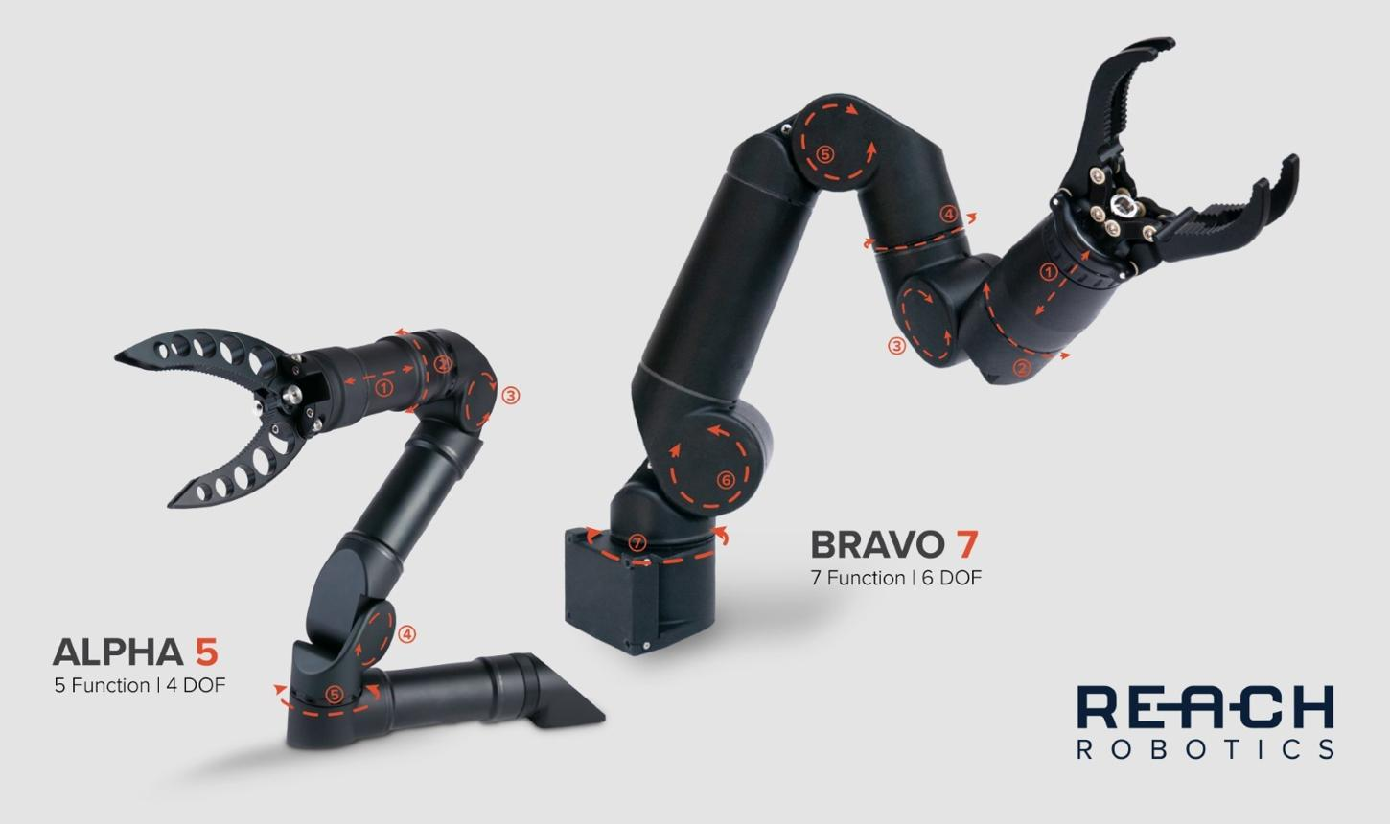
Reach Robotics — full product catalogue
Manipulator catalogue and individual arm datasheets
Open catalogue and download PDFs
Note: I verified the catalogue and documentation pages, but not every link is a direct PDF file. The Reach Robotics page explicitly lists downloadable PDFs; the QYSEA brochure is hosted on Google Drive.

E-Brochure.pdf - Google Drive
+2

5. Videos showing how the equipment works
The following videos demonstrate the relevant operations, particularly underwater targeting, gripping, and retrieval.
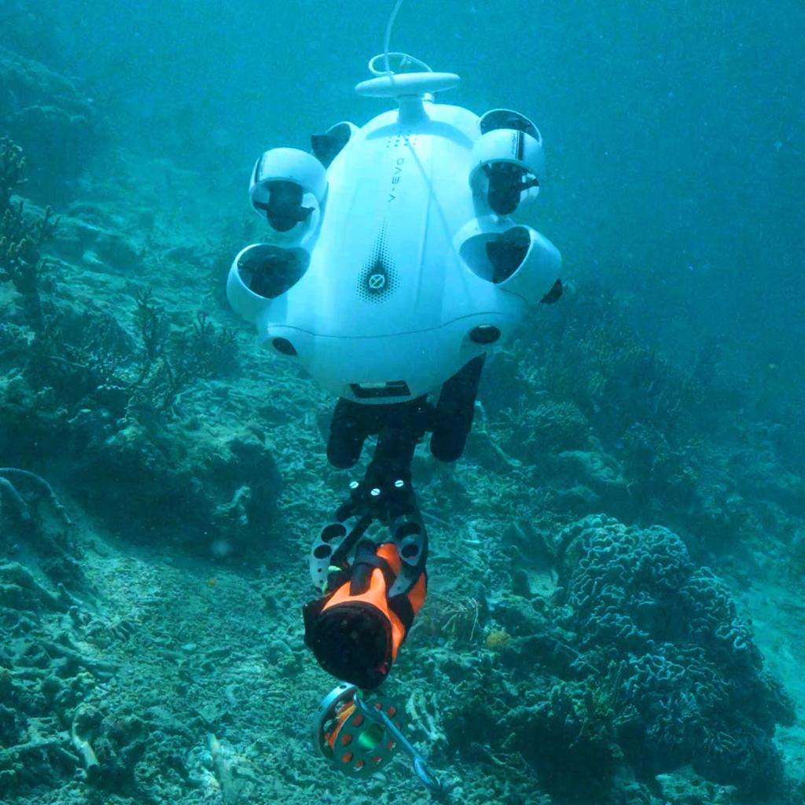
1. Charpie — underwater target grabbing and retrieving
Shows the robot targeting and retrieving an underwater object.
Open MP4 video
View video on the product page
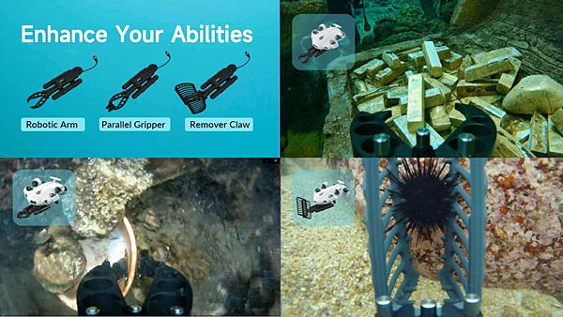
2. Charpie — underwater object picking
Short demonstration of a gripper picking up an object underwater.
Open MP4 video
View product demonstrations
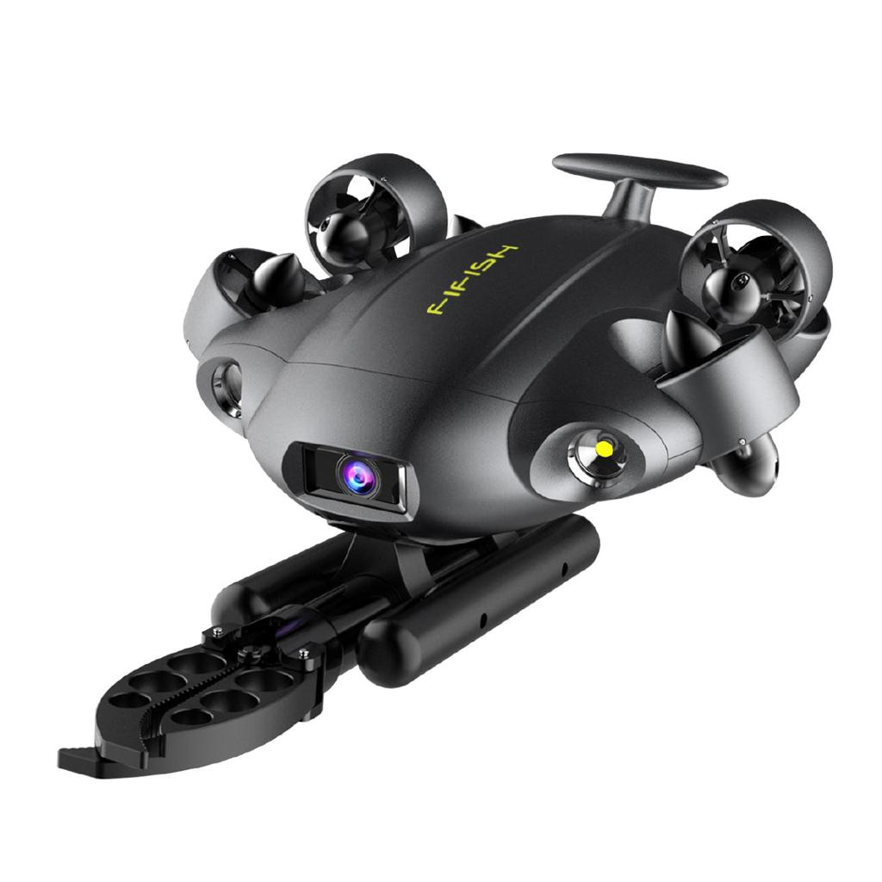
3. FIFISH — robotic arm tutorial
Installation and use of the two-finger underwater arm.
Watch official tutorial videos
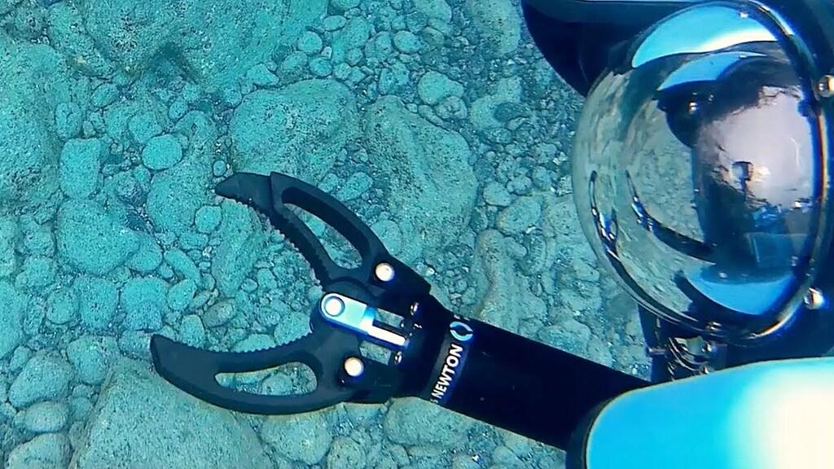
4. Blue Robotics — Newton Subsea Gripper
Gripper demonstration and technical background.
Watch the launch demonstration
Gripper details and guides

Downloading the videos
The two Charpie links above point to MP4 files, so you can try opening them in your browser and saving them with Ctrl+S, or use wget in Windows:
wget "https://charpierov.com/wp-content/uploads/2025/02/Underwater-Picking.mp4" -O "Underwater-Picking.mp4"
I attempted to retrieve the MP4 files directly for you, but the downloads failed in this session. I therefore cannot provide verified local download files; the links above are the original video URLs.

6. What I would build for sea cucumber and sea urchin collection
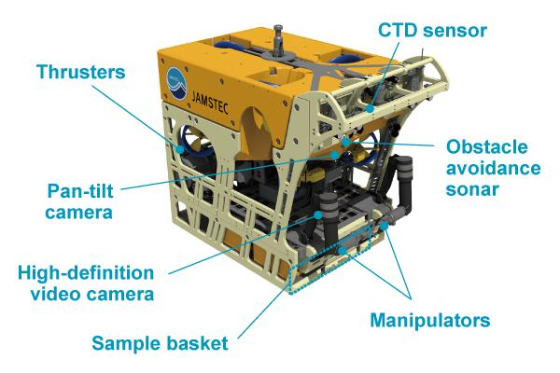
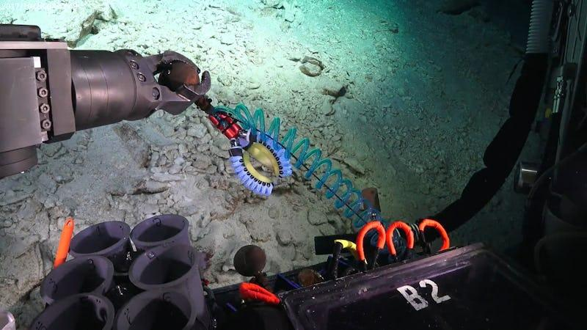
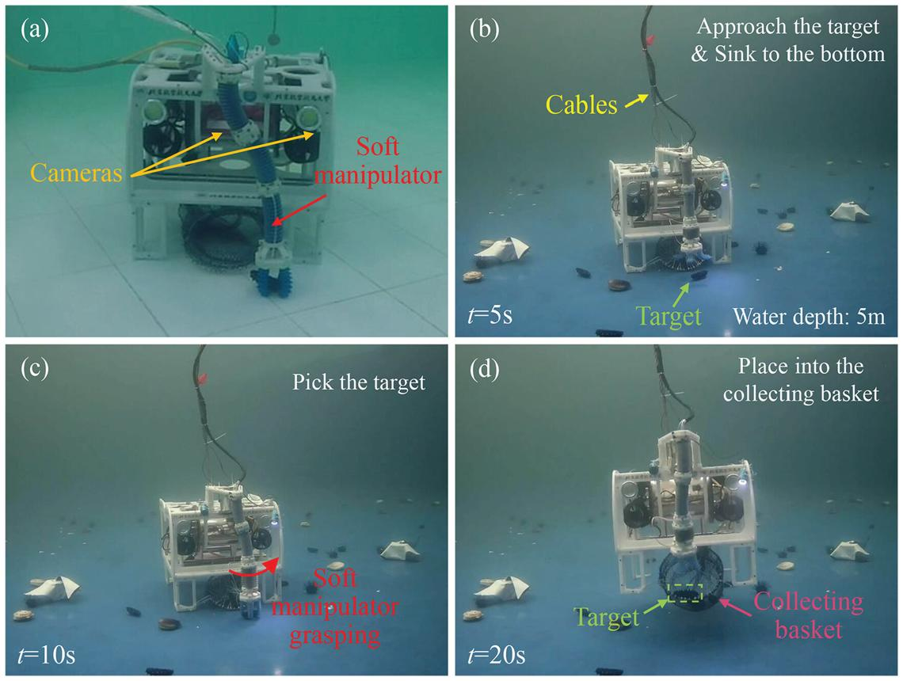
12
For your application, I would start with an ROV that has:
- A live camera with strong lights for spotting animals on the seabed.
- Stable hovering or position hold so the operator can line up the tool.
- A replaceable end effector: soft parallel jaws for suitable targets, or a scoop for animals that are difficult to grip.
- A collection basket or retrieval container so collected animals are not lost.
- An optional imaging sonar for turbid water, where a normal camera may not see far.
- A tether long enough for the working area, with a depth rating appropriate for your site.
My practical choice: FIFISH V-EVO for a low-cost initial trial; BlueROV2 for a more customizable prototype. I would not buy a large industrial ROV until the collection tool has been tested on the actual seabed.
One final point: commercial collection of sea cucumbers and sea urchins may require fisheries permits, and local rules can limit species, size, season, or collection method.

7. Three details that would let me narrow this down
The right robot and price can change dramatically with operating depth and the seabed conditions.
1. How deep is the water where you will collect them?
0–10 m
10–30 m
30–100 m
100–300 m
Over 300 m
2. What is the seabed like?
Sand or mud
Rocky seabed
Mixed sand, rock, and vegetation
3. What is your total budget?
Under US$2,000
US$2,000–5,000
US$5,000–15,000
Over US$15,000
Find the best equipment for my conditions
Recommend and compare underwater ROVs specifically for sea cucumber and sea urchin collection. Water depth: 0–10 m. Seabed: Mixed seabed. Total budget: US$2,000–5,000. Prioritize suitable harvesting tools, live camera, verified catalog PDF links, current prices, and downloadable demonstration videos.

Recommended setup for your conditions
Water depth: 0–10 m · Mixed seabed · Budget: US$2,000–5,000
For this budget, I recommend starting with the QYSEA FIFISH V-EVO Arm Pack, then testing a gentle collection tool and small basket. It leaves more budget for field testing than a work-class ROV. The current official listing shows $1,699 for the Arm Pack.

QYSEA Store
+1

QYSEA FIFISH V-EVO Arm Pack

$1,699
Official US store price checked October 2026
- Live 4K camera and 5,000-lumen lighting.
- 100 m depth rating, comfortably above your 10 m requirement.
- Omnidirectional movement and an included arm package.
- Best for locating and collecting individual animals in relatively calm conditions.
Buy / view official listing · Manuals and video guides

1. Best options compared
Equipment | Current price | Fit for your project
FIFISH V-EVO Arm Pack | $1,699 | Best starting point for live viewing and light collection
FIFISH V-EVO Standard Pack | $1,399 | Good camera platform, but you would need to add a compatible arm
BlueROV2 + Newton Gripper | $5,620 before other costs | Excellent customization, but already above budget
Charpie ROV + manipulator | Confirm complete package quote | Potential alternative if a compatible ROV package fits your budget
The BlueROV2 currently starts at $4,900, and its Newton gripper costs $720, so the combined price exceeds your $5,000 limit before shipping or any collection-basket modifications.
Affordable and Capable Underwater ROV
+1

2. Suggested budget for a complete collection prototype
The V-EVO Arm Pack is listed at $1,699. QYSEA also lists its two-finger robotic arm separately from $399 and a retrieval hook for $49. Avoid purchasing a second arm if the Arm Pack already includes one.
QYSEA Store
+1
Item | Budget estimate
FIFISH V-EVO Arm Pack | $1,699
Small removable collection basket and mounting hardware | $100–250
Soft protective jaw covers or a simple scoop attachment | $50–200
Spare parts and basic maintenance supplies | $100–200
Estimated prototype total | $1,949–2,349
These basket, tool, and maintenance figures are planning allowances, not manufacturer quotes. Confirm the arm's payload and mounting compatibility before ordering custom parts. Shipping, import tax, and any required accessories are additional.
That leaves approximately $2,650–3,050 of your budget for field trials, a better collection tool, or a spare ROV battery if needed.

3. Official catalogues and downloadable PDFs
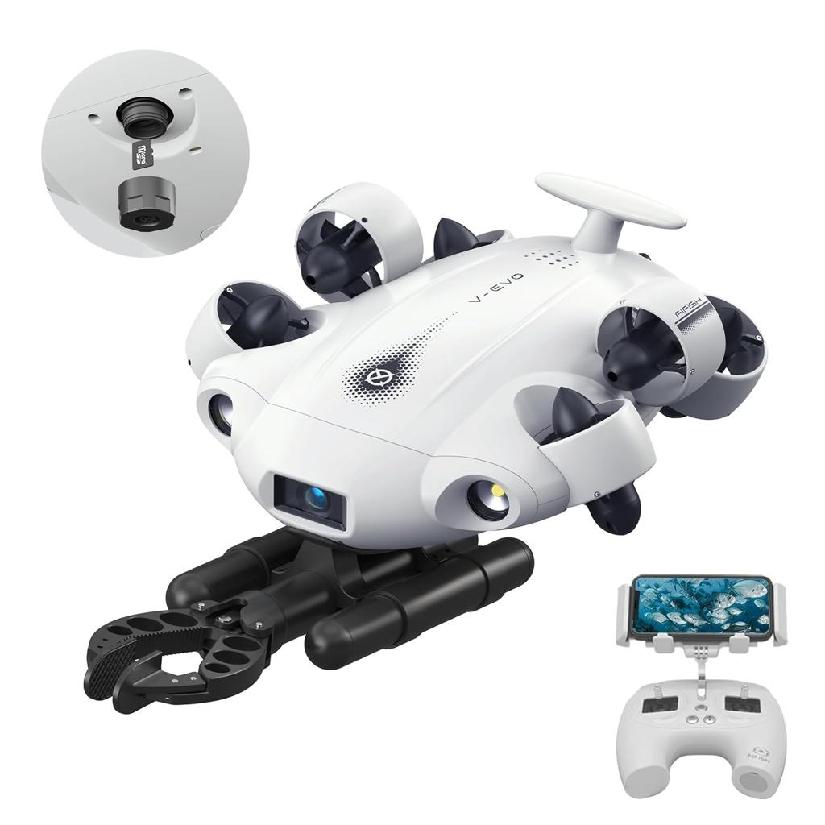
FIFISH V-EVO
Best match for your budget
Official product and package listing
Manuals and video guides
Downloads and support resources
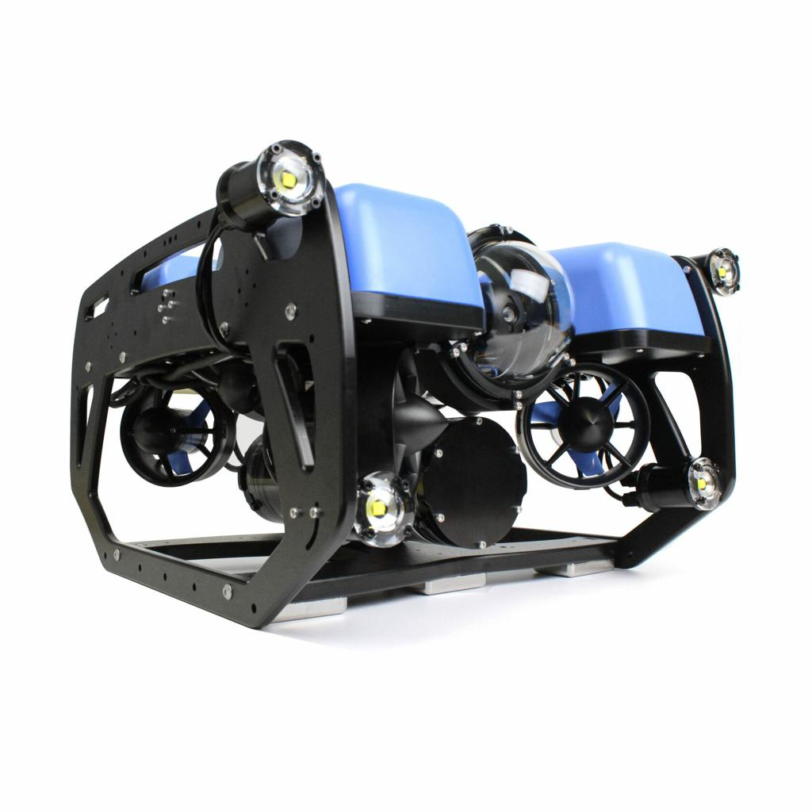
BlueROV2
Best alternative for custom development, but over budget when equipped with the gripper
Download official BlueROV2 datasheet PDF
Current price and configurations
Newton gripper specifications
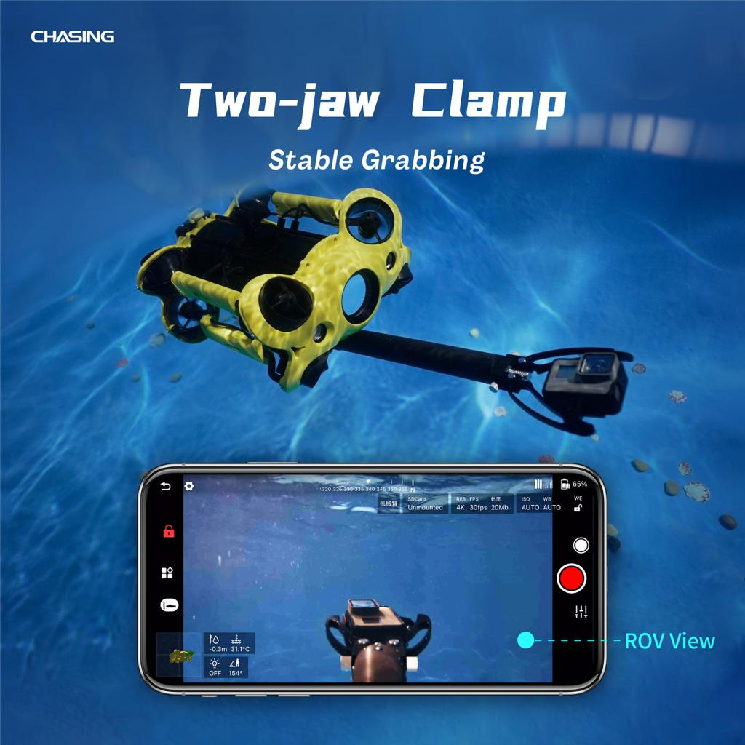
Charpie ROV manipulator
Worth asking about if you prefer a commercial manipulator
Manipulator product page, specifications and videos
ROV product range
The BlueROV2 PDF is a direct manufacturer datasheet. QYSEA provides its V-EVO manuals and accessory instructions through its support pages rather than the same direct PDF catalogue format.
DATASHEET
+2

4. Underwater working videos and download links
These videos demonstrate the essential operation: piloting an ROV, viewing a target, and manipulating an object.
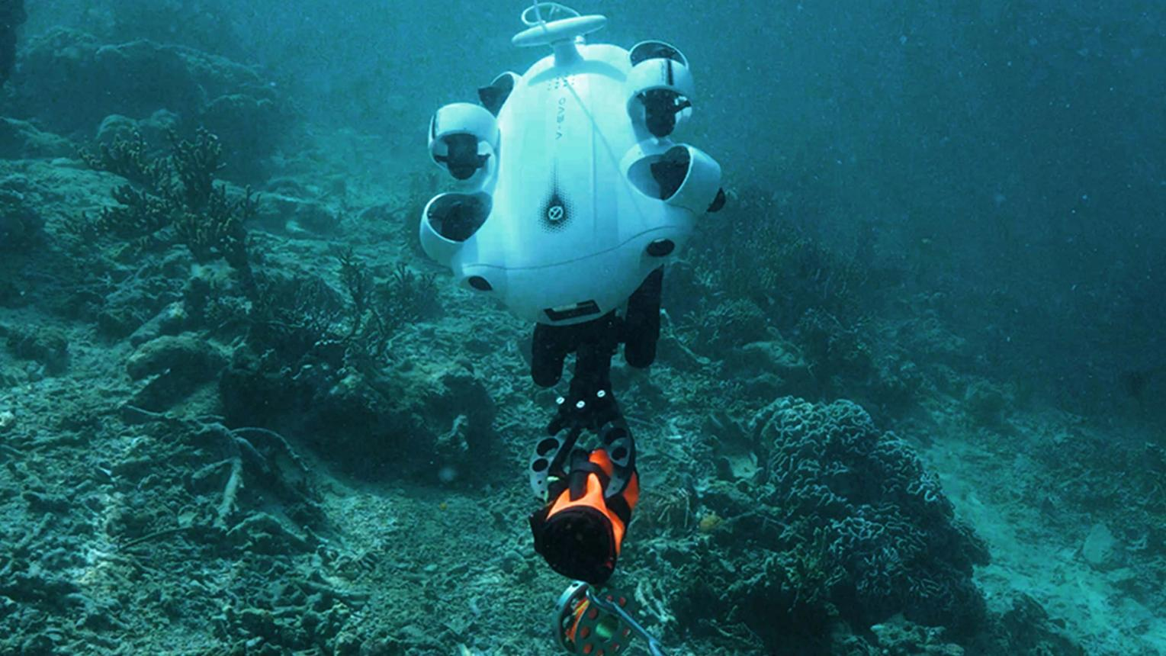
FIFISH V-EVO overview
Camera, movement, lighting, and underwater inspection.
Watch overview on official product page
More video guides
Newton Subsea Gripper demonstration
Shows the operation of an underwater gripper.
Watch on YouTube
Official gripper page and technical details
Charpie — underwater target retrieval
Direct MP4 demonstration of underwater grabbing and retrieval.
Open or save MP4
Open or save underwater picking MP4

How to save the MP4 videos on Windows
For a direct MP4 link, open it in Chrome and use the video player's download option if available. Alternatively, use PowerShell with curl.exe:
curl.exe -L "https://charpierov.com/wp-content/uploads/2025/02/Underwater-Picking.mp4" -o "Underwater-Picking.mp4"
The links above are source videos, not files hosted by me. I haven't verified that every video can be downloaded successfully from your network.

5. Important harvesting-tool recommendation
For your mixed seabed, I would prioritize a removable scoop with a retaining basket, rather than relying entirely on a conventional two-finger gripper.
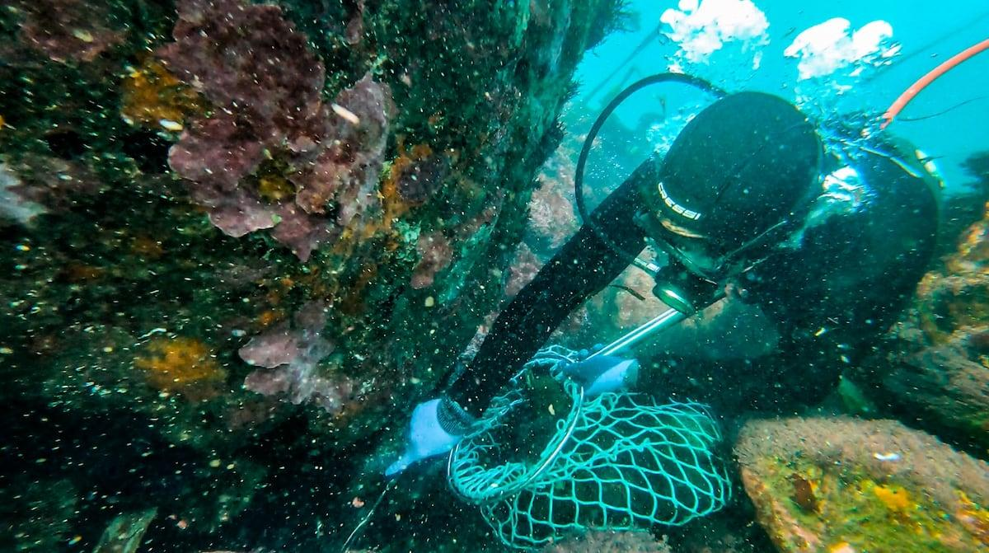
Scoop and basket
Potentially gentler on sea cucumbers; useful where animals sit on sand or among small rocks.
Soft-jaw gripper
More precise for individual targets, but requires careful force control to avoid damaging sea cucumbers or sea urchins.
A basket should have openings small enough to retain the target species but large enough to let water and sediment pass through. Test it in a controlled area before collecting animals commercially.
Final recommendation: Buy the FIFISH V-EVO Arm Pack first, verify the included arm and its capabilities, and prototype a removable scoop or basket. It offers the best balance of cost, live imaging, and ease of deployment for your 0–10 m operating depth. The BlueROV2 is the better platform if custom engineering is your main priority and you can increase the budget.

