We are going to build the smoke/fire monitoring system using IP camera. Currently, we have already built the hazard detection project named "Guard" using QT c++ and AirbnbRating.onnx module. The issue is that the correct hazard identification rate is too low. we are going to update the AI model dynamically write using the system. when the "Guard" project detects the smoke or fireEvent, it saves the screen into a PNG file and user see the PNG file and mark it "yes" when it from real smoke or fire screen. After repeating this work a lot of TimelineSender, we are going to update the AirbnbRating.onnx model file with the marked PNG files. - Give me your opinion for this plan, Is it right or not? - Is there any similar sample project like this in github? then give me download it. How to call such dynamic learning feature in AI field? - Write the specification for this project into a md file and download it. - Write the python code to update the onnx file. After write the code give me the tutorial for it. - Write QT C++ project for use the drive the dynamic learning after collecting all the PNG files.

Guard — AI Smoke & Fire Dynamic Learning System
Your plan is fundamentally good. I recommend implementing it as a human-in-the-loop active learning system: Guard detects possible smoke or fire, saves the relevant camera frame, collects human verification, and periodically trains an improved model using those verified examples.
There is one important technical distinction: you generally cannot improve an arbitrary .onnx file simply by adding PNG images to it. ONNX is primarily a model exchange and inference format. The usual approach is to train or fine-tune the model in its original training framework, validate the new model, export it to ONNX, and then deploy the new version into Guard.

1. Recommended architecture
IP camera
Continuous video stream
Guard — Qt/C++
Run AirbnbRating.onnx inference and detect possible hazards
PNG capture + event database
Save image, timestamp, camera ID, prediction and confidence
Human verification UI
Confirm smoke/fire, reject false alarms, or mark uncertain
Verified training dataset
Organize positive, negative and independently verified examples
Python training pipeline
Train → evaluate → export ONNX → test candidate model
Validated model deployment
Deploy only if acceptance criteria pass; retain rollback capability

2. Is your learning plan correct?
Yes, with a few important changes.
Your proposed approach | My recommendation
Save a PNG when smoke/fire is detected | Correct. Also preserve selected normal frames and false positives.
User marks an image Yes | Good start, but add Smoke, Fire, Neither, and Uncertain.
Collect many labeled images | Correct, but include different lighting, weather, steam, dust, fog and camera views.
Update the ONNX file directly | Train in the model's original framework and export a new ONNX file.
Deploy the updated model | Deploy only after evaluating it against a fixed, independent test dataset.
Repeat learning continuously | Use scheduled training and controlled model releases rather than modifying the live model after every label.

The most important risk
If Guard only saves frames after it has already detected smoke or fire, your dataset will be biased toward the current model's mistakes and predictions. It may never learn about hazards that the current model completely misses.
To reduce this problem, also collect:
- Randomly sampled frames from normal operation.
- Frames from user-reported incidents that Guard did not detect.
- False positives such as steam, clouds, headlights, reflections and dust.
- Multiple frames from different stages of each incident.
Avoid putting nearly identical frames from one video incident into both the training and test sets. That can make the model appear much more accurate than it really is.

3. Similar GitHub projects you can download
These are useful starting points. They do not necessarily implement your exact Qt-based labeling and retraining workflow, but they cover important parts of it.
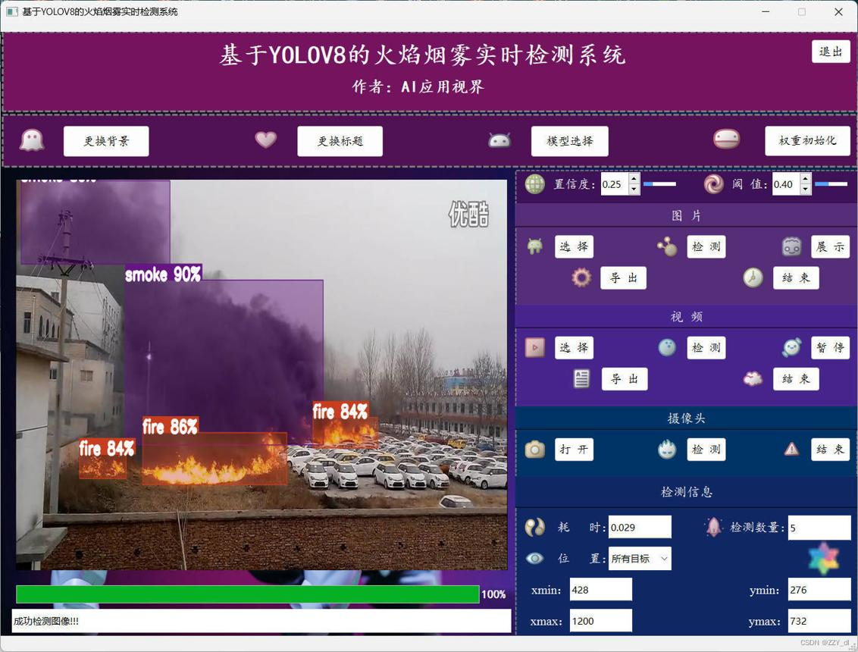
1. fire-smoke-detector-yolov8
Best starting point for smoke/fire detection
Uses a fine-tuned YOLOv8 model with temporal filtering and zone-based alerts.
GitHub repository · Download ZIP

GitHub
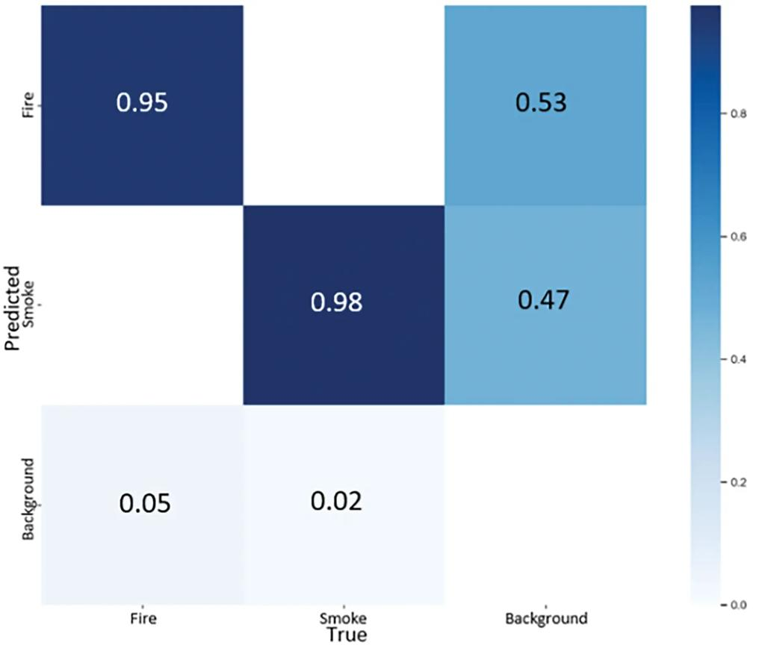
2. Fire-and-Smoke-Detection
Best for studying training and evaluation
Includes a training notebook, model weights and evaluation artifacts.
GitHub repository · Download ZIP
GitHub
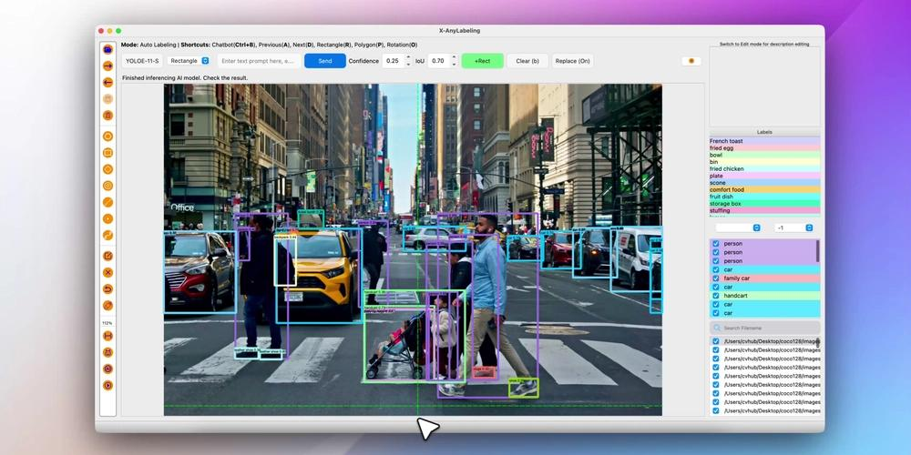
3. SmartLabeler
Best match for your dynamic learning concept
Demonstrates selecting informative images, human annotation and iterative retraining.
GitHub repository · Download ZIP
GitHub
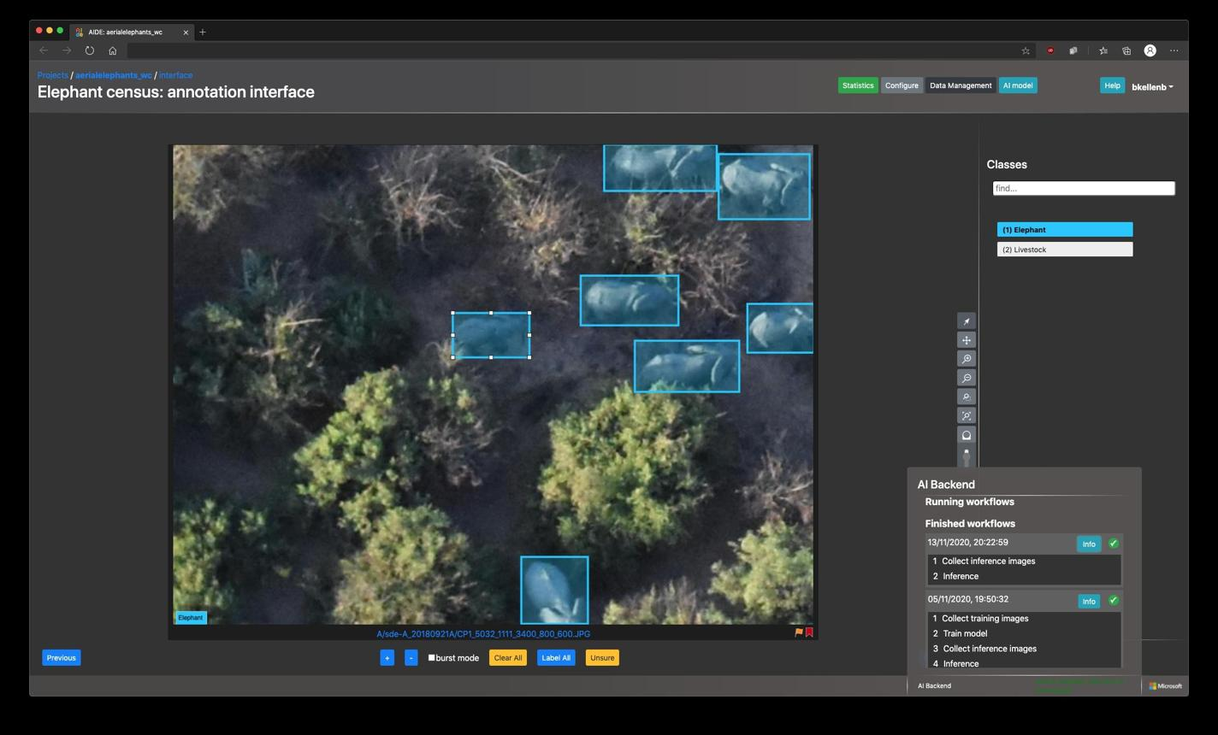
4. AIDE
Best for a larger annotation platform
Combines image annotation, model-assisted labeling and training workflows.
GitHub repository · Download ZIP
GitHub
These links are repository source downloads, not prebuilt Windows applications. Check each repository's current license before incorporating its code into a commercial product.

4. What is this feature called in AI?
The terminology matters because your proposed system combines several related techniques.
Term | Meaning in Guard
Human-in-the-loop learning | A person verifies model predictions and supplies labels.
Active learning | The system selects uncertain or informative images for review.
Supervised fine-tuning | A model learns from labeled smoke, fire and normal images.
Continuous learning / continual learning | The model is periodically updated as new verified data arrives.
MLOps | The process for dataset versions, model testing, releases and rollback.
The best name for the complete feature is Human-in-the-Loop Active Learning and Model Retraining.
One distinction: merely adding labels to a dataset is not online learning. The model only learns when you run a training or fine-tuning operation.

5. Download the Guard project specification and starter code
I've created a starter package containing the project specification, Python training pipeline, and Qt/C++ labeling application.
Guard Dynamic Learning — Starter Package
ZIP archive · Specification + Python + Qt/C++ source
Download the complete project
Project specification
Download Guard_Dynamic_Learning_Specification.md
Python training script
Open train_classifier.py
Qt/C++ image labeler
Open main.cpp
The Qt application is a prototype: it reviews captured images, saves labels, and launches Python training through QProcess. It does not yet integrate with your existing Guard camera pipeline or automatically deploy a trained model.

6. Python tutorial: training a new ONNX model
The supplied Python code is a working starting point for a three-class image classifier. It is not a universal ONNX fine-tuning script.
It uses the Ultralytics training and export workflow documented here: Classification training and ONNX export.

Ultralytics Docs
+1

Step 1 — Install Python dependencies
On Windows, open Command Prompt or PowerShell in the extracted project directory.
cd Guard_Dynamic_Learning\python

py -3.11 -m venv .venv
.\.venv\Scripts\activate

python -m pip install --upgrade pip
pip install -r requirements.txt
A compatible Python environment and sufficient disk space are required. A GPU is recommended for faster training.

Step 2 — Prepare the captured images
Create a directory containing the PNG files and a CSV file containing their labels.
Example labels.csv:
filename,label
camera1_001.png,smoke
camera1_002.png,fire
camera1_003.png,neither
camera1_004.png,uncertain
The meaning of each label is:
- smoke: confirmed smoke.
- fire: confirmed fire.
- neither: false alarm or normal scene.
- uncertain: exclude until a reviewer can make a reliable decision.
You need examples of all three trainable classes. A small collection can test the workflow, but it will not establish reliable fire detection performance.

Step 3 — Run the training script
Assuming your images are in ../inbox and the CSV is in the same parent directory:
python train_classifier.py `
--inbox ../inbox `
--labels ../labels.csv `
--work-dir ./training_work `
--model yolo11n-cls.pt `
--epochs 30 `
--imgsz 224
What the script does:
- Reads the labels and validates the image paths.
- Excludes images marked uncertain.
- Creates training, validation and test folders.
- Fine-tunes the selected classification checkpoint.
- Evaluates the candidate against the test split.
- Exports the candidate model to ONNX.
The first run may download the pretrained checkpoint.

Step 4 — Find the output
The training run produces a best.pt checkpoint and, if export succeeds, a candidate .onnx model under the training work directory.
Do not overwrite AirbnbRating.onnx with this candidate. The candidate is a different model architecture and requires matching preprocessing, output interpretation and class mapping in Guard.

Step 5 — Evaluate before deployment
Review the confusion matrix and per-class results. In particular:
- How often is real smoke missed?
- How often is real fire missed?
- How often are steam, fog or clouds mistaken for smoke?
- Does performance remain acceptable on night-time footage?
- Does inference run fast enough on the actual Guard computer?
The supplied script is a starting pipeline, not a complete safety validation process. Its initial random image split can also leak information across sets when many frames come from the same incident. For a real release, split by incident, camera or time period and keep a fixed independent test set.

7. Qt/C++ tutorial: operating the learning workflow
The supplied Qt 6 Widgets project is designed to be a separate review utility first, so you can validate the labeling and training process before integrating it into Guard.

Build the Qt application
Open qt_guard_labeler/CMakeLists.txt in Qt Creator and select a Qt 6 kit that matches your installed compiler.
Alternatively:
cmake -S . -B build -DCMAKE_PREFIX_PATH="C:/Qt/6.x.x/msvc2022_64"
cmake --build build --config Release
Replace the Qt installation path with your actual Qt version and kit.

Operate the labeler
1. Load captured images
Select the directory where Guard saves PNG screenshots.
2. Verify each image
Choose Smoke, Fire, Neither / False alarm, or Uncertain. The application appends the label to labels.csv.
3. Configure Python training
Set the Python executable to the virtual environment's Python executable, and set Script to the full path of train_classifier.py.
4. Start training
Click Start training (candidate only). The process output appears in the log area.
Before production use, improve the prototype to edit existing labels instead of appending duplicate rows, store camera/event metadata, and prevent training from starting when the dataset is incomplete.

8. How to integrate it into your existing Guard application
My recommendation is to separate Guard's real-time inference from the training workflow.
- Guard process: camera streaming, inference, alarms, screenshot capture and event metadata.
- Review UI: human verification and label management.
- Training process: Python-based dataset preparation, training, evaluation and ONNX export.
- Deployment manager: validates the candidate, switches model versions and supports rollback.
Never retrain the model inside the camera's inference loop. A training job can consume substantial CPU, memory and GPU resources, and should not interrupt hazard monitoring.
One additional improvement is to use confidence thresholds to prioritize the review queue. For example, Guard can prioritize low-confidence predictions and cases where consecutive frames disagree, while still sampling normal footage and accepting reports of missed incidents.

9. One critical question before updating AirbnbRating.onnx
Do you have the original source code or training checkpoint used to create AirbnbRating.onnx?
Original model files available
Yes — source code and original training checkpoint (such as .pt)
I have the original training source code only
No — I only have AirbnbRating.onnx
What does the current model output?
One class or score for the whole image
Bounding boxes around smoke or fire
I'm not sure
Continue with my model details
Your answer determines whether we should fine-tune the existing architecture or build a new smoke/fire model and integrate it into Guard.
For the Guard smoke/fire project: model availability = original source code and checkpoint; model output type = unknown. Recommend the correct retraining pipeline and Qt/C++ integration for AirbnbRating.onnx.

1. Recommended pipeline for your existing model
Since you have both the original source code and training checkpoint, I recommend continuing training the existing model first, rather than replacing it with a different architecture immediately.
Phase 1 — Identify the model
Inspect the source, checkpoint, ONNX inputs/outputs, preprocessing and class mapping.
Phase 2 — Build the verified dataset
Combine original training images with new human-labeled smoke, fire and negative examples.
Phase 3 — Fine-tune
Load the original checkpoint in its original framework and continue training with a conservative learning rate.
Phase 4 — Validate and export
Compare the candidate against the current model, export ONNX, and test inference parity.
Phase 5 — Release
Load the approved model in Guard, monitor performance, and retain the previous version for rollback.
The key is to recover the model's actual training configuration. A checkpoint is valuable because it may contain weights and, depending on the framework, architecture or training metadata. The ONNX file itself exposes input/output information, but does not necessarily preserve everything needed to continue training.
GitHub
+1

2. First, identify what AirbnbRating.onnx does
You can inspect its input and output tensor names and shapes using ONNX Runtime's Python API. This is a diagnostic step, not a substitute for inspecting the original source code.
Install the inspection dependencies:
pip install onnx onnxruntime
Save this as inspect_onnx.py:
import onnx
import onnxruntime as ort

model_path = "AirbnbRating.onnx"

model = onnx.load(model_path)
onnx.checker.check_model(model)

session = ort.InferenceSession(
model_path,
providers=["CPUExecutionProvider"]
)

print("Inputs:")
for item in session.get_inputs():
print(
"name =", item.name,
"shape =", item.shape,
"type =", item.type
)

print("\nOutputs:")
for item in session.get_outputs():
print(
"name =", item.name,
"shape =", item.shape,
"type =", item.type
)

print("\nMetadata:")
for item in model.metadata_props:
print(item.key, "=", item.value)
Run:
python inspect_onnx.py
The shapes provide useful clues. For example, an input shaped like [1, 3, 224, 224] commonly represents one RGB image, while an output shaped like [1, 3] might represent three class scores. These are examples only; do not assume that they describe your model.
Also check the original source for:
- Model class or architecture name.
- Original training framework and version.
- Input image size, color order and normalization.
- Output class IDs and their meanings.
- Whether the model performs classification, object detection or another task.
- The exact preprocessing and postprocessing used by Guard.

3. Choose the correct training branch
Once you inspect the source, follow the appropriate branch.

A. If the model is an image classifier
Recommended if applicable
- Each image receives a class or score.
- Fine-tune the original classification checkpoint using labeled images.
- Include a negative class for normal scenes and common visual confounders.
- Export the trained checkpoint to ONNX using the original framework's export process.
If the original model is an Ultralytics classifier, use its documented training and export workflow: Classification documentation.
Ultralytics Docs

B. If the model is an object detector
- Each image may contain bounding boxes, classes and confidence scores.
- PNG images alone are insufficient for standard supervised detector training; annotate the smoke/fire regions with bounding boxes.
- Fine-tune the original detector checkpoint with the original training framework.
- Export and validate the candidate ONNX detector.
Object detection training and export.
Ultralytics Docs

C. If the model is a different architecture
- Follow its original framework and training code.
- Recover the architecture, checkpoint format, loss function, label encoding and optimizer configuration.
- Reproduce the original inference preprocessing before comparing model outputs.
Do not use the sample Ultralytics classifier script unless the original model is actually compatible with that workflow.

4. Qt/C++ integration design
For Guard, I would separate the application into four components.
Component | Responsibility
HazardDetector | Runs the current ONNX model and emits hazard events.
EventRecorder | Saves PNG images and event metadata.
LabelReviewWidget | Displays captured images and records human labels.
TrainingManager | Starts Python training, captures logs, validates the candidate and manages model versions.

Run training asynchronously with QProcess
Do not train directly inside the UI thread or the real-time inference loop. Qt's QProcess can launch a separate Python process and deliver its standard output and error asynchronously.
// trainingmanager.h
#pragma once

#include <QObject>
#include <QProcess>
#include <QStringList>

class TrainingManager : public QObject
{
Q_OBJECT

public:
explicit TrainingManager(QObject *parent = nullptr)
: QObject(parent)
{
connect(&process, &QProcess::readyReadStandardOutput,
this, [this]() {
emit logMessage(
QString::fromLocal8Bit(
process.readAllStandardOutput()));
});

connect(&process, &QProcess::readyReadStandardError,
this, [this]() {
emit logMessage(
QString::fromLocal8Bit(
process.readAllStandardError()));
});

connect(&process,
QOverload<int, QProcess::ExitStatus>::of(
&QProcess::finished),
this, [this](int exitCode,
QProcess::ExitStatus status) {
emit trainingFinished(
status == QProcess::NormalExit && exitCode == 0,
exitCode);
});
}

bool startTraining(const QString &pythonExecutable,
const QString &scriptPath,
const QString &inbox,
const QString &labelsCsv,
const QString &workDir,
const QString &checkpoint)
{
if (process.state() != QProcess::NotRunning)
return false;

QStringList args {
scriptPath,
"--inbox", inbox,
"--labels", labelsCsv,
"--work-dir", workDir,
"--model", checkpoint
};

process.start(pythonExecutable, args);
return true;
}

signals:
void logMessage(const QString &message);
void trainingFinished(bool success, int exitCode);

private:
QProcess process;
};
This launcher matches the starter Python script, so it is appropriate only if you choose that sample training pipeline. For the existing model, replace the script and arguments with the original training project's entry point and configuration.

Deploy the new ONNX model safely
I recommend using versioned model files:
models/
production/
model_v001.onnx
candidates/
model_v002.onnx
reports/
model_v002_evaluation.json
The deployment process should be:
- Train the candidate without touching the production model.
- Run evaluation against the same fixed test dataset used for the previous version.
- Confirm the candidate's input/output shapes, class mapping and preprocessing are compatible with Guard.
- Load the candidate into a separate ONNX Runtime session and run a smoke test.
- Switch the inference component to the candidate only after the tests pass.
- Keep the previous model available for rollback.
For ONNX inference in C++, use the official ONNX Runtime C/C++ API.
onnxruntime
If Guard already creates an ONNX Runtime session, you may be able to reuse its inference wrapper. However, the session should not be replaced while another thread is actively using it. Build and test a candidate session first, then perform a synchronized switch or restart the inference component safely.

5. My final recommendation
Keep the existing Guard model and use the original checkpoint as your starting point. Collect verified examples, retrain in the original framework, export a candidate ONNX file, and validate it before deployment.
To turn this into the exact training implementation for your model, upload these three items:
- The original model training source code, especially the model definition and training script.
- The checkpoint file used to produce AirbnbRating.onnx.
- The section of Guard's C++ code that loads the ONNX model, preprocesses frames and interprets its outputs.
You do not need to upload private camera footage or camera credentials. With those source files, I can identify the actual architecture and output type, adapt the training code to your existing model, and write the corresponding Qt/C++ integration instead of relying on assumptions about what AirbnbRating.onnx contains.

