We are going to build the mobile devive with LCD display and Raaspberry PI 3B and the camera which is cheap and wichi is clear in image quality.
The mobile device should have features such as recording, playing, selecting recorded files, So the mobile device should have buttons in UI if we use touch LCD display, and should have physical buttons if we use the no-touch LCD display. The goal is to save cost and it should be solid in any environment, and the device should be smaller as much as possible because it's mobile*.*
- At the perspective of cost and solidity, what is better in Touch LCD and no-touch LCD for this product building?
As I know Raspberry PI 3B is not produced in VideoCompositingLayout. In this case, we have to select alternative which can substitute the Raspberry Pi 3B, and it should be able to render 25 camera frames per second in 480x320 pixel resolution, and it should be able to lower in electric consumption as much as possible like Raspberry Pi.
- Which one is the best option in alternating from Raspberry Pi 3B?
- Give me the catalogs and prices for the processor or board for the alternative, The defects of nano Pi is that it consume and heat to be increased more electric power than Raspberry Pi, so we can't choose the nano Pi, So give me the processor or board which consume lower power and produce lower heat*.*
For the keybasords which are used to record play. seleect files etc, we are going to use the keyboards which are triggered by inductor. There is power button up and down button, record, play and pause button stop buttons.
Give me the model of the keyboard and price, catalogs in pdf.
And give me the picture of the keyboard in png format. Because we have to make the beautiful and solid outer box which contain the keyboard, LCD display, we have to concern about the shape of the keyboard.
And give me your opinion wheather the inductor-triggered button is better than normal physical-processing button or not.

Recommended hardware for your compact mobile camera device
For your device, I would prioritize four things: low power consumption, low heat, a small enclosure, and reliable physical controls. The design should support camera preview at 480 × 320 and 25 FPS, video recording, file selection, playback, pause, and stop.
My initial recommendation is to use a low-power ARM board, a small LCD, and sealed front-panel buttons. A touchscreen is convenient, but for a device intended to be carried and used in different environments, physical controls behind a sealed front panel may offer better reliability.

1. Touchscreen vs. non-touch LCD
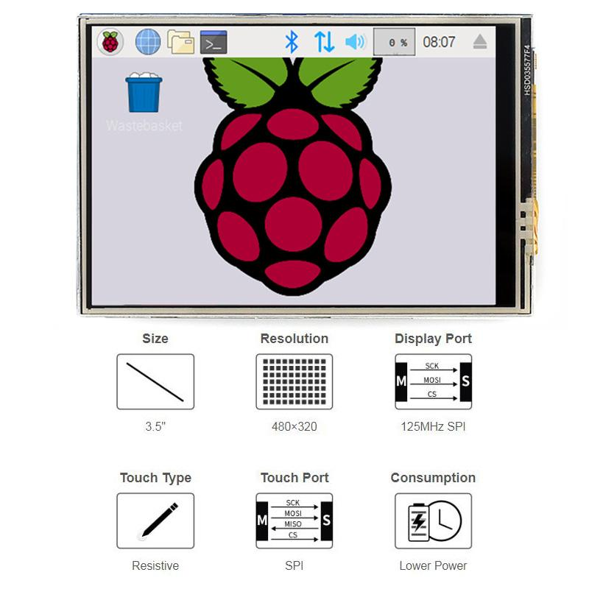
Option A — Touch LCD
Simpler controls
- Record, play, pause, stop, and file-selection buttons appear on the screen.
- Fewer physical control components and less front-panel wiring.
- Easier to change the interface in software.
- The display surface may be harder to operate with gloves, moisture, or dirt, depending on the touch technology.
- A damaged touchscreen can make the device difficult to operate.
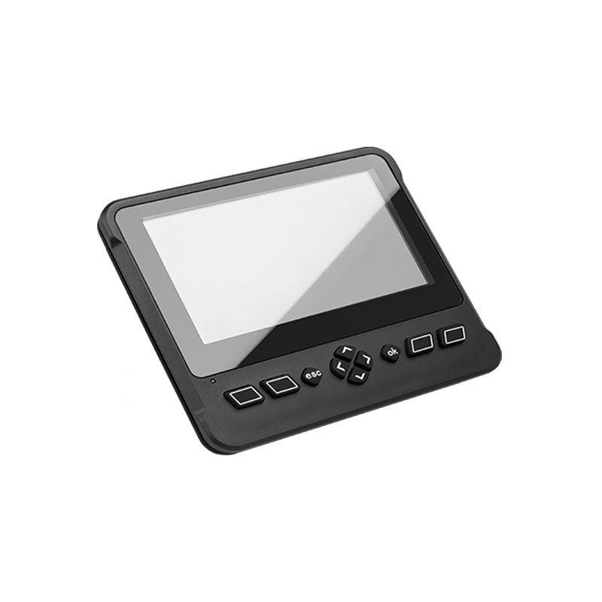
Option B — Non-touch LCD + physical buttons
My preferred starting point
- Dedicated controls remain usable without interacting with the display surface.
- The front panel can be designed for dust and moisture resistance.
- Tactile feedback helps users operate the device without looking at the buttons.
- Additional buttons, wiring, and mounting hardware add cost and assembly work.
- A sealed button panel can be durable, but ordinary exposed buttons are not automatically waterproof.
My recommendation: choose a non-touch LCD with a sealed six-control panel if reliability in varied environments is more important than having the fewest components. If the enclosure must be extremely small and cost is the overriding priority, a touchscreen is still a good option.
The final cost comparison should include the LCD, controller, buttons, wiring, enclosure, assembly, and protection—not just the display price.

2. Best alternative to Raspberry Pi 3B
My first board to test would be the Raspberry Pi Zero 2 W. It is compact, has a CSI camera connector, and supports hardware H.264 encoding at up to 1080p30. That gives it enough theoretical video capability for your 480 × 320, 25 FPS target, provided the camera pipeline, display rendering, and file recording are configured correctly.

Raspberry Pi
+1
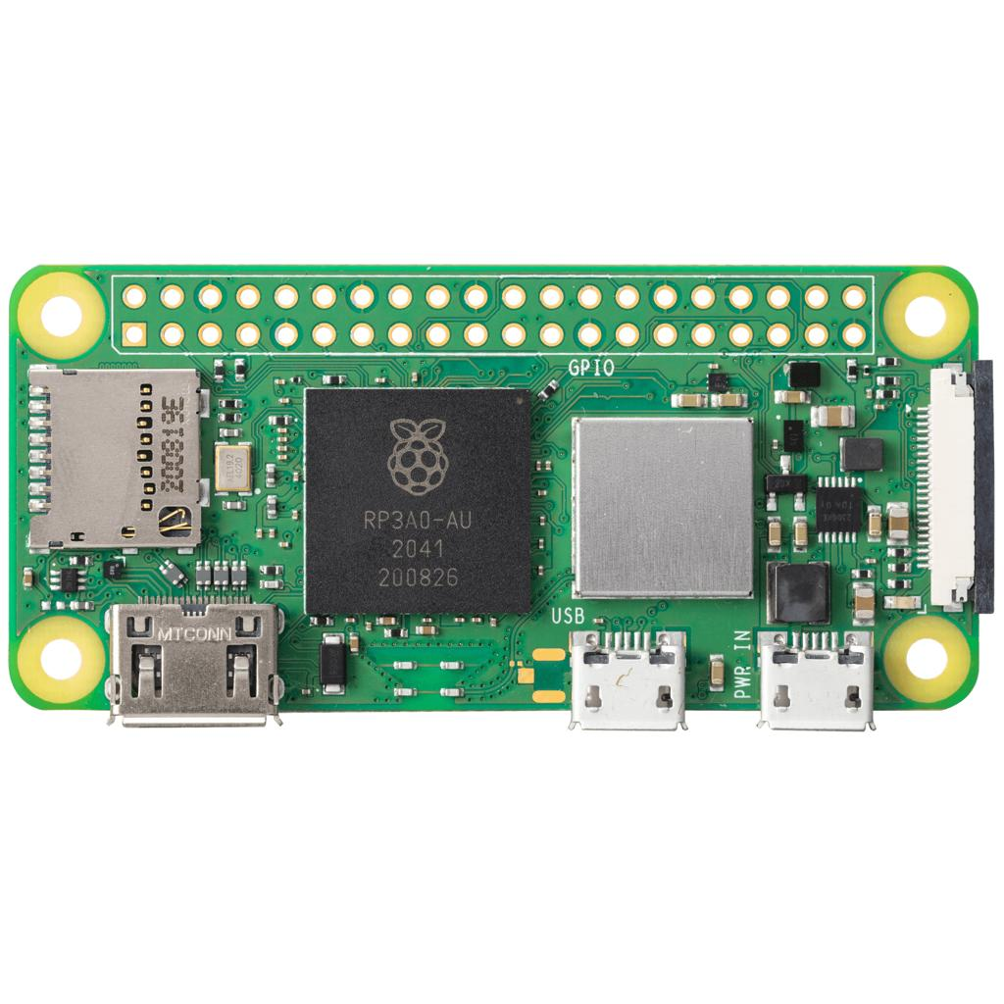
1. Raspberry Pi Zero 2 W
Best first prototype
Official product page and specifications
65 × 30 mm · 512 MB RAM · quad-core Cortex-A53 · CSI camera connector
Official product page: Specifications, documentation and purchase options.
Indicative board price: around US$15, subject to regional availability.
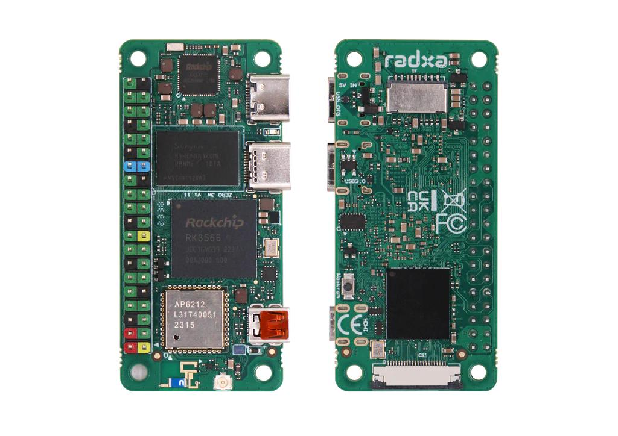
2. Radxa ZERO 3W
Quad-core Cortex-A55, up to 1.6 GHz, with a more capable GPU and optional eMMC configurations. A reasonable alternative if the Zero 2 W lacks performance headroom.
Official catalog: Radxa ZERO 3W specifications and documentation.
Price: depends on RAM, storage and supplier; obtain a current quotation.
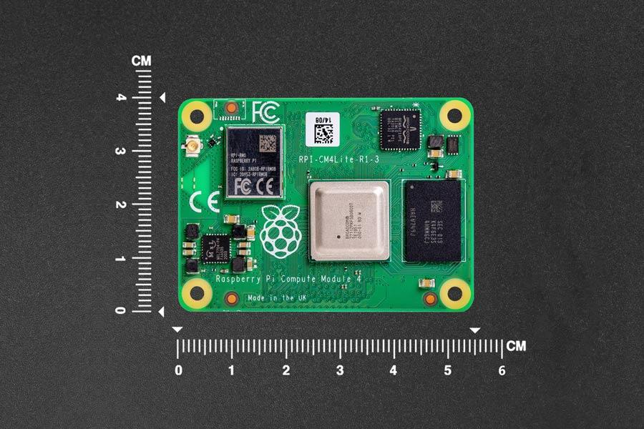
3. Raspberry Pi Compute Module 4 Lite
Better suited to a custom carrier PCB and a production enclosure than a quick prototype. It has more CPU capability, but it is not my first choice when minimizing power and heat is the overriding requirement.
Official catalog: CM4 specifications, datasheets and STEP files.
Official page lists the CM4 family from US$41.25; exact variants cost differently.
Raspberry Pi

Board comparison
Requirement | Pi Zero 2 W | Radxa ZERO 3W | Compute Module 4
Small size | Excellent | Excellent | Excellent module size
Low-power design priority | Best starting point | Needs measurement | Not the first choice
Camera interface | CSI-2 | Check selected camera and connector | CSI-2
480 × 320 at 25 FPS | Plausible; test end-to-end | Plausible; test end-to-end | Plausible
Hardware H.264 encoding | Supported | Verify exact hardware/software pipeline | Supported
Custom production PCB | Possible with care | Possible | Best suited to carrier-board integration
Development effort | Low | Moderate | Moderate to high
These are design-fit judgments, not a claim that one board has the lowest measured power in every workload.

What about the claim that Raspberry Pi 3B is no longer produced?
I would verify the exact model's current availability with the manufacturer or authorized distributor before assuming it has been discontinued. You do not need to stay with the Pi 3B, however: the Zero 2 W is substantially smaller, and its official product page states that it is intended to remain in production until at least January 2030.
Raspberry Pi
+1

3. Camera recommendation
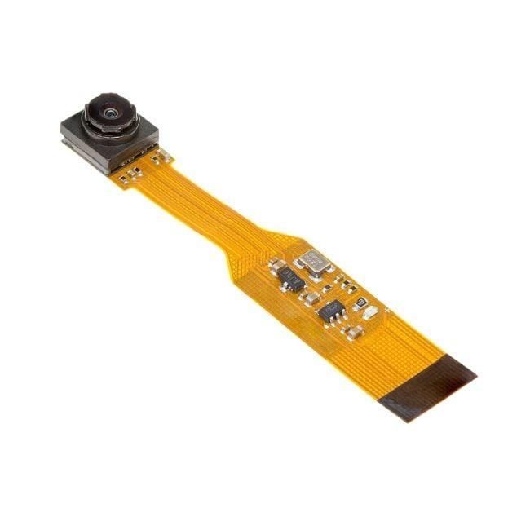
Arducam OV5647 5MP Mini Camera Module

$6.99–$8.49
Listed prices on the manufacturer's pages; availability and compatible cable options vary.
- 5 MP sensor with fixed-focus lens.
- Small camera PCB, approximately 25 × 24 mm.
- CSI ribbon interface; a suitable ribbon cable is required for the Pi Zero connector.
- The manufacturer lists video modes up to 1080p, and a related Zero-compatible variant supports up to 30 FPS.

Arducam
+1
Catalog, specifications and purchase page.
For a clear picture at 480 × 320, the sensor is likely sufficient. Image quality will depend heavily on lens focus, illumination, exposure, sensor placement, and the viewing distance. If this is for a medical inspection or another demanding close-up task, test the actual lens and lighting rather than choosing solely by megapixel count.
One important distinction: 25 FPS preview and 25 FPS recording are different requirements. A display may refresh at 25 FPS while the camera capture or encoded recording drops frames. Test all three together: camera capture, Qt preview, and H.264 recording to storage.

4. Inductive-triggered buttons: models, prices and catalogs
The technology you are describing is usually called inductive touch buttons or an inductive touch keypad. It is different from an ordinary inductive proximity sensor: the keypad detects tiny changes in a metal panel when a user presses it.
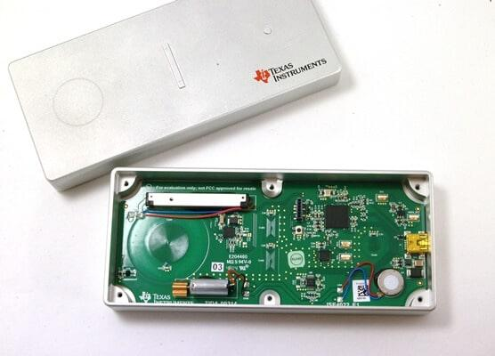
electronicsforu

Best reference design: Texas Instruments TIDA-01102
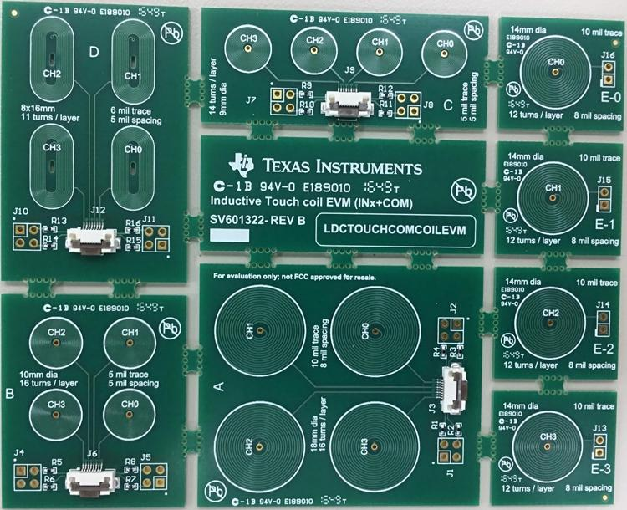
TI TIDA-01102
Designed around a stainless-steel panel with 16 inductive buttons. It demonstrates a sealed interface that can be designed to achieve IP67 protection against dust and water ingress.

Texas Instruments
Price: no standard retail keypad price; this is an engineering reference design, not a ready-to-install product.
Catalog: Official TI product and documentation page.
Useful downloadable documentation:
- Design guide PDF — inductive stainless-steel keypad.
- Assembly drawing PDF.
- Bill of materials PDF.
- Schematic PDF.
These documents are useful for engineering your own panel, rather than ordering a finished six-button keypad.

What should you buy for the prototype?
Option | Indicative price per button | Advantages | Disadvantages
Sealed tactile panel-mount pushbutton | US$1–5 | Low development cost, clear tactile feedback | Moving parts; sealing varies by model
Industrial metal pushbutton with IP67 rating | US$2–10 | Rugged, tactile, easier to integrate | Larger, more expensive, still mechanical
Custom inductive-touch button system | No reliable universal unit price | Smooth, sealed metal face with no moving button mechanism | Custom PCB, sensors, firmware, calibration and validation required
These are preliminary budgeting ranges, not verified quotes for a particular model. Prices vary with size, quantity, materials and protection rating.
For mechanical buttons, start by comparing sealed panel-mount switch catalogs from manufacturers such as E-Switch: Official catalog and product documentation.

5. Is inductive touch better than normal physical buttons?
Inductive buttons are better when environmental sealing is critical.
There are no moving button parts penetrating the front panel. The metal surface can be continuous, reducing the paths through which dust and water could enter. This can be particularly valuable for a portable instrument used outdoors or in wet environments.
Texas Instruments
Mechanical buttons are better for a low-cost first prototype.
Users can feel the click, accidental activation is easier to control through switch force and travel, and the wiring is simple. Replacing a failed button is also straightforward.
One important point: inductive touch buttons typically sense metal deformation or a change in the sensor's inductance. They are not necessarily activated by simply bringing a finger near the panel. A suitable design must account for panel thickness, press force, sensor geometry, electrical noise and button sensitivity.
My choice for your product:
- Prototype: six sealed mechanical panel-mount buttons.
- Production model requiring high water/dust resistance: evaluate a custom inductive keypad.
- If the device will be cleaned frequently with liquids, specify and test the complete enclosure's IP rating rather than relying only on the button component's rating.

6. Proposed button layout and outer-box concept
Here is a visual concept for the device enclosure, with the LCD above a six-button metal control panel.
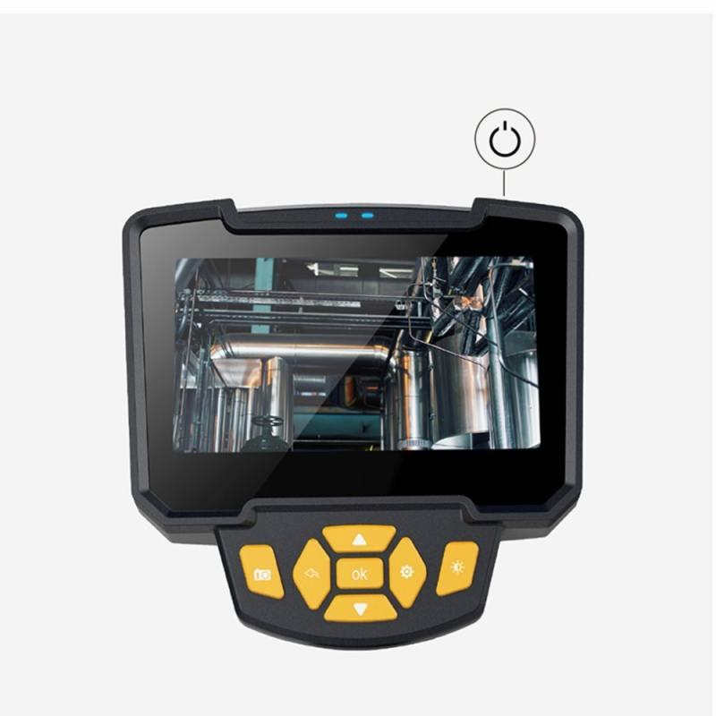
wonderlong
Concept reference for the enclosure shape and control arrangement. The final CAD design should use the actual LCD dimensions, camera connector, battery and selected switch specifications.
The six-button layout I recommend is:
Power
Up
Down
Record
Play / Pause
Stop
Suggested arrangement: navigation and power in the upper row; recording and playback controls in the lower row. Use distinct shapes or raised markings for critical controls.

PNG image of the keyboard and enclosure concept
I've generated a high-resolution concept image you can use as a visual reference while discussing the enclosure with a mechanical designer.
Open the generated PNG concept

7. Final recommended prototype configuration
Component | Recommendation
Processor board | Raspberry Pi Zero 2 W
Camera | Arducam OV5647 5 MP CSI module
Display | Compact 480 × 320 LCD, preferably non-touch for this version
Buttons | Six sealed panel-mount pushbuttons
Recording | Hardware H.264 encoding, MP4 container
Storage | High-endurance microSD card
Enclosure | Compact, gasketed housing with protected connectors
Power | Battery pack with a regulated 5 V supply, sized after measuring total load
Before committing to the final board, run a continuous recording test at 480 × 320 and 25 FPS while updating the Qt preview and responding to button inputs. Measure power consumption, processor temperature, dropped frames and recording reliability over an extended run. The camera, LCD backlight, storage and voltage regulator all contribute to total power consumption.
The Zero 2 W is my recommended starting point because it is small, inexpensive and supports hardware video encoding. The main thing to prove in a prototype is whether its CPU, memory and software pipeline can sustain your complete workload—not merely whether it can capture 25 frames per second in isolation

